Training: Discovery, Part 4 - Landing Pages
Step-by-step guide to building a public landing page from blocks: creating the page, adding and setting up blocks, publishing and versions
Dr Johan Pieterse
Document control
Field | Value
Document title | Training: Discovery, Part 4 - Landing Pages
Author | Dr Johan Pieterse
Owner | The Archive and Heritage Group (Pty) Ltd
Version | 1.0
Status | Released
Date | 15 October 2026
Prepared for | Administrators and archivists who present collections to the public
Classification | Public
Reference | AHG-TRN-DIS-04
Contents
Right-click and choose Update Field to build this list.
List of Tables
Right-click and choose Update Field to build this list.
This guide goes with part 4 of the discovery training videos. A landing page is a public page built from blocks, to introduce a collection or welcome visitors. The guide covers creating a page, adding blocks, setting each one up, publishing, and restoring an earlier version. Allow about 15 minutes.

Before you start
What you need before you start
What | Notes
Building pages | An administrator account.
Image carousel | The IIIF plugin enabled, and a IIIF collection to show.
Seeing a page | Anyone, once it is active and published.

1. Create a page
Landing pages are listed at Admin > Landing Pages (/admin/landing-pages). Each has its own address, /landing/<address>. Choose Create New Page and fill in:
New page settings
Field | Notes
Page name | For staff; shown in the list.
URL slug | The page’s address, for example discovery-practice. Made from the name if left empty.
Description | A note for colleagues on what the page is for.
Set as default home page | Leave off unless the page should replace the site’s front page.
Active | On, so the public can see the page once it is published.
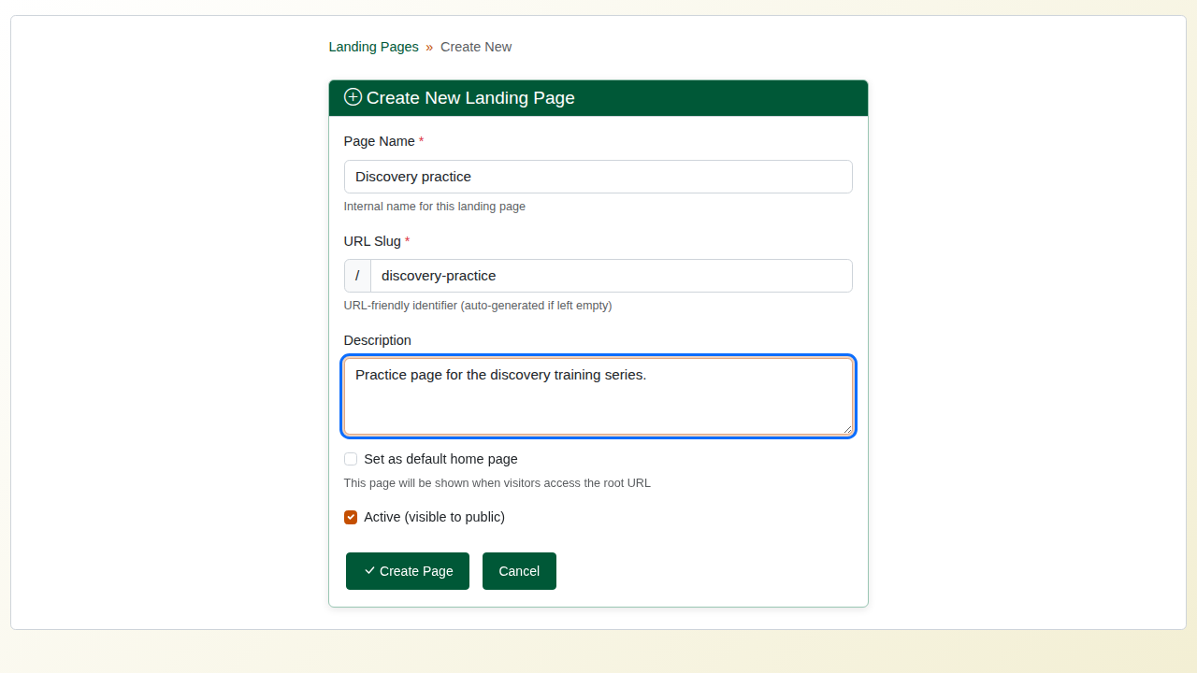
The new page form.

2. Add blocks
The editor shows the blocks on the left, grouped as Layout, Content, Data and Other, and the page on the right. Click a block to add it; the page reloads with the block at the end. Drag a block by its handle to change the order. Each block has buttons to hide it (it stays on the page in the editor, but visitors do not see it), edit it, copy it or delete it.
Commonly used blocks
Block | What it shows
Hero banner | A large title and subtitle, over an image or a plain band
Statistics | Counts of records, repositories, people and organisations, and digital objects
Recent items | The newest published records, with thumbnails
Image carousel | The images of a IIIF collection as a slideshow
Rows (1, 2 or 3 columns) | Containers that place other blocks side by side
Text, search box, browse panels, holdings, map, quick links | Further blocks for content and navigation
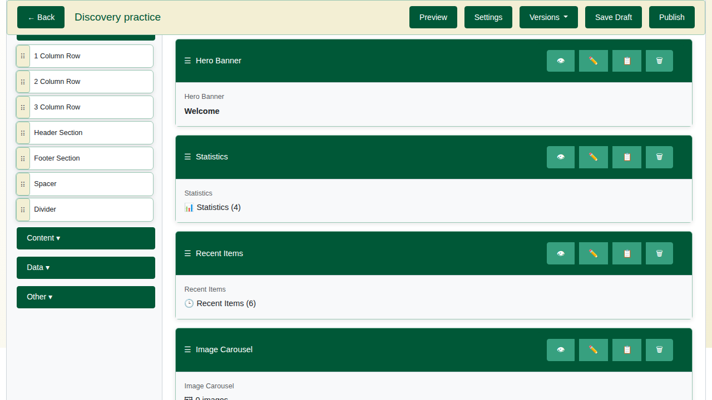
The page with four blocks.

3. Set up each block
Choose the pencil on a block to open its settings on the right, change them, and choose Save Changes. The editor card then shows the new values.
For the hero banner, set the title, subtitle and height (for example 300px). For the image carousel, enter the IIIF collection’s short name (for example featured-collection-1) and a heading.
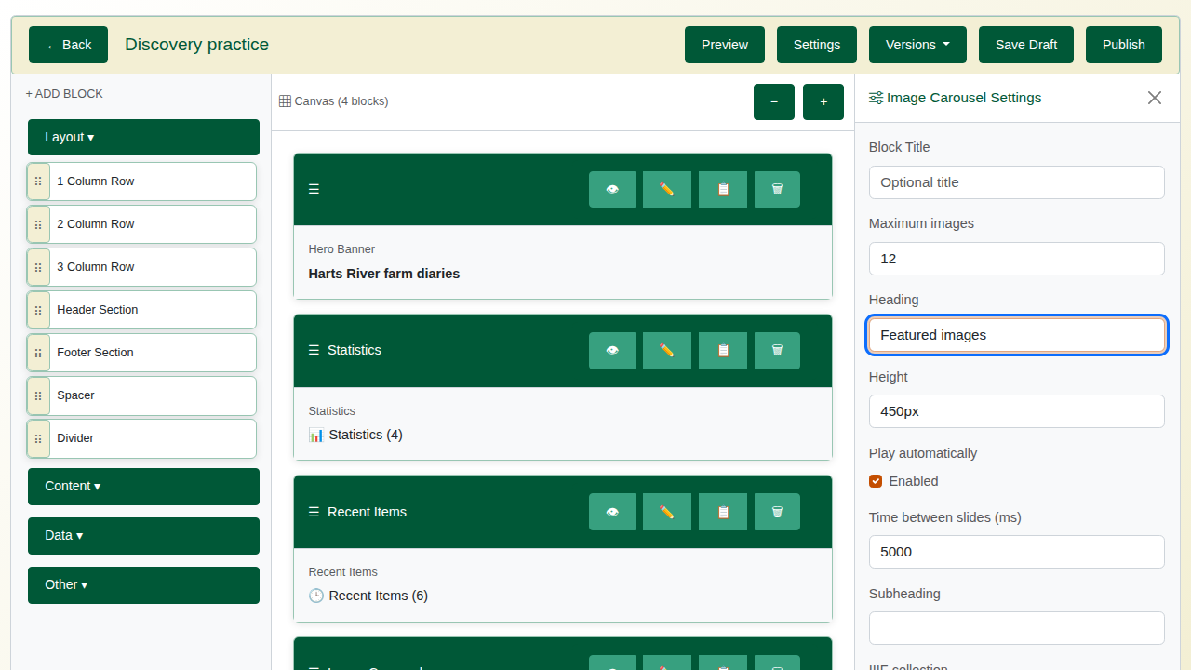
The carousel settings.
Statistics and recent items need no settings. They are counted and listed from the catalogue every time the page is shown, and only published records appear on them.

4. Publish
Save Draft keeps your work without changing what visitors see. Publish makes it live. Each publish keeps a version, and the Versions menu restores an earlier one.

5. The result
Open the page at its address (/landing/discovery-practice in the video) to see it as a visitor does. Link it from a menu or the home page so visitors can find it.
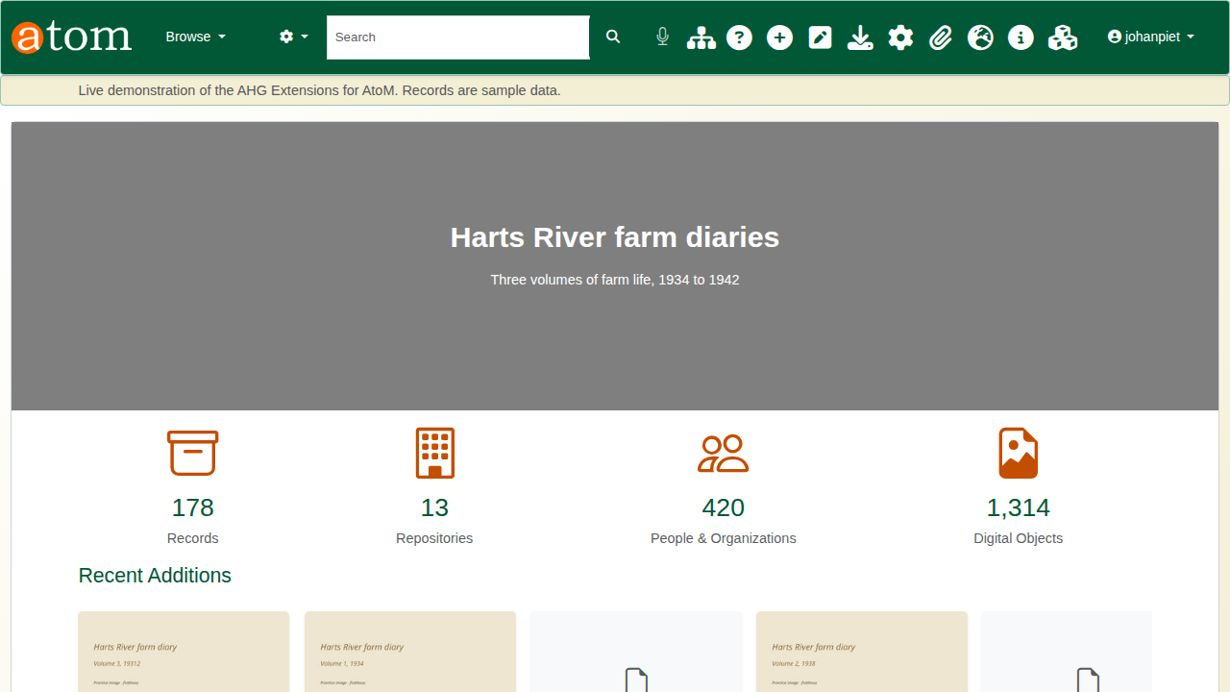
The published page.
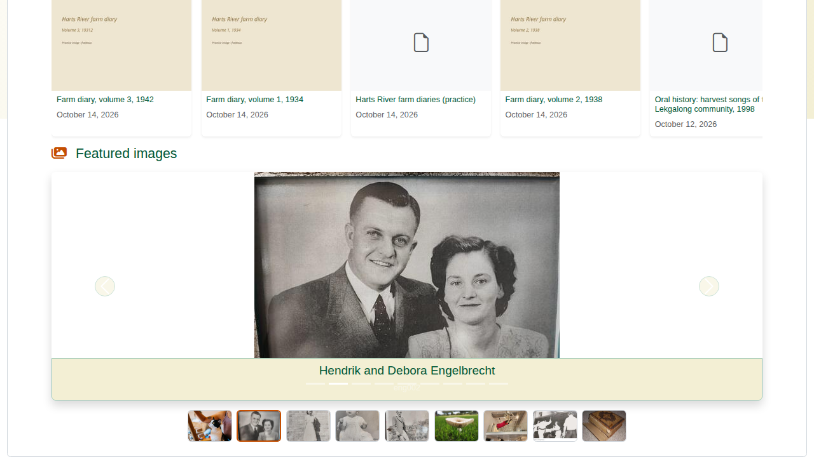
The carousel on the published page.

Recap
- Create the page.
- Add blocks.
- Set up each block.
- Publish, and check the page as a visitor sees it.
Part 5 covers DOIs for records and the public chatbot.

