Training: Compliance, Part 4 - Rights, TK Labels and Embargoes
Step-by-step guide to recording rights statements and licences, community TK labels and cultural notices, and placing and lifting an embargo
Dr Johan Pieterse
Document control
Field | Value
Document title | Training: Compliance, Part 4 - Rights, TK Labels and Embargoes
Author | Dr Johan Pieterse
Owner | The Archive and Heritage Group (Pty) Ltd
Version | 1.0
Status | Released
Date | 12 October 2026
Prepared for | Archivists and rights officers using the AHG extensions
Classification | Public
Reference | AHG-TRN-CMP-04
Contents
Right-click and choose Update Field to build this list.
List of Tables
Right-click and choose Update Field to build this list.
This guide goes with part 4 of the compliance training videos. It covers four tasks on an oral history recording: recording its copyright status and licence, attaching the community’s traditional knowledge (TK) label and cultural notice, embargoing it while the community is consulted, and lifting the embargo. Allow about 15 minutes.

Before you start
What you need before you start
What | Notes
An editor or administrator account | Rights, ICIP and embargoes are staff tasks; visitors cannot open these pages.
A practice record | The video uses “Oral history: harvest songs of the Lekgalong community, 1998”. The community and everyone in it are fictitious.

1. Rights statement and licence
On the record, click Add extended rights (or Edit extended rights once set). Choose the Rights Statement from the RightsStatements.org list and, where the material is openly licensed, the Creative Commons License. A rights holder can be chosen from the donors. Click Save Rights.
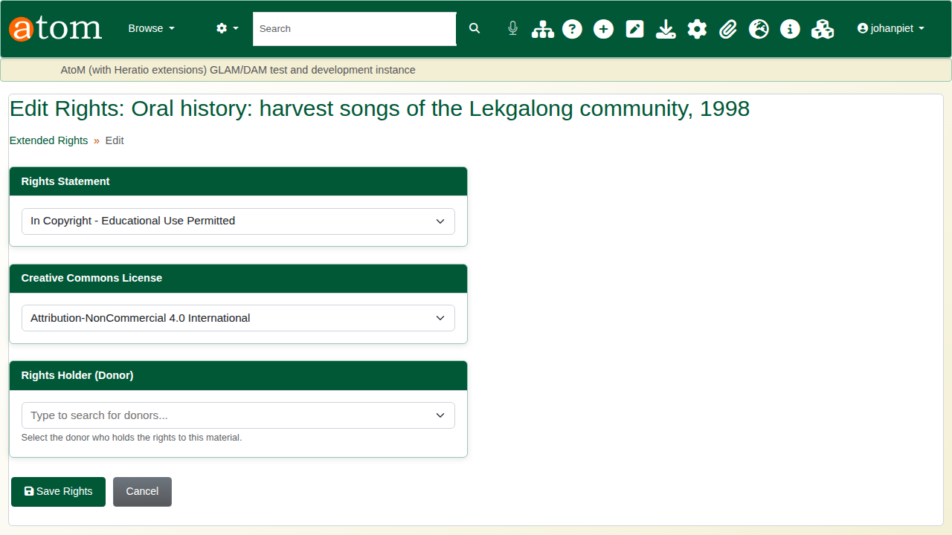
The rights form.
The record shows the statement and licence, each linked to its published definition.
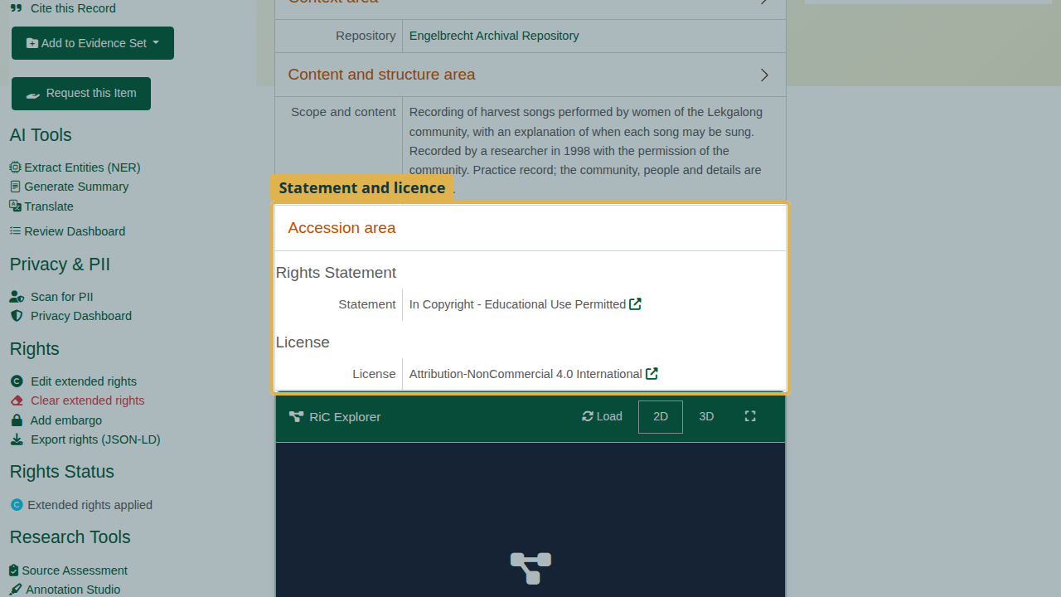
Rights on the record.

2. The community
TK labels and cultural notices belong to a community, so record the community first: Indigenous cultural & IP > Communities > Add Community (/icip/community/add). Give its name and where it is. The State/Territory list is Australian; for a community elsewhere choose Other / outside Australia and use Region. Click Create Community.
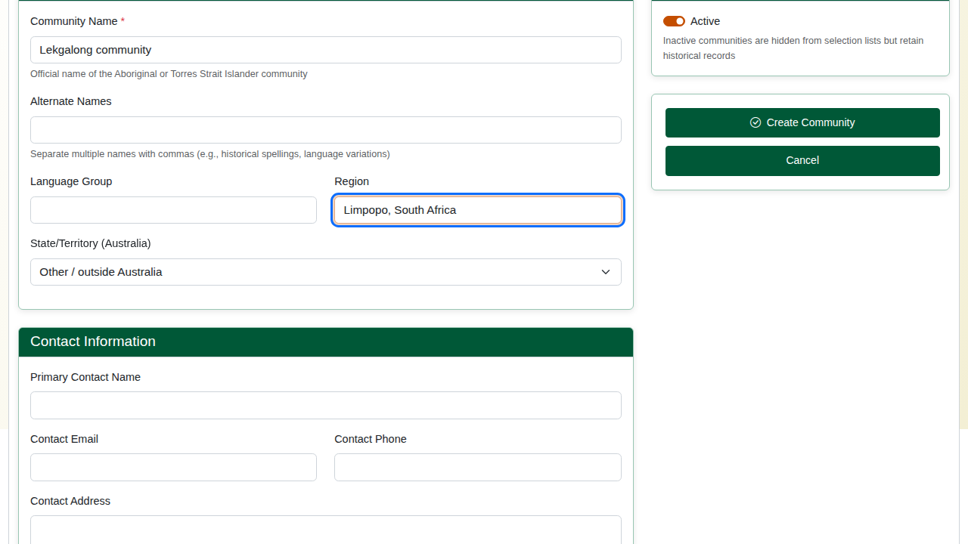
Adding the community.
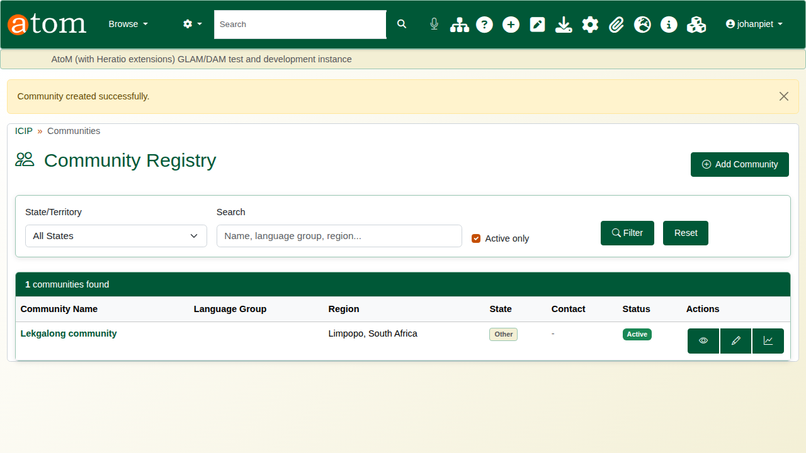
The community registry.

3. TK label and cultural notice
From the record, open Manage cultural notices & labels. Under TK Labels, choose the label (here TK Community Voice), the community, and who applied it: the community itself or the institution. Click Add Label.
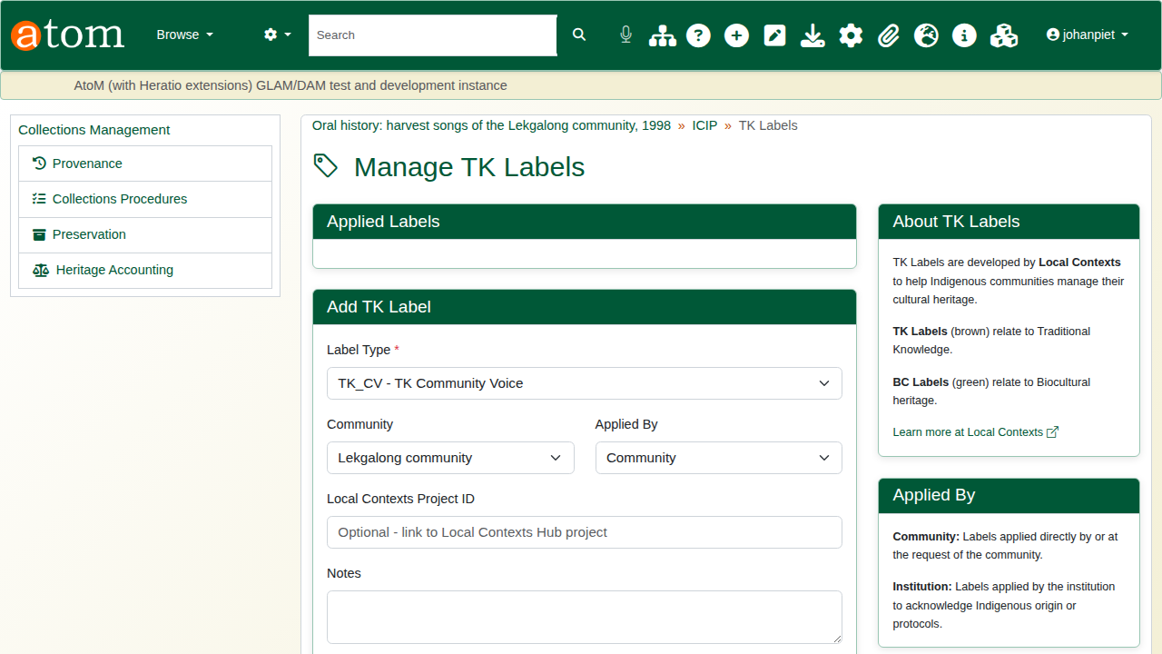
Adding a TK label.
Under Notices, choose the notice type (here Seasonal Restriction), the community and, if the default wording does not fit, the community’s own text. Start and end dates are optional, and Apply to child records passes the notice down the hierarchy. Click Add Notice.
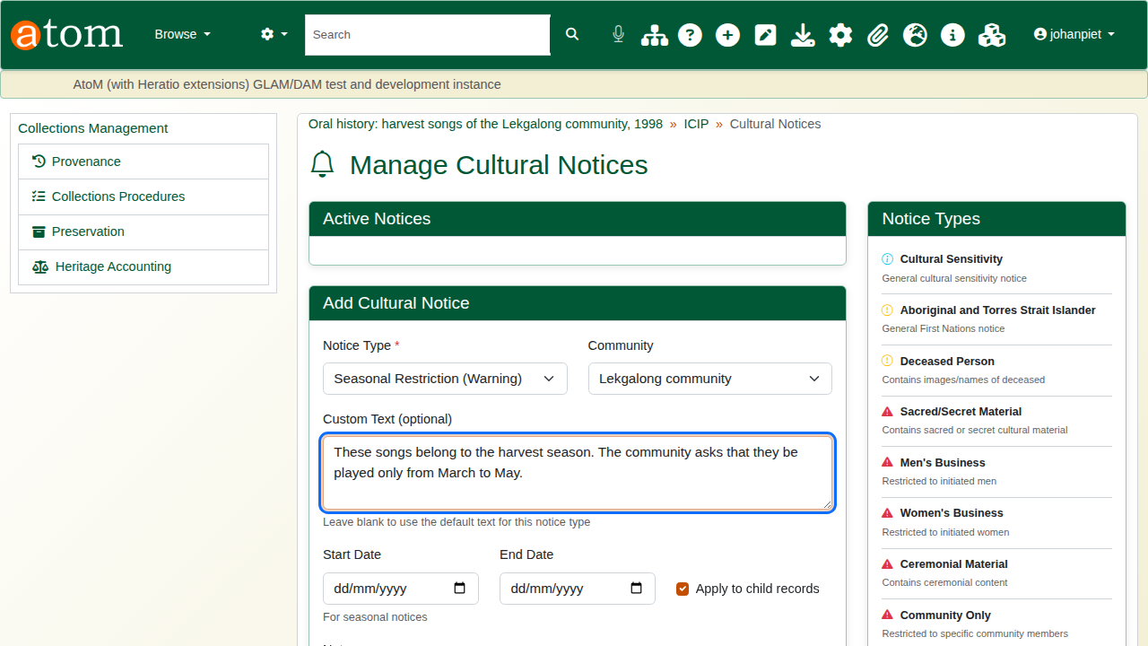
Adding a cultural notice.
The notice appears at the top of the record.
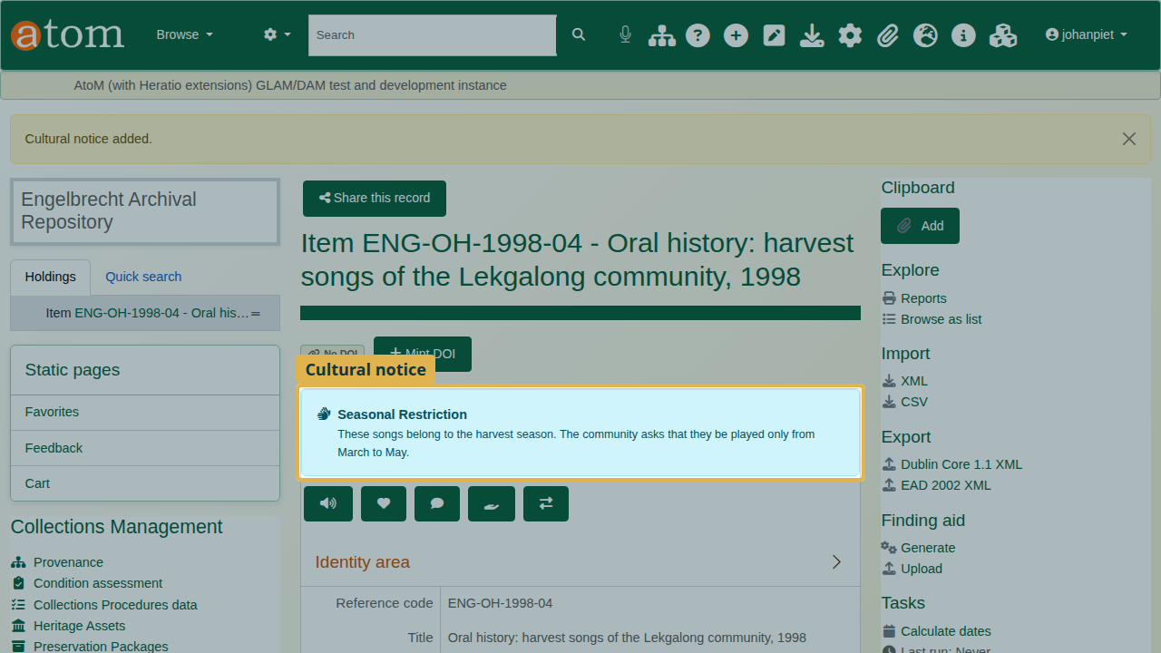
The notice on the record.

4. What visitors see
Signed out, a visitor sees the cultural notice first, then the TK label under Indigenous cultural & IP, the rights statement and the licence.
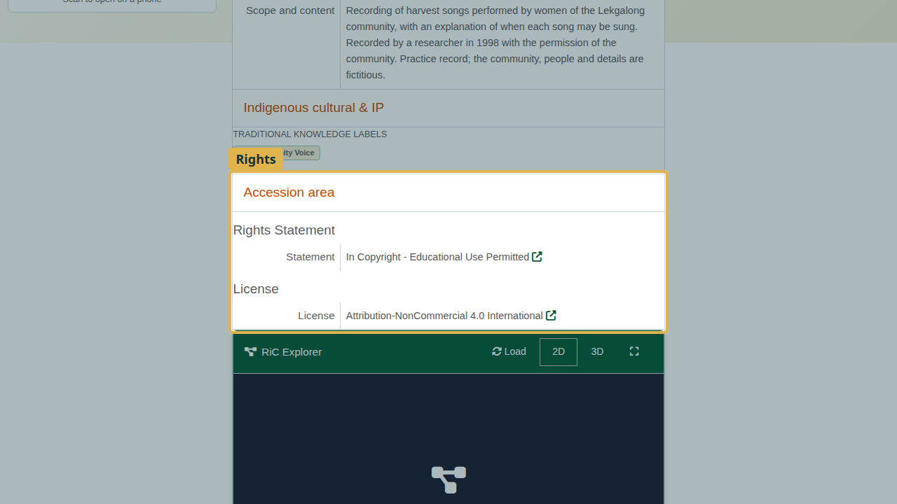
The record as a visitor sees it.

5. Embargo
On the record, click Add embargo.
Embargo types
Embargo type | Effect
Full | Hides the record completely from visitors, including search
Metadata Only | Hides the digital objects; the description stays visible
Digital Object | Restricts downloads
Custom | As configured for your site
Set the start and end dates, or tick Perpetual for no end date. The Reason is shown to visitors who are turned away; Internal Notes are for staff only.
The deliberate mistake: an end date before the start date. The embargo is refused with “The end date is before the start date”, and everything typed is kept.
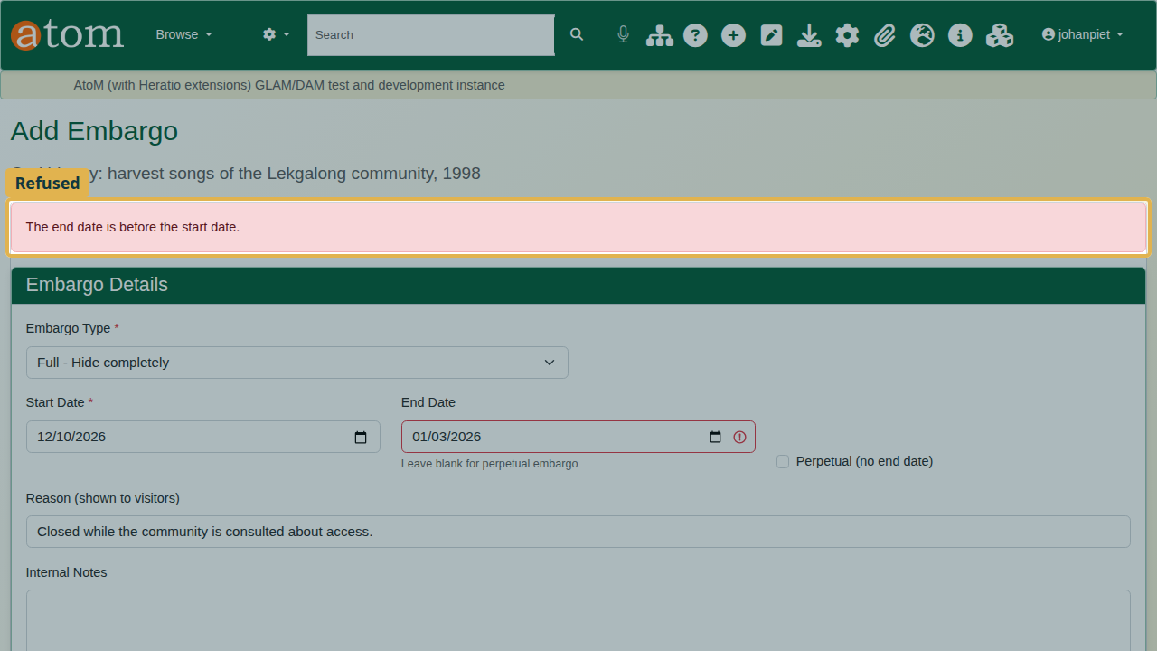
The dates refused.
Correct the end date and click Create Embargo. The record shows that it is embargoed.
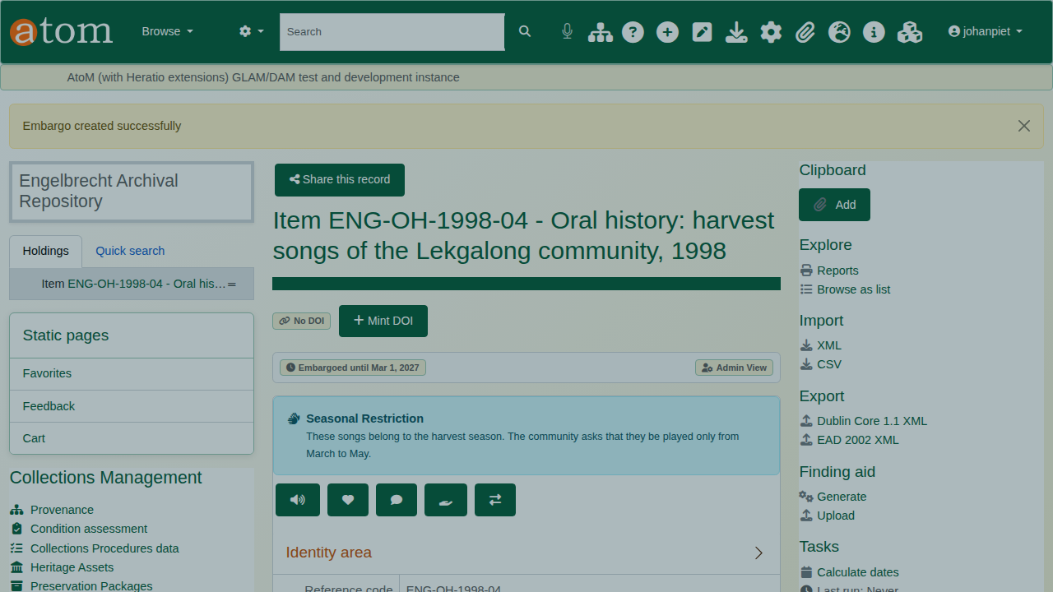
The record under embargo.
Signed out, the record is closed. The visitor is told it is under embargo, until when, and why. The title is withheld, and the record no longer appears in search results.
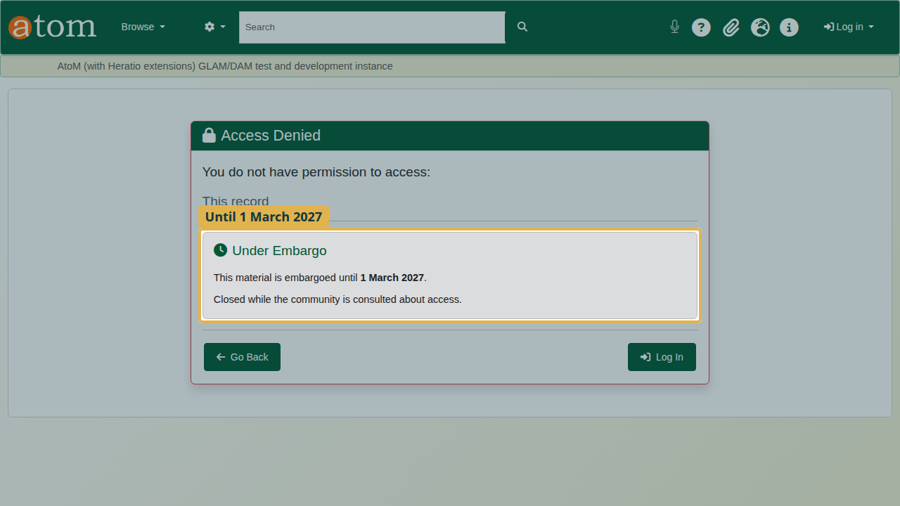
What a visitor sees.

6. Lift the embargo
Embargo Management (/extendedRights/embargoes) lists every active embargo, those with an end date first.
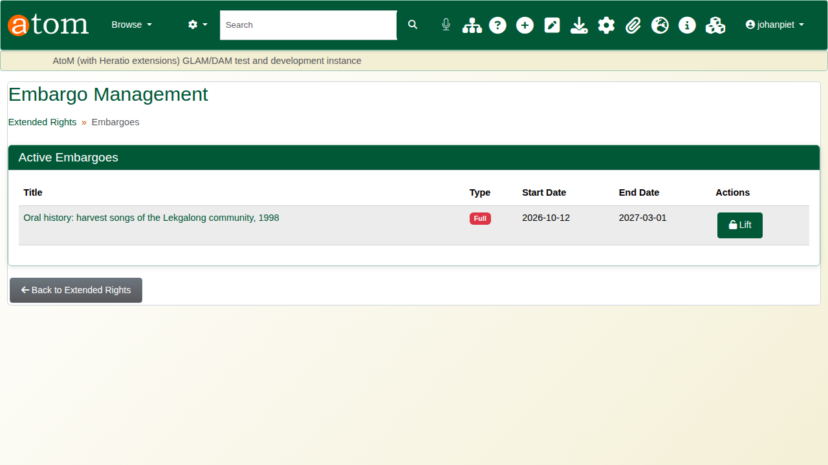
Embargo Management.
Click Lift, give the reason, and click Lift Embargo. The record opens again, and the lift is recorded with who did it and why. An embargo with an end date is also released by the scheduled embargo:process task once that date passes.
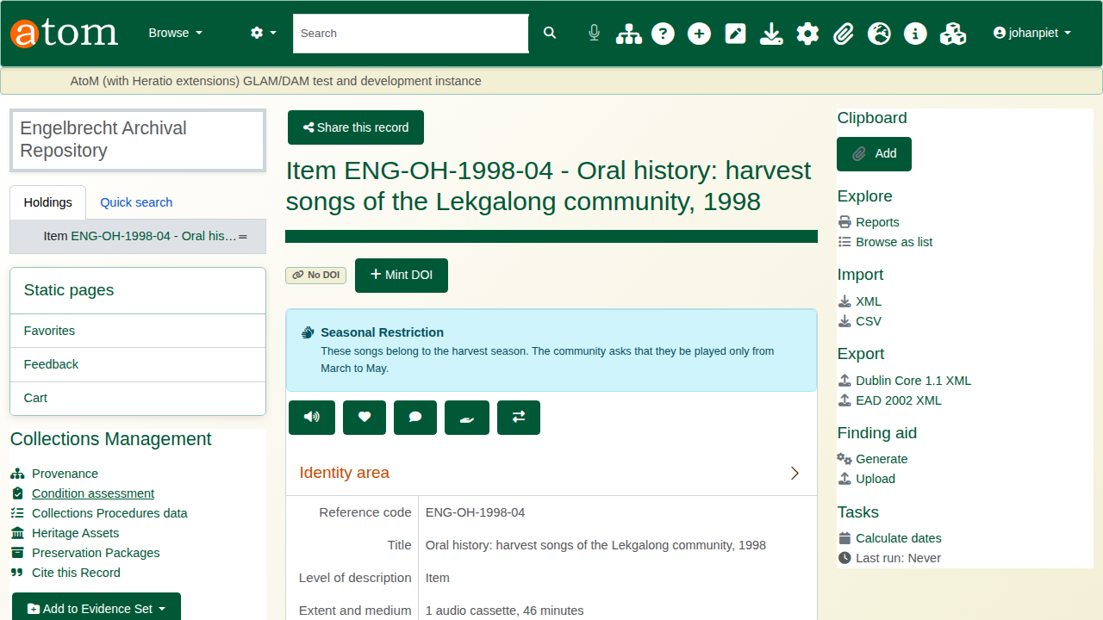
The embargo lifted.

Recap
- Record the rights statement and licence.
- Record the community, then its TK labels and cultural notices.
- Check what visitors see.
- Embargo with an end date and a reason; lift it when the time comes.
Part 5 covers the audit trail.

