Training: Preservation, Part 3 - Backup and Restore
Step-by-step guide to configuring backups, making a backup in the background, verifying backups and restoring them
Dr Johan Pieterse
Document control
Field | Value
Document title | Training: Preservation, Part 3 - Backup and Restore
Author | Dr Johan Pieterse
Owner | The Archive and Heritage Group (Pty) Ltd
Version | 1.0
Status | Released
Date | 14 October 2026
Prepared for | System administrators and archivists using the AHG extensions
Classification | Public
Reference | AHG-TRN-PRS-03
Contents
Right-click and choose Update Field to build this list.
List of Tables
Right-click and choose Update Field to build this list.
This guide goes with part 3 of the preservation training videos. You set where backups are kept, make a database backup, see it listed and verified, and look at how a backup is restored. Allow about 15 minutes.

Before you start
What you need before you start
What | Notes
An administrator account | Admin > Backup & Restore (/backup).
Separate storage | Network storage or another disk the web server can write to.
Care with restore | Restoring overwrites the live database. Practise restores on a test system, never on production.

1. Settings
Settings (/backup/settings) sets:
Backup settings
Setting | Notes
Backup path | Where backups are written. Keep it off the server’s own disk; it must be writable by the web server user.
Log path | The backup log.
Max backups, retention days | Older backups beyond these limits are removed.
Default components | Database, uploads (digital objects), custom plugins, AHG framework.
Plugins to back up | Which AHG plugins a plugin backup includes.
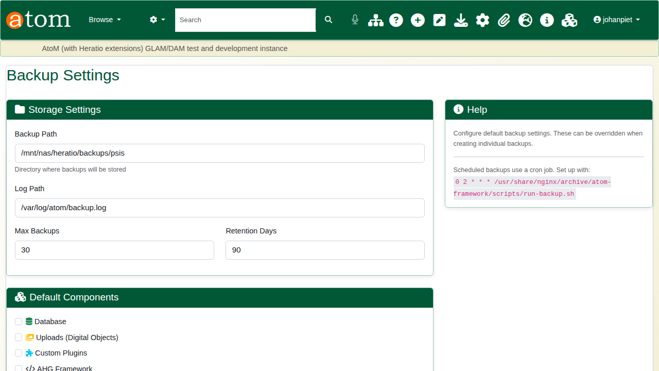
Backup settings.

2. Making a backup
The Backup & Restore page shows the database, the storage path with the number and total size of backups, quick actions (Database Only, Full Backup, Incremental Backup) and any backup schedules.
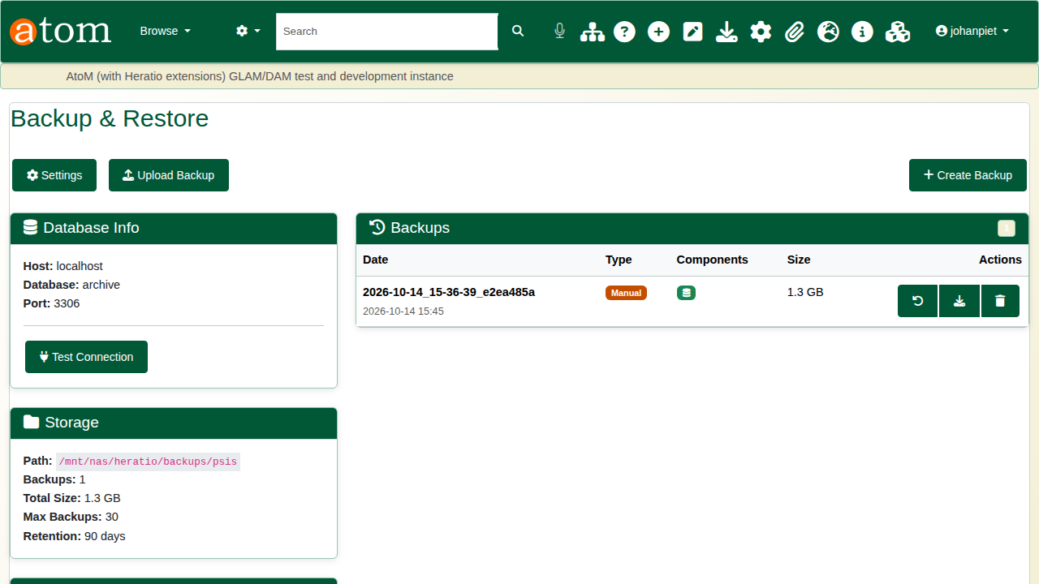
The backup page.
Choose Database Only (or Create Backup to pick components) and start it. The backup runs in the background (php symfony backup:create), because a real database takes minutes to dump: the page shows a “Backup running in the background” banner, you can leave and come back, and the list updates when it finishes. A second backup cannot be started while one is running.
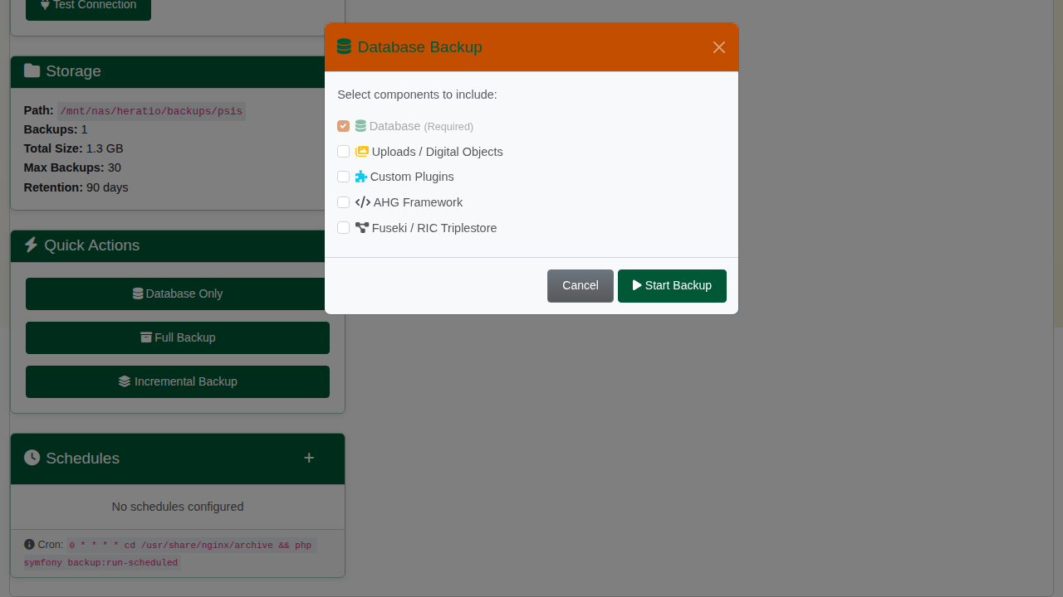
Starting a database backup.
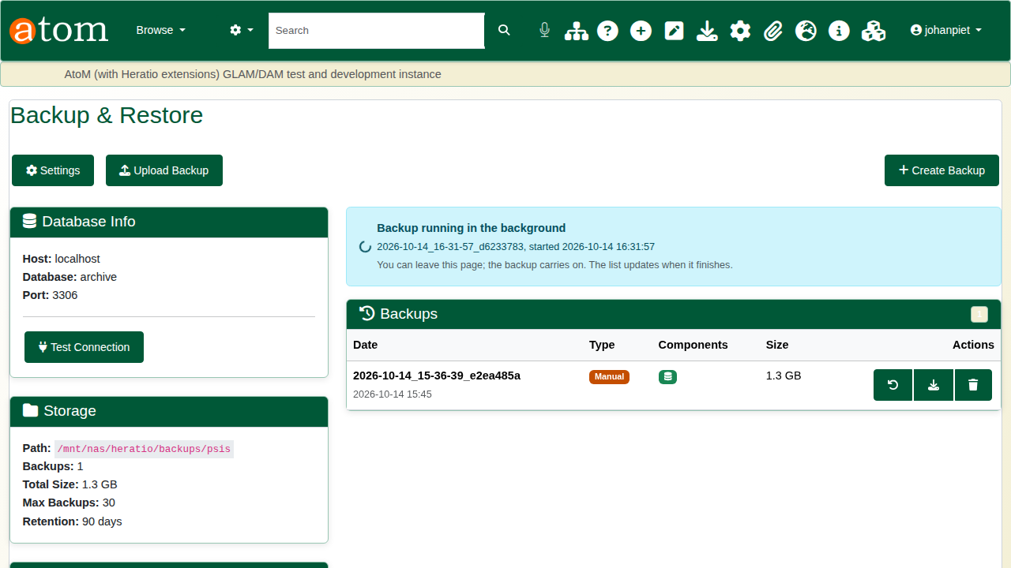
The backup running in the background.
Each finished backup is listed with its date, type, components and size, with buttons to restore, download and delete it. On disk it is a folder (the compressed database dump and a manifest.json) and a zip of the same. A dump that does not complete (for example, if mysqldump reports an error) fails the backup rather than recording an incomplete one.
Backups can also be scheduled from the page (Schedules). Schedules only run if the schedule runner, php symfony backup:run-scheduled, is started hourly by cron as the web server user, for example 0 * * * * www-data cd /usr/share/nginx/archive && php symfony backup:run-scheduled.

3. Verification
The preservation scheduler’s Weekly Backup Verification checks every backup file in the backup path: it records the SHA-256 checksum and tests the archive’s integrity. Results appear on Admin > Preservation > Backup & Replication (/admin/preservation/backup) with the verified, failed and warning counts, and on the scheduler (see part 2). A schedule can be run at once from the scheduler with its play button.
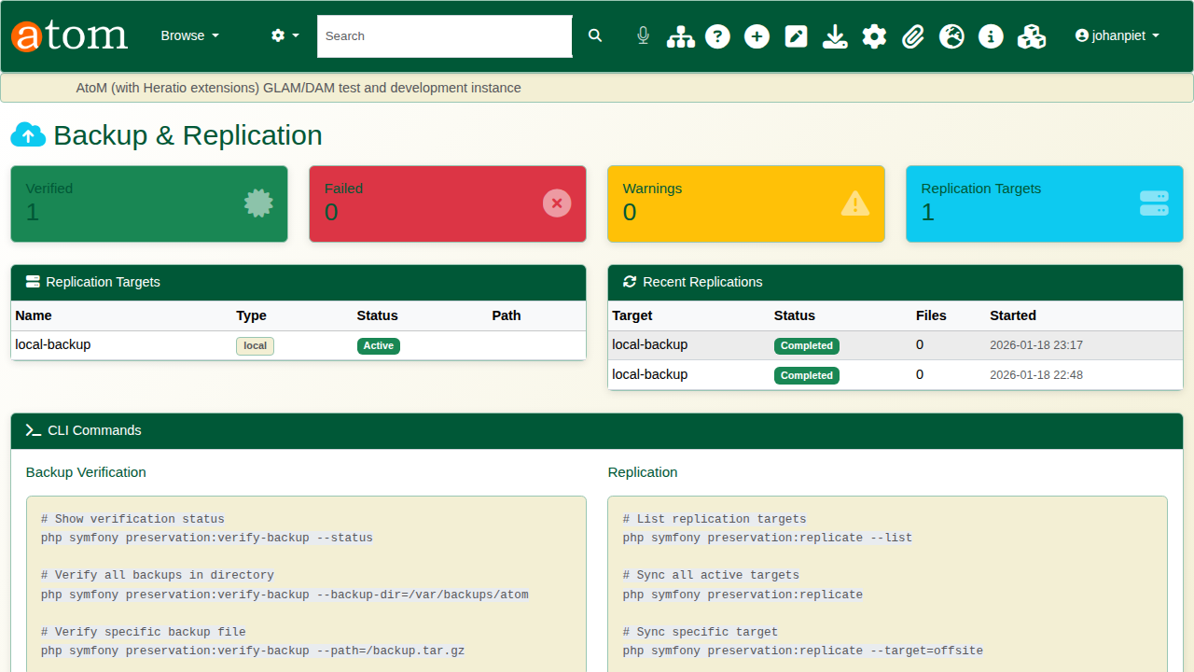
Backup verification results.

4. Restore
Open a backup’s restore button to see its details and choose what to restore: database, uploads, plugins or framework (only the components the backup holds are offered). The warning is plain: restoring overwrites existing data and cannot be undone. Start Restore asks for confirmation before it begins.
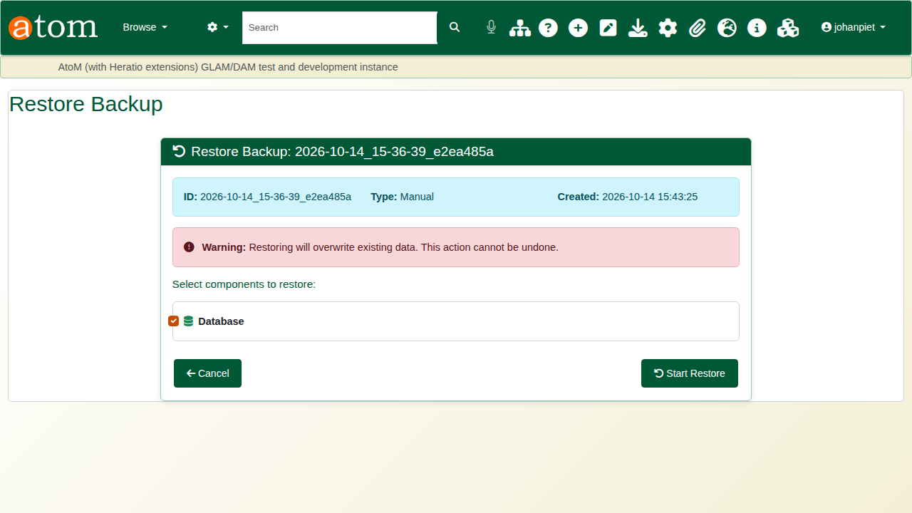
The restore screen.
A backup made on another system can be brought in with Upload Backup: a full backup archive (.tar.gz) or a database dump (.sql or .sql.gz), up to 2 GB, then restored from the uploaded copy.
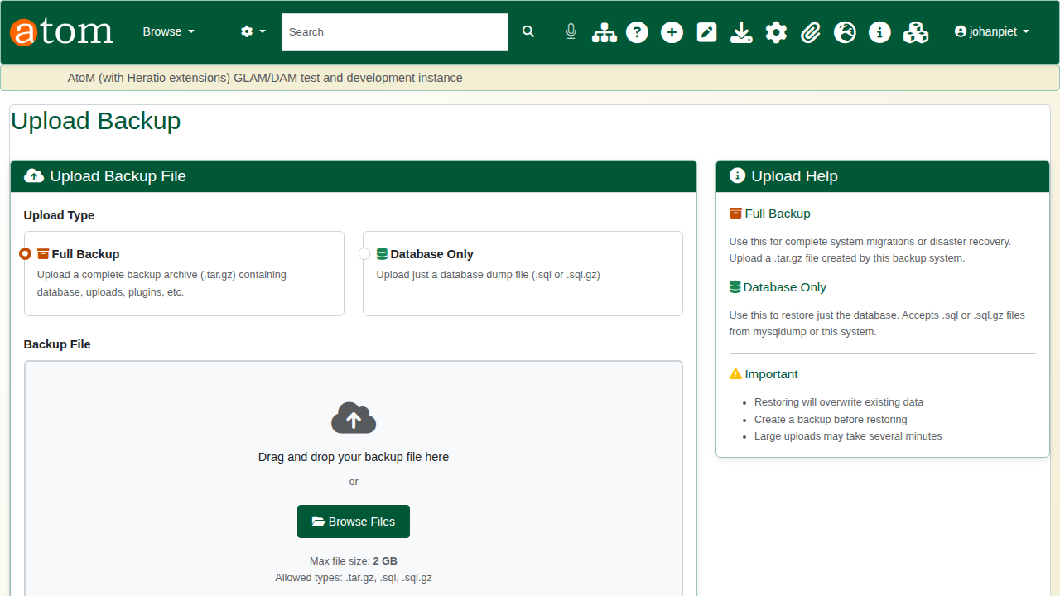
Uploading a backup.

Recap
- Keep backups on separate storage the web server can write to.
- Back up on a schedule, and on demand before big changes.
- Verify backups regularly.
- Restore with care, knowing exactly what will be overwritten.
Part 4 covers the portable offline export of the catalogue.

