Training: Importing a Hierarchy from CSV
Step-by-step guide to building a fonds, its series, files and items from one CSV file with Data Ingest
Dr Johan Pieterse
Document control
Field | Value
Document title | Training: Importing a Hierarchy from CSV
Author | Dr Johan Pieterse
Owner | The Archive and Heritage Group (Pty) Ltd
Version | 1.0
Status | Released
Date | 9 October 2026
Prepared for | AtoM users of the AHG extensions
Classification | Public
Reference | AHG-TRN-INGEST-01
Contents
Right-click and choose Update Field to build this list.
List of Tables
Right-click and choose Update Field to build this list.
This guide goes with the training video of the same name (watch on YouTube). It takes you through one complete import: a small fonds with two series, three files and an item, built from a single CSV file. You make one deliberate mistake on the way and fix it, so that you know what to do when it happens with your own data.
Allow about 20 minutes to work through it with the practice file.

Before you start
You need three things.
What you need before you start
What | Where to check
An administrator account | The AHG Plugins menu (the stacked cubes icon in the top bar) only appears for administrators.
Data Ingest enabled | AHG Plugins menu > Data Ingest section. If the section is missing, ask your system administrator to enable ahgIngestPlugin.
The practice file | groenkloof-farm-records-practice.csv, in docs/training-files/ of the AHG extensions catalogue.
Use a test or training instance if you have one. The import creates real records; you can delete them afterwards (see “Cleaning up”).

1. Prepare the CSV
Open the practice file in Excel, LibreOffice Calc or any spreadsheet.
The first row holds the column names. They must be spelt exactly as AtoM spells them, including capitals, because that is how Data Ingest recognises each column. The practice file uses these:
Columns in the practice file
Column | What it holds | Required
legacyId | A short name for this row, unique in the file | Yes, for a hierarchy
parentId | The legacyId of the row this one sits under; empty for the top | Yes, for a hierarchy
identifier | The reference code segment | Recommended
title | The title of the description | Yes
levelOfDescription | Fonds, Series, File, Item and so on | Yes
creationDates | Display date, free text | No
creationDatesStart | Start date, YYYY or YYYY-MM or YYYY-MM-DD | No
creationDatesEnd | End date, same formats | No
extentAndMedium | Extent and medium | No
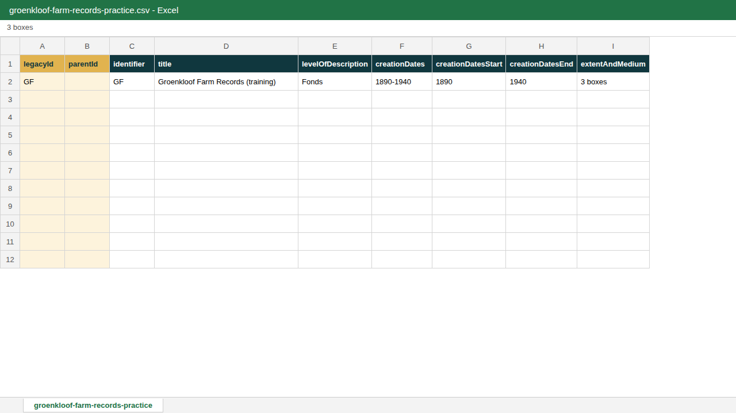
The fonds row: its parentId is empty because nothing sits above it.
How the hierarchy works:
- The fonds (row 2) has an empty parentId.
- The Accounts series (row 3) has parentId GF, the legacyId of the fonds.
- Rows do not have to be in order. The rent receipt (row 4) points to GF-A1, a file that only appears on row 5. Data Ingest creates parents first whatever the order of the file.
- The remaining rows follow the same pattern.
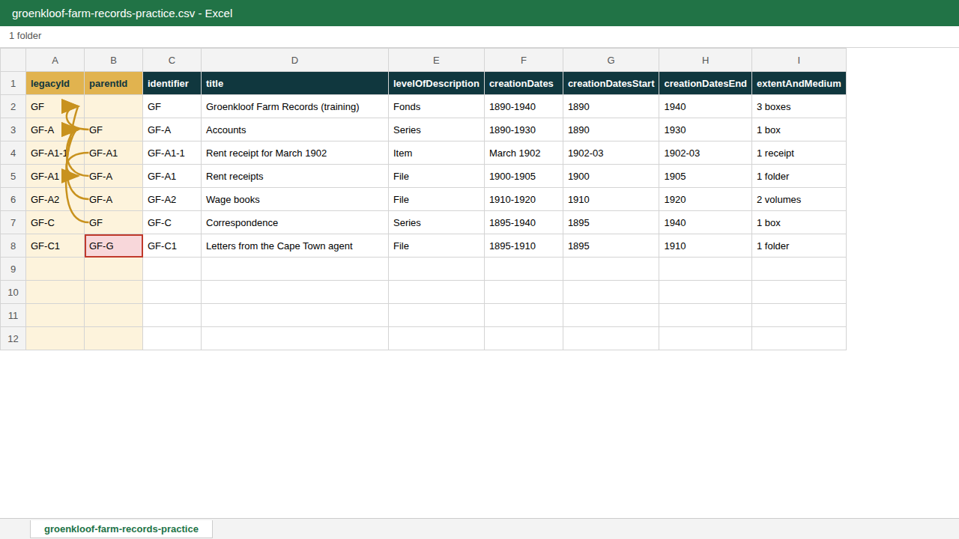
Row 8 has a deliberate mistake: its parentId is GF-G, which does not exist.
Look at the last row. The letters belong under Correspondence (GF-C), but the parentId says GF-G. Leave the mistake in for now; you fix it in step 5.
Save the file as CSV UTF-8 (comma delimited). In Excel: File > Save As > CSV UTF-8. Other CSV types can garble accented characters.

2. Start a new ingest
- In the top bar, open the AHG Plugins menu (stacked cubes icon).
- Under Data Ingest, choose New Ingest.
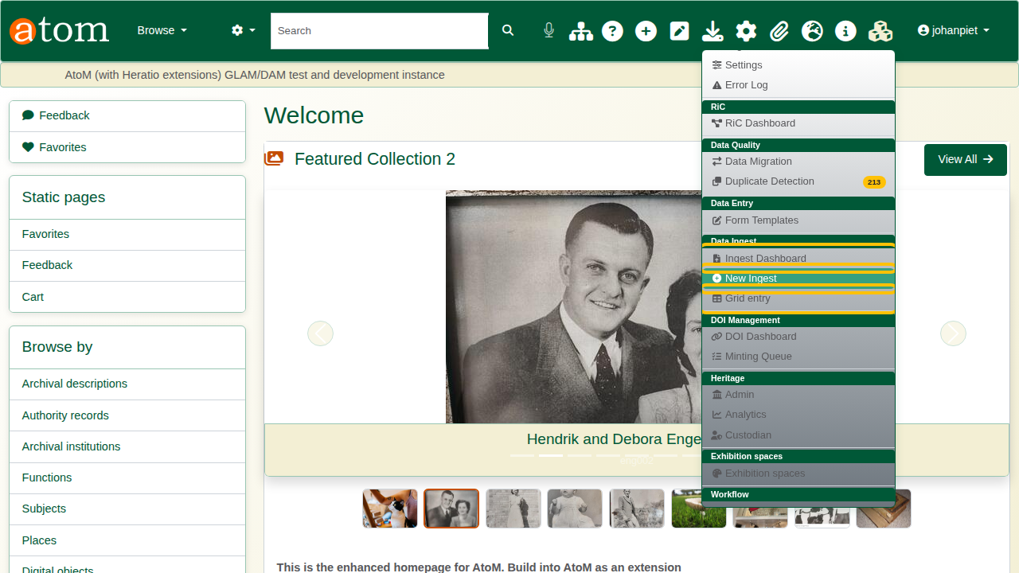
AHG Plugins menu > Data Ingest > New Ingest.
- Enter a Session Title you will recognise later on the Ingest Dashboard, for example “Groenkloof Farm Records - training”.
- Leave Record Type on Archival Descriptions.
- Choose the Sector (Archive) and the Descriptive Standard (ISAD(G)).
- Choose the Repository that will hold the records.
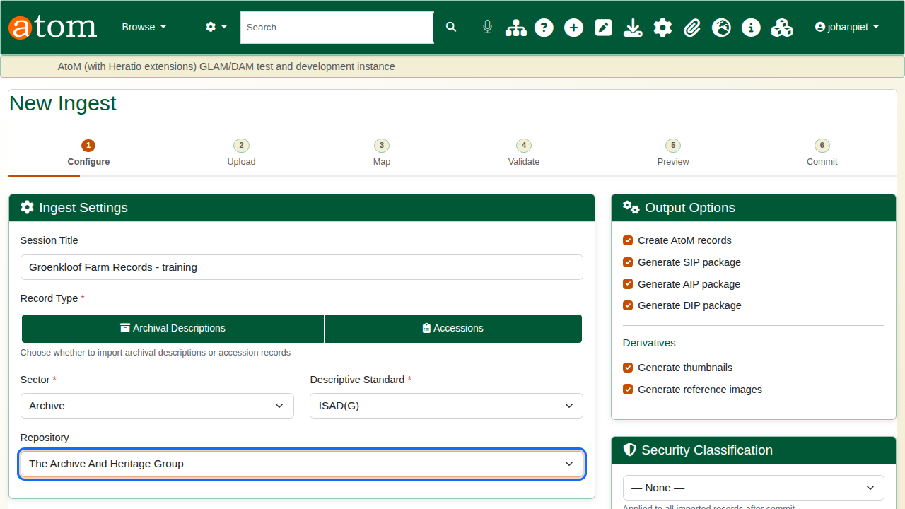
Ingest Settings with sector, standard and repository chosen.
- Under Hierarchy Placement, choose Use hierarchy from CSV (legacyId/parentId). This is the important choice: “Top-level” would put every row directly at the top of the tree.
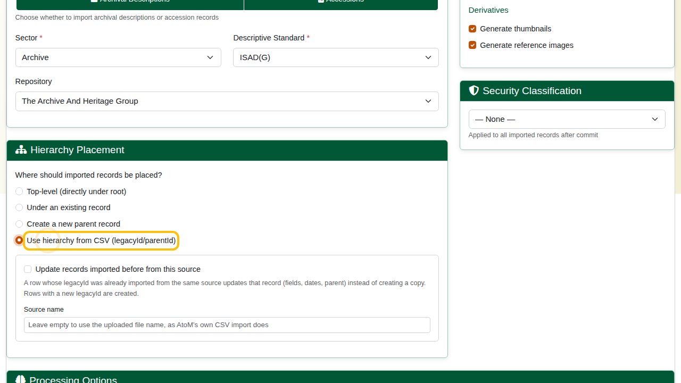
Hierarchy Placement: Use hierarchy from CSV.
- Leave the output and processing options as they are and click Next: Upload Files.

3. Upload the file
Click Choose File, select your CSV and click Upload.
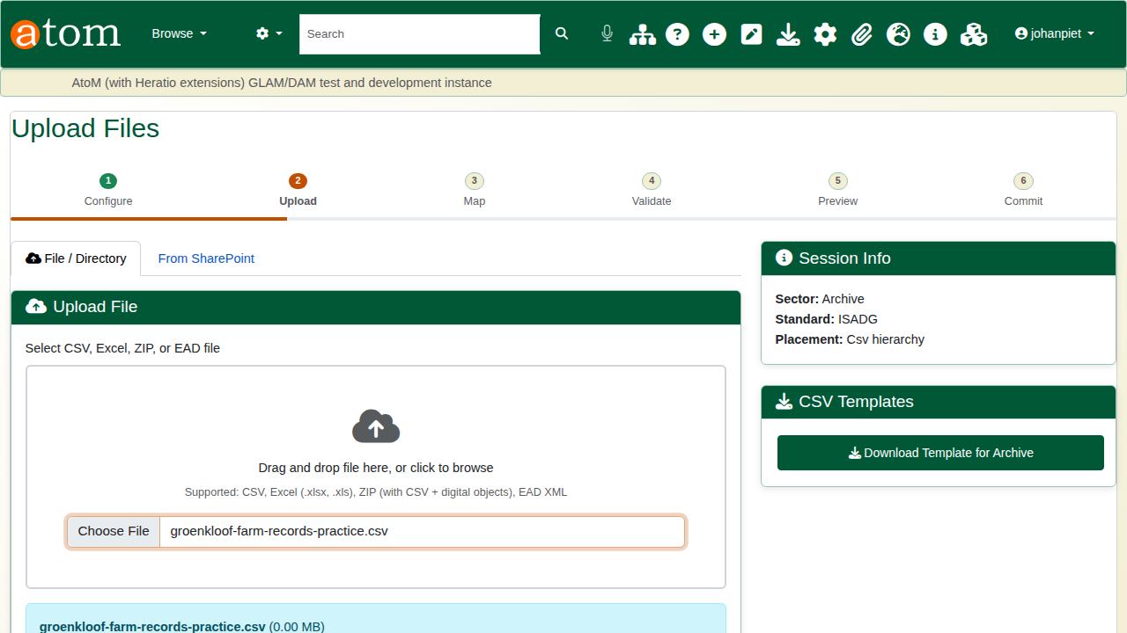
Upload Files, with the practice file chosen.

4. Check the mapping
The Map step pairs each column in your file (Source Column) with a field in AtoM (Target Field). Because the practice file uses AtoM’s own column names, every column maps itself.
Check that legacyId and parentId map to legacyId and parentId. A column that has not mapped is shown in red; choose its field from the list, or tick Ignore.
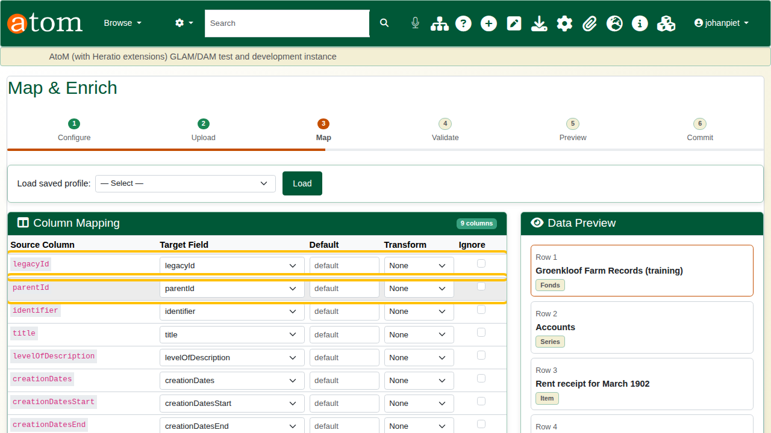
Column Mapping: each column paired with its AtoM field.
Click Save Mappings & Validate.

5. Validate and fix errors
Validation checks every row before anything is created. With the practice file, the summary shows 7 rows: 6 valid and 1 error.
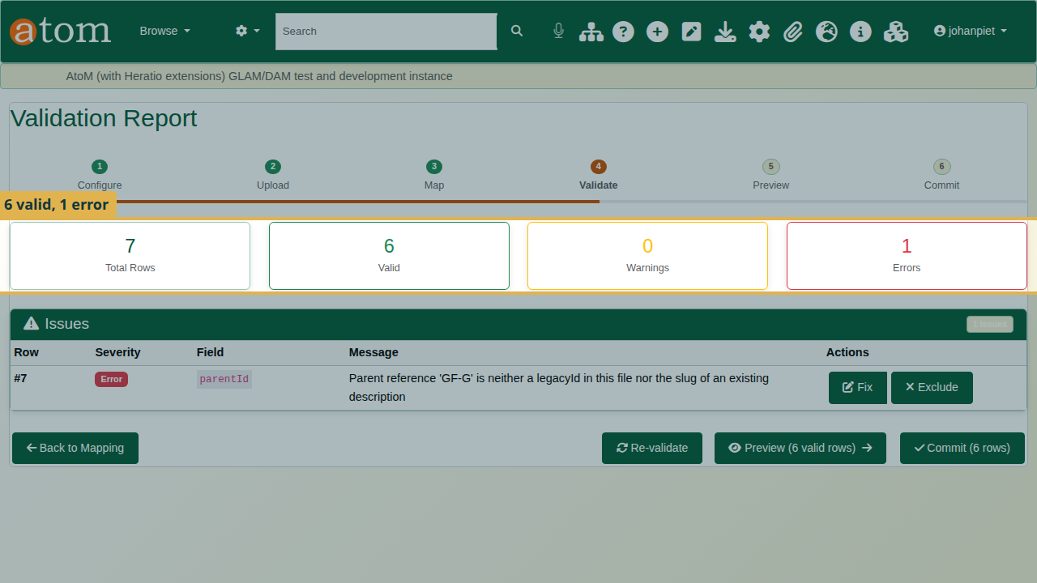
Validation Report: 6 valid, 1 error, and the issue on row 7.
The Issues table says what is wrong: row 7, field parentId, “Parent reference ‘GF-G’ is neither a legacyId in this file nor the slug of an existing description”.
Row numbers count data rows, so row 7 is the seventh row after the heading (row 8 in the spreadsheet).
To fix it:
- Click Fix on the row.
- Enter the correct value, GF-C.
- Click Apply Fix.
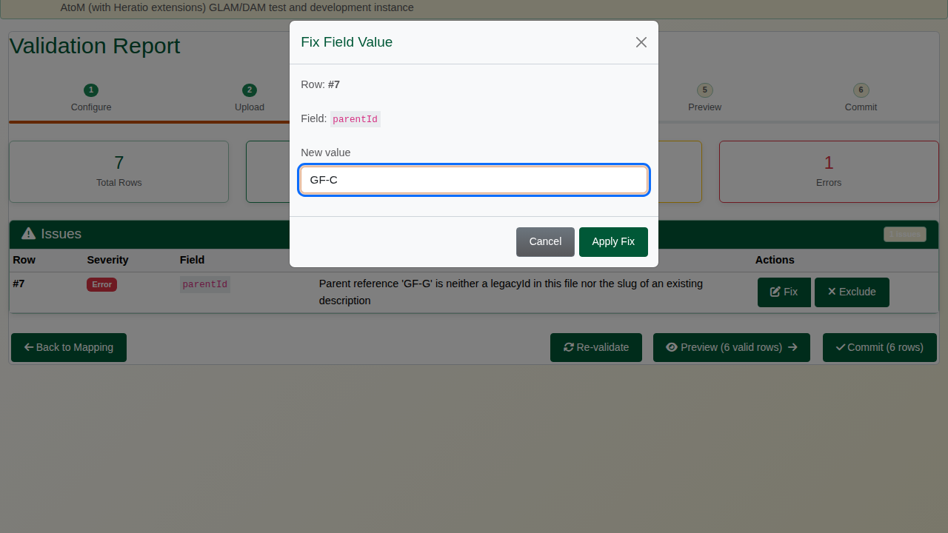
The Fix Field Value dialog with GF-C entered.
The row is checked again and all 7 rows are valid.
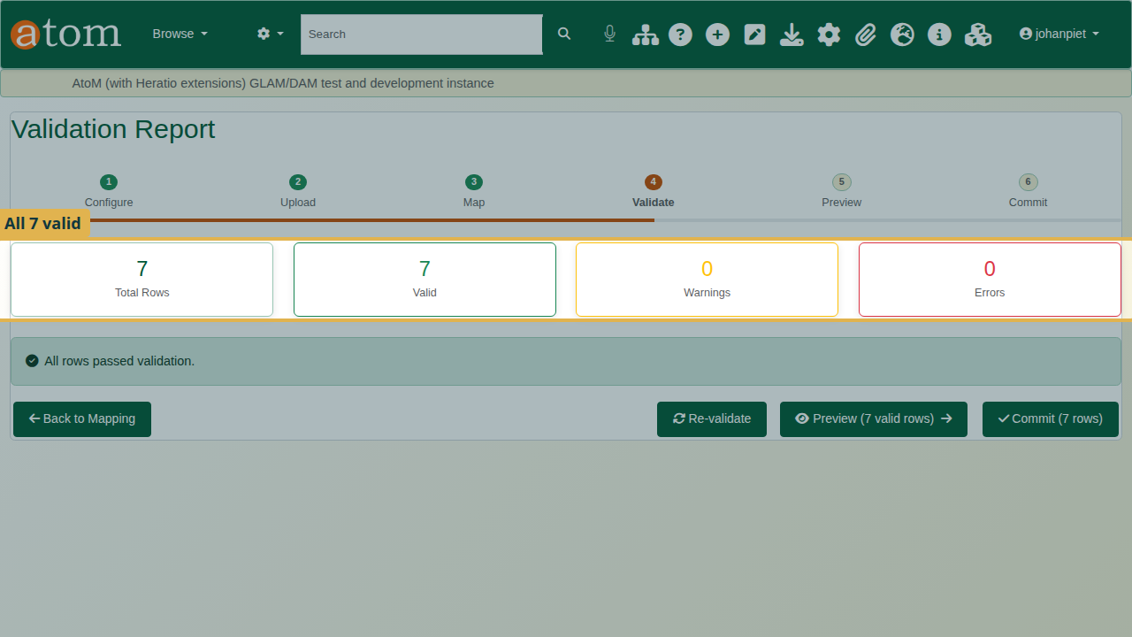
After the fix: 7 valid, 0 errors.
If a row cannot be fixed, Exclude leaves it out of the import instead.
Fix changes the value only in this ingest session, not in your file. Correct the CSV as well, so that the next import of the same file is clean.
Other hierarchy errors you may see at validation:
Hierarchy validation messages
Message | Cause | What to do
Parent reference ‘X’ is neither a legacyId in this file nor the slug of an existing description | A typo in parentId, or the parent row is missing | Fix the parentId, or add the parent row
Row is its own parent | parentId equals the row’s own legacyId | Correct the parentId
Parent chain loops back to this row | A is under B and B is under A, possibly through other rows | Find the loop and break it

6. Preview and dry run
Click Preview. Click Expand All and check that every record sits where you expect. The letters are now under Correspondence.
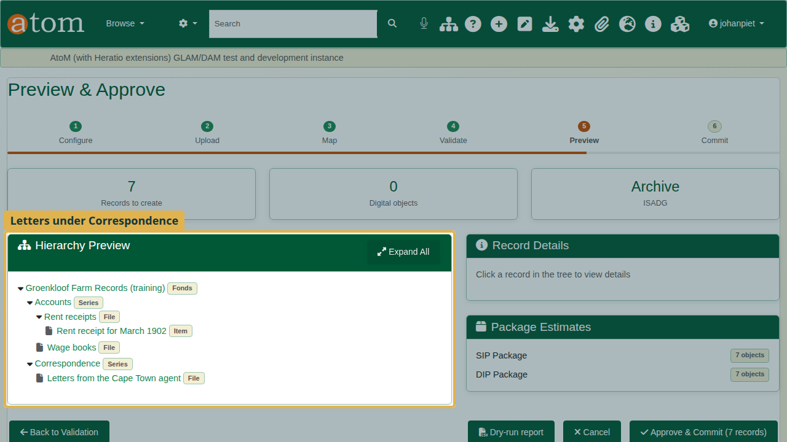
Hierarchy Preview: the letters file under Correspondence.
Click Dry-run report to download a report of exactly what the commit will do, row by row, without creating anything. Parents come first, whatever the order of your file. Keep the report with your accession paperwork.
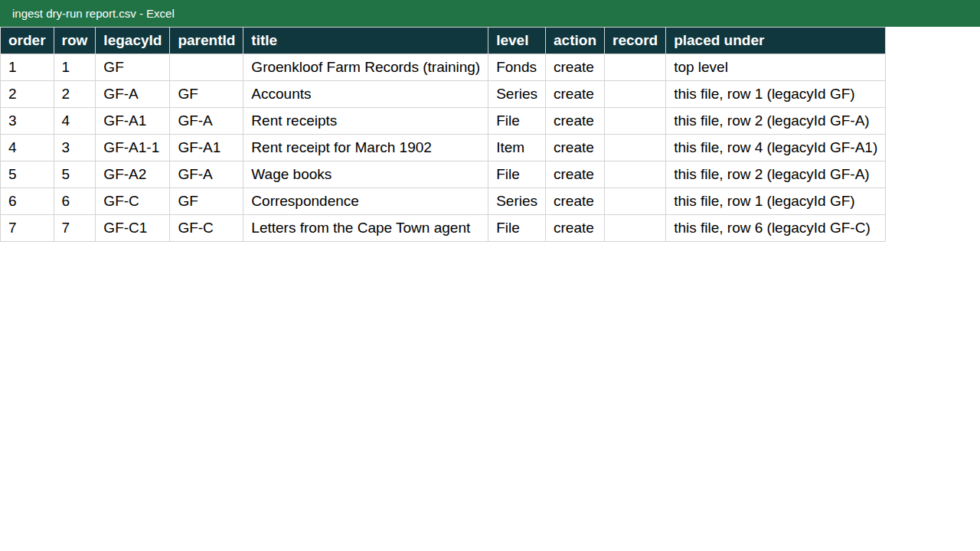
The dry-run report: order, action and where each record will be placed.

7. Commit
Click Approve & Commit, then Start Commit. The records are created in the background; you can leave the page and return to it from the Ingest Dashboard.
When the job finishes, the completion report shows how many records were created, and any errors.
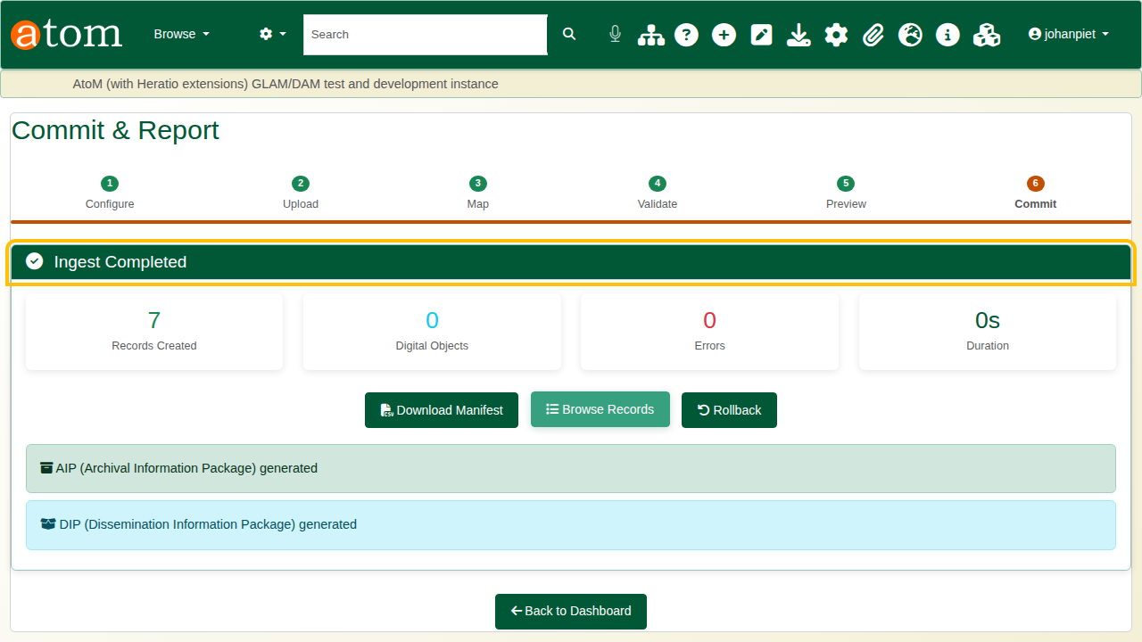
Ingest Completed: 7 records created, 0 errors.

8. Check the result
- Search for Groenkloof and open the fonds.
- The tree on the left shows the fonds with its two series. Open Correspondence from the tree: the letters file is under it.
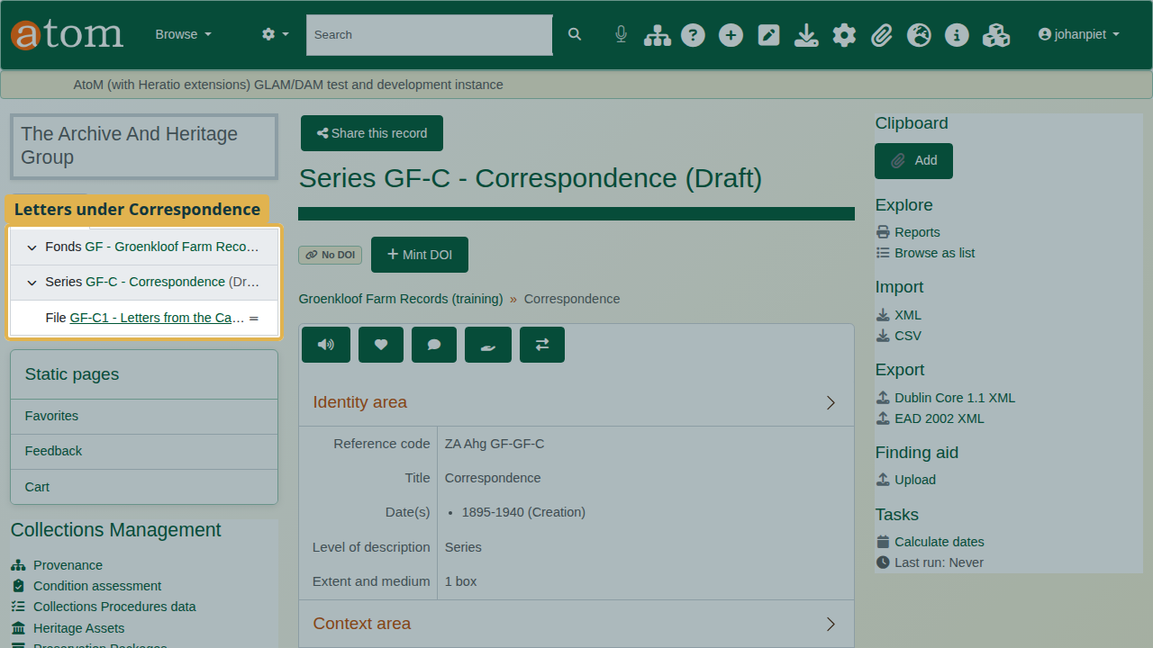
Correspondence, with the letters file under it in the tree.
- Note (Draft) after the title. Imported records are saved as drafts, so the public cannot see them yet. Check the descriptions, then publish them when they are ready: on the fonds, choose More > Update publication status, and apply it to the descendants as well.
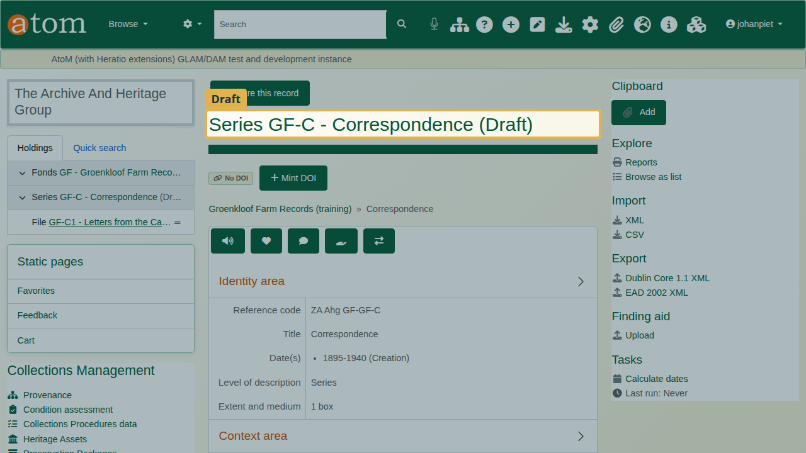
The (Draft) marker after the title.

Recap
- Build the CSV with AtoM’s column names, using legacyId and parentId for the hierarchy.
- AHG Plugins > Data Ingest > New Ingest, and choose Use hierarchy from CSV.
- Upload the file and check the mapping.
- Fix errors at validation, and in your file.
- Preview, run a dry run, and commit.
- Check the tree, then publish.

Cleaning up
To remove the practice records, open the fonds and choose Delete. AtoM deletes the series, files and item under it as well.

