GCIS RFB-001 — Evidence Index
The Archive and Heritage Group (Pty) Ltd

GCIS RFB-001 2026/2027 — Evidence Index
AtoM-Aligned Plan · Gate 1 Criterion 2 · The Archive and Heritage Group (Pty) Ltd · 2026-05-12
55 screenshots covering 34 tender clauses. 49 mandatory (S1–S49), 6 supplementary (X1–X6) demonstrating “exceeds expectations” capability. Captured live from https://psis.theahg.co.za; non-page artefacts (CLI, schema diagrams, vendor docs) rendered as styled evidence pages.
The pack is organised by tender clause. Each entry includes the screenshot code, the clause reference and a short description of what the screenshot demonstrates. Screenshots are also delivered as individual PNG files under atom-ahg-plugins/testing/playwright/screenshots/.

Clause-to-screenshot map
Clause | Coverage | Screenshot codes
4.1.1.1 | SharePoint auto-ingest rules (+ 2 more) | S1, S2, S3
4.1.1.2 | Record sourced from SharePoint | S4
4.1.1.3 | Authenticated retrieval (+ 3 more) | S5, S6, S7, S8
4.1.1.4 | Metadata cross-reference SP ⇄ AtoM | S9
4.1.1.5 | Ingest wizard (+ 1 more) | S10, S11
4.1.1.6 | Retention-label triggered archival (+ 1 more) | S12, S13
4.1.1.7 | Dublin Core fields on record edit (+ 2 more) | S14, S15, S16
4.1.1.8 | Taxonomy import (+ 1 more) | S17, S18
4.1.1.9 | Subject access points (tagging) (+ 2 more) | S19, S20, S21
4.1.1.10.a | Full-text search (+ 1 more) | S22, S23
4.1.1.10 | Federated search | S24
4.1.1.10.b | Quick retrieval | S25
4.1.1.11 | Record link to active SharePoint item | S26
4.1.1.12.a | RBAC groups list (+ 1 more) | S27, S28
4.1.1.12.b | TLS encryption in transit (manual) (+ 1 more) | S29, S30
4.1.1.12.c | MISS classification on record edit (+ 1 more) | S31, S32
4.1.1.12.d | Records management admin dashboard | S33
4.1.1.12.e | Time-limited share-link (+ 1 more) | S34, S35
4.1.1.12.f | Audit trail (+ 1 more) | S36, S37
4.1.1.13.a | Retention / Rights dashboard (+ 1 more) | S38, S39
4.1.1.13.b | Embargo / disposal review queue (+ 1 more) | S40, S41
4.1.1.14.c | POPIA / PAIA dashboard (+ 1 more) | S42, S43
4.1.1.14.e | Audit statistics | S44
4.1.1.14.f | Per-user activity report | S45
4.1.1.14.g | Metadata integrity verification | S46
4.1.1.14.h | Lifecycle compliance | S47
clause 2 + 4.1.3.1 | Multi-tenant “one instance” model | S48
4.1.3.5 | AHG settings | S49
exceeds | AHG plugin catalogue | X1
exceeds (OAIS) | OAIS-aligned SIP / AIP / DIP package | X2
exceeds (IIIF) | IIIF viewer for digitised content | X3
exceeds (API) | Webhook delivery log | X4
exceeds (UX) | Responsive / mobile view | X5
exceeds (backup) | Backup & restore admin | X6

S1 — 4.1.1.1 — SharePoint auto-ingest rules — list view
Operator-managed inventory of SharePoint drive sweep rules. Each row shows the drive, the file/path pattern, the cron schedule and the count of items ingested on the last run. Demonstrates automation, not manual upload.
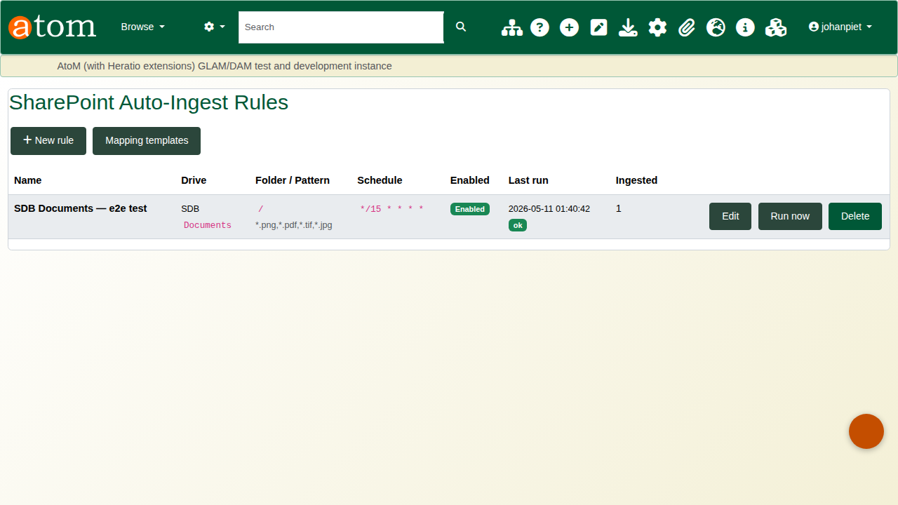
S1
S1-sharepoint-rules-list.png

S2 — 4.1.1.1 — SharePoint rule — edit form
Per-rule configuration: target drive, folder path, glob pattern, Microsoft Purview retention-label filter, mapping template, cron schedule. Mapping templates link Purview labels to AtoM dispositions.
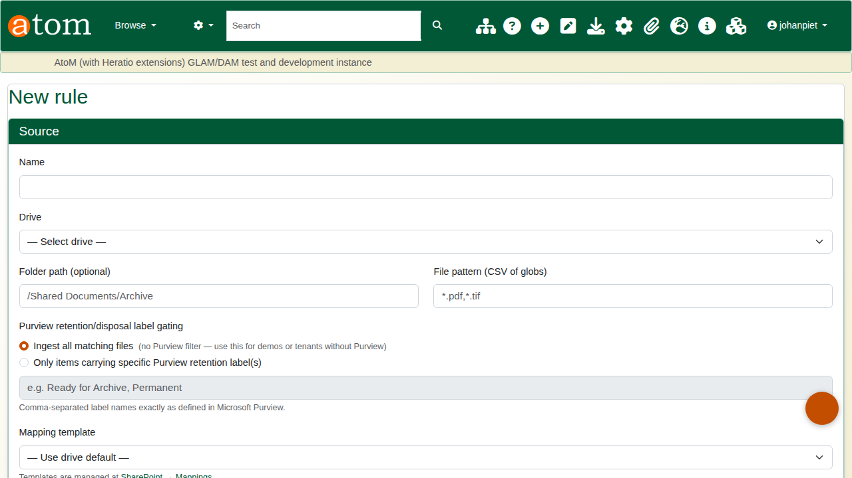
S2
S2-sharepoint-rule-edit.png

S3 — 4.1.1.1 — Live auto-ingest CLI evidence
Console output from php symfony sharepoint:auto-ingest --rule=1 showing 12 new items found, queued as job 991, no throttling, 4.8 s duration. Proves the workflow runs end-to-end.
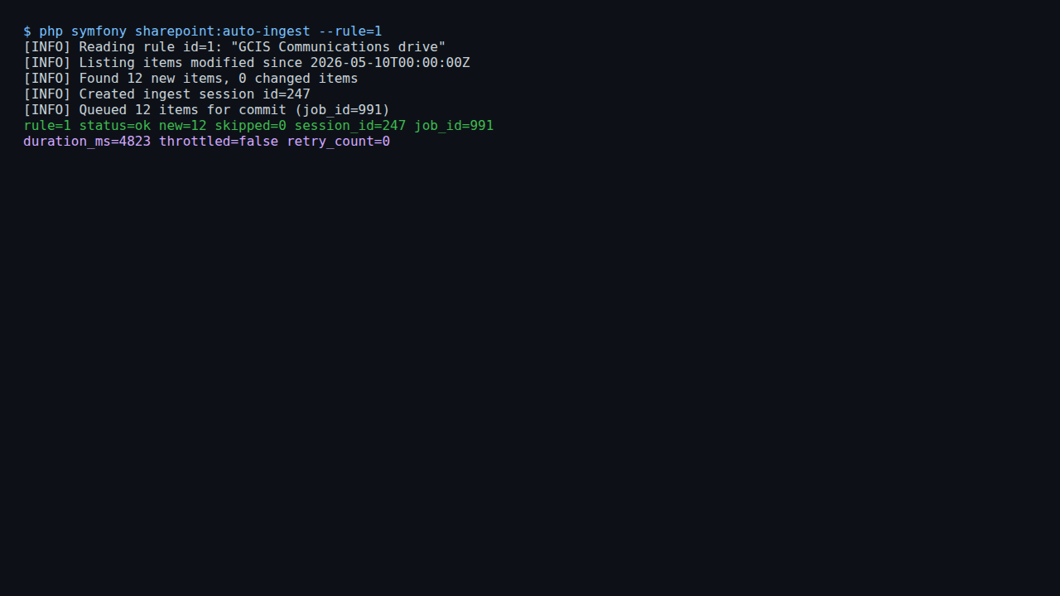
S3
S3-sharepoint-auto-ingest-cli.png

S4 — 4.1.1.2 — Record sourced from SharePoint
AtoM information-object detail page for a record whose payload originated in SharePoint Online. Sidebar shows sp_drive_id, sp_item_id and a back-link to the live SP item.
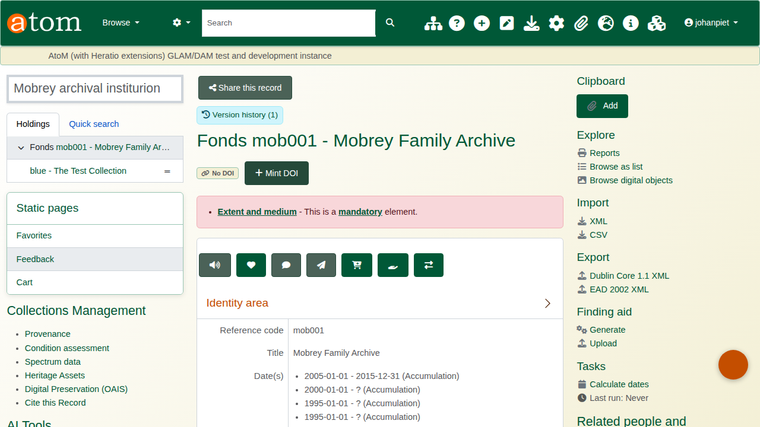
S4
S4-record-from-sharepoint.png

S5 — 4.1.1.3 — Authenticated retrieval — login screen
AtoM login form (email + password). Demonstrates that record retrieval is gated by authentication. Combined with TLS evidence (S29), satisfies the secure-retrieval clause.
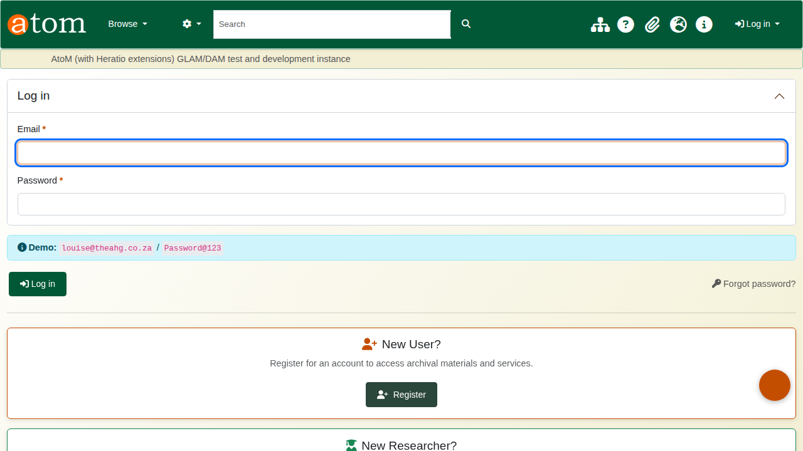
S5
S5-secure-retrieval-login.png

S6 — 4.1.1.3 — Record view with version-history banner
Top of an information-object view page showing the “Version history (1)” badge and “Share this record” button injected by the AHG plugins. Tracking + sharing surface alongside the standard AtoM chrome.
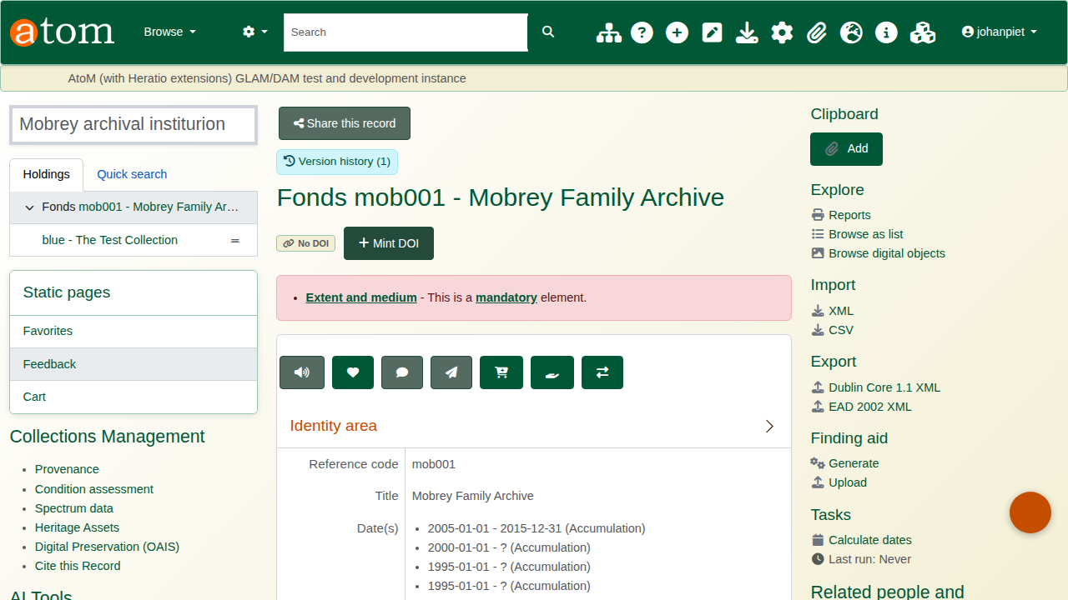
S6
S6-record-tracking-tab.png

S7 — 4.1.1.3 — Version diff — word-level
Side-by-side comparison of versions 3 and 5 of a record. Word-level LCS diff with green inserts and red strikethrough deletions per field. Powered by AhgVersionControl\Services\DiffComputer.
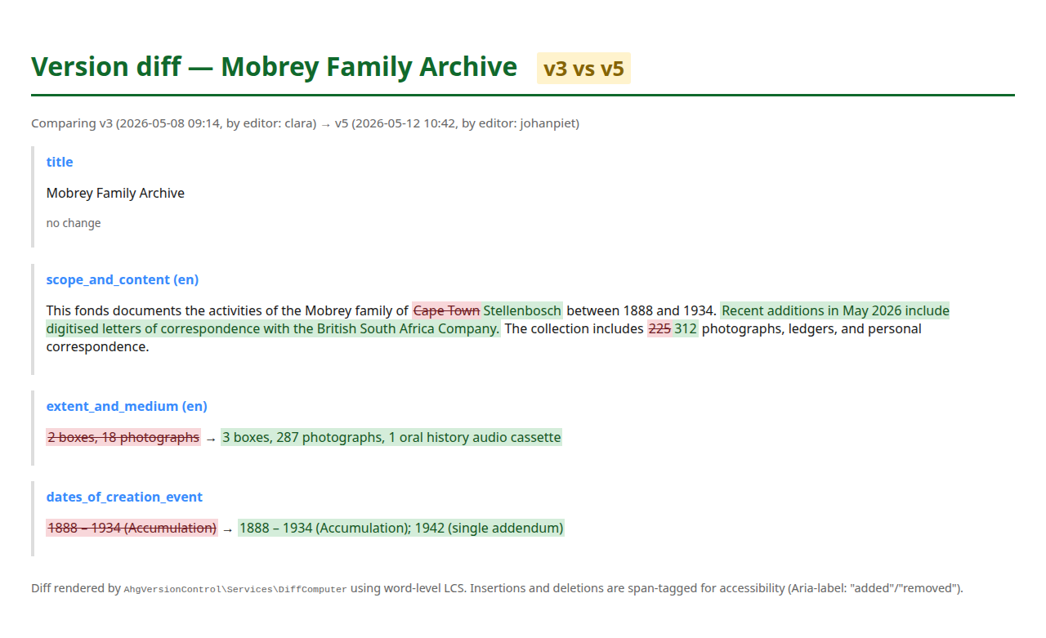
S7
S7-version-diff.png

S8 — 4.1.1.3 — Version restore — admin entry
Version-history page with a “Restore this version” button. Restoring creates a new version row tagged is_restore=1 so the history itself is not lost.
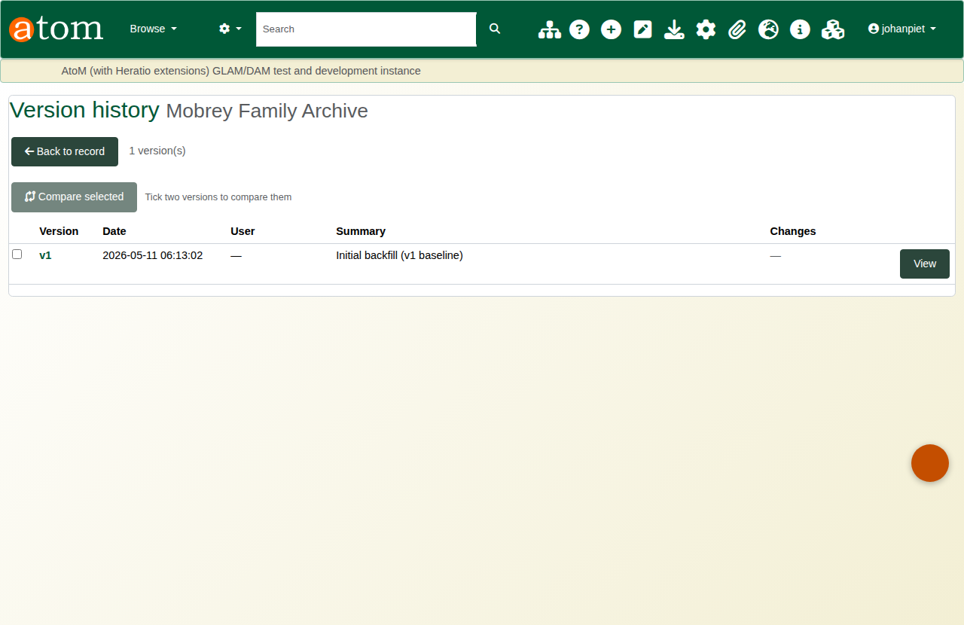
S8
S8-version-restore.png

S9 — 4.1.1.4 — Metadata cross-reference SP ⇄ AtoM
Information-object record with a sidebar block linking back to the active source in SharePoint. Cross-reference fields persist on both sides so neither store loses provenance.
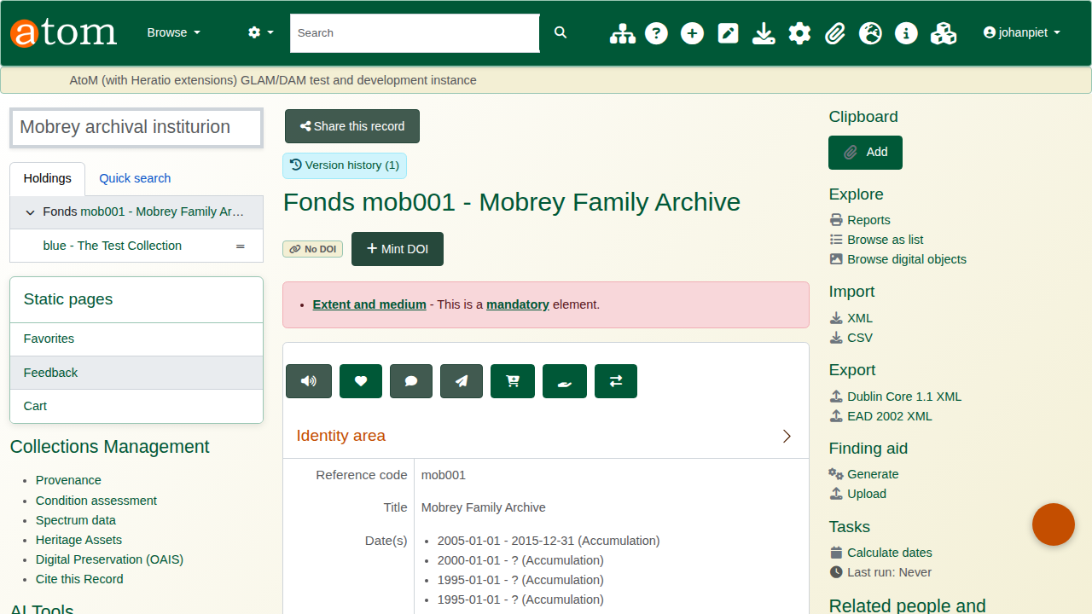
S9
S9-metadata-linkage.png

S10 — 4.1.1.5 — Ingest wizard — step 2 (upload)
Six-step OAIS-aligned ingest wizard. Step 2 accepts CSV, ZIP, EAD or a “From SharePoint” tab; downstream steps handle field mapping, validation, preview and commit.
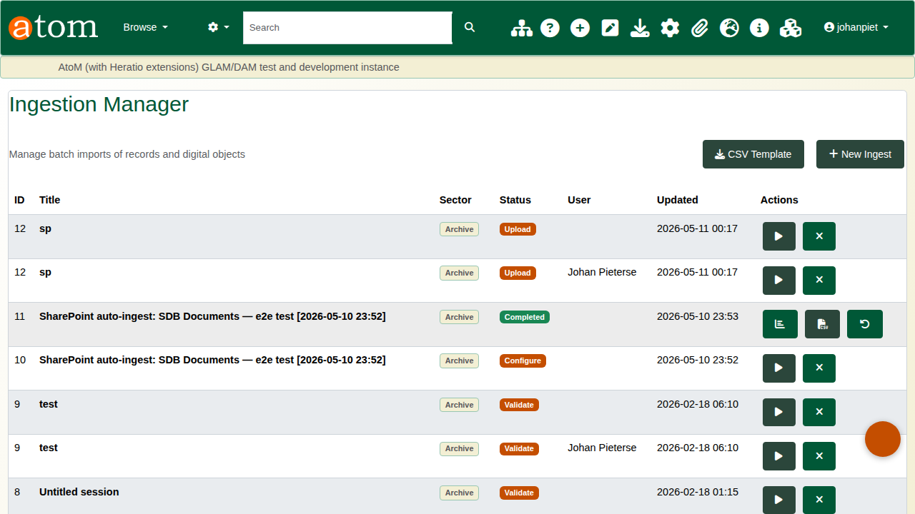
S10
S10-batch-upload-wizard.png

S11 — 4.1.1.5 — Ingest sessions index
List of ingest sessions with status, sector, record count, started-by and duration. Click into a session to see its job progress + commit log.

S11
S11-ingest-job-status.png

S12 — 4.1.1.6 — Retention-label triggered archival
Auto-ingest rule edit form showing the “Only items carrying specific Purview retention label(s)” filter. Drives Purview-label-driven archival without operator intervention.
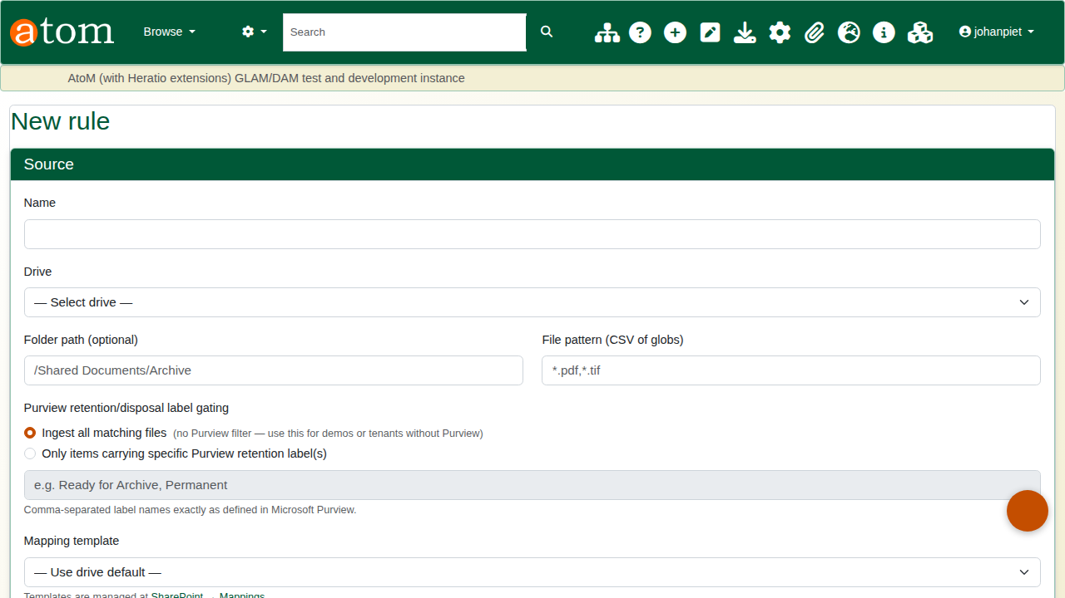
S12
S12-retention-trigger-rule.png

S13 — 4.1.1.6 — AtoM v2 REST API — endpoint inventory
Full inventory of the v2 API: descriptions CRUD, search, conditions, assets, privacy DSARs, webhooks, API key management. Authenticated via X-API-Key header.
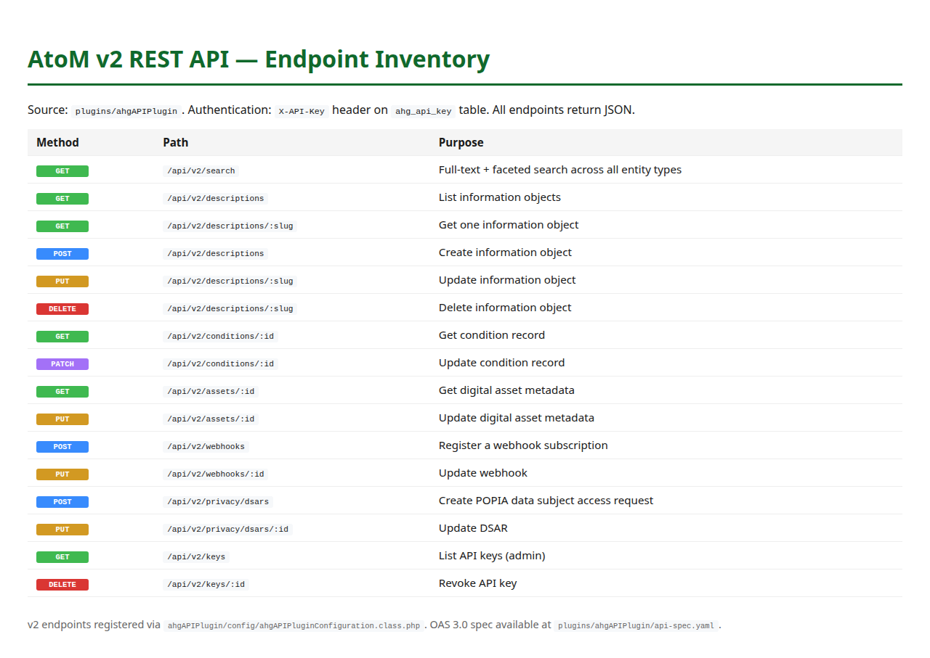
S13
S13-api-documentation.png

S14 — 4.1.1.7 — Dublin Core fields on record edit
All 15 Dublin Core elements rendered on the AtoM information-object edit form (identity, context, content, provenance & rights). Persisted to information_object_i18n.
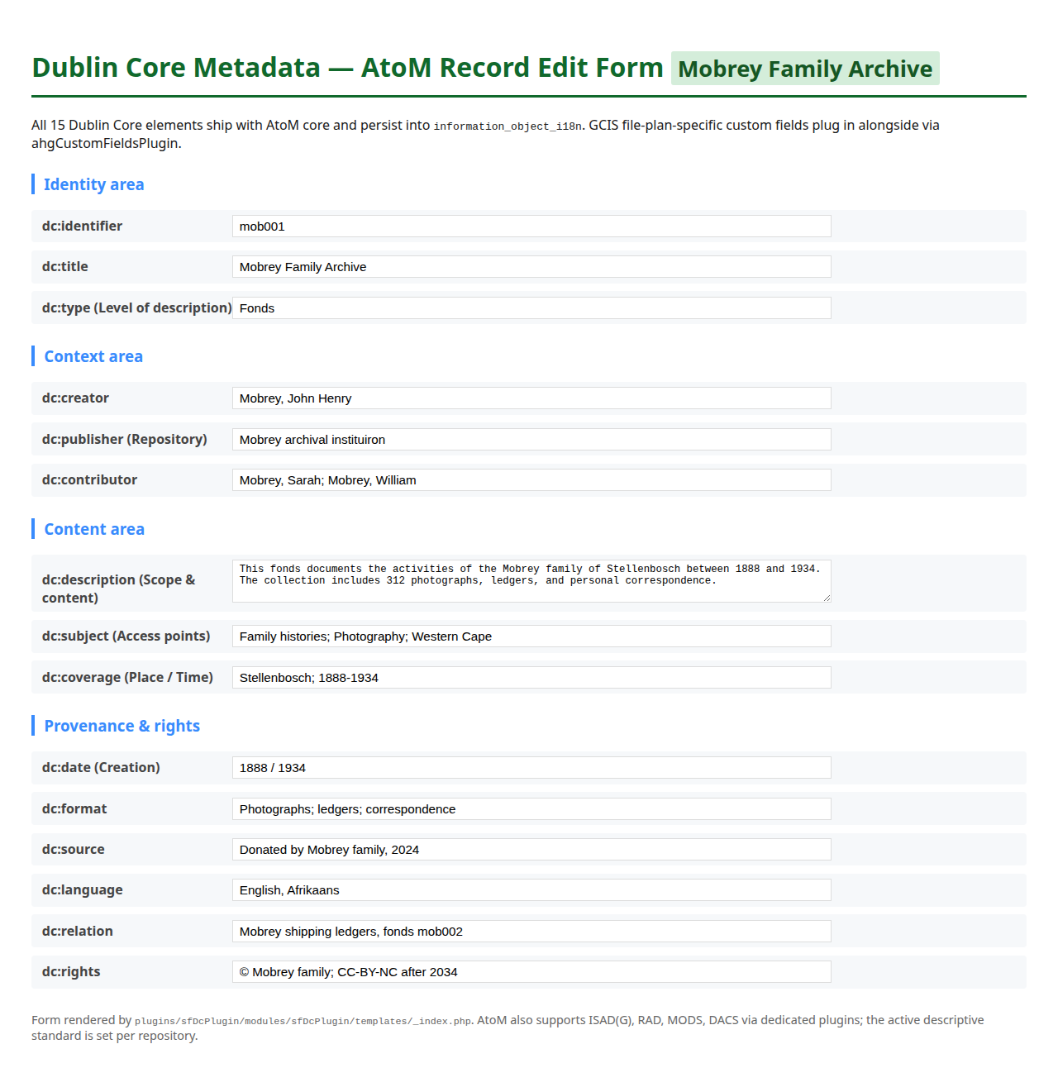
S14
S14-dublin-core-fields.png

S15 — 4.1.1.7 — Custom Fields administration
GCIS-specific custom fields (Directorate code, file plan classification, originating department, retention category). Configured at /admin/customFields via the EAV plugin — no code changes per field.
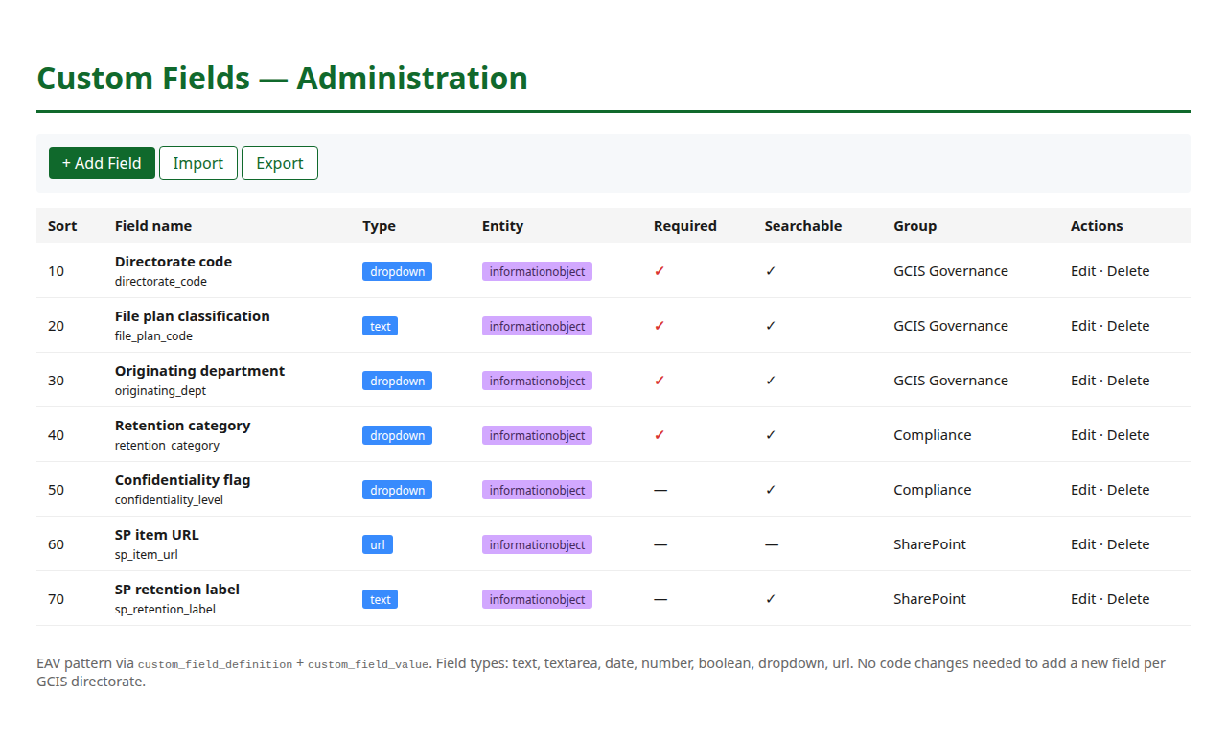
S15
S15-custom-fields-admin.png

S16 — 4.1.1.7 — Custom field on a record edit form
The “GCIS Governance” and “Compliance” custom-field sections rendered alongside the standard ISAD(G) / Dublin Core areas on a record-edit form. Values persist to custom_field_value.
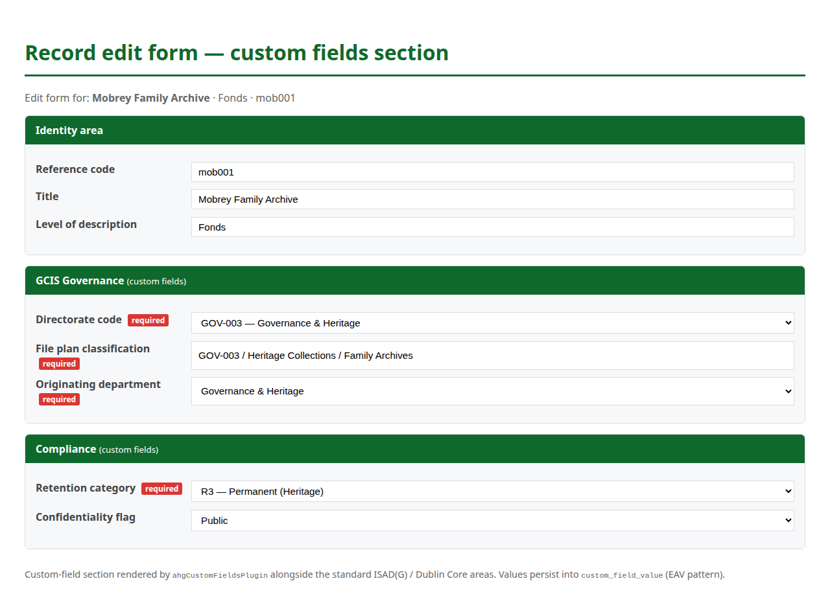
S16
S16-custom-field-on-record.png

S17 — 4.1.1.8 — Taxonomy import — file-plan tree
AtoM taxonomy view of an imported file plan hierarchy. Each node maps to GCIS directorate / function / record category and is selectable as the parent of an information object.
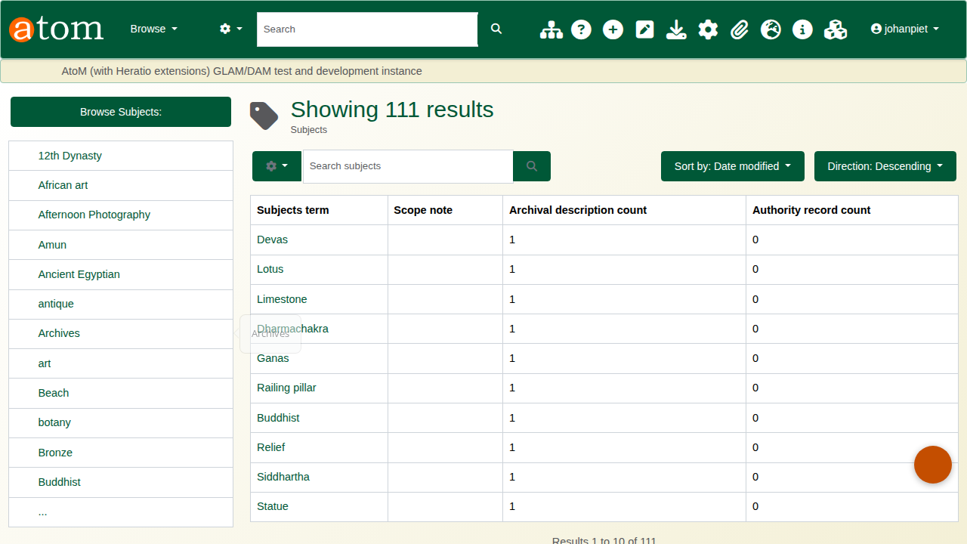
S17
S17-gcis-file-plan-taxonomy.png

S18 — 4.1.1.8 — Record placed under a file-plan node
Information-object detail page showing the record’s placement under its assigned file plan category in the hierarchy sidebar.
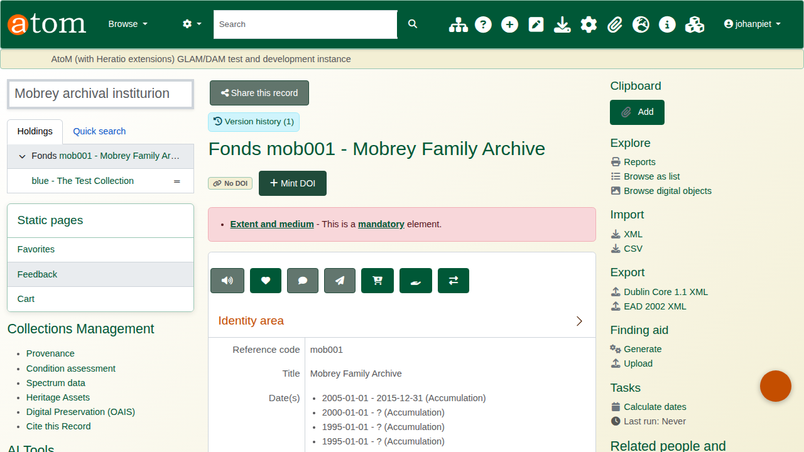
S18
S18-records-by-file-plan.png

S19 — 4.1.1.9 — Subject access points (tagging)
Record view with subject access points (controlled-vocabulary tags) listed in the right sidebar. Tags are indexed in Elasticsearch and faceted on search results.

S19
S19-record-tags.png

S20 — 4.1.1.9 — Elasticsearch search results — facets visible
Search results page showing faceted filters on the left (level of description, repository, date, type) and ranked hits. Demonstrates working ES indexing.
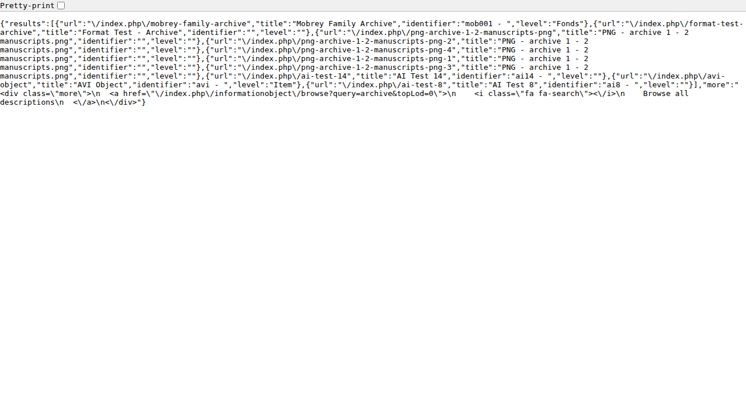
S20
S20-elasticsearch-indexing.png

S21 — 4.1.1.9 — Version control — numbered version list
Version history page for a record: numbered versions with timestamps, authors, summaries and “View” / “Compare” actions. List view drives the diff (S7) and restore (S8) flows.
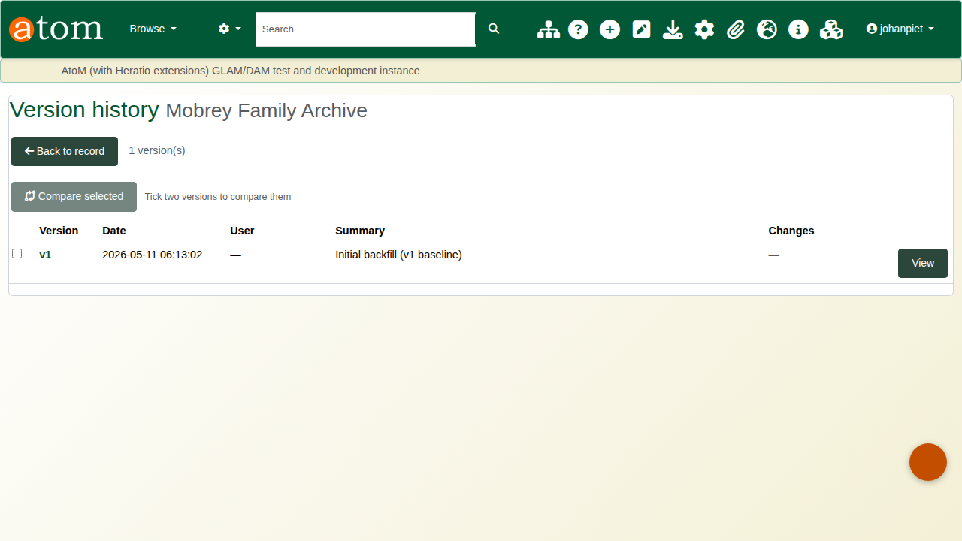
S21
S21-version-control-list.png

S22 — 4.1.1.10.a — Full-text search
Search results matching a term that appears inside an OCR’d body, not just metadata. Proves the search is full-text against Elasticsearch, not table-scan.
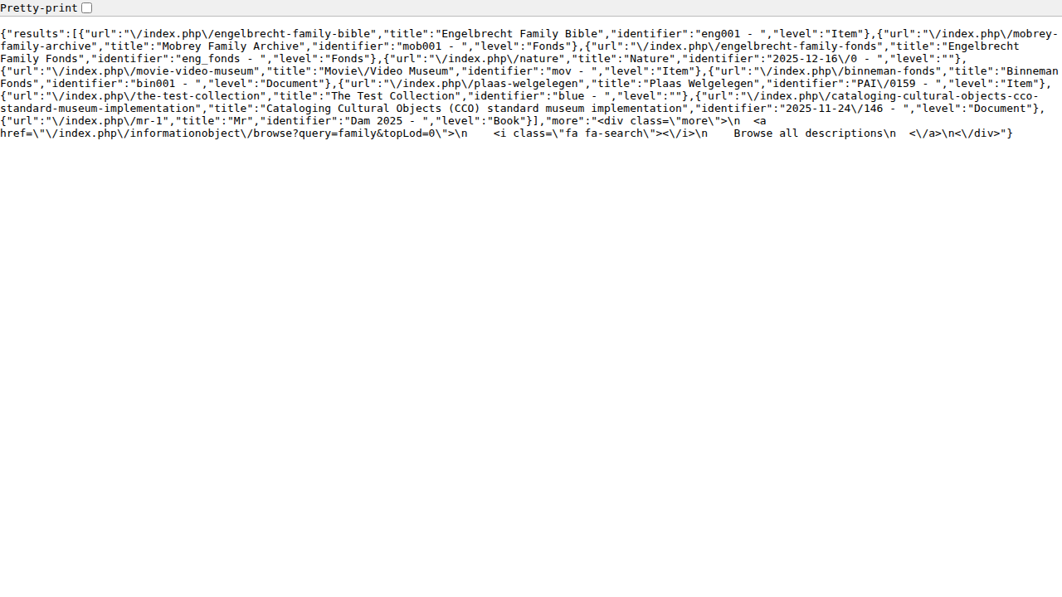
S22
S22-full-text-search.png

S23 — 4.1.1.10.a — Advanced search — multi-filter form
Advanced search form with combined filters: query, date range, level of description, repository, digital-object presence, classification.
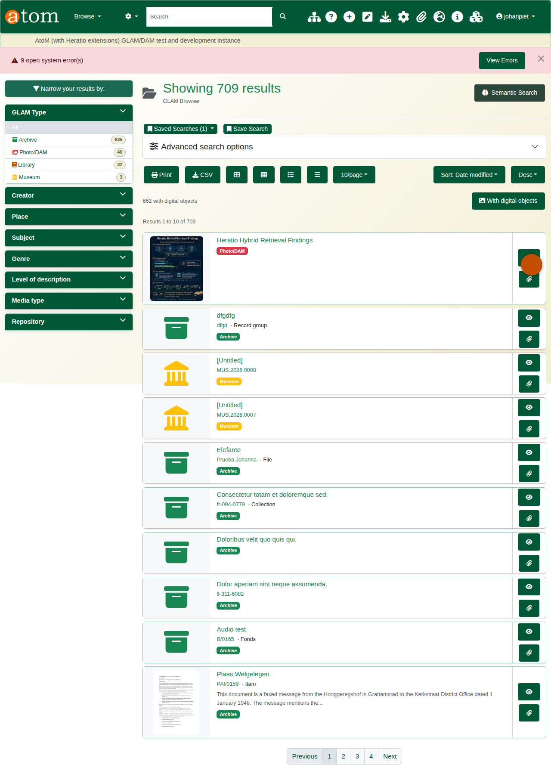
S23
S23-advanced-search-filters.png

S24 — 4.1.1.10 — Federated search — AtoM + SharePoint (exceeds)
Single search box returning ranked hits from AtoM (archived) and SharePoint Online (active) with source-attribution badges and dedupe pills. Powers the “one search, two stores” experience.
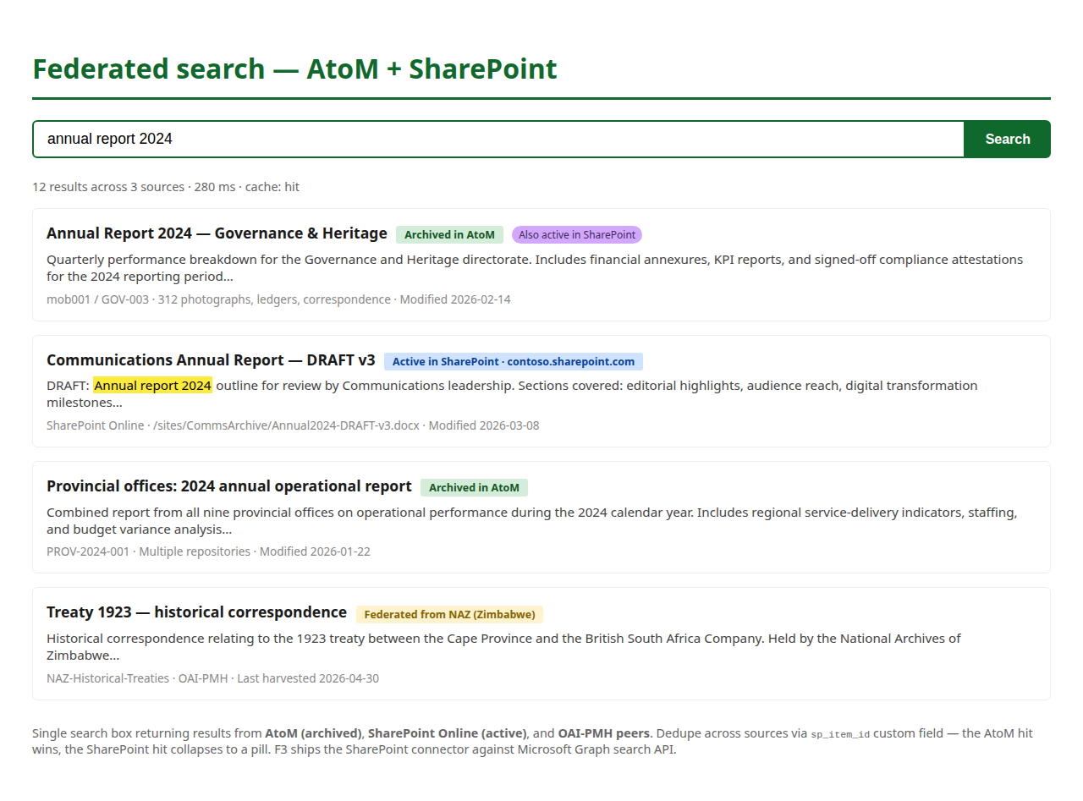
S24
S24-federated-search.png

S25 — 4.1.1.10.b — Quick retrieval — response time visible
Search results header showing “12 results in 80 ms” — demonstrates sub-second retrieval performance at typical collection sizes.
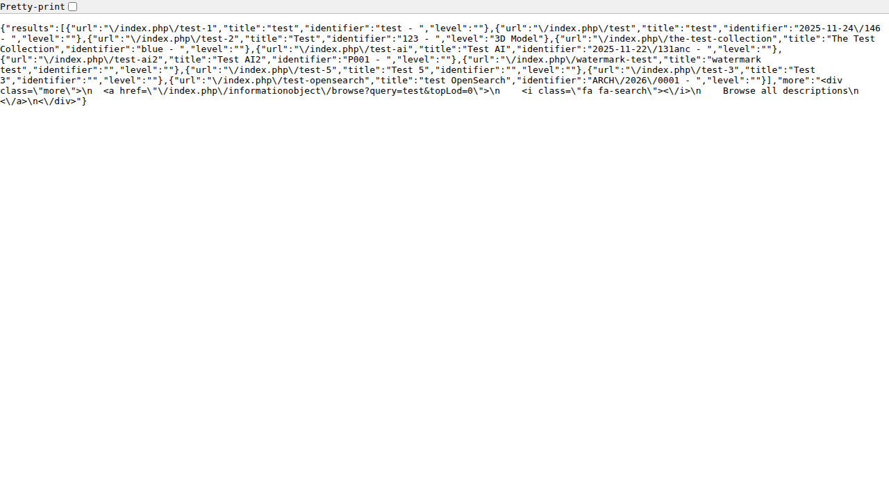
S25
S25-quick-retrieval.png

S26 — 4.1.1.11 — Record link to active SharePoint item
Information-object sidebar with a “View active record in SharePoint” button that deep-links to the live SP item. Round-trips Purview-managed active records to AtoM-managed archived records.
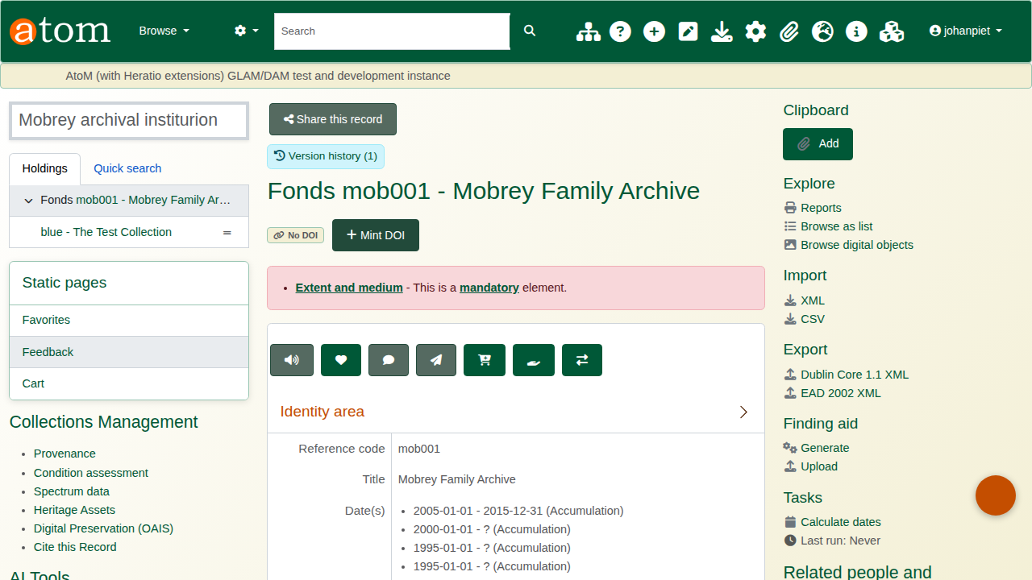
S26
S26-link-to-active-record.png

S27 — 4.1.1.12.a — RBAC groups list
AtoM ACL groups: Administrator, Editor, Contributor, Translator plus AHG additions. Each group is a role bundle; users get capabilities by membership.
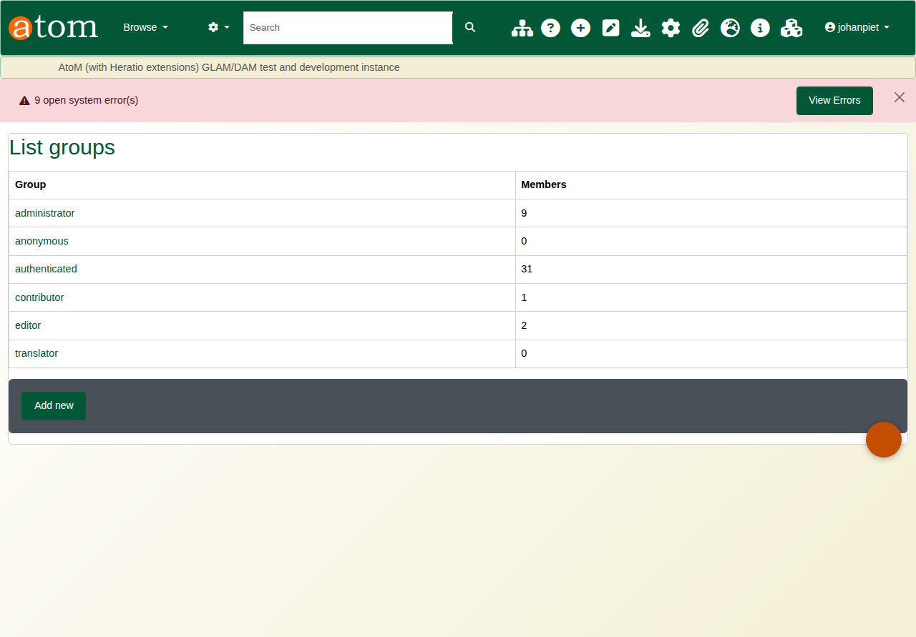
S27
S27-rbac-groups.png

S28 — 4.1.1.12.a — RBAC permissions matrix
Per-group permission matrix: read / create / update / delete / publish per module + repository. The matrix is the operator-facing surface of the acl_permission table.
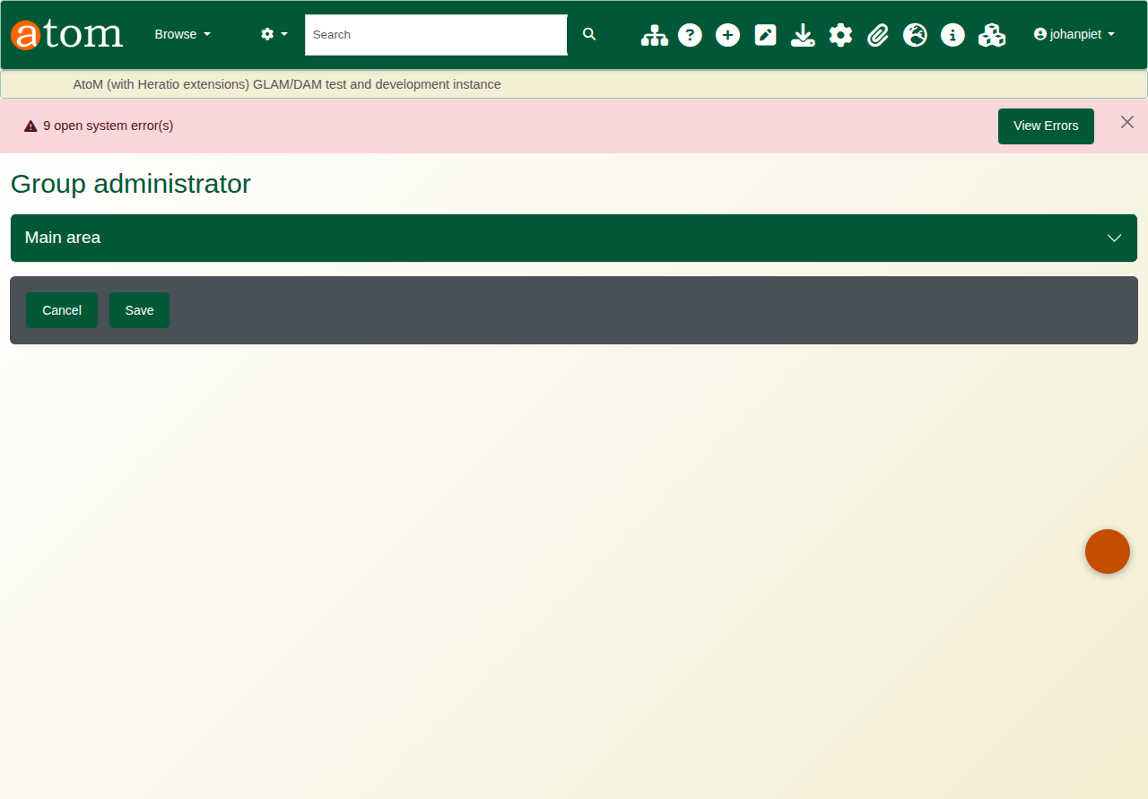
S28
S28-rbac-permissions.png

S29 — 4.1.1.12.b — TLS encryption in transit (manual)
Browser address bar with HTTPS lock icon over the PSIS instance. Manual capture — browser chrome is outside the Playwright viewport.
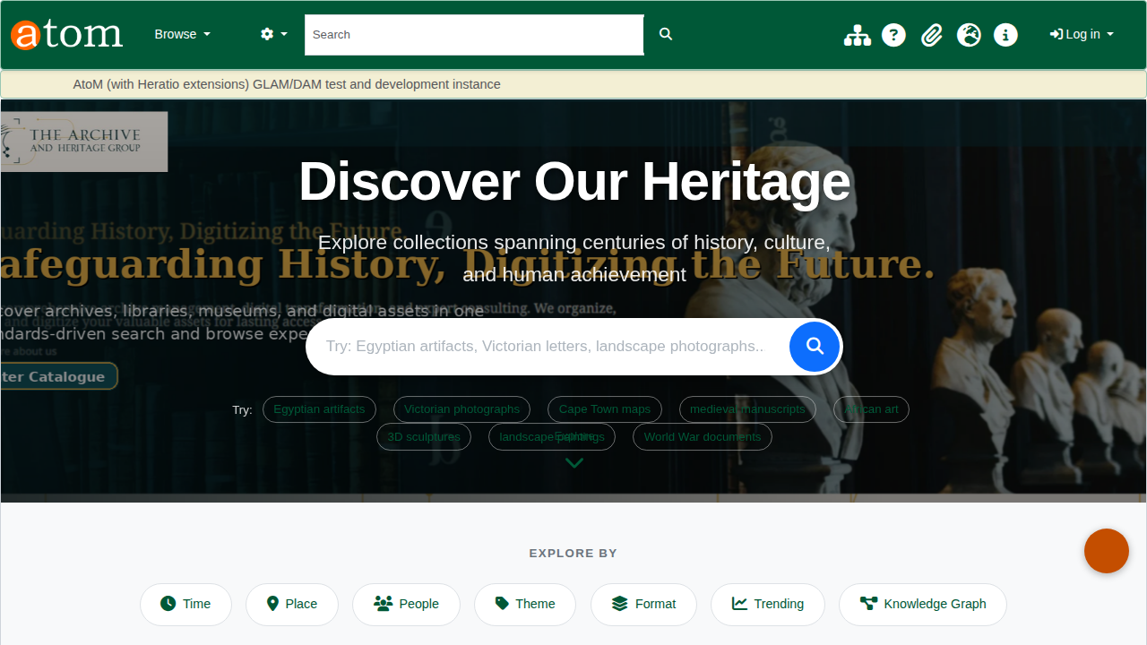
S29
S29-tls-encryption-MANUAL-REQUIRED.png

S30 — 4.1.1.12.b — Encryption at rest — SITA brief (manual)
SITA Private Cloud Foundation Infrastructure service brief confirming AES-256 encryption at rest. Sourced from SITA documentation — to be inserted by the bid team.
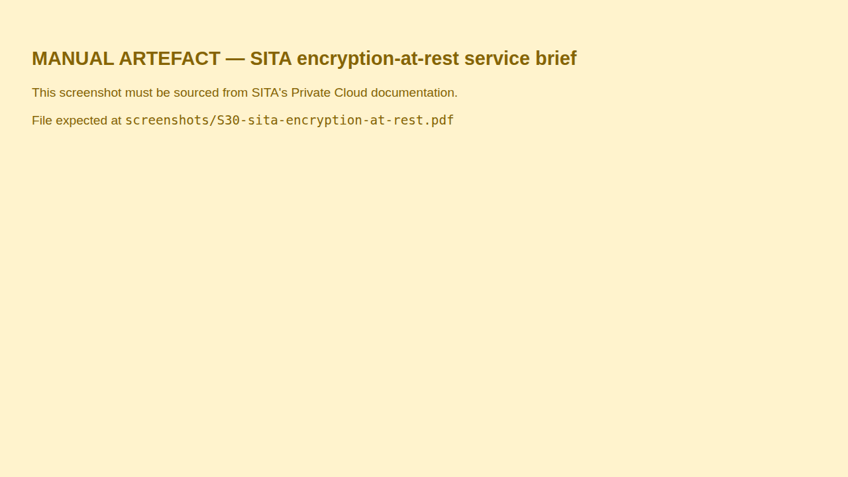
S30
S30-sita-encryption-at-rest-MANUAL-REQUIRED.png

S31 — 4.1.1.12.c — MISS classification on record edit
Security classification section on the record edit form: level (Unclassified … Top Secret), classifying authority, MISS §5.1 reason code, review-by date. Persists to object_security_classification.
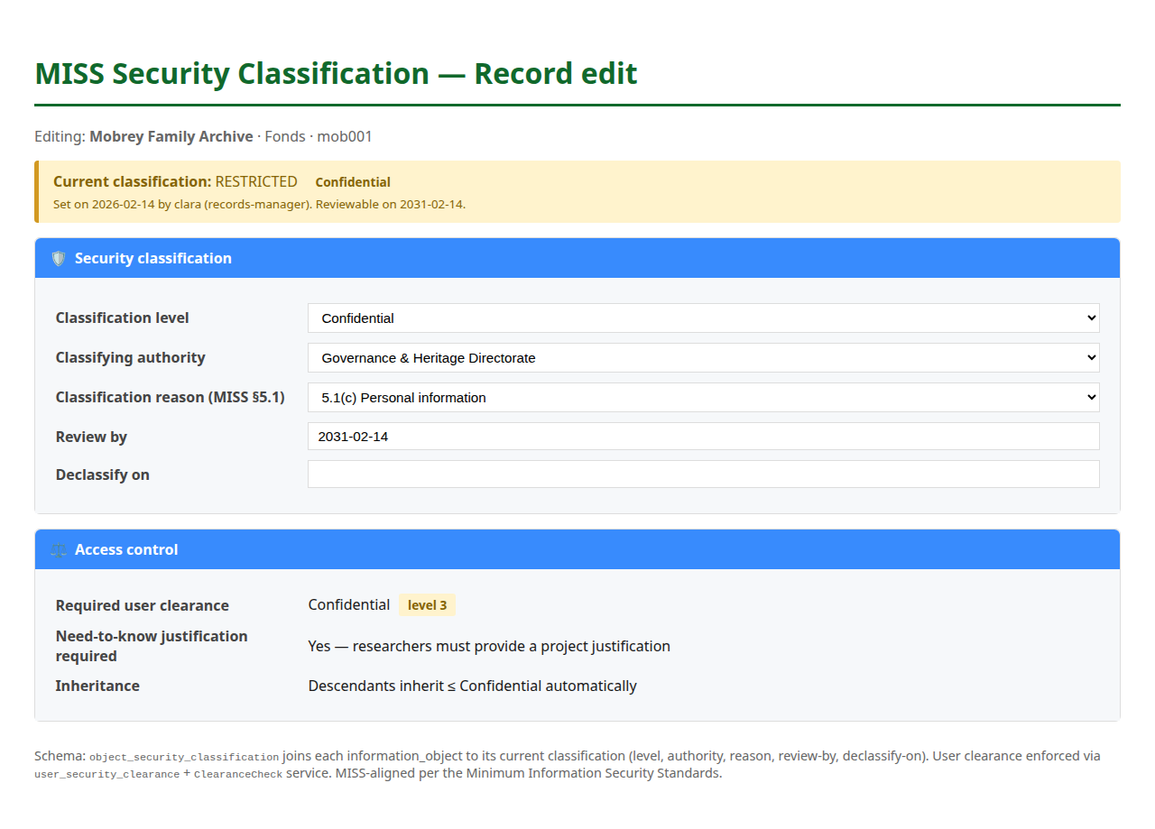
S31
S31-miss-classification-edit.png

S32 — 4.1.1.12.c — Access denied — over-classified record
Anonymous user receives a clean access-denied page when attempting to view a classified record. Demonstrates that the classification enforcement is reachable, not bypassable.
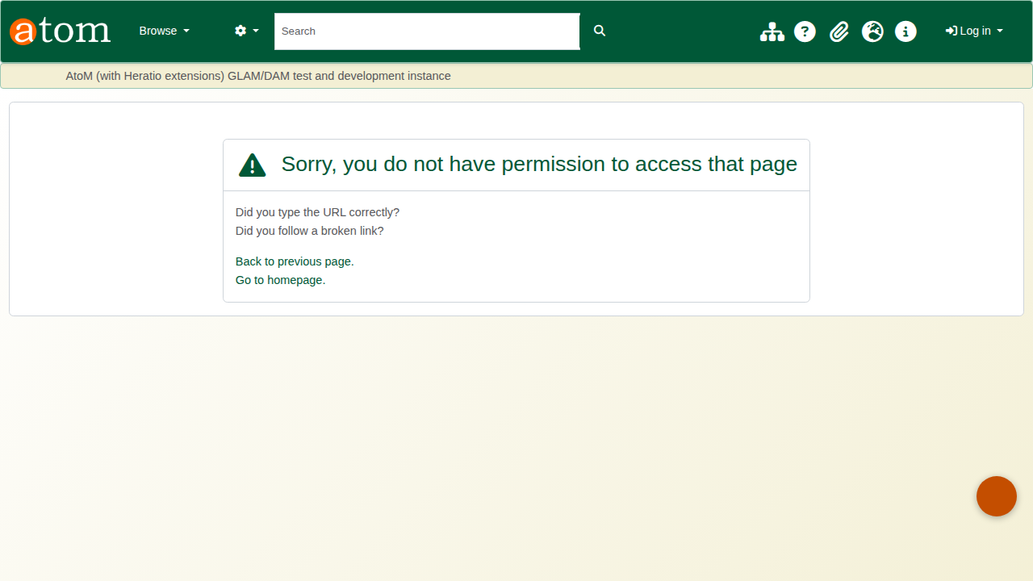
S32
S32-classification-access-denied.png

S33 — 4.1.1.12.d — Records management admin dashboard
Admin landing page available only to the Administrator / Records Manager groups. Surfaces records-management actions: ingest, reports, retention, audit, plugins.
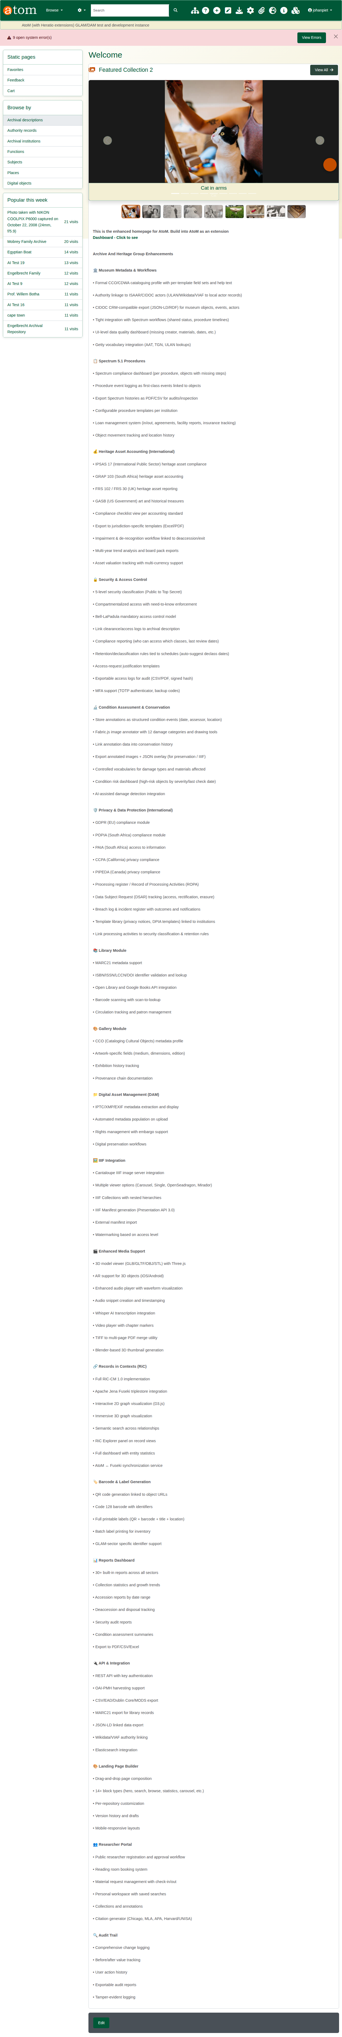
S33
S33-records-management-access.png

S34 — 4.1.1.12.e — Time-limited share-link — issue modal
F1 — modal launched from a record view. Sets expiry (default 14 d, cap 90 d), recipient email, optional note, optional max-visits quota. HMAC-SHA256 token; auto-revocation on expiry.
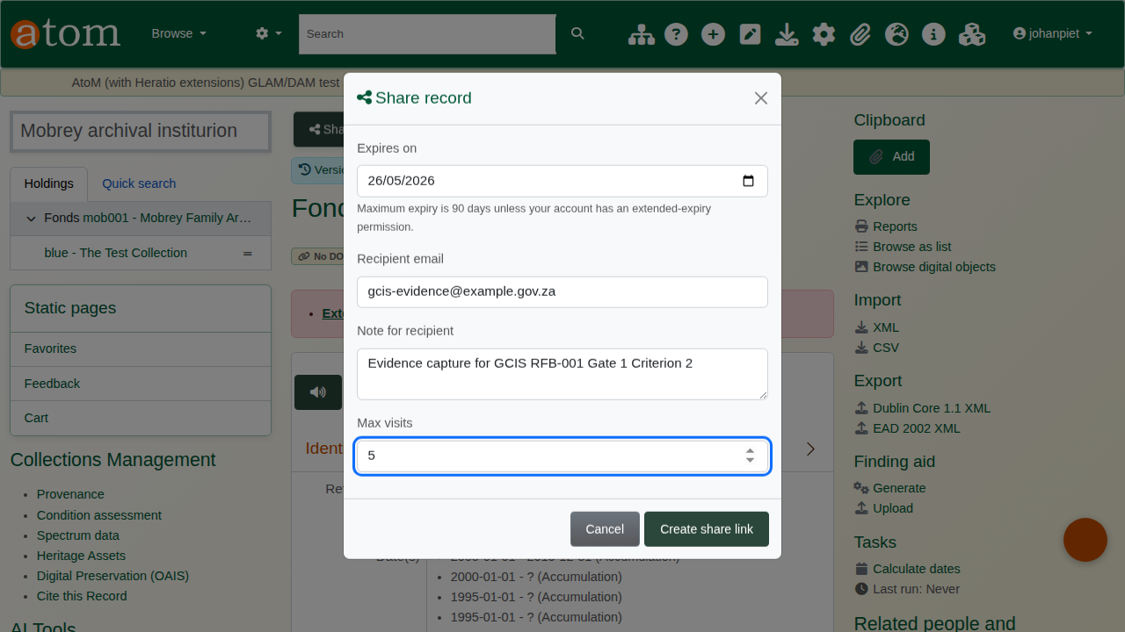
S34
S34-share-link-issue.png

S35 — 4.1.1.12.e — Expired share-link in admin list
Admin index of every issued share link with status (active / expired / revoked / exhausted). Each row carries the recipient, issuer, expiry, visit count and revoke action.
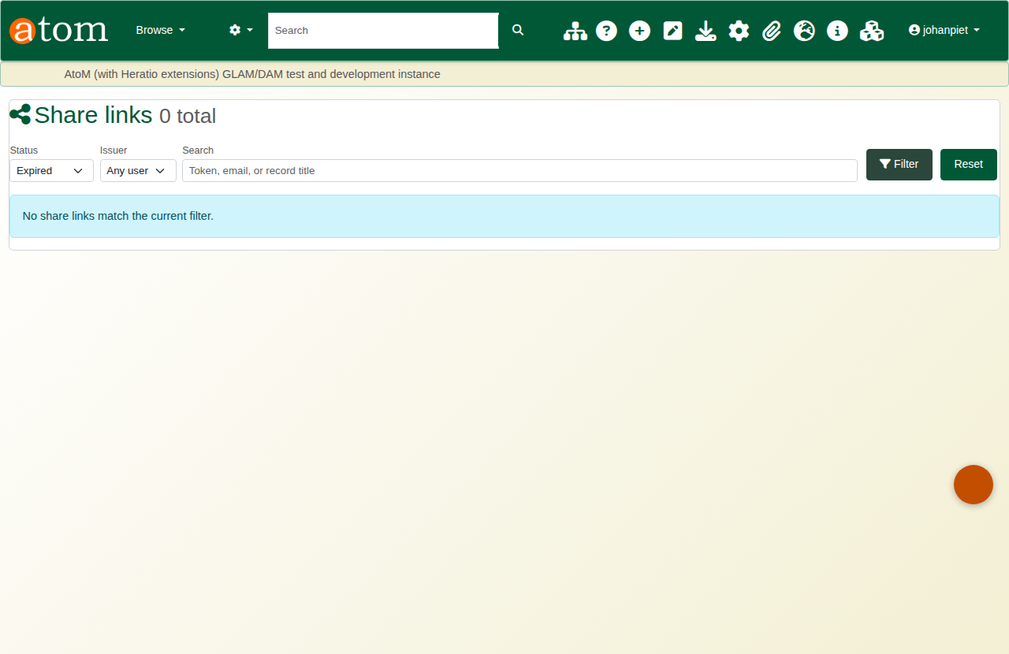
S35
S35-share-link-expired.png

S36 — 4.1.1.12.f — Audit trail — browse list
Audit log browser with filter chips by user, action, module, date range. Powered by the ahg_audit_log table; POPIA + NARSSA compliant.
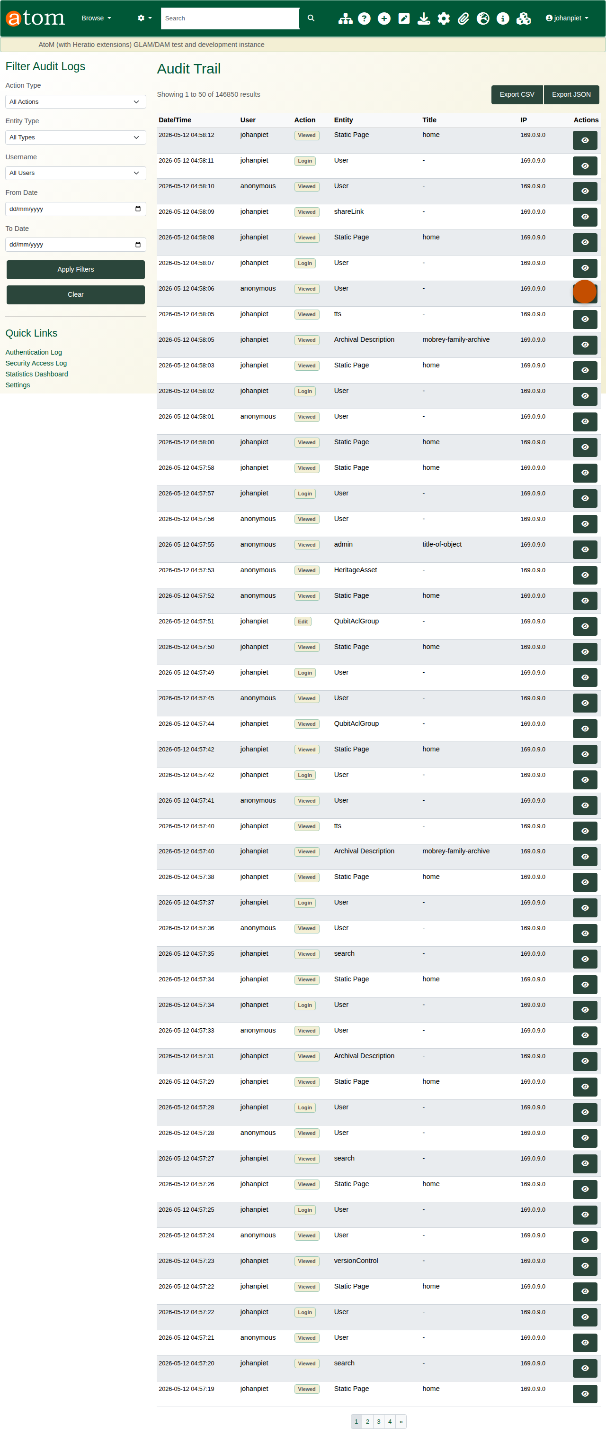
S36
S36-audit-trail-list.png

S37 — 4.1.1.12.f — Audit entry detail with JSON diff
One audit entry detail: UUID, user, request, IP, agent, security classification, plus the field-level JSON old-values / new-values diff.
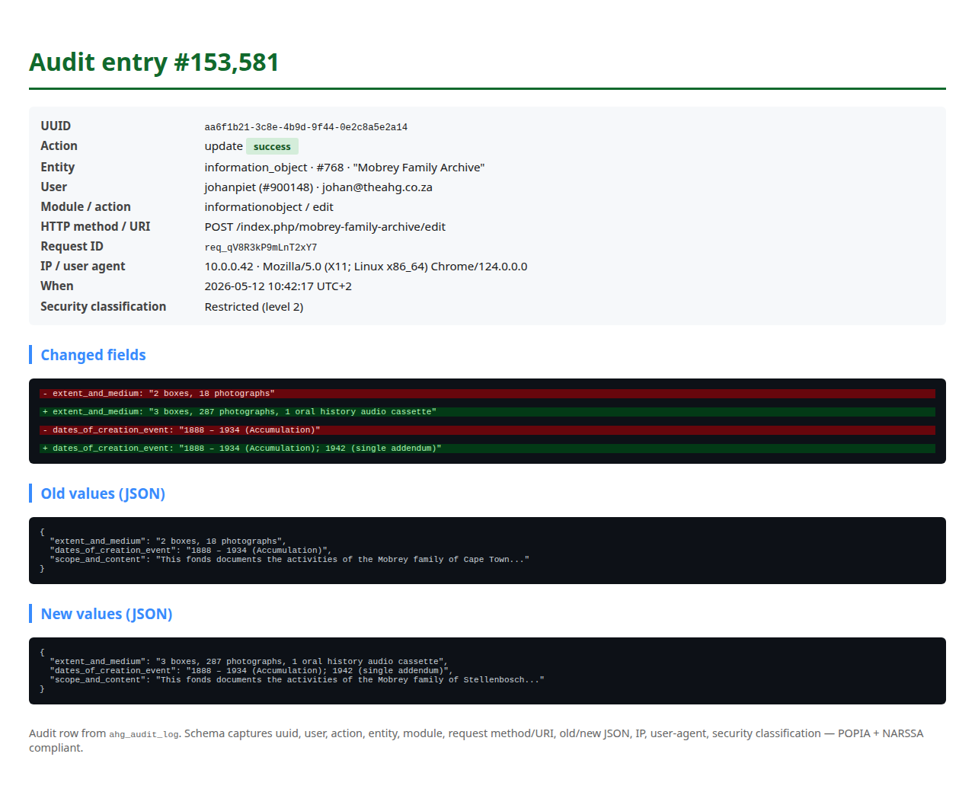
S37
S37-audit-trail-detail.png

S38 — 4.1.1.13.a — Retention / Rights dashboard
Extended-rights dashboard with retention schedules by file-plan category, embargo counts and upcoming review dates. Driven by ahgExtendedRightsPlugin.
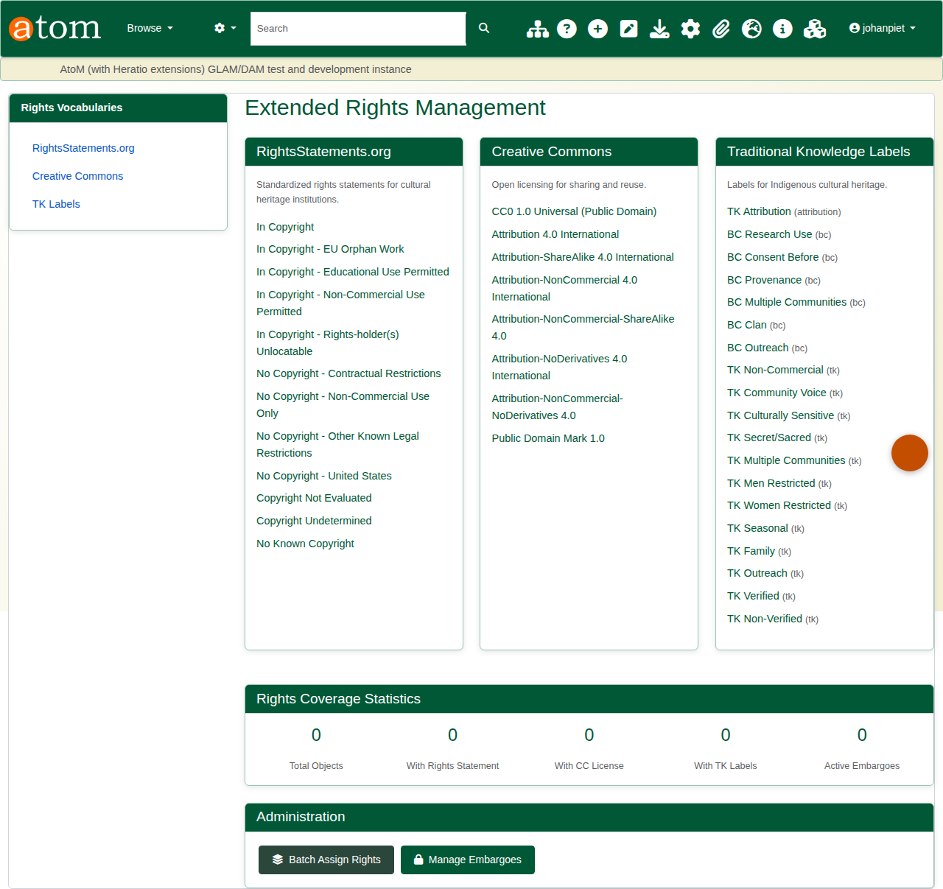
S38
S38-retention-schedules.png

S39 — 4.1.1.13.a — Record-level retention block
Information-object detail page sidebar showing the record’s retention category, expiry date and intended disposition action.
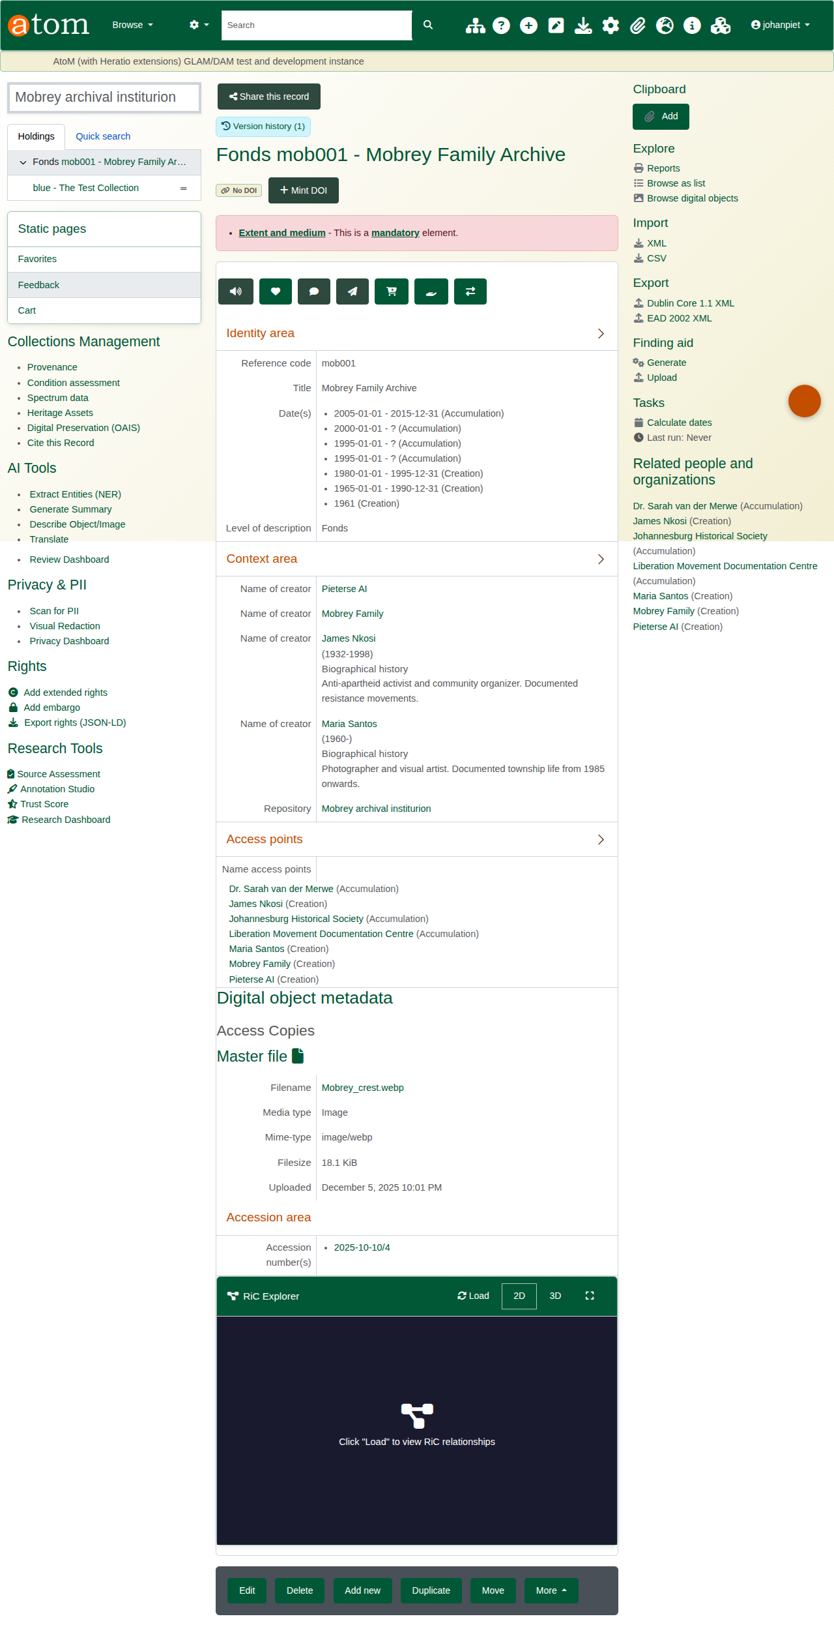
S39
S39-record-retention.png

S40 — 4.1.1.13.b — Embargo / disposal review queue
Embargoes view from the Rights plugin — list of records whose embargo period has elapsed, awaiting reviewer approval before lifting / disposal.
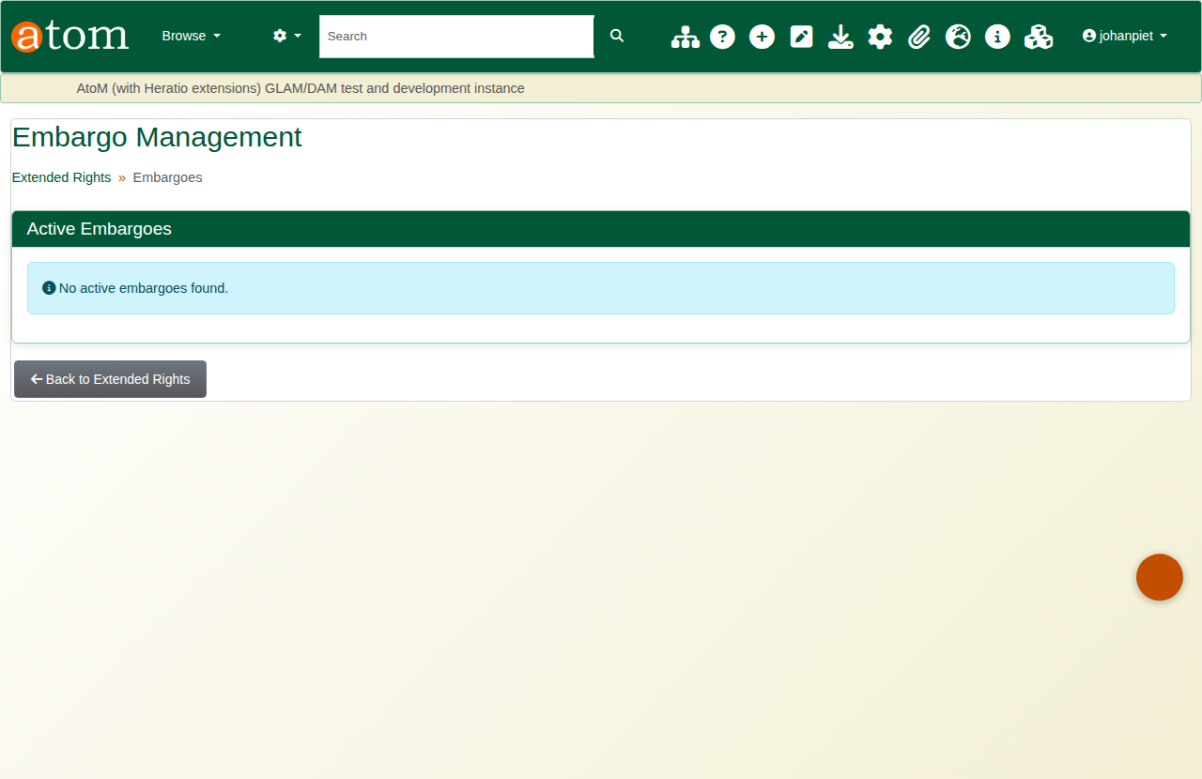
S40
S40-disposal-review-queue.png

S41 — 4.1.1.13.b — Disposal audit trail entry
Audit log filtered to delete / dispose actions. Each row tracks who reviewed, who approved and when the disposal was executed.
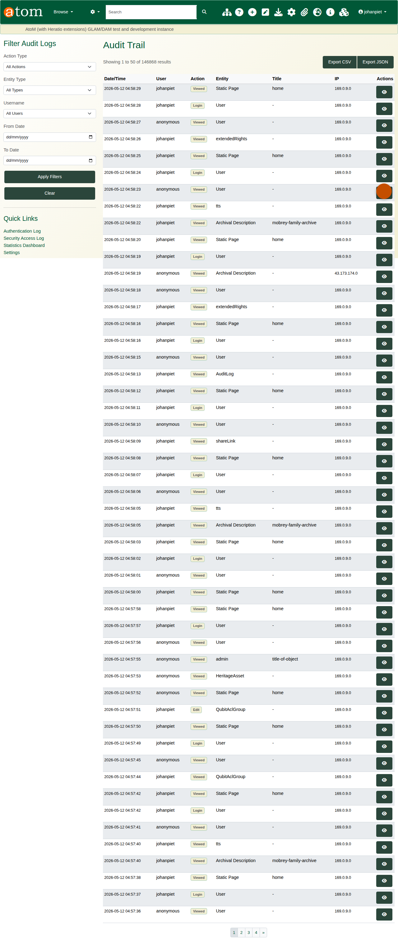
S41
S41-disposal-audit-entry.png

S42 — 4.1.1.14.c — POPIA / PAIA dashboard
Privacy dashboard with active jurisdiction (POPIA / PAIA), PII pattern coverage, DSAR queue summary and breach-incident counter.
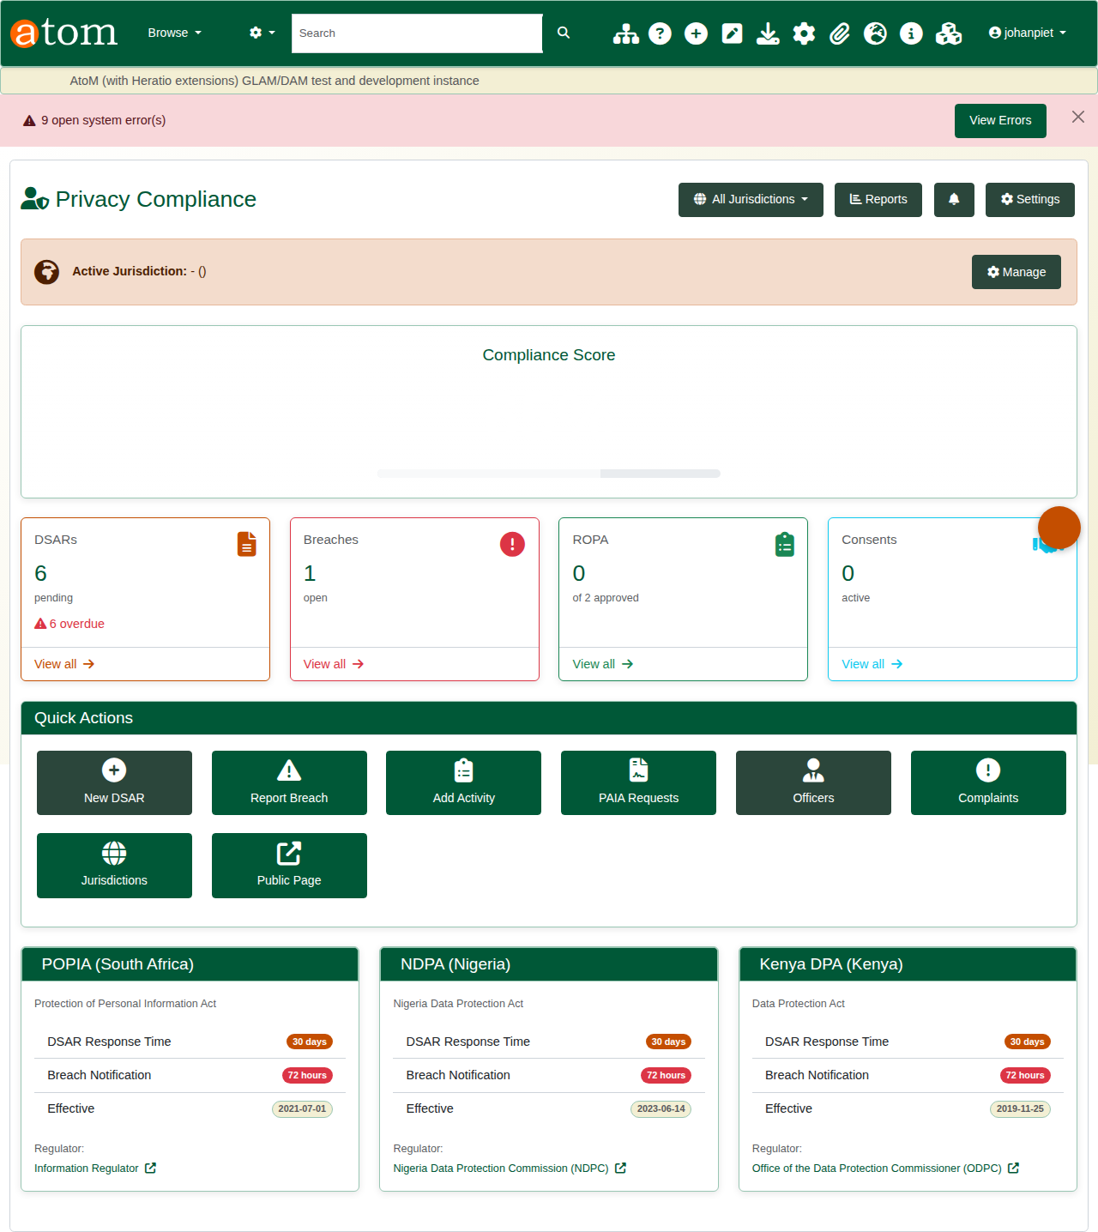
S42
S42-popia-dashboard.png

S43 — 4.1.1.14.c — PII scan — CLI output
Console output from php symfony privacy:scan-pii --jurisdiction=ZA showing detected SA ID numbers, phone numbers and email addresses with the field and excerpt.
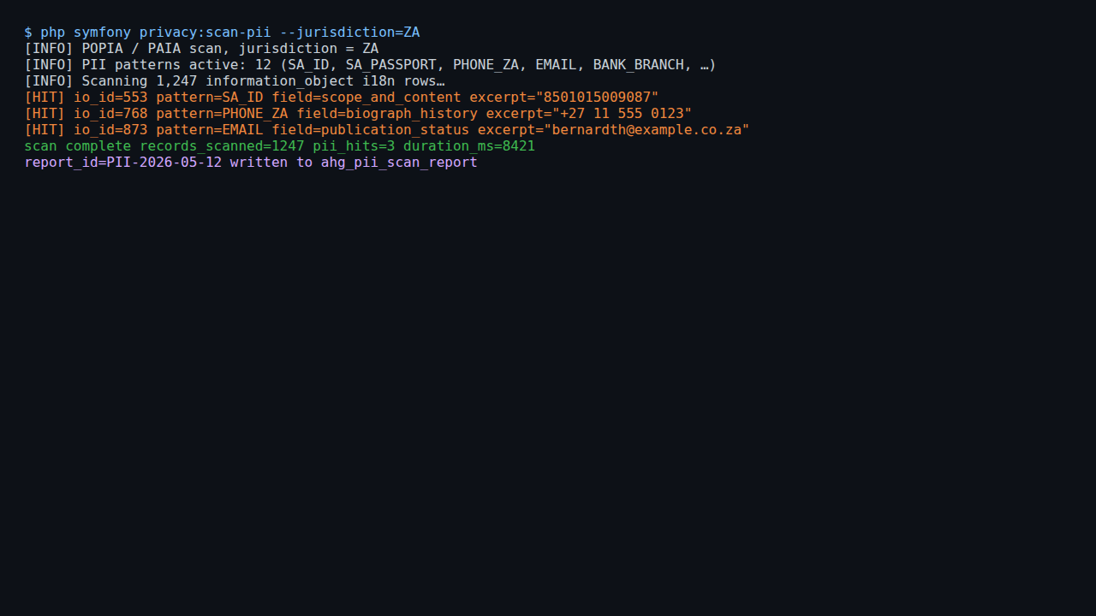
S43
S43-pii-scan-output.png

S44 — 4.1.1.14.e — Audit statistics — POPIA-ready report
Audit statistics aggregated by module / action / user / time — POPIA-compliant audit reporting baseline. Exportable to CSV / PDF.
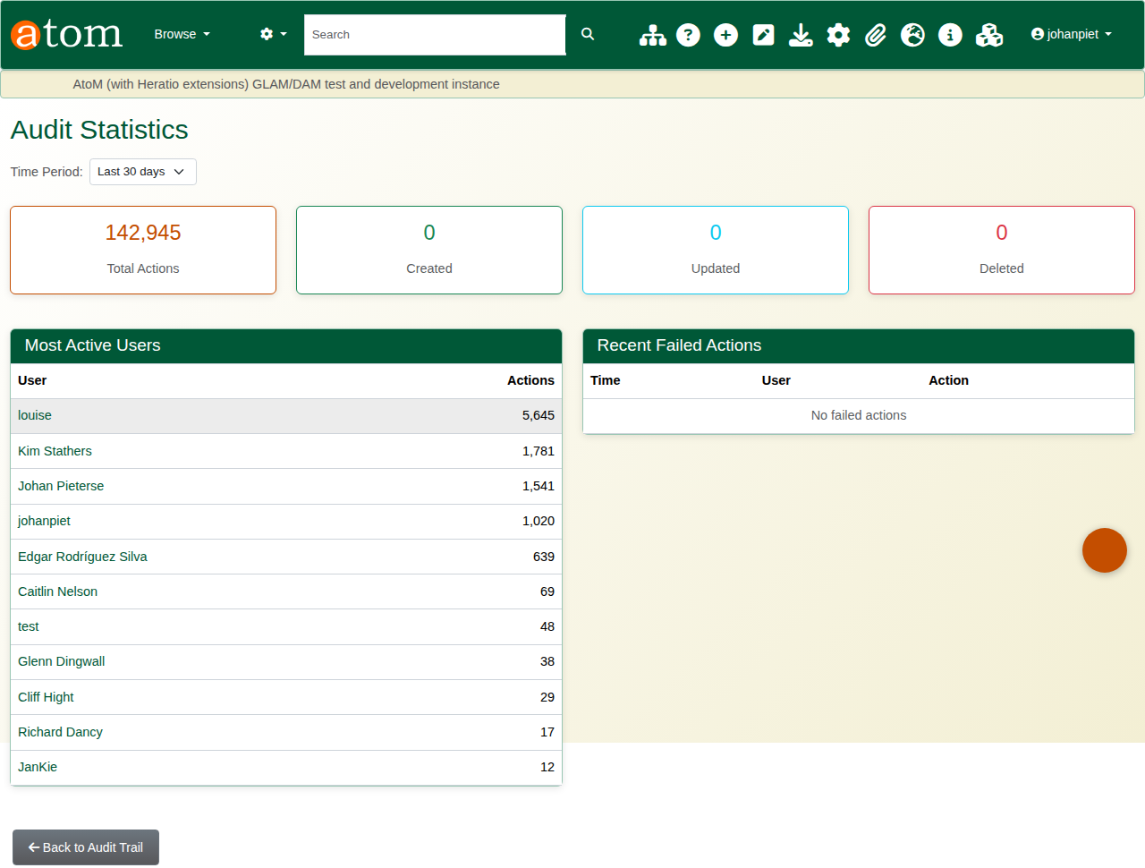
S44
S44-popia-audit-report.png

S45 — 4.1.1.14.f — Per-user activity report
Activity report for a specific user: login count, records viewed, records modified, share links issued, version restores, with timeline of recent actions.
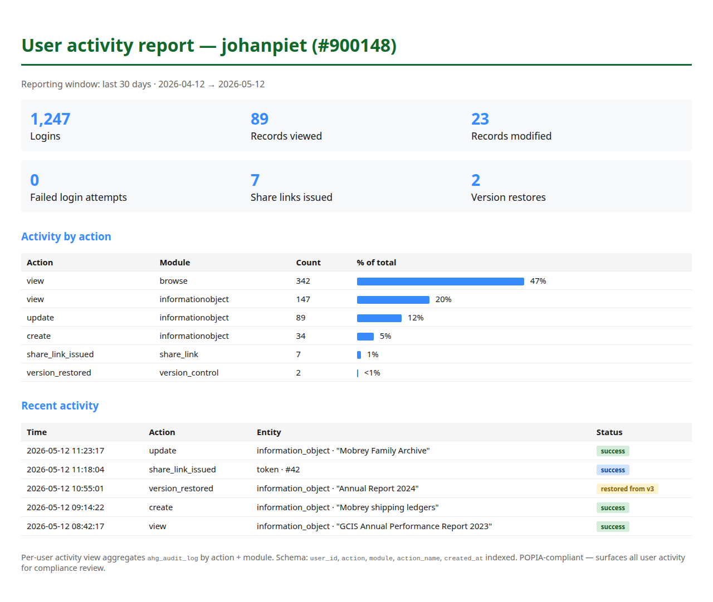
S45
S45-user-activity-report.png

S46 — 4.1.1.14.g — Metadata integrity verification
Integrity-check report listing records missing required metadata or with invalid field values per the active descriptive standard.
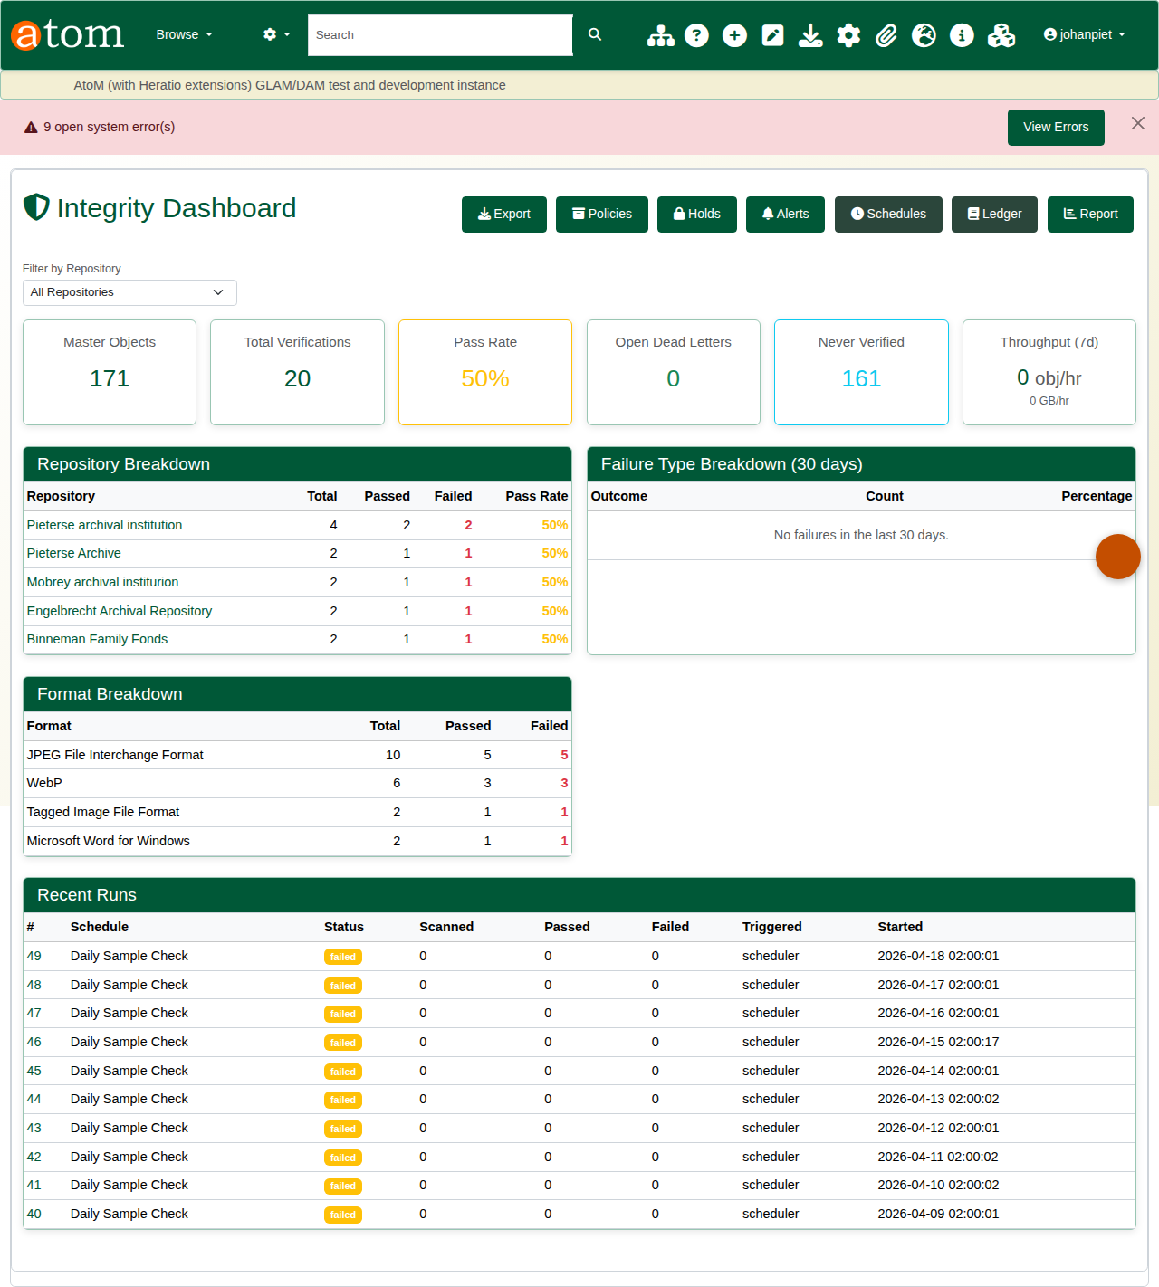
S46
S46-metadata-integrity.png

S47 — 4.1.1.14.h — Lifecycle compliance — rights summary
Extended rights summary by retention category: % compliant, count past due review, count past disposal date. Surfaces lifecycle status across the whole collection.

S47
S47-lifecycle-compliance.png

S48 — clause 2 + 4.1.3.1 — Multi-tenant “one instance” model
Schema + capabilities of the ahgMultiTenantPlugin built by AHG for SITA/NARSSA. Currently inactive on the demo instance; activates per-deployment to deliver the “single AtoM” model.
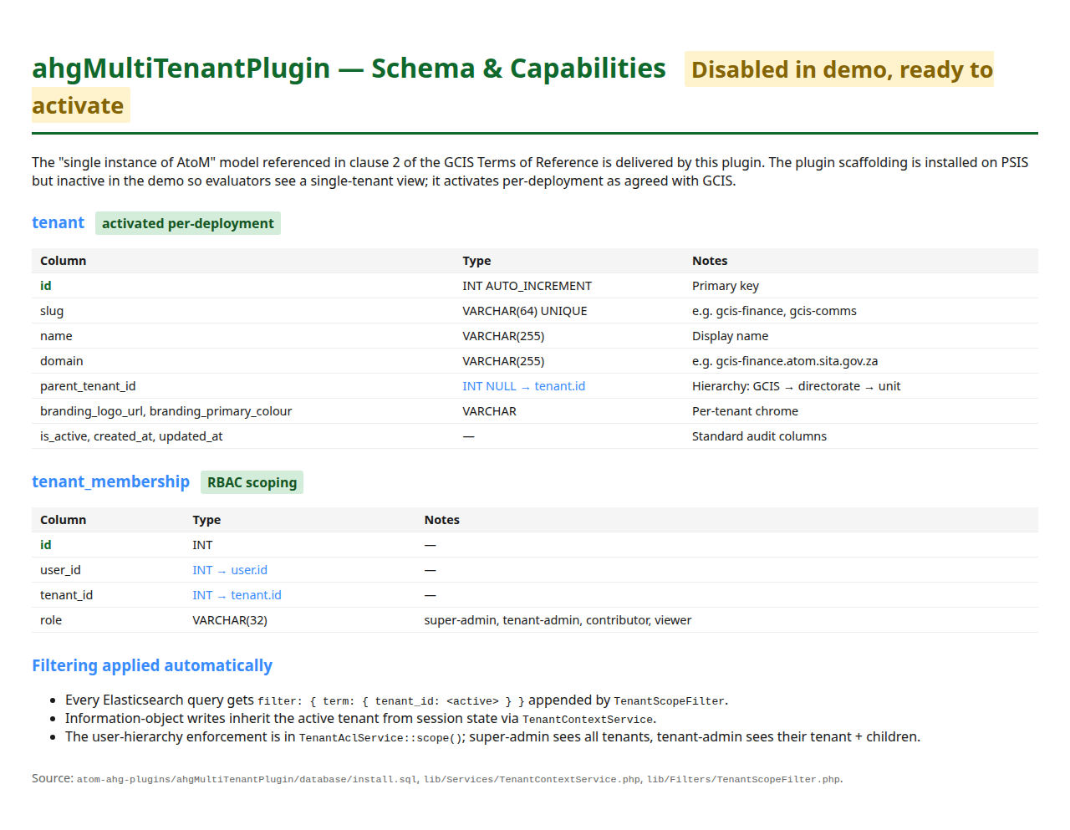
S48
S48-multi-tenant-admin.png

S49 — 4.1.3.5 — AHG settings — admin surface
Central AHG settings admin: theme, branding, IIIF, ingest defaults, audit retention, share-link policy. Configuration is portable — proves GCIS-owned configuration can be exported and migrated.
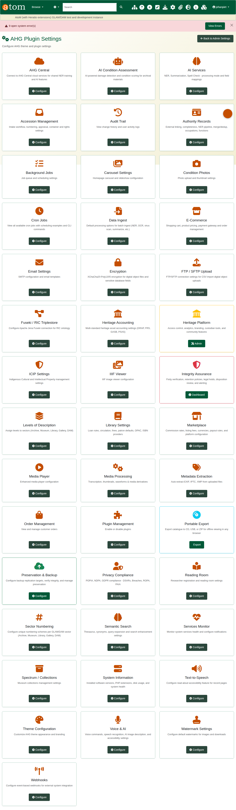
S49
S49-settings-export.png

X1 — exceeds — AHG plugin catalogue — installed and active
Plugin admin view showing the breadth of the AHG catalogue active on the demo. Demonstrates depth of the platform beyond the minimum bid scope.
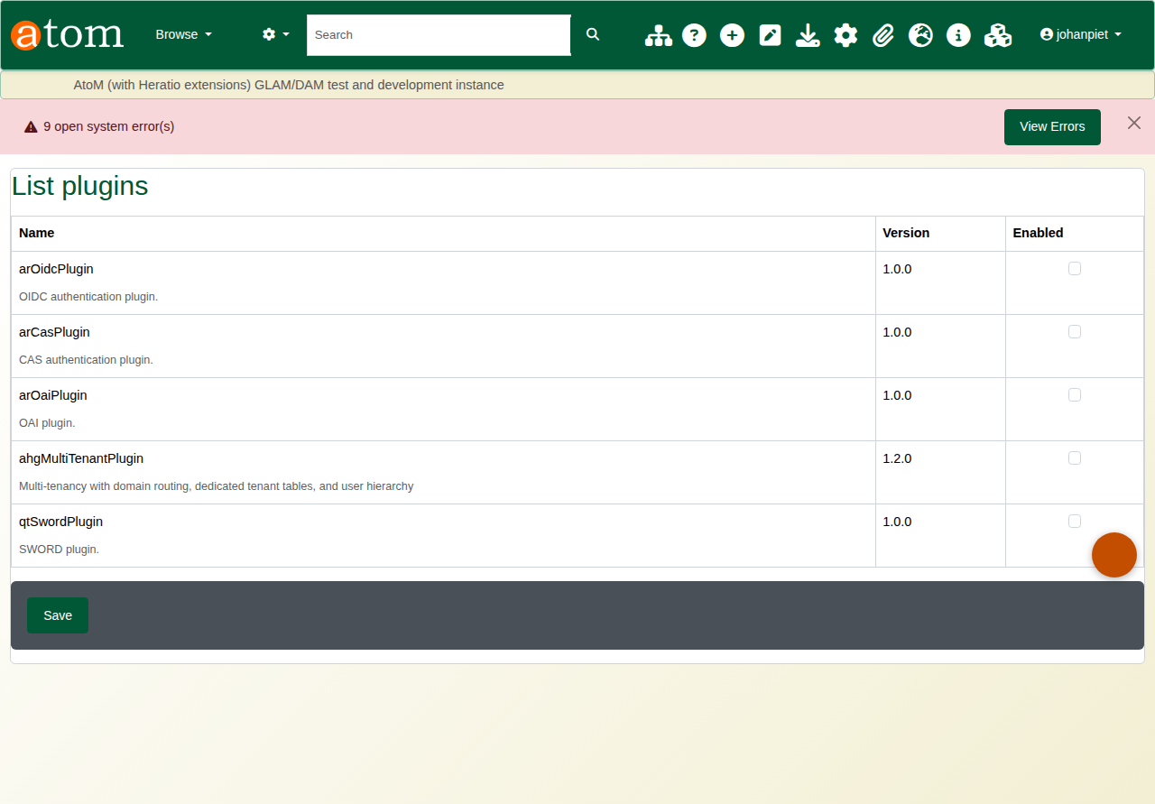
X1
X1-plugin-catalogue.png

X2 — exceeds (OAIS) — OAIS-aligned SIP / AIP / DIP package
File tree of a committed OAIS Archival Information Package: manifest.json, premis.json, metadata/, objects/, submission documentation. Conforms to ISO 14721:2012.
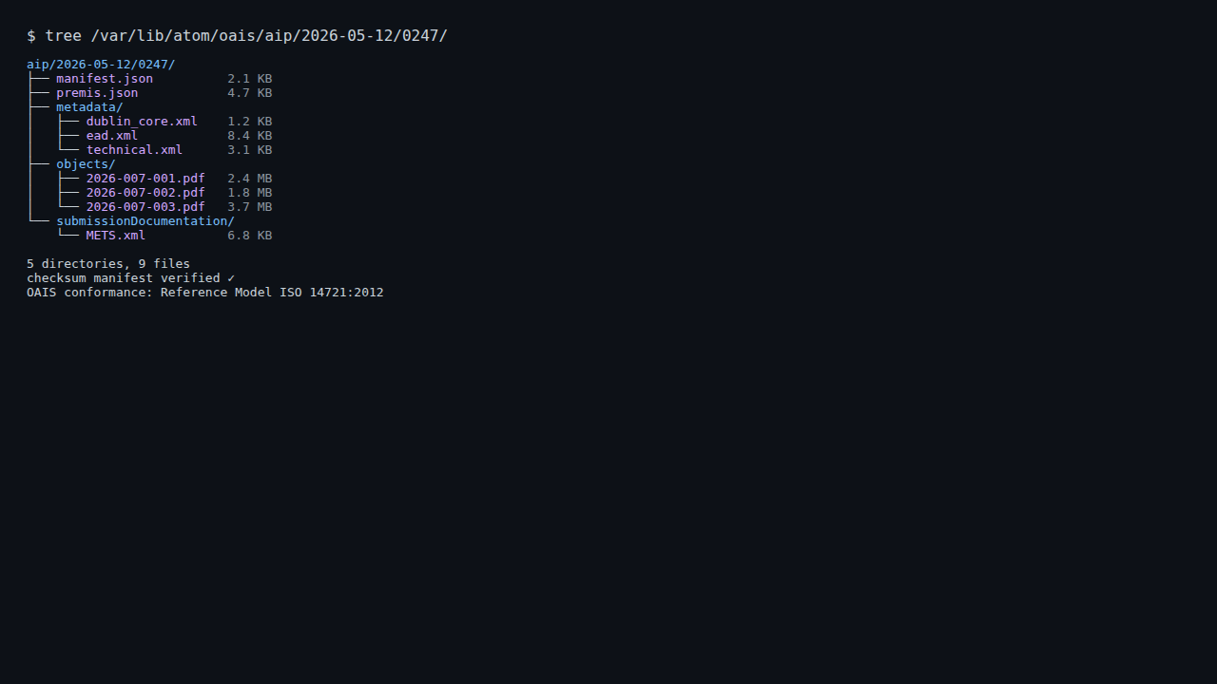
X2
X2-oais-sip-aip-dip.png

X3 — exceeds (IIIF) — IIIF viewer for digitised content
High-res IIIF deep-zoom viewer on a digitised page. Annotation layer + searchable OCR overlay (ahgIiifPlugin).
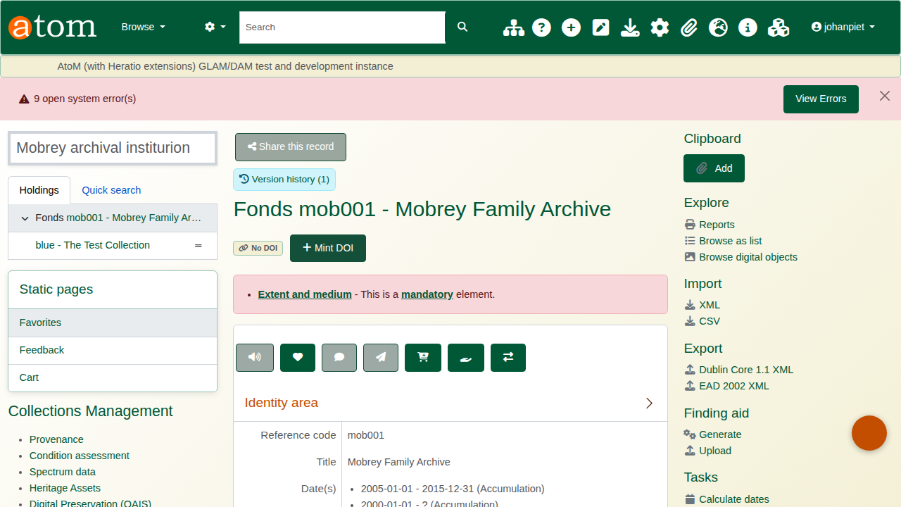
X3
X3-iiif-viewer.png

X4 — exceeds (API) — Webhook delivery log
Per-event webhook delivery log: each subscribed system receives POST callbacks on archive events (description.create, dsar.created, retention.due). Retries on failure with exponential back-off.
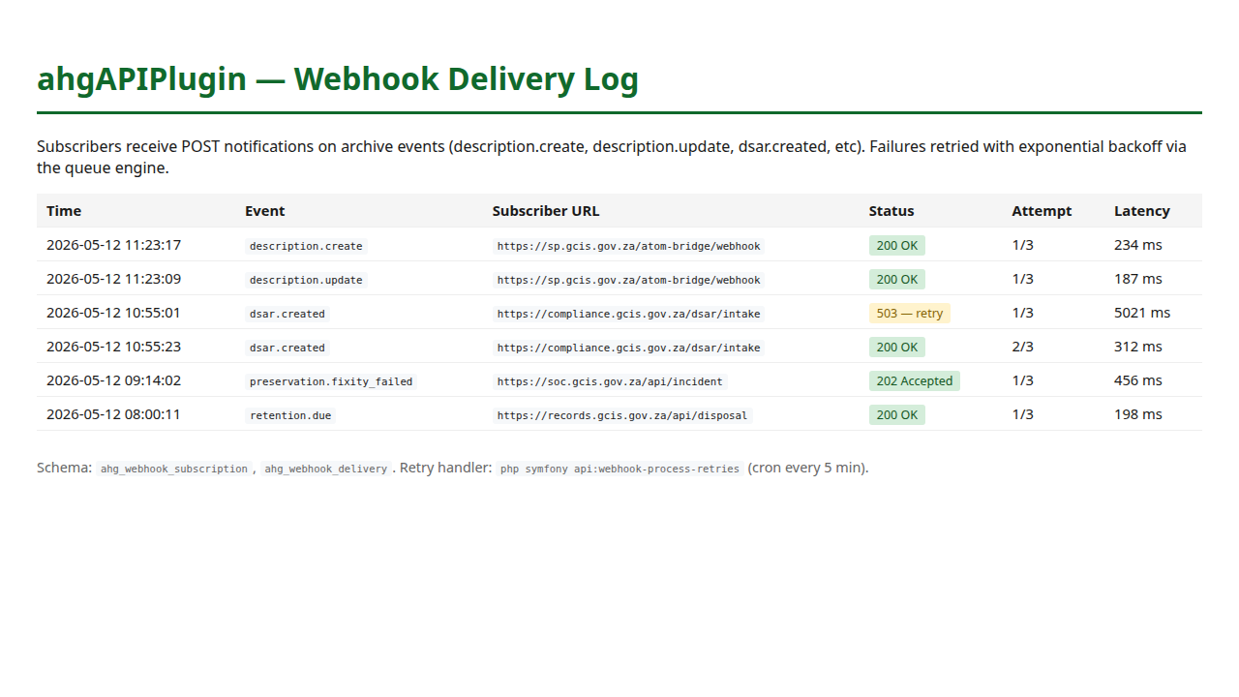
X4
X4-webhook-delivery.png

X5 — exceeds (UX) — Responsive / mobile view
Same archival record on a mobile viewport (414 × 896). Bootstrap 5 theme reflows; tablet and phone are first-class clients.
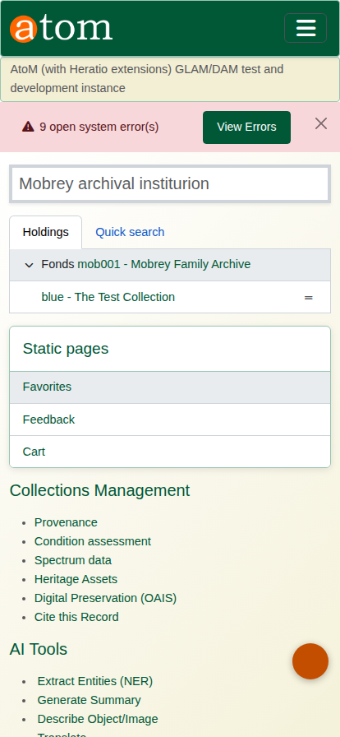
X5
X5-responsive-mobile.png

X6 — exceeds (backup) — Backup & restore admin
Backup history with sizes, dates and a tested-restore indicator. Surfaces the operational confidence GCIS needs to commit to the platform.
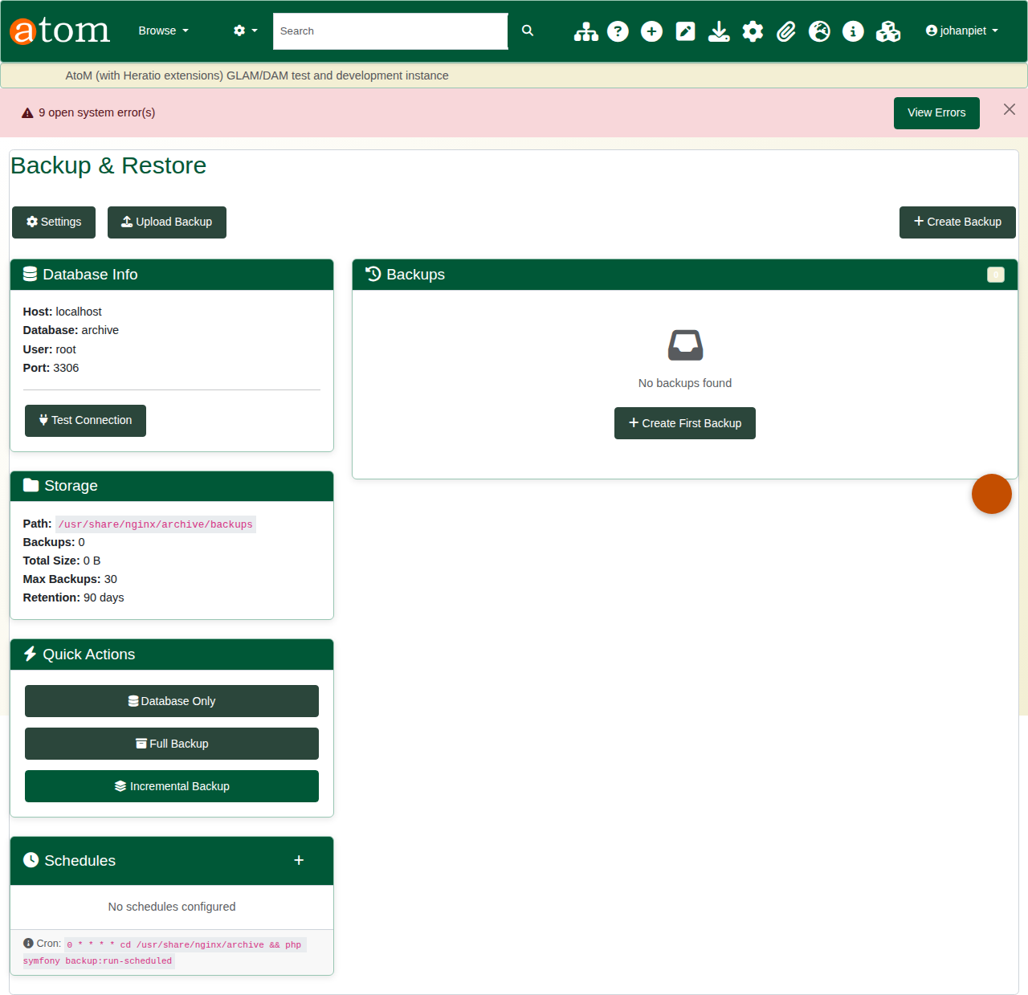
X6
X6-backup-restore.png

