The Model Was Never the Hard Part

A Framework for AI in Records and Archives
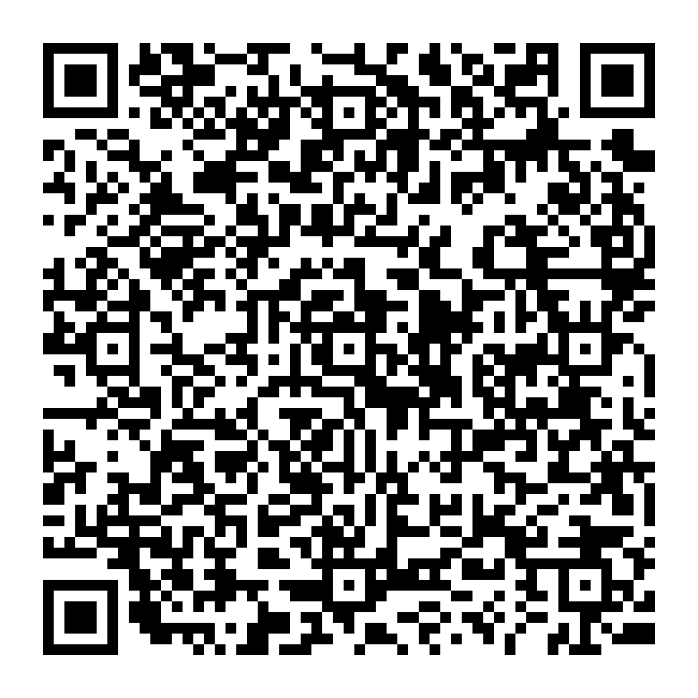{width=8cm}
Scan to read: https://heratio.theahg.co.za/articles/the-model-was-never-the-hard-part-a-framework-for-ai-in-records-and-archives

