NAME: ARCHANA DEVI.P
REG NO: 192521192
COURSE: DESIGN ANALYSIS OF ALGORITHM
CODE: CSA0613
ASSIGNMENT: CO4_AT_2

QUESTION:
Q7. Minimum Spanning Tree – Network Design
An ISP wants to connect multiple cities with minimum cable cost. Analyze how Prim’s or
Kruskal’s algorithm can be applied to construct a Minimum Spanning Tree. Design a feasible
solution by comparing both algorithms. Suggest appropriate tools and data structures for
implementation. Analyze the time complexity of each approach. Interpret the results in terms
of cost optimization and practical network design.

1. Industry-Based Problem Scenario
- An Internet Service Provider (ISP) plans to build a network connecting multiple cities. Each city requires reliable connectivity, and the ISP wants to minimize the total cost of laying fiber-optic cables.
- The cities can be represented as vertices (nodes), while the possible cable connections between cities are represented as weighted edges. The weight of an edge represents the estimated cable installation cost.
The objective is to connect all cities while ensuring:
- Every city is connected to the network.
- The total cable installation cost is minimum.
- No unnecessary cycles are created.
- The network uses the minimum number of required connections.
This problem can be solved using a Minimum Spanning Tree (MST).
2. Problem Statement
Given a weighted graph representing cities and possible cable connections, construct a network that connects all cities with the minimum possible total cable cost.
The solution should:
- Represent cities as graph vertices.
- Represent cable connections as weighted edges.
- Apply Prim's Algorithm and Kruskal's Algorithm.
- Construct a Minimum Spanning Tree.
- Compare the performance of both algorithms.
- Analyze the total cost and practical network design benefits.
3. Input and Output
Input
The input consists of:
- A set of cities.
- Possible connections between cities.
- Cost of laying cable between each pair of connected cities.
Example
Cities: A, B, C, D, E
Connections:
A -- B : 2
A -- C : 3
B -- C : 1
B -- D : 4
C -- D : 5
C -- E : 6
D -- E : 7
The numbers represent cable installation costs.
Output
The output should contain:
- The edges selected for the Minimum Spanning Tree.
- Total minimum cable cost.
- Comparison between Prim's and Kruskal's algorithms.
4. Graph Representation
The network can be represented as a weighted undirected graph.
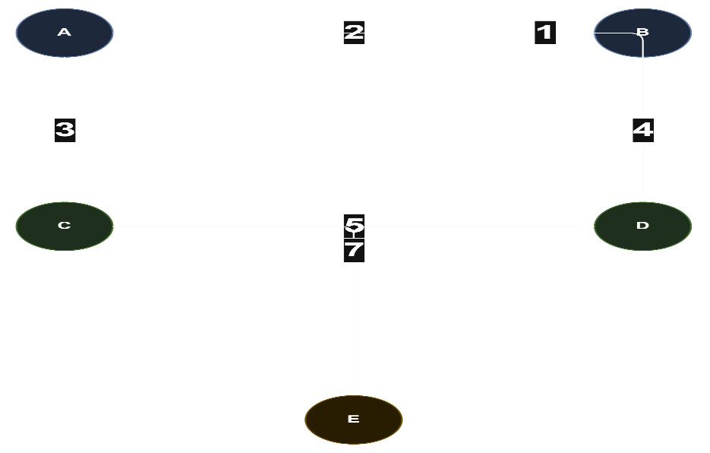

Each connection has a cost associated with it.
For example:
Connection | Cable Cost
A – B | 2
A – C | 3
B – C | 1
B – D | 4
C – D | 5
C – E | 6
D – E | 7

5. Minimum Spanning Tree Concept
A Minimum Spanning Tree (MST) is a subset of graph edges that:
- Connects all vertices.
- Contains no cycles.
- Uses exactly V − 1 edges for V vertices.
- Has the minimum possible total edge weight.
For the example network, one possible MST is:
B -- C : 1
A -- B : 2
B -- D : 4
C -- E : 6
Total Cost
1 + 2 + 4 + 6 = 13
Therefore, the ISP can connect all five cities with a minimum cable cost of 13 units.
6. Approach 1 – Prim's Algorithm
Prim's Algorithm builds the MST by starting from one city and gradually expanding the network.
Working Procedure
- Select a starting city.
- Mark it as visited.
- Find the minimum-cost edge connecting a visited city to an unvisited city.
- Add the edge to the MST.
- Repeat until all cities are connected.
Pseudocode
ALGORITHM Prim(Graph, start)
Create empty MST
Mark all vertices as unvisited
Mark start as visited
WHILE MST contains fewer than V - 1 edges
Select minimum-cost edge (u, v)
WHERE:
u is visited
v is unvisited
Add edge (u, v) to MST
Mark v as visited
END WHILE
RETURN MST
END ALGORITHM
7. Approach 2 – Kruskal's Algorithm
Kruskal's Algorithm constructs the MST by selecting edges in increasing order of cost.
Working Procedure
- Sort all edges according to their weights.
- Select the smallest edge.
- Add it if it does not form a cycle.
- Repeat until V − 1 edges are selected.
A Disjoint Set Union (Union-Find) data structure is commonly used to detect cycles efficiently.

Pseudocode
ALGORITHM Kruskal(Graph)
Create empty MST
Sort all edges in increasing order of cost
FOR each edge (u, v) in sorted edges
IF u and v belong to different components THEN
Add (u, v) to MST
Merge the components
END IF
IF MST contains V - 1 edges THEN
BREAK
END IF
END FOR
RETURN MST
END ALGORITHM
8. Python Implementation
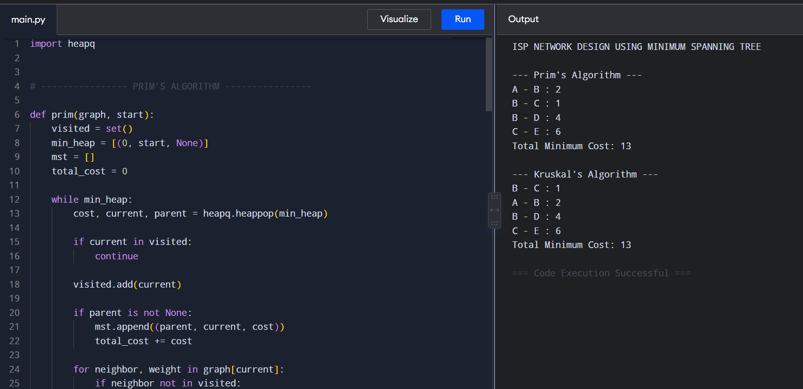

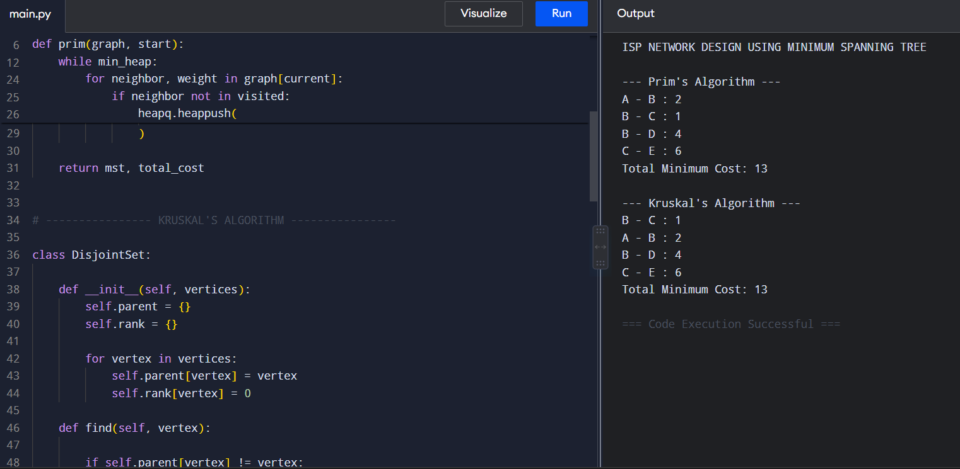
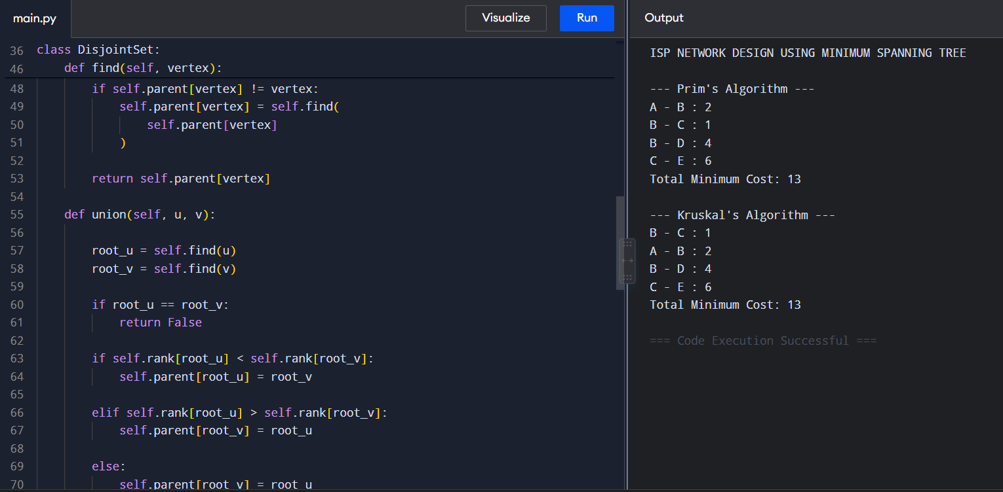
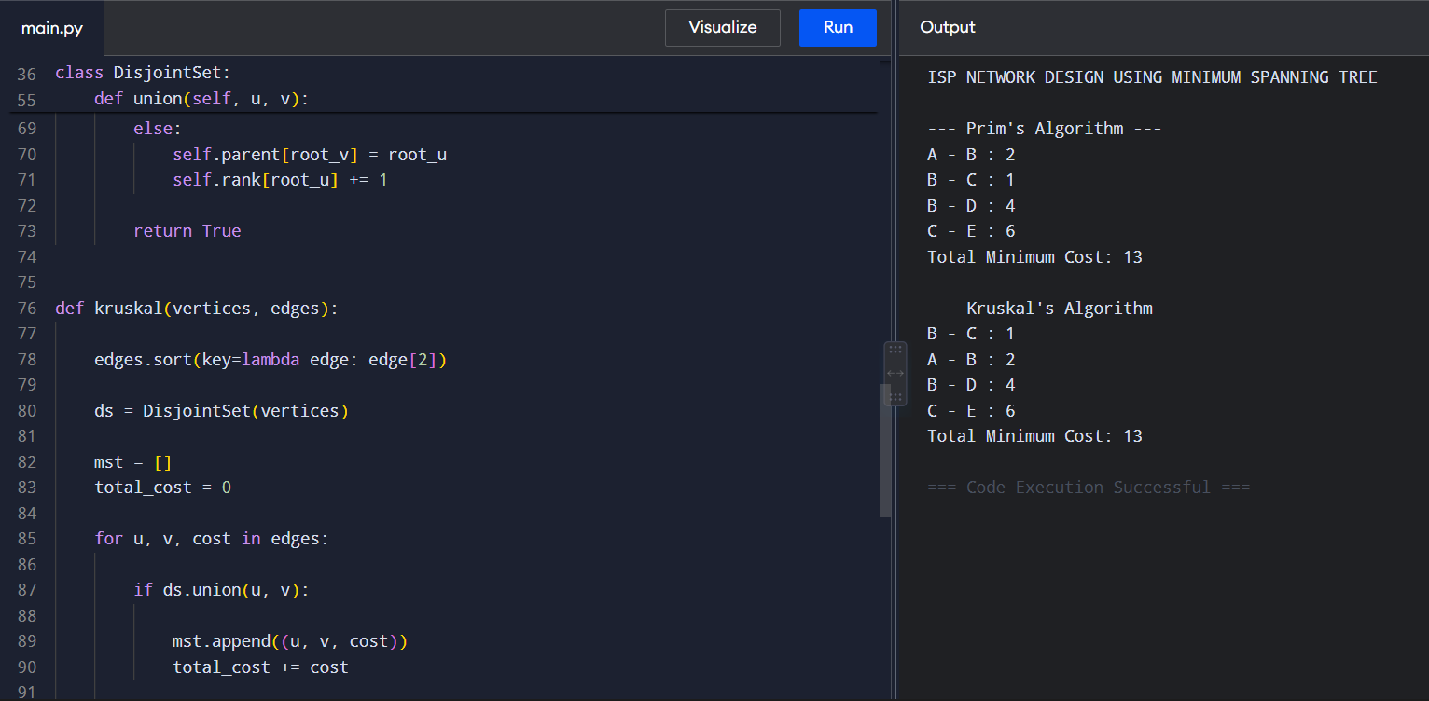
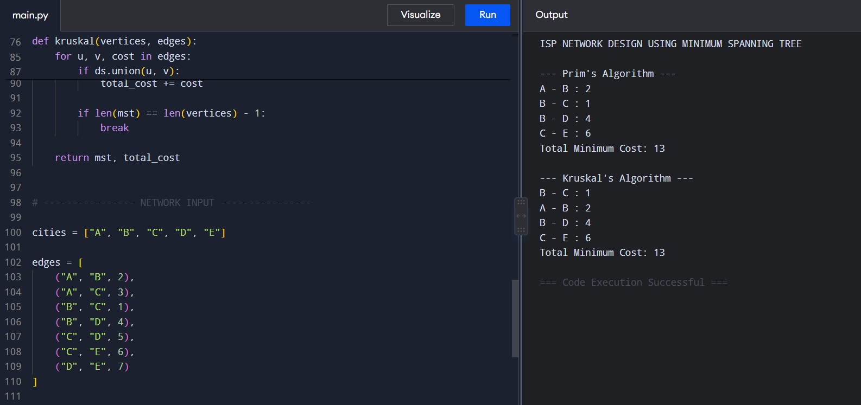
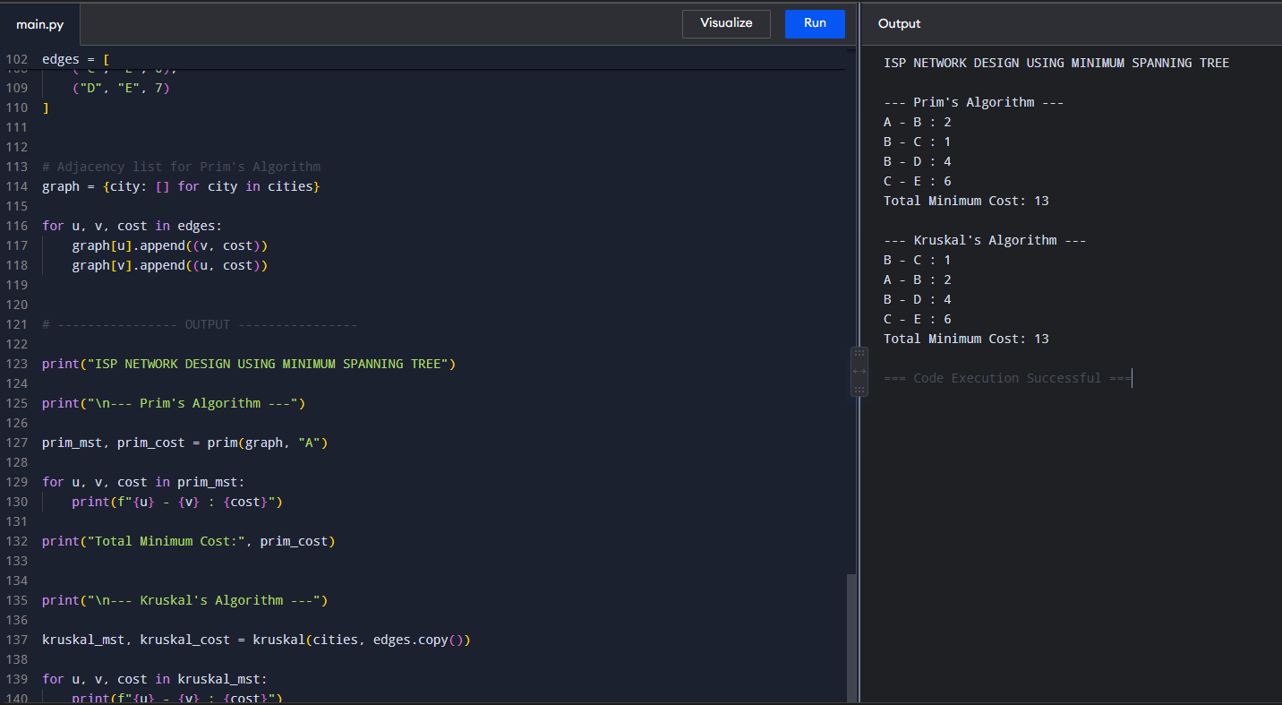
10. Comparison of Prim's and Kruskal's Algorithms
Feature | Prim's Algorithm | Kruskal's Algorithm
Main approach | Expands from a starting vertex | Selects globally minimum edges
Main data structure | Priority Queue / Min Heap | Union-Find / Disjoint Set
Graph representation | Adjacency List | Edge List
Best suitable for | Dense graphs | Sparse graphs
Cycle detection | Not explicitly required | Required using Union-Find
Time complexity | O(E log V) | O(E log E)
Network growth | Builds one connected network gradually | Connects components gradually

Where:
- V = Number of cities.
- E = Number of possible cable connections.
11. Data Structures and Tools
Recommended Data Structures
1. Graph
An adjacency list is suitable for representing the ISP network.
Example:
A → (B, 2), (C, 3)
B → (A, 2), (C, 1), (D, 4)
2. Priority Queue
Used by Prim's Algorithm to efficiently select the lowest-cost connection.
3. Edge List
Used by Kruskal's Algorithm to store and sort all possible cable connections.
4. Disjoint Set Union
Used to efficiently determine whether adding an edge will create a cycle.
12. Time Complexity Analysis
Prim's Algorithm
Using:
- Adjacency List
- Binary Min Heap
The time complexity is:
O(E log V)
The space complexity is approximately:
O(V + E)

Kruskal's Algorithm
The major operation is sorting all edges.
The time complexity is:
O(E log E)
Since:
E ≤ V²
Kruskal's complexity is also commonly related to:
O(E log V)
The Union-Find operations are nearly constant time when path compression and union by rank are used.
13. Result Analysis
For the given network:
Total Possible Cable Cost
2 + 3 + 1 + 4 + 5 + 6 + 7 = 28 units
Minimum Spanning Tree Cost
13 units
Cost Reduction
28 − 13 = 15 units
The ISP does not need to install every possible connection. By selecting only the MST connections, all cities remain connected while reducing unnecessary cable installation.
MST Connections
B — C
A — B
B — D
C — E
All five cities are connected using only four connections, which is the minimum required number of edges.
14. Practical Network Design Interpretation
The MST approach provides several practical advantages for an ISP:
- Reduces total fiber-optic cable installation costs.
- Connects all required cities.
- Avoids unnecessary redundant connections.
- Simplifies the initial network design.
- Helps in planning large-scale communication infrastructure.
- Can be applied to fiber networks, electrical networks, road networks, and pipeline systems.
Important Practical Limitation
- A basic MST does not provide redundancy. If one selected cable connection fails, some cities may become disconnected.
- Therefore, in a real ISP network, the MST can be used as the minimum-cost base network. Additional backup links may then be added for reliability and fault tolerance.
15. Conclusion
- The Minimum Spanning Tree approach provides an efficient solution for designing a cost-optimized ISP network. Both Prim's Algorithm and Kruskal's Algorithm can successfully identify the minimum set of cable connections required to connect all cities.
- In this implementation, both algorithms produce the same minimum network cost of 13 units. Prim's Algorithm is particularly suitable for networks that are dense and can be efficiently represented using adjacency lists and priority queues. Kruskal's Algorithm is often more convenient for sparse networks because it processes sorted edges and uses the Union-Find data structure for efficient cycle detection.
- The results demonstrate that MST algorithms can significantly reduce infrastructure costs while maintaining complete connectivity, making them highly relevant to practical network design in the telecommunications industry.

