Name: Matthew Keane Y. Mariano
Section: BSIT-4D
Subject: ITEC-116
Repository link Archlight2002/Hyposelenia: Frostmoon

Avtivity 2: Chat Room + Rest API

This project is a real-time chat application that allows users to join chatrooms and exchange messages instantly. The system consists of two main components:
- Backend: A REST API that manages chatrooms and message history, integrated with WebSockets to enable real-time communication capabilities.
- Frontend: A user interface that displays a list of available rooms and the live chat conversation, allowing users to send and receive messages dynamically.

The system is built using:
- Backend: NestJS (Node.js Framework)
- Database: Xampp
- Frontend: React + Vite
- API Documentation: Swagger UI

This system demonstrates how a modern full-stack application is structured, including database modeling, API endpoint design, component-based UI development, and end-to-end CRUD operations.
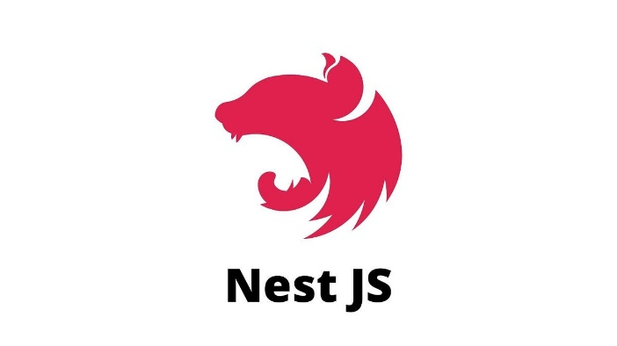

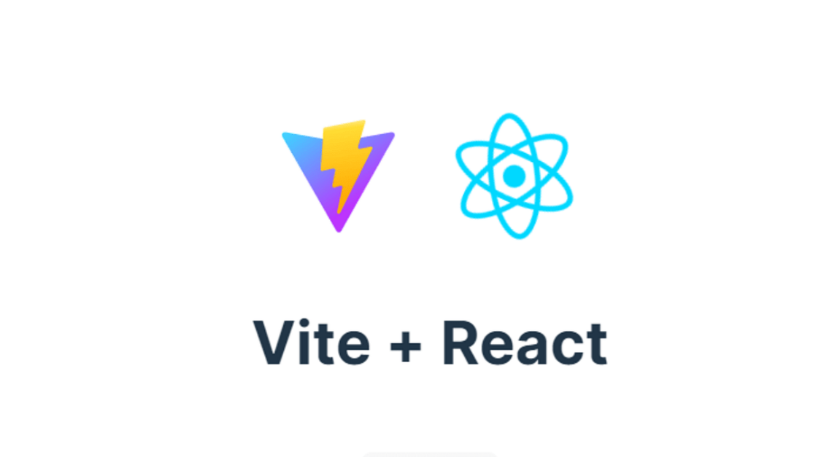
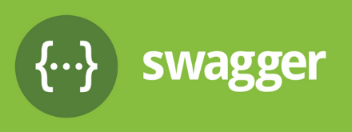

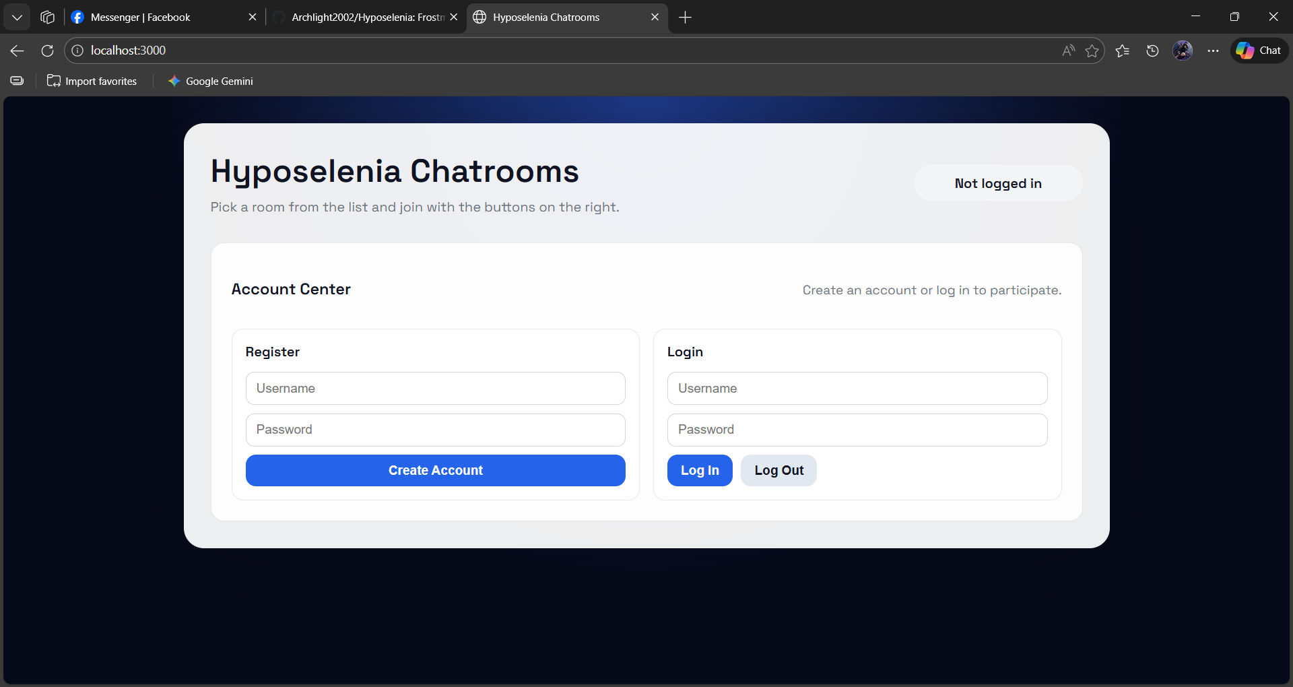

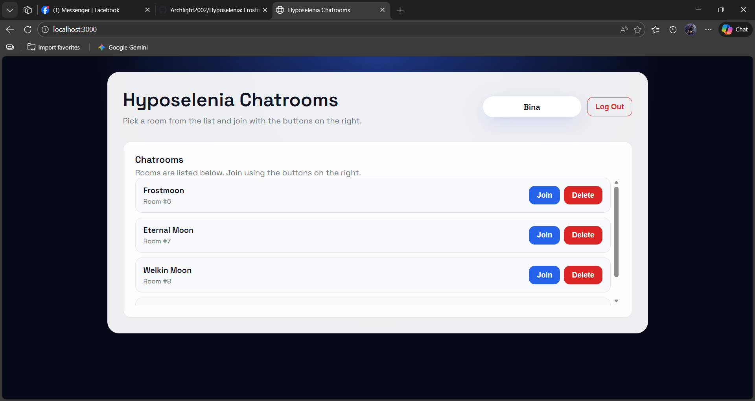
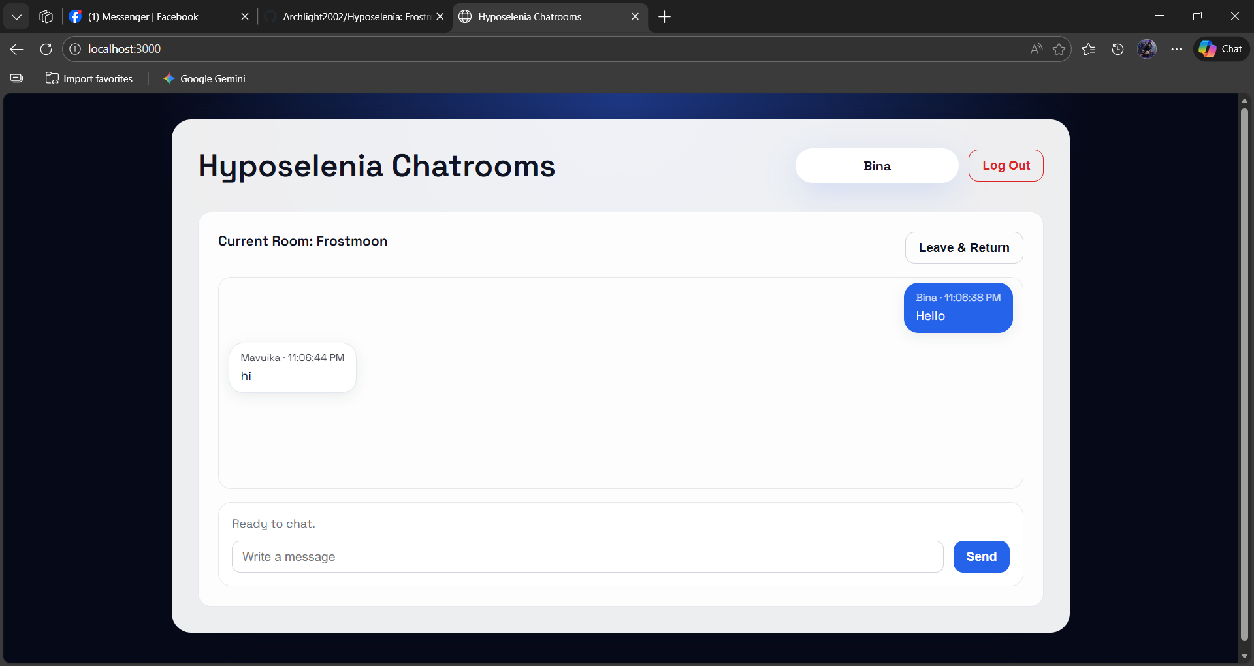
Instruction how to run the project:

Step 1: *Clone or download* the project folder to your local machine.
Step 2: Open the folder in *Visual Studio Code* (or any code editor).

Step 3: Run npm install in the terminal to install all dependencies.
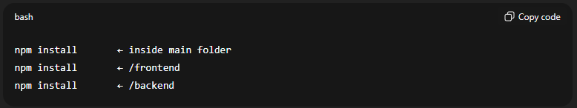
Step 4: Start the development server using npm run dev and copy the link on the terminal.
example. http://localhost:3000. For the app
http://localhost:3000/api. For the swagger
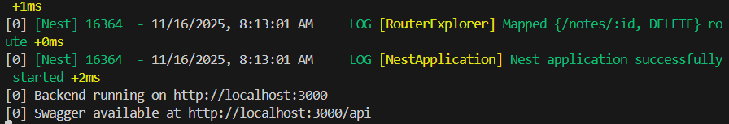
This command automatically launches:
- Backend server (NestJS)
- Frontend (Vite)
- Swagger API documentations
Step 5: Open your browser and paste link that you have copy on terminal to view the app.
Step 6: Use the Register page to create a new account, then log in using your credentials to test the authentication system.

