МИНИСТЕРСТВО НАУКИ И ВЫСШЕГО ОБРАЗОВАНИЯ   
РОССИЙСКОЙ ФЕДЕРАЦИИ

ФЕДЕРАЛЬНОЕ ГОСУДАРСТВЕННОЕ БЮДЖЕТНОЕ ОБРАЗОВАТЕЛЬНОЕ УЧРЕЖДЕНИЕ ВЫСШЕГО ОБРАЗОВАНИЯ

**«БЕЛГОРОДСКИЙ ГОСУДАРСТВЕННЫЙ**

**ТЕХНОЛОГИЧЕСКИЙ УНИВЕРСИТЕТ им. В. Г. ШУХОВА»**

**(БГТУ им. В.Г. Шухова)**

Кафедра программного обеспечения вычислительной техники и автоматизированных систем

Лабораторная работа №1

по дисциплине «Технологии Web-программирования»

тема: «HTML. Разработка макетов и верстка шаблонов web-приложения с помощью языков HTML и CSS»

Выполнил: ст. группы ВТ-42

Потрехаев Ю.О

Проверил: Картамышев С.В.

Белгород 2021 г.

**Цель работы:** изучить основы работы протокола передачи гипертекста HTTP. Изучить основы разметки страниц с помощью языка HTML. Изучить основы вёрстки страниц, адаптированных под различные устройства. Изучить основы работы задания стилей для разметки страницы с помощью языка CSS. Разработать макеты и «сверстать» страницы для web-приложения.

**Внешний вид страниц**

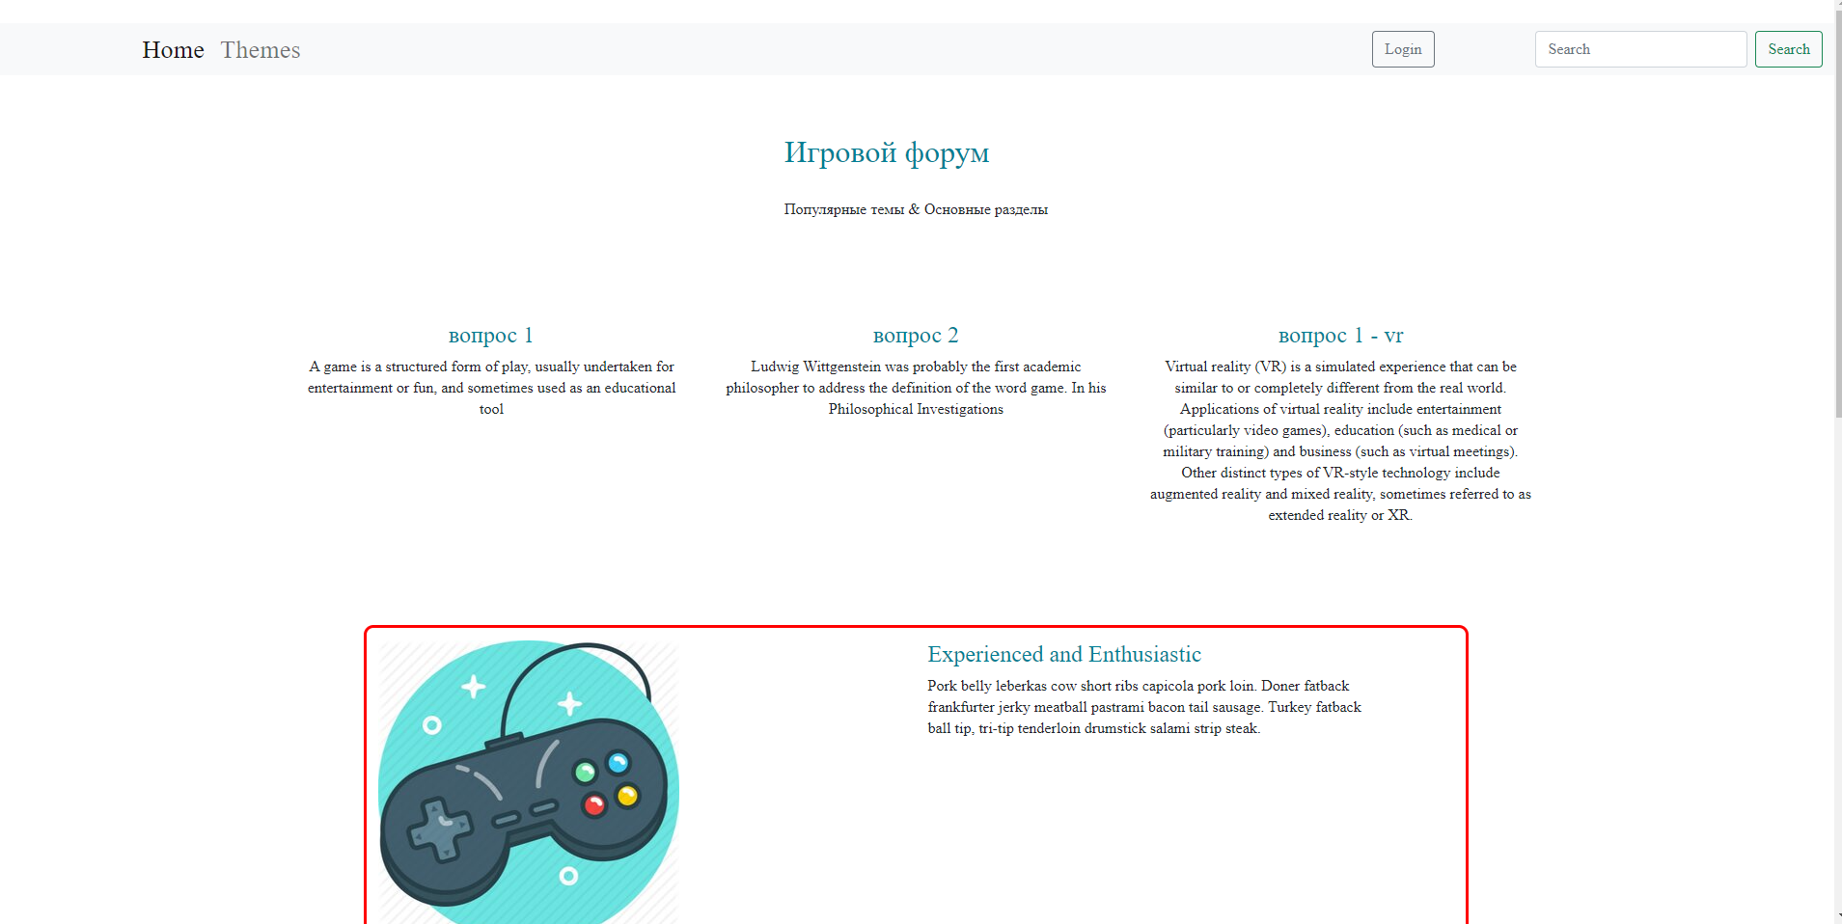

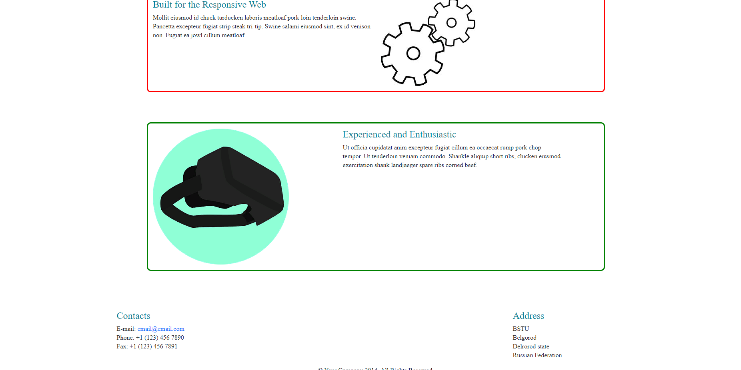

**Приложение**

**index.html**

<!DOCTYPE html>  
<html lang="en">  
<head>  
 <meta charset="utf-8">  
 <title>Home</title>  
 <link href="https://cdn.jsdelivr.net/npm/bootstrap@5.1.3/dist/css/bootstrap.min.css" rel="stylesheet" integrity="sha384-1BmE4kWBq78iYhFldvKuhfTAU6auU8tT94WrHftjDbrCEXSU1oBoqyl2QvZ6jIW3" crossorigin="anonymous">  
 <link href="css/main.css" rel="stylesheet">  
</head>  
  
<body>  
 <header class="header">   
 <nav class="navbar navbar-expand-lg navbar-light bg-light">  
 <div class="container-fluid">  
 <a class="navbar-brand" href="index.html"><img src="D:\programms\solutions\web_lab1\triangle\images\logo_m.png" alt=""></a>   
 <div class="collapse navbar-collapse">  
 <ul class="navbar-nav me-auto mb-2 mb-lg-0">  
 <li class="nav-item">  
 <a class="nav-link active" aria-current="page" href="index.html">Home</a>  
 </li>  
 <li class="nav-item">  
 <a class="nav-link" href="themes.html">Themes</a>  
 </li>   
 </ul>  
 <a href="login-reg.html" class = "login">  
 <button type="button" class="btn btn-outline-secondary d-flex login">Login</button></a>  
 <form class="d-flex">  
 <input class="form-control me-2" type="search" placeholder="Search" aria-label="Search">  
 <button class="btn btn-outline-success" type="submit">Search</button>  
 </form>  
 </div>  
 </div>  
 </nav>  
 </header>

<section class="title">  
 <div class="vertical-center">  
 <div class="container">  
 <div class="d-flex justify-content-center name-title">   
 <div>  
 <h1 >Игровой форум </h1>  
 <p> <br> Популярные темы &AMP; Основные разделы</p>  
 </div>   
 </div>  
 </div>  
 </div>  
 </section>  
   
 <section >  
 <div class="container">  
 <div class="row">  
 <div class="col-md-4 text-center ">  
 <div class="desc">  
 <a class="cont_ref" href="quest.html">   
 <h2>вопрос 1</h2>  
 </a>  
 <p> A game is a structured form of play, usually undertaken for entertainment or fun, and sometimes used as an educational tool</p>  
 </div>  
 </div>  
 <div class="col-md-4 text-center">  
 <div class="desc">  
 <a class="cont_ref" href="quest.html">  
 <h2>вопрос 2</h2>  
 </a>  
 <p>Ludwig Wittgenstein was probably the first academic philosopher to address the definition of the word game. In his Philosophical Investigations</p>  
 </div>  
 </div>  
 <div class="col-md-4 text-center">  
 <div class="desc">  
 <a class="cont_ref" href="quest.html">  
 <h2>вопрос 1 - vr</h2>  
 </a>  
 <p>Virtual reality (VR) is a simulated experience that can be similar to or completely different from the real world. Applications of virtual reality include entertainment (particularly video games), education (such as medical or military training) and business (such as virtual meetings). Other distinct types of VR-style technology include augmented reality and mixed reality, sometimes referred to as extended reality or XR.</p>  
 </div>  
 </div>  
 </div>  
 </div>  
</section>  
  
<section >  
 <div class="container">  
 <div class="row thems">  
 <div class="col-sm-6 fadeInLeft">  
 <img src="images/gp.jpg" class="img-responsive align-self-lg-center" alt="">  
 </div>  
 <div class="col-sm-5 fadeInLeft" >  
 <h2>Experienced and Enthusiastic</h2>  
 <P>Pork belly leberkas cow short ribs capicola pork loin. Doner fatback frankfurter jerky meatball pastrami bacon tail sausage. Turkey fatback ball tip, tri-tip tenderloin drumstick salami strip steak.</P>  
 </div>  
 </div>  
 <div class="row thems">  
 <div class="col-sm-6 col-sm-offset-1 align-right fadeInLeft">  
 <h2>Built for the Responsive Web</h2>  
 <P>Mollit eiusmod id chuck turducken laboris meatloaf pork loin tenderloin swine. Pancetta excepteur fugiat strip steak tri-tip. Swine salami eiusmod sint, ex id venison non. Fugiat ea jowl cillum meatloaf.</P>  
 </div>  
 <div class="col-sm-5 wow fadeInRight">  
 <img src="images/settings.jpg" class="img-responsive align-self-lg-center" alt="">  
 </div>  
 </div>  
 <div class="row thems">  
 <div class="col-sm-5 wow fadeInLeft">  
 <img src="images/vr-1911452__340.png" class="img-responsive align-self-lg-center" alt="">  
 </div>  
 <div class="col-sm-6 wow fadeInRight">  
 <h2>Experienced and Enthusiastic</h2>  
 <P>Ut officia cupidatat anim excepteur fugiat cillum ea occaecat rump pork chop tempor. Ut tenderloin veniam commodo. Shankle aliquip short ribs, chicken eiusmod exercitation shank landjaeger spare ribs corned beef.</P>  
 </div>  
 </div>  
 </div>  
</section>  
 <footer >  
 <div class="container">  
 <div class="row justify-content-between">  
 <div class="col-sm-12 text-center bottom-separator">  
 <img src="images/home/under.png" class="img-responsive inline" alt="">  
 </div>  
 <div class="col-md-3 col-sm-6 align-self-baseline">  
 <h2>Contacts</h2>  
 <address>  
 E-mail: <a href="mailto:someone@example.com">email@email.com</a> <br>   
 Phone: +1 (123) 456 7890 <br>   
 Fax: +1 (123) 456 7891 <br>   
 </address>  
 </div>  
 <div class="col-md-3 col-sm-6 align-self-end">  
 <h2>Address</h2>  
 <address>  
 BSTU <br>   
 Belgorod <br>   
 Delrorod state <br>   
 Russian Federation <br>   
 </address>  
 </div>  
   
 <div class="col-sm-12 ">  
 <div class="copyright-text text-center">  
 <p>&copy; Your Company 2014. All Rights Reserved.</p>  
 </div>  
 </div>  
 </div>  
 </div>  
 <script src="https://cdn.jsdelivr.net/npm/bootstrap@5.1.3/dist/js/bootstrap.bundle.min.js" integrity="sha384-ka7Sk0Gln4gmtz2MlQnikT1wXgYsOg+OMhuP+IlRH9sENBO0LRn5q+8nbTov4+1p" crossorigin="anonymous"></script>  
 </footer>  
</body>  
</html>

**themes.html**

<!DOCTYPE html>

<html lang="en">

<head>

<meta charset="utf-8">

<title>Themes</title>

<link href="https://cdn.jsdelivr.net/npm/bootstrap@5.1.3/dist/css/bootstrap.min.css" rel="stylesheet" integrity="sha384-1BmE4kWBq78iYhFldvKuhfTAU6auU8tT94WrHftjDbrCEXSU1oBoqyl2QvZ6jIW3" crossorigin="anonymous">

<link href="css/main.css" rel="stylesheet">

<link rel="shortcut icon" href="images/ico/favicon.ico">

</head><!--/head-->

<body>

<header class="header">

<nav class="navbar navbar-expand-lg navbar-light bg-light">

<div class="container-fluid">

<a class="navbar-brand" href="index.html"><img src="D:\programms\solutions\web_lab1\triangle\images\logo_m.png" alt=""></a>

<div class="collapse navbar-collapse">

<ul class="navbar-nav me-auto mb-2 mb-lg-0">

<li class="nav-item">

<a class="nav-link active" href="index.html">Home</a>

</li>

<li class="nav-item">

<a class="nav-link" href="themes.html">Themes</a>

</li>

</ul>

<a href="login-reg.html" class = "login">

<button type="button" class="btn btn-outline-secondary d-flex login">Login</button></a>

<form class="d-flex">

<input class="form-control me-2" type="search" placeholder="Search" aria-label="Search">

<button class="btn btn-outline-success" type="submit">Search</button>

</form>

</div>

</div>

</nav>

</header>

<!--/#header-->

<section class="title">

<div class="vertical-center">

<div class="container">

<div class="d-flex justify-content-center name-title">

<div>

<h1 >Список тем</h1>

</div>

</div>

</div>

</div>

</section>

<!--/#services-->

<section >

<div class="d-flex justify-content-center">

<a class="btn btn-primary btn-lg" href="new_quest.html" role="button">новый вопрос</a>

</div>

<div class="list-group">

<h1>Gamming theme</h1>

<a href="quest.html" class="list-group-item list-group-item-action">вопрос 1 </a>

<a href="quest.html" class="list-group-item list-group-item-action">вопрос 2</a>

<a href="quest.html" class="list-group-item list-group-item-action">вопрос 3</a>

</div>

<div class="list-group">

<h1>Virtual Reality</h1>

<a href="quest.html" class="list-group-item list-group-item-action ">вопрос 1 </a>

<a href="quest.html" class="list-group-item list-group-item-action">вопрос 2</a>

<a href="quest.html" class="list-group-item list-group-item-action">вопрос 3</a>

</div>

<div class="list-group">

<h1>Hard settings</h1>

<a href="quest.html" class="list-group-item list-group-item-action">вопрос 1 </a>

<a href="quest.html" class="list-group-item list-group-item-action">вопрос 2</a>

<a href="quest.html" class="list-group-item list-group-item-action">вопрос 3</a>

</div>

</section>

<footer >

<div class="container">

<div class="row justify-content-between">

<div class="col-sm-12 text-center bottom-separator">

<img src="images/home/under.png" class="img-responsive inline" alt="">

</div>

<div class="col-md-3 col-sm-6 align-self-baseline">

<h2>Contacts</h2>

<address>

E-mail: <a href="mailto:someone@example.com">email@email.com</a> <br>

Phone: +1 (123) 456 7890 <br>

Fax: +1 (123) 456 7891 <br>

</address>

</div>

<div class="col-md-3 col-sm-6 align-self-end">

<h2>Address</h2>

<address>

BSTU <br>

Belgorod <br>

Delrorod state <br>

Russian Federation <br>

</address>

</div>

<div class="col-sm-12 ">

<div class="copyright-text text-center">

<p>&copy; Your Company 2014. All Rights Reserved.</p>

</div>

</div>

</div>

</div>

<script src="https://cdn.jsdelivr.net/npm/bootstrap@5.1.3/dist/js/bootstrap.bundle.min.js" integrity="sha384-ka7Sk0Gln4gmtz2MlQnikT1wXgYsOg+OMhuP+IlRH9sENBO0LRn5q+8nbTov4+1p" crossorigin="anonymous"></script>

</footer>

<!--/#footer-->

</body>

</html>

**quest.html**

<!DOCTYPE html>

<html lang="en">

<head>

<meta charset="utf-8">

<title>quest</title>

<link href="https://cdn.jsdelivr.net/npm/bootstrap@5.1.3/dist/css/bootstrap.min.css" rel="stylesheet" integrity="sha384-1BmE4kWBq78iYhFldvKuhfTAU6auU8tT94WrHftjDbrCEXSU1oBoqyl2QvZ6jIW3" crossorigin="anonymous">

<link href="css/main.css" rel="stylesheet">

<link rel="shortcut icon" href="images/ico/favicon.ico">

</head><!--/head-->

<body>

<header class="header">

<nav class="navbar navbar-expand-lg navbar-light bg-light">

<div class="container-fluid">

<a class="navbar-brand" href="index.html"><img src="D:\programms\solutions\web_lab1\triangle\images\logo_m.png" alt=""></a>

<div class="collapse navbar-collapse">

<ul class="navbar-nav me-auto mb-2 mb-lg-0">

<li class="nav-item">

<a class="nav-link active" href="index.html">Home</a>

</li>

<li class="nav-item">

<a class="nav-link" href="themes.html">Themes</a>

</li>

</ul>

<a href="login-reg.html" class = "login">

<button type="button" class="btn btn-outline-secondary d-flex login">Login</button></a>

<form class="d-flex">

<input class="form-control me-2" type="search" placeholder="Search" aria-label="Search">

<button class="btn btn-outline-success" type="submit">Search</button>

</form>

</div>

</div>

</nav>

</header>

<section class="title">

<div class="vertical-center">

<div class="container">

<div class="d-flex justify-content-center name-title">

<div>

<h1 > Наименование вопроса </h1>

</div>

</div>

</div>

</div>

<div class="deac-q">

<p>Описание вопроса</p>

</div>

</section>

<section>

<div class="container">

<div class="row ansv-q">

<div class="col-md-2 nm_a cent">

<p>автор 1 </p>

</div>

<div class="col-md-2 t-ansv">

<p> Ответ автора 1</p>

</div>

</div>

<div class="row ansv-q">

<div class="col-md-2 nm_a">

<p>автор 2 </p>

</div>

<div class="col-md-2 t-ansv">

<p> Ответ автора 2</p>

</div>

</div>

<div class="row ansv-q">

<div class="col-md-2 nm_a">

<p>автор 1 </p>

</div>

<div class="col-md-2 t-ansv">

<p> Ещё один ответ автора 1</p>

</div>

</div>

<form>

<p><b>Введите ваш ответ:</b></p>

<p><textarea rows="10" cols="45" name="text"></textarea></p>

<p><input class="btn btn-primary " type="submit" value="Отправить"></p>

</form>

</div>

</section>

<footer >

<div class="container">

<div class="row justify-content-between">

<div class="col-sm-12 text-center bottom-separator">

<img src="images/home/under.png" class="img-responsive inline" alt="">

</div>

<div class="col-md-3 col-sm-6 align-self-baseline">

<h2>Contacts</h2>

<address>

E-mail: <a href="mailto:someone@example.com">email@email.com</a> <br>

Phone: +1 (123) 456 7890 <br>

Fax: +1 (123) 456 7891 <br>

</address>

</div>

<div class="col-md-3 col-sm-6 align-self-end">

<h2>Address</h2>

<address>

BSTU <br>

Belgorod <br>

Delrorod state <br>

Russian Federation <br>

</address>

</div>

<div class="col-sm-12 ">

<div class="copyright-text text-center">

<p>&copy; Your Company 2014. All Rights Reserved.</p>

</div>

</div>

</div>

</div>

<script src="https://cdn.jsdelivr.net/npm/bootstrap@5.1.3/dist/js/bootstrap.bundle.min.js" integrity="sha384-ka7Sk0Gln4gmtz2MlQnikT1wXgYsOg+OMhuP+IlRH9sENBO0LRn5q+8nbTov4+1p" crossorigin="anonymous"></script>

</footer>

</body>

</html>

**login-reg.html**

<!DOCTYPE html>

<html lang="en">

<head>

<meta charset="utf-8">

<title>login</title>

<link href="https://cdn.jsdelivr.net/npm/bootstrap@5.1.3/dist/css/bootstrap.min.css" rel="stylesheet" integrity="sha384-1BmE4kWBq78iYhFldvKuhfTAU6auU8tT94WrHftjDbrCEXSU1oBoqyl2QvZ6jIW3" crossorigin="anonymous">

<link href="css/main.css" rel="stylesheet">

<link rel="shortcut icon" href="images/ico/favicon.ico">

</head>

<body>

<header class="header">

<nav class="navbar navbar-expand-lg navbar-light bg-light">

<div class="container-fluid">

<a class="navbar-brand" href="index.html"><img src="D:\programms\solutions\web_lab1\triangle\images\logo_m.png" alt=""></a>

<div class="collapse navbar-collapse">

<ul class="navbar-nav me-auto mb-2 mb-lg-0">

<li class="nav-item">

<a class="nav-link active" href="index.html">Home</a>

</li>

<li class="nav-item">

<a class="nav-link" href="themes.html">Themes</a>

</li>

</ul>

<a href="login-reg.html" class = "login">

<button type="button" class="btn btn-outline-secondary d-flex">Login</button></a>

<form class="d-flex">

<input class="form-control me-2" type="search" placeholder="Search" aria-label="Search">

<button class="btn btn-outline-success" type="submit">Search</button>

</form>

</div>

</div>

</nav>

</header>

<form class="form-signin">

<img class="mb-4" src="images/logo_m_sh.png" alt="" width="72" height="72">

<h1 class="h3 mb-3 font-weight-normal">Please sign in</h1>

<label for="inputEmail" class="sr-only">Email address</label>

<input type="email" id="inputEmail" class="form-control" placeholder="Email address" required="" autofocus="">

<label for="inputPassword" class="sr-only">Password</label>

<input type="password" id="inputPassword" class="form-control" placeholder="Password" required="">

<div class="checkbox mb-3">

<label>

<input type="checkbox" value="remember-me"> Remember me

</label>

</div>

<button class="btn btn-lg btn-primary btn-block" type="submit">Sign in</button>

</form>

<footer >

<div class="container">

<div class="row justify-content-between">

<div class="col-sm-12 text-center bottom-separator">

<img src="images/home/under.png" class="img-responsive inline" alt="">

</div>

<div class="col-md-3 col-sm-6 align-self-baseline">

<h2>Contacts</h2>

<address>

E-mail: <a href="mailto:someone@example.com">email@email.com</a> <br>

Phone: +1 (123) 456 7890 <br>

Fax: +1 (123) 456 7891 <br>

</address>

</div>

<div class="col-md-3 col-sm-6 align-self-end">

<h2>Address</h2>

<address>

BSTU <br>

Belgorod <br>

Delrorod state <br>

Russian Federation <br>

</address>

</div>

<div class="col-sm-12 ">

<div class="copyright-text text-center">

<p>&copy; Your Company 2014. All Rights Reserved.</p>

</div>

</div>

</div>

</div>

<script src="https://cdn.jsdelivr.net/npm/bootstrap@5.1.3/dist/js/bootstrap.bundle.min.js" integrity="sha384-ka7Sk0Gln4gmtz2MlQnikT1wXgYsOg+OMhuP+IlRH9sENBO0LRn5q+8nbTov4+1p" crossorigin="anonymous"></script>

</footer>

</body>

</html>

**new_quest.html**

<!DOCTYPE html>

<html lang="en">

<head>

<meta charset="utf-8">

<title>new_quest</title>

<link href="https://cdn.jsdelivr.net/npm/bootstrap@5.1.3/dist/css/bootstrap.min.css" rel="stylesheet" integrity="sha384-1BmE4kWBq78iYhFldvKuhfTAU6auU8tT94WrHftjDbrCEXSU1oBoqyl2QvZ6jIW3" crossorigin="anonymous">

<link href="css/main.css" rel="stylesheet">

<link rel="shortcut icon" href="images/ico/favicon.ico">

</head>

<body>

<header class="header">

<nav class="navbar navbar-expand-lg navbar-light bg-light">

<div class="container-fluid">

<a class="navbar-brand" href="index.html"><img src="D:\programms\solutions\web_lab1\triangle\images\logo_m.png" alt=""></a>

<div class="collapse navbar-collapse">

<ul class="navbar-nav me-auto mb-2 mb-lg-0">

<li class="nav-item">

<a class="nav-link active" href="index.html">Home</a>

</li>

<li class="nav-item">

<a class="nav-link" href="themes.html">Themes</a>

</li>

</ul>

<a href="login-reg.html" class = "login">

<button type="button" class="btn btn-outline-secondary d-flex">Login</button></a>

<form class="d-flex">

<input class="form-control me-2" type="search" placeholder="Search" aria-label="Search">

<button class="btn btn-outline-success" type="submit">Search</button>

</form>

</div>

</div>

</nav>

</header>

<section>

<div class="nw-q">

<form>

<p><b>Введите название вашего вопроса:</b></p>

<p><textarea rows="2" cols="45" name="text"></textarea></p>

<p><b>Введите ваш вопрос:</b></p>

<p><textarea rows="10" cols="45" name="text"></textarea></p>

<p><input class="btn btn-primary disabled" type="submit" value="Отправить"></p>

</form>

</div>

</section>

<footer >

<div class="container">

<div class="row justify-content-between">

<div class="col-sm-12 text-center bottom-separator">

<img src="images/home/under.png" class="img-responsive inline" alt="">

</div>

<div class="col-md-3 col-sm-6 align-self-baseline">

<h2>Contacts</h2>

<address>

E-mail: <a href="mailto:someone@example.com">email@email.com</a> <br>

Phone: +1 (123) 456 7890 <br>

Fax: +1 (123) 456 7891 <br>

</address>

</div>

<div class="col-md-3 col-sm-6 align-self-end">

<h2>Address</h2>

<address>

BSTU <br>

Belgorod <br>

Delrorod state <br>

Russian Federation <br>

</address>

</div>

<div class="col-sm-12 ">

<div class="copyright-text text-center">

<p>&copy; Your Company 2014. All Rights Reserved.</p>

</div>

</div>

</div>

</div>

<script src="https://cdn.jsdelivr.net/npm/bootstrap@5.1.3/dist/js/bootstrap.bundle.min.js" integrity="sha384-ka7Sk0Gln4gmtz2MlQnikT1wXgYsOg+OMhuP+IlRH9sENBO0LRn5q+8nbTov4+1p" crossorigin="anonymous"></script>

</footer>

</body>

</html>