If you don‘t want to evolve pokemon like Scyther or Onix (or any other lol), you gan give them an Everstone.

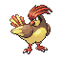Pidgeotto level 32

Golbat level 36
Poliwag level 15
Into Politoed using Sun Stone
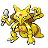Kadabra - level 36
Machop level 20
Machoke level 32
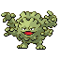Golem level 32
Slowpoke into Slowbro using Water Stone
Into Slowking using Moon Stone
Haunter level 36
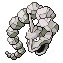Onix level 36
Drowzee level 30
Koffing level 30
Rhyhorn level 36
Chansey level 40
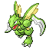Scyther level 36
Horsea level 25
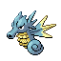Seadra level 40
Goldeen level 28
Eevee into Espeon using Sun Stone
Eevee into Umbreon using Moon Stone
Porygon level 36
Omanyte Level 34
Kabuto Level 34
Dratini level 30
Dragonair level 45
Hoothoot level 25
Pichu level 10
Cleffa level 10
Igglybuff level 10
Togepi level 20
Marill level 22
Wooper level 25
Snubull level 28
Slugma level 25
Swinub level 28
Houndour level 24
Smoochum level 25
Elekid level 25
Magby level 25
Tailow level 25
Shroomish level 25
Baltoy level 30
Feebas level 20 (just like Gyarados)
Trapinch level 25
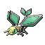Vibrava level 35
Spheal level 22
Sealeo level 36

Azurill level 12
Snorunt level 32
Meditite level 28
Dukull level 30
Loudred level 30

 Clamperl into Huntail using Sun Stone
Clamperl into Gorebyss using Moon Stone

Shuppet level 30
Aron level 25
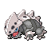Lairon level 36
Bagon level 30
Shelgon level 45
Lileep Level 34

Anorith Level 34

