Министерство образования, науки и молодежной политики
Краснодарского края
Государственное бюджетное профессиональное образовательное учреждение Краснодарского края «Ейский полипрофильный колледж»

РАЗРАБОТКА ПРОГРАММНЫХ МОДУЛЕЙ

ЛАБОРАТОРНАЯ РАБОТА №15
по теме:

Элементы управления списком: ListBox, ComboBox и CheckedListBox. Работа с формами

Выполнил:
студент ЕПК, группа И-31
Сафронов Данил

Проверил:
преподаватель дисциплины «Разработка программных модулей»
Фомин А. Т.

Ейск 2024

1 Цель работы
Изучение способов использования элементов управления и получение навыков по обработке событий.

2 Программа со списками

2.1 Программный код
Листинг 1. Form1.cs
1 using System;
2 using System.Windows.Forms;
3
4 namespace Code
5 {
6 public partial class Form1 : Form
7 {
8 public Form1()
9 {
10 InitializeComponent();
11 }
12
13 private void button1_Click(object sender, EventArgs e)
14 {
15 if (comboBox1.Text.Length != 0)
16 {
17 checkedListBox1.Items.Add(comboBox1.Text);
18 }
19 else MessageBox.Show("Выберите элемент из списка или введите новый");
20 }
21
22 private void button2_Click(object sender, EventArgs e)
23 {
24 while (checkedListBox1.CheckedIndices.Count > 0)
25 checkedListBox1.Items.RemoveAt(checkedListBox1.CheckedIndices[0]);
26 }
27
28 private void button3_Click(object sender, EventArgs e)
29 {
30 checkedListBox1.Sorted = true;
31 }
32 }
33 }
Листинг 2. Form1.Designer.cs
1 using System.Windows.Forms;
2 using System.Drawing;
3 namespace Code
4 {
5 partial class Form1
6 {
7 private System.ComponentModel.IContainer components = null;
8 protected override void Dispose(bool disposing)
9 {
10 if (disposing && (components != null))
11 {
12 components.Dispose();
13 }
14 base.Dispose(disposing);
15 }
16
17 #region Windows Form Designer generated code
18 private void InitializeComponent()
19 {
20 this.groupBox1 = new GroupBox();
21 this.checkedListBox1 = new CheckedListBox();
22 this.comboBox1 = new ComboBox();
23 this.button1 = new Button();
24 this.button2 = new Button();
25 this.button3 = new Button();
26 this.groupBox1.SuspendLayout();
27 this.SuspendLayout();
28 //
29 // groupBox1
30 //
31 this.groupBox1.Controls.Add(this.checkedListBox1);
32 this.groupBox1.Location = new Point(12, 12);
33 this.groupBox1.Name = "groupBox1";
34 this.groupBox1.Size = new Size(200, 113);
35 this.groupBox1.TabIndex = 0;
36 this.groupBox1.TabStop = false;
37 this.groupBox1.Text = "Список участников";
38 //
39 // checkedListBox1
40 //
41 this.checkedListBox1.FormattingEnabled = true;
42 this.checkedListBox1.Location = new Point(39, 21);
43 this.checkedListBox1.Name = "memberList";
44 this.checkedListBox1.Size = new Size(120, 79);
45 this.checkedListBox1.TabIndex = 0;
46 //
47 // comboBox1
48 //
49 this.comboBox1.FormattingEnabled = true;
50 this.comboBox1.Items.AddRange(new object[] {
51 "Коваленко Вальдемар",
52 "Коваль Владислав",
53 "Коленвал Мирослав",
54 "Григорян"});
55 this.comboBox1.Location = new Point(254, 12);
56 this.comboBox1.Name = "peopleList";
57 this.comboBox1.Size = new Size(121, 21);
58 this.comboBox1.TabIndex = 1;
59 //
60 // button1
61 //
62 this.button1.Location = new Point(254, 59);
63 this.button1.Name = "buttonAdd";
64 this.button1.Size = new Size(97, 23);
65 this.button1.TabIndex = 2;
66 this.button1.Text = "Добавить";
67 this.button1.UseVisualStyleBackColor = true;
68 this.button1.Click += new System.EventHandler(this.button1_Click);
69 //
70 // button2
71 //
72 this.button2.Location = new Point(254, 102);
73 this.button2.Name = "buttonDelete";
74 this.button2.Size = new Size(97, 23);
75 this.button2.TabIndex = 3;
76 this.button2.Text = "Удалить";
77 this.button2.UseVisualStyleBackColor = true;
78 this.button2.Click += new System.EventHandler(this.button2_Click);
79 //
80 // button3
81 //
82 this.button3.Location = new Point(254, 149);
83 this.button3.Name = "buttonSort";
84 this.button3.Size = new Size(97, 23);
85 this.button3.TabIndex = 4;
86 this.button3.Text = "Сортировать";
87 this.button3.UseVisualStyleBackColor = true;
88 this.button3.Click += new System.EventHandler(this.button3_Click);
89 //
90 // Form1
91 //
92 this.AutoScaleDimensions = new SizeF(6F, 13F);
93 this.AutoScaleMode = AutoScaleMode.Font;
94 this.ClientSize = new Size(800, 450);
95 this.Controls.Add(this.button3);
96 this.Controls.Add(this.button2);
97 this.Controls.Add(this.button1);
98 this.Controls.Add(this.comboBox1);
99 this.Controls.Add(this.groupBox1);
100 this.FormBorderStyle = FormBorderStyle.Fixed3D;
101 this.Name = "Form1";
102 this.Text = "Form1";
103 this.groupBox1.ResumeLayout(false);
104 this.ResumeLayout(false);
105
106 }
107
108 #endregion
109
110 private GroupBox groupBox1;
111 private CheckedListBox checkedListBox1;
112 private ComboBox comboBox1;
113 private Button button1;
114 private Button button2;
115 private Button button3;
116 }
117 }
118

2.2 Скриншоты

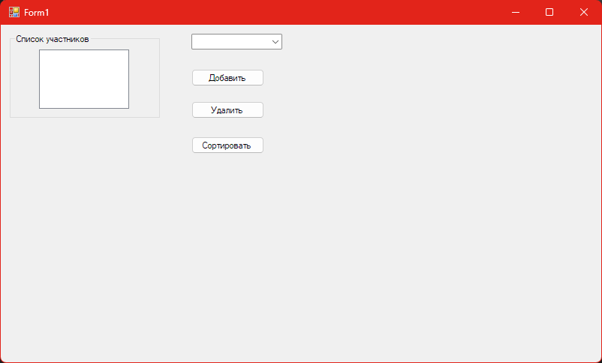Рис. 1: Интерфейс
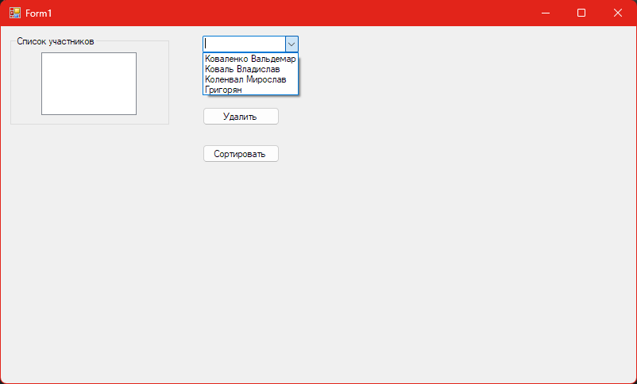Рис. 2: Список участников
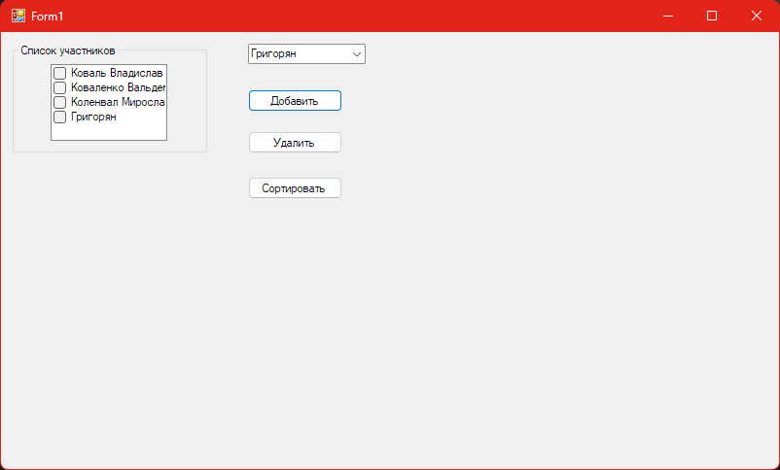Рис. 3: Добавление в список
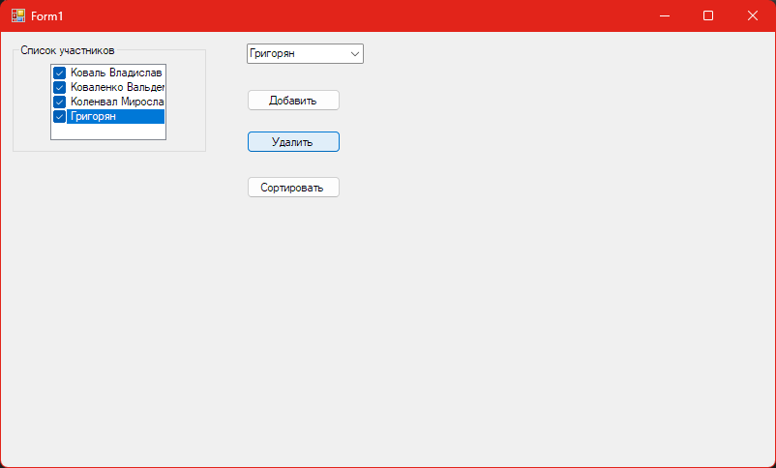Рис. 4: Удаление

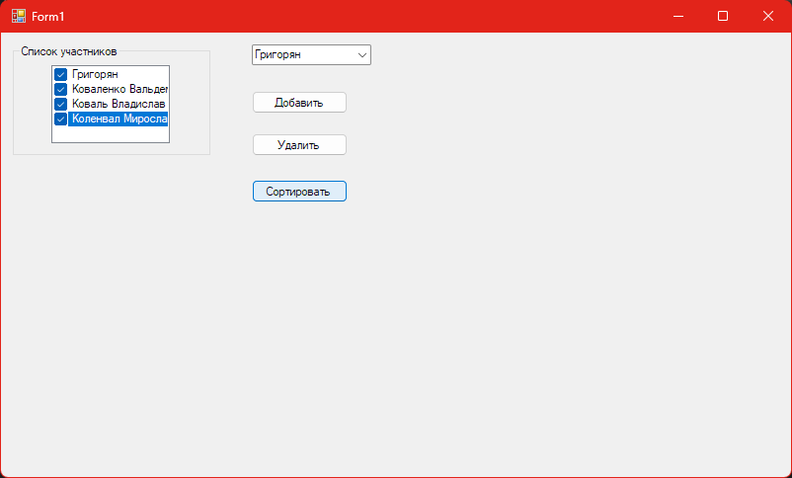Рис. 5: Сортировка

3 Программа с дочерней формой

3.1 Программный код
Листинг 3. ParentForm.cs
1 using System;
2 using System.Windows.Forms;
3
4 namespace MdiApplication
5 {
6 public partial class ParentForm : Form
7 {
8 public ParentForm()
9 {
10 InitializeComponent();
11 }
12
13 private void exitToolStripMenuItem_Click(object sender, EventArgs e)
14 {
15 this.Close();
16 }
17
18 private void cascadeToolStripMenuItem_Click(object sender, EventArgs e)
19 {
20 this.LayoutMdi(MdiLayout.Cascade);
21 }
22
23 private void tileToolStripMenuItem_Click(object sender, EventArgs e)
24 {
25 this.LayoutMdi(MdiLayout.TileHorizontal);
26 }
27
28 private void newToolStripMenuItem_Click(object sender, EventArgs e)
29 {
30 var newChild = new ChildForm();
31 newChild.MdiParent = this;
32 newChild.Show();
33 newChild.Text = newChild.Text + " " + ++openDocuments;
34 }
35 }
36 }
Листинг 4. ParentForm.Designer.cs
1 using System.Windows.Forms;
2 namespace MdiApplication
3 {
4 partial class ParentForm
5 {
6 private System.ComponentModel.IContainer components = null;
7
8 protected override void Dispose(bool disposing)
9 {
10 if (disposing && (components != null))
11 {
12 components.Dispose();
13 }
14 base.Dispose(disposing);
15 }
16
17 #region Windows Form Designer generated code
18
19 /// <summary>
20 /// Required method for Designer support - do not modify
21 /// the contents of this method with the code editor.
22 /// </summary>
23 private void InitializeComponent()
24 {
25 this.menuStrip1 = new MenuStrip();
26 this.fileToolStripMenuItem = new ToolStripMenuItem();
27 this.newToolStripMenuItem = new ToolStripMenuItem();
28 this.exitToolStripMenuItem = new ToolStripMenuItem();
29 this.windowToolStripMenuItem = new ToolStripMenuItem();
30 this.cascadeToolStripMenuItem = new ToolStripMenuItem();
31 this.tileToolStripMenuItem = new ToolStripMenuItem();
32 this.menuStrip1.SuspendLayout();
33 this.SuspendLayout();
34 //
35 // menuStrip1
36 //
37 this.menuStrip1.Items.AddRange(new ToolStripItem[] {
38 this.fileToolStripMenuItem,
39 this.windowToolStripMenuItem});
40 this.menuStrip1.Location = new System.Drawing.Point(0, 0);
41 this.menuStrip1.Name = "menuStrip1";
42 this.menuStrip1.Size = new System.Drawing.Size(800, 24);
43 this.menuStrip1.TabIndex = 1;
44 this.menuStrip1.Text = "menuStrip1";
45 //
46 // fileToolStripMenuItem
47 //
48 this.fileToolStripMenuItem.DropDownItems.AddRange(new ToolStripItem[] {
49 this.newToolStripMenuItem,
50 this.exitToolStripMenuItem});
51 this.fileToolStripMenuItem.Name = "fileToolStripMenuItem";
52 this.fileToolStripMenuItem.Size = new System.Drawing.Size(37, 20);
53 this.fileToolStripMenuItem.Text = "File";
54 //
55 // newToolStripMenuItem
56 //
57 this.newToolStripMenuItem.Name = "newToolStripMenuItem";
58 this.newToolStripMenuItem.Size = new System.Drawing.Size(180, 22);
59 this.newToolStripMenuItem.Text = "New";
60 this.newToolStripMenuItem.Click += new System.EventHandler(this.newToolStripMenuItem_Click);
61 //
62 // exitToolStripMenuItem
63 //
64 this.exitToolStripMenuItem.Name = "exitToolStripMenuItem";
65 this.exitToolStripMenuItem.Size = new System.Drawing.Size(98, 22);
66 this.exitToolStripMenuItem.Text = "Exit";
67 this.exitToolStripMenuItem.Click += new System.EventHandler(this.exitToolStripMenuItem_Click);
68 //
69 // windowToolStripMenuItem
70 //
71 this.windowToolStripMenuItem.DropDownItems.AddRange(new ToolStripItem[] {
72 this.cascadeToolStripMenuItem,
73 this.tileToolStripMenuItem});
74 this.windowToolStripMenuItem.Name = "windowToolStripMenuItem";
75 this.windowToolStripMenuItem.Size = new System.Drawing.Size(63, 20);
76 this.windowToolStripMenuItem.Text = "Window";
77 //
78 // cascadeToolStripMenuItem
79 //
80 this.cascadeToolStripMenuItem.Name = "cascadeToolStripMenuItem";
81 this.cascadeToolStripMenuItem.Size = new System.Drawing.Size(180, 22);
82 this.cascadeToolStripMenuItem.Text = "Cascade";
83 this.cascadeToolStripMenuItem.Click += new System.EventHandler(this.cascadeToolStripMenuItem_Click);
84 //
85 // tileToolStripMenuItem
86 //
87 this.tileToolStripMenuItem.Name = "tileToolStripMenuItem";
88 this.tileToolStripMenuItem.Size = new System.Drawing.Size(180, 22);
89 this.tileToolStripMenuItem.Text = "Tile";
90 this.tileToolStripMenuItem.Click += new System.EventHandler(this.tileToolStripMenuItem_Click);
91 //
92 // ParentForm
93 //
94 this.AutoScaleDimensions = new System.Drawing.SizeF(6F, 13F);
95 this.AutoScaleMode = System.Windows.Forms.AutoScaleMode.Font;
96 this.ClientSize = new System.Drawing.Size(800, 450);
97 this.Controls.Add(this.menuStrip1);
98 this.IsMdiContainer = true;
99 this.MainMenuStrip = this.menuStrip1;
100 this.Name = "ParentForm";
101 this.Text = "Parent Form";
102 this.menuStrip1.ResumeLayout(false);
103 this.menuStrip1.PerformLayout();
104 this.ResumeLayout(false);
105 this.PerformLayout();
106
107 }
108
109 #endregion
110
111 private MenuStrip menuStrip1;
112 private ToolStripMenuItem fileToolStripMenuItem;
113 private ToolStripMenuItem newToolStripMenuItem;
114 private ToolStripMenuItem exitToolStripMenuItem;
115 private ToolStripMenuItem windowToolStripMenuItem;
116 private ToolStripMenuItem cascadeToolStripMenuItem;
117 private ToolStripMenuItem tileToolStripMenuItem;
118 private int openDocuments = 0;
119 }
120 }
121
Листинг 5. ChildForm.cs
1 using System;
2 using System.Windows.Forms;
3
4 namespace MdiApplication
5 {
6 public partial class ChildForm : Form
7 {
8 public ChildForm()
9 {
10 InitializeComponent();
11 }
12
13 private void toggleForegroundToolStripMenuItem_Click(object sender, EventArgs e)
14 {
15 if (toggleForegroundToolStripMenuItem.Checked)
16 {
17 toggleForegroundToolStripMenuItem.Checked = false;
18 richTextBox1.ForeColor = System.Drawing.Color.Black;
19 }
20 else
21 {
22 toggleForegroundToolStripMenuItem.Checked = true;
23 richTextBox1.ForeColor = System.Drawing.Color.Blue;
24 }
25 }
26 }
27 }
Листинг 6. ChildForm.Designer.cs
1 using System.Windows.Forms;
2 namespace MdiApplication
3 {
4 partial class ChildForm
5 {
6 private System.ComponentModel.IContainer components = null;
7
8 protected override void Dispose(bool disposing)
9 {
10 if (disposing && (components != null))
11 {
12 components.Dispose();
13 }
14 base.Dispose(disposing);
15 }
16
17 #region Windows Form Designer generated code
18
19 /// <summary>
20 /// Required method for Designer support - do not modify
21 /// the contents of this method with the code editor.
22 /// </summary>
23 private void InitializeComponent()
24 {
25 this.richTextBox1 = new RichTextBox();
26 this.menuStrip1 = new MenuStrip();
27 this.formatToolStripMenuItem = new ToolStripMenuItem();
28 this.toggleForegroundToolStripMenuItem = new ToolStripMenuItem();
29 this.menuStrip1.SuspendLayout();
30 this.SuspendLayout();
31 //
32 // richTextBox1
33 //
34 this.richTextBox1.Dock = System.Windows.Forms.DockStyle.Fill;
35 this.richTextBox1.Location = new System.Drawing.Point(0, 24);
36 this.richTextBox1.Name = "ChildTextBox";
37 this.richTextBox1.Size = new System.Drawing.Size(800, 426);
38 this.richTextBox1.TabIndex = 0;
39 this.richTextBox1.Text = "";
40 //
41 // menuStrip1
42 //
43 this.menuStrip1.Items.AddRange(new ToolStripItem[] {
44 this.formatToolStripMenuItem});
45 this.menuStrip1.Location = new System.Drawing.Point(0, 0);
46 this.menuStrip1.Name = "ChildWindowMenu";
47 this.menuStrip1.Size = new System.Drawing.Size(800, 24);
48 this.menuStrip1.TabIndex = 1;
49 this.menuStrip1.Text = "menuStrip1";
50 //
51 // formatToolStripMenuItem
52 //
53 this.formatToolStripMenuItem.DropDownItems.AddRange(new ToolStripItem[] {
54 this.toggleForegroundToolStripMenuItem});
55 this.formatToolStripMenuItem.MergeAction = System.Windows.Forms.MergeAction.Insert;
56 this.formatToolStripMenuItem.MergeIndex = 1;
57 this.formatToolStripMenuItem.Name = "FormatMenuItem";
58 this.formatToolStripMenuItem.Size = new System.Drawing.Size(57, 20);
59 this.formatToolStripMenuItem.Text = "Format";
60 //
61 // toggleForegroundToolStripMenuItem
62 //
63 this.toggleForegroundToolStripMenuItem.Name = "ToggleMenuItem";
64 this.toggleForegroundToolStripMenuItem.Size = new System.Drawing.Size(180, 22);
65 this.toggleForegroundToolStripMenuItem.Text = "Toggle foreground";
66 this.toggleForegroundToolStripMenuItem.Click += new System.EventHandler(this.toggleForegroundToolStripMenuItem_Click);
67 //
68 // ChildForm
69 //
70 this.AutoScaleDimensions = new System.Drawing.SizeF(6F, 13F);
71 this.AutoScaleMode = System.Windows.Forms.AutoScaleMode.Font;
72 this.ClientSize = new System.Drawing.Size(800, 450);
73 this.Controls.Add(this.richTextBox1);
74 this.Controls.Add(this.menuStrip1);
75 this.MainMenuStrip = this.menuStrip1;
76 this.Name = "ChildForm";
77 this.Text = "ChildForm";
78 this.menuStrip1.ResumeLayout(false);
79 this.menuStrip1.PerformLayout();
80 this.ResumeLayout(false);
81 this.PerformLayout();
82
83 }
84
85 #endregion
86
87 private RichTextBox richTextBox1;
88 private MenuStrip menuStrip1;
89 private ToolStripMenuItem formatToolStripMenuItem;
90 private ToolStripMenuItem toggleForegroundToolStripMenuItem;
91 }
92 }

3.2 Скриншоты
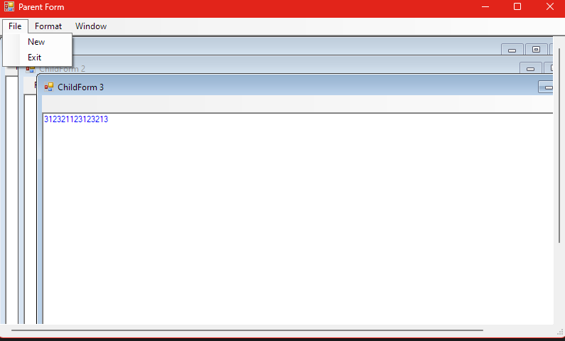Рис. 6: Интерфейс с уже созданными дочерними формами и измененным цветом текста
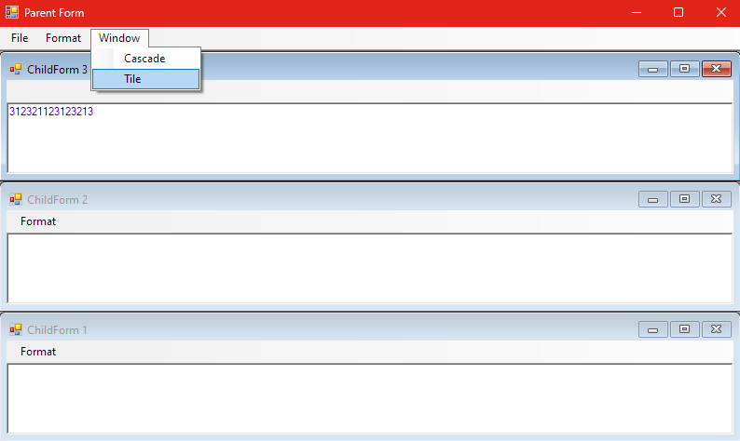Рис. 7: Tile View

4 Программа по дополнительному заданию №1

4.1 Программный код
Листинг 7. Form1.cs
1 using System.Drawing;
2 using System.Windows.Forms;
3 using System;
4
5 namespace Ellipse
6 {
7 public partial class Form1 : Form
8 {
9 public Form1()
10 {
11 InitializeComponent();
12 this.FormBorderStyle = FormBorderStyle.None;
13 this.BackColor = Color.White;
14 var button1 = new Button();
15 button1.Click += button1_Click;
16 this.Controls.Add(button1);
17 this.Load += Form1_Load;
18 }
19
20 private void Form1_Load(object sender, EventArgs e)
21 {
22 System.Drawing.Drawing2D.GraphicsPath myPath = new System.Drawing.Drawing2D.GraphicsPath();
23 myPath.AddEllipse(0, 0, this.Width, this.Height);
24 Region myRegion = new Region(myPath);
25 this.Region = myRegion;
26 }
27
28 private void button1_Click(object sender, EventArgs e)
29 {
30 this.Close();
31 }
32 }
33 }
Листинг 8. Form1.Designer.cs
1 using System.Windows.Forms;
2
3 namespace Ellipse
4 {
5 partial class Form1
6 {
7 private System.ComponentModel.IContainer components = null;
8 protected override void Dispose(bool disposing)
9 {
10 if (disposing && (components != null))
11 {
12 components.Dispose();
13 }
14 base.Dispose(disposing);
15 }
16
17 #region Windows Form Designer generated code
18 private void InitializeComponent()
19 {
20 this.button1 = new System.Windows.Forms.Button();
21 this.SuspendLayout();
22 //
23 // button1
24 //
25 this.button1.Location = new System.Drawing.Point(450, 350);
26 this.button1.Name = "button1";
27 this.button1.Size = new System.Drawing.Size(75, 23);
28 this.button1.TabIndex = 0;
29 this.button1.Text = "Exit";
30 this.button1.UseVisualStyleBackColor = true;
31 this.button1.Click += new System.EventHandler(this.button1_Click);
32 //
33 // Form1
34 //
35 this.AutoScaleDimensions = new System.Drawing.SizeF(6F, 13F);
36 this.AutoScaleMode = System.Windows.Forms.AutoScaleMode.Font;
37 this.ClientSize = new System.Drawing.Size(1036, 607);
38 this.Controls.Add(this.button1);
39 this.FormBorderStyle = System.Windows.Forms.FormBorderStyle.None;
40 this.Name = "Form1";
41 this.Text = "Form1";
42 this.ResumeLayout(false);
43
44 }
45
46 #endregion
47
48 private Button button1;
49 }
50 }

4.2 Скриншоты
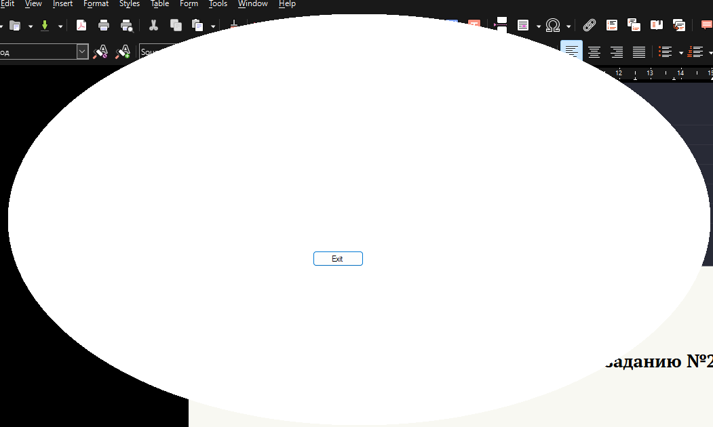Рис. 8: Интерфейс

5 Программа по дополнительному заданию №2

5.1 Программный код
Листинг 9. StartForm.cs
1 using System.Windows.Forms;
2 using System;
3
4 namespace Romb
5 {
6 public partial class StartForm : Form
7 {
8 public StartForm()
9 {
10 InitializeComponent();
11 }
12
13 private void button1_Click(object sender, EventArgs e)
14 {
15 Romb romb = new Romb();
16 romb.Show(this);
17 }
18 }
19 }
Листинг 10. StartForm.Designer.cs
1 using static System.Net.Mime.MediaTypeNames;
2 using System.Drawing;
3 using System.Windows.Forms;
4 using System.Xml.Linq;
5
6 namespace Romb
7 {
8 partial class StartForm
9 {
10 private System.ComponentModel.IContainer components = null;
11 protected override void Dispose(bool disposing)
12 {
13 if (disposing && (components != null))
14 {
15 components.Dispose();
16 }
17 base.Dispose(disposing);
18 }
19
20 #region Windows Form Designer generated code
21
22 private void InitializeComponent()
23 {
24 button1 = new Button();
25 SuspendLayout();
26 //
27 // button1
28 //
29 button1.Location = new Point(322, 167);
30 button1.Name = "button1";
31 button1.Size = new Size(163, 37);
32 button1.TabIndex = 0;
33 button1.Text = "Click me";
34 button1.UseVisualStyleBackColor = true;
35 button1.Click += button1_Click;
36 //
37 // StartForm
38 //
39 AutoScaleDimensions = new SizeF(7F, 15F);
40 AutoScaleMode = AutoScaleMode.Font;
41 ClientSize = new Size(800, 450);
42 Controls.Add(button1);
43 Name = "StartForm";
44 Text = "Start Form";
45 ResumeLayout(false);
46 }
47
48 #endregion
49
50 private Button button1;
51 }
52 }
Листинг 11. Romb.cs
1 using System;
2 using System.Drawing;
3 using System.Drawing.Drawing2D;
4 using System.Windows.Forms;
5
6 namespace Romb
7 {
8 public partial class Romb : Form
9 {
10 public Romb()
11 {
12 InitializeComponent();
13 this.FormBorderStyle = FormBorderStyle.None;
14 this.BackColor = Color.Green;
15 button1.Click += button1_Click;
16 this.Controls.Add(button1);
17 this.Load += Form1_Load;
18 }
19
20 private void Form1_Load(object sender, EventArgs e)
21 {
22 this.BackColor = Color.Yellow;
23 using (GraphicsPath myPath = new GraphicsPath())
24 {
25 myPath.AddLines(new[]
26 {
27 new Point(0, this.Height/2),
28 new Point(this.Width/2, 0),
29 new Point(this.Width, this.Height/2),
30 new Point(this.Width/2, this.Height)
31 });
32 Region = new Region(myPath);
33 }
34 }
35
36 private void button1_Click(object sender, EventArgs e)
37 {
38 this.Close();
39 }
40 }
41 }
Листинг 12. Romb.Designer.cs
1 using System.Drawing;
2 using System.Windows.Forms;
3
4 namespace Romb
5 {
6 partial class Romb
7 {
8 private System.ComponentModel.IContainer components = null;
9
10 protected override void Dispose(bool disposing)
11 {
12 if (disposing && (components != null))
13 {
14 components.Dispose();
15 }
16 base.Dispose(disposing);
17 }
18
19 #region Windows Form Designer generated code
20
21 private void InitializeComponent()
22 {
23 this.button1 = new Button();
24 this.SuspendLayout();
25 //
26 // button1
27 //
28 this.button1.Location = new System.Drawing.Point(300, 150);
29 this.button1.Name = "button1";
30 this.button1.Size = new System.Drawing.Size(100, 40);
31 this.button1.TabIndex = 0;
32 this.button1.Text = "Close";
33 this.button1.UseVisualStyleBackColor = true;
34 this.button1.Click += new System.EventHandler(this.button1_Click);
35 //
36 // Romb
37 //
38 this.AutoScaleDimensions = new System.Drawing.SizeF(6F, 13F);
39 this.AutoScaleMode = System.Windows.Forms.AutoScaleMode.Font;
40 this.ClientSize = new System.Drawing.Size(714, 410);
41 this.Controls.Add(this.button1);
42 this.Name = "Romb";
43 this.Text = "Form2";
44 this.ResumeLayout(false);
45 }
46
47 #endregion
48
49 private Button button1;
50 }
51 }

5.2 Скриншоты
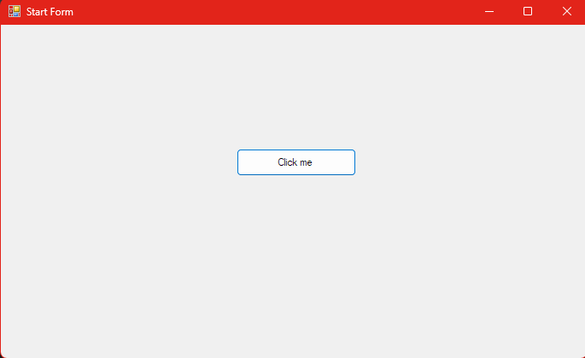Рис. 9: Интерфейс
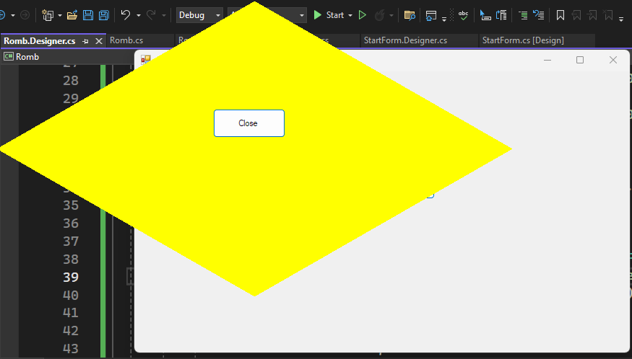Рис. 10: Ромб

6 Вывод
В результате выполнения данной лабораторной работы, я создал 2 приложения с помощью Windows Forms на языке программирования C#. Код обоих приложений приведен в листингах 1, 2, 3, 4, 5, 6. После кода есть скриншоты, на которых изображен интерфейс и функционал созданных приложений. Рекомендации по улучшению приложения: расширить выбор расположения дочерних форм в форме.

