Министерство образования, науки и молодежной политики
Краснодарского края
Государственное бюджетное профессиональное образовательное учреждение Краснодарского края «Ейский полипрофильный колледж»

РАЗРАБОТКА СИСТЕМНОЕ ПРОГРАММИРОВАНИЕ

ЛАБОРАТОРНАЯ РАБОТА №2
по теме:

Асинхронное программирование

в Windows Forms

Выполнил:
студент ЕПК, группа И-31
Сафронов Данил

Проверил:
преподаватель дисциплины «Системое прораммирование»
Фомин А. Т.

Ейск 2024

1 Цель работы
Изучение возможностей, реализующих асинхронное программирование и получение навыков по работе в программе с потоками.

2 Программный код
Листинг 1. Form1.cs
1 using System.Windows.Forms;
2 using System.Drawing;
3 using System;
4
5 namespace Code
6 {
7 public partial class Form1 : Form
8 {
9 public Form1()
10 {
11 InitializeComponent();
12 }
13 public delegate void SetProgressDelegate(int val);
14 public void SetProgress(int val)
15 {
16 if (progressBar1.InvokeRequired)
17 {
18 SetProgressDelegate del = new
19 SetProgressDelegate(SetProgress);
20 this.Invoke(del, new object[] { val });
21 }
22 else
23 {
24 progressBar1.Value = val;
25 }
26 }
27 private delegate void TimeConsumingMethodDelegate(int seconds);
28 private void TimeConsumingMethod(int seconds)
29 {
30 for (int j = 1; j <= seconds; j++)
31 {
32 System.Threading.Thread.Sleep(1000);
33 SetProgress((int)(j * 100) / seconds);
34 if (Cancel) break;
35 }
36 if (Cancel)
37 {
38 MessageBox.Show("Cancelled");
39 Cancel = false;
40 }
41 else
42 {
43 MessageBox.Show("Complete");
44 }
45 }
46 #region Listeners
47 public void TextBox1_KeyPress(object sender, KeyPressEventArgs e)
48 {
49 if (!char.IsDigit(e.KeyChar))
50 {
51 e.Handled = true;
52 MessageBox.Show("Поле должно содержать цифры");
53 }
54 }
55 private void button1_Click(object sender, EventArgs e)
56 {
57 if (!(textBox1.Text == ""))
58 {
59 int i = int.Parse(textBox1.Text);
60 backgroundWorker1.RunWorkerAsync(i);
61 }
62 var del = new TimeConsumingMethodDelegate(TimeConsumingMethod);
63 del.BeginInvoke(int.Parse(textBox1.Text), null, null);
64 }
65 public void button2_Click(object sender, EventArgs e)
66 {
67 Cancel = true;
68 backgroundWorker1.CancelAsync();
69 }
70
71 private void backgroundWorker1_DoWork(object sender, System.ComponentModel.DoWorkEventArgs e)
72 {
73 int i;
74 i = int.Parse(e.Argument.ToString());
75 for (int j = 1; j <= i; j++)
76 {
77 if (backgroundWorker1.CancellationPending)
78 {
79 e.Cancel = true;
80 return;
81 }
82 System.Threading.Thread.Sleep(1000);
83 backgroundWorker1.ReportProgress((int)(j * 100 / i));
84 }
85 }
86
87 private void backgroundWorker1_ProgressChanged(object sender, System.ComponentModel.ProgressChangedEventArgs e)
88 {
89 progressBar1.Value = e.ProgressPercentage;
90 }
91
92 private void backgroundWorker1_RunWorkerCompleted(object sender, System.ComponentModel.RunWorkerCompletedEventArgs e)
93 {
94 if (!(e.Cancelled))
95 MessageBox.Show("Run Completed!");
96 else
97 MessageBox.Show("Run Cancelled");
98 }
99 #endregion
100
101 }
102 }
Листинг 2. Form1.Designer.cs
1 using System.Drawing;
2 using System.Windows.Forms;
3
4 namespace Code
5 {
6 partial class Form1
7 {
8 private System.ComponentModel.IContainer components = null;
9
10 /// <summary>
11 /// Clean up any resources being used.
12 /// </summary>
13 /// <param name="disposing">true if managed resources should be disposed; otherwise, false.</param>
14 protected override void Dispose(bool disposing)
15 {
16 if (disposing && (components != null))
17 {
18 components.Dispose();
19 }
20 base.Dispose(disposing);
21 }
22
23 #region Windows Form Designer generated code
24
25 /// <summary>
26 /// Required method for Designer support - do not modify
27 /// the contents of this method with the code editor.
28 /// </summary>
29 private void InitializeComponent()
30 {
31 this.components = new System.ComponentModel.Container();
32 this.contextMenuStrip1 = new System.Windows.Forms.ContextMenuStrip(this.components);
33 this.backgroundWorker1 = new System.ComponentModel.BackgroundWorker();
34 this.progressBar1 = new System.Windows.Forms.ProgressBar();
35 this.label1 = new System.Windows.Forms.Label();
36 this.textBox1 = new System.Windows.Forms.TextBox();
37 this.button1 = new System.Windows.Forms.Button();
38 this.button2 = new System.Windows.Forms.Button();
39 this.label2 = new System.Windows.Forms.Label();
40 this.SuspendLayout();
41 //
42 // contextMenuStrip1
43 //
44 this.contextMenuStrip1.Name = "contextMenuStrip1";
45 this.contextMenuStrip1.Size = new System.Drawing.Size(61, 4);
46 //
47 // backgroundWorker1
48 //
49 this.backgroundWorker1.WorkerReportsProgress = true;
50 this.backgroundWorker1.WorkerSupportsCancellation = true;
51 this.backgroundWorker1.DoWork += new System.ComponentModel.DoWorkEventHandler(this.backgroundWorker1_DoWork);
52 this.backgroundWorker1.ProgressChanged += new System.ComponentModel.ProgressChangedEventHandler(this.backgroundWorker1_ProgressChanged);
53 this.backgroundWorker1.RunWorkerCompleted += new System.ComponentModel.RunWorkerCompletedEventHandler(this.backgroundWorker1_RunWorkerCompleted);
54 //
55 // progressBar1
56 //
57 this.progressBar1.Location = new System.Drawing.Point(110, 40);
58 this.progressBar1.Name = "progressBar1";
59 this.progressBar1.Size = new System.Drawing.Size(240, 20);
60 this.progressBar1.TabIndex = 3;
61 //
62 // label1
63 //
64 this.label1.AutoSize = true;
65 this.label1.Location = new System.Drawing.Point(10, 15);
66 this.label1.Name = "label1";
67 this.label1.Size = new System.Drawing.Size(89, 13);
68 this.label1.TabIndex = 0;
69 this.label1.Text = "Seconds to sleep";
70 //
71 // textBox1
72 //
73 this.textBox1.Location = new System.Drawing.Point(105, 13);
74 this.textBox1.Name = "textBox1";
75 this.textBox1.Size = new System.Drawing.Size(80, 20);
76 this.textBox1.TabIndex = 1;
77 this.textBox1.KeyPress += new System.Windows.Forms.KeyPressEventHandler(this.TextBox1_KeyPress);
78 //
79 // button1
80 //
81 this.button1.Location = new System.Drawing.Point(195, 12);
82 this.button1.Name = "button1";
83 this.button1.Size = new System.Drawing.Size(75, 25);
84 this.button1.TabIndex = 4;
85 this.button1.Text = "Start";
86 this.button1.UseVisualStyleBackColor = true;
87 this.button1.Click += new System.EventHandler(this.button1_Click);
88 //
89 // button2
90 //
91 this.button2.Location = new System.Drawing.Point(270, 12);
92 this.button2.Name = "button2";
93 this.button2.Size = new System.Drawing.Size(75, 25);
94 this.button2.TabIndex = 5;
95 this.button2.Text = "Cancel";
96 this.button2.UseVisualStyleBackColor = true;
97 this.button2.Click += new System.EventHandler(this.button2_Click);
98 //
99 // label2
100 //
101 this.label2.AutoSize = true;
102 this.label2.Location = new System.Drawing.Point(10, 40);
103 this.label2.Name = "label2";
104 this.label2.Size = new System.Drawing.Size(48, 13);
105 this.label2.TabIndex = 6;
106 this.label2.Text = "Progress";
107 //
108 // Form1
109 //
110 this.AutoScaleDimensions = new System.Drawing.SizeF(6F, 13F);
111 this.AutoScaleMode = System.Windows.Forms.AutoScaleMode.Font;
112 this.ClientSize = new System.Drawing.Size(685, 358);
113 this.Controls.Add(this.label2);
114 this.Controls.Add(this.button2);
115 this.Controls.Add(this.button1);
116 this.Controls.Add(this.progressBar1);
117 this.Controls.Add(this.textBox1);
118 this.Controls.Add(this.label1);
119 this.Name = "Form1";
120 this.Text = "Form1";
121 this.ResumeLayout(false);
122 this.PerformLayout();
123
124 }
125
126 #endregion
127 bool Cancel;
128 private ContextMenuStrip contextMenuStrip1;
129 private System.ComponentModel.BackgroundWorker backgroundWorker1;
130 private ProgressBar progressBar1;
131 private Label label1;
132 private TextBox textBox1;
133 private Button button1;
134 private Button button2;
135 private Label label2;
136 }
137 }

3 Скриншоты

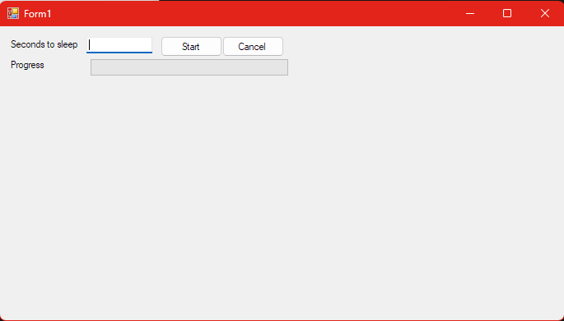Рис. 1: Интерфейс
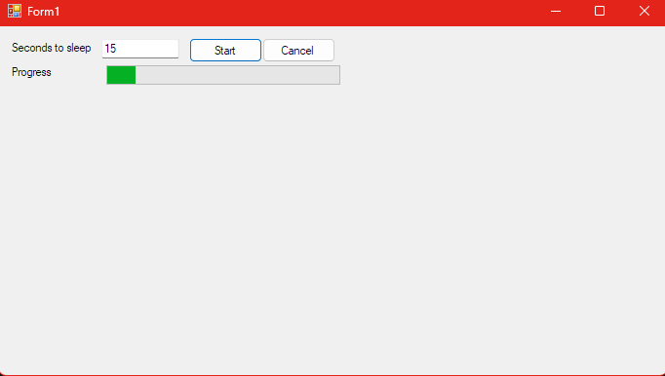Рис. 2: Прогресс выполнения

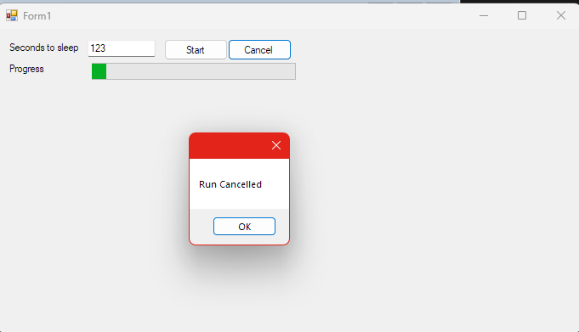Рис. 3: Отмена выполнения
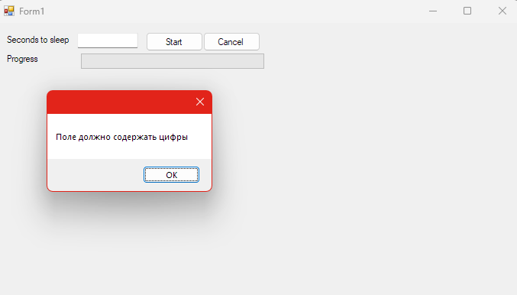Рис. 4: Обработка исключительной ситуации при вводе символов

