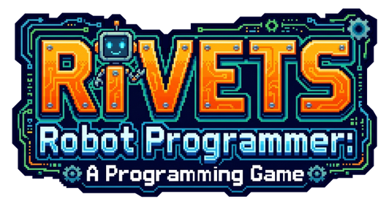
GAME DESIGN DOCUMENT
University of Macedonia
Department of Applied Informatics
M.Sc. in Software Development & Cloud
Serious Game Design & Development, Summer Semester
Archontis E. Kostis - mai26037@uom.edu.gr
June 2026
Built with Greenfoot
Source Code: github.com/ArchontisKostis/codebot-maze-serious-game

Permission to share project with other students | YES

Table of Contents
1. Introduction 3
1.1 Game at a glance 3
2. Reference Points & Backround 3
3. Audience, Goals and Expected Benefits 4
3.1 Target audience 4
3.2 Learning objectives and content 4
3.3 Expected benefits and learning outcomes 4
4. Design Approach 5
4.1 Framework: CMX 5
4.2 Learning strategy and scaffolding 5
4.3 Key design decisions 6
5. Narrative and Game World 6
5.1 Premise 6
5.2 Characters 7
5.3 Story arc 7
6. Gameplay, Rules and the Robot Script Language 7
6.1 The core loop 7
6.2 The Robot Script Language (RSL) 8
6.3 Controls 8
6.4 Objectives, win and fail 8
6.5 Rules summary 8
7. Progression, Scoring and Rewards 9
7.1 Scoring model 9
7.3 Final classification 9
7.4 Progress and free play 10
8. User Interface and Audio 10
8.1 Screen layout 10
8.2 Audio 11
9. Technical Architecture and Implementation 11
9.1 Technologies 11
9.2 Subsystems 11
9.3 The language pipeline 12
9.4 Developer and Instructor Cheats 12
10. The Level Editor 13
11. Evaluation Plan 13
11.2 Sample questionnaire 14
Appendix A: Code Inventory 14
Appendix B: Robot Script grammar (full) 16

1. Introduction
“RIVETS: Robot Programmer” is a serious game whose purpose is education, specifically, teaching the foundations of imperative programming and computational thinking to learners with little to no prior coding experience. The game teaches the basics of programming through play, as the player writes short programs to guide a robot through 15 maze chambers, using a custom programming language.
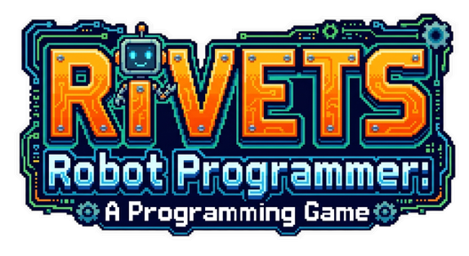
Figure 1. Game Logo

1.1 Game at a glance
Attribute | Value
Title | RIVETS: Robot Programmer
Purpose | Teach the foundations of programming and computational thinking
Genre | 2D top-down, tile-based puzzle / coding game
Content | A custom-made imperative language (four move commands + counted loops), 15 built-in chambers, plus a free-play / custom-level mode
Platform | Desktop (Windows, macOS, Linux)
Technologies | Java & Greenfoot

2. Reference Points & Backround
Most games that teach programming fall into two categories: block-based, where pre-made blocks are snapped together like puzzle pieces, and text-based, where the learner writes real code [1]. Project Rivets falls in the second category, the table bellow compares our game with the best-known ones, including those used in Greek schools.
Tool | What it is | Relation to Project Rivets
Block-based tools
Scratch (MIT) | A block-based environment for roughly ages 10-18: programs, stories and games are built by snapping puzzle-piece blocks together. | Keeps Scratch's low-friction visual spirit but replaces blocks with typed text.
Blockly, Code.org Maze, Lightbot | Block- or icon-based maze puzzles: assemble a short sequence to move a character to a goal. | As with Scratch, the blocks are replaced with a real typed language, run by a lexer-parser-interpreter pipeline.
Text-based tools
Karel the Robot | A robot on a grid driven by a small imperative language. | The closest relative. Project Rivets embeds the editor, terminal and robot in one game and adds a story plus a star/abstraction score that also grades code quality and not just completion.
MicroWorlds Pro | A Logo/turtle microworld used in schools (including Greece) for teachiing programming. | Shares the idea of controlling an agent in a microworld, but is puzzle and goal driven with an explicit objective rather than open turtle drawing.

3. Audience, Goals and Expected Benefits

3.1 Target audience
Dimension | Description
Age | 8 and over. Aimed mainly at school students. Also suitable for anyone older who is new to programming.
Prior knowledge | None assumed. Every concept and keyword is introduced from zero. There is no programming toolchain to install and no syntax to know in advance.
Gender / culture | Gender-neutral. The robotics lab setting and abstract puzzles carry no gendered or culturally specific assumptions. All in-game text is in clear, simple English.
Context of use | Self-directed play at home, or guided use in a classroom or lab as a first taste of programming. Fully offline.
Also useful for | Teachers who want a low-friction way to show sequencing, loops and debugging and who can build their own mazes with the level editor.

3.2 Learning objectives and content
The overall goal of the game is to take a complete beginner and, through the game, lead them to write and reason about real programs. The content is delivered in four groups of increasing abstraction (sequencing, then counted iteration, then nested iteration).
Level group | What the player learns
Group A: Command Discovery (Chambers 1-4) | That a program is an explicit, ordered sequence of instructions executed literally + the four movement commands.
Group B: Sequencing Mastery (Chambers 5-7) | Composing longer multi-direction routes and planning ahead (decomposition and algorithm design)
Group C: Loop Introduction  (Chambers 8-10) | Spotting repetition and expressing it with repeat(N) … end (loop is a cleaner alternative of a repeated sequence)
Group D: Structural Reasoning (Chambers 11-15) | Seeing two-dimensional regularity, using nested loops, and judging when a loop fits and when sequential code is still needed

3.3 Expected benefits and learning outcomes
After finishing the campaign, a player should be able to:
- read a problem (a maze) and break it down into an ordered sequence of explicit steps.
- write, run and debug a real program, reading plain-language error messages and fixing them.
- spot repetition and express it with a counted loop instead of repeating commands by hand.
- use nested loops to capture two-dimensional, structured patterns.

4. Design Approach

4.1 Framework: CMX
The game's design is based on CMX [2], a framework created specifically for educational programming games.
CMX concern | How Project Rivets addresses it
Learning objectives | Teach programming and computational thinking, with concrete per-group goals.
Pedagogy / strategy | Problem-based: every chamber is solved by building a program.
Learning content | Sequencing, then counted iteration, then nested iteration, across 15 chambers.
Scenario & characters | A researcher trains the robot RIVETS, with narration.
Virtual world | A 960×720 simulation-lab interface with a 24×20 tile maze.
Programming editor | An in-game code editor with syntax highlighting and a live terminal.
Language & compiler | A real Robot Script Language run by full a lexer, parser and interpreter pipeline.
Scaffolding | Command unlocks, onboarding overlays, intro pop-ups, and plain-English errors.
Awards & incentives | Coins, a 0-3 star rating per level (chamber) and a final classification.
Reflection & evaluation | A star overview, the terminal trace for players, and an evaluation plan for the serious game.

4.2 Learning strategy and scaffolding
The approach is problem-based: each chamber is a problem whose only solution is a working program, so the player learns by building rather than being told. The core idea is that the robot does exactly as is told (what the program says), and not what the player “meant”. A lesson players absorb the first time the robot walks straight into a wall. Support for beginners is built into the game progression:
- Commands unlock one at a time: moveRight first, then moveDown, and repeat at last. This is so the language never arrives all at once to the player.
- An onboarding overlay walks new players through the editor, the RUN/RESET buttons and the terminal.
- Each chamber opens with a short intro pop-up: the story, the available commands with one example, and an objective.
- Errors are written in plain English, naming the line and the problem (e.g. “Line 3: Expected 'end' to close repeat(8)”), so mistakes are a lesson rather than a wall.
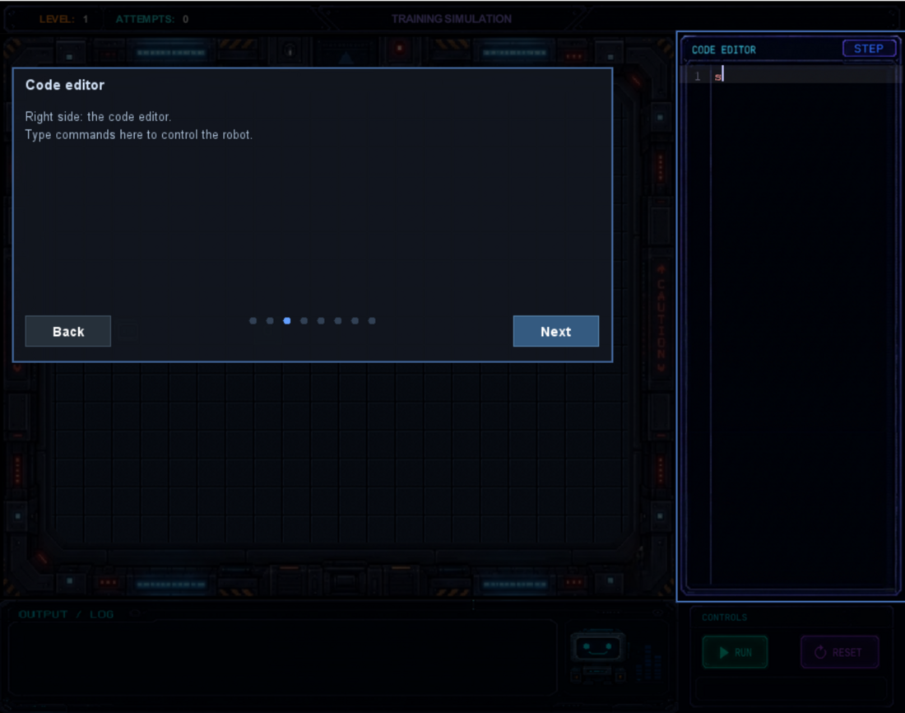
Figure 2. First-run onboarding spotlights each region of the screen in turn.

4.3 Key design decisions
Decision | Why
Typed text, not drag-and-drop blocks | Players write and read real code, so the skill transfers to actual programming.
A tiny six-keyword language | Mastery is reachable and cognitive load stays very low. Players can memorize the whole language in under a minute.
A real lexer-parser-interpreter (not string matching) | Players run genuine programs, and errors are real and explained in plain English. This is not directly relative to the gameplay experience or pedagogy but it makes the enhancement of the language easier and the overall implementation cleaner and more maintainable.
One instruction animated per frame | Execution and iteration are visible, building an accurate mental model.
Commands unlock one at a time | The language is introduced gradually, never all at once.
Loops are rewarded but never required | Every chamber is finishable without the use of loops. Usage of loops is rewarded as a clean code approach.
A separate web level editor | Teachers and players can create and share new chambers.

5. Narrative and Game World

5.1 Premise
The player is a new researcher at the Axiom Robotics Training Division. Their job is to train RIVETS, the lab's most advanced robot, by writing the programs it runs through fifteen sealed simulation chambers. In the story, every program is a training input, RIVETS absorbs the structure and quality of each session, and the accumulated quality decides what kind of machine it will become.
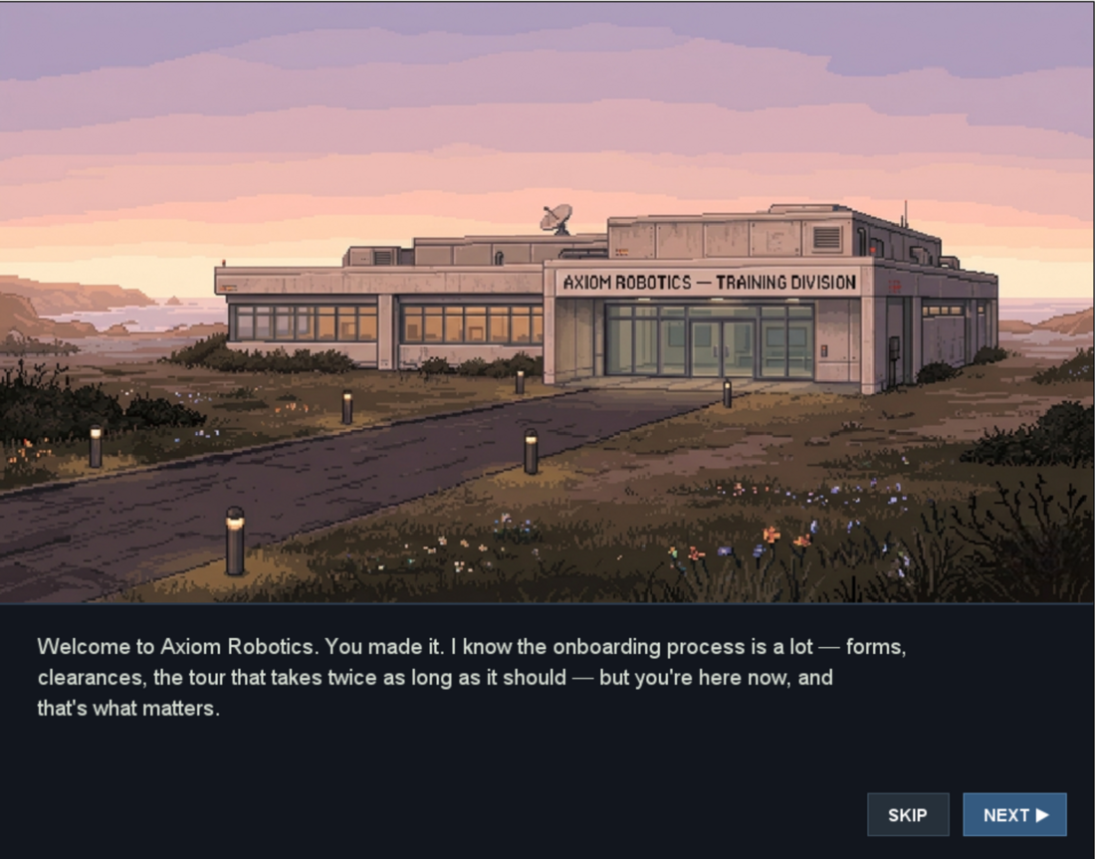
Figure 3. Intro Slide 1

5.2 Characters
Character | Role
RIVETS (the robot) | The prototype being trained and the player's on-screen agent. It runs the player's program exactly as written.
The researcher (player) | An unnamed stand-in for whoever is at the keyboard. There is no avatar, the player's presence is the code in the editor.
Helen | A senior researcher who narrates the game.

5.3 Story arc
1. Arrival | An 8 slide intro, narrated by Helen, sets up the lab, the project and the stakes.
2. Training | Across the 15 chambers, short pop-ups frame RIVETS's progress and unlock each new command.
3. Classification | When every chamber is complete, the lab issues a final verdict on RIVETS intelligence based on the player's total score

6. Gameplay, Rules and the Robot Script Language

6.1 The core loop
The game runs on a tight loop the player repeats over and over:
- Read the maze: find the robot's start, the goal, any coins, and the walls.
- Write a program in the editor using the commands unlocked so far.
- Run: the code is lexed, parsed and then executed one instruction per frame, so the robot steps tile-by-tile while the terminal logs each action.
- Observe: watch where the robot succeeds, gets blocked, or misses a coin. Read any errors in the terminal.
- Refine: RESET returns the robot to its start (code is not affected), the player edits and re-runs the program.

6.2 The Robot Script Language (RSL)
The Robot Script Language is a tiny custom made imperative language we created with six . The language is case and whitespace insensitive, so players can format freely and are never tripped up by capitalisation.
Source text | Meaning | Token
moveUp, moveDown, moveLeft, moveRight | Move the robot exactly one tile in that direction. | MOVE_UP / DOWN / LEFT / RIGHT
repeat(N)...end | Run the enclosed block N times (N must be 1-100). May be nested. | REPEAT...END
1-100 | The loop count. | NUMBER

Robot Script - grammar (EBNF)
program ::= statement* EOF
statement ::= move | repeat
move ::= "moveUp" | "moveDown" | "moveLeft" | "moveRight"
repeat ::= "repeat" "(" NUMBER ")" statement* "end"

6.3 Controls
Input | Action
Typing, Enter, Backspace, Tab | Edit the program in the code editor (with live syntax highlighting).
RUN button | Lex and parse the editor text and start the robot's animated run.
RESET button | Return the robot to its start tile and clear the terminal (the code is kept)
Menu buttons | START, FREE PLAY, SETTINGS, INSTRUCTIONS, CREDITS on the home screen.

6.4 Objectives, win and fail
Win | The robot reaches the goal, a sound plays, a completion overlay shows the star rating, and the next chamber unlocks.
Classification | When every chamber is complete, the lab issues a final verdict on RIVETS based on the player's total score
No hard fail | The program simply may not reach the goal. The player presses RESET and tries again.

6.5 Rules summary
Rule | Detail
Grid | 24×20 tiles. The robot occupies one tile and moves one tile per instruction.
Walls | Impassable. A move into a wall is cancelled and reported.
Coins | Optional collectibles on floor tiles. Collected by stepping on them, they also feed the score.
Loops | Repeat count must be 1-100 and blocks may be nested to any depth. The end token closes the most recent repeat.
Goal | Reaching the goal completes the chamber. As mentioned, every chamber can be finished without loops but loops are rewarded.

7. Progression, Scoring and Rewards

7.1 Scoring model
Every completed chamber yields a score from 0 to 100, produced by one of two scorers (CompletionScorer & AbstractionScorer), and that score becomes a 0-3 star rating.
Chambers 1 to 7 are scored on based completion: how many coins were collected and how few attempts it took. While, Chambers 8 to 15 are scored on abstraction: whether the player used loops, and how deeply nested. A player who brute-forces a loop chamber still finishes, but the low rating is an invitation to come back and improve.
Sequential solution (1 star) | Loop solution (3 stars)
// reach a goal 5 right, 2 down  moveRight  moveRight  moveRight  moveRight  moveRight  moveDown  moveDown | // same path, structured  repeat(5)  moveRight  end  repeat(2)  moveDown  end
The same path, solved two ways (a sequence and a loop)

7.3 Final classification
The collected Stars add up across all fifteen chambers (maximum 45). At the last chamber (Chamber 15) the game issues the final robot's classification. This is the story's climax, and the game's headline achievement.
Classification | Stars | Meaning
Type III:  Expert Programmer | 40-45 | Consistently optimal, well-structured solutions.
Type II:  Advanced Programmer | 28-39 | Mostly correct with solid use of loops.
Type I:  Apprentice Programmer | 15-27 | The fundamentals proved but little to no abstraction was used.
Training Incomplete | 0-14 | Not enough chambers cleared to classify.
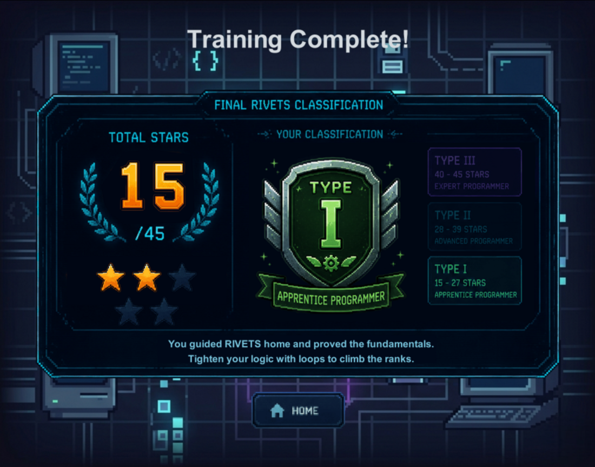
Figure 5. The final classification screen (here: Type I).

7.4 Progress and free play
Progress stays visible throughout the game. The HUD shows the current chamber and attempt count while on the end of every level an overview shows the stars earned. Beyond the campaign, Free Play allows users to load custom mazes (which don't affect campaign progress) made with the accompanying level editor (see Section 10).

8. User Interface and Audio

8.1 Screen layout
The game window is 960×720 px, split into four always visible regions, so the player never loses sight of the maze while coding, keeping code and effect side by side.
Region | Size (px) | Purpose
Game area | 720 × 600 | The 24×20 tile maze with the robot, walls, coins and goal.
Code editor | 240 × 600 | Multi-line editor with live syntax highlighting and line numbers (right side).
Terminal | 720 × 120 | Execution log, errors and completion / star messages (bottom-left).
Controls | 240 × 120 | RUN & RESET buttons (bottom-right).
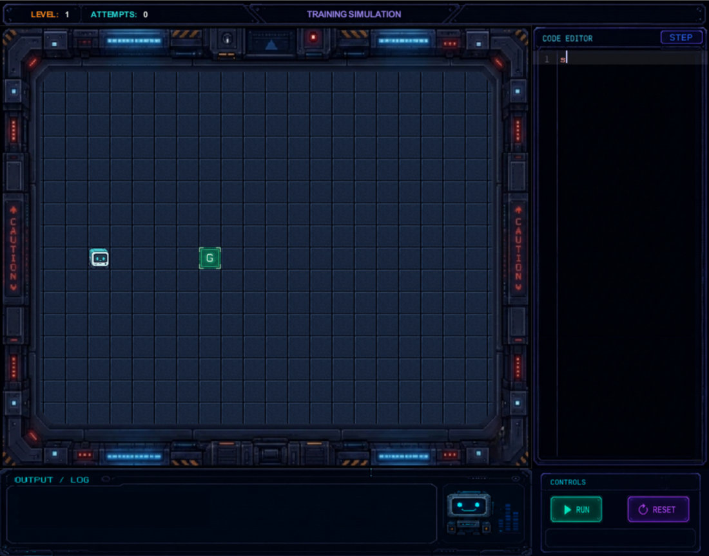
Figure 6. The gameplay screen: maze (left), code editor (right), terminal (bottom-left) and controls (bottom-right).

8.2 Audio
Event | Sound file | Source
Any button click | generic-btn-click.mp3 | Mixkit
RUN pressed | run-btn-click-sound.mp3 | Mixkit
RESET pressed | reset-code-btn-click-sound.mp3 | Mixkit
Goal reached | goal-reached-notification.mp3 | Mixkit
Lexer / parser error | error-sound.mp3 | Mixkit

9. Technical Architecture and Implementation

9.1 Technologies
The game is written in Java using the Greenfoot framework, which supplies the World/Actor model, the game loop, image drawing and keyboard input. The game runs on Windows, macOS and Linux, is fully offline and the source code is version-controlled on GitHub.

9.2 Subsystems
The classes are grouped into loosely-coupled subsystems with clear responsibilities:
- Worlds / screens: Home, Intro, Loading, the main Simulation world, Load Custom and the Final Classification finale.
- Language pipeline: Lexer → Parser → Interpreter over a small AST, driven by a shared compilation/execution service.
- Editor, input and terminal: the in-game code editor, syntax highlighter, terminal manager and a paste field for custom levels.
- Tile and level system: a fixed 24×20 tile map with background and object layers, an ASCII map parser, and the custom-level parser/loader.
- Scoring and progression: the LevelScorer interface with the Completion and Abstraction implementations, plus the level and progress managers.
- UI overlays: pop-ups, onboarding, level complete and other overlays, plus the shared layout and theme.
To see all the used classes along with their roles and responsibilities in the game’s codebase refer to Appendix A.

9.3 The language pipeline
The game runs the player's code through a real language pipeline, as shown in the figure below.
Figure 7. The Robot Script pipeline: text → tokens → AST → one move per frame.
- Lexer: scans the raw text into a flat list of tokens (move keywords, repeat/end, parentheses and numbers), reporting unknown words with their line number.
- Parser: a recursive-descent parser that turns the tokens into an Abstract Syntax Tree of three node types: Program, MoveStatement and RepeatStatement. It validates the loop count (1-100) and that every repeat has a matching end. An example syntax tree for reference is shown in Figure 8.
- Interpreter: instead of running the program straight to the end, it keeps a stack of loop frames and returns exactly one MoveStatement for each game frame so the robot steps visibly.

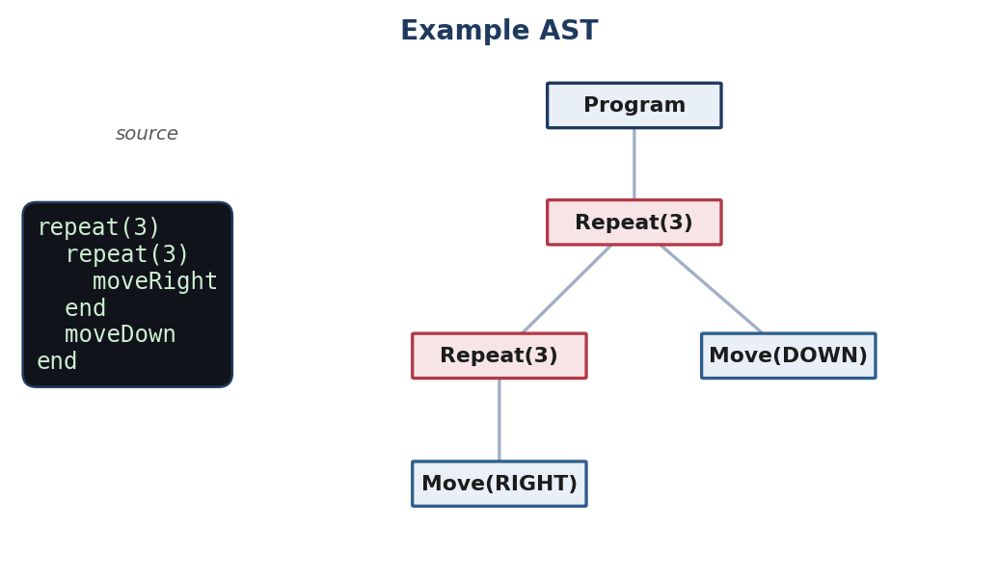
Figure 8. Example AST.

9.4 Developer and Instructor Cheats
Typing certain commands into the code editor triggers developer shortcuts (cheats). They let an instructor jump straight to any chamber to demonstrate a concept, or a developer test quickly, without playing through:
Command | Effect
goto N | Jump straight to chamber N.
skip | Complete the current chamber.
coins | Collect every coin in the current chamber.
stars | Award 3 stars for the current chamber.
end | Jump to the final classification screen.
resetAll | Wipe all progress and return to chamber 1.

10. The Level Editor
Project Rivets ships with a custom level editor. The level editor is a separate web application for building and sharing custom chambers, hosted at codebot.archontis.gr/lvl-editor. It is a no-backend, static web app built in plain HTML5, CSS & JS. It reuses the game's art and palette, so editor and game look identical and exports levels as a .lvl text file or a single-line base64 share-code.
Users can paint a 24×20 grid with the palette (wall, floor, start, goal, coin) starting from either a blank shell or a ready-made template. The editor validates the level (exactly one start and one goal) before letting it be exported. The level can then be pasted into the game through Free Play → Load Custom.
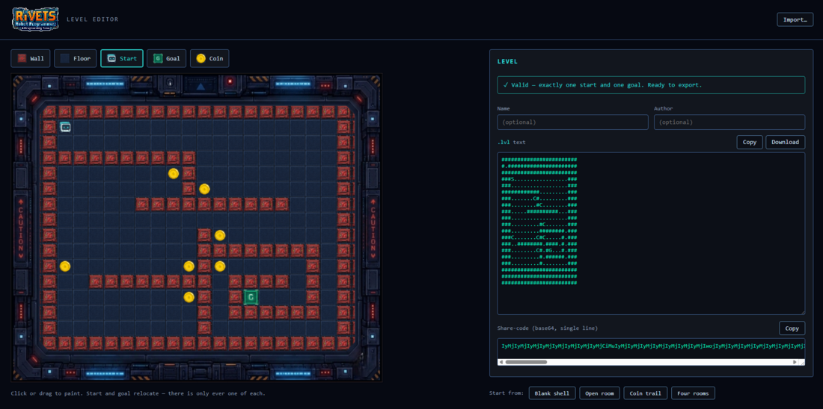
Figure 9. The companion web level editor

11. Evaluation Plan
To know whether the game meets its goals it would need to be tried with real players. A full study was outside the scope of this project (due to time and participant constraints), so no data was collected. The plan below details what a proper evaluation would involve, and is organized around six areas.
Area | Applied to Project Rivets
Player profile and interest | Prior programming exposure and gaming habits, captured before play, to put the results in context.
Performance | Smooth execution (no bugs or lag during runs).
Engagement and fun | Whether the story, art, animation and star system hold interest without overloading the player.
Interaction and difficulty | Whether challenge is matched to skill, and whether the feedback and language are clear and consistent.
Educational value | Whether players feel they learned the concepts the game tries to teach by playing (sequencing, loops and debugging), and would use such a game again.
Player results | The objective outcome: chambers completed, stars earned, and the final classification.

11.2 Sample questionnaire
A short questionnaire, answered on a 1-5 scale (1 = strongly disagree … 5 = strongly agree):
Question | 1 | 2 | 3 | 4 | 5
The game held my attention and I wanted to keep playing.
The robot's step-by-step movement helped me understand how my program runs.
I understood when and why to use a repeat loop.
The error messages helped me find and fix my mistakes.
The difficulty increased at a comfortable pace.
The star rating made me want to improve my solution.
I would like to learn more programming with a game like this.

Appendix A: Code Inventory
Worlds and screens
Class | Role | Source
HomeWorld | Main Menu World | Original
IntroWorld | Plays the intro opening slides before the campaign. | Original
LoadingWorld | Loading Screen shown between major transitions. Builds the next world lazily. | Original
SimulationWorld | The main gameplay world: hosts the maze, editor, terminal and controls. | Original
FreePlayWorld | Free-play menu: routes to Load Custom without touching campaign progress. | Original
LoadCustomWorld | Paste/import screen for custom levels | Original
FinalClassificationWorld | Campaign finale, composites the classification certificate. | Original
Language pipeline
Class | Role | Source
Lexer | Tokenises source text and reports lex errors with line numbers. | Original
Parser | Parser that builds the AST and validates repeat counts and matching end. | Original
Interpreter | Stack-based engine returning one move per frame for animated execution. | Original
Program, Statement, MoveStatement, RepeatStatement | AST: root, marker interface, move leaf, and counted-loop node. | Original
ProgramCompilationPipeline | Shared program flow used by RUN and STEP. | Original
ProgramExecutionService | Drives stepwise execution and terminal logging during a run. | Original
Editor, terminal and input
Class | Role | Source
CodeEditor | In-game multi-line code editor (typing, caret, current-line highlight). | Original
CodeSyntaxHighlighter | Provides per-line syntax highlighting for the Robot Script Language. | Original
TerminalManager | Renders the output/terminal panel | Original
LevelInputField | Multi-line input field for the Load Custom screen | Original
ClipboardAccess | Reads OS clipboard text for the PASTE button (used for custom levels) | Original
Robot, actors and buttons
Class | Role | Source
RobotActor | The robot players program: steps one tile per command. Has collision. | Original
Goal, Obstacle, Coin | Goal tile, impassable wall, and collectible coin actors. | Original
CommandButton, MenuButton, StartButton | Clickable command buttons and menu buttons. | Original
Tile and level system
Class | Role | Source
TileMap, TileCell, TileObjectKind | Fixed 24×20 grid model: cells, background + one object per tile. | Original
TileBackgroundId, TileBackgroundRegistry | Background-tile identifiers mapped to artwork. | Original
TileActorLayer, GameAreaTilePainter | Spawns actors per tile and paints background tiles. | Original
GameAreaConfig, GameScreenLayout | Single source of truth for grid/pixel geometry and UI layout. | Original
AsciiTileMapParse, TileLevelInstalle, ParsedTileLevel | Build a tile-map from ASCII rows and install it into the world. | Original
Levels and level loading
Class | Role | Source
Level (interface) | Contract every chamber implements | Original
Level1 … Level15 | The 15 built-in campaign chambers. | Original
LevelManager, LevelProgressionController | Track current level, unlocked commands and campaign progress. | Original
LevelDefinition, LevelDocumentParser, LevelLoadResult | Source-independent level data, custom level parser, level outcomes/errors. | Original
CustomLevel | A level built at runtime from pasted/loaded custom-level input. | Original
Scoring, overlays, story and state
Class | Role | Source
LevelScorer, CompletionScorer, AbstractionScorer, ScorerKind | 0-100 scoring interface and its rules. | Original
PopupOverlay, LevelCompleteOverlay, ProgramStopOverlayController | Modal pop-ups, the level-complete star screen, and run-stop handling. | Original
OnboardFlow, OnboardOverlay, OnboardStep, OnboardRegistry | First-run spotlight onboarding tutorial. | Original
IntroSlideData, IntroSlideRegistry | Data for the narrated intro slides. | Original
UiTheme, Settings, Sfx | Shared palette, global settings, sound-effect helper. | Original
CheatEngine, MyWorldSessionState, MyWorldCoinTracker | Developer Cheat Engine, per-session state, coin tracking. | Original

Appendix B: Robot Script grammar (full)
(* Robot Script - formal grammar (ISO/IEC 14977 EBNF) *)

program = { statement } , EOF ;
statement = move | repeat-stmt ;
move = "moveUp" | "moveDown" | "moveLeft" | "moveRight" ;
repeat-stmt = "repeat" , "(" , number , ")" , { statement } , "end" ;
number = digit , { digit } ; (* must be 1..100 *)

(* keywords are case-insensitive; whitespace is ignored between tokens;
one move runs per game frame; repeats may be nested. *)

