**Centers for Medicare & Medicaid Services**

**Relational Assurance Database (RAD)**

**User Guide**

**Version 1.0 02/12/2018**

**Contact Number:** HHSM-500-2017-00022

# GETTING STARTED

The following sections describe system requirements for accessing the RAD System.

## Set-up Considerations

CMS screens are designed to be viewed at a minimum screen resolution of 800 x 600. To optimize your access to the Electronic Survey screen resolution should be set to 1024 x 768 or higher.

Access to the Internet is required as the Electronic Survey is a web-based application. The following Internet browsers are compatible for the Electronic Survey:

* Internet Explorer, version 8.0 or higher
* Mozilla Firefox
* Chrome
* Microsoft Edge

## User Access Considerations

There are no special user access considerations.

## Login

Users will log in with a unique user name and password already created by the System Administrator

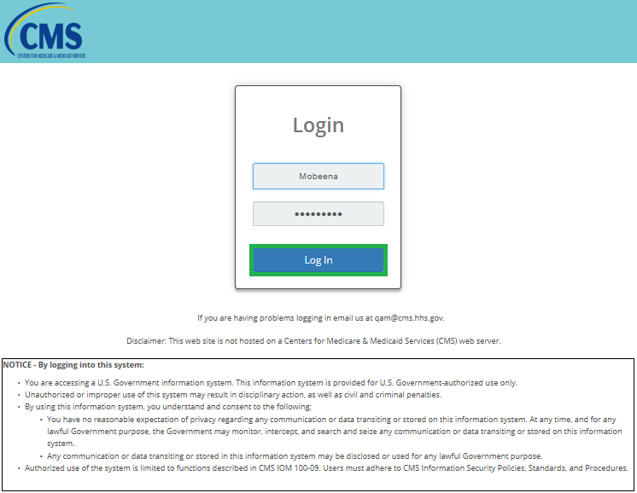

## 

## Accessing the System

System Administrators, CMS Users, Quality Manager, Quality Monitors, MAC Users and MAC Administrators will access the RAD.

## Navigation

Upon successful login, the Homepage displays different hyperlinks which are:

1. Home
2. Scorecard
3. Report
4. CSR
5. Rebuttal
6. User Management
7. My Account
8. Help Guide

## Description of the Homepage

The Homepage displays the following:

1. CMS Logo at the top left corner
2. User Name, Logout button and Screen Magnifier at the top right corner
3. Hyperlink to Home at the bottom right corner
4. Hyperlink to Privacy, Security and Disclaimer at the bottom right corner
5. Hyperlink to Contact Us at the bottom right corner

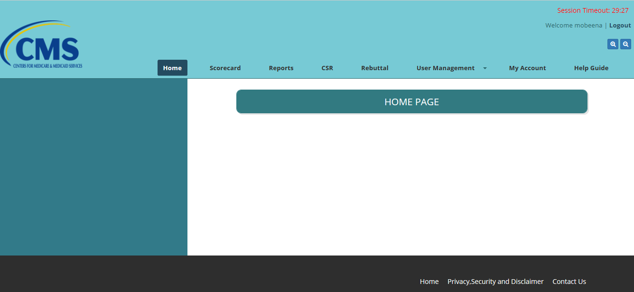

# USING THE SYSTEM

## SCORECARD

1. This page shows different filters which enable users to either filter their search by selecting one of the following:
2. MAC
3. Status
4. Jurisdiction
5. QM Name/QM ID
6. Scorecard Type
7. From Date
8. To Date

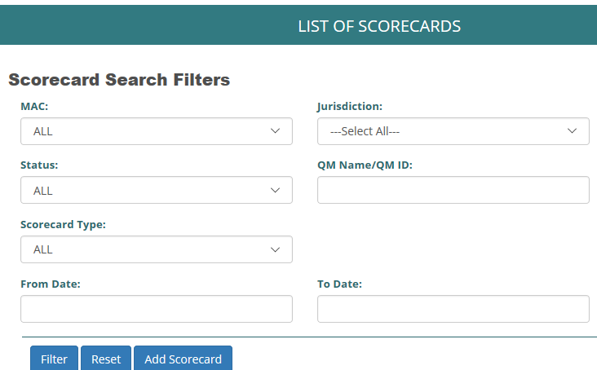

1. Select MAC, Status, Jurisdiction, Scorecard Type, QM Name/ID, From Date and To Date.

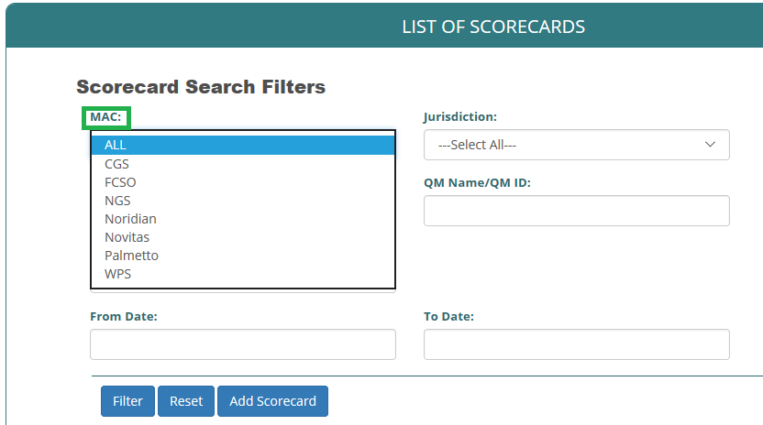

1. Select Status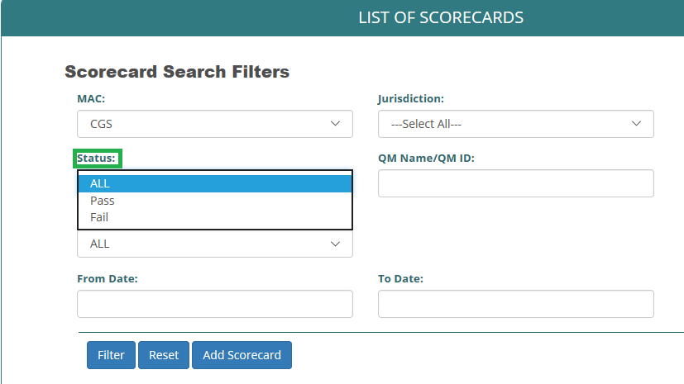
2. Select Scorecard Type

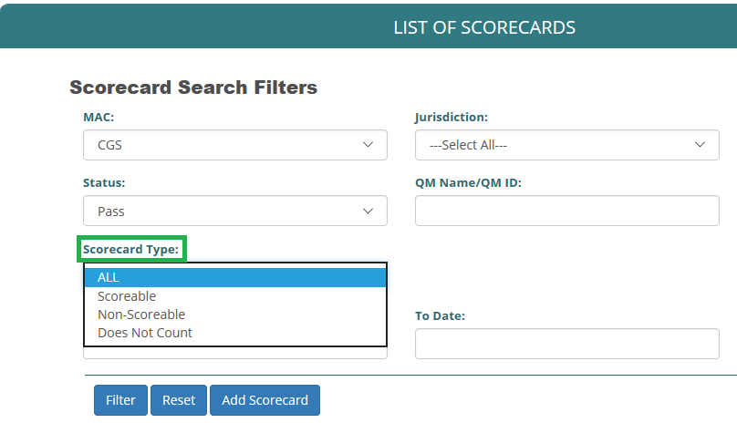

1. Select Jurisdiction

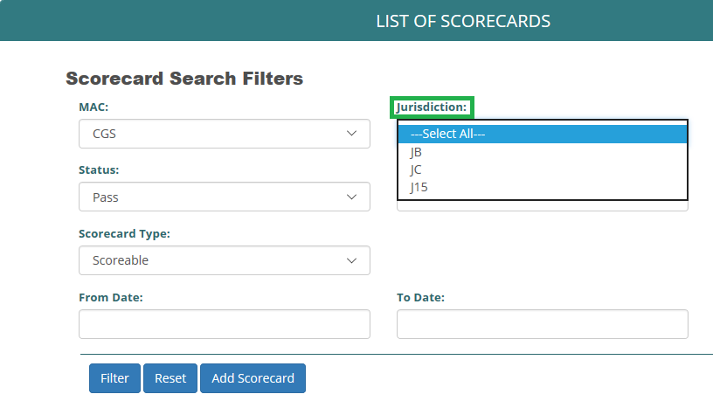

1. Select From Date

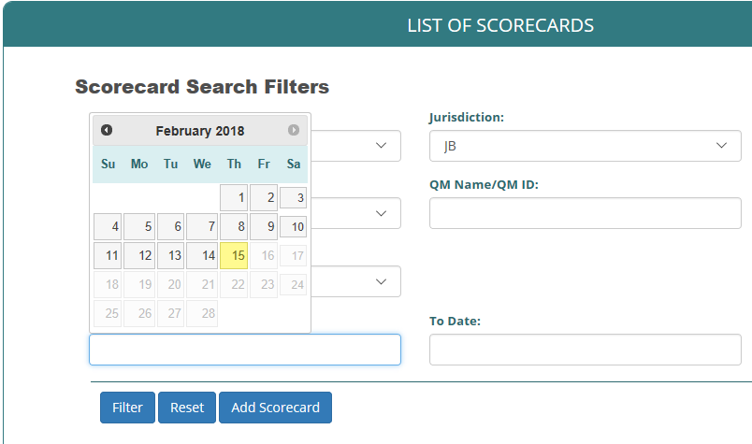

From Date

1. Select To Date

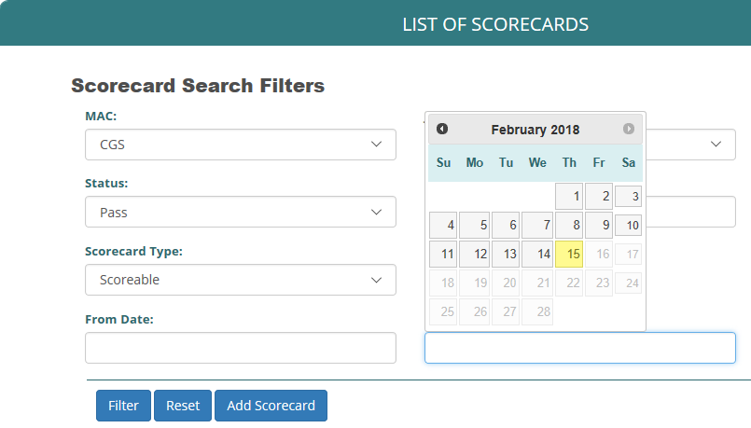

To Date

1. Click on Filter button to generate Scorecard list
2. Click on Reset button to start over
3. Click on Add Scorecard to add a new Scorecard
4. Click on View button to view list of Scorecard
5. Click on Edit button to edit ScoreCard
6. Export list in CSV, Excel XML and PDF format

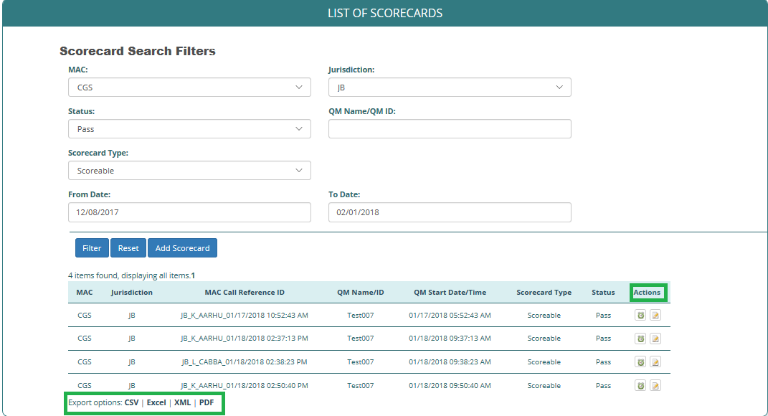

View

Edit

Download in any of these format

## REPORTS

## This shows the Search Report Screen where Users can generate different reports by MAC, Jurisdiction, Program, PCC/Location, Scorecard Type, From Date, To Date and Call Result.

## 

## Select MAC

## 

## Select Jurisdiction

## 

## Select Program

## 

## Select PCC/Location

## 

## Select From Date

## 

## Select To Date

## 

## Select Scorecard Type

## 

## Select Call Result

## 

## Select Compliance

## 

## Search by Rebuttal, select Call Category and Rebuttal Status

## User can generate Report or Reset your by clicking on the Generate Report or Reset Button at the bottom of the page

## 

Click to reset

Click to generate report

## CSR LIST

1. Click on the checkbox (Keep current list) at the top right corner of the page to maintain the current CSR list.
2. To upload a new CSR list, click on the Browse button and it will take user to the actual computer where documents are saved. From here, user can select the folder that contains the CSR list to be uploaded.

## 

Click the box to keep current list

## The system will ask if user really wants to keep current list by a pop-up confirmation tab

## 

Click if user wants to keep current list

Cancel if the box is wrongfully checked

## After user selects the file to be uploaded, then the right MAC and Jurisdiction will be selected before clicking on Upload File button. User can also search the CSR section by selecting the From Date, To Date and by selecting a specific MAC and Jurisdiction. User can also click on Previous and Next to go to the next page or return to the previous page

## 

Click to upload

## REBBUTAL LIST

This page shows the list of Rebuttals that has been generated. Authorized user can Add, View and Edit this list. User will be able to download the rebuttal list in CVS, Excel, XML and PDF format.

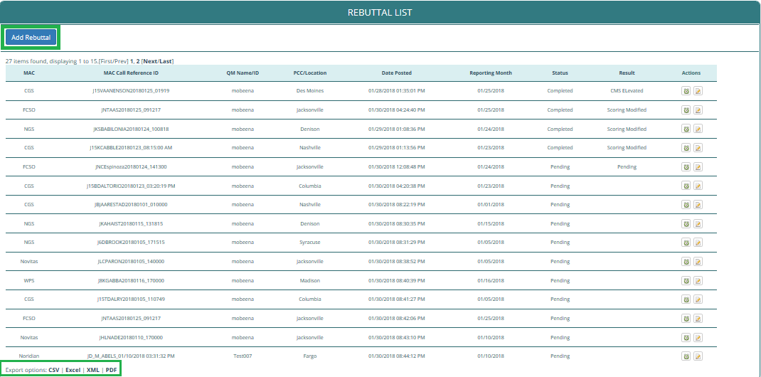

Add Rebuttal

Edit Rebuttal

View Rebuttal

## USER MANAGEMENT

When a user clicks on User Management button, it shows a drop down that has Create Users and List of Users.

To create new User, click on Create Users and it allows a user to create a new User.

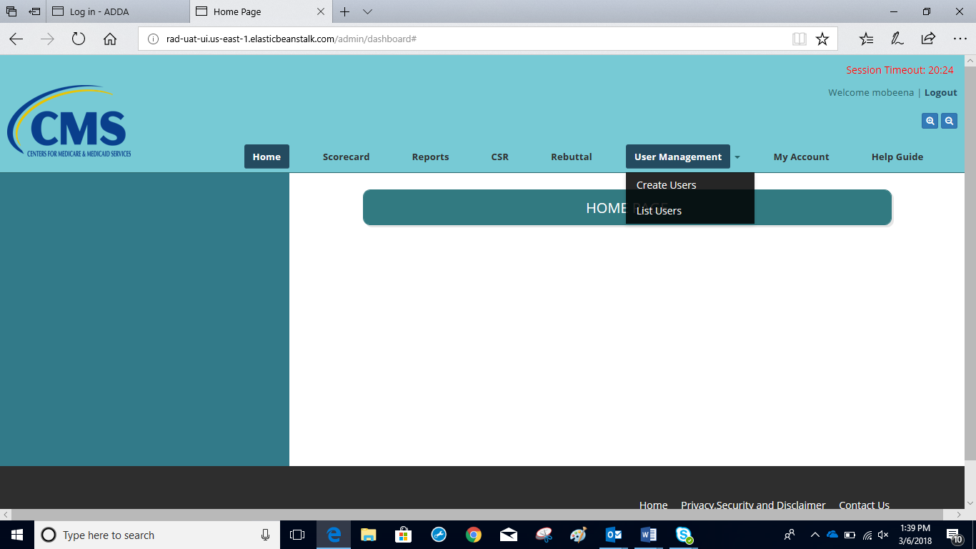

## CREATE USER

1. Users can be created following the steps below:
2. Create a user name
3. Create Strong Password
4. Confirm Password
5. Fill in First Name
6. Fill in Middle Name
7. Fill in Last Name
8. Fill in Email ID
9. Select Role
10. Select Organization
11. Select MAC
12. Select Jurisdiction
13. Select PCC Location
14. Submit

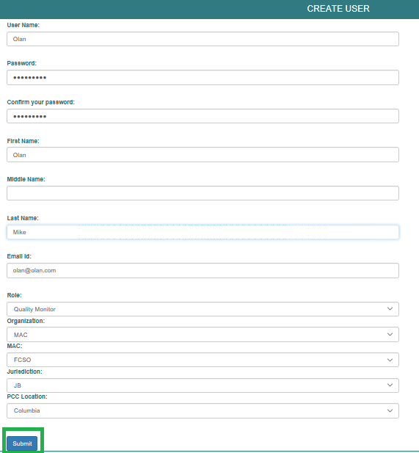

Click to create user after all information have been verified

1. Select Role

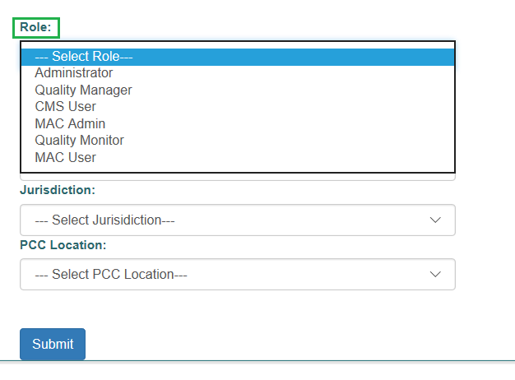

1. Select Organization

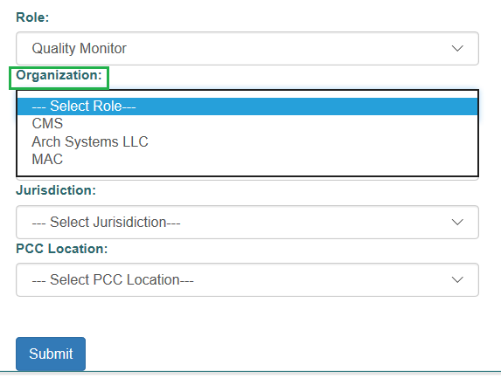

1. Select MAC

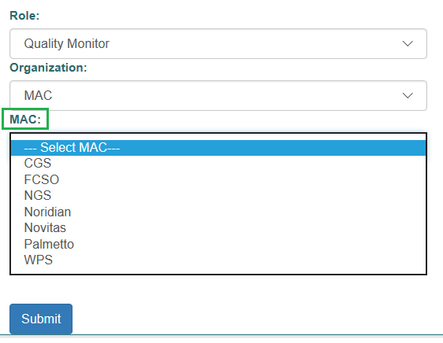

1. Select Jurisdiction

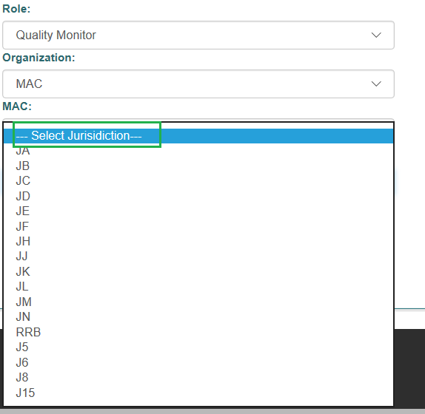

1. Select PCC Location

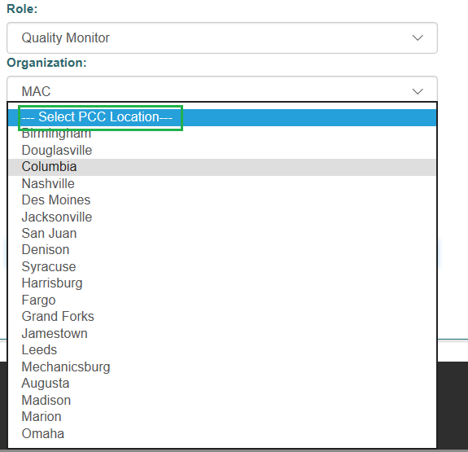

## LIST OF USERS

View Users by clicking on List of Users button. Also, search for a specific User by the Last Name, Role and Organization.

Administrator can make a User Active or Inactive by double clicking on ‘Inactive’ or ‘Active’ under User Access.

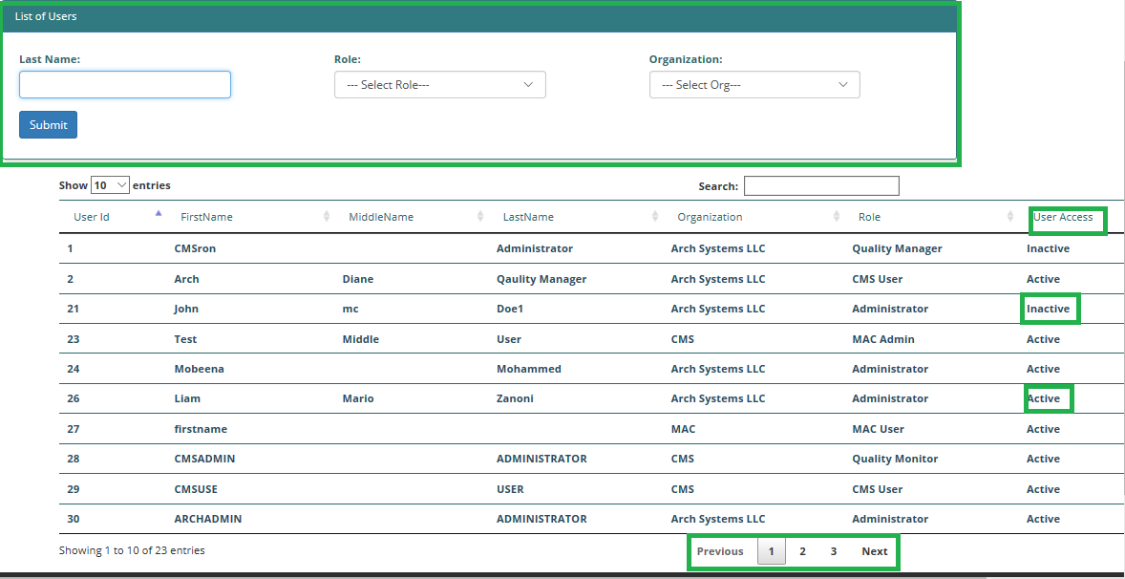

## MY ACCOUNT

This page shows the user’s account information in these order

1. User name
2. First Name
3. Middle Name
4. Last Name
5. Email ID
6. Role
7. Organization
8. MAC
9. Jurisdiction
10. PCC Location

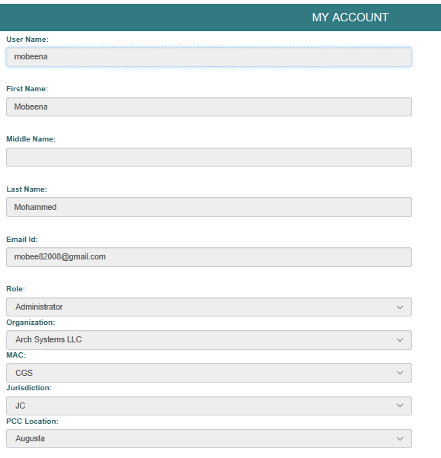

## HELP GUIDE

The Help Guide page contains two important pieces of information: who to contact for technical support and a link for accessing the User Guide. When the user clicks the link, the User Guide opens in a new window.

# 

# Acronyms

|  |  |  |
| --- | --- | --- |
| **Acronym** | **Literal Translation** | **Definition** |
| CMS | Centers for Medicare and Medicaid Services | CMS is a Federal agency within the United States Department of Health and Human Services that administers the Medicare program and works in partnership with state governments to administer  Medicaid, the State Children’s Health Insurance Program, and health insurance portability standards. |
| PDF | Portable Document Format | A file format used to represent documents in a manner independent of application software, hardware, and  operating system. |
| XML | Extensible Markup Language | XML is a set of rules for encoding documents in a machine-readable format. |
| CSV | Comma Separated Values | A CSV is a comma separated values file which allows data to be saved in a table structured format. CSVs look like a garden-variety spreadsheet but with a .csv extension. Traditionally they take the form of a text file containing information separated by commas. |
| RAD | Relational Assurance Database |  |
| QM | Quality Manager / Quality Monitor |  |
| MAC |  |  |

# Record of Changes

|  |  |  |  |
| --- | --- | --- | --- |
| **Version Number** | **Date** | **Author/Owner** | **Description of Change** |
| 1.0_D | 02/21/2018 | Arch Systems, Inc. | Baseline Draft Version |
|  |  |  |  |
|  |  |  |  |
|  |  |  |  |
|  |  |  |  |
|  |  |  |  |
|  |  |  |  |
|  |  |  |  |
|  |  |  |  |