**Project Title:** Air Quality Monitoring

**Phase 2: Innovation**

**ABSTRACT:** When air get mixed with harmful gases and substances it is called air pollution. The major pollutants of air are gases such as ammonia, carbon monoxide, sulphur dioxide, nitrous oxides, methane etc. Pollutant air can causes severe health effects such as heart disease, lungs cancer, respiratory infections etc.

**INTRODUCTION:**

This project is aimed to develop an IOT based application to deal with air pollution. With the help of sensors such as MQ7 various air parameters are sensed and transmitted ESP32 development board plays important role in this project. The prototype connects with Wi-Fi and uploads all air parameters to centralized server

**EXISTING SYSTEM:**

* To collect parameters many electro mechanical devices are used.
* These devices are heavy and not economical to install at many places.
* Periodical collection of data is difficult.
* Still manual intervention is required for collecting and feeding data to central servers

**PROPOSED SYSTEM:**

* Since its IOT based product all functional units are connected in a network.
* All things such as sensors base station, centralized server work together by means of communication over network .
* Data collected from sensors gets uploaded to cloud servers instantly.
* For authorities such as pollution control board, data is easily available.They can draw conclusions and take actions instantly

**SYSTEM MODEL:**

The system is designed by using hardware components operated by software and programming tools that are discussed below.

**Hardware Components:**

The hardware components used in the system is NodeMCU as a micro-controller. MQ series gas sensors include MQ-7 to detect carbon monoxide, MQ-4 to detect methane,MQ-2 to detect smoke and LPG , MQ-137 to detect ammonia gas, and MQ 135 to detect overall pollutants. These sensors detect gasses like Methane, Eng. Proc. 2022, 20, 45 CO, LPG, and overall air quality. On the single input pin in NodeMCU. On the output side of the microcontroller, an LCD, exhaust fan. NodeMCU Interface. buzzer are connected for alarming and alerting about the rising air pollution level.

**Software Components :**

Software Components Arduino IDE is used to program NodeMCU to run the system. It is a platform used for compiling and uploading programs to the microcontrollers. This platform supports C and C+. Also, ThingSpeak to show the graphical results and PushBullet for notification Arduino IDE is used to program NodeMCU to run the system. This platform supports C and C+ . Also, ThingSpeak to show the graphical results and PushBullet for notification purposes is used, and our own created Web App is used to collect data from both apps and present it on one platform.

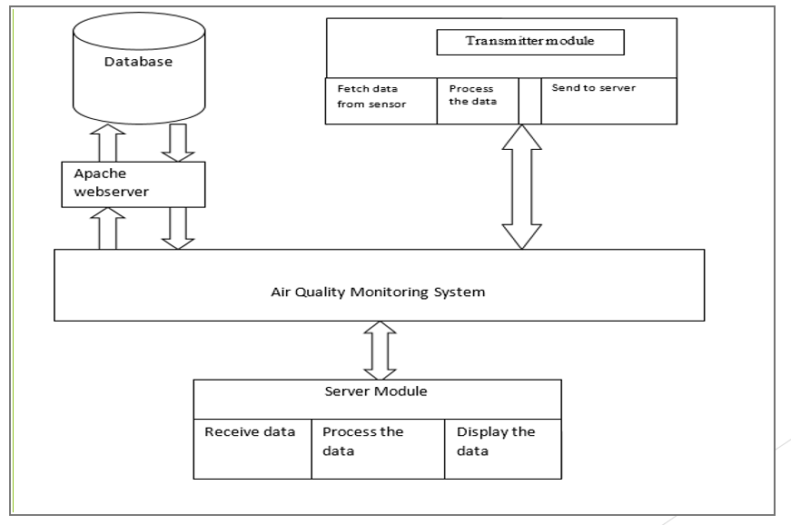

**CONCLUSION:**

We also created a low-cost surveillance program. The semiconductor gas sensors may be used to track the gas concentrations of the target gas. A device has numerous advantages such as low-cost, rapid response, low maintenances, continuous measurement capacity, etc., using semiconductor sensors. One of the system's key benefits is a compact scale. The WLAN, the network server and the site server Gateway Node are all bundled into one lightweight edition.