**DESKTOP** (English version)

**LOG IN**

**ID 001**

Title: Unencrypted connection

Operating environment: web browser FF 58.0, operating system W8 64-bit

Precondition: open <http://front.dev.ncf-fonda.hetzner.lfac.dk/> in web browser; user can’t be logged in

Test steps:

1. user clicks on “log in” button

2. user clicks once on the “email” field with the left mouse button

Result: browser warns the user about an insecure connection

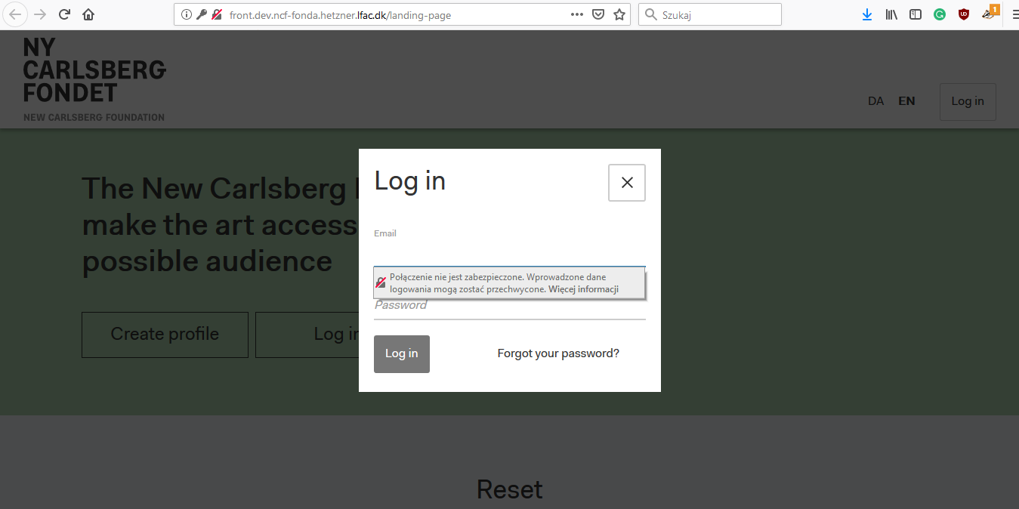

Expected result:no warning is present

**ID 002**

Title: Inactive “Log in” button with less than 7 characters in the ”password” field

Operating environment: web browser FF 58.0, operating system W8 64-bit

Precondition: open <http://front.dev.ncf-fonda.hetzner.lfac.dk/> in web browser; user can’t be logged in

Test steps:

1. user clicks on “log in” button

2. user fills “email” field with wrong or correct data

3. user enters 7 letters or less in “password” field

Result: inactive “log in” button with no message indicating what’s wrong

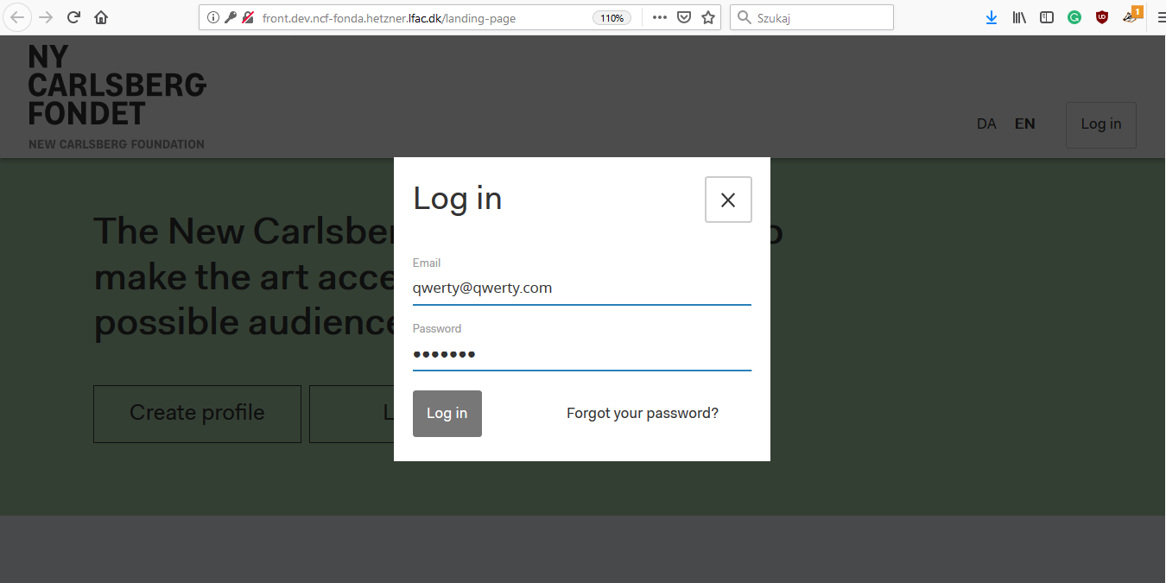

Expected result: active “log in” button

**ID 003**

Title: Login form is sent via GET request

Operating environment: web browser FF 58.0, operating system W8 64-bit

Precondition: open <http://front.dev.ncf-fonda.hetzner.lfac.dk/> in web browser; user can’t be logged in

Data test:

Test steps:

1. user clicks on “log in” button

2. user fills “email” and “password” fields with data from data test

3. user cliks F12 key to get developer tools

4. user clicks once on the blue “log in” button with the left mouse button

5. user clicks in console “Network” button to read statuses and methods

6. user choose “status 403, GET method”

Result: Login and password data are written as a plain text in the URL of request (method GET instead of POST) and visible to everybody

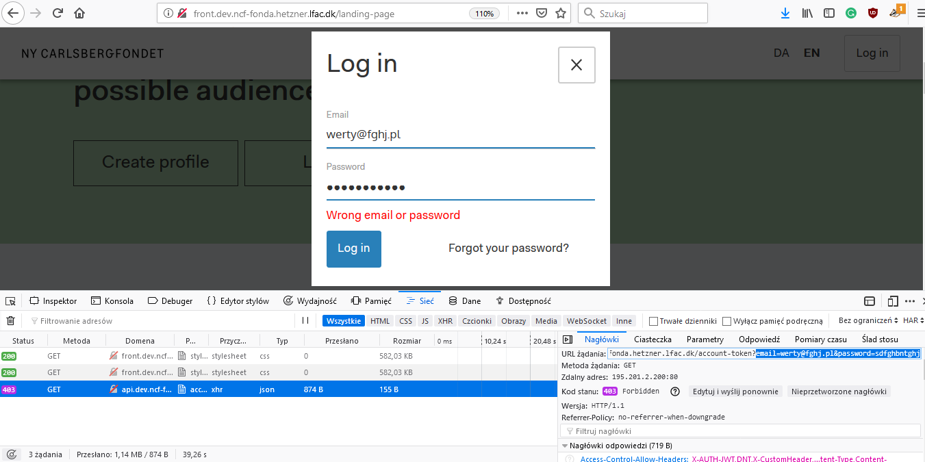

Expected result: use POST method and send data in request body

**CREATING A PROFILE**

**ID 004**

Title: Missing “repeat password” field

Operating environment: web browser FF 58.0, operating system W8 64-bit

Precondition: open <http://front.dev.ncf-fonda.hetzner.lfac.dk/> in web browser; user can’t be logged in

Test steps:

1. user clicks on “create profile” button

Result: there is no “repeat password” field to prevent mistakes in the user’s password

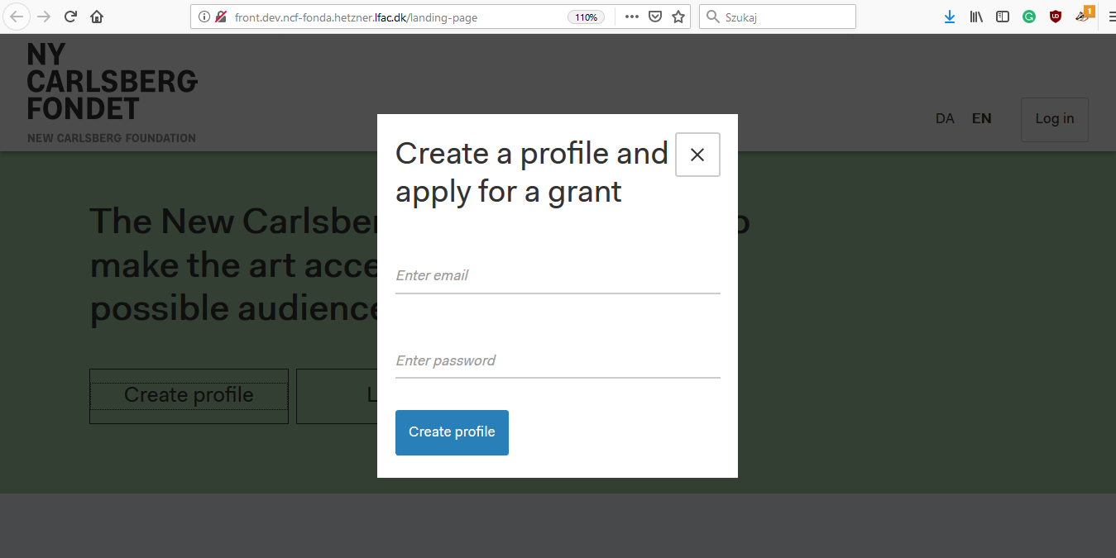

Expected result: registration form should contain a “repeat password” field

**ID 005**

Title: No information about required password length

Operating environment: web browser FF 58.0, operating system W8 64-bit

Precondition: open <http://front.dev.ncf-fonda.hetzner.lfac.dk/> in web browser; user can’t be logged in

Test steps:

1. user clicks on “create profile” button

2. user enters correct email

3. user enters six-letters password

Result: No message about required password length on the screen

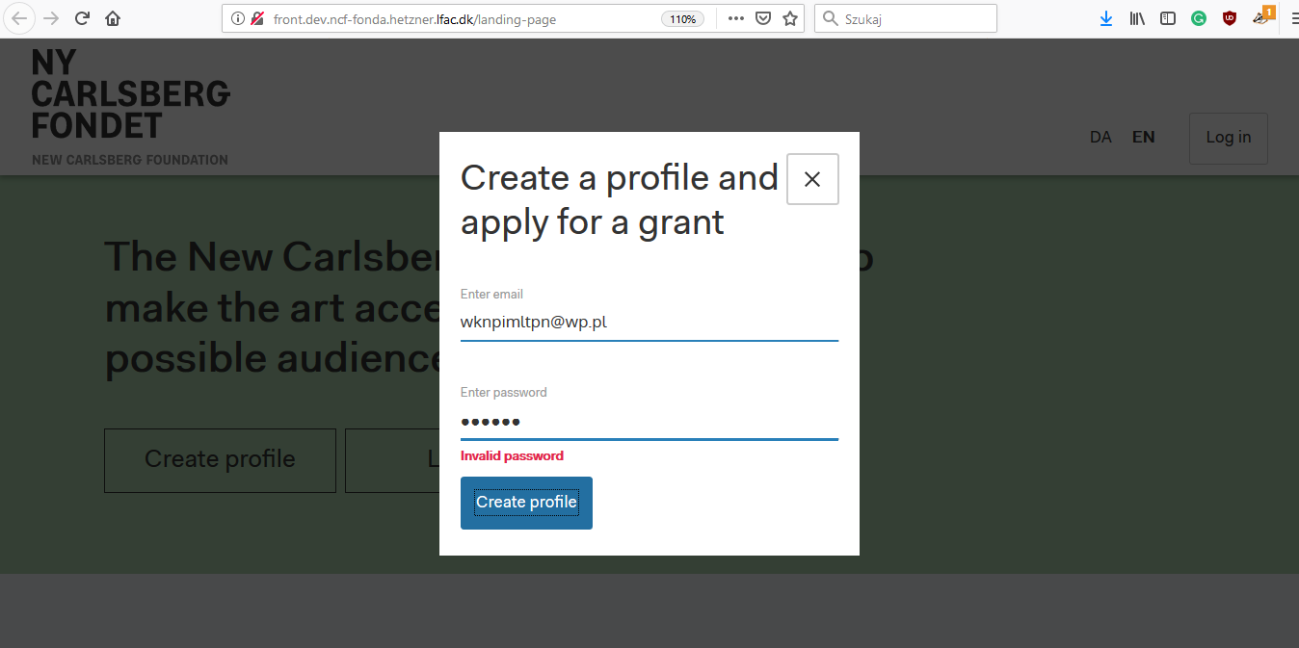

Expected result: a message indicating that the password should have at least 8 characters.

**ID 006**

Title: main content after create account is displayed under the navigation bar

Operating environment: web browser FF 58.0, operating system W8 64-bit

Precondition: open <http://front.dev.ncf-fonda.hetzner.lfac.dk/> in web browser; user can’t be logged in

Test steps:

1. user clicks on “create profile” button

2. “thank you for creating an account – check your email” is displayed on the screen

Result: “thank you for creating an account – check your email” message is hidden under the navigation bar

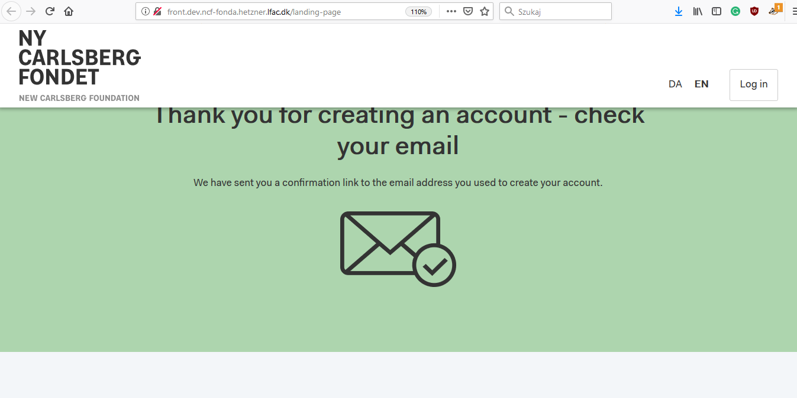

Expected result: “thank you for creating an account – check your email” message is not hidden under the navigation bar

**MOBILE VIEW** (English version)

Phone: Redmi Note 4

**LOG IN**

**ID 007**

Title: “email” field is not marked as required

Operating environment: web browser Chrome 72.0, operating system Android 7.0

Precondition: open <http://front.dev.ncf-fonda.hetzner.lfac.dk/> in web browser; user can’t be logged in

Test steps:

1. user clicks on “log in” button in

Result: there is no asterisk next to the “email” which means the field is required

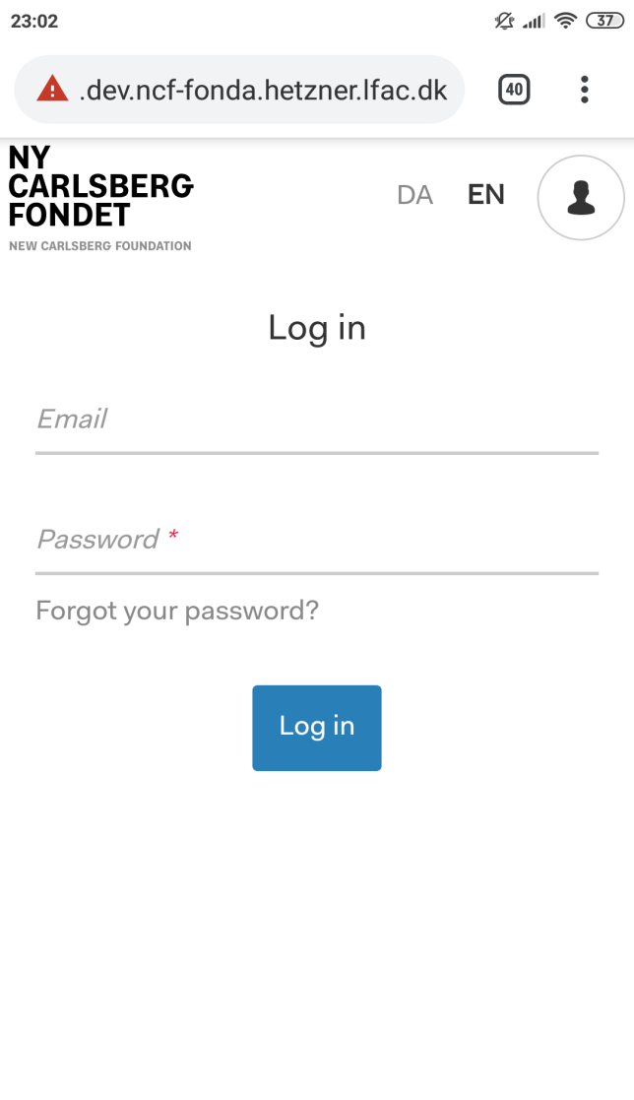

Expected result: “email” and “password” fields are marked with asterisk (which means they are required to log in)

**ID 008**

Title: label on the “log in” button disappears

Operating environment: web browser Chrome 72.0, operating system Android 7.0

Precondition: open <http://front.dev.ncf-fonda.hetzner.lfac.dk/> in web browser; user can’t be logged in

Test steps:

1. user clicks on “log in” button

2. user fills “email” and “password” fields with wrong data

3. user clicks once on the blue “log in” button with the left mouse button

Result: label on the “log in” button disappears

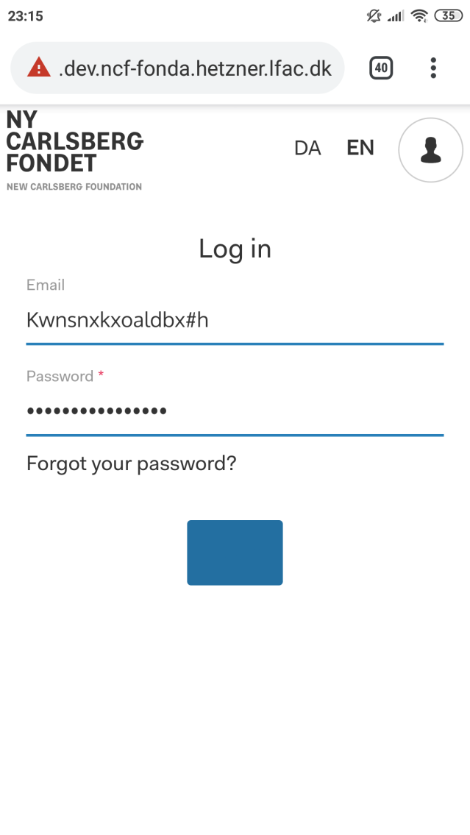

Expected result: label on the “log in” button doesn’t disappear

**ID 009**

Title: “wrong email or password” message doesn’t appear with an invalid email address and/or password

Operating environment: web browser Chrome 72.0, operating system Android 7.0

Precondition: open <http://front.dev.ncf-fonda.hetzner.lfac.dk/> in web browser; user can’t be logged in

Test steps:

1. user clicks on “log in” button

2. user fills “email” and/or “password” fields with wrong data

3. user clicks once on the blue “log in” button with the left mouse button

Result: there is no “wrong email or password” message



Expected result: “wrong email or password” message should appear with an invalid email address and/or password

**ID 010**

Title: “close” button covers “create a profile and apply for a grant” message

Operating environment: web browser Chrome 72.0, operating system Android 7.0

Precondition: open <http://front.dev.ncf-fonda.hetzner.lfac.dk/> in web browser; user can’t be logged in

Test steps:

1. user clicks on “create profile” button

2. “create a profile and apply for a grant” is displayed on the screen

Result: “close” button covers “create a profile and apply for a grant” message

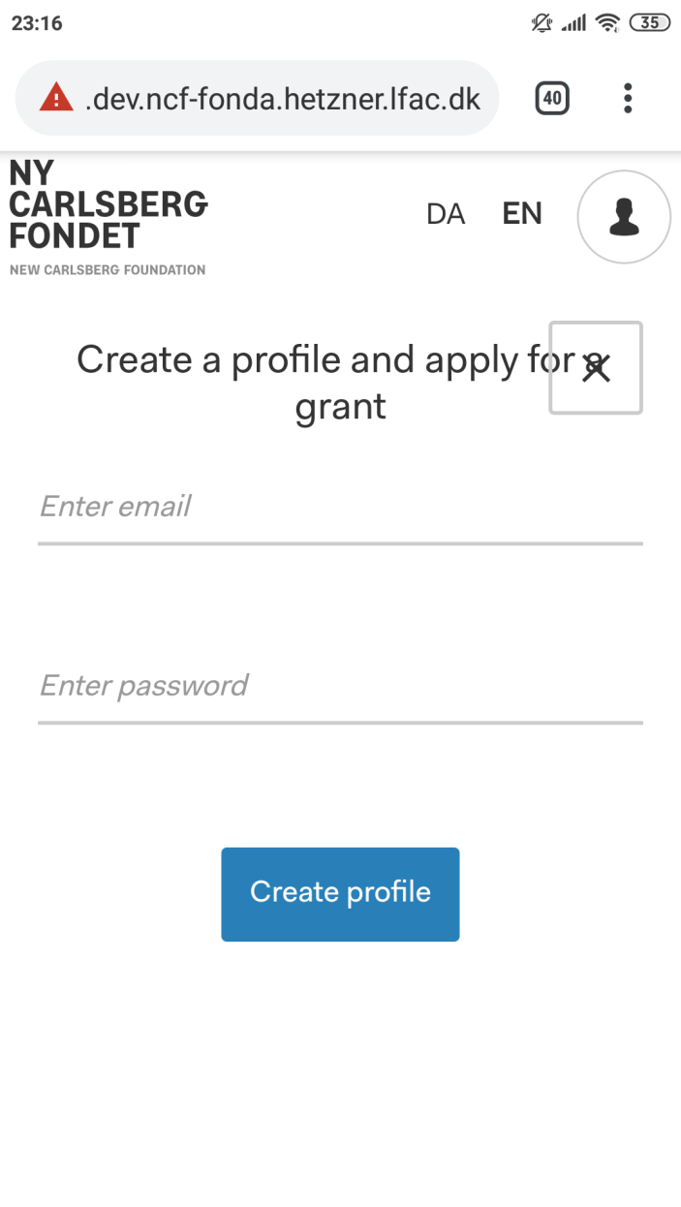

Expected result: “close” button doesn’t cover “create a profile and apply for a grant” message