Project 2 Report
Lossy Image Source Coding and BSC/BEC Channel Coding

1. Introduction
This project implements a complete digital image communication system. The input graph/image dataset is first compressed by a lossy source coding method. The compressed bit stream is then protected by simple channel coding and transmitted through simulated Binary Symmetric Channel (BSC) and Binary Erasure Channel (BEC) models. Finally, the receiver decodes the channel output, reconstructs the image, and evaluates the recovered image quality.
The system is evaluated from three required perspectives: accuracy, algorithm complexity, and Peak Signal-to-Noise Ratio (PSNR). In this report, accuracy is mainly measured by Bit Error Rate (BER) after channel decoding, while algorithm complexity is approximated by runtime of source coding, channel coding, channel simulation, and channel decoding.

2. Dataset
The image dataset is stored in the graph/ folder. It contains ten graph images, including bar chart, box plot, contour plot, heatmap, line plot, pie chart, scatter plot, subplot image, sine grating, and zone plate. These images include both simple plots and relatively complex visual patterns, which is useful for comparing compression and transmission quality under different channel conditions.

3. Lossy Source Coding Method
The source coding module applies a JPEG-like lossy compression pipeline based on block DCT. Each image is converted into grayscale, divided into 8 by 8 blocks, transformed by two-dimensional DCT, quantized according to a quality factor, scanned in zigzag order, and compressed using run-length and entropy coding methods. At the receiver side, inverse operations are used to reconstruct the image.
• DCT converts spatial pixel values into frequency coefficients.
• Quantization removes less important high-frequency information and creates lossy compression.
• Zigzag scanning and run-length coding improve compression efficiency by exploiting long runs of zeros.
• The quality factor controls the rate-distortion trade-off: higher quality usually gives higher PSNR but lower compression ratio.

4. Channel Models and Channel Coding
Two channel models are simulated. In the BSC model, each transmitted bit is independently flipped with probability p. In the BEC model, each transmitted bit is independently erased with probability p, and the receiver knows which positions are erased. The project supports three channel coding choices: no channel coding, repetition coding, and Hamming (7,4) coding.
Model / Code | Description | Expected Effect
BSC | Random bit flips with probability p | Tests error-correction ability under noisy binary transmission
BEC | Random erasures with probability p | Tests recovery ability when loss positions are known
None | Direct transmission without redundancy | Lowest complexity but weakest robustness
Repetition | Each bit is repeated several times and decoded by majority vote | Simple and robust but introduces large redundancy
Hamming (7,4) | Linear block code with single-bit error correction | Better trade-off between redundancy and correction ability

5. Experiment Design
The final integration script run_full_experiment.py runs all combinations of selected images, channel models, channel codes, and error probabilities. The experiment was run on all ten images with the following default settings:
• Source coding quality factor: 50
• Channels: BSC and BEC
• Channel codes: none, repetition, and Hamming (7,4)
• Error / erasure probabilities: 0, 0.01, 0.05, and 0.1
• Metrics: PSNR, MSE, BER, compression ratio, bits per pixel, redundancy rate, corrected errors, uncorrectable blocks, and runtime.

6. Results and Analysis

6.1 Evaluation Metrics
Metric | Meaning | How to Interpret
PSNR | Peak Signal-to-Noise Ratio of reconstructed image | Higher PSNR means better image quality
BER | End-to-end bit error rate after channel decoding | Lower BER means higher transmission accuracy
Compression ratio | Original size divided by compressed size | Higher ratio means stronger compression
Runtime | Execution time of encoding, channel simulation, and decoding | Lower runtime means lower computational complexity
Success rate | Proportion of trials whose recovered image could be decoded successfully | Higher success rate means the compressed bitstream is more robust to channel impairment

6.2 Overall Summary
The complete experiment was conducted on ten graph images using two channel models and three channel coding schemes. The complete numerical results are stored in output_final/final_metrics.csv. The following table summarizes the average performance for each channel and coding scheme. Recovered PSNR is averaged over successful image reconstruction trials, while BER and runtime are averaged over all corresponding transmission trials.
Channel | Code | Successful / Total | Success Rate | Avg. PSNR (dB) | Avg. BER | Avg. Time (s) | Redundancy
BEC | Hamming (7,4) | 10/40 | 25.0% | 36.18 | 0.00817 | 0.735 | 1.75x
BEC | None | 10/40 | 25.0% | 36.18 | 0.02165 | 0.314 | 1.00x
BEC | Repetition | 24/40 | 60.0% | 31.87 | 0.00014 | 1.423 | 3.00x
BSC | Hamming (7,4) | 10/40 | 25.0% | 36.18 | 0.02179 | 0.723 | 1.75x
BSC | None | 10/40 | 25.0% | 36.18 | 0.03999 | 0.314 | 1.00x
BSC | Repetition | 11/40 | 27.5% | 33.21 | 0.00883 | 1.422 | 3.00x
The table indicates that direct transmission has the lowest runtime but is less robust under noisy channels. Repetition coding introduces the highest redundancy and runtime, but it reduces BER significantly in the BEC case. Hamming coding adds moderate redundancy and provides error-correction capability, although severe channel errors can still corrupt the compressed bitstream and prevent successful image reconstruction.

6.3 BER Analysis
Figure 1 shows the average BER after channel decoding under different channel error or erasure probabilities. As the channel error probability increases, BER generally increases. Direct transmission without channel coding is more sensitive to channel noise. Channel coding reduces BER compared with direct transmission, but the improvement depends on the channel model and coding scheme.
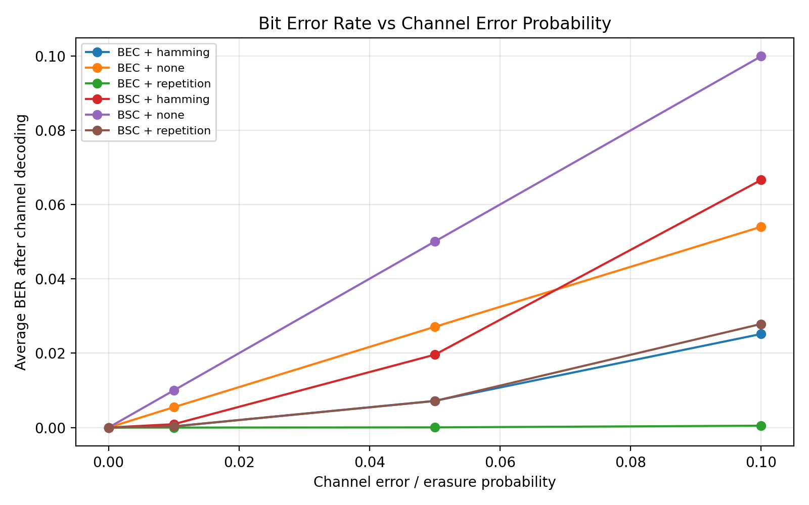
Figure 1. Average Bit Error Rate vs Channel Error Probability.

6.4 PSNR Analysis
Figure 2 shows the average recovered PSNR under different channel conditions. Higher PSNR indicates better reconstructed image quality. The results show that image quality decreases when the channel becomes noisier. Because the compressed bitstream is sensitive to structural bit errors, some high-error cases may fail to reconstruct a valid image and are therefore excluded from the PSNR average.
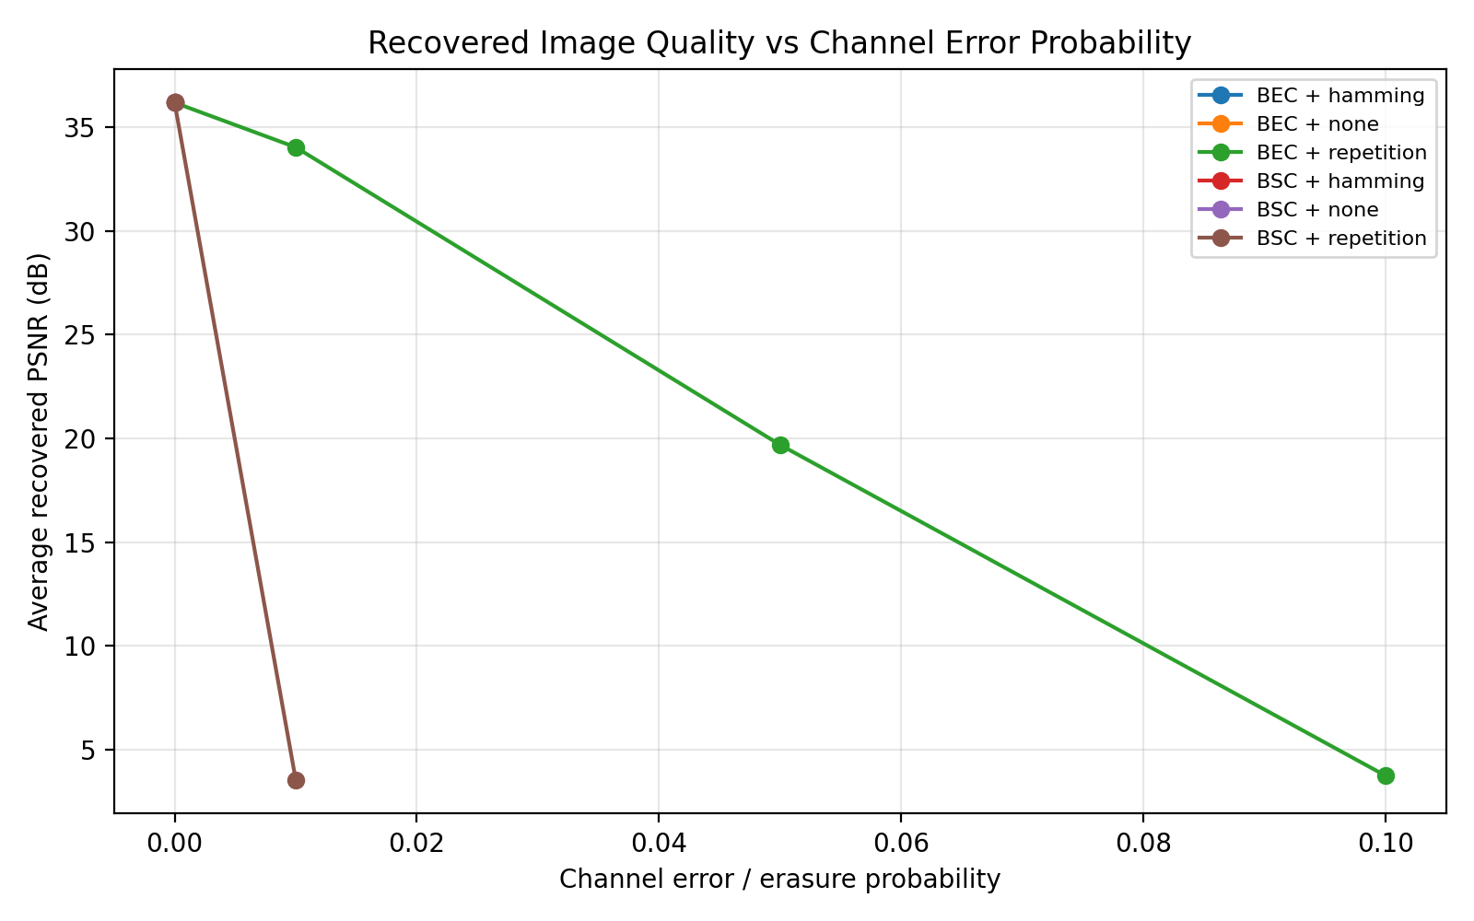
Figure 2. Average Recovered Image Quality (PSNR) vs Channel Error Probability.

6.5 Algorithm Complexity Analysis
Figure 3 compares the average total runtime of different channel coding schemes. Direct transmission has the lowest runtime because no redundancy is added. Repetition coding has higher complexity due to repeated bits and majority-vote decoding. Hamming coding provides error-correction ability with moderate additional complexity.
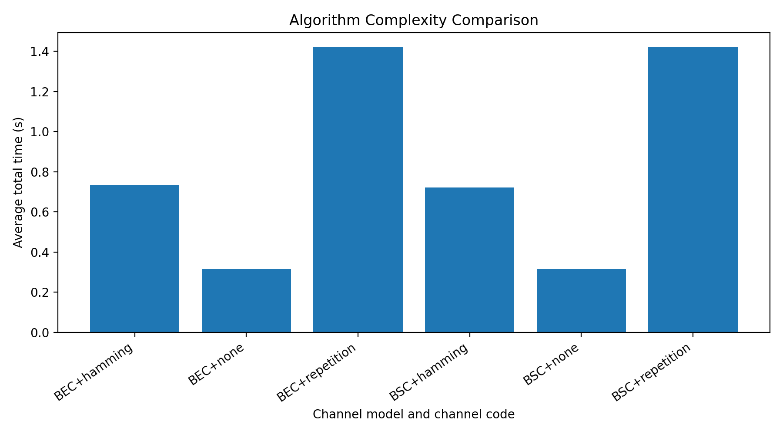
Figure 3. Average Total Runtime for Different Channel Coding Schemes.

7. Conclusion
This project demonstrates the interaction between source coding and channel coding in a simulated image transmission system. Lossy source coding reduces the number of bits needed for transmission, while channel coding improves robustness against errors and erasures. The experiments show the rate-distortion and reliability-complexity trade-offs in digital communication. A practical communication system must balance compression efficiency, recovered image quality, error protection, redundancy, and algorithm complexity.

8. Individual Contributions
Member | Main Responsibility
Li Chaoyang | Lossy source coding: DCT compression, quantization, entropy coding, and reconstruction
Xie Mengzhen | Channel coding and simulation: BSC, BEC, repetition code, Hamming code, and BER calculation
Li Junyao | Experimental analysis: PSNR, BER, complexity, CSV output, and figures
Ding Zhuo | Integration: code merging, final testing, package organization, and English report

References
[1] T. M. Cover and J. A. Thomas, Elements of Information Theory, 2nd ed., Wiley, 2006.
[2] R. G. Gallager, Information Theory and Reliable Communication, Wiley, 1968.
[3] Course handout: Project 2 - Lossy source coding for image and simple channel coding over BSC and BEC.

