
Arcola FCDK HyPi Upgrade Guide

Parts list

You should have received the following parts:
- Ready made DC-DC converter board
- 8 position terminal block
- USB connector
- Arduino headers (4 different pieces)
- Relay x2
- Push button switch x2
- Diode x2
- Transistor x2
- 1kΩ resistor x4
- 0.3 bar pressure switch
- Prototyping board
There may be extras of some components.
You will also need:
- Arcola Fuel Cell Developer Kit (FCDK)
- Wires, wire cutters and strippers
- Soldering tools and solder
- Multimeter
- Plyers
- Optionally tools to cut the prototyping board (hacksaw or Dremel) and/or expand holes to allow the Arduino headers to be fitted (file or small drill) and super glue.
- RaspberryPi (any model)

Assembly instructions
Solder the components to the board, connecting them up as shown in the circuit diagram over-leaf.

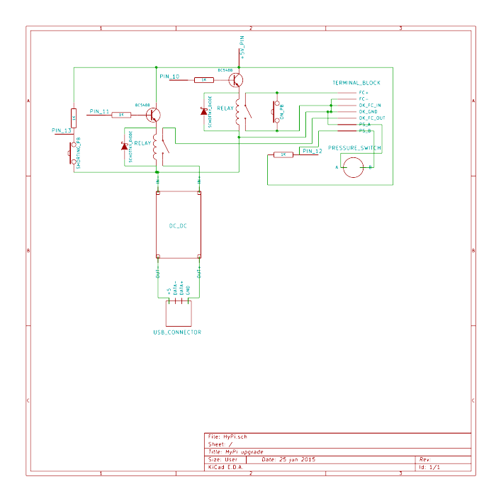
The wires from the fuel cell stack should be connected to the FC+ (red) and FC- (black) terminals on the terminal block on the upgrade board, not to the FCDK board as stated in the FCDK manual. This is so that the upgrade board can disconnect the fuel cell stack should the stack potential get below the safe minimum or, more current than the safe maximum be drawn.
The DK_FC_IN terminal should be connected to the FCDK board FC_IN terminal and, the DK_GND terminal to the FCDK board GND terminal next to it.
The DK_FC_OUT terminal should be connected to the FCDK FC_OUT terminal.
The PURGE terminals on the FCDK board should be connected to the purge valve supplied with the fuel cell developer kit as normal (which way round does not matter).
The PS_A and PS_B terminals on the upgrade board should be connected to the pressure switch wires (again, which wire is connected to which pin does not matter).
The final terminal is unused. If the terminals are connected in the following order, this makes it easy to wire up to the FCDK board: (unused), DK_FC_OUT, FC+, FC-, DK_GND, PS_A, PS_B.
The USB connector will need to have one of the PCB fixing tabs bent so that it can be placed flat onto the board (the other tab can be left if the USB connector is located at the edge of the board).
The relay coil is connected across pins A1 and A2 in the diagram below, the switch side is pins 14 and 11.
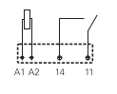
The pin arrangement for the transistors is shown below.
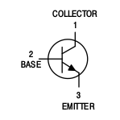
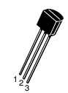
The diodes should be connected with the side without the grey band to ground.
Optionally, glue the Arduino headers to the board. As the Ardunio header positions are not standard, the header with pins 8-13 on will not fit if it is lined up with the holes on the prototyping board. Either the holes can be enlarged using a file or drill or, the header attached to the side of the prototyping board (with a space cut in the prototyping board to make space for it). The latter option is easiest but, most fragile. Alternatively, as there aren't many pins to connect, wires can be attached to the headers on the FCDK board directly, as long as no more shields need to be attached above.
Connect up the tubes to the HydroSticks, purge valve, and stack as described in the fuel cell developer kit manual, ensuring the clip valve is closed, and plug the FCDK board into the Arduino.

Loading software
The latest version of the software can be downloaded from GitHub from: https://github.com/ArcolaEnergy/fuel-cell-developer-kit/raw/master/fcdk.zip
To load it onto the Arduino:
- Download and install the Arduino IDE from https://www.arduino.cc/en/Main/Software, connect the Arduino.
- Follow the setup instructions at https://www.arduino.cc/en/Guide/Windows, MacOSX or Linux as appropriate, connecting the Arduino and verifying that it is working.
- Import the FCDK library by clicking on Sketch > Import Library… > Add Library… and selecting the zip file downloaded from GitHib.
- Open the fcdk_hypi.ino example by clicking on File > Examples > FCDK > fcdk_hypi.
- Click on the Upload button.

Starting the stack
The clip-valve can now be opened to allow hydrogen into the stack. If the stack fans do not start immediately, disconnect the purge valve tube from the stack momentarily to allow air in the stack out. Push the on push button and hold it for a few seconds as soon as possible after starting the stack. The stack will not be purged until after this has been done so, unless this is done soon after the stack is started, the hydrogen will be consumed and it will stop again, requiring it to be purged manually by disconnecting and reconnecting the purge value tube to the stack.

Tuning the output potential
Before the RaspberryPi can be powered, the output potential of the DC-DC must be tuned. This is achieved by turning the small screw on the top of the blue trim-pot on the DC-DC board. The potential between the DC-DC output pins should be measured using a multimeter and, the screw adjusted until this is close to 5V (not more than 5.25V or the RaspberryPi may be damaged).

Running the RaspberryPi
Finally, the RaspberryPi can be connected to the USB port. The power will not be available for the RaspberryPi immediately after the On button is pressed as, in order to provide better performance of the fuel cell stack, the stack will be shorted at least four times and purged at least once before the USB power is enabled. Normally, this is done continually during operation but, shorting the stack can disrupt power to the RaspberryPi so, this stops after the USB power is enabled.

Monitoring stack performance
The Stack potential and the current being drawn is reported by the Arduino via the serial link. This can be monitored using the USB link or, by connecting pin 1 on the Arduino to the RaspberryPi GPIO pin 15 using a potential divider to lower the potential and monitoring the RaspberryPi UART at board rate 9600, 8 data bits, no parity bit, 1 stop bit. A diagram is shown below.

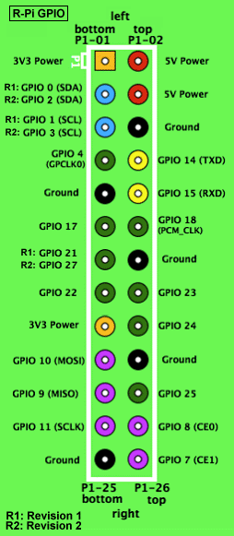
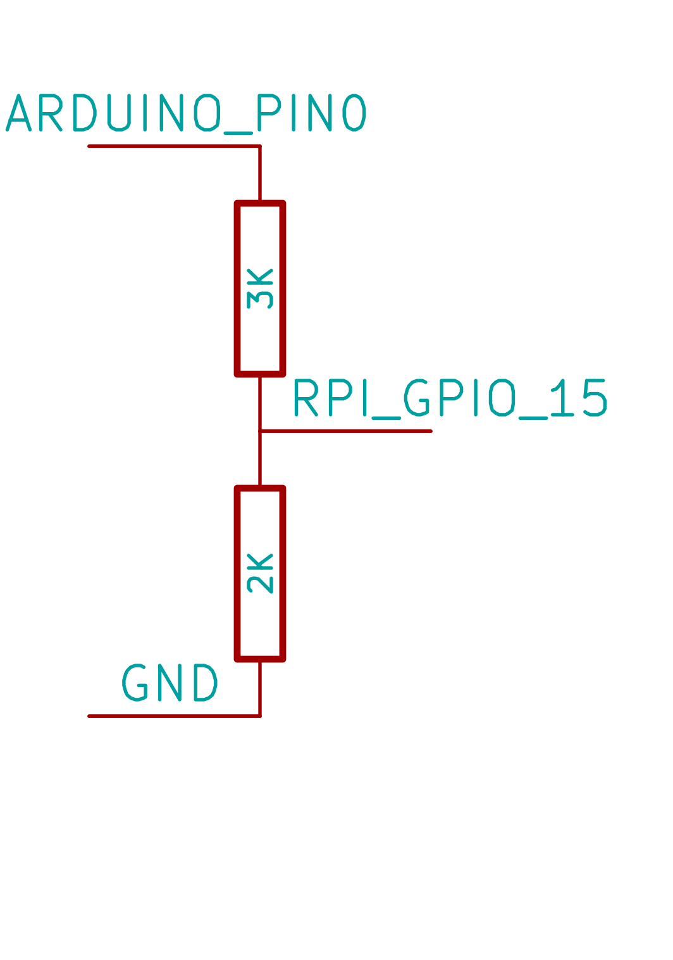
Shorting the stack
If the stack performance is poor, the stack can be run with short circuiting enabled. This is accomplished by holding down the shorting button while pressing the on button. The RaspberryPi should not be connected if this is done as it will lose power when the stack is shorted.

