Documentation
PostgreSQL

For easier demonstration and explanation, I’ll be using pgAdmin 4. You can find it alongside SQL Shell after you install PostgreSQL (depends on where you placed it after installation)
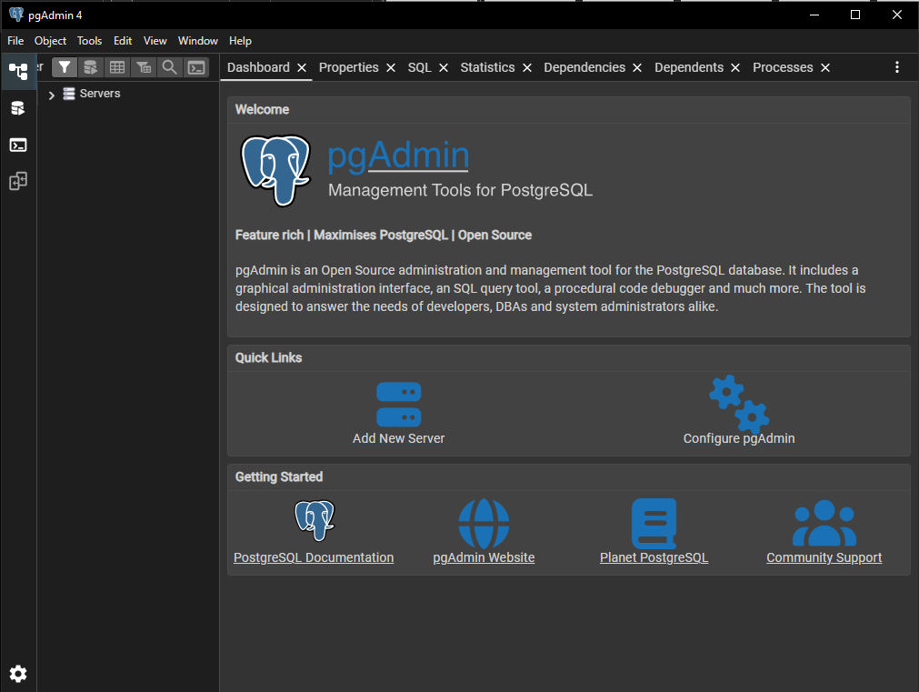

Dependencies – pg (for js and postgresql connectivity)
npm install pg

Initial Installation
Create the database for the project with the name db_users
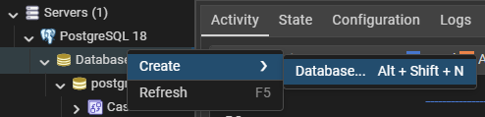
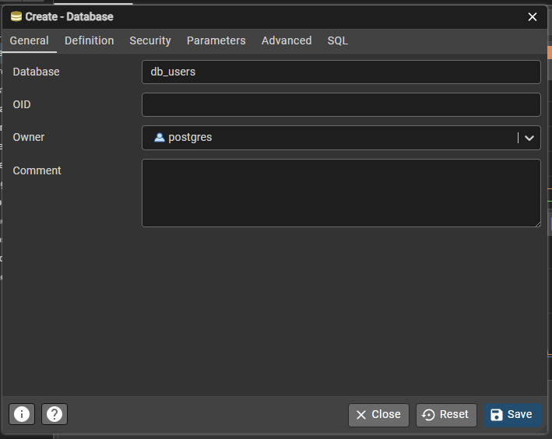

For psql:
CREATE DATABASE db_users
WITH
OWNER = postgres
ENCODING = 'UTF8'
LOCALE_PROVIDER = 'libc'
CONNECTION LIMIT = -1
IS_TEMPLATE = False;

Right click the db you made then press PSQL Tool
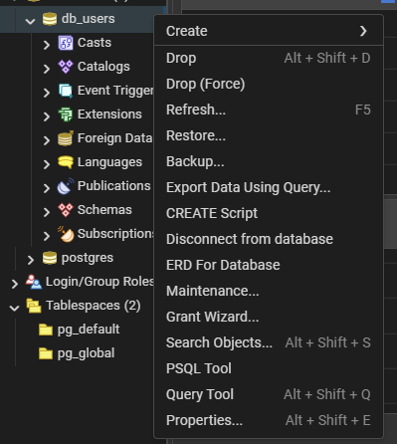

Create a table named tbl_users
(NOTE: IF YOU MADE A MISTAKE BEFORE THE CURRENT LINE, YOU CANNOT GO BACK)
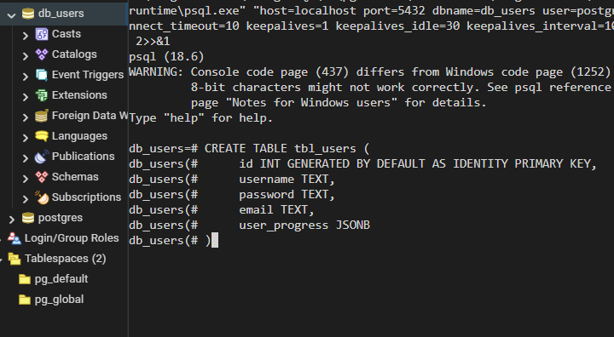
CREATE TABLE tbl_users (
id INT GENERATED BY DEFAULT AS IDENTITY PRIMARY KEY,
username TEXT,
password TEXT,
email TEXT,
user_progress JSONB
);
JSONB is a modern version of the old JSON data type, JSONB is slower than JSON when writing but JSONB is pre-parsed, has indexing, no strict column order and stored as decompressed binary.

VIEWS
Views are pre-constructed queries (shortcuts) that the back-end can utilize. But first, it must be initialized before it can be used

Ex.
CREATE VIEW getAllUsers AS
SELECT username, email
FROM tbl_users;

SELECT * FROM getAllUsers; // Returns usernames and emails from tbl_users

VIEWS List
// Returns usernames from tbl_users
CREATE VIEW getAllUsers AS
SELECT username, email
FROM tbl_users;

SELECT * FROM getAllUsers;

NOTE DYNAMIC VARIABLE HANDLING STILL UNDER STUDY

SELECT COMMANDS
Pretty much the same with MSQL commands except JSONB

List
// Login Check
SELECT id
FROM tbl_users
WHERE (username = ‘?’ OR email = ‘?’) AND password = ‘?’;

// Get User Progress
SELECT user_progress
FROM tbl_users
WHERE id = ?;

// Get Specific User Progress
( Retrieve JSON element = [->], Retrieve the text inside the JSON element = [->>])
SELECT user_progress -> ‘Progress’ ->> ‘Lesson1’
FROM tbl_ users
WHERE id = ?;

INSERT COMMANDS
Same with MYQL
Ex.
INSERT INTO tbl_users (username, password, email, user_progress)
VALUES
(‘Setsu’, ‘Pass’, ‘setsudesu17@gmail.com’,
'{
“Progress”: {
“Lesson1”: “Finished”,
“Lesson2”: “Current”,
“Lesson1”: “NotStarted”
},
“QuizProgress”: {
“Quiz1”: “Finished”,
“Quiz2”: “Current”,
“Quiz1”: “NotStarted”
},
“QuizScores”: {
“Quiz1”: 100,
“Quiz2”: “Current”,
“Quiz3”: “NotStarted”
}
}'::jsonb
);
// When inserting 2 or more, just add more below VALUES ex. VALUES (insertrow1), (insertrow2);
UPDATE COMMANDS
Same with MYSQL except JSONB

// Change Username, Password, Email
UPDATE tbl_users
SET username = ‘new_username’ // password = ‘new_password’ // email = ‘new_email’
WHERE id = ?;

// Update user_progress
UPDATE tbl_users
SET user_progress[ ‘PARENT’ ][ ‘CHILD’ ] = ‘ ”newVal” ‘::jsonb
WHERE id = ?;
// Parents = [ “Progress”, “QuizProgress”, “QuizScores” ];
// Children = (Anything under the parents [ex. Progress = ( “Lesson1”, “Lesson2”, “Lesson3” )])

