POSTGRES Documentation
Forgot Password – [Unfortunately, Windows only]
Yeah I forgot mine so ima do a documentation to prevent others to make my mistake

First, locate your PostgreSQL folder (unless you moved it or relocated it, it is usually located in C:\Program Files\PostgreSQL) and move to [version], in my case; 18.

Go to data and locate pg_hba.conf file

Open it using notepad, vscode or anything u like as long as you can modify the text
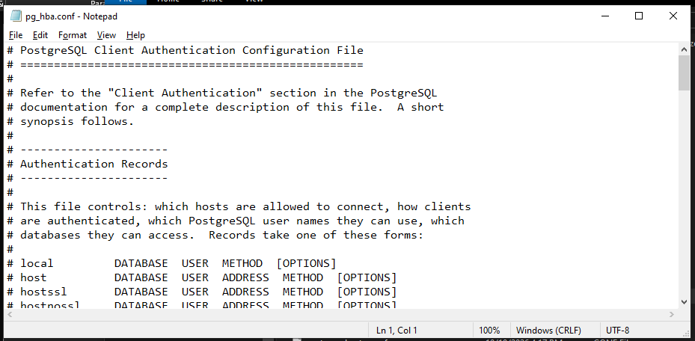
Scroll down till you find these lines:
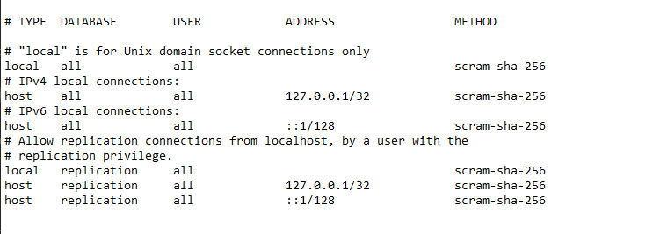

Edit the security method (METHOD) for all connections and change it into trust, this makes postgres to automatically trust your device and not require authentication from you. Save the file right after [DO NOT CLOSE THIS WINDOW YET, WE NEED TO CHANGE IT BACK AFTER FOR SAFETY REASONS]
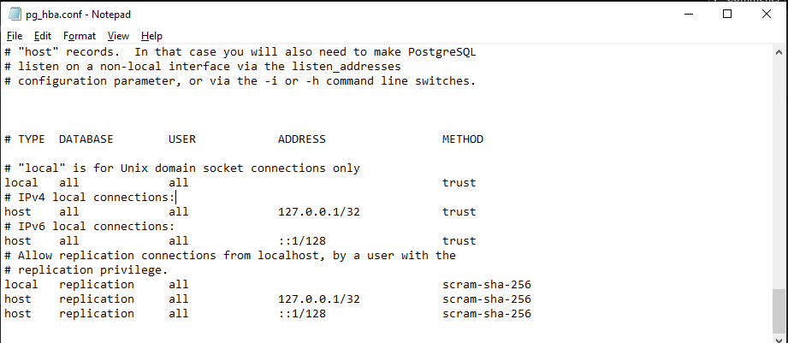

Open Services (search it in the windows search bar) and locate the postgres service, restart the service so the modified value earlier can take effect [Do not close this yet, because we will need to restart the service again after reverting our changes]
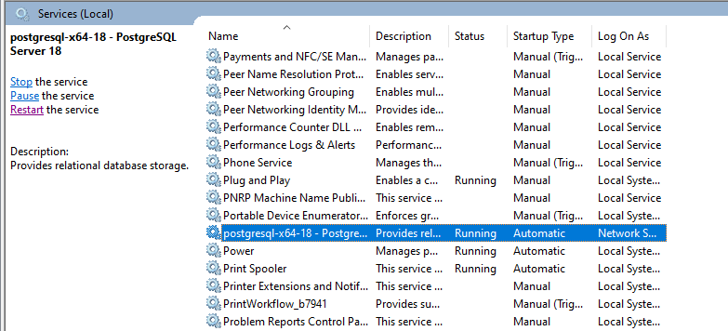

Proceed to pgAdmin and click on servers, it will still ask for a password. Now you can just press enter even if its blank. You will now be able to login back
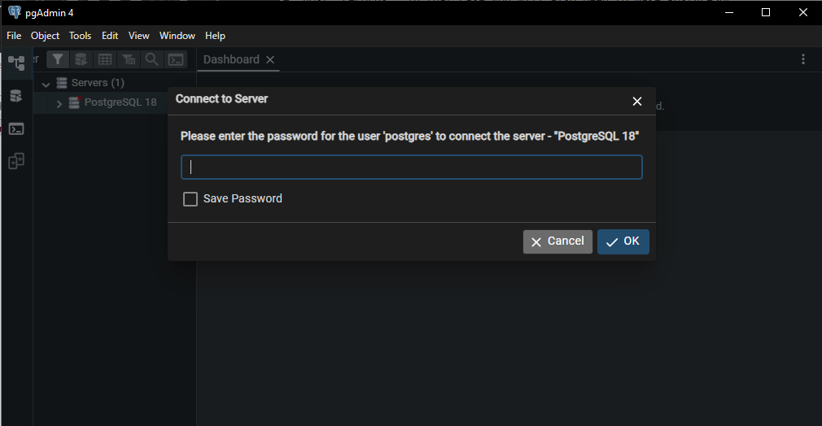

After that, locate Login/Group Roles under PostGreSQL 18. Find postgres account, right click then click properties and change its password under definition, save it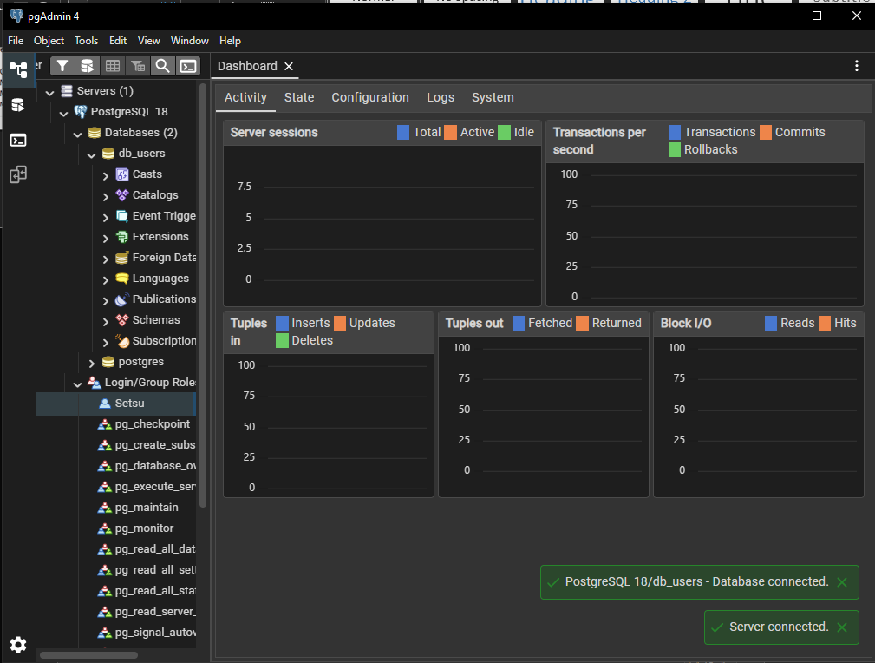
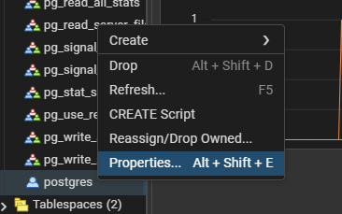
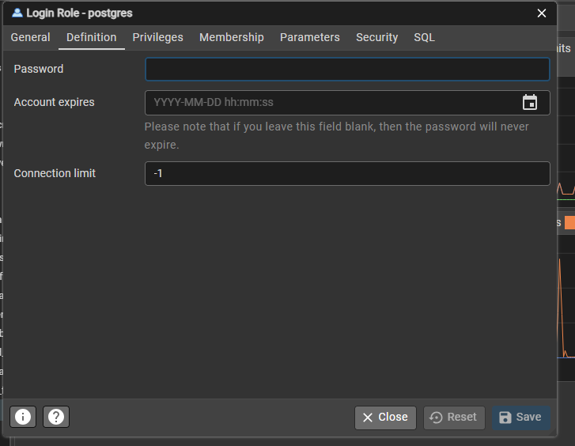

Now go back to the pg_hba.conf and change the method back to scram-sha-256, save it and close the window
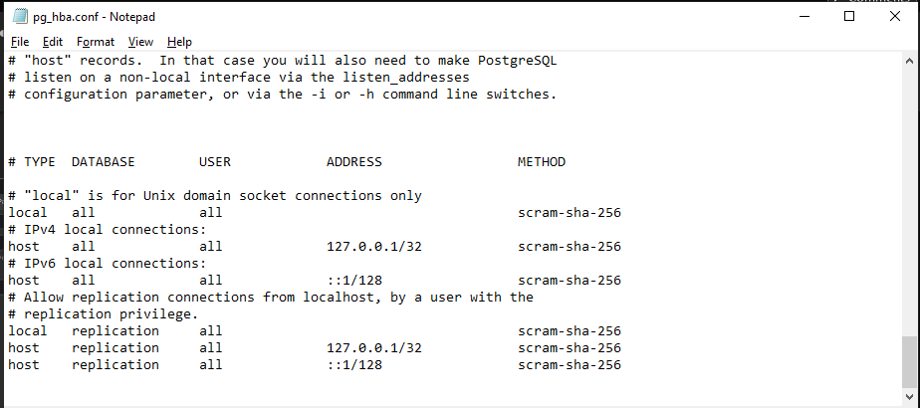

Restart the postgresql service and you are all done!


