Sensors’ Details:

1. Dallas Instrument Temperature sensor (DS18B20):
2. Communicates over one-wire bus communication
3. Power supply range: 3.0V to 5.5V
4. Operating temperature range: -55ºC to +125ºC
5. Accuracy +/-0.5 ºC (between the range -10ºC to 85ºC)

Source: <https://www.analog.com/media/en/technical-documentation/data-sheets/ds18b20.pdf>

1. DF Robot Turbidity (NTU value) sensor (SEN0189):

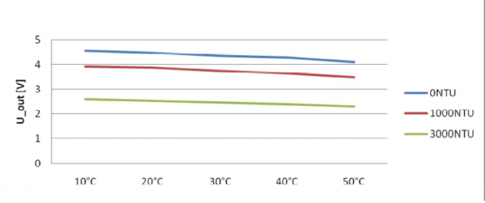

Source: https://wiki.dfrobot.com/Turbidity_sensor_SKU__SEN0189

1. Operating Voltage: 5V DC
2. Operating Current: 40mA (MAX)
3. Response Time: <500ms
4. Insulation Resistance: 100M (Min)
5. Output Method: Analog
6. Analog output: 0-4.5V
7. Digital Output: High/Low-level signal (you can adjust the threshold value by adjusting the potentiometer)
8. Operating Temperature: 5℃~90 ℃

1. DF Robot Dissolved Oxygen sensor (SEN0237):

Dissolved Oxygen Probe

* 1. Type: Galvanic Probe
  2. Detection Range: 0~20 mg/L
  3. Temperature Range: 0~40 ℃
  4. Response Time: Up to 98% full response, within 90 seconds (25℃)
  5. Pressure Range: 0~50 PSI
  6. Electrode Service Life: 1 year (normal use)
  7. Maintenance Period:
     1. Membrane Cap Replacement Period:
        1. 1~2 months (in muddy water);
        2. 4~5 months (in clean water)
     2. Filling Solution Replacement Period: Once every month

Signal Converter Board

1. Supply Voltage: 3.3~5.5V
2. Output Signal: 0~3.0V
3. Signal Connector: Gravity Analog Interface (PH2.0-3P)

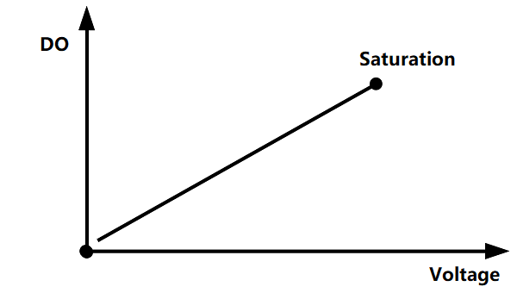

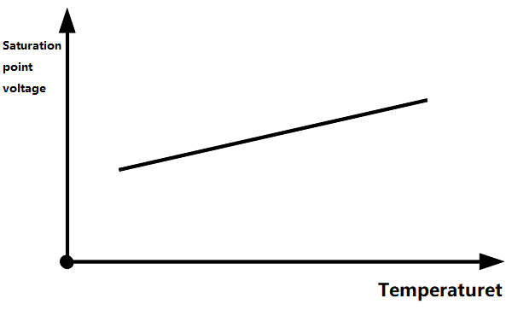

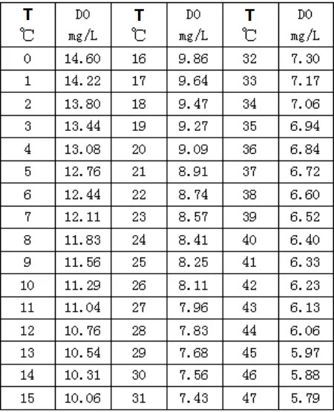

Source: <https://wiki.dfrobot.com/Gravity__Analog_Dissolved_Oxygen_Sensor_SKU_SEN0237>

1. DF Robot pH sensor V2.2 (SEN0161-V2):

**Signal Conversion Board (Transmitter) V2**

Supply Voltage: 3.3~5.5V

Output Voltage: 0~3.0V

Probe Connector: BNC

Signal Connector: PH2.0-3P

Measurement Accuracy: ±0.1@25℃

**pH Probe**

Probe Type: Laboratory Grade

Detection Range: 0~14

Temperature Range: 5~60°C

Zero Point: 7±0.5

Response Time: <2min

Internal Resistance: <250MΩ

Probe Life: >0.5 year

Source: https://wiki.dfrobot.com/Gravity__Analog_pH_Sensor_Meter_Kit_V2_SKU_SEN0161-V2

1. MQ-137 Ammonia sensor:

Source: <https://cdn.sparkfun.com/assets/7/0/2/f/8/MQ137__Ver1.4__-_Manual.pdf>

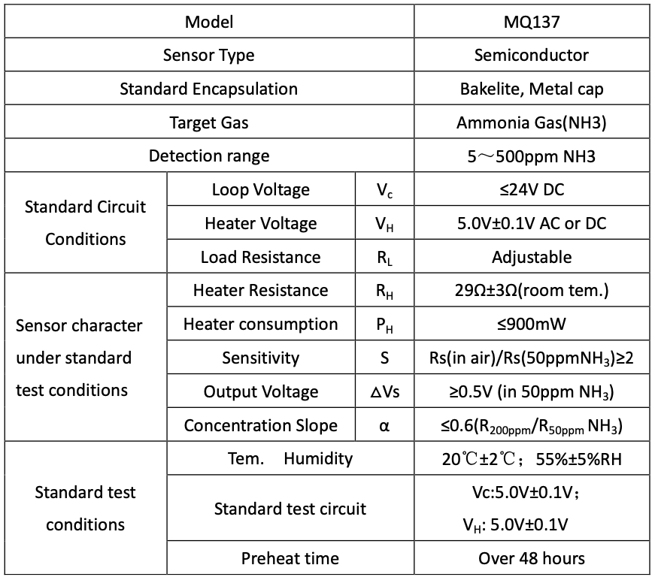

1. MQ-135 Nitrate sensor:

Source: <https://components101.com/sensors/mq135-gas-sensor-for-air-quality>

* Wide detecting scope
* Fast response and High sensitivity
* Stable and long life
* Operating Voltage is +5V
* Detect/Measure NH3, NOx, alcohol, Benzene, smoke, CO2, etc.
* Analog output voltage: 0V to 5V
* Digital output voltage: 0V or 5V (TTL Logic)
* Preheat duration 20 seconds
* Can be used as a Digital or analog sensor
* The Sensitivity of Digital pin can be varied using the potentiometer

