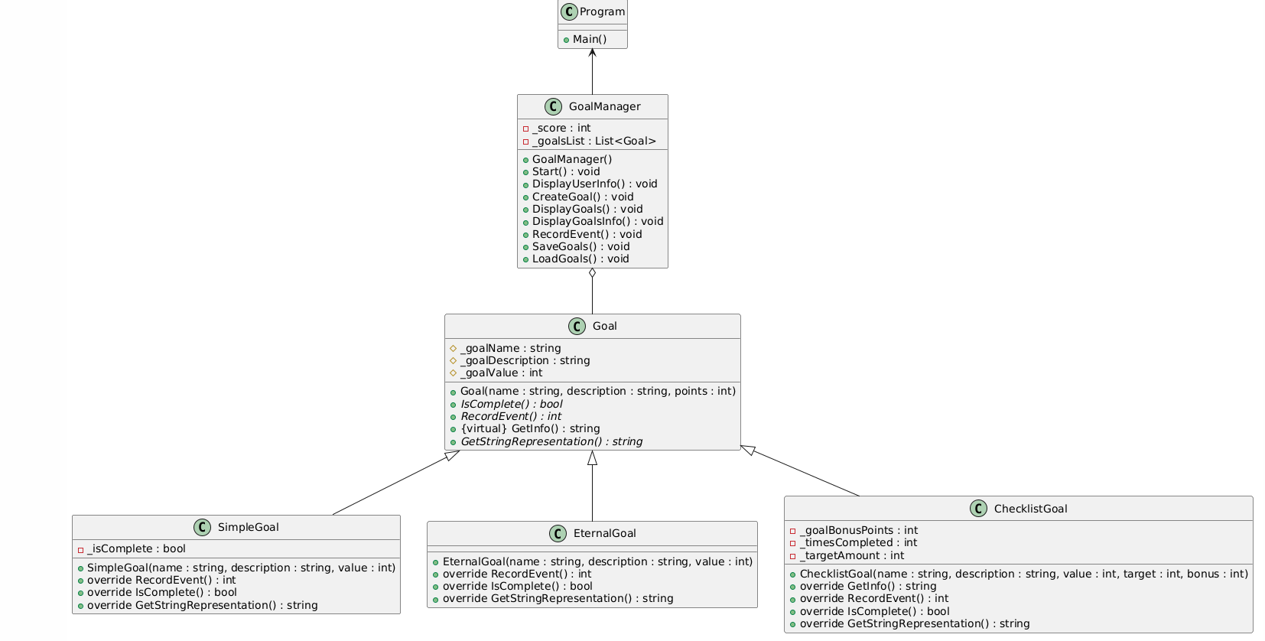

The base goal class provides a few common protected variables and functions that set up for the three classes of Simple Goal, Eternal Goal, and Checklist Goal. Each of these classes has a few overrides to tailor to the specific information that needs to be returned or processed. The Goal Manager acts as an interface and processor for all of this information, enabling the saving and loading of files and interacting with the main program to allow for a smooth user interaction experience without cluttering the main program itself.

