DataGuard DG-100
Optical Chamber Bench Bring-up & Calibration Checklist
Getting the dual-wavelength ADPD4101 scatter chamber returning real, calibrated smoke data

Arctic Engineering · Cape Town
Document owner: ___________________ Version: _______ Date: ____ / ____ / 2026
This is the core novel element and the hardest electromechanical step — record measurements and photographs at every numbered step as design evidence.

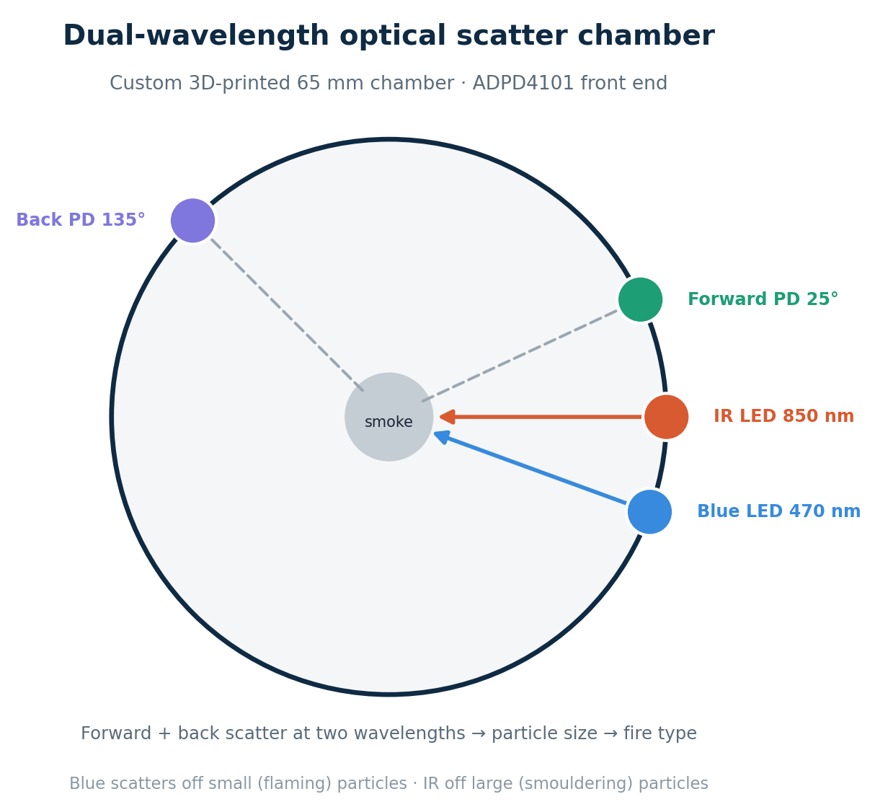
Top-down cross-section: IR 0°, blue 340°, forward PD 25°, back PD 135° in the 3D-printed chamber.

Prerequisites

- Populated chamber: 2 LEDs (IR 850 nm, blue 470 nm) and 2 photodiodes (BPW34) seated at their bore angles; PDs shielded from direct LED line-of-sight.
- Breakout: EVAL-ADPD4101-ARDZ assembled; LEDs on LEDX1/LEDX2, PDs on IN1/IN2.
- Power: ADPD VDD on 3V3; VLED on a separate clean rail; common ground.
- Tooling: EVAL board + ADI Wavetool/evaluation software on a PC; USB; clean-air environment and the two smoke sources.

Calibration & bring-up steps

# | Check / method | Expected result | Result · date · initials
1 | Power on; read the chip ID over I²C at 0x24. Record the value. | Device responds; ID recorded (confirm against datasheet for your silicon revision).
2 | Dark test — all LEDs off, read all four channels. | Low / near-zero counts — confirms on-chip ambient rejection is working.
3 | In Wavetool, configure two time-slots: Slot A = IR (LEDX1), Slot B = Blue (LEDX2); each slot samples IN1 (forward) and IN2 (back). Set pulse count and integration window. | Four channels (fwd-IR, back-IR, fwd-blue, back-blue) report data.
4 | Tune LED currents in clean air, one wavelength at a time. | Each channel sits well above noise but is not saturated; record the LED current per wavelength.
5 | Capture a clean-air baseline (≈64-sample average). Record fwd_ir, fwd_blue, back_ir, back_blue. | Stable baseline; values recorded as the clean-air zero.
6 | Smouldering test — introduce large-particle smoke. | Total scatter rises; forward/back ratio high; blue/IR ratio near 1 (large particles). Record.
7 | Flaming test — introduce fine-particle smoke. | Blue/IR ratio rises (small particles); forward/back lower. Record — this validates particle-size discrimination, the key R&D outcome.
8 | Export the register set from Wavetool; paste into ADPD_INIT[] in adpd4101.h, ending with the go-active write. | Register array populated from the empirically tuned configuration.
9 | Verify the five 'VERIFY' register addresses (FIFO status, chip ID, op-mode, FIFO data, expected ID) against the datasheet; confirm 16-bit register addressing. | Register map confirmed for your part.
10 | Verify FIFO unpack in readResultSet(): FRAME_BYTES and channel order (A-IN1, A-IN2, B-IN1, B-IN2) match the slot configuration. | Unpacked channels map to the correct physical PD/wavelength.
11 | Flash firmware; watch the serial log on boot. | '[ADPD4101] Baseline:' prints non-zero, stable counts in clean air.
12 | Enable the chamber from the admin UI (use_adpd = true) — no reflash. | confstate echoes the change; chamber.smoke_pct begins populating telemetry.
13 | Calibrate smoke_fullscale (adpd_fullscale) against a known obscuration / reference detector. | Reported smoke % tracks the reference (lower fullscale = more sensitive).
14 | Tune ratio cut-offs (irblue_small/large, fwdback_small/large) so the fire-type hint matches the smouldering vs flaming sources from earlier steps. | Hint correctly reports smouldering / flaming / mixed.
15 | Repeatability — repeat the clean-air → smoke cycle three times. | Baseline re-zeros each time; smoke % repeatable within tolerance.

Troubleshooting

Symptom | Likely cause & action
Chip ID mismatch / no I²C response | Check 0x24 address, wiring, and that the breakout is powered. Some revisions report a different ID — confirm against the datasheet before assuming a fault.
One channel reads zero | Photodiode polarity reversed, or that PD/LED not seated. Re-check anode/cathode and the bore.
Channel saturates | LED current too high or ambient leak into the chamber; reduce current, improve light-sealing.
Noisy / drifting reads | VLED likely sharing the ESP32 supply — move it to a separate clean rail. Check grounding.
No FIFO data | Time-slot/FIFO configuration or FIFO status mask wrong; re-check the Wavetool export and FRAME_BYTES.
Smoke % won't track reference | Re-run clean-air baseline; adjust adpd_fullscale; confirm the reference detector and chamber see the same smoke.

Sign-off
Role | Name / signature | Date
Built / tested by
Reviewed by
Approved by

