DataGuard DG-100
R&D Evidence Dossier
Supporting a UK R&D tax-relief claim — proof of design and technological advance

Arctic Engineering · Cape Town
Document owner: ___________________ Version: _______ Date: ____ / ____ / 2026
Draft for completion with your R&D tax adviser. Bracketed fields [ ] require company-specific dates, names and figures.

Disclaimer. This dossier organises the technical evidence for an R&D tax-relief claim under the UK scheme. It is not tax advice. The qualifying activities, boundaries and costs should be confirmed with a qualified R&D tax adviser or accountant before submission, and the framing tested against the current HMRC guidance (the DSIT/BEIS guidelines on the meaning of R&D).

1. Company & project summary

Field | Detail
Company | Arctic Engineering [legal entity name / company number]
Project | DataGuard DG-100 — multi-modal early fire detection & classification platform
Field of technology | Embedded electronics, optical sensing, fire detection & multi-sensor signal fusion
Accounting period(s) claimed | [period start] – [period end]
Competent professional(s) | [Name(s) and qualifications — e.g. electronic / embedded engineer responsible]
Project status at date of dossier | Software platform built and verified; custom optical chamber designed, with electromechanical integration and calibration in progress.

2. The advance in science or technology sought

The project seeks an appreciable improvement over the readily-available baseline in fire detection technology: a single, low-cost device that not only detects a fire earlier than a conventional detector, but classifies the type of fire (smouldering, flaming or electrical overheating) by fusing several complementary sensing modalities — combustion gases, volatile organics, precise rate-of-rise temperature, aspirating smoke, and a custom dual-wavelength optical scatter chamber that infers particle size.
The intended advance is twofold: (a) earlier and more reliable detection in the smouldering phase, and (b) a substantial reduction in false alarms — a critical requirement in data-centre environments where a needless suppression discharge is itself a costly incident — achieved at a bill-of-materials cost that scales across a large fleet.

3. Baseline — the readily-available state of technology

Against which the advance is measured:
- Conventional point smoke detectors are single-modality and react comparatively late, after visible smoke.
- High-end aspirating detectors (e.g. VESDA) are sensitive but expensive and still read a single modality — they detect smoke, not the nature of its source.
- Generic optical smoke sensors typically use a single wavelength and cannot discriminate particle size, so cannot distinguish a smouldering fire from a flaming one, nor smoke from steam.
- Multi-sensor fusion is discussed in the literature, but no integrated, low-cost product combining a custom dual-wavelength forward/back scatter chamber with this particular sensor set and on-device classification was readily available or deducible by a competent professional from existing knowledge.

4. The scientific & technological uncertainties

The emphasis of the R&D — and the source of genuine uncertainty — is the electromechanics and mixed-signal integration, not the application logic. The principal uncertainties are:
# | Technological uncertainty
U1 | Optical chamber design. Whether a custom 3D-printed dual-wavelength, forward/back-scatter geometry could produce repeatable, separable signals that map scatter ratios to particle size for fire-type classification. Chamber geometry, bore angles, LED drive currents, internal reflections and baseline drift were all unknown in advance and not derivable from a datasheet.
U2 | Mixed-signal integration. Whether microvolt-level electrochemical gas measurements, a high-impedance optical front-end, an SPI precision-RTD and aspirating analog inputs could coexist on one microcontroller and a shared I²C bus without unacceptable cross-talk — including coupling of the optical LED drive pulses and multi-device bus loading.
U3 | Calibration & repeatability. Whether clean-air baselining and runtime calibration could deliver repeatable obscuration/percentage readings across separate physical builds and over time, given drift, ambient light and temperature effects.
U4 | Fusion for false-alarm rejection. Whether a scoring/fusion scheme across heterogeneous, not-absolutely-calibrated signals could simultaneously achieve earlier detection and reject confounders such as steam, cooking and humidity.
U5 | Field-deployable system. Whether all of the above could be achieved within embedded power, memory and cost constraints while remaining remotely tunable in the field without re-flashing.

5. How the uncertainties are being resolved

The work is a systematic investigation, proceeding by design, build, measurement and iteration rather than by routine application of existing methods:
- Iterative design of the optical chamber — CAD and 3D-print revisions of the chamber body and bore angles, and selection of emitter/detector wavelengths and positions.
- Driver development and bench experimentation using the ADI Wavetool to configure the two optical time-slots and empirically tune LED currents until forward/back scatter is clean and separable.
- Controlled experiments with smouldering versus flaming smoke sources to test whether dual-wavelength scatter reliably discriminates particle size (recorded in the chamber bench checklist).
- A deliberate architectural response to uncertainty: a runtime-tunable configuration layer that allows every detection threshold to be adjusted live, without re-flashing — enabling efficient empirical exploration of the parameter space during development.
- A staged bring-up and test protocol with explicit pass/fail criteria and recorded measurements, plus an independent review and hardening of the codebase.
Iterations and unsuccessful attempts are retained as evidence: the process of resolving the uncertainty — including approaches that did not work and were revised — is itself the qualifying R&D.
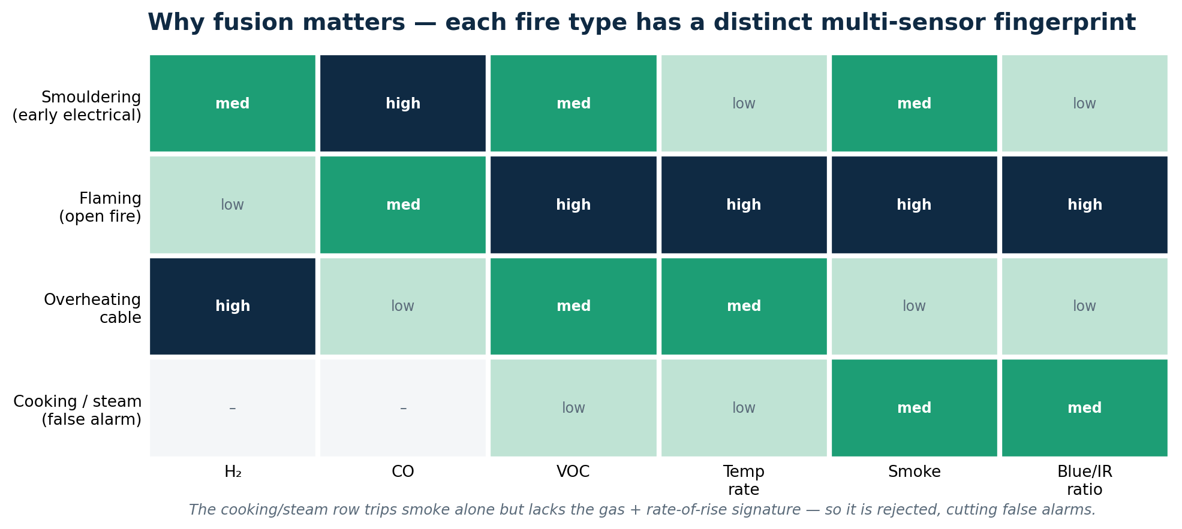
Working hypothesis under test: each fire type — and each false alarm — produces a distinct multi-sensor signature.

6. Competent professionals

The work is led by [name/role], an embedded electronics engineer with experience in [domain]. The uncertainties above were not readily resolvable by a competent professional from publicly available knowledge: the integration of a custom dual-wavelength scatter chamber with this sensor suite, and the calibration to achieve repeatable particle-size discrimination, required original experimentation rather than the routine application of established techniques.

7. Project timeline & iterations

Complete this log as work proceeds; it is the spine of the evidence base. Each row should tie an activity to the uncertainty it addressed and the outcome.
Date | Activity | Uncertainty | Outcome / iteration
[date] | Chamber geometry design & first 3D print | U1 | [outcome]
[date] | ADPD4101 driver + Wavetool slot configuration | U1, U2 | [outcome]
[date] | LED current tuning & clean-air baseline | U1, U3 | [outcome]
[date] | Smouldering vs flaming discrimination tests | U1, U4 | [outcome]
[date] | Multi-sensor integration & bus noise work | U2 | [outcome]
[date] | Fusion / false-alarm rejection tuning | U4 | [outcome]
[date] | [ ... ] |  | [ ... ]

8. R&D boundary & qualifying activities

The R&D begins when work to resolve the technological uncertainty starts and ends when that uncertainty is resolved (or work to resolve it ceases). Routine production, cosmetic or purely commercial work falls outside — confirm the precise boundary with your adviser.
- Qualifying (indicative): chamber design iterations; driver and firmware development addressing the uncertainties; bench experimentation and calibration; integration and noise-mitigation work; analysis of test results.
- Likely non-qualifying (indicative): routine assembly once the design is proven; marketing, sales and general business activity; final productionising that contains no remaining uncertainty.

Indicative qualifying cost categories
To be quantified with your adviser:
Category | Notes
Staff costs | Time of the competent professional(s) and supporting staff on qualifying activities.
Subcontractors / externally provided workers | Any outsourced engineering, per the scheme rules.
Consumables / prototype materials | Optical components, breakout board, sensors, 3D-print materials and parts consumed in development.
Software / cloud | Development tooling and cloud services used in the R&D.
Utilities | Apportioned power/heat/water consumed in the R&D, per the scheme rules.

9. Evidence index

The artefacts below substantiate the claim. Map each uncertainty to its supporting evidence.
Evidence | Substantiates
3D model / CAD of the optical chamber & revision history | U1 — design iteration
Firmware source & version-control commit history | U1, U2, U3, U4, U5 — systematic development
Prototype Bring-up & Test Protocol (with completed results) | U2, U3, U4 — integration & testing
Optical Chamber Bench Bring-up & Calibration Checklist (completed) | U1, U3 — optical design & calibration
Bench test logs, measurements & photographs | U1, U3, U4 — experimental record
Wavetool register exports & LED-current settings | U1 — empirical optical tuning
Bill of materials & purchase records | Cost evidence (consumables)
Dashboard / classification screenshots | U4 — fusion behaviour
Independent code-audit notes & fixes | Systematic, professional process

Next step. Complete the bracketed fields and the timeline as the prototype is brought up, attach the test records and photographs, and review the boundary and costs with your R&D tax adviser before submission.

