*Arctos Webinar 1*  
**October 2nd 2017, 10:39 am EDT**

**How does your current level of knowledge about Arctos compare to that prior to the webinar?**

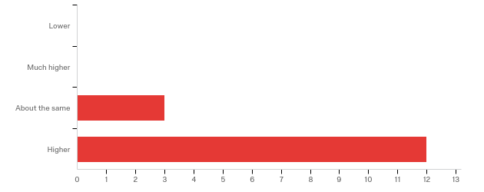

**The overall quality of the webinar was:**

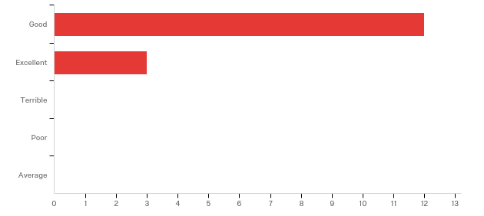

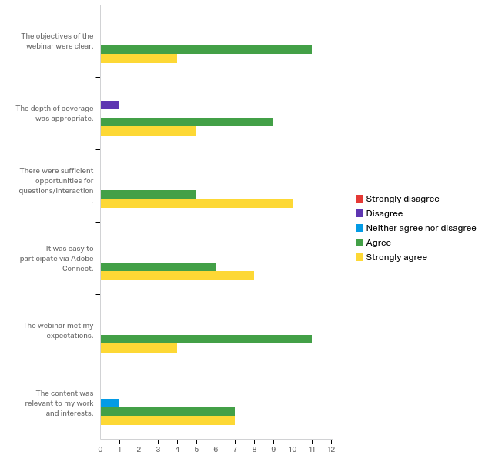

**Where did you learn about this webinar? Please check all that apply.**

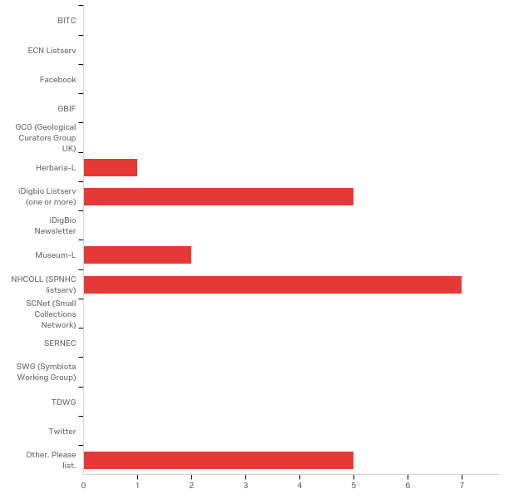

|  |
| --- |
| Other. Please list. |
| Arctos list |
| Arctos email |
| Arctic working group |
| Mammal-L |
| invitation from Mariel Campbell |

**In what country do you currently live?**

|  |
| --- |
| Argentina |
| US = 14 |

**Do you currently use Arctos as your collections data management system?**

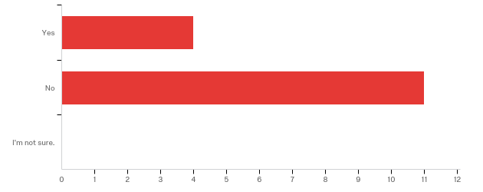

**Are you considering using Arctos as your collections management system in the future?**

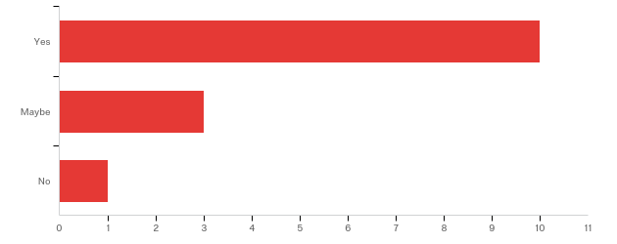

**Do you currently use Arctos to search for specimens as part of your research?**

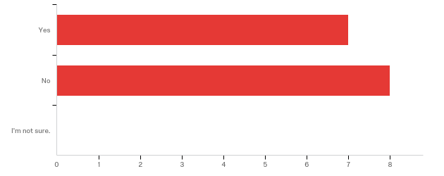

**Do you have any questions about Arctos that were not addressed in the webinar?**

|  |
| --- |
| The introduction was quickly very technical and hard to follow. I would suggest biting off smaller chunks of topic and explaining those really well and slowly. |
| getting started seems to a challenge. Would be great to review the steps for the newcomers |
| Not at this time. |

**Please share any ideas you may have for future Arctos webinar topics.**

|  |
| --- |
| How do collections decide which permissions to give to staff, students, etc. |
| All of those are already on the list! |
| Migrating data into ARCTOS Making labels, forms for loans, etc. |
| Using Arctos for ethnographic/cultural collections  **Any other comments, questions, or suggestions for improvement?**   |  | | --- | | Please increase the font size when showing computer screens. It was very hard to read and follow along on the web pages. Also, please flip through menus more slowly so we can keep track and possibly view them later. | | It was very hard to see and read fields on screen. Next time a zoomed in version would be nice. | | Thanks! | |

**What is your current gender identity?**

|  |  |  |
| --- | --- | --- |
| Answer | % | Count |
| Female | 60.00% | 9 |
| Male | 13.33% | 2 |
| Transgender | 0.00% | 0 |
| I do not wish to provide. | 26.67% | 4 |
| Total | 100% | 15 |

**Ethnic Identity**

|  |  |  |
| --- | --- | --- |
| Answer | % | Count |
| Hispanic or Latino | 20.00% | 3 |
| Not Hispanic or Latino | 60.00% | 9 |
| I do not wish to provide. | 20.00% | 3 |
| Total | 100% | 15 |

**Racial Identity. You may check more than one.**

|  |  |  |
| --- | --- | --- |
| Answer | % | Count |
| American Indian or Alaskan Native | 0.00% | 0 |
| Asian | 0.00% | 0 |
| Black or African American | 0.00% | 0 |
| Native Hawaiian or Other Pacific Islander | 0.00% | 0 |
| White | 73.33% | 11 |
| Other | 6.67% | 1 |
| I do not wish to provide. | 20.00% | 3 |
| Total | 100% | 15 |