*Arctos Webinar Oct 2018 Geographical Data*  
**November 5th 2018, 11:51 am EST**

**How does your current knowledge about how Arctos handles geographical data compare to that prior to the webinar?**

|  |  |  |
| --- | --- | --- |
| Answer | % | Count |
| Lower | 0% | 0 |
| About the same | 0% | 0 |
| Higher | 100% | 3 |
| Much higher | 0% | 0 |
| Total | 100% | 3 |

**The overall quality of the webinar was:**

|  |  |  |  |
| --- | --- | --- | --- |
| # | Answer | % | Count |
| 25 | Terrible | 0.00% | 0 |
| 26 | Poor | 0.00% | 0 |
| 27 | Average | 0.00% | 0 |
| 28 | Good | 66.67% | 2 |
| 29 | Excellent | 33.33% | 1 |
|  | Total | 100% | 3 |

**Where did you learn about this webinar? Please check all that apply.**

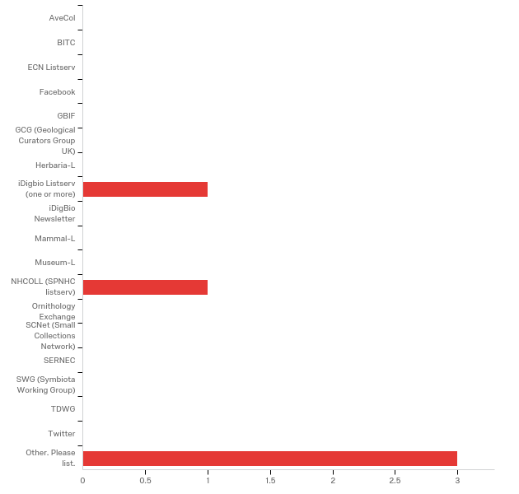

Other. Please list.

|  |
| --- |
| Arctos Working Group |
| Arctos List-Serv and from Mariel Campbell |
| Arctos Working Group |

**Do you have any questions about Arctos that were not addressed in the webinar?**

|  |
| --- |
| None |
| We look forward to Part II. |

**In what country do you currently live?**

|  |
| --- |
| USA |
| USA |
| USA |

**Which of the following describes your familiarity with Arctos?**

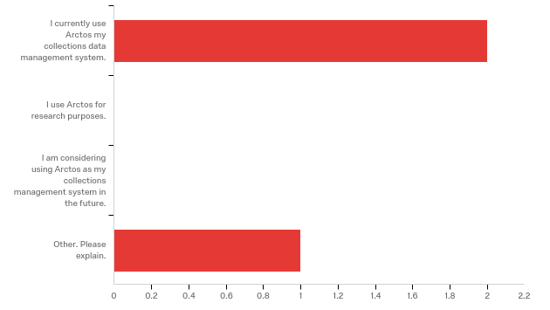

Other. Please explain.

|  |
| --- |
| Transitioning to Arctos |

**Any other comments, questions, or suggestions for improvement?**

|  |
| --- |
| Very clear. Excellent job! |