*Arctos Webinar December 2018 Taxonomy*

**How does your current knowledge about how Arctos handles taxonomy compare to that prior to the webinar?**

|  |  |  |
| --- | --- | --- |
| Answer | % | Count |
| Lower | 0% | 0 |
| About the same | 0% | 0 |
| Higher | 100% | 2 |
| Much higher | 0% | 0 |
| Total | 100% | 2 |

**The overall quality of the webinar was:**

|  |  |  |
| --- | --- | --- |
| Answer | % | Count |
| Terrible | 0.00% | 0 |
| Poor | 0.00% | 0 |
| Average | 0.00% | 0 |
| Good | 100.00% | 2 |
| Excellent | 0.00% | 0 |
| Total | 100% | 2 |

**Where did you learn about this webinar? Please check all that apply.**

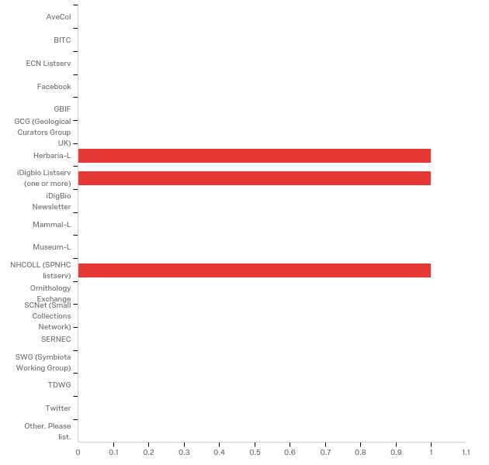

**Do you have any questions about Arctos that were not addressed in the webinar?**

|  |
| --- |
| The synonymy system and ease of adding new taxa seems dangerous. Also, shouldn't some classification ranks (e.g., kingdom, phylum) be required? |

**In what country do you currently live?**

|  |
| --- |
| US |

**Please share any ideas you may have for future Arctos webinar topics.**

|  |
| --- |
| It would be great to have some basic step-by-step instructions to follow for some of the topics. Something like a practice problem in a stats class. I can see that being really valuable for beginning Arctos users for both searches as well as collection databases entry. |

**Which of the following describes your familiarity with Arctos?**

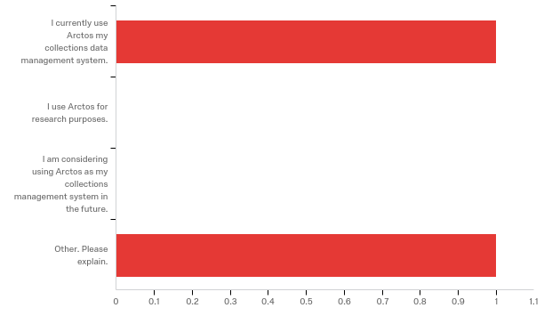

Other. Please explain.

|  |
| --- |
| transitioning to arctos |