***Arctos Webinar February Media***

**Which of the following describes your familiarity with Arctos?**

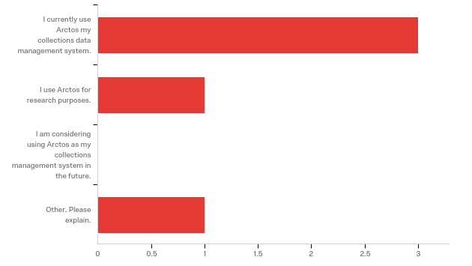

Other. Please explain.

|  |
| --- |
| I was interested in how far along the IT dimension of colllections management has come. |

**How does your current knowledge about how Arctos handles media compare to that prior to the webinar?**

|  |  |  |
| --- | --- | --- |
| Answer | % | Count |
| Lower | 0% | 0 |
| About the same | 0% | 0 |
| Higher | 80% | 4 |
| Much higher | 20% | 1 |
| Total | 100% | 5 |

**The overall quality of the webinar was:**

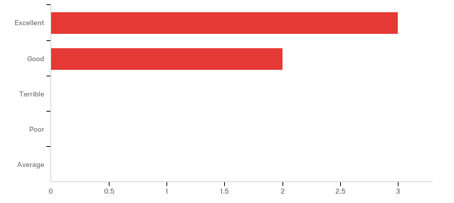

**Any other comments, questions, or suggestions for improvement?**

|  |
| --- |
| It's come a long way from the days of "my collection, my group, my data, show me your PhD diploma, Scientists-only" mentality, frankly all due to the IT revolution / evolution of the past 50 years. |

**Where did you learn about this webinar? Please check all that apply.**

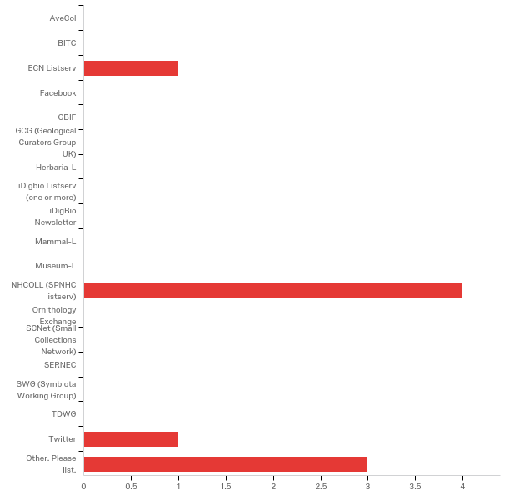

|  |
| --- |
| Other. Please list. |
| Arctos Working Group |
| Arctos Working Group |
| Colleague |

**Do you have any questions about Arctos that were not addressed in the webinar?**

|  |
| --- |
| How much will it cost to maintain the IT system (networked across existing collections) on a sustained basis? How much will it cost to pursue (design, develop, implement, maintain) the IT growth (new features, functionality, migration to newer technology, ...), and what are the prospects for funding such? |
| It makes me anxious to get our media uploaded to Arctos! |

**In what country do you currently live?**

USA n = 5