**Arctos Webinar September 10, 2019**

**Arctos Collection Metrics and Data Quality Improvement Tools**

**Which of the following describes your familiarity with Arctos?**

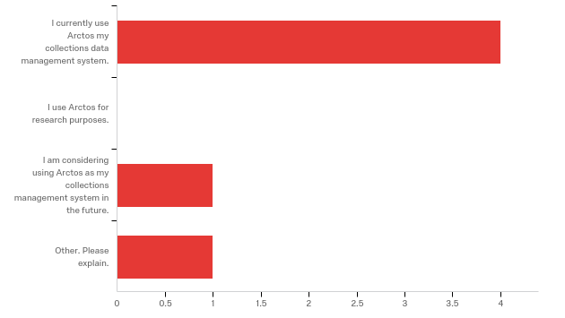

|  |
| --- |
| Other. Please explain. |
| I am a Database Manager who wants to know what databases are currently available and what they can do. |

**Where did you learn about this webinar? Please check all that apply.**

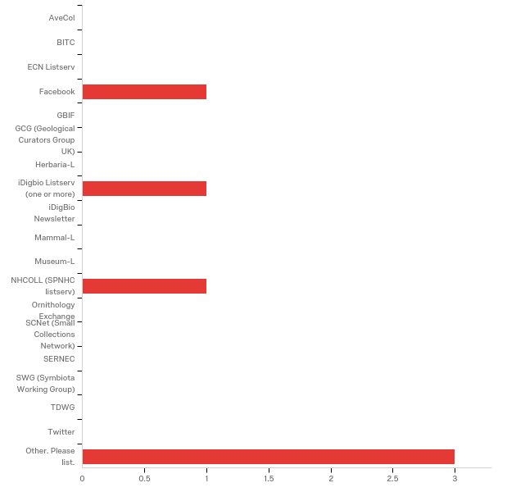

Other. Please list.

|  |
| --- |
| Arctos |
| Arctos Working Group |
| Arctos communications |

**In what country do you currently live?**

6 USA

**How does your current knowledge about using Arctos to manage collection metrics/improve data quality compare to that prior to the webinar?**

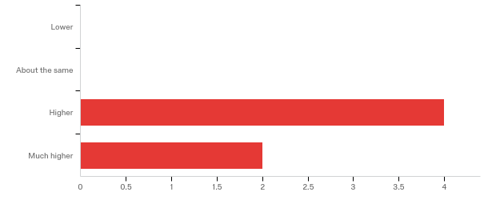

**The overall quality of the webinar was:**

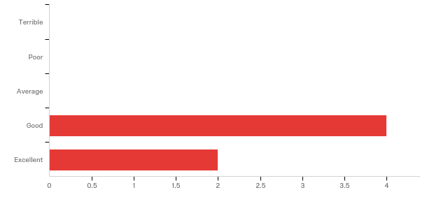

**Please share any ideas you may have for future Arctos webinar topics.**

|  |
| --- |
| How about one that looks at how you add operators to Arctos when you're setting up a collection or training new students. |

**Do you have any questions about Arctos' capabilities related to collection metrics or data quality that were not addressed in the webinar?**

No responses

**Any other comments, questions, or suggestions for improvement?**

No responses