*Arctos Webinar 2*  
**November 8th 2017, 10:37 am EST**

**How does your current level of knowledge about Arctos compare to that prior to the webinar?**

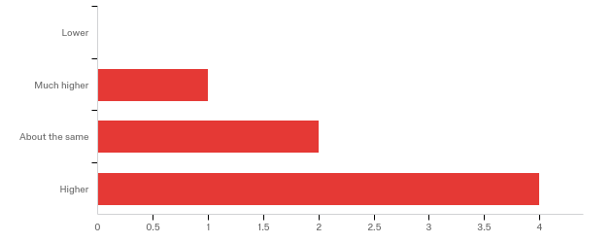

**Please rate your level of agreement with the following statements about the webinar:**

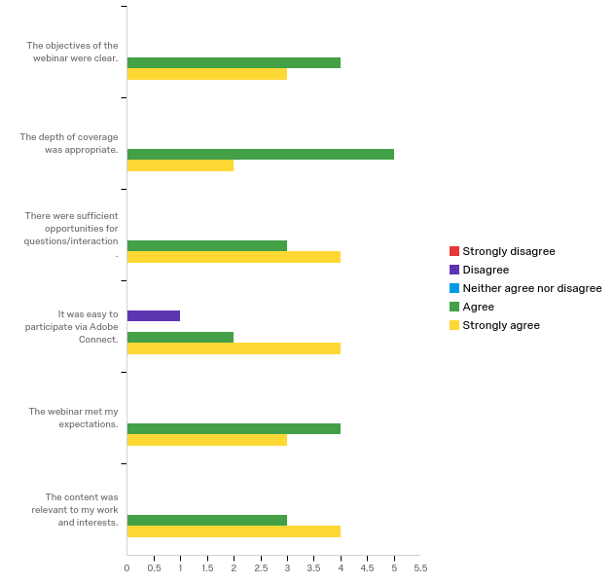

**The overall quality of the webinar was:**

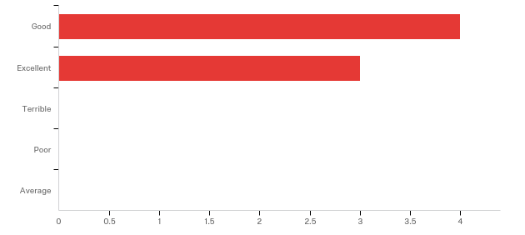

**Where did you learn about this webinar? Please check all that apply.**

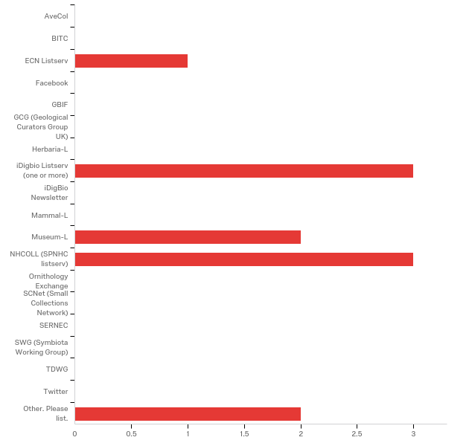

|  |  |  |
| --- | --- | --- |
| Answer | % | Count |
| AveCol | 0.00% | 0 |
| BITC | 0.00% | 0 |
| ECN Listserv | 9.09% | 1 |
| Facebook | 0.00% | 0 |
| GBIF | 0.00% | 0 |
| GCG (Geological Curators Group UK) | 0.00% | 0 |
| Herbaria-L | 0.00% | 0 |
| iDigbio Listserv (one or more) | 27.27% | 3 |
| iDigBio Newsletter | 0.00% | 0 |
| Mammal-L | 0.00% | 0 |
| Museum-L | 18.18% | 2 |
| NHCOLL (SPNHC listserv) | 27.27% | 3 |
| Ornithology Exchange | 0.00% | 0 |
| SCNet (Small Collections Network) | 0.00% | 0 |
| SERNEC | 0.00% | 0 |
| SWG (Symbiota Working Group) | 0.00% | 0 |
| TDWG | 0.00% | 0 |
| Twitter | 0.00% | 0 |
| Other. Please list. | 18.18% | 2 |
| Total | 100% | 11 |

Other. Please list.

|  |
| --- |
| Other. Please list. - Text |
| Work email |
| Marie Selby Botanical Gardens botany staff |

**Do you have any questions about searching in Arctos that were not addressed in the webinar?**

**In what country do you currently live?**

|  |
| --- |
| United States |
| USA |
| U.S. |
| USA |
| United States |
| USA |
| USA |

**Do you currently use Arctos as your collections data management system?**

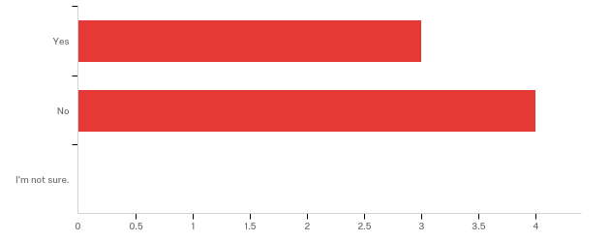

**Are you considering using Arctos as your collections management system in the future?**

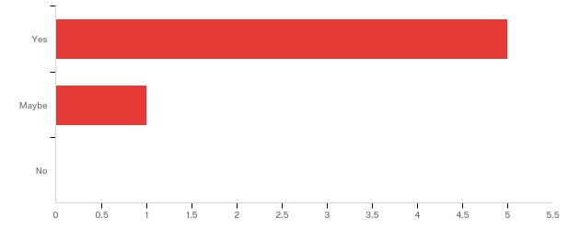

**Do you currently use Arctos to search for specimens as part of your research?**

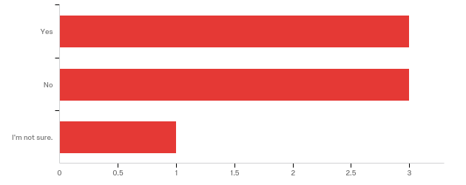

**Please share any ideas you may have for future Arctos webinar topics.**

|  |
| --- |
| Steps and pit falls of teaching Arctos use to students. |

**Any other comments, questions, or suggestions for improvement?**

|  |
| --- |
| Erica is a great host!! |