**Arctos Webinar 3 - Transactions**

Number of Respondents = 9; all US residents

**How does your current level of knowledge about Arctos compare to that prior to the webinar?**

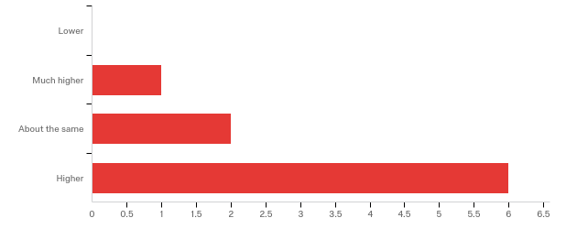

**Please rate your level of agreement with the following statements about the webinar:**

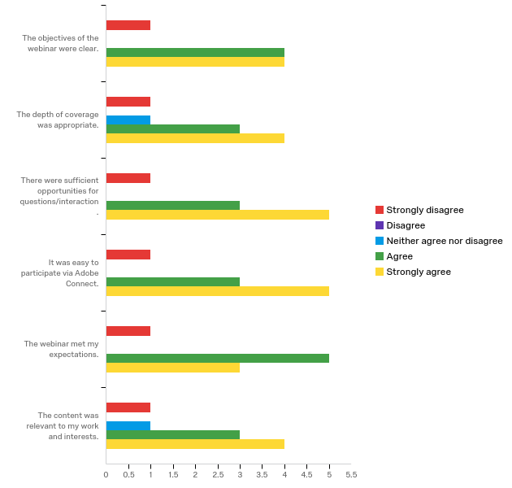

**The overall quality of the webinar was:**

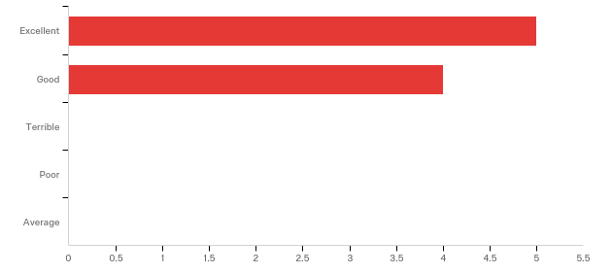

**Where did you learn about this webinar? Please check all that apply.**

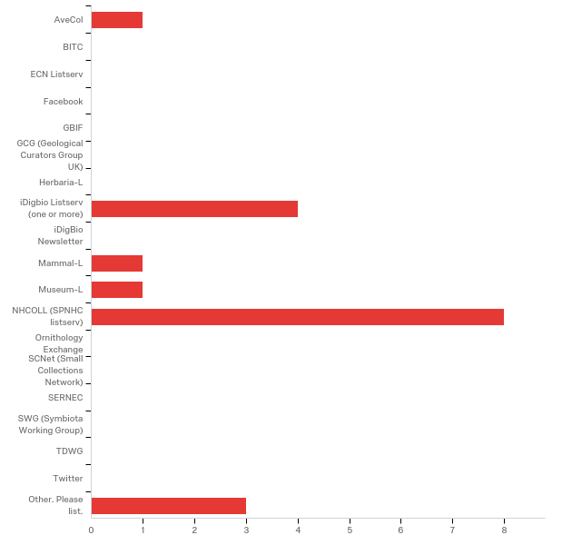

|  |
| --- |
| Other. Please list. - Text |
| Herbarium Curator |
| AWG |
| Arctos listserv |

**Do you have any questions about transactions in Arctos that were not addressed in the webinar?**

|  |
| --- |
| I'm new, but I'm learning more with each broadcast. |

**Any other comments, questions, or suggestions for improvement?**

|  |
| --- |
| Things were covered quite quickly - as there was quite a lot of ground to cover, it makes sense...and because I am new to hearing about Arctos. For others in the audience, the webinar might not have been as useful to them if you went over things in more depth. Not sure.... I need to do some homework on Arctos! :) |
| Multiple mics on at the same time for webinar presenters was distracting. |
| Make sure presenters speak into mike, sometimes it feels as if we are listening into a private conversation as some voices fade in and out |

**Which of the following describes your familiarity with Arctos?**

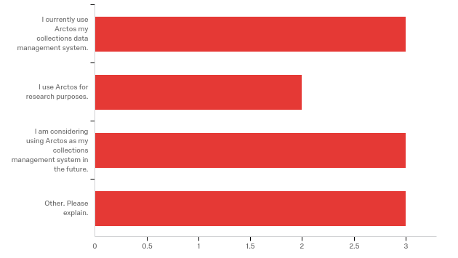

|  |
| --- |
| Other. Please explain. - Text |
| Just heard about Arctos. Seeing what it is all about. |
| We are in the process of migrating our data into Arctos |
| I use Specify and am curious about how transactions are handled in Arctos vs. Specify |