**Arctos Webinar 4 – Projects, Publications, Citations**

Number of Respondents = 7; all US residents

**How does your current level of knowledge about Arctos compare to that prior to the webinar?**

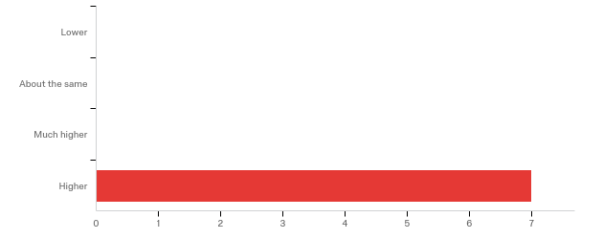

**Please rate your level of agreement with the following statements about the webinar:**

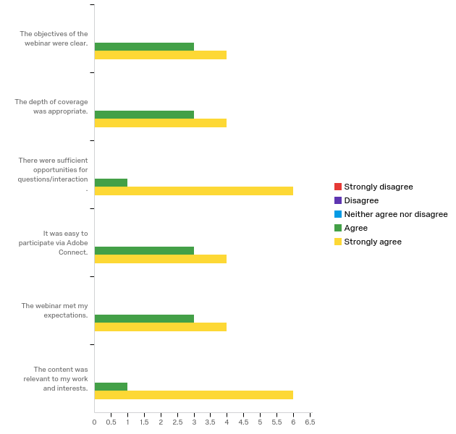

**The overall quality of the webinar was:**

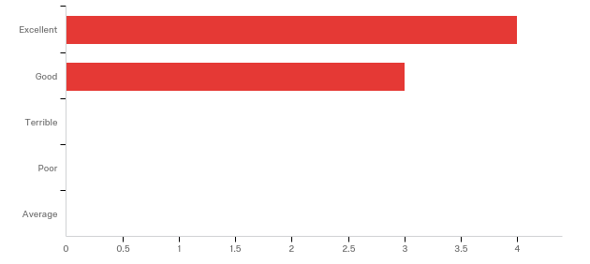

**Where did you learn about this webinar? Please check all that apply.**

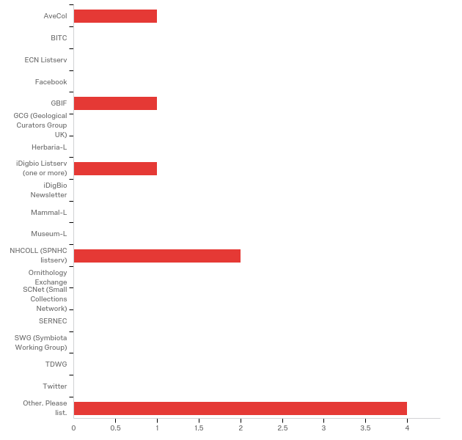

|  |
| --- |
| Other. Please list. - Text |
| Arctos googlegroup |
| Arctos Working Group |
| Arctos |
| Krimmel |

**Do you have any questions about projects, publications, and citations in Arctos that were not addressed in the webinar?**

|  |
| --- |
| I had several questions answered about things I didn't understand previously. |

**Any other comments, questions, or suggestions for improvement?**

|  |
| --- |
| Excellent job! |

**Please share any ideas you may have for future Arctos webinar topics.**

|  |
| --- |
| Bulkloading citations demonstrated as part of data bulkloading would be useful. |
| How Arctos connects with other search engines and groups, such as Vertnet. |

**Which of the following describes your familiarity with Arctos?**

