**Arctos Webinar 5: Data Entry & Bulkloading**

**January 9, 2018**

How does your current level of knowledge about Arctos compare to that prior to the webinar?

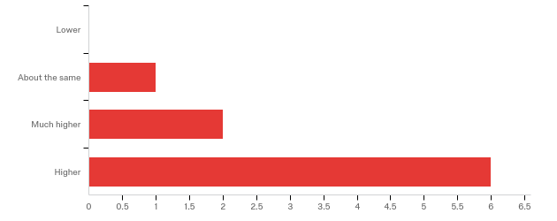

**Please rate your level of agreement with the following statements about the webinar:**

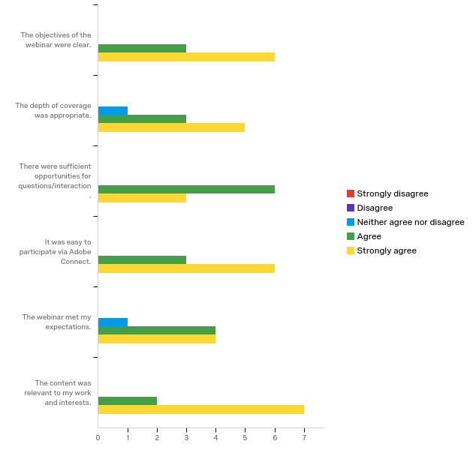

**The overall quality of the webinar was:**

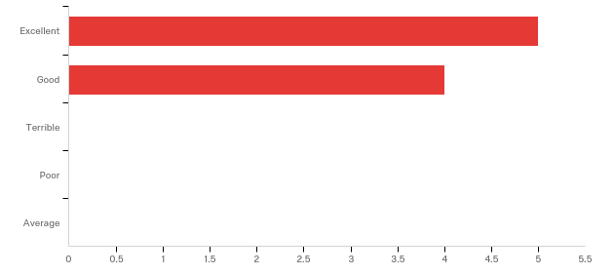

**Where did you learn about this webinar? Please check all that apply.**

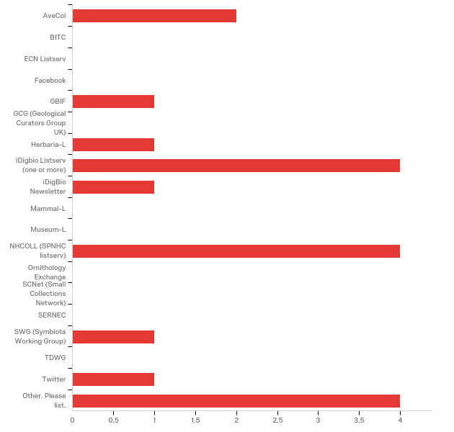

Other. Please list.

|  |
| --- |
| Arctos headline |
| Arctos banner |
| Arctos Google group |
| Harvard MCZ email |

**Do you have any questions about data entry and bulkloading in Arctos that were not addressed in the webinar?**

|  |
| --- |
| It would be nice to have a "code table" of common html for ampersands, apostrophes, etc. |
| Many, but I think this webinar was a great overview! |
| No. |

**Any other comments, questions, or suggestions for improvement?**

|  |
| --- |
| Keep it up! Wish we had had these sessions several years ago when we first got started. Might be helpful to have a session on GitHub. How it's used, how to navigate the site, what's appropriate to raise as an issue, when is it better to use the "contact us" on bugs, etc. |
| Emily was such an organized presenter |
| I've done data entry for many years in Arctos, and learned a lot of new tricks - things I hadn't really noticed before too on the data entry screen. This will be a great tool for teaching new students. I will require them to watch this as part of their training. |
| Maybe you can collect the questions asked in each of these and create a document as a result of these webinars - to go with them? Could be especially useful for those listening later - if the questions and answers are extracted from this very detailed and super insightful webinar. It's clear that Emily spent a lot of time to put this information together - and it was explained very well. |

**In what country do you currently live?**

All were US

**Please share any ideas you may have for future Arctos webinar topics.**

|  |
| --- |
| How geography is structure. How to geolocate. Importance of geolocation. How research use the geography data we provide. |
| Agents |
| More details on the other kinds of bulkloaders available. |
| Creating labels and loan forms using Arctos templates that then can be printed from Arctos. |
| Walking through different errors may be helpful because it's not always obvious what a user should do with the error information. |

**Which of the following describes your familiarity with Arctos?**

