*Arctos Webinar 6*  
**February 21st 2018, 10:24 am EST**

**How does your current level of knowledge about Arctos compare to that prior to the webinar?**

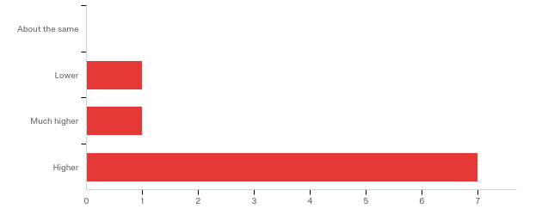

**Please rate your level of agreement with the following statements about the webinar:**

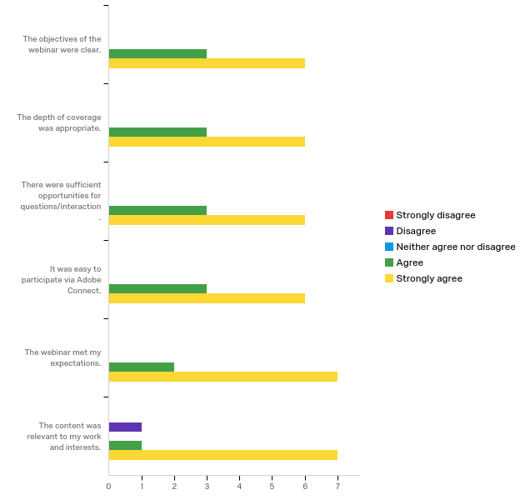

**The overall quality of the webinar was:**

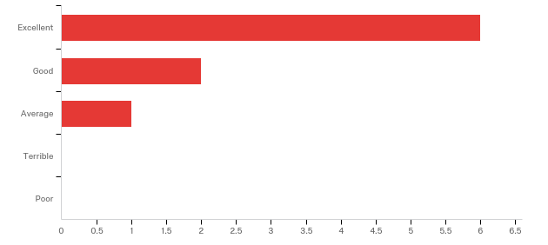

**Do you have any questions about data cleaning tools prior to migrating to Arctos that were not addressed in the webinar?**

|  |
| --- |
| A lot of helpful information was presented in this webinar. This would be a great topic for a 'How to' Guide in the Arctos Handbook, although there is a lot to cover so even including links where users could get more information/documentation (e.g., Open Refine) would be helpful. |
| There were some instances of JSON being used in OpenRefine. Is there a good reference to use for JSON syntax? |
| No, I wanted to use OpenRefine more and this helped me figure it out! |

**Any other comments, questions, or suggestions for improvement?**

|  |
| --- |
| That was super helpful, thank you! |
| One speaker had some technical difficulties, and it was hard for me to hear her (Teresa Mayfield). |

**Where did you learn about this webinar? Please check all that apply.**

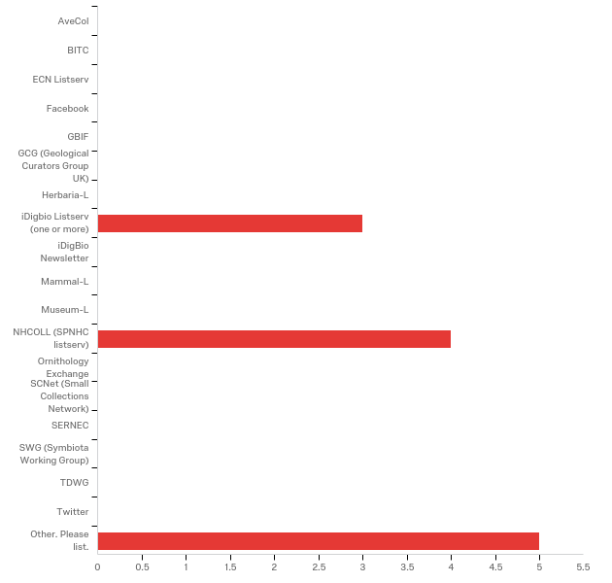

|  |  |  |
| --- | --- | --- |
| Answer | % | Count |
| AveCol | 0.00% | 0 |
| BITC | 0.00% | 0 |
| ECN Listserv | 0.00% | 0 |
| Facebook | 0.00% | 0 |
| GBIF | 0.00% | 0 |
| GCG (Geological Curators Group UK) | 0.00% | 0 |
| Herbaria-L | 0.00% | 0 |
| iDigbio Listserv (one or more) | 25.00% | 3 |
| iDigBio Newsletter | 0.00% | 0 |
| Mammal-L | 0.00% | 0 |
| Museum-L | 0.00% | 0 |
| NHCOLL (SPNHC listserv) | 33.33% | 4 |
| Ornithology Exchange | 0.00% | 0 |
| SCNet (Small Collections Network) | 0.00% | 0 |
| SERNEC | 0.00% | 0 |
| SWG (Symbiota Working Group) | 0.00% | 0 |
| TDWG | 0.00% | 0 |
| Twitter | 0.00% | 0 |
| Other. Please list. | 41.67% | 5 |
| Total | 100% | 12 |

Other. Please list.

|  |
| --- |
| Arctos Working Group |
| Arctos Working Group |
| Arctos user |
| Arctos listserv |
| AWG |

**In what country do you currently live?**

All US

**Please share any ideas you may have for future Arctos webinar topics.**

|  |
| --- |
| sound quality in this webinar was poorer than in previous webinars |

**Which of the following describes your familiarity with Arctos?**

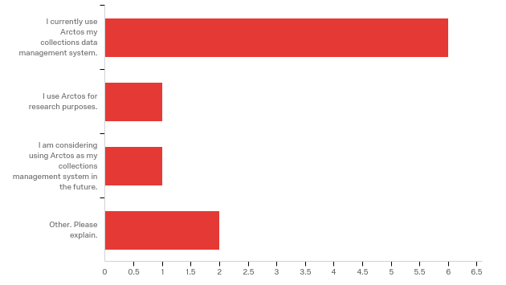

Other. Please explain.

|  |
| --- |
| Seeking experience with Arctos for CV building. |
| I use Specify instead of Arctos, but was interested in the data-cleaning tools. |