*Arctos Webinar 8*  
**May 1st 2018, 11:33 am EDT**

**How does your current level of knowledge about Arctos compare to that prior to the webinar?**

|  |  |  |
| --- | --- | --- |
| Answer | % | Count |
| Lower | 17% | 1 |
| About the same | 0% | 0 |
| Higher | 83% | 5 |
| Much higher | 0% | 0 |
| Total | 100% | 6 |

**Please rate your level of agreement with the following statements about the webinar:**

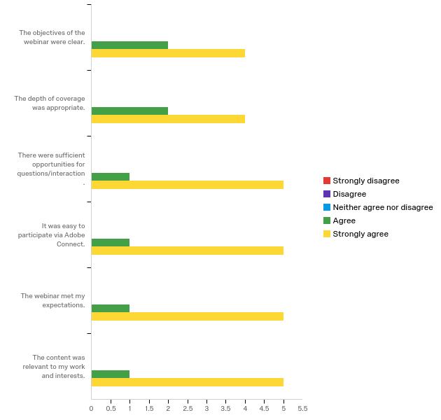

**The overall quality of the webinar was:**

|  |  |  |
| --- | --- | --- |
| Answer | % | Count |
| Terrible | 0.00% | 0 |
| Poor | 0.00% | 0 |
| Average | 16.67% | 1 |
| Good | 0.00% | 0 |
| Excellent | 83.33% | 5 |
| Total | 100% | 6 |

**Where did you learn about this webinar? Please check all that apply.**

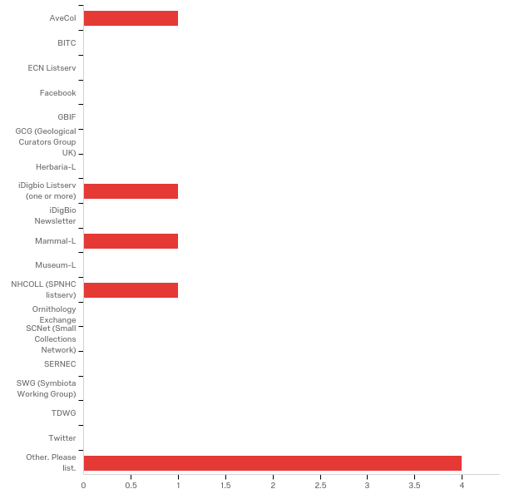

|  |  |  |
| --- | --- | --- |
| Answer | % | Count |
| AveCol | 12.50% | 1 |
| BITC | 0.00% | 0 |
| ECN Listserv | 0.00% | 0 |
| Facebook | 0.00% | 0 |
| GBIF | 0.00% | 0 |
| GCG (Geological Curators Group UK) | 0.00% | 0 |
| Herbaria-L | 0.00% | 0 |
| iDigbio Listserv (one or more) | 12.50% | 1 |
| iDigBio Newsletter | 0.00% | 0 |
| Mammal-L | 12.50% | 1 |
| Museum-L | 0.00% | 0 |
| NHCOLL (SPNHC listserv) | 12.50% | 1 |
| Ornithology Exchange | 0.00% | 0 |
| SCNet (Small Collections Network) | 0.00% | 0 |
| SERNEC | 0.00% | 0 |
| SWG (Symbiota Working Group) | 0.00% | 0 |
| TDWG | 0.00% | 0 |
| Twitter | 0.00% | 0 |
| Other. Please list. | 50.00% | 4 |
| Total | 100% | 8 |

Other. Please list.

|  |
| --- |
| Other. Please list. - Text |
| Arctos listserv |
| Arctos Working Group |
| Arctos working group |
| Arctos WG |

**Do you have any questions about tissues, containers, and object tracking in Arctos that were not addressed in the webinar?**

|  |
| --- |
| No |
| Not clear about how to set up the scanner so the barcode is imported into Arctos, but once I get the equipment I'm sure it'll include instructions and become apparent |

**In what country do you currently live?**

**All US**

**Which of the following describes your familiarity with Arctos?**

|  |  |  |
| --- | --- | --- |
| Answer | % | Count |
| I currently use Arctos my collections data management system. | 100.00% | 6 |
| I use Arctos for research purposes. | 0.00% | 0 |
| I am considering using Arctos as my collections management system in the future. | 0.00% | 0 |
| Other. Please explain. | 0.00% | 0 |
| Total | 100% | 6 |

**Any other comments, questions, or suggestions for improvement?**

|  |
| --- |
| Thanks so much! |