Initial Report  
*Arctos Webinar October 2019*  
**October 10th 2019, 7:38 am MDT**

**Where did you learn about this webinar? Please check all that apply.**

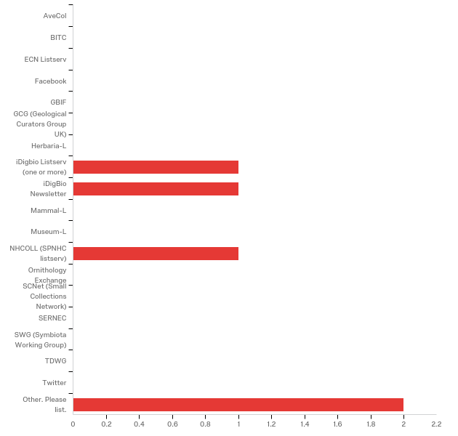

|  |  |  |  |
| --- | --- | --- | --- |
| # | Answer | % | Count |
| 58 | AveCol | 0.00% | 0 |
| 40 | BITC | 0.00% | 0 |
| 25 | ECN Listserv | 0.00% | 0 |
| 4 | Facebook | 0.00% | 0 |
| 1 | GBIF | 0.00% | 0 |
| 14 | GCG (Geological Curators Group UK) | 0.00% | 0 |
| 15 | Herbaria-L | 0.00% | 0 |
| 16 | iDigbio Listserv (one or more) | 20.00% | 1 |
| 8 | iDigBio Newsletter | 20.00% | 1 |
| 56 | Mammal-L | 0.00% | 0 |
| 17 | Museum-L | 0.00% | 0 |
| 18 | NHCOLL (SPNHC listserv) | 20.00% | 1 |
| 57 | Ornithology Exchange | 0.00% | 0 |
| 19 | SCNet (Small Collections Network) | 0.00% | 0 |
| 20 | SERNEC | 0.00% | 0 |
| 21 | SWG (Symbiota Working Group) | 0.00% | 0 |
| 22 | TDWG | 0.00% | 0 |
| 3 | Twitter | 0.00% | 0 |
| 7 | Other. Please list. | 40.00% | 2 |
|  | Total | 100% | 5 |

Other. Please list.

|  |
| --- |
| Other. Please list. - Text |
| iDigBio Events list on front page |

|  |  |  |  |  |  |  |  |  |  |  |  |  |  |  |  |  |  |  |  |  |  |  |  |  |  |  |  |
| --- | --- | --- | --- | --- | --- | --- | --- | --- | --- | --- | --- | --- | --- | --- | --- | --- | --- | --- | --- | --- | --- | --- | --- | --- | --- | --- | --- |
| Arctos  **Which of the following describes your familiarity with Arctos?**  Picture 5   |  |  |  |  | | --- | --- | --- | --- | | # | Answer | % | Count | | 1 | I currently use Arctos my collections data management system. | 40.00% | 2 | | 2 | I use Arctos for research purposes. | 0.00% | 0 | | 3 | I am considering using Arctos as my collections management system in the future. | 20.00% | 1 | | 4 | Other. Please explain. | 40.00% | 2 | |  | Total | 100% | 5 |     Q16_4_TEXT - Other. Please explain.   |  | | --- | | Other. Please explain. - Text | | Helping community with CMS for collections | | I am a database manager who wants to know about the different databases currently available. | |

|  |
| --- |
| **How does your current knowledge about using Arctos Publications and Projects compare to that prior to the webinar?** |

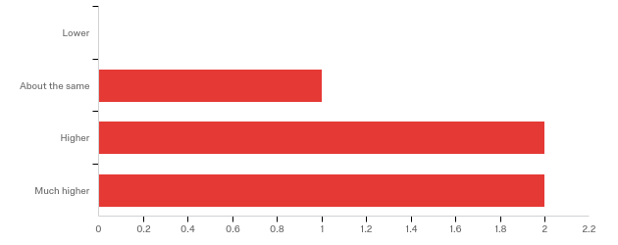

|  |  |  |  |  |  |  |  |
| --- | --- | --- | --- | --- | --- | --- | --- |
| # | Field | Minimum | Maximum | Mean | Std Deviation | Variance | Count |
| 1 | How does your current knowledge about using Arctos Publications and Projects compare to that prior to the webinar? | 2.00 | 4.00 | 3.20 | 0.75 | 0.56 | 5 |

|  |  |  |  |
| --- | --- | --- | --- |
| # | Answer | % | Count |
| 1 | Lower | 0.00% | 0 |
| 2 | About the same | 20.00% | 1 |
| 3 | Higher | 40.00% | 2 |
| 4 | Much higher | 40.00% | 2 |
|  | Total | 100% | 5 |

**Q20 - The overall quality of the webinar was:**

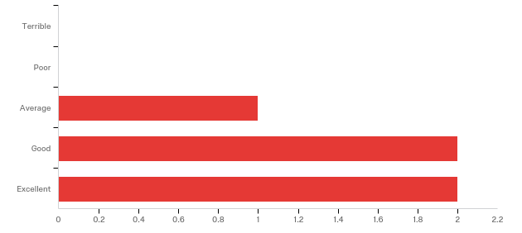

|  |  |  |  |  |  |  |  |
| --- | --- | --- | --- | --- | --- | --- | --- |
| # | Field | Minimum | Maximum | Mean | Std Deviation | Variance | Count |
| 1 | The overall quality of the webinar was: | 27.00 | 29.00 | 28.20 | 0.75 | 0.56 | 5 |

|  |  |  |  |
| --- | --- | --- | --- |
| # | Answer | % | Count |
| 25 | Terrible | 0.00% | 0 |
| 26 | Poor | 0.00% | 0 |
| 27 | Average | 20.00% | 1 |
| 28 | Good | 40.00% | 2 |
| 29 | Excellent | 40.00% | 2 |
|  | Total | 100% | 5 |

**Do you have any questions about Arctos Publications and Projects that were not addressed in the webinar?**

|  |
| --- |
| Do you have any questions about Arctos Publications and Projects that were not addressed in the webinar? |
| No - excellent presentation and very nice -- useful -- features! |

**Any other comments, questions, or suggestions for improvement?**

**Please share any ideas you may have for future Arctos webinar topics.**

More on visualization that you showed.

**Demographics**

**Racial Identity. You may check more than one.**

|  |  |  |  |
| --- | --- | --- | --- |
| # | Answer | % | Count |
| 1 | American Indian or Alaskan Native | 0.00% | 0 |
| 2 | Asian | 20.00% | 1 |
| 3 | Black or African American | 0.00% | 0 |
| 4 | Native Hawaiian or Other Pacific Islander | 0.00% | 0 |
| 5 | White | 60.00% | 3 |
| 6 | Other | 0.00% | 0 |
| 7 | I do not wish to provide. | 20.00% | 1 |
|  | Total | 100% | 5 |

**In what country do you currently live?**

|  |
| --- |
| In what country do you currently live? |
| USA |
| United States |
| United States |
| United States |
| United States of America |

**Q12 - Gender Identity**

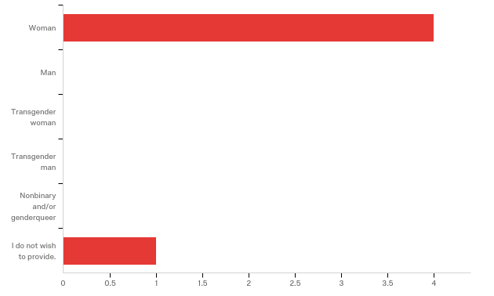

|  |  |  |  |  |  |  |  |
| --- | --- | --- | --- | --- | --- | --- | --- |
| # | Field | Minimum | Maximum | Mean | Std Deviation | Variance | Count |
| 1 | Gender Identity | 1.00 | 9.00 | 2.60 | 3.20 | 10.24 | 5 |

|  |  |  |  |
| --- | --- | --- | --- |
| # | Answer | % | Count |
| 1 | Woman | 80.00% | 4 |
| 2 | Man | 0.00% | 0 |
| 5 | Transgender woman | 0.00% | 0 |
| 6 | Transgender man | 0.00% | 0 |
| 7 | Nonbinary and/or genderqueer | 0.00% | 0 |
| 9 | I do not wish to provide. | 20.00% | 1 |
|  | Total | 100% | 5 |

**Q13 - Ethnicity**

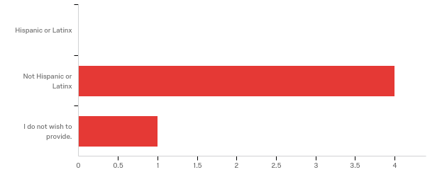

|  |  |  |  |  |  |  |  |
| --- | --- | --- | --- | --- | --- | --- | --- |
| # | Field | Minimum | Maximum | Mean | Std Deviation | Variance | Count |
| 1 | Ethnicity | 2.00 | 3.00 | 2.20 | 0.40 | 0.16 | 5 |

|  |  |  |  |
| --- | --- | --- | --- |
| # | Answer | % | Count |
| 1 | Hispanic or Latinx | 0.00% | 0 |
| 2 | Not Hispanic or Latinx | 80.00% | 4 |
| 3 | I do not wish to provide. | 20.00% | 1 |
|  | Total | 100% | 5 |