Function Workflow Flowchart
Visual map of the code pipeline from setup and data pulls to cohort tracking and final summaries

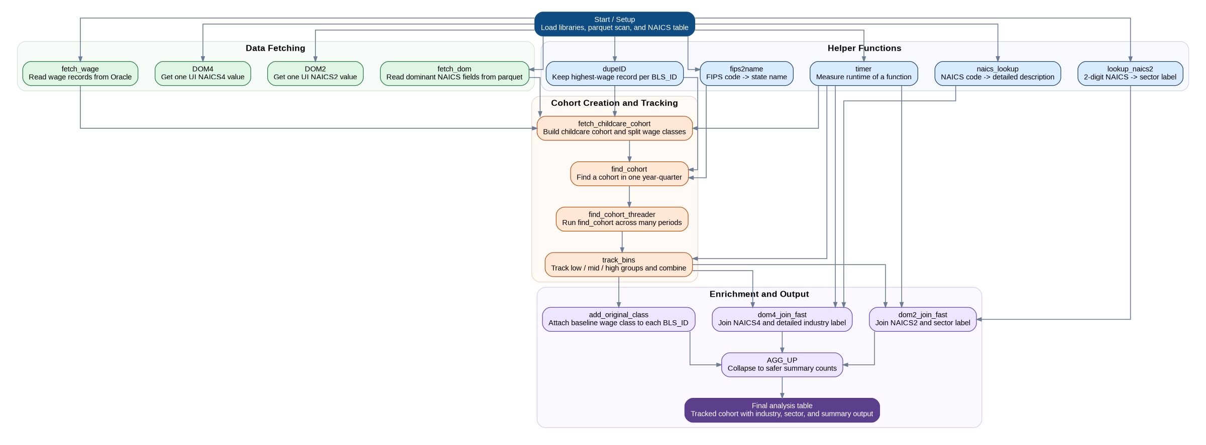
Grouped into Helper Functions, Data Fetching, Cohort Creation and Tracking, and Enrichment and Output.

