------------------------------1----------------------

* Generate Private key from CA side

* openssl genrsa -des3 -out CA.key 2048

pass: arcuman

------------------------2---------------------------------------

openssl req -x509 -new -days 365 -sha256 -key ./CA.key -sha256 -out ./CA.crt

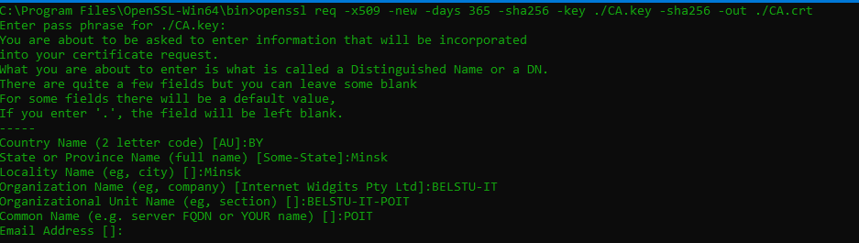

------------------------------------3---------------------

openssl genrsa -out ./LAB.key 2048

---------------------------------4--------------

Создаём файл

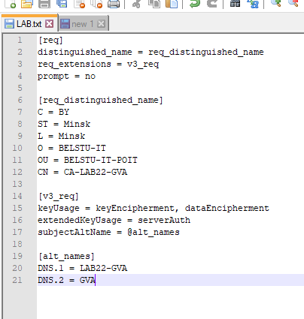

openssl req -new -key ./LAB.key -out ./certRequest.csr -sha256 -config ./LAB.cfg

openssl x509 -req -days 365 -sha256 -in ./certRequest.csr -CA ./CA.crt -CAkey ./CA.key -CAcreateserial -out ./LAB.crt -extensions v3_req -extfile ./LAB.cfg

