JUAN CARLO
The Heart of Tasteful Celebrations
EVENT MANAGEMENT AND OPERATIONS MONITORING SYSTEM
USER MANUAL
A per-department guide to using the system: each department’s features, notifications, business rules, and step-by-step procedures across the full contract and event workflow.
Prepared for Juan Carlo Catering Services
Document Version 3.0
TABLE OF CONTENTS
Right-click this area and choose “Update Field” to generate the Table of Contents.

Chapter 1. Introduction

1.1 Purpose of the User Manual
This user manual serves as a guide for using the Event Management and Operations Monitoring System of Juan Carlo Catering Services. It is organized per department, so each department can read its own chapter and immediately see the features available to it, the notifications it receives, the business rules that govern its work, and the step-by-step procedures for its day-to-day scenarios. The manual covers the full operational flow from booking and contract processing to pre-event preparation, post-event checking, and contract closing.

1.2 Overview of the System
The system is a centralized, role-based web application that supports the major operational processes of the company: menu tasting bookings, contract creation and approval, department validation, payment recording and collection enforcement, pre-event preparation, purchasing and shortage handling, logistics and staff transportation, post-event checking with return reconciliation, incident reporting, inventory management, and management reporting. All departments work on a shared record of each event, and the system routes tasks, statuses, and notifications to the responsible department automatically.

1.3 Scope and Coverage
This manual covers the use of the system by authorized users of every department: Sales, Accounting, Creative, Linen, Stockroom, Kitchen, Banquet, Logistics, Purchasing, and Admin. It documents each department’s dashboard, features, notifications, printable forms, and reports, together with the shared modules (login, notifications, settings, incidents, and reports). It does not cover technical system development, source code structure, or server administration.

1.4 How This Manual Is Organized
Chapter 2 explains how to access the system and the parts of the interface shared by every role. Chapters 3 to 12 are the department guides — one chapter per department, each following the same structure: the department’s features at a glance, the notifications it receives, the business rules that apply to it, and step-by-step procedures for its scenarios. Chapter 13 covers reports and records. The appendices contain the master business-rule tables and cross-department scenario walkthroughs.

1.5 General Process Flow of the System
The process begins when the Sales department records a menu tasting booking and prepares the contract from the client’s finalized details. The concerned inventory departments (Creative, Linen, Stockroom) validate their assigned items on the draft, Sales confirms the payment term, and the contract is signed. Accounting records payments and approves the contract for preparation once the required collection is met. The operating departments (Kitchen, Banquet, Logistics, Creative, Linen, Stockroom) then prepare for the event; Purchasing handles any shortage through budget-approved procurement. After the event, the departments perform post-event checks, logistics reconciles returned items, incidents are reported where needed, and Accounting closes the contract. Throughout the flow the system enforces the payment collection timeline, places overdue contracts on hold, and keeps every department informed through notifications.

Chapter 2. Accessing the System

2.1 Logging In
Open the system’s web address in a browser. Enter the email address and password assigned to your department account, then click Sign In. If the credentials are correct, the system opens the dashboard for your role; otherwise an error message is shown. Only authorized users can access the system.
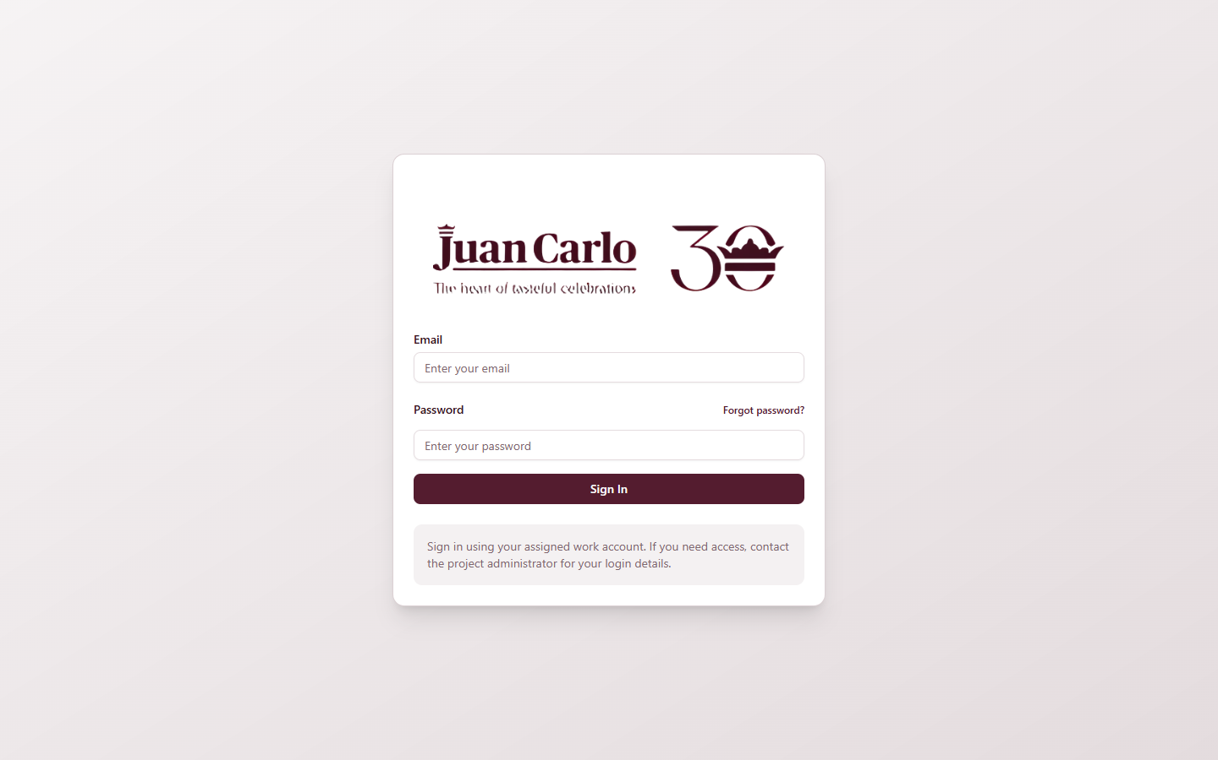
Figure 2.1.1 Login Page

2.2 Forgot Password
If you have forgotten your password, click Forgot password? on the login page. Enter your registered email address to request a reset code, then enter the code together with your new password to regain access. If you do not receive a code or cannot reset your password, contact the system administrator.

2.3 User Roles and Access
The system uses role-based access control: each account sees only the modules and records that belong to its department. Table 2.1 summarizes the roles and their main access.
Table 2.1 User Roles, Departments, and System Access
User Role | Main Access | Limitations / Notes
Admin | Full access to all modules, records, user management, and management overrides (release hold, delete contract) | Highest level of access
Sales (Account Executive) | Menu tasting booking, contract creation, draft review, payment term confirmation, signature workflow, signed contracts, sales reports | Handles the main client transaction flow
Accounting | Payment recording, collection timeline, contract approval, payment holds, procurement budget approval, monthly budget, contract closing, finance reports | Focused on financial control and approvals
Creative | Creative inventory, draft validation, pre-event preparation, purchasing requests, post-event checking, incident reporting | Limited to creative/decor items
Linen | Linen inventory, draft validation, pre-event preparation, purchasing requests, post-event checking, incident reporting | Limited to linen items
Stockroom | Stockroom inventory, equipment validation, preparation, purchasing requests, post-event checking, incident reporting | Limited to equipment and supplies
Kitchen | Kitchen dashboard, menu checklist, item preparation, kitchen inventory, kitchen reports | Sees menu and preparation information only; contract prices are hidden
Banquet (Supervisor) | Banquet dashboard, staffing plan and assignments, staff directory, check-in sheet, banquet reports | Views banquet-related contract information only
Logistics | Logistics workflow (transport booking, staff transportation, load and dispatch), fleet management (drivers and trucks), logistics reports | Focused on transport; contract prices are hidden
Purchasing | Purchasing dashboard queues, requisition forms, supplier database, proof of purchase | No direct access to department inventory pages

2.4 Navigating the Interface
After logging in, the navigation menu on the left lists the modules available to your role. The Notifications box and the account menu stay visible at the lower-left corner. The main working area shows the dashboard or module you selected. Every role also has access to the Settings page (profile information and password) and, where applicable, the Reports and Incidents pages.

2.5 Notifications
The Notifications panel opens from the lower-left box, which shows the number of pending actions. Each notification links directly to the related contract or request. A notification whose task has already been completed is tagged Done, so departments can tell at a glance which alerts still need action. Notifications belonging to a deleted contract are removed automatically, and notifications of a closed contract expire shortly after closing. Table 2.2 lists the notification types used by the system.
Table 2.2 Notification Types
Notification | When It Appears | Primary Audience
Contract submitted | A signed contract is forwarded for accounting review | Accounting
Contract approved | Accounting approves an event for preparation; each department receives its own task alert | All operating departments
Payment received | A client payment is recorded | Accounting, Sales
Payment follow-up | One month before the 40% collection due date | Accounting
Payment milestone due | The 40% collection reaches its due date | Accounting
Account uncollectible | The 30-day aging window lapses without collection | Accounting
Final balance due | The 60% balance approaches its due date (two months before the event) | Accounting
Contract on hold | The final balance is overdue and the contract is automatically placed on hold | Accounting, Sales, Admin
SLA warning | The final-details deadline (one month before the event) has passed | Sales
Conflict alert | A same-day booking conflict is detected (venue, inventory, vehicle) | Affected departments
Incident reported | An incident report is filed | Affected department, Admin
Task assigned | A task is routed to a department (e.g., validation, preparation, readiness) | Affected department
Deadline reminder | Time-based reminders: kitchen 2-week sourcing and 7-day preparation alerts, 3-day transport booking alert, post-event checks due, ready-to-close | Kitchen, Logistics, Accounting

2.6 Settings
The Settings page lets a user review profile information, adjust notification preferences, and change the account password. Users are encouraged to keep their password private and to change it periodically.

2.7 Logging Out
Log out through the account menu at the lower-left corner when finished. Logging out ends the session and returns to the login page. Always log out on shared computers.

Chapter 3. Sales Department Guide

3.1 Role Overview and Features
The Sales department (Account Executives) owns the client-facing flow: tasting bookings, contract creation, coordination of draft validation, payment-term confirmation, and the signature workflow. Table 3.1 lists the Sales features at a glance.
Table 3.1 Sales Features at a Glance
Feature | What It Does
Menu Tastings | Book, confirm, complete, or cancel tasting sessions; record client feedback; hourly slots from 10:00 AM to 5:00 PM, one booking per slot per day (double-booked slots are rejected automatically)
Contract creation | Tabbed form (Client Info, Event Details, Package & Menu, Add-Ons, Summary) pre-filled from the tasting; saves as a draft
Draft coordination | Tracks per-department validation status: Awaiting Department Validation → Confirm Payment Term → Ready For Signature
Payment term confirmation | Confirms the agreed term (40/60 split or full payment) after inventory validation; the term shows “N/A — confirmed after signing” until then
Signature workflow | Send for signature; print the signature copy; capture client and staff e-signatures; download the Signature-Ready PDF at any time; mark client signed
Signed Contracts page | Reference list of all signed agreements
Booking calendar | Calendar views of tastings and events for scheduling
Sales report | Contract pipeline, tasting conversion, package mix, payments posted (see Chapter 13)

3.2 Notifications Received by Sales
Table 3.2 Sales Notifications
Notification | Meaning / Required Action
Draft contract ready for payment term confirmation | All inventory sections are validated; open the Payments tab and confirm the term
Contract on hold | A contract’s final balance is overdue; coordinate with the client and Accounting
SLA warning | The final-details deadline (one month before the event) has passed; finalize the details
Conflict alert | A same-day venue or inventory conflict affects one of your contracts
Contract closed | Accounting has closed the contract after post-event completion

3.3 Business Rules That Govern Sales Work
Table 3.3 Sales-Related Business Rules
Rule | Detail
Reservation fee | A PHP 30,000 reservation fee validates the booking; it is strictly non-refundable and counts toward the 40% down payment
Tasting slots | Hourly, 10:00 AM–5:00 PM; one booking per slot per day; one active booking per client email
Booking before payment | A booking and its tasting can be recorded before any payment; payments are only posted after the contract is signed
Payment term at creation | The term is not chosen at creation; the Summary tab shows “N/A — confirmed after signing” until Sales confirms it
Venue conflict | Two contracts cannot use the same venue on the same date; the system flags the conflict and blocks approval
Final details SLA | All final event details are due no later than one month before the event
Price visibility | Package price and total contract value are visible only to Sales, Accounting, and Admin

3.4 Booking a Menu Tasting
Overview. The tasting is the client’s first transaction. Booking it records the client details and reserves an hourly slot.
1. Open Menu Tastings from the navigation menu and click Book Tasting.
2. Fill in the client details, event information, expected guests, tasting date, tasting time, and tasting pax.
3. Click Book Tasting to save. The booking appears in the list with status Booked. If the chosen date and time slot is already taken, the system rejects the booking and asks for another slot.
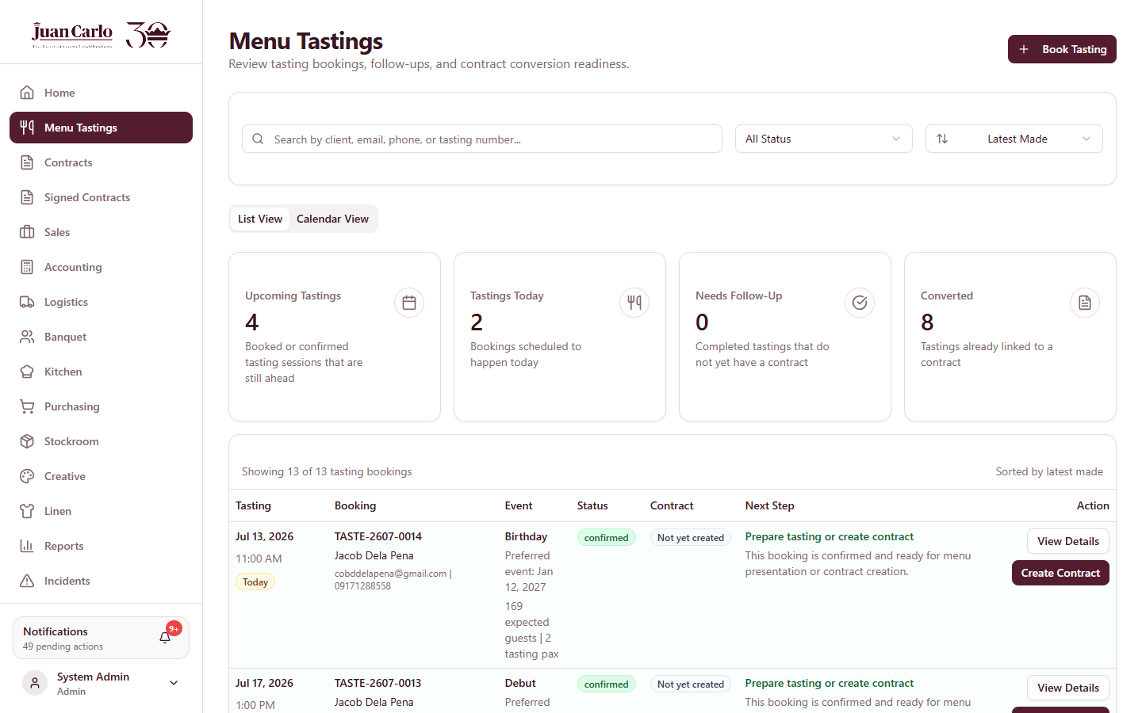
Figure 3.4.1 Menu Tastings list with the Book Tasting button
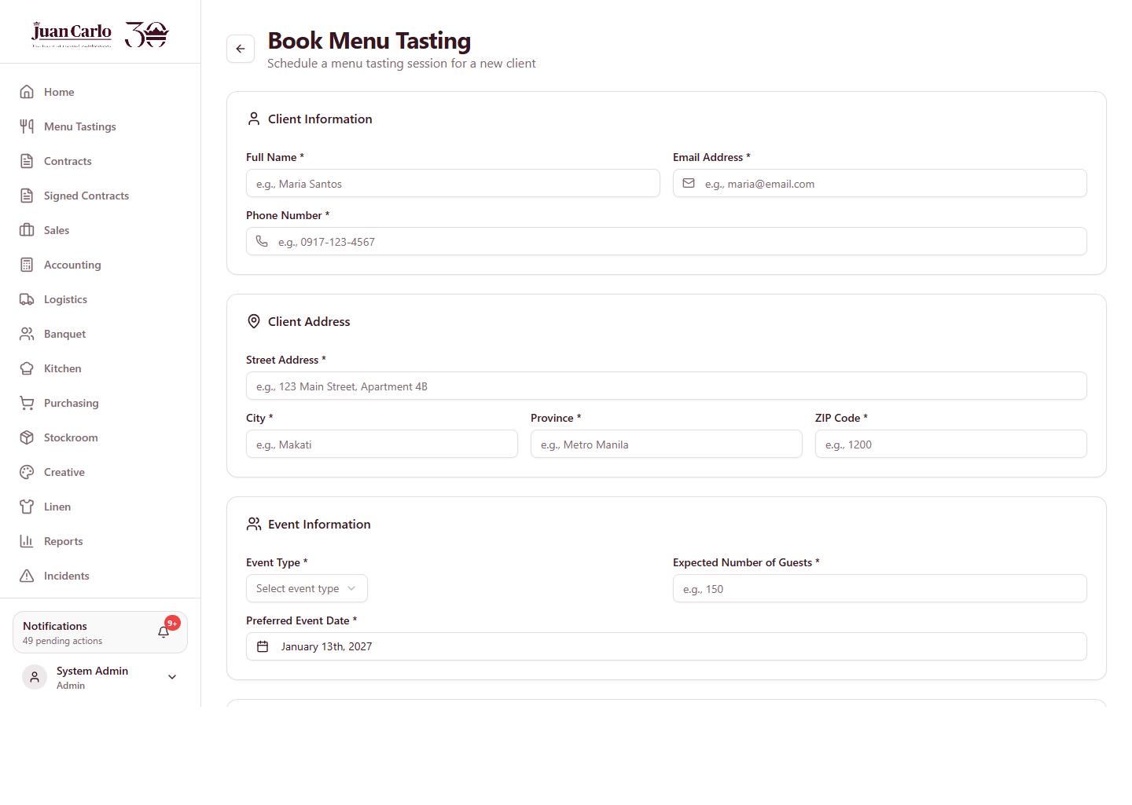
Figure 3.4.2 Book Menu Tasting form

3.5 Managing Bookings
Overview. Bookings are managed from the list and calendar views. Opening a booking shows its lifecycle actions.
1. Use List View to browse bookings and Confirm Booking to confirm attendance; use Calendar View to monitor bookings by date.
2. Click View Details on a booking to open it. Depending on status and date you may Confirm Booking, Record Feedback (marks the tasting Completed and stores the client’s comments, items liked, and items to change), Mark No-Show, or Cancel Booking.
3. Recorded feedback follows the contract: the kitchen later sees the tasting comments on the contract’s Preferences tab.
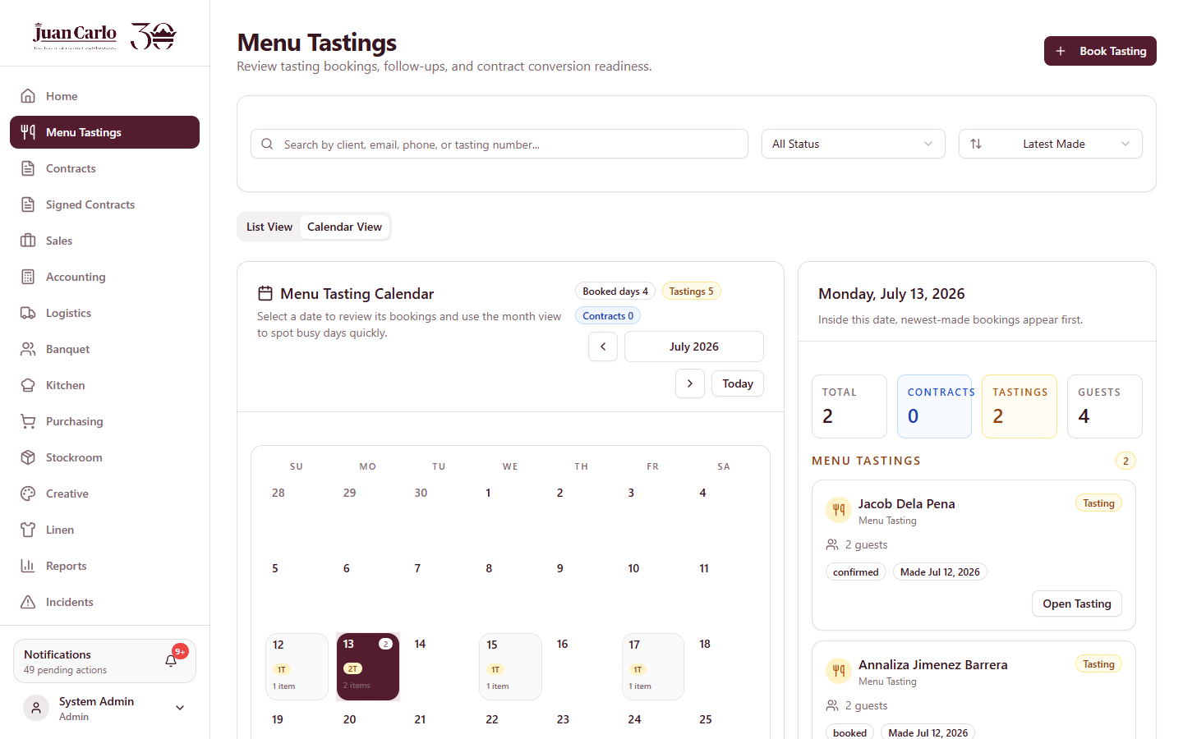
Figure 3.5.1 Menu Tastings calendar view
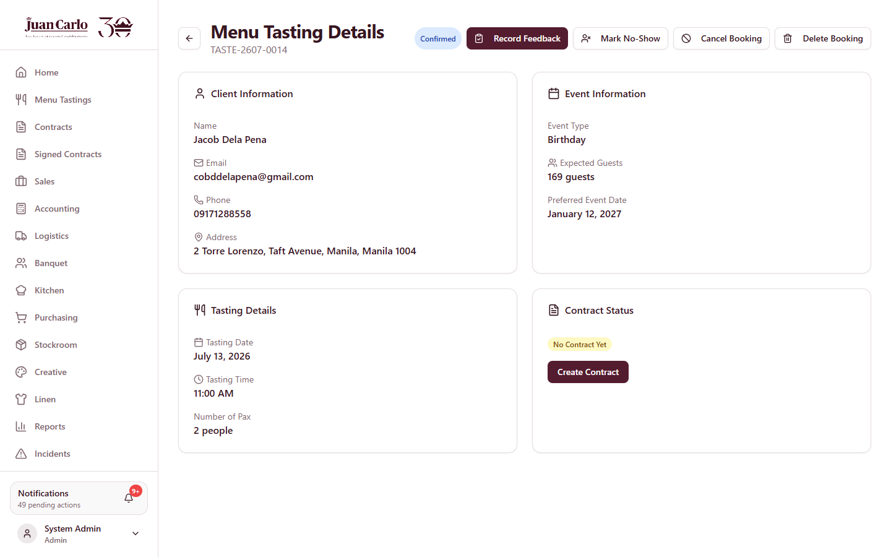
Figure 3.5.2 Menu tasting details with lifecycle actions

3.6 Creating the Contract
Overview. From a completed booking, click Create Contract. The tabbed form opens pre-filled with the booking information. Complete each tab, then save as a draft.
1. Client Info — client name, contact number, email, and complete address.
2. Event Details — event type, date, and venue. The system warns when the venue capacity is below the expected pax and when another contract already uses the venue on the same date.
3. Package and Menu — select the package and menu; dish counts are limited by the package (for example, Basic allows three mains, two sides, one dessert, one drink). Dishes carried over from the tasting keep the client’s comments.
4. Add-Ons — select creative, linen, and stockroom items from live inventory. Availability is checked against the event date: quantities reserved by another same-day event are shown as unavailable, and alternatives are suggested for shortages. Setup quantities are suggested from the expected guest count.
5. Summary — review everything. The Payment Term line shows N/A — confirmed after signing. Click Create Contract to save the draft.
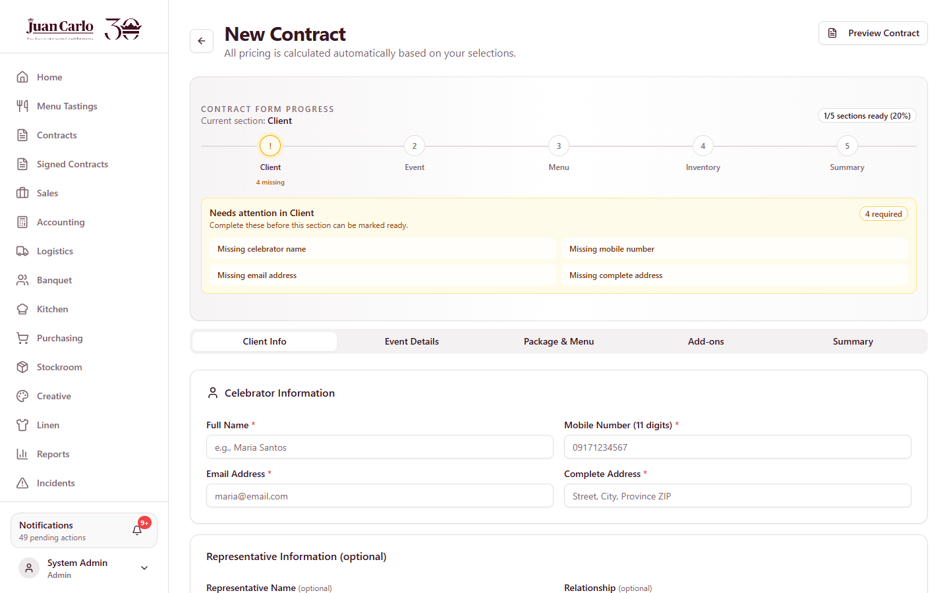
Figure 3.6.1 Contract – Client Info tab
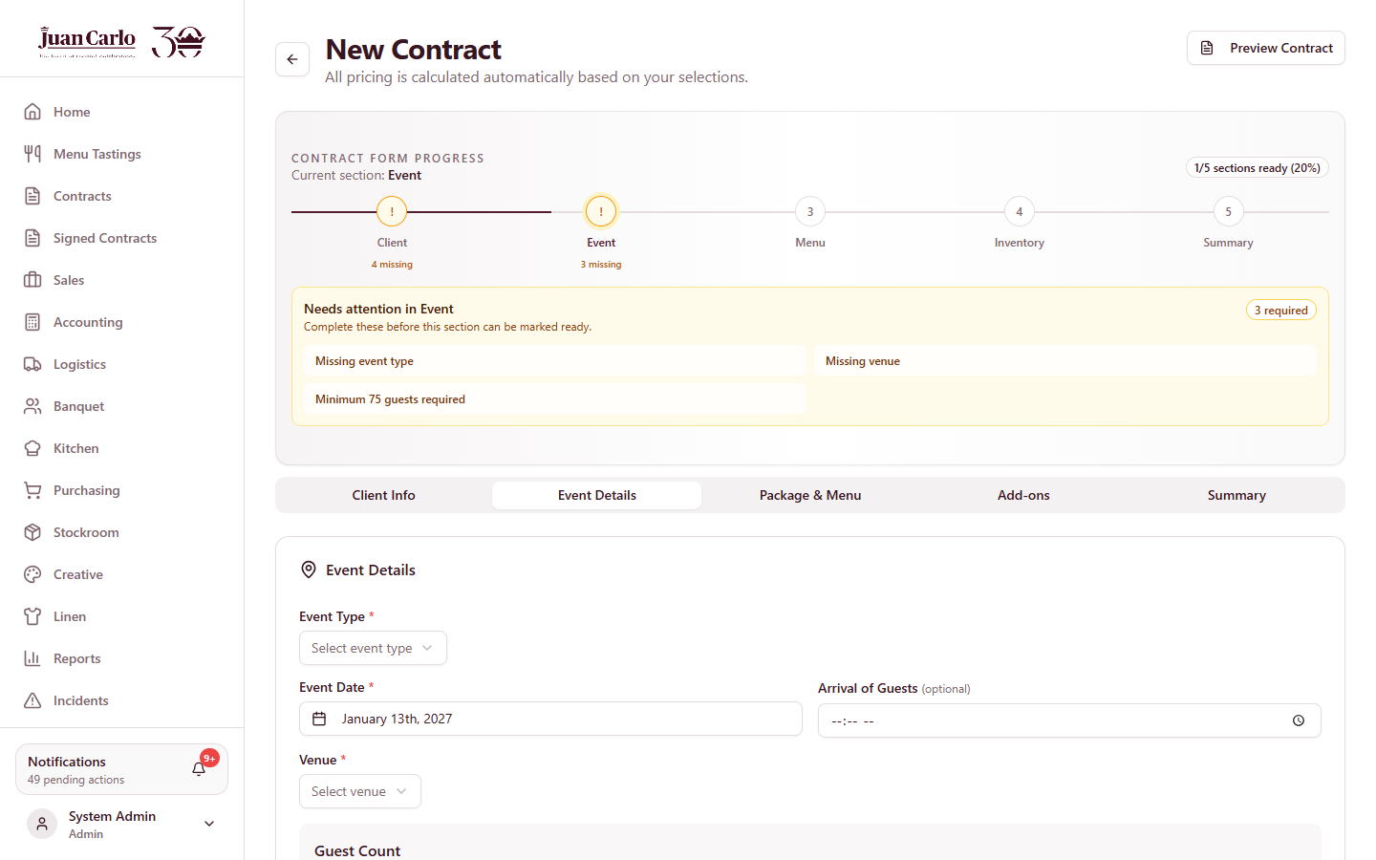
Figure 3.6.2 Contract – Event Details tab
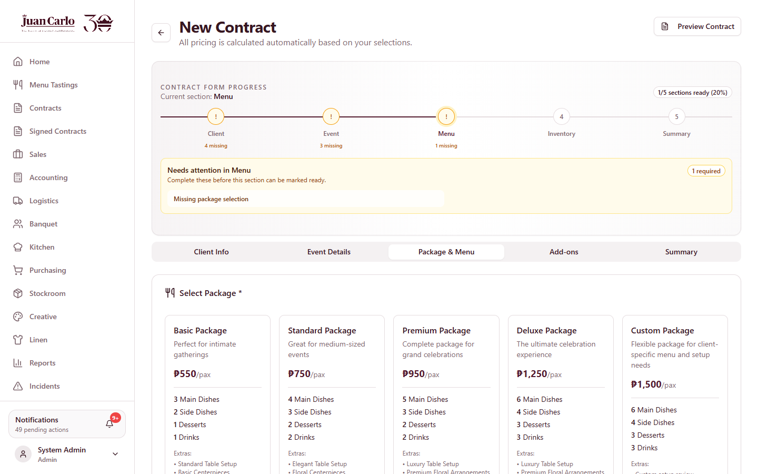
Figure 3.6.3 Contract – Package and Menu tab
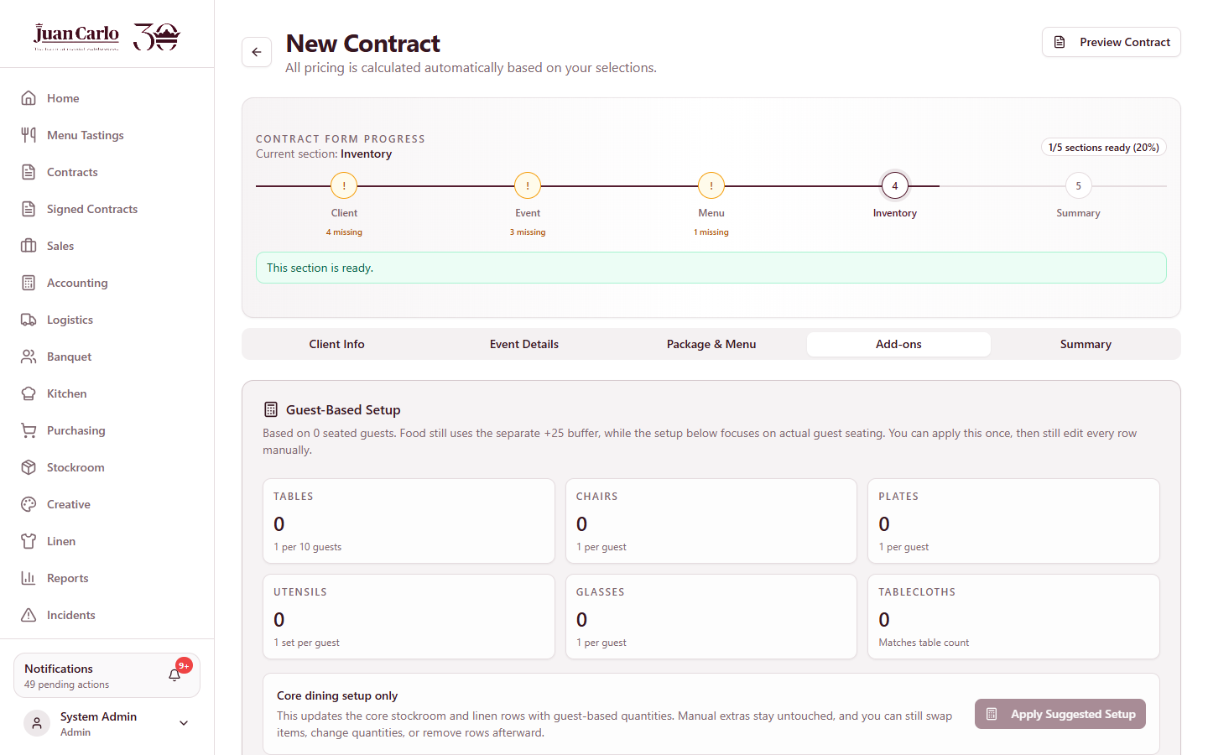
Figure 3.6.4 Contract – Add-Ons tab
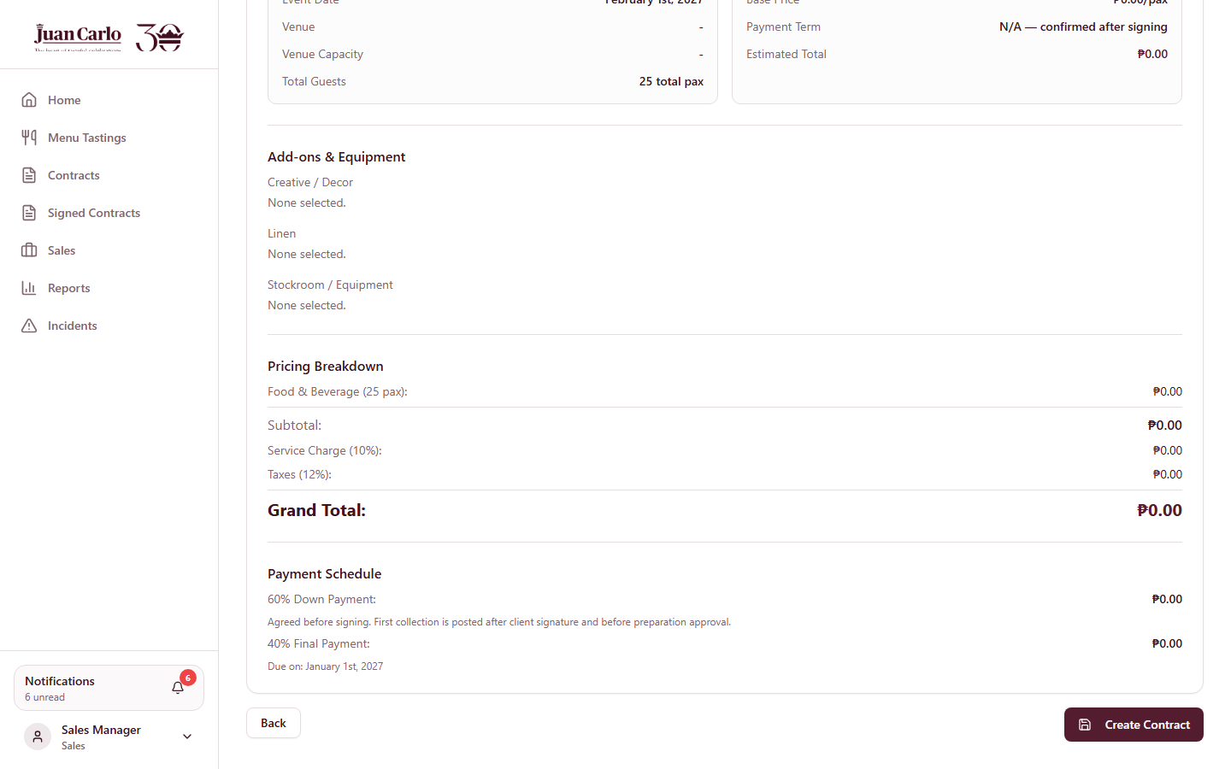
Figure 3.6.5 Contract – Summary tab

3.7 Draft Validation and Payment Term
Overview. While the contract is a draft, its stage badge tells each department what is next: Awaiting Department Validation (Creative, Linen, Stockroom must confirm their sections), Confirm Payment Term (Sales action), then Ready For Signature.
1. Monitor the draft from the contract page; departments that have validated show as such, and the badge updates as sections are confirmed.
2. When validation is complete, open the Payments tab and confirm the agreed term — the 40/60 split or full payment. The system blocks confirmation until the inventory sections are validated.
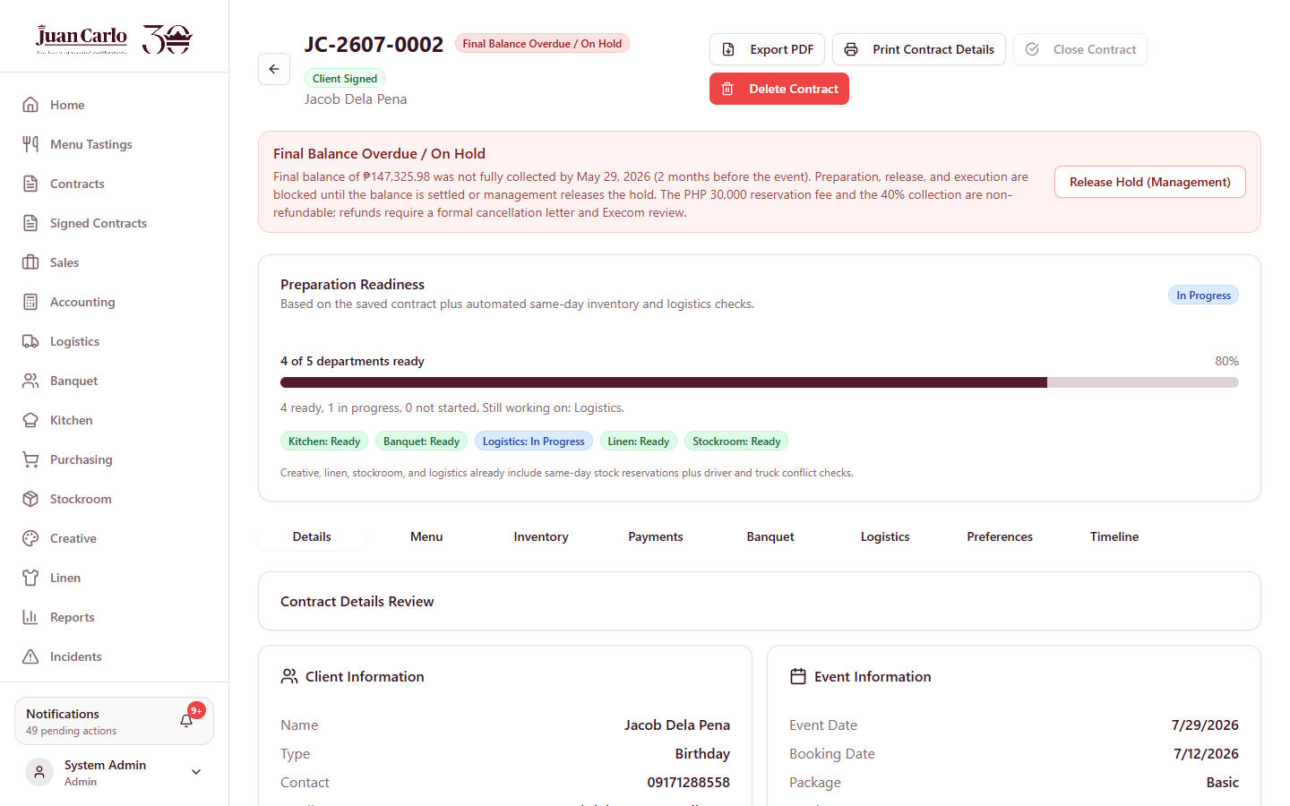
Figure 3.7.1 Contract details page with stage badge

3.8 Signature Workflow
Overview. Once the draft is Ready For Signature, Sales releases it for signing and records the outcome. Three routes are available: a status-only send, a printable signature copy, and an electronic signature packet.
1. Click Send For Signature and choose how to proceed: move the contract to signature status, open the printable signature copy, or prepare the e-signature PDF.
2. For e-signing, upload the client and staff signature images; the system generates the Signature-Ready PDF, which can be downloaded or printed from its built-in toolbar.
3. The View Signature-Ready PDF button on the contract reopens the prepared PDF at any time for viewing or downloading.
4. When the client has signed (physically or electronically), click Mark Client Signed. The contract is forwarded to Accounting.
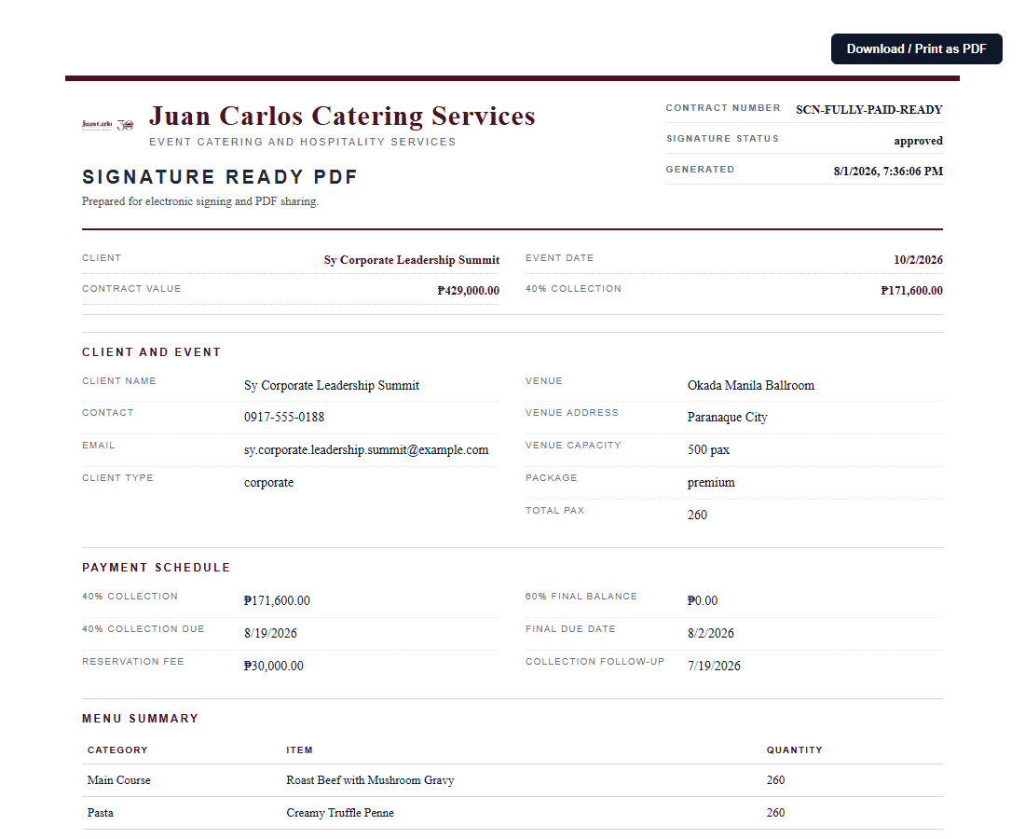
Figure 3.8.1 Signature dialog and Signature-Ready PDF with download toolbar

3.9 Signed Contracts and Monitoring
The Signed Contracts page lists all signed agreements for reference. The Sales Dashboard summarizes the pipeline, and the booking calendar shows tastings and events by date. The Sales report (Chapter 13) covers pipeline status, tasting conversion, package mix, and payments posted.
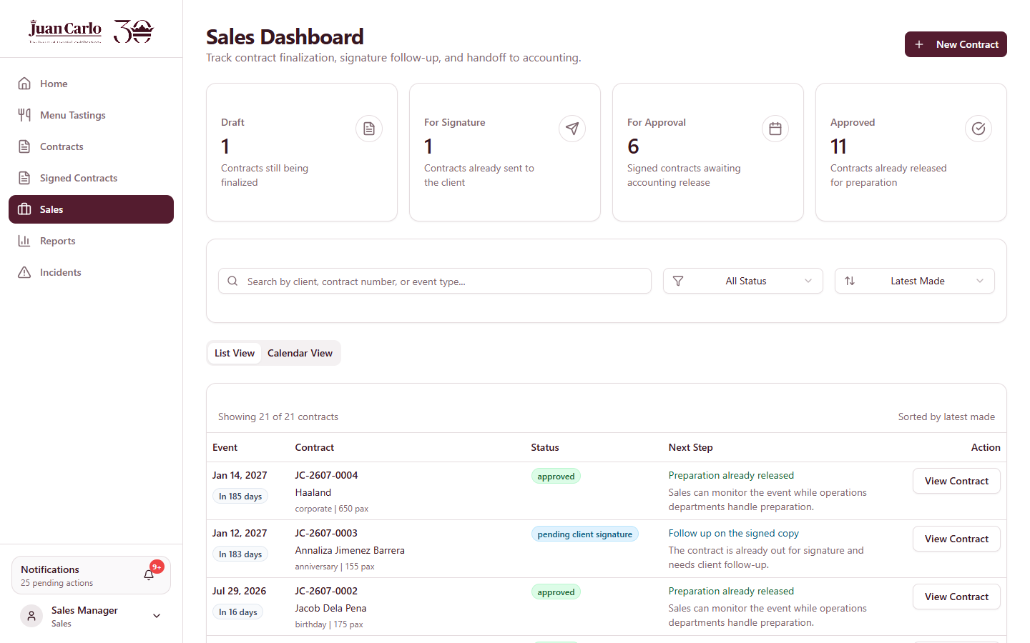
Figure 3.9.1 Sales Dashboard
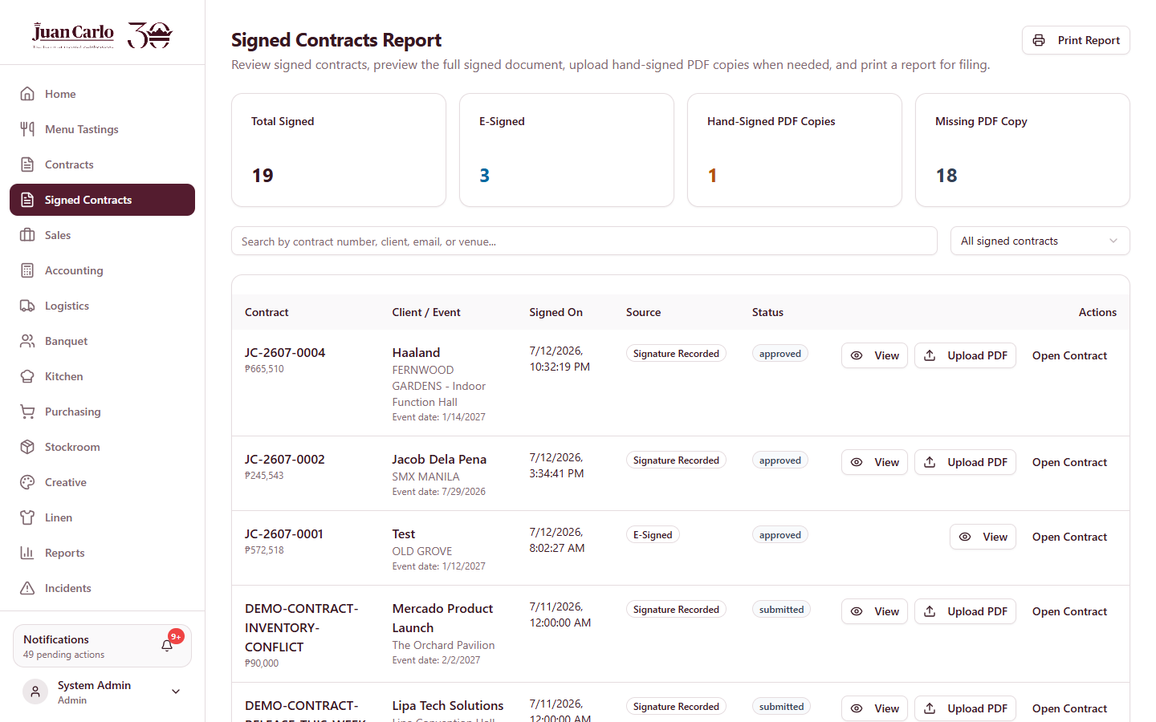
Figure 3.9.2 Signed Contracts page

3.10 Sales Scenarios
• Two clients want the same tasting slot. The second booking is rejected with “The slot on that date is already booked.” Choose another slot or date.
• Two events on the same day. Same-day contracts are allowed, but the system flags venue conflicts, checks inventory against both events, and prevents vehicles and staff from being double-booked.
• Client details change late. Details can be edited while the contract is a draft. After approval, changes to material lists are locked seven days before the event (material freeze).
• Contract goes on hold. If the final balance is not collected on time, the stage shows Final Balance Overdue / On Hold; preparation stops until Accounting settles it or management releases the hold.

Chapter 4. Accounting Department Guide

4.1 Role Overview and Features
Accounting controls the financial life of every contract: recording payments, enforcing the collection timeline, approving contracts for preparation, approving procurement budgets, maintaining the monthly operating budget, and closing contracts after the event. Table 4.1 lists the Accounting features.
Table 4.1 Accounting Features at a Glance
Feature | What It Does
Payment recording | Posts client payments with amount, method, and provisional receipt number; blocked until the client has signed; a payment cannot exceed the remaining balance
Collection timeline | Automatic follow-ups, milestone alerts, 30-day aging, and uncollectible marking based on the booking and event dates
Approve For Preparation | Releases an event to the operating departments once the signature and required collection are in place and no shortage is uncovered
Payment hold | Automatically holds a contract whose 60% balance is overdue; blocks preparation, release, and execution until settled or released by management
Procurement budget approval | Reviews purchasing budget requests with a checklist and a live budget check; approves or returns them
Monthly budget | Sets the monthly operating budget per category; suggestions are derived from the trailing three months of confirmed procurement spend
Contract closing | Closes the contract after the event when fully paid, logistics completed, and post-event checks done
Finance reports | AR aging (30/60/90), collections trend, financial position, receivables schedule, payment ledger, procurement budget register (Chapter 13)

4.2 Notifications Received by Accounting
Table 4.2 Accounting Notifications
Notification | Meaning / Required Action
Signed contract ready for Accounting | A contract was signed; review it and record collections
Start 40% collection follow-up | One month before the 40% due date; begin client follow-ups
40% collection task | The 40% due date has arrived; unresolved accounts enter the 30-day aging window
Account uncollectible | The aging window lapsed without collection
Final balance due | The 60% balance must be fully collected two months before the event
Contract on hold | The final balance was not collected on time; the contract is automatically held
Budget request awaiting approval | Purchasing submitted a budget request; review and decide
Expense confirmation needed | Purchasing submitted proof of purchase; confirm the expense
Post-event checks due | The event has ended; departments must record their return checks
Ready to close | All post-event checks are complete; the contract is awaiting close

4.3 Business Rules Enforced by the System
The collection and control rules below follow the company’s documented business rules (thesis Appendix H) and are enforced automatically.
Table 4.3 Financial Business Rules
Rule | Detail
Reservation fee | PHP 30,000 upon booking; strictly non-refundable; counted as part of the 40% collection
40% down payment | Due two months after the booking date; follow-up alert starts one month ahead
30-day aging | A missed 40% enters a 30-day aging window; past it the account may be classified uncollectible
60% final balance | Due two months before the event date
Automatic hold | An unpaid final balance past its due date places the contract on hold: preparation, release, and execution are blocked; no automatic refund of the 40% or the reservation fee; refunds require a formal cancellation letter and Execom review
Early full payment | Clients may pay 100% at any time; a fully paid contract skips the collection rules and lifts any hold automatically
Post only after signing | Payments can be posted only after the client has signed; a payment cannot exceed the remaining balance
Price confidentiality | Package price and total contract value are shown only to Accounting, Sales, and Admin — including on exported PDFs

4.4 Recording Payments
Overview. Payments are recorded on the contract’s Payments tab after the client has signed.
1. Open the contract and select the Payments tab.
2. Enter the amount, payment method, and the provisional receipt number, then record the payment. The system rejects an amount above the remaining balance.
3. The payment status updates automatically (unpaid → partially paid → paid), and an official provisional receipt can be exported for the client.
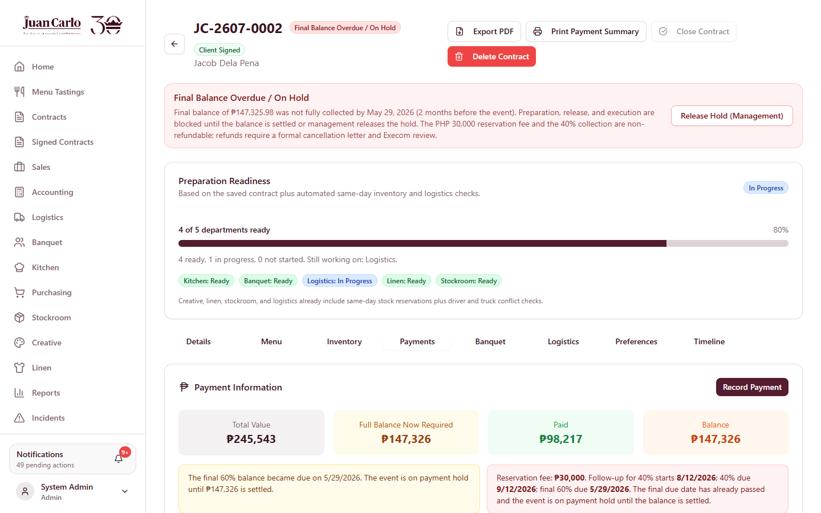
Figure 4.4.1 Contract Payments tab

4.5 Approving a Contract for Preparation
Overview. Approval releases the event to the operating departments.
1. Review the signed contract from the Accounting Dashboard or the contract page.
2. Confirm the requirements: client signature recorded, the 40% collection received (or full payment if the final due date has passed), and no uncovered inventory shortage.
3. Click Approve For Preparation. Every operating department is notified of its task; the kitchen alert asks it to review the menu now and explains the later preparation windows.
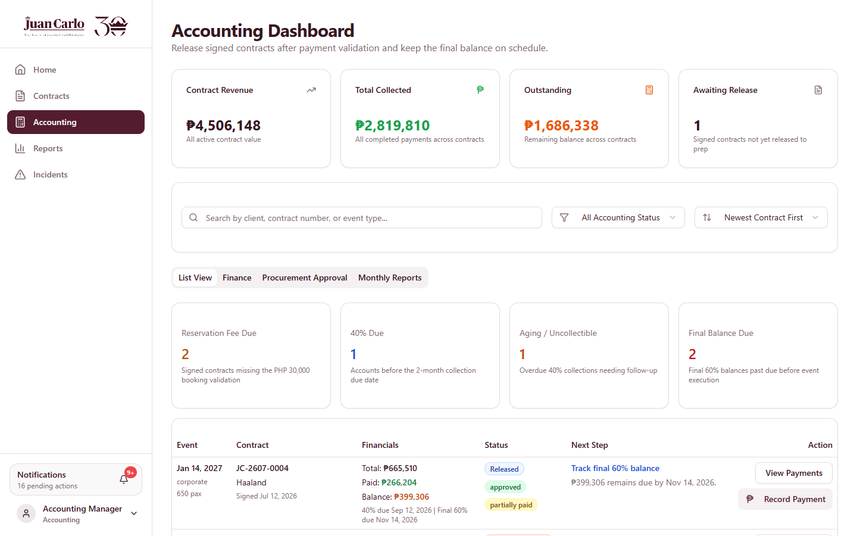
Figure 4.5.1 Accounting Dashboard

4.6 Payment Holds
Overview. When the 60% balance is not fully collected by its due date, the system places the contract on Final Balance Overdue / On Hold automatically. While held, preparation and execution actions across all departments are blocked. Non-finance departments see the hold notice without monetary amounts.
1. Settle the balance to lift the hold automatically, or
2. Ask management (Admin) to click Release Hold (Management) on the contract when an exception is approved.

Figure 4.6.1 Contract placed on Final Balance Overdue / On Hold

4.7 Procurement Budget Approval
Overview. Purchasing submits budget requests for shortages. Accounting reviews each request against the monthly budget before money is released.
1. Open the Procurement Approval queue on the Accounting Dashboard.
2. Review the request, supplier quotation, and amount. Complete the review checklist. The system checks the request against the month’s remaining category budget and blocks approval when the budget is insufficient.
3. Approve the request, or return it with a rejection reason so Purchasing can revise it.
4. After Purchasing submits the proof of purchase, confirm the expense to complete the request.
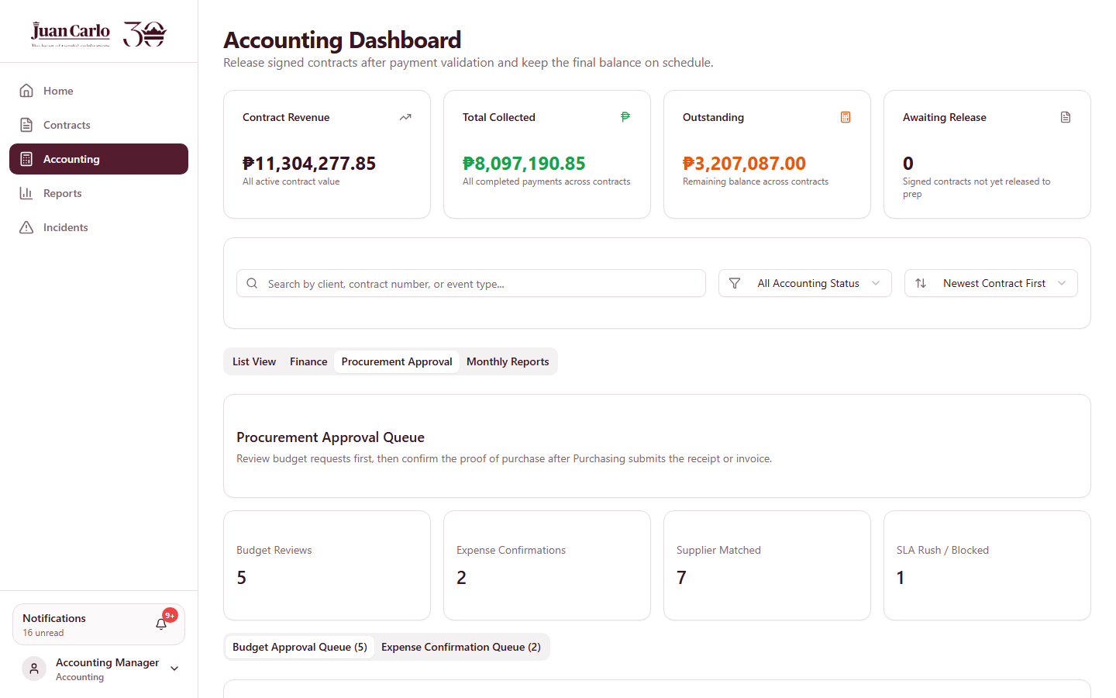
Figure 4.7.1 Accounting procurement approval queue with review checklist

4.8 Monthly Operating Budget
Overview. Accounting maintains a monthly budget that procurement approvals draw against.
1. Open the Finance module from the Accounting area and select the month.
2. Set the amounts per category. Use Standard Amounts for the template or Suggest From Last 3 Months to derive Creative, Linen, and Stockroom amounts from the trailing three months of confirmed procurement spend.
3. Click Save Monthly Budget. The budget check during procurement approval uses these amounts.
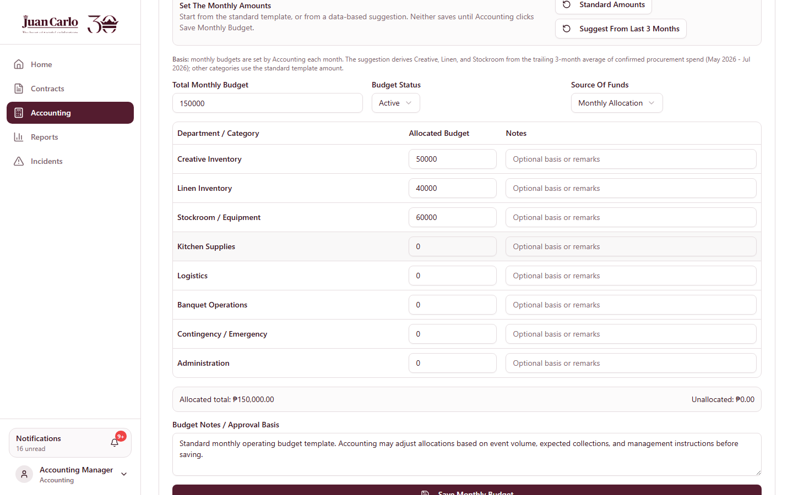
Figure 4.8.1 Monthly budget editor in the Finance module

4.9 Closing the Contract
Overview. After the event, the contract moves through Post-Event Checks to Awaiting Contract Close, and Accounting closes it.
1. Wait for the Ready to close notification — it is sent automatically when every department’s post-event checks are complete and the logistics booking is closed out.
2. Confirm that the balance is fully collected.
3. Open the contract and click Close Contract. Closing requires: the event date has passed, full payment, logistics marked completed, and no pending post-event checks. The contract is then recorded as completed and its notifications expire automatically.

4.10 Accounting Scenarios
• Client pays everything up front. Record the full amount; the collection timeline and holds no longer apply.
• 40% missed. The system opens the follow-up and milestone alerts, then the 30-day aging window; if still unpaid, the account is flagged uncollectible for review.
• 60% missed. The contract is held automatically; preparation stops until payment or a management release.
• Budget request exceeds the month’s budget. Approval is blocked with the shortfall shown; adjust the monthly budget or return the request.

Chapter 5. Creative Department Guide

5.1 Role Overview and Features
The Creative department manages the visual side of events: backdrops, props, floral arrangements, centerpieces, and related decor. It validates creative items on draft contracts, prepares them before events, and checks them back in afterward.
Table 5.1 Creative Features at a Glance
Feature | What It Does
Creative Inventory page | Add, edit, delete, and monitor creative items (backdrops, decor, floral, props, signage); stock quantity, status, and low-stock indicators
Draft validation | Review and confirm the items assigned to a draft contract before it can proceed to signature
Pre-event preparation | Mark each assigned item Prepared before the event; printable pull-out summary
Purchasing requests | Request purchase or rental when an item is short; sent to Purchasing for budget processing
Post-event checking | Verify returned items after the event; report incidents for missing or damaged items
Department report | Readiness, low stock, purchasing activity, and incidents for creative/decor items (Chapter 13)

Table 5.2 Rules That Affect Creative
Rule | Detail
Same-day availability | Item availability is computed per event date; quantities reserved by another same-day event are unavailable, and alternatives are suggested
Material freeze | Seven days before the event, assigned materials are locked to that event; releasing or editing them requires management (Admin)
Requisition lead time | Purchase and rental requisitions require a seven-day lead time and Accounting budget approval
Post-event accountability | Items loaded out must be accounted for after the event; unresolved variances go to the missing-and-damaged summary and may be charged unless a valid counter-report is filed
Price visibility | Package price and contract value are hidden from this department

5.3 Validating a Draft Contract
Overview. Draft contracts that include your items appear on your dashboard as validation tasks. Validation confirms the item list is complete and correct before signature.
1. Open the contract and select the Inventory tab.
2. Review the creative/decor items items, quantities, and availability for the event date.
3. Click Confirm Creative Assets when the section is correct. Your view of the draft shows Validated; the contract proceeds when all departments have confirmed.

5.4 Pre-Event Preparation
Overview. After Accounting approves the event, prepare each assigned item.
1. Open the approved event from your dashboard (it also appears under This Week seven days out).
2. On the Inventory tab, set each item to Prepared using its dropdown. All items must be Prepared for your department to show Ready.
3. Click Print Pull-Out Summary for the physical pull-out list used when handing items to Logistics.

5.5 Requesting Purchase or Rental
Overview. When an item is short for the event date, raise a purchasing request from the contract.
1. On the shortage item, click Request Purchasing Or Rental.
2. Enter the request type, quantity, date needed, and reason, then click Send To Purchasing. Purchasing prepares the budget request for Accounting approval (Chapter 11).

5.6 Post-Event Checking and Incidents
Overview. After the event date passes, verify the returned items.
1. Open the contract’s Inventory tab; items start as Pending Post-Event Check.
2. Select Checked and Returned for complete items.
3. For missing or damaged items, click Report Incident; the contract and item are pre-filled. Submit the report with severity, description, affected quantity, and an optional photo.
4. The driver’s Return / Pickup Checklist and the logistics Return Reconciliation panel track the same items, so complete your checks promptly.
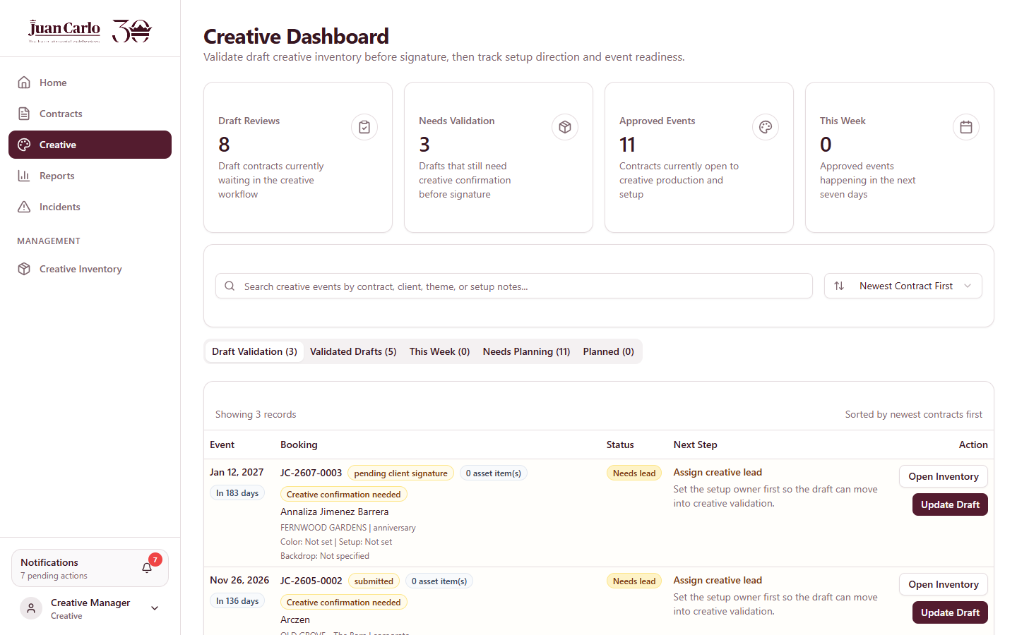
Figure 5.6.1 Creative Dashboard
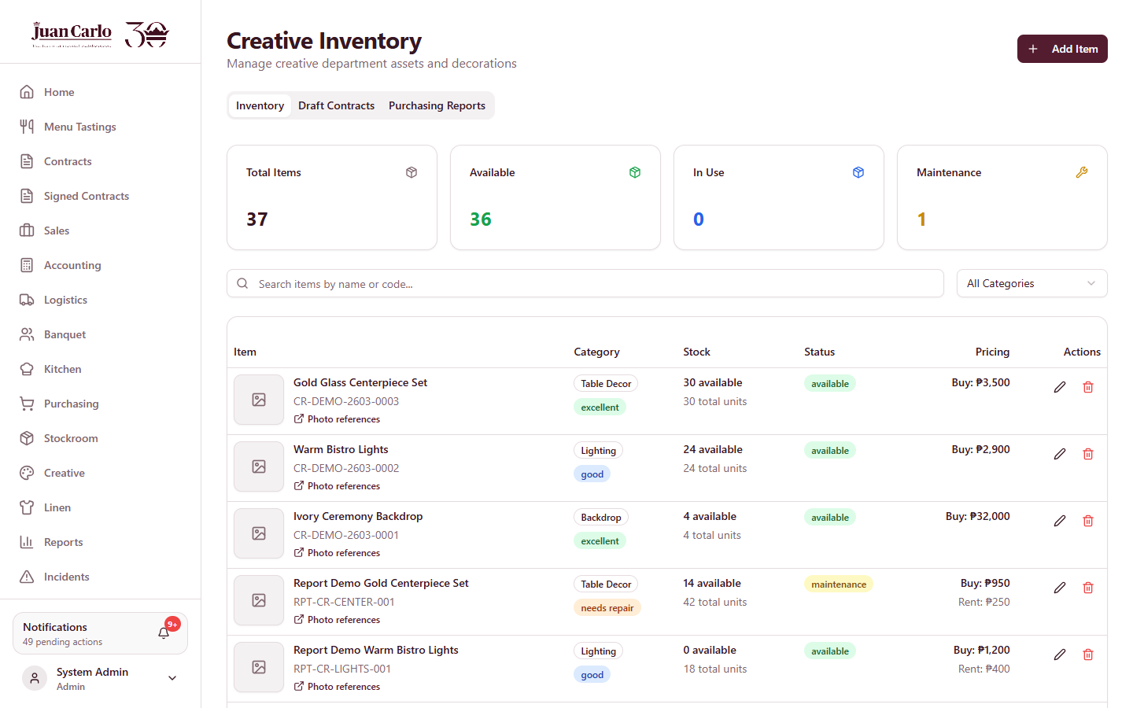
Figure 5.6.2 Creative Inventory page
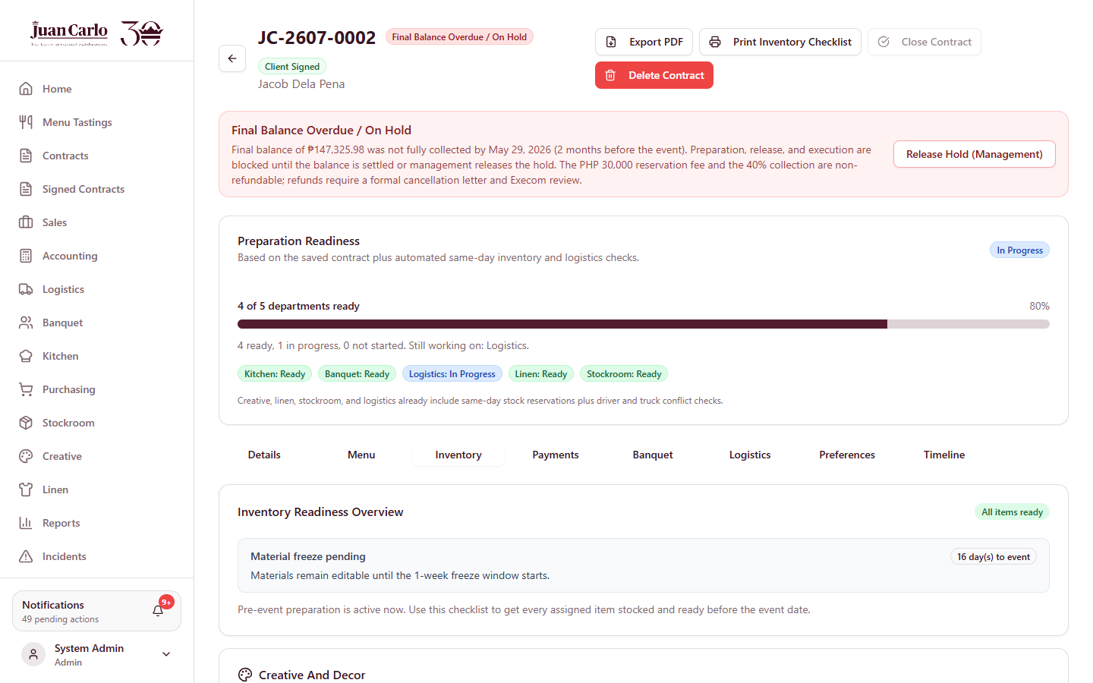
Figure 5.6.3 Contract Inventory tab used for validation and preparation
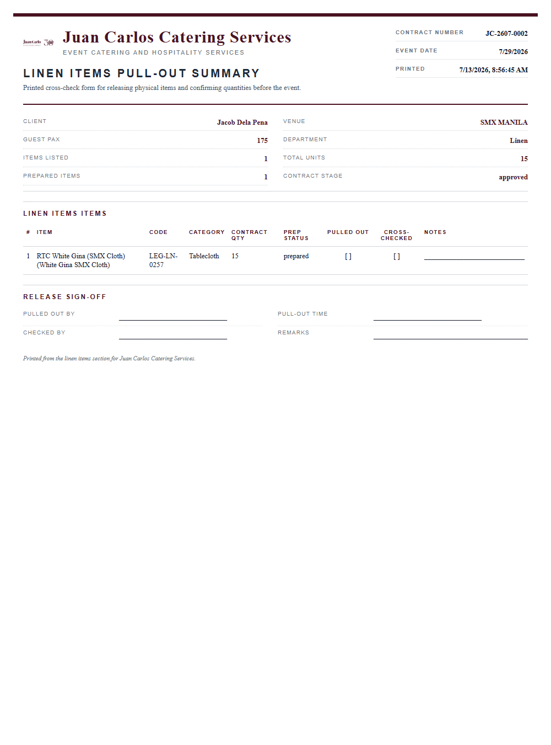
Figure 5.6.4 Printed Pull-Out Summary

Chapter 6. Linen Department Guide

6.1 Role Overview and Features
The Linen department manages tablecloths, napkins, chair covers, skirting, and other fabrics. Its workflow mirrors the other inventory departments: validate the draft, prepare items, request replacements when short, and verify returns after the event (items may also pass through laundry status).
Table 6.1 Linen Features at a Glance
Feature | What It Does
Linen Inventory page | Add, edit, delete, and monitor linen items (tablecloths, napkins, covers, skirting); stock quantity, status, and low-stock indicators
Draft validation | Review and confirm the items assigned to a draft contract before it can proceed to signature
Pre-event preparation | Mark each assigned item Prepared before the event; printable pull-out summary
Purchasing requests | Request purchase or rental when an item is short; sent to Purchasing for budget processing
Post-event checking | Verify returned items after the event; report incidents for missing or damaged items
Department report | Readiness, low stock, purchasing activity, and incidents for linen items (Chapter 13)

Table 6.2 Rules That Affect Linen
Rule | Detail
Same-day availability | Item availability is computed per event date; quantities reserved by another same-day event are unavailable, and alternatives are suggested
Material freeze | Seven days before the event, assigned materials are locked to that event; releasing or editing them requires management (Admin)
Requisition lead time | Purchase and rental requisitions require a seven-day lead time and Accounting budget approval
Post-event accountability | Items loaded out must be accounted for after the event; unresolved variances go to the missing-and-damaged summary and may be charged unless a valid counter-report is filed
Price visibility | Package price and contract value are hidden from this department

6.3 Validating a Draft Contract
Overview. Draft contracts that include your items appear on your dashboard as validation tasks. Validation confirms the item list is complete and correct before signature.
1. Open the contract and select the Inventory tab.
2. Review the linen items items, quantities, and availability for the event date.
3. Click Confirm Linen Requirements when the section is correct. Your view of the draft shows Validated; the contract proceeds when all departments have confirmed.

6.4 Pre-Event Preparation
Overview. After Accounting approves the event, prepare each assigned item.
1. Open the approved event from your dashboard (it also appears under This Week seven days out).
2. On the Inventory tab, set each item to Prepared using its dropdown. All items must be Prepared for your department to show Ready.
3. Click Print Pull-Out Summary for the physical pull-out list used when handing items to Logistics.

6.5 Requesting Purchase or Rental
Overview. When an item is short for the event date, raise a purchasing request from the contract.
1. On the shortage item, click Request Purchasing Or Rental.
2. Enter the request type, quantity, date needed, and reason, then click Send To Purchasing. Purchasing prepares the budget request for Accounting approval (Chapter 11).

6.6 Post-Event Checking and Incidents
Overview. After the event date passes, verify the returned items.
1. Open the contract’s Inventory tab; items start as Pending Post-Event Check.
2. Select Checked and Returned for complete items.
3. For missing or damaged items, click Report Incident; the contract and item are pre-filled. Submit the report with severity, description, affected quantity, and an optional photo.
4. The driver’s Return / Pickup Checklist and the logistics Return Reconciliation panel track the same items, so complete your checks promptly.
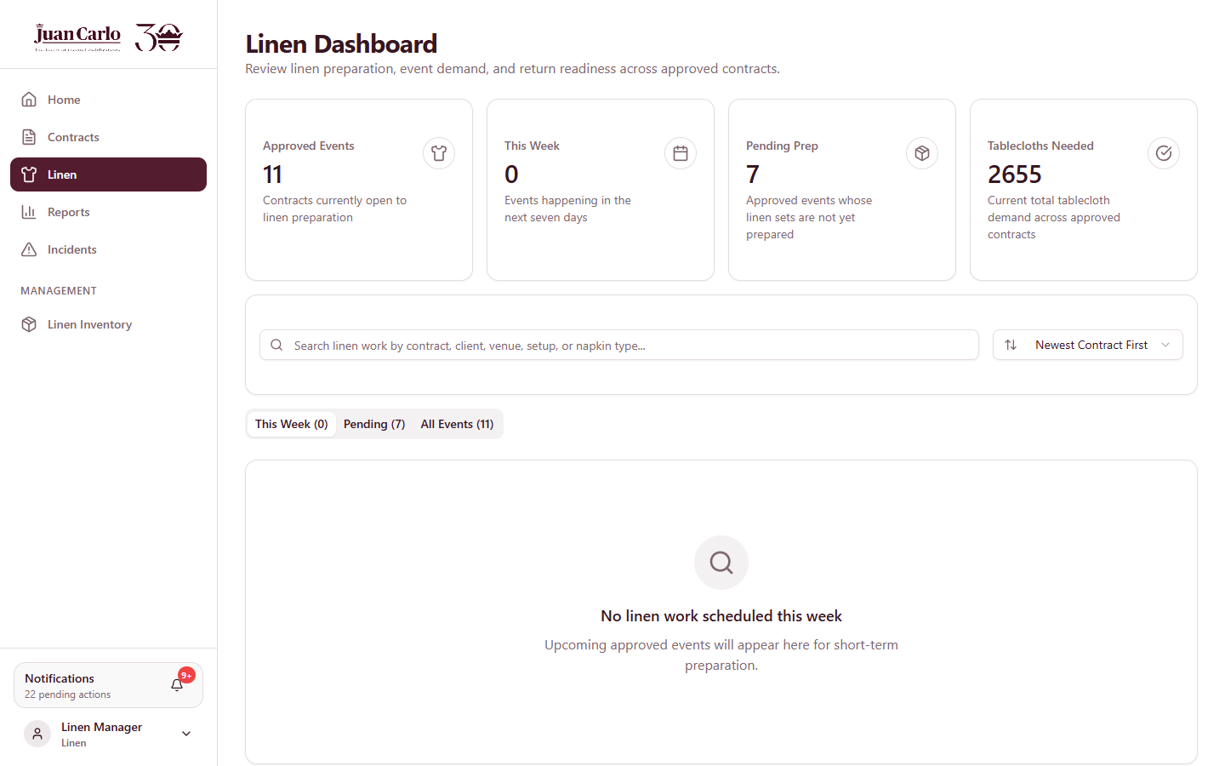
Figure 6.6.1 Linen Dashboard
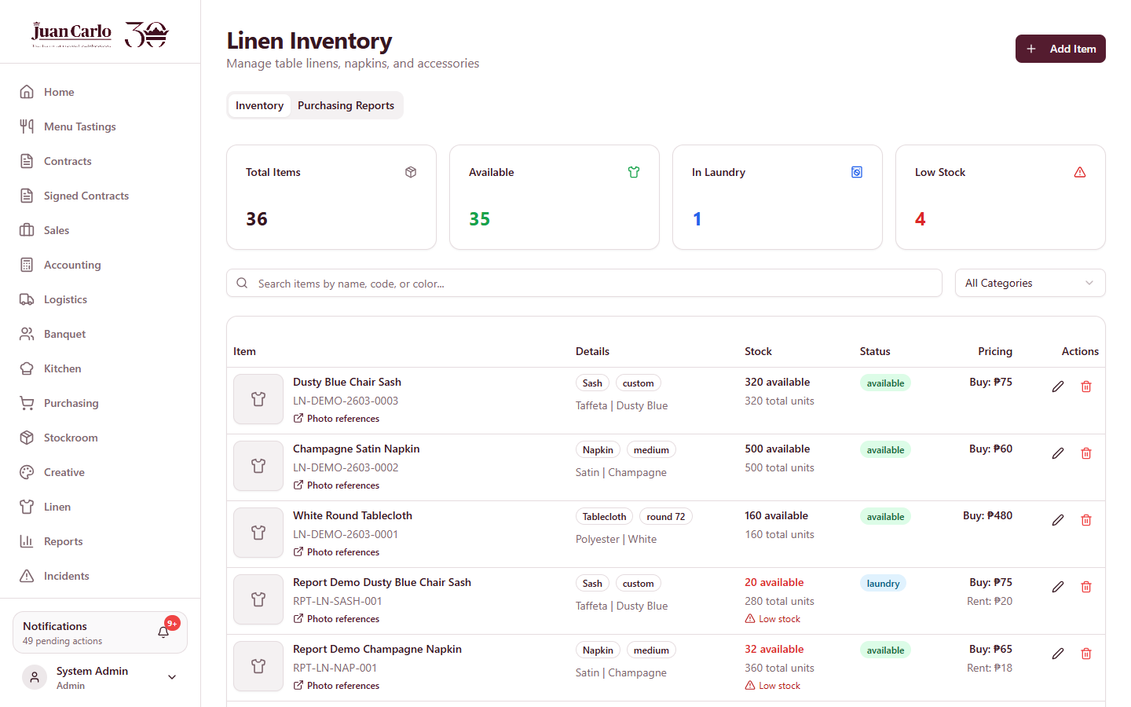
Figure 6.6.2 Linen Inventory page

Chapter 7. Stockroom Department Guide

7.1 Role Overview and Features
The Stockroom manages equipment and operating supplies: tables, chairs, chafing dishes, utensils, cleaning supplies, and similar items. It validates the equipment checklist on drafts, prepares equipment for loading, and reconciles returns. Stockroom preparation drives the Stockroom “Done” progress on the contract.
Table 7.1 Stockroom Features at a Glance
Feature | What It Does
Stockroom Inventory page | Add, edit, delete, and monitor equipment and supplies; stock quantity, status, and low-stock indicators
Draft validation | Review and confirm the items assigned to a draft contract before it can proceed to signature
Pre-event preparation | Mark each assigned item Prepared before the event; printable pull-out summary
Purchasing requests | Request purchase or rental when an item is short; sent to Purchasing for budget processing
Post-event checking | Verify returned items after the event; report incidents for missing or damaged items
Department report | Readiness, low stock, purchasing activity, and incidents for equipment and supplies (Chapter 13)

Table 7.2 Rules That Affect Stockroom
Rule | Detail
Same-day availability | Item availability is computed per event date; quantities reserved by another same-day event are unavailable, and alternatives are suggested
Material freeze | Seven days before the event, assigned materials are locked to that event; releasing or editing them requires management (Admin)
Requisition lead time | Purchase and rental requisitions require a seven-day lead time and Accounting budget approval
Post-event accountability | Items loaded out must be accounted for after the event; unresolved variances go to the missing-and-damaged summary and may be charged unless a valid counter-report is filed
Price visibility | Package price and contract value are hidden from this department

7.3 Validating a Draft Contract
Overview. Draft contracts that include your items appear on your dashboard as validation tasks. Validation confirms the item list is complete and correct before signature.
1. Open the contract and select the Inventory tab.
2. Review the equipment and supplies items, quantities, and availability for the event date.
3. Click Confirm Equipment Checklist when the section is correct. Your view of the draft shows Validated; the contract proceeds when all departments have confirmed.

7.4 Pre-Event Preparation
Overview. After Accounting approves the event, prepare each assigned item.
1. Open the approved event from your dashboard (it also appears under This Week seven days out).
2. On the Inventory tab, set each item to Prepared using its dropdown. All items must be Prepared for your department to show Ready.
3. Click Print Pull-Out Summary for the physical pull-out list used when handing items to Logistics.

7.5 Requesting Purchase or Rental
Overview. When an item is short for the event date, raise a purchasing request from the contract.
1. On the shortage item, click Request Purchasing Or Rental.
2. Enter the request type, quantity, date needed, and reason, then click Send To Purchasing. Purchasing prepares the budget request for Accounting approval (Chapter 11).

7.6 Post-Event Checking and Incidents
Overview. After the event date passes, verify the returned items.
1. Open the contract’s Inventory tab; items start as Pending Post-Event Check.
2. Select Checked and Returned for complete items.
3. For missing or damaged items, click Report Incident; the contract and item are pre-filled. Submit the report with severity, description, affected quantity, and an optional photo.
4. The driver’s Return / Pickup Checklist and the logistics Return Reconciliation panel track the same items, so complete your checks promptly.
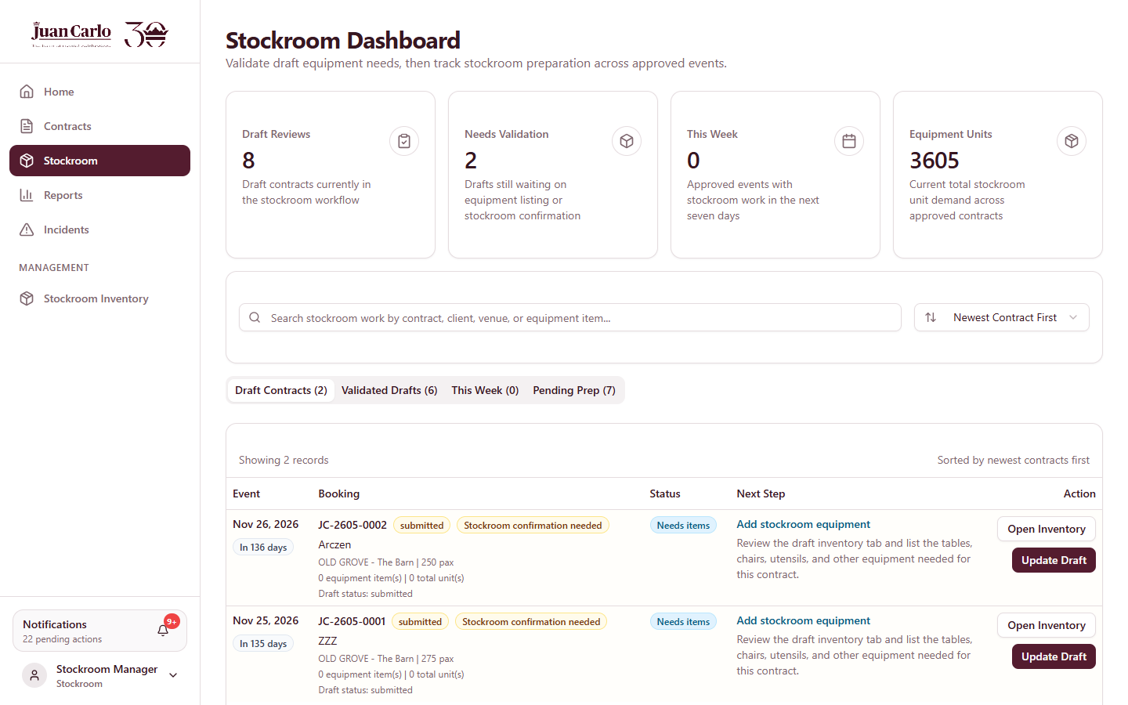
Figure 7.6.1 Stockroom Dashboard
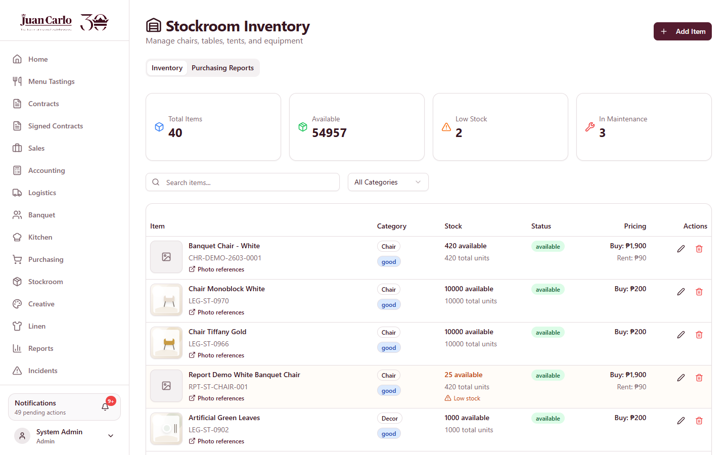
Figure 7.6.2 Stockroom Inventory page

7.7 Inventory Page Basics (Creative, Linen, Stockroom, Kitchen)
Each inventory page supports the same record management:
• Add Item — opens a form for name, category, quantity, minimum stock, price, condition/status, and image.
• Edit (pencil icon) — updates an item; Delete (trash icon) — removes it after confirmation.
• Monitoring — the Stock and Status columns show availability (available, in use, in laundry, reserved, maintenance); low-stock items are highlighted; search and category filters locate items quickly.
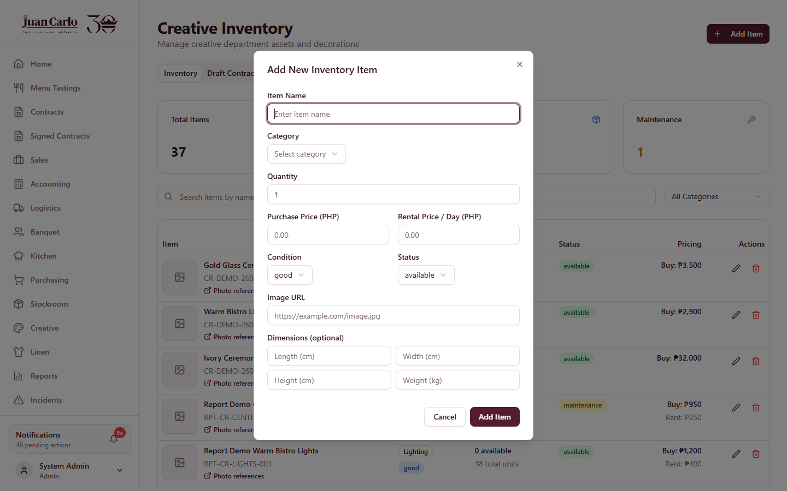
Figure 7.7.1 Add Item dialog

Chapter 8. Kitchen Department Guide

8.1 Role Overview and Features
The Kitchen prepares the menu for each approved event. It confirms the menu checklist, marks item preparation, and maintains the kitchen inventory. The Kitchen sees menu and preparation information only — contract prices are hidden, and its contract view has no Inventory tab.
Table 8.1 Kitchen Features at a Glance
Feature | What It Does
Kitchen Dashboard | Approved events with menu checklists, item status, cooking location, and This Week focus
Menu checklist | Per-dish confirmation on the contract’s Menu tab; required before preparation can be marked ready
Item preparation status | Pending → Procured → Prepared per event; “Mark Ready” completes kitchen preparation
Preferences tab | Shows the client’s menu tasting feedback (rating, comments, items liked / to change, per-dish notes)
Printable kitchen checklist | Physical checklist of dishes with preparation notes
Kitchen inventory | Kitchen items and supplies with stock levels
Kitchen report | Checklist completion, preparation status, low stock, incidents (Chapter 13)

8.2 Kitchen Notifications and Timing Rules
Kitchen work is driven by the event date. The system sends the alerts below automatically; food preparation may only begin when the event is within seven days.
Table 8.2 Kitchen Alerts and Windows
Alert / Window | Meaning
Approved event – review menu | Sent at approval; review and confirm the menu checklist now — preparation comes later
Two weeks before the event | “Start sourcing items” reminder; begin sourcing and advance status to Procured
Seven days before the event | “Begin preparations” alert; food preparation may start, and the event enters the This Week tab
Final details deadline | All client details are final one month before the event, aligning the prep window
During event week | The kitchen sees the stage label “Event Week” on the contract

8.3 Confirming the Menu Checklist
1. Open the approved event from the Kitchen Dashboard or the contract’s Menu tab.
2. Tick each dish after review; the checklist counter tracks completion (e.g., 4/4 confirmed).
3. Check the Preferences tab for the client’s tasting feedback and per-dish comments before finalizing quantities.
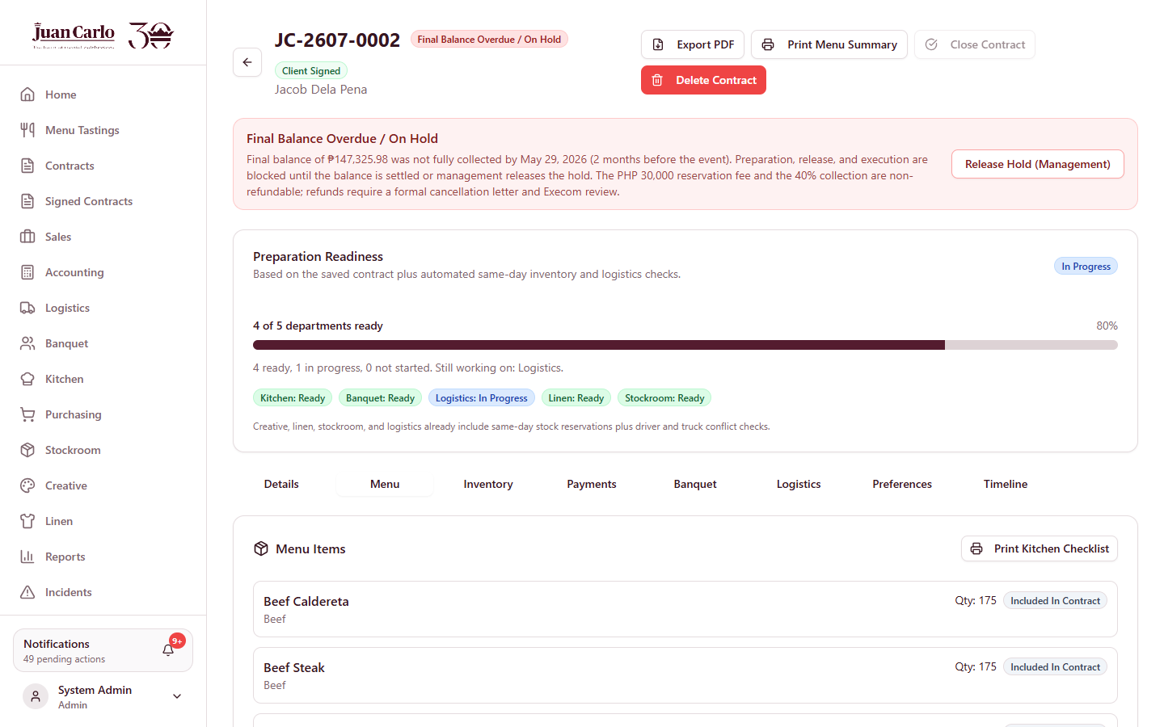
Figure 8.3.1 Contract Menu tab used for kitchen preparation

8.4 Marking Preparation Ready
1. Advance the item status to Procured once sourcing is done (two-week window).
2. Within seven days of the event, complete preparation and click Mark Ready. The system requires the menu checklist to be fully confirmed first.
3. Kitchen readiness feeds the contract’s Preparation Readiness panel and the logistics load-readiness board.
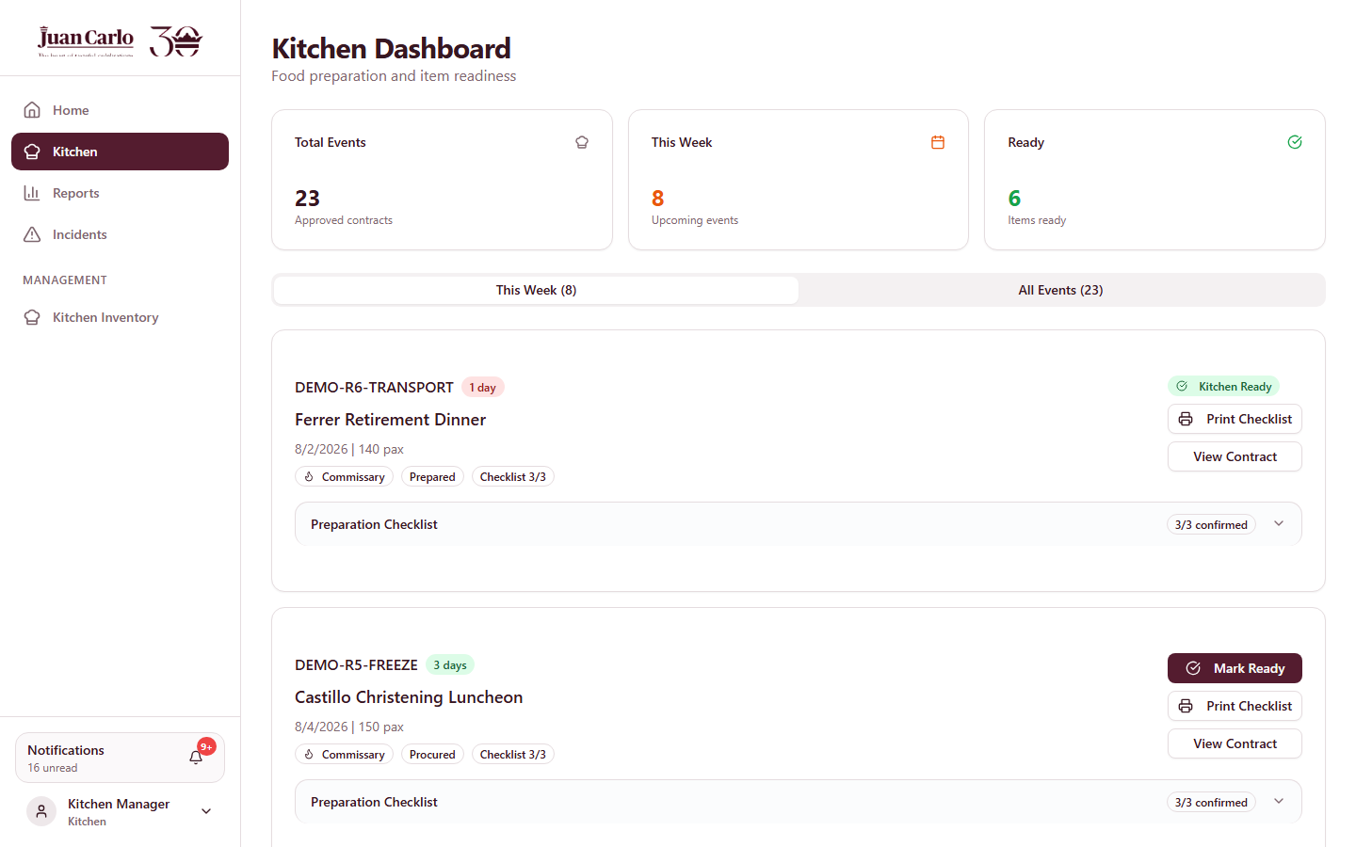
Figure 8.4.1 Kitchen Dashboard

8.5 Printing the Kitchen Checklist
1. On the contract’s Menu tab, click Print Kitchen Checklist to export the contract details and dish checklist with prep notes.
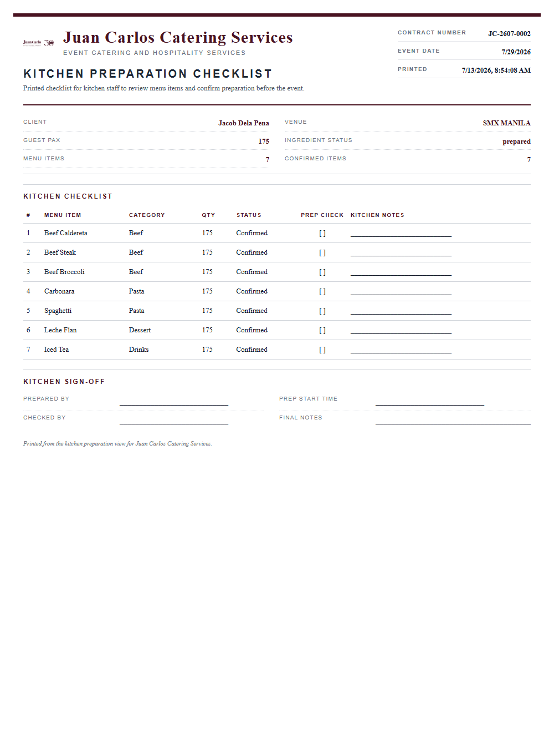
Figure 8.5.1 Printed Kitchen Checklist

8.6 Kitchen Inventory
The Kitchen Inventory page manages kitchen items and supplies with the same add/edit/delete and monitoring features as the other inventory pages (see 7.7).
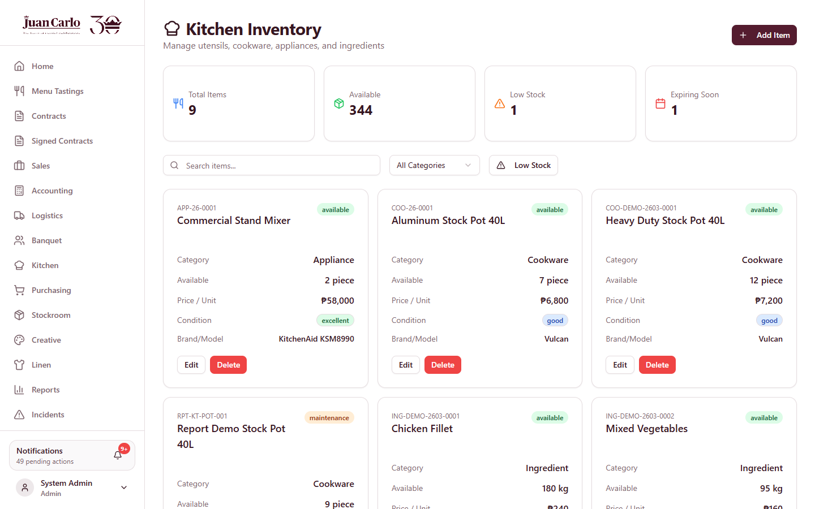
Figure 8.6.1 Kitchen Inventory page

8.7 Kitchen Scenarios
• Event three weeks away. Review and confirm the menu checklist; wait for the two-week sourcing alert before buying.
• Missing ingredient in stock. Update kitchen inventory; shortage alerts flow into purchasing when applicable.
• Trying to Mark Ready early. The system blocks readiness until every dish on the checklist is confirmed.
• Where do my prepared items go? Kitchen items appear on the logistics load manifest and the driver pickup checklist; food is excluded from the post-event return checklist because it is consumed.

Chapter 9. Banquet Department Guide

9.1 Role Overview and Features
The Banquet department staffs each approved event: it plans the crew per role, assigns available staff, and manages the on-site check-in sheet. Line staff are kept as records in the Staff Directory; only supervisors log in.
Table 9.1 Banquet Features at a Glance
Feature | What It Does
Banquet Dashboard | Approved events with staffing status and planning windows
Staffing plan | Role-based plan (head captain, service staff, food runners, bussers, bartenders, setup crew) suggested from the guest count
Staff assignment | Assign available staff per role; the picker excludes staff already booked on the same day
Load Recommended Plan | One click fills the plan and assignments with available, suggested staff
Staff Check-In Sheet | Printable per-role attendance sheet with sign-off blocks
Staff Directory | Banquet staff records: roles, employment type, ratings, event history
Banquet report | Staffing coverage, staff pool, incidents (Chapter 13)

9.2 Staffing Rules and Windows
Table 9.2 Banquet Rules
Rule | Detail
Waitstaff bracket | One waiter per 25 guests (e.g., 40 waiters for a 1,000-pax event), plus the role-based plan for other positions
Planning window | Staffing becomes editable after accounting approval; forecast → planning → freeze stages are shown on the contract
Roster freeze | Within seven days of the event the roster is locked; late replacements require management (Admin), with the change recorded
Same-day exclusivity | A staff member can only be assigned to one event per day
Supervisor requirement | An event needs an assigned supervisor together with the role plan to be considered covered

9.3 Building the Staffing Plan
1. Open the approved contract and select the Banquet tab. Review the service guest count (defaults from the contract pax).
2. Click Load Recommended Plan to auto-fill the role plan and suggested staff, or set the plan numbers per role manually.
3. Assign staff per role from the dropdown — suggested members are tagged Suggested — and click Add Staff.
4. Choose the supervisor, then click Save Banquet Form. Coverage (assigned vs planned) updates on the contract.
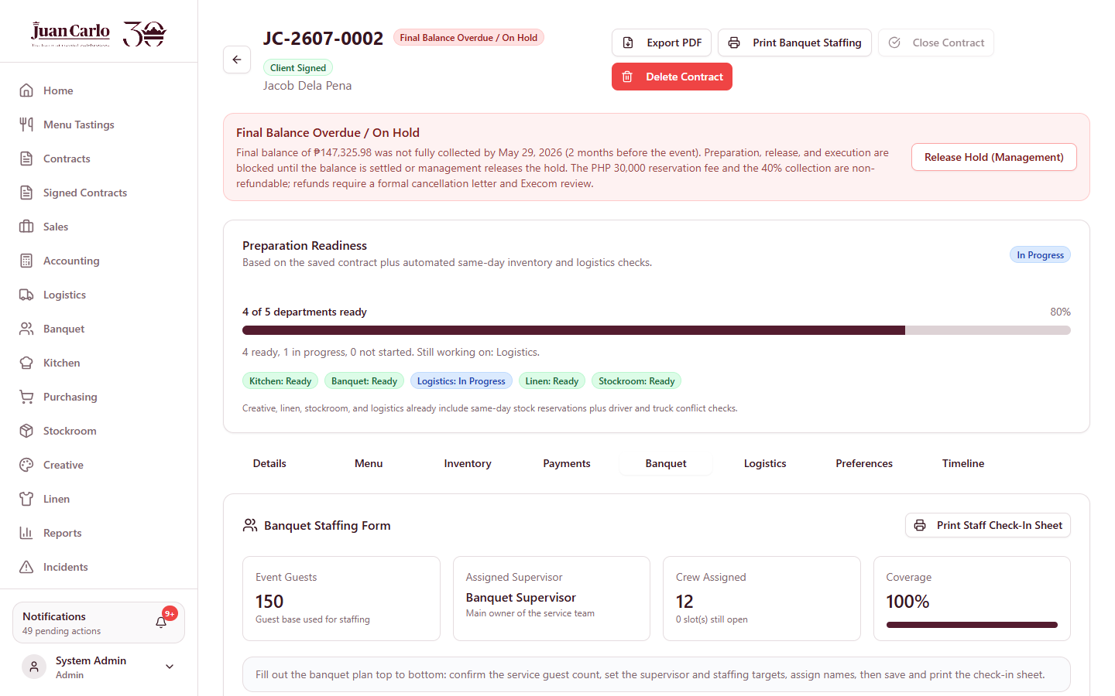
Figure 9.3.1 Contract Banquet tab (staffing form)

9.4 Printing the Staff Check-In Sheet
1. On the Banquet tab, click Print Staff Check-In Sheet. The sheet lists the crew per role with Present, Time In/Out, Station, and Signature columns, plus sign-off blocks for the on-site supervisor (BISOL) and the Account Executive.
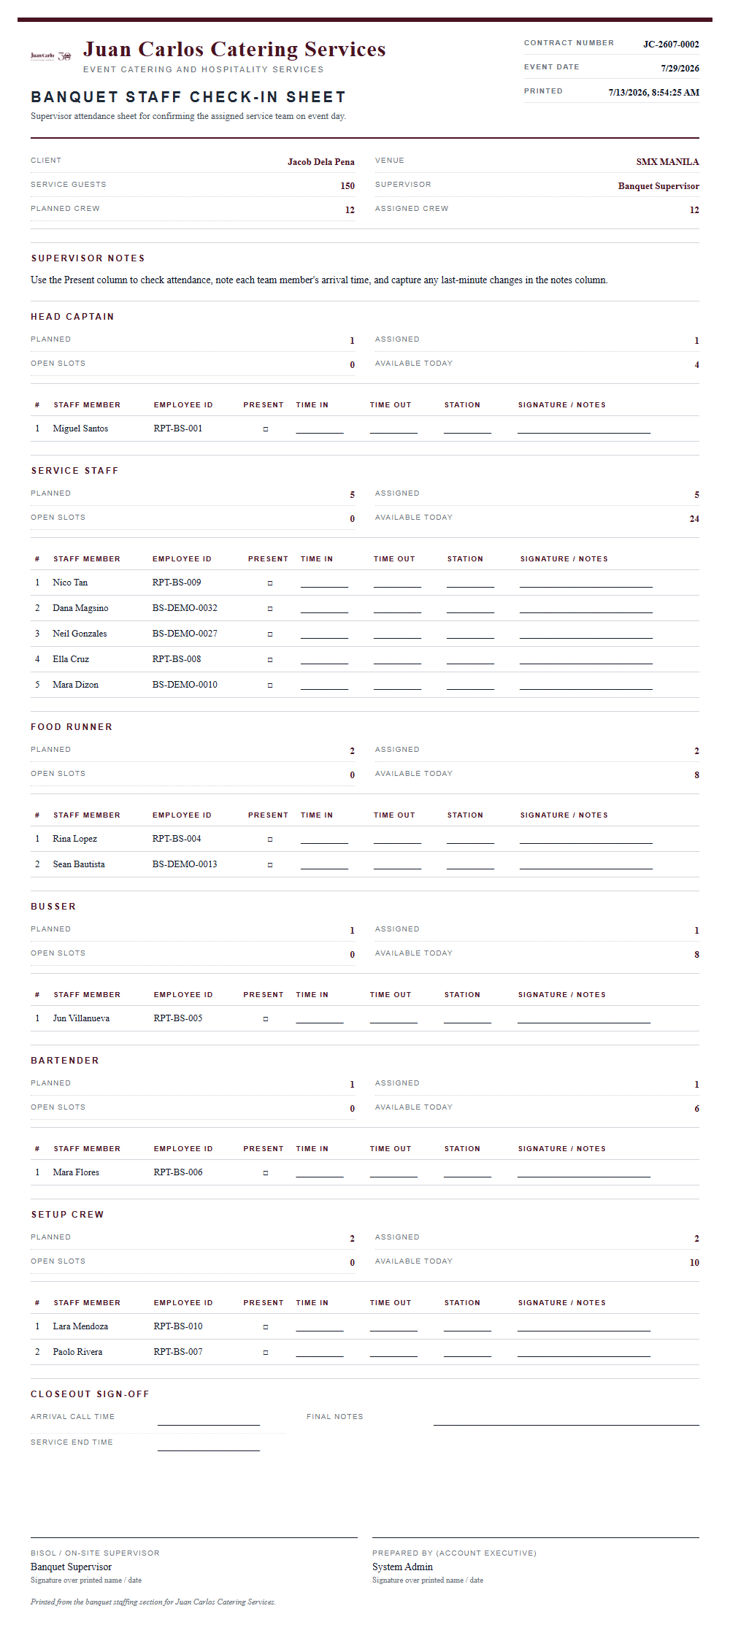
Figure 9.4.1 Printed Banquet Staff Check-In Sheet

9.5 Staff Directory
The Banquet Staff page maintains the staff records: personal details, role, employment type, status, rating, and events worked. Admins may create supervisor login accounts from eligible records.
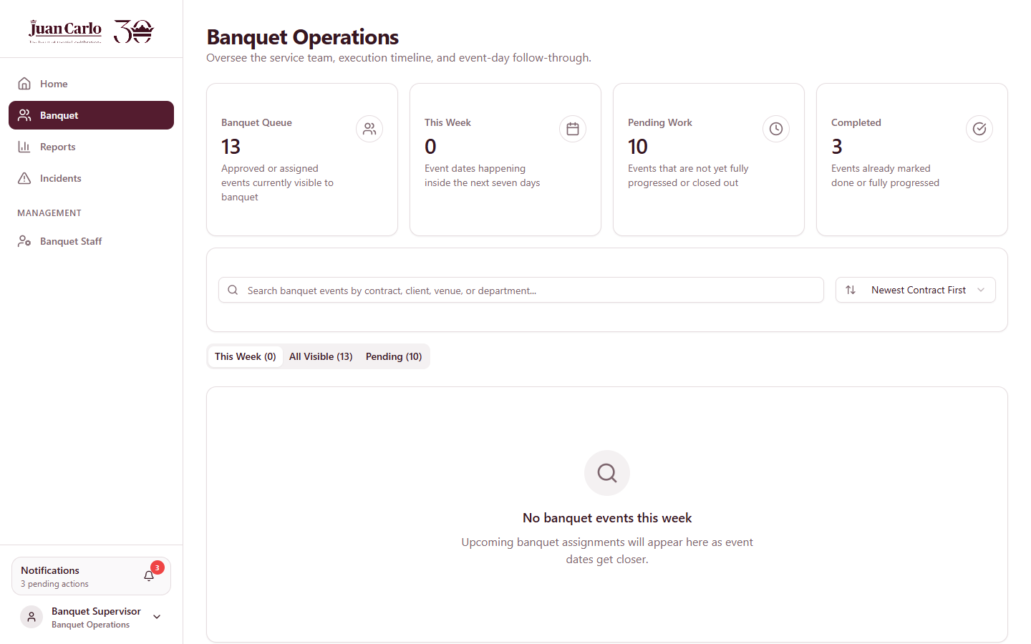
Figure 9.5.1 Banquet Dashboard

9.6 Banquet Scenarios
• 1,000-pax wedding. The suggested plan proposes 40 waiters (1:25) plus runners, bussers, bartenders, and setup crew scaled to the guest count.
• Staff member already booked that day. They do not appear in the picker for a second same-day event.
• Change of crew three days before the event. The roster is frozen; ask an Admin to record the controlled replacement.
• During the event. The supervisor reports on-site issues through Incidents (see Chapter 13).

Chapter 10. Logistics Department Guide

10.1 Role Overview and Features
Logistics moves everything: the equipment and materials of every department to the venue and back, and the staff to the event. Its contract workspace is organized as a guided three-step workflow — 1. Inventory Transport, 2. Staff Transport, and Load & Dispatch (info) — with a progress panel that reaches 100% only when all three are complete.
Table 10.1 Logistics Features at a Glance
Feature | What It Does
Logistics workflow | Three sub-tabs with completion tracking: Inventory Transport, Staff Transport, Load & Dispatch (info)
Transport booking | Assign the cargo truck and driver with recommended matches, capacity fit, and same-day conflict checks; auto-saves
Staff transportation | Separate booking that carries staff in passenger-tagged vehicles; auto-assign by headcount and seat capacity, or pick vehicles and drivers manually
Load manifest | Everything to bring per department — kitchen food, equipment, linen, decor — with preparation status
Department load readiness | Pick-up readiness per department, allowing early loading of departments already Ready
Printable forms | Dispatch Sheet, Trip Ticket (with return counts), Driver Pickup Checklist, Return / Pickup Checklist
Return reconciliation | Post-event accounting of loaded vs returned items per department
Fleet management (Drivers & Trucks) | Driver and vehicle records, passenger tagging, seat capacity, assignments
Logistics report | Assignment status, fleet snapshot, incidents (Chapter 13)

10.2 Transport Rules Enforced by the System
Table 10.2 Logistics Rules
Rule | Detail
Three-day lead time | Transportation must be arranged at least three days before the event; the system warns on approved events inside three days without a truck and sends reminder notifications
Truck sizing | Trucks are matched by required cubic meters; if the load exceeds the internal fleet, additional trucks are rented via a purchase/rental requisition (seven-day lead, Accounting approval)
Same-day conflicts | A truck, driver, or passenger vehicle already committed to another event that day cannot be double-booked
Number coding (UVVRP) | For Metro Manila venues, vehicles are checked against the plate-digit coding day (Mon 1–2, Tue 3–4, Wed 5–6, Thu 7–8, Fri 9–0); coded vehicles are excluded from selection for that date
Passenger safety | Staff ride only in passenger-tagged vehicles (vans, coasters, buses, SUVs) — never in the back of a cargo truck; every staff vehicle needs a driver
Loading window | Equipment loading may begin the day before the event; dispatch happens on the event day
Return accountability | Teams may not leave the venue until returned equipment matches the checklist (supervisor return count and warehouse second count); variances go to the missing-and-damaged summary

10.3 Step 1 — Inventory Transport (Cargo)
1. Open the approved contract’s Logistics tab. The workflow panel shows the three steps and current progress.
2. In 1. Inventory Transport, review the event date, venue, estimated load (m³), and the Dispatch Decision Review checks.
3. Pick the truck and driver — the Recommended Match considers capacity and availability; selections auto-save. Conflicting or coded vehicles are excluded.
4. The stage advances automatically (Transport Booked → Ready For Dispatch); use Mark Dispatched on the event day.
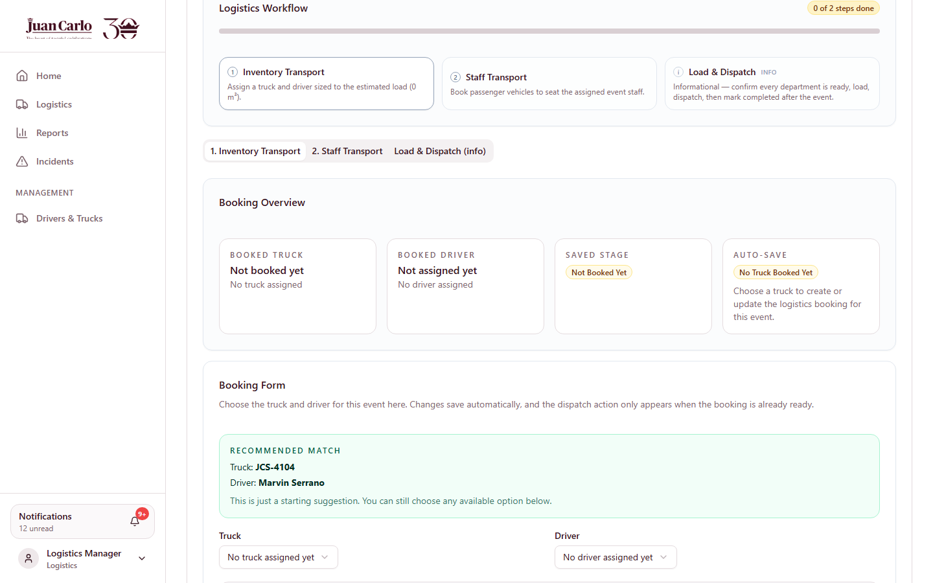
Figure 10.3.1 Logistics workflow panel with sub-tabs and Inventory Transport step

10.4 Step 2 — Staff Transportation
Overview. Staff transportation is a second booking that carries the assigned banquet crew and supervisor.
1. Open 2. Staff Transport. The headcount comes from the banquet assignments plus the supervisor.
2. Click Auto-Assign Vehicles to book the fewest passenger vehicles that seat everyone, or pick vehicles manually and choose a driver per vehicle.
3. The booking shows staff count, seats booked, and vehicles; a shortfall warning appears if seats are insufficient. Same-day and coding conflicts are excluded automatically.
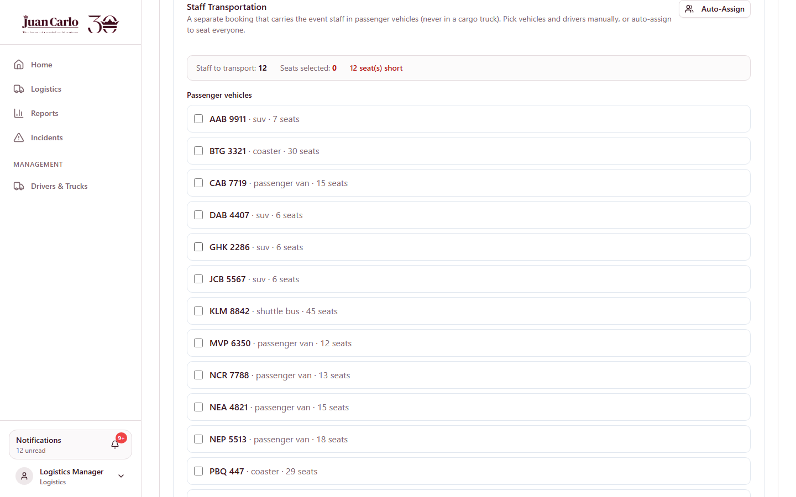
Figure 10.4.1 Staff Transportation booking with auto-assign

10.5 Step 3 — Load & Dispatch (info)
1. Open Load & Dispatch (info). The Department Load Readiness board shows which departments are Ready for pickup — early loading may start with Ready departments the day before the event.
2. Review the Load Manifest — kitchen food, equipment, linen, and decor with quantities and preparation status.
3. Print the driver documents: Driver Pickup Checklist (collect from departments, with release/receive sign-offs), Dispatch Sheet, and Trip Ticket (full manifest with Loaded, Returned, Second Count, and Variance columns).
4. After the event, print the Return / Pickup Checklist (reusable items to collect from the venue; food excluded) and mark the booking Completed once the trucks return.
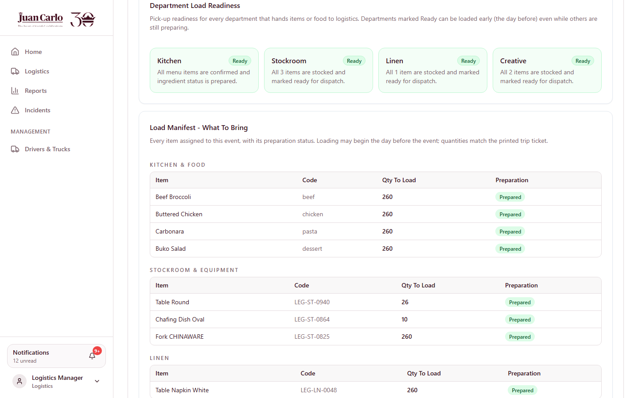
Figure 10.5.1 Load & Dispatch: readiness board and load manifest
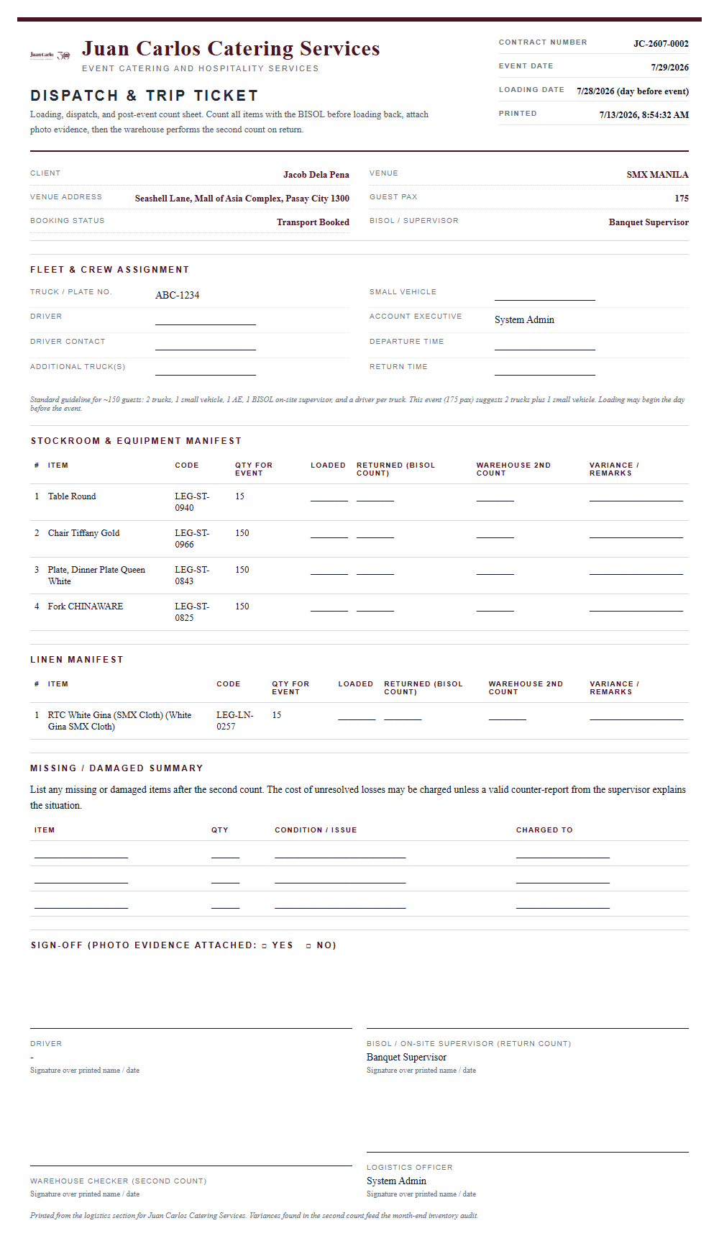
Figure 10.5.2 Printed Dispatch and Trip Ticket

10.6 Return Reconciliation
Overview. After the event date, the Return Reconciliation panel compares each department’s loaded items against post-event checks: “X of Y items checked/returned” with pending counts highlighted. Discrepancies are recorded as incidents; unresolved losses feed the missing-and-damaged summary. Marking the logistics booking Completed is one of the requirements for closing the contract.
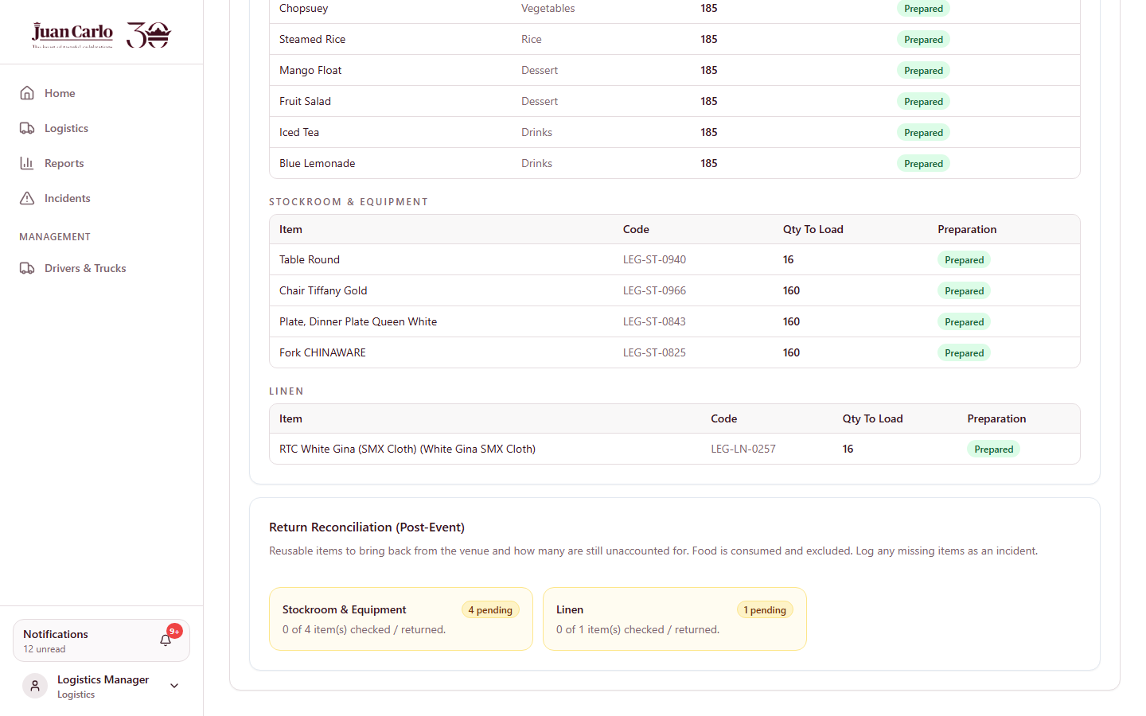
Figure 10.6.1 Return Reconciliation panel (post-event)

10.7 Fleet Management (Drivers & Trucks)
1. Open Drivers & Trucks from the Management menu to maintain the fleet.
2. Add or edit drivers (license details, contact) and vehicles (plate, type, cargo capacity, and for staff vehicles the Passenger vehicle tag with seat capacity).
3. Assign drivers to vehicles; availability and status (available, in use, maintenance) feed every booking screen.
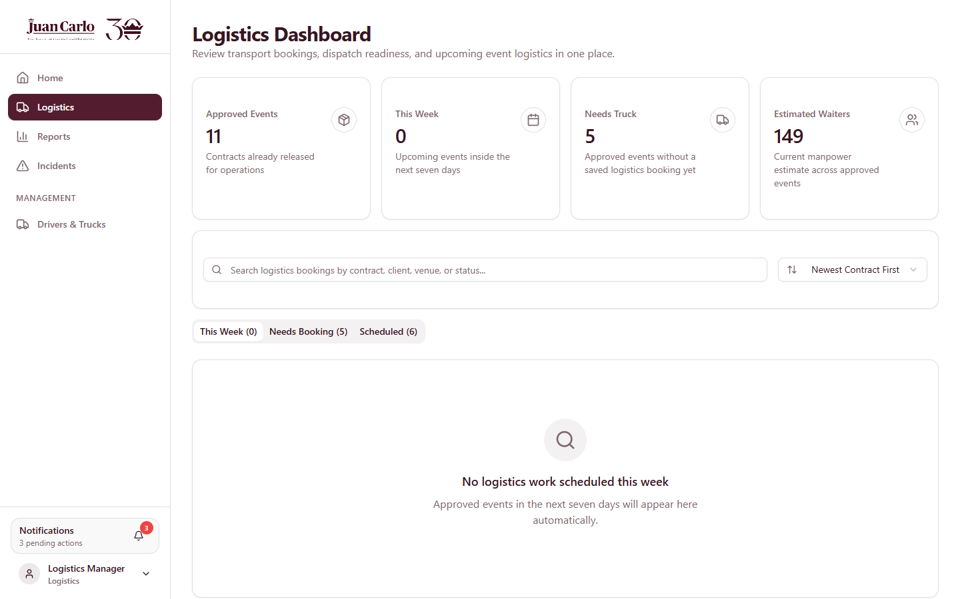
Figure 10.7.1 Logistics Dashboard

10.8 Logistics Scenarios
• Two events on the same day. Each event books its own truck, driver, and staff vehicles; anything committed to the other event is excluded automatically.
• Metro Manila event on a coding day. A vehicle whose plate is coded that weekday is excluded; the system notes the coding conflict.
• Load exceeds fleet capacity. File a rental requisition through Purchasing (seven-day lead time, Accounting approval).
• Event within three days, no truck yet. A lead-time warning appears on the contract and a reminder notification is sent — book immediately.
• Early pickup. The readiness board shows Stockroom Ready while Kitchen is still preparing — load the stockroom items the day before, collect the food on event day.
• Items missing at pack-up. The return count differs from the checklist; the team stays until reconciled or an incident is filed for the variance.

Chapter 11. Purchasing Department Guide

11.1 Role Overview and Features
Purchasing turns department shortages into fulfilled orders: it receives purchase/rental requests, prepares supplier quotations and budget requests, obtains Accounting approval, procures the items, and submits proof of purchase. The dashboard organizes requests into process queues.
Table 11.1 Purchasing Features at a Glance
Feature | What It Does
Request queues | Needs Budget Request → Waiting Budget Approval → Budget Approved → Waiting Expense Confirmation → Completed
Quotation & budget request | Select supplier, expected fulfillment date, unit price, and notes; submit to Accounting
Requisition forms | Item Requisition (stockable), Purchase Requisition (bought/rented), Emergency Requisition (lead time lapsed; needs Material Control Manager approval) — all follow “no signature, no request, no release”
Supplier database | Supplier records with coverage areas, departments served, and preferred tagging
Proof of purchase | Invoice/OR/rental reference with receipt image, submitted for Accounting confirmation
Purchasing report | Request movement, supplier coverage, quoted totals, fulfillment status (Chapter 13)

11.2 Rules That Govern Purchasing
Table 11.2 Purchasing Rules
Rule | Detail
Seven-day lead time | Standard item and purchase requisitions require a seven-day lead before the date needed
Emergency route | When the lead time has lapsed, only the Emergency Requisition Form may be used, with Material Control Manager approval
Budget approval first | No procurement without an approved budget request; approvals are checked against the monthly category budget
Proof required | Every approved purchase ends with proof of purchase confirmed by Accounting before the request is Completed
Who can request | Creative, Linen, Stockroom, and Logistics raise requests; Purchasing and Admin may also create them

11.3 Processing a Request
1. Open the Purchasing Dashboard. New department requests appear under Needs Budget Request.
2. Open the request, choose the supplier, set the expected fulfillment date and unit price, add notes, and submit the budget request to Accounting.
3. Track it under Waiting Budget Approval. If Accounting returns it, revise the quotation and resubmit.
4. Once approved, procure the items, then open Budget Approved and click Submit Proof Of Purchase — enter the invoice/OR/rental reference and attach the receipt image.
5. After Accounting confirms the expense, the request moves to Completed and the department’s inventory is updated with the acquired quantity.
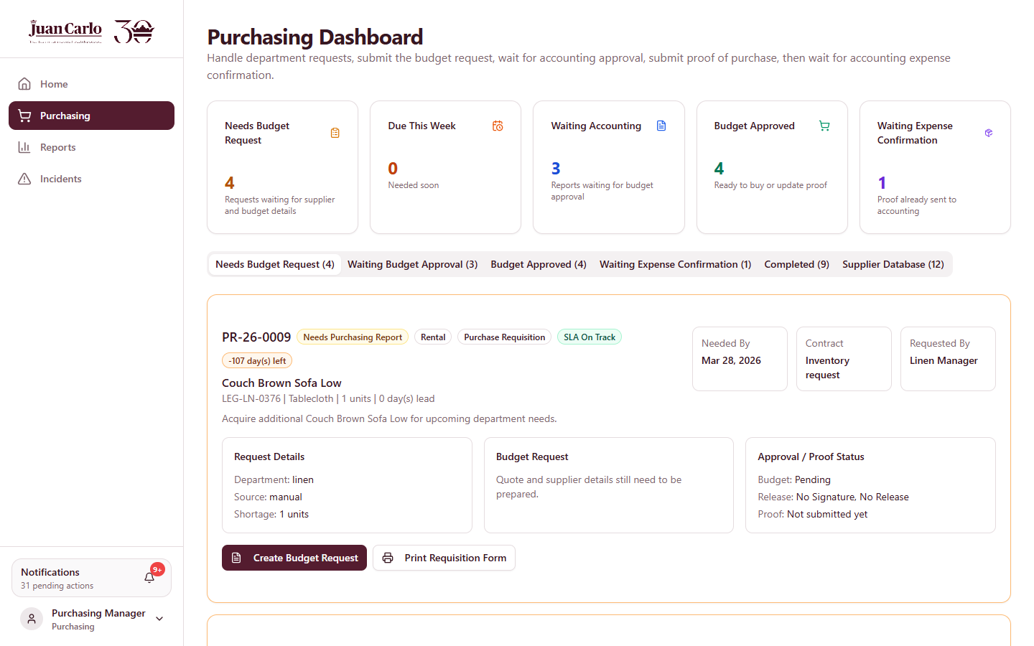
Figure 11.3.1 Purchasing Dashboard queues and request card

11.4 Printing Requisition Forms
1. On a request card, click Print Requisition Form. The correct form is produced automatically: Item Requisition, Purchase Requisition, or Emergency Requisition.
2. The printout carries the requested item, supplier quotation and budget, the lead-time note, the cash-versus-purchase-order option, and the full approval-signature chain.

11.5 Supplier Database
The Supplier Directory stores each supplier’s contact details, location, departments served, request types, and preferred status. Purchasing selects suppliers from this directory when preparing quotations.

11.6 Purchasing Scenarios
• Linen shortage two weeks out. The linen request arrives in the queue; quote, get budget approval, rent, submit proof — inside the seven-day lead.
• Rush breakage three days before the event. Standard lead time has lapsed — use the Emergency Requisition with Material Control Manager approval.
• Budget rejected. Read Accounting’s reason, adjust supplier or price, and resubmit.

Chapter 12. Admin Guide

12.1 Role Overview and Features
The Admin account manages users and system records, sees every module, and performs the management overrides that other roles cannot.
Table 12.1 Admin Features at a Glance
Feature | What It Does
Admin Management | Create user accounts, assign roles/departments, activate or deactivate users
Full visibility | All contracts, dashboards, inventories, reports, and logs
Release Hold (Management) | Lifts a payment hold when an exception is approved
Material freeze override | May edit or release frozen materials inside the seven-day window
Roster freeze override | Records controlled banquet staff replacements inside seven days
Delete Contract | Removes a contract (with its notifications); tasting links are released
Cancel Contract | Records a management-reviewed cancellation with reason
Supervisor accounts | Creates banquet supervisor logins from eligible staff records
Admin report | Full-system analytics (Chapter 13)

12.2 Managing Users
1. Open Admin Management from the Management menu.
2. Create an account with name, email, password, role, and department; deactivate accounts that should lose access.
3. For banquet supervisors, use the Staff Directory’s Create Account on an eligible supervisory record.
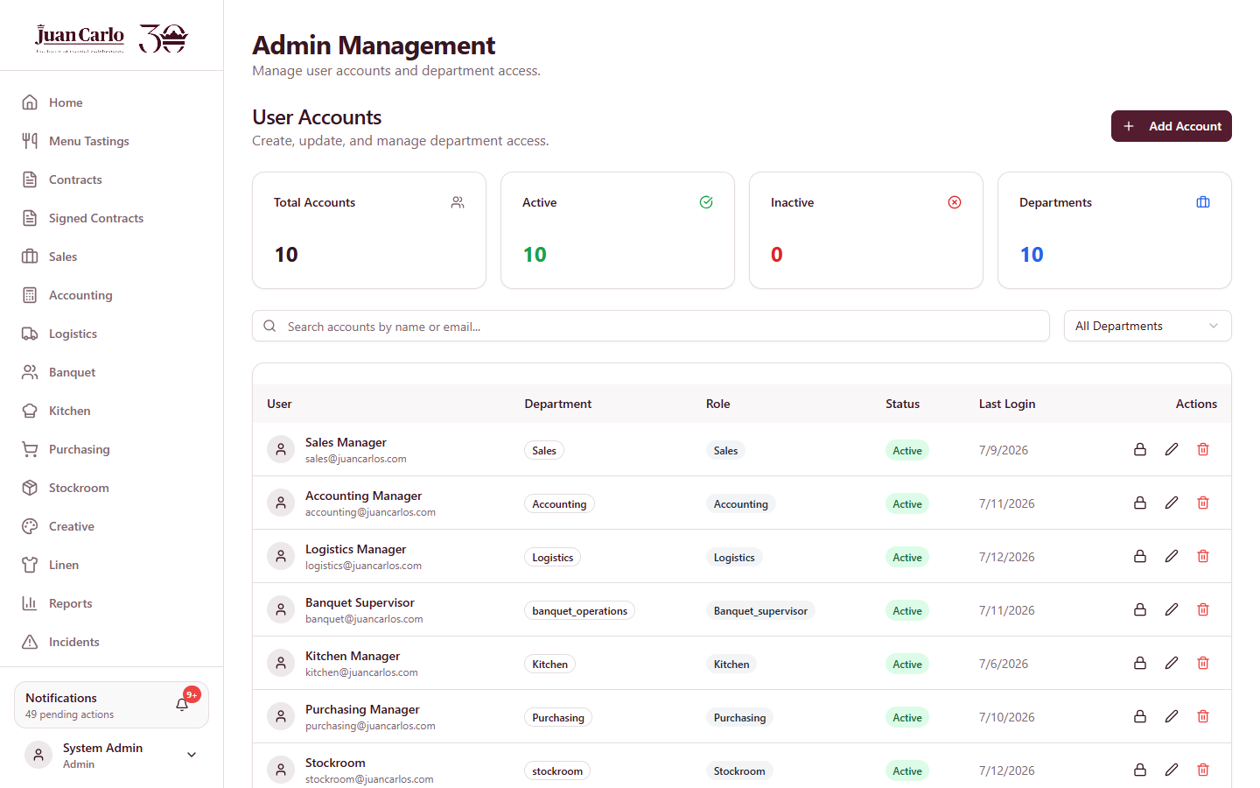
Figure 12.2.1 Admin Management (account creation and role assignment)

12.3 Management Overrides
• Release a payment hold — on a held contract, click Release Hold (Management); the release is recorded.
• Frozen materials / roster — inside seven days before the event, only Admin can change assigned materials or banquet staffing; changes should be treated as controlled replacements.
• Delete / cancel contracts — deletion removes the contract and its notifications and frees its tasting; cancellation records the reason (the reservation fee and collected milestones remain non-refundable).
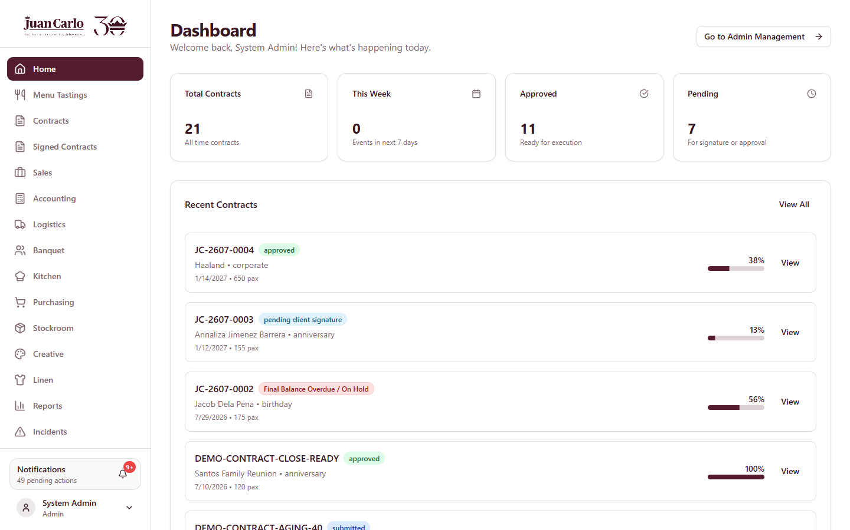
Figure 12.3.1 Admin Dashboard

Chapter 13. Reports, Records, and Incidents

13.1 Department Reports
The Reports page builds a role-specific report for a chosen date range, combining summary cards, charts, and detailed tables. Every report can be printed or exported to Excel (per section or in full). Table 13.1 shows what each role receives.
Table 13.1 Report Contents per Role
Role | Report Contents
Sales | Contract pipeline, signed contracts, contract value, tasting conversion; status/event-type/package charts; tasting and payment tables
Accounting | Contract revenue, cash collected, accounts receivable, overdue A/R, available budget; monthly collections trend; A/R aging (30/60/90) chart and schedule; financial position; receivables schedule; payment ledger; approval queue; procurement budget register
Creative / Linen / Stockroom | Events with assigned items, prepared vs pending, low-stock and attention items, purchasing requests, incidents
Kitchen | Events with menus, checklist completion, prepared events, kitchen stock alerts, menu category mix, incidents
Banquet | Staffing coverage, events with staff plans, active staff pool, role mix, staff directory snapshot, incidents
Logistics | Assignment status, ready/dispatched counts, truck and driver status, fleet snapshot, incidents
Purchasing | Request volume and status, open requests, quoted totals, supplier coverage, request register
Admin | Everything above in one report: full-system analytics with finance summaries, user access, inventory snapshots, operations snapshot, and incident register

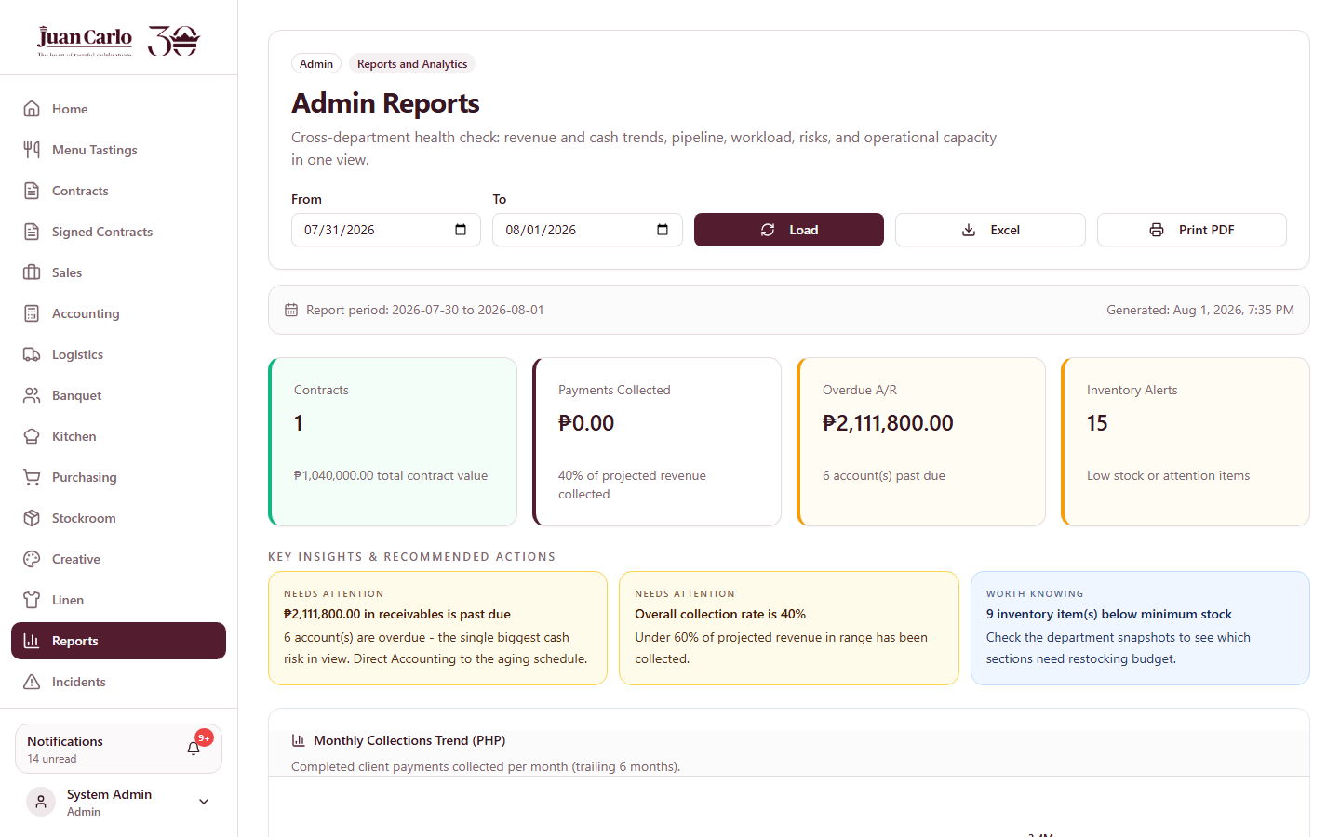
Figure 13.1.1 Reports page

13.2 Signed Contracts
The Signed Contracts page lists all contracts with recorded client signatures — the reference archive of completed agreements. Exported contract PDFs show package price and total contract value only to Sales, Accounting, and Admin.

13.3 Incidents
Overview. Any department can document problems — damaged equipment, missing items, food spoilage, vehicle breakdowns, staff or client issues — through the Incidents page. Incidents filed from post-event checking arrive with the contract and item pre-filled.
1. Open Incidents and click Report Incident (or use Report Incident on a post-event item).
2. Select the contract and incident type, enter the date, severity, and description; affected quantity and a damage photo are optional.
3. Click Submit Report. The incident is linked to the contract and item, notifies the affected department, and appears in reports.
4. When settled, click Resolve on the incident. Per policy, on-site incidents must be logged by the time staff return to the office the following day.
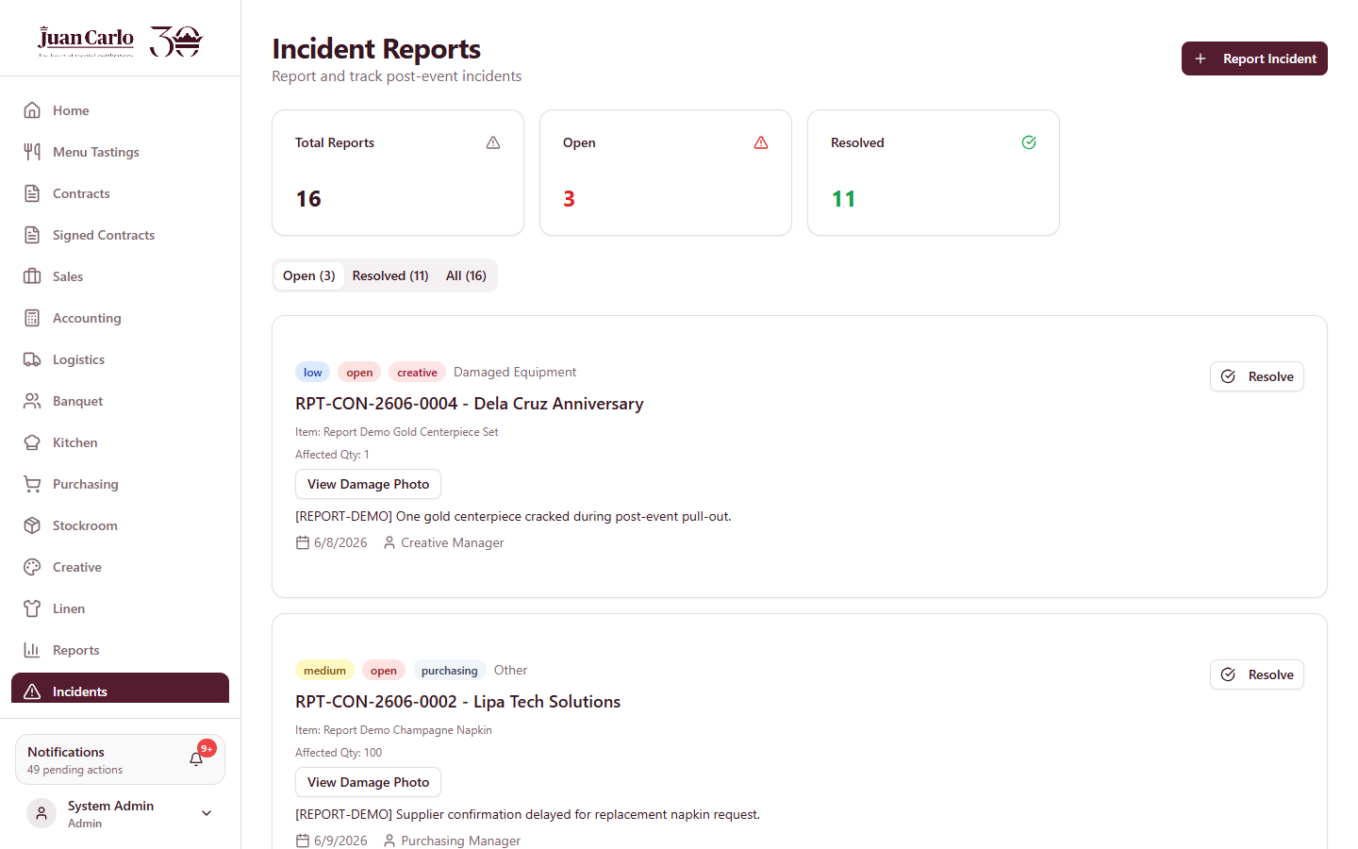
Figure 13.3.1 Incidents page
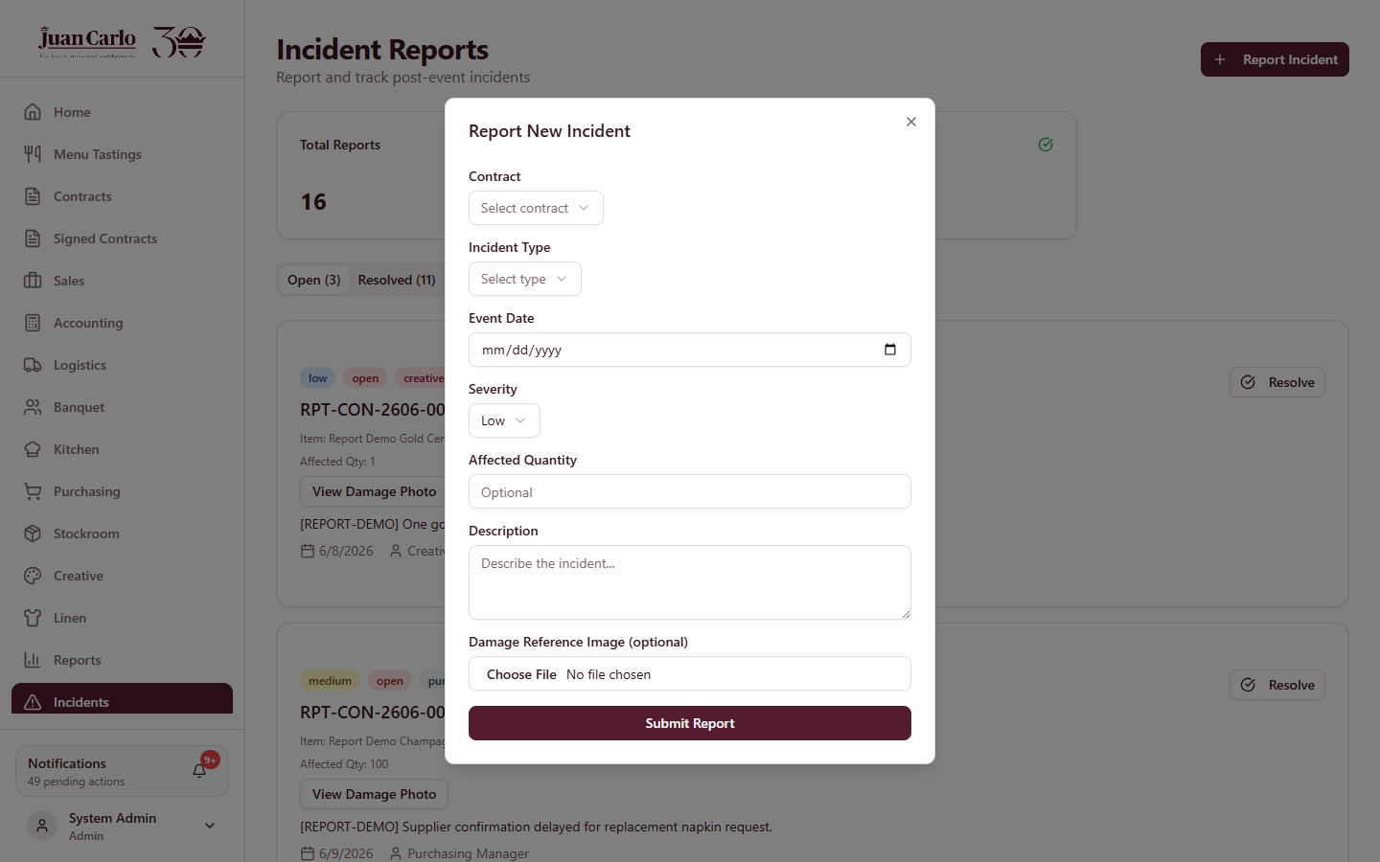
Figure 13.3.2 Report Incident form

Appendix A. Master Business Rules and Timeline
The rules below are drawn from the company’s documented business rules and are enforced by the system throughout the workflow. The booking date and the event date run on separate timelines.
Table A.1 Collection and Preparation Timeline
Rule | Timing | Based On
Reservation fee (PHP 30,000, non-refundable) | Upon booking; part of the 40% | Booking
40% follow-up alert | One month before the 40% due date | Booking date
40% payment due | Two months after booking | Booking date
30-day aging to uncollectible | Thirty days after the 40% due date | Booking date
Final 60% balance due | Two months before the event | Event date
Automatic payment hold | When the 60% is unpaid past due | Event date
Final details deadline (SLA) | One month before the event | Event date
Kitchen sourcing alert | Two weeks before the event | Event date
Kitchen preparation window | Seven days before the event | Event date
Material freeze | Seven days before the event | Event date
Banquet roster freeze | Seven days before the event | Event date
Transport booking lead time | Three days before the event | Event date
Requisition lead time | Seven days before the date needed | Date needed
Equipment loading | The day before the event | Event date
Post-event checks and reconciliation | After the event date | Event date
Contract closing | After checks complete and full payment | Event date

Table A.2 Access and Accountability Rules
Rule | Detail
Role-based access | Each department sees only the modules and records for its responsibility
Price confidentiality | Package price and total contract value are visible only to Accounting, Sales, and Admin — on screen and in exported PDFs
Payments after signing | Payments are posted only once the contract has been signed
Same-day conflict control | Venues, inventory items, vehicles, drivers, and banquet staff cannot be double-committed on the same date
Number coding (UVVRP) | Metro Manila events exclude vehicles whose plate digit is coded on that weekday
Return accountability | Loaded-out equipment must match the return counts; variances feed the missing-and-damaged summary and may be charged without a valid counter-report
Incident logging | On-site incidents must be logged by the next office day, linked to the contract and item
No signature, no release | Requisition forms carry the full approval-signature chain before any release

Appendix B. Cross-Department Scenario Walkthroughs

B.1 A Contract’s Full Journey
1. Sales books the tasting, records feedback, creates the contract, and saves the draft.
2. Creative, Linen, Stockroom validate their sections; Sales confirms the payment term and runs the signature workflow.
3. Accounting records the reservation fee and 40%, then approves the event for preparation.
4. Kitchen confirms the menu, sources at two weeks, prepares within seven days. Banquet staffs the event. Creative/Linen/Stockroom prepare items. Logistics books transport and staff vehicles, loads with the readiness board, and dispatches.
5. After the event, departments run post-event checks, Logistics reconciles returns and completes the booking, incidents are filed where needed, and Accounting closes the fully paid contract.

B.2 Two Events on the Same Day
The system checks every shared resource per date: the venue cannot be double-booked; inventory availability is computed net of the other event; trucks, drivers, passenger vehicles, and banquet staff already committed to one event are excluded from the other; and tasting slots are one-per-hour. Conflicts surface as alerts on the contract and block approval until resolved.

B.3 An Item Runs Short
The Add-Ons tab or the department’s validation shows the shortage with same-day context and suggested alternatives. The department raises a purchase/rental request; Purchasing quotes it; Accounting approves the budget against the month’s allocation; Purchasing procures and submits proof; the inventory is updated — all inside the seven-day lead time, or through the emergency route with Material Control Manager approval.

B.4 A Payment Is Missed
The system escalates automatically: follow-up alert, milestone-due task, the 30-day aging window, and — for the final balance — an automatic hold that freezes preparation across all departments until settlement or a management release. The reservation fee and collected milestones remain non-refundable throughout.

