JUAN CARLO
The Heart of Tasteful Celebrations

EVENT MANAGEMENT AND OPERATIONS MONITORING SYSTEM

SYSTEM WALKTHROUGH
A guided walkthrough of one complete contract lifecycle, from the client’s menu tasting booking through to the closure of the contract after the event.

Prepared for Juan Carlo Catering Services
Document Version 3.0

TABLE OF CONTENTS
Chapter 1. About the System 5
1.1 Purpose of this Walkthrough 5
1.2 Overview of the System 5
1.3 Scope and Coverage 5
1.4 Users and Departments 5
1.5 Assumptions 6
1.6 Exclusions 6
Chapter 2. Important Notes 7
2.1 Dates Shift With the Demonstration Date 7
2.2 Automatic Background Processes 7
2.3 Notifications 7
Chapter 3. The Walkthrough Scenario 8
3.1 Client and Event Background 8
3.2 Accounts Used 8
3.3 How Each Stage Is Presented 9
Chapter 4. Stage 1 – Menu Tasting Booking 10
4.1 Logging In 10
4.2 Creating the Booking 11
4.3 Selecting the Dishes for Tasting 13
4.4 What This Hands Over 15
Chapter 5. Stage 2 – Menu Tasting Feedback 16
5.1 Confirming the Booking 16
5.2 Recording the Client’s Reaction to Each Dish 17
5.3 Why the Notes Matter Later 19
5.4 What This Hands Over 19
Chapter 6. Stage 3 – Contract Preparation 20
6.1 Opening the Contract Form 20
6.2 Event Details 21
6.3 Package and Menu 22
6.4 Comments on the Chosen Dishes 23
6.5 Add-Ons and Department Requirements 24
6.6 Summary and Saving the Draft 25
6.7 What This Hands Over 27
Chapter 7. Stage 4 – Draft Inventory Validation 28
7.1 Opening the Validation View 28
7.2 How Availability Is Calculated 29
7.3 Handling a Shortage 30
7.4 Confirming a Section 32
7.5 What This Hands Over 32
Chapter 8. Stage 5 – Purchasing and Shortage Handling 34
8.1 The Purchasing Queue 34
8.2 Sourcing a Supplier and Preparing the Budget Request 35
8.3 Accounting Approves the Budget 36
8.4 Purchase, Proof and Expense Confirmation 37
8.5 Done Tags Across the Chain 38
8.6 What This Hands Over 39
Chapter 9. Stage 6 – Payment and Contract Approval 40
9.1 Confirming the Payment Arrangement 40
9.2 Signature 40
9.3 Recording Payments 41
9.4 The Overpayment Guard 41
9.5 Approving the Contract for Preparation 42
9.6 What This Hands Over 43
Chapter 10. Stage 7 – Pre-Event Preparation 44
10.1 Kitchen 44
10.2 Banquet 47
10.3 Logistics — Two Separate Bookings 49
10.3.1 Inventory Transport 49
10.3.2 Staff Transport 50
10.3.3 Availability and Restrictions 51
10.4 What This Hands Over 52
Chapter 11. Stage 8 – Event Week and the Material Freeze 53
11.1 The Contract Changes Stage by Itself 53
11.2 What the Freeze Prevents 54
11.3 What the Kitchen Sees Instead 54
11.4 Same-Day Stock Is Still Enforced 55
11.5 What This Hands Over 55
Chapter 12. Stage 9 – Post-Event Checks and Contract Closure 56
12.1 Checking the Returned Items 56
12.2 Returning Rented Items 58
12.3 The Contract Becomes Ready to Close 59
12.4 Closing the Contract 59
12.5 The Lifecycle in One View 60
Appendix A. Business Rules Applied 62
A.1 Collection and Payment 62
A.2 Contract and Menu 62
A.3 Inventory and Procurement 62
A.4 Staffing and Transport 63
Appendix B. Notification Reference 65
B.1 How Notifications Behave 65
B.2 Triggered by Another Department 65
B.3 Triggered by the Calendar 65
B.4 Known Limitations 66

Chapter 1. About the System

1.1 Purpose of this Walkthrough
This document is a walkthrough of the Event Management and Operations Monitoring System of Juan Carlo Catering Services. Rather than describing every screen in isolation, it follows a single client booking from beginning to end, so that the reader can see how one event actually moves through the organization.
The walkthrough is written as a continuous scenario. Each stage names the department that performs the work, states what prompted them to act, lists the exact information entered into the system, and identifies which department receives the work next. Reading the document from start to finish reproduces the full life of one contract.
● Note: This document is a walkthrough, not a reference manual. It follows one path through the system. Alternative paths and exception handling are described only where the scenario encounters them.

1.2 Overview of the System
The system supports the operational processes involved in catering event management. It covers menu tasting bookings, contract creation and approval, departmental inventory validation, procurement of shortages, pre-event preparation across the kitchen, banquet and logistics departments, post-event checking, and the financial closure of the contract.
Work is passed between departments by the system itself. When one department completes a step, the system records the change and notifies the department that must act next. No department is expected to discover its own work by searching for it.

1.3 Scope and Coverage
The walkthrough covers the complete lifecycle of one contract, organized into nine stages:
• Stage 1 – Menu tasting booking (Sales)
• Stage 2 – Menu tasting feedback (Sales)
• Stage 3 – Contract preparation (Sales)
• Stage 4 – Draft inventory validation (Creative, Linen, Stockroom)
• Stage 5 – Purchasing and shortage handling (Purchasing, Accounting)
• Stage 6 – Payment and contract approval (Sales, Accounting)
• Stage 7 – Pre-event preparation (Kitchen, Banquet, Logistics)
• Stage 8 – Event week and the material freeze (all departments)
• Stage 9 – Post-event checking and contract closure (Departments, Accounting)

1.4 Users and Departments
The system applies role-based access control. Each account is given access only to the features related to its department. Table 1.1 lists the roles that appear in this walkthrough.
Role | Main access | Appears in
Admin | Full access to all modules and management functions | Oversight, exemptions
Sales (Account Executive) | Menu tasting booking, tasting feedback, contract creation, payment term confirmation, contract signing | Stages 1, 2, 3, 6
Accounting | Payment recording, procurement approval, contract approval, contract closure | Stages 5, 6, 9
Creative | Creative inventory, draft validation, preparation, post-event checking | Stages 4, 7, 9
Linen | Linen inventory, draft validation, preparation, post-event checking | Stages 4, 7, 9
Stockroom | Equipment inventory, draft validation, preparation, post-event checking | Stages 4, 5, 7, 9
Kitchen | Menu checklist, ingredient preparation, kitchen inventory | Stages 7, 8
Banquet | Banquet staffing plan, attendance sheet | Stage 7
Logistics | Inventory transport, staff transport, dispatch | Stages 7, 8
Purchasing | Procurement requests, supplier sourcing, proof of purchase | Stage 5

1.5 Assumptions
The walkthrough assumes the following:
• The user has a stable internet connection and a current version of Google Chrome or Microsoft Edge.
• The application server and the database are running, and the demonstration data has been loaded.
• Each department account listed in Chapter 3 exists and is active.
• The inventory records, fleet records and banquet staff records used by the scenario are already present in the system.

1.6 Exclusions
The following are outside the coverage of the system and of this walkthrough:
• Client-side communication such as email correspondence and phone negotiation.
• Refund processing for cancelled events. Under Appendix H, refunds require a formal cancellation letter and Execom review, which are handled outside the system.
• Final management interpretation of reports, and the business decisions arising from them.
• Correction of information entered incorrectly by the user, such as a misspelled client name.

Chapter 2. Important Notes
The following notes apply to the whole walkthrough and should be read before the demonstration begins.

2.1 Dates Shift With the Demonstration Date
All dates in this walkthrough are relative to the day the demonstration is performed. The tasting is booked a few days ahead, and the event date is set close enough that the later stages — event week, post-event checking and closure — can all be reached within a single sitting.
● Note: In normal operation an event is booked months in advance. The compressed timeline used here is a demonstration convenience only; the business rules themselves are unchanged.

2.2 Automatic Background Processes
Three background processes run when the server starts and every six hours thereafter. They generate reminders without anyone being logged in:
• The payment compliance sweep issues collection reminders, places contracts on hold when the final balance is overdue, releases holds once the balance is settled, and announces when post-event checks may begin.
• The kitchen preparation sweep issues a sourcing reminder two weeks before an event and a begin-preparation reminder once the event is within seven days.
• The transport lead-time sweep reminds Logistics when an event is within three days and transport is still unbooked.
● Note: Because these run on a six-hour cycle, a reminder may appear up to six hours after the moment it becomes due. No business rule depends on minute-level precision.

2.3 Notifications
Every department receives its work through the notification area, reached from the bell icon in the top bar. A notification carries a direct link to the exact record that needs attention. When the underlying task has already been completed, the notification re-labels itself with a green Done tag instead of a red priority tag. A notification may be dismissed individually using the × control at its top right.

Chapter 3. The Walkthrough Scenario

3.1 Client and Event Background
Amanda Robles is planning a 60th birthday celebration for a family member. She contacts Juan Carlo Catering Services to arrange a menu tasting before committing to a package. The Account Executive records her enquiry in the system, and from that point the booking is tracked by the system until the contract is closed after the event.
Table 3.1 contains the information Amanda provided. It is used throughout the walkthrough.
Field | Value
Client name | Amanda Robles
Email address | amanda.robles@example.com
Contact number | 09175550188
Address | 24 Mabini Street, Barangay Poblacion, Lipa City, Batangas 4217
Event type | Birthday
Expected guests | 180
Preferred event date | Saturday, 22 August 2026
Tasting date and time | Tuesday, 4 August 2026, 2:00 PM
Tasting attendees | 4 persons
Dishes for tasting | Beef Caldereta; Chicken Cordon Bleu; Lechon Kawali; Baked Macaroni; Buko Pandan
Client notes | Celebrant prefers mildly spiced dishes. Two guests are lactose intolerant.
Venue (agreed later) | Lima Park Hotel – Grand Ballroom, Malvar, Batangas

● Note: The venue is outside Metro Manila, so the Metro Manila number coding rule does not restrict vehicle choice for this event. The rule is demonstrated separately in Stage 7.

3.2 Accounts Used
Table 3.2 lists the department accounts used during the walkthrough. Each stage states which account performs the step.
Department | Email address | Used in
Sales | sales@juancarlos.com | Stages 1, 2, 3, 6
Kitchen | kitchen@juancarlos.com | Stages 7, 8
Creative | creative@juancarlos.com | Stages 4, 7, 9
Linen | linen@juancarlos.com | Stages 4, 7, 9
Stockroom | stockroom@juancarlos.com | Stages 4, 5, 7, 9
Purchasing | purchasing@juancarlos.com | Stage 5
Accounting | accounting@juancarlos.com | Stages 5, 6, 9
Banquet | banquet@juancarlos.com | Stage 7
Logistics | logistics@juancarlos.com | Stages 7, 8
Admin | admin@juancarlos.com | Oversight and exemptions

● Note: Passwords are issued separately by the system administrator and are not printed in this document.

3.3 How Each Stage Is Presented
Every stage in Chapters 4 to 12 follows the same three-part structure:
• What prompts this stage — the notification, queue entry or deadline that causes the department to act.
• Steps — the numbered actions performed in the system, with the exact values entered.
• What this hands over — the department that receives the work next, and what the system sends them.

Chapter 4. Stage 1 – Menu Tasting Booking
Performed by: Sales (Account Executive)
What prompts this stage: A client enquiry received outside the system. This is the only step in the whole lifecycle that begins outside the system; every stage after it is prompted by the system itself.

4.1 Logging In
1. The Account Executive opens the system and enters the Sales account credentials, then clicks the Sign In button.
Email address: sales@juancarlos.com
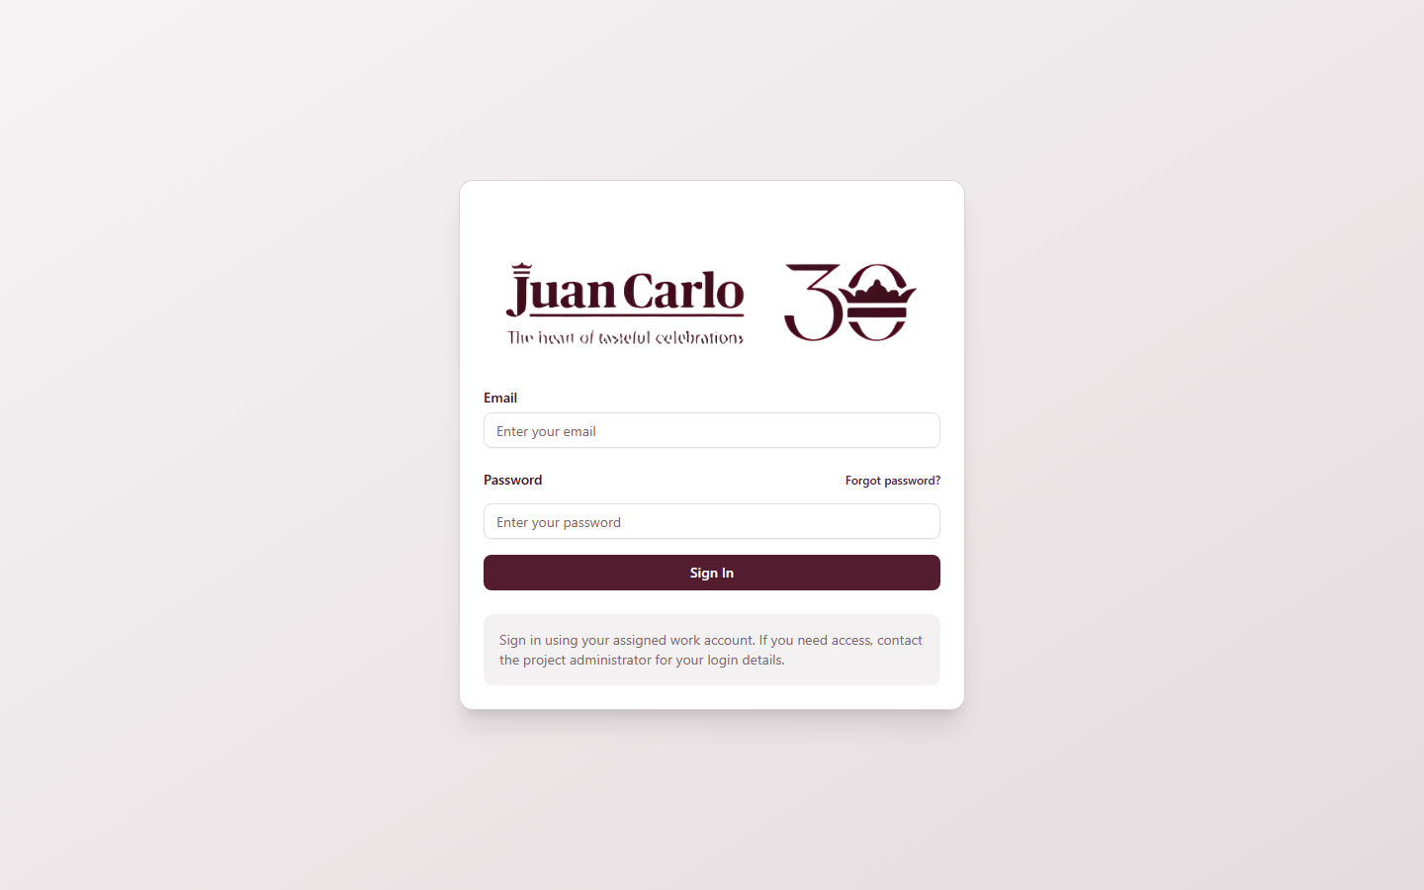
Figure 4.1 Login page
2. After signing in, the Account Executive is taken to the Sales dashboard, which shows the current bookings, draft contracts awaiting action, and the notification bell in the top bar.
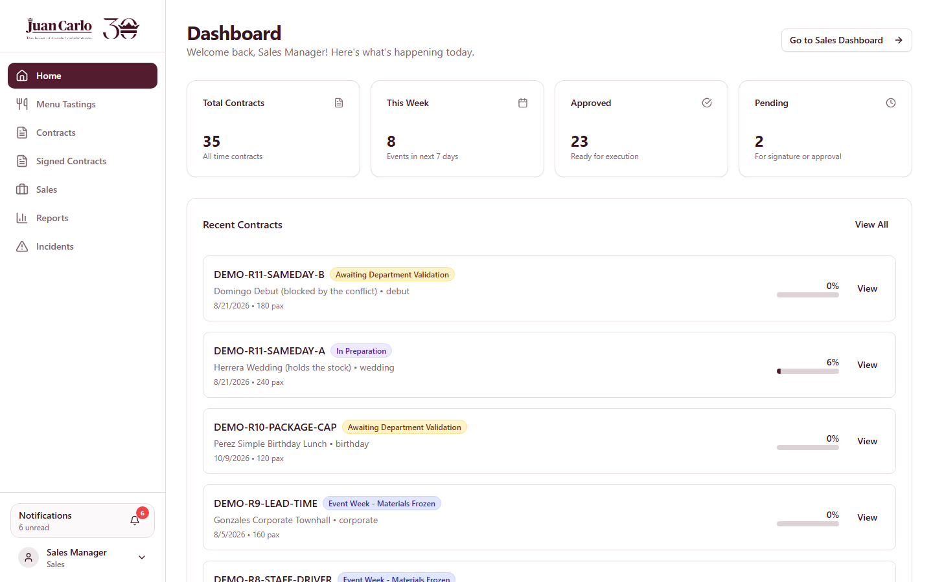
Figure 4.2 Sales dashboard

4.2 Creating the Booking
3. From the sidebar the Account Executive opens Menu Tastings, then clicks the Book Tasting button at the upper right of the page.
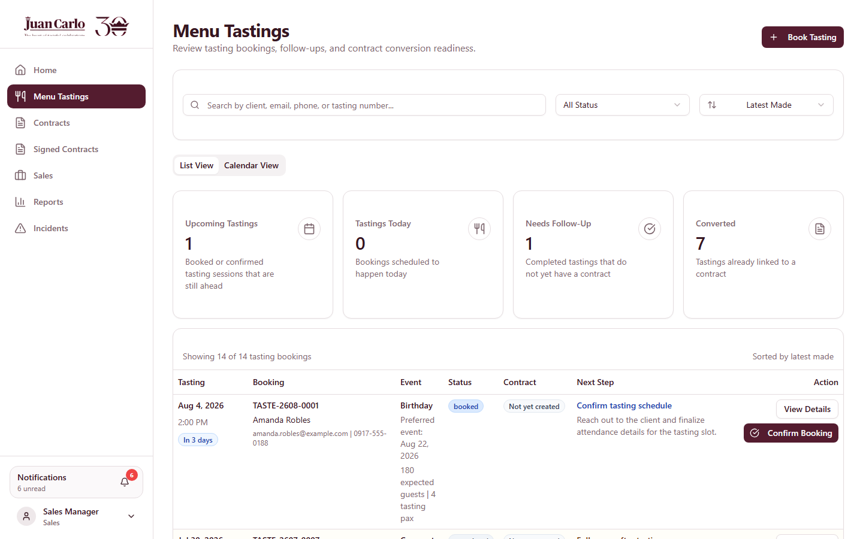
Figure 4.3 Menu Tastings list with the Book Tasting button
4. The booking form opens. The Account Executive enters the details Amanda provided.
Client name: Amanda Robles
Email address: amanda.robles@example.com
Contact number: 09175550188
Address: 24 Mabini Street, Barangay Poblacion, Lipa City, Batangas 4217
Event type: Birthday
Expected guests: 180
Preferred event date: 22 August 2026
Tasting date and time: 4 August 2026, 2:00 PM
Number of tasting attendees: 4
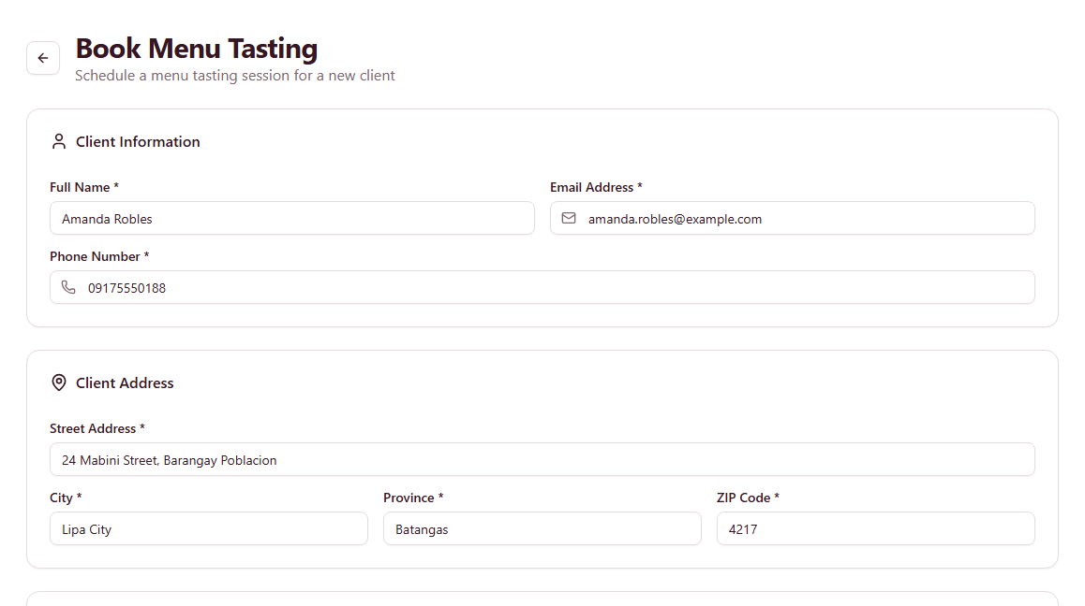
Figure 4.4 Menu tasting booking form with the client details entered

4.3 Selecting the Dishes for Tasting
The booking form allows the Account Executive to select the specific dishes the client will taste. The dishes are drawn from the same menu catalogue used later during contract creation, so the tasting and the contract always refer to the same items.
5. The Account Executive selects the five dishes agreed with the client, and records the client’s preferences in the Tasting Notes field.
Mains (4): Beef Caldereta; Chicken Cordon Bleu; Lechon Kawali; Fish Fillet with Lemon Butter
Sides (3): Baked Macaroni; Chopsuey; Steamed Rice
Desserts (2): Buko Pandan; Leche Flan
Drinks (2): Iced Tea; Lemonade
Tasting notes: Celebrant prefers mildly spiced dishes. Two guests are lactose intolerant.
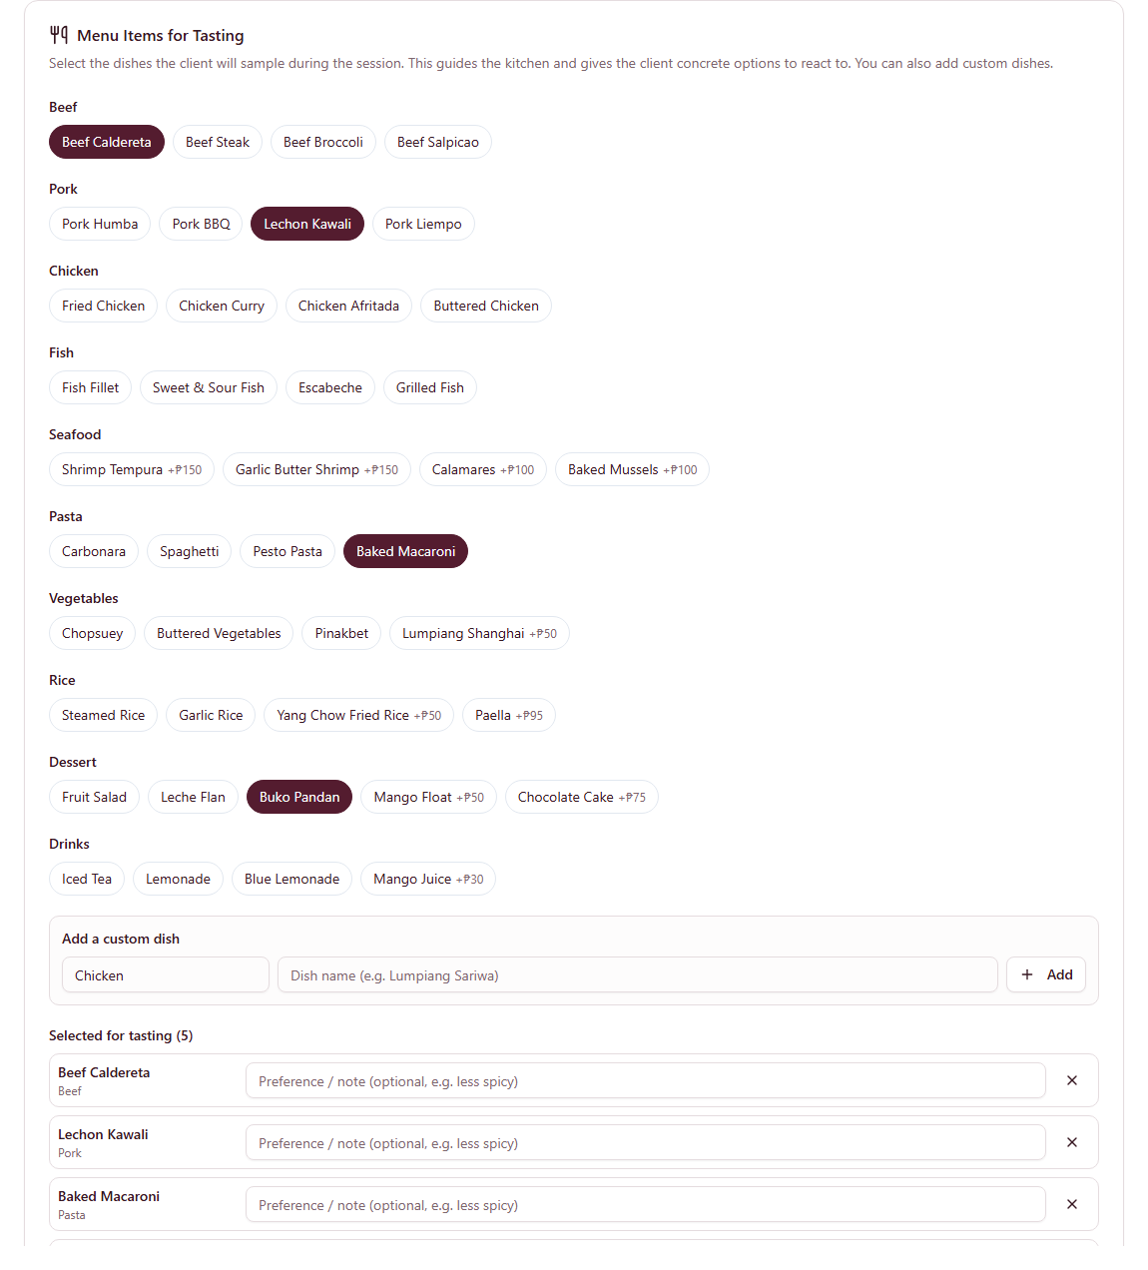
Figure 4.5 Dish selection for the tasting, with the selected dishes summarised
6. The Account Executive clicks Book Tasting to save the booking. The system assigns the reference number and records the booking as Booked.
Tasting reference: TASTE-2608-0001
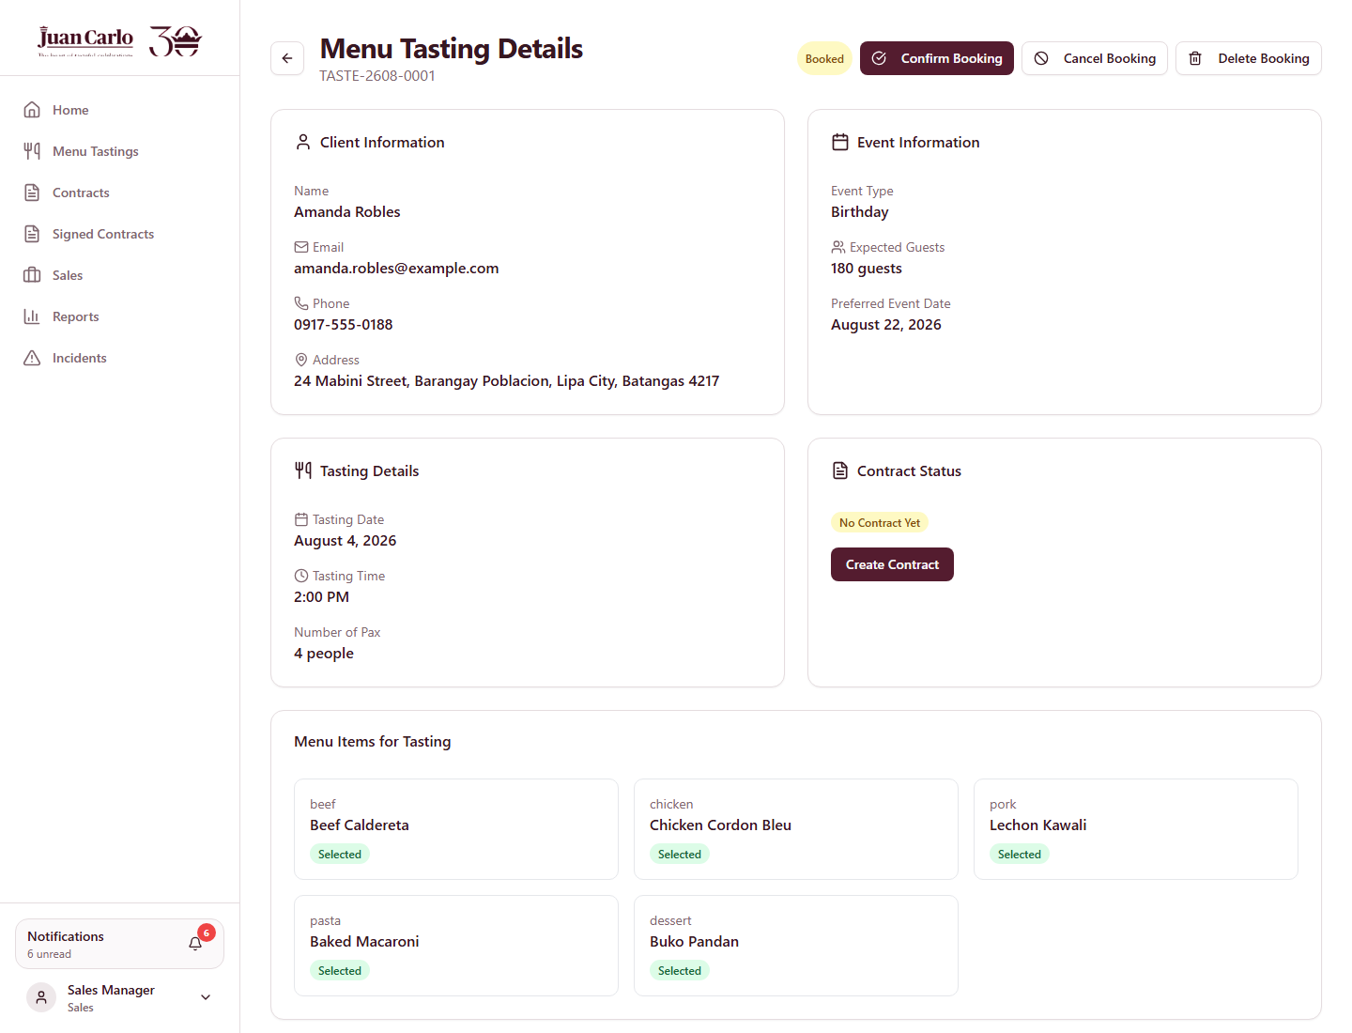
Figure 4.6 Saved menu tasting booking TASTE-2608-0001
● Note: The system prevents two bookings from taking the same date and time slot, and prevents the same client email from holding more than one active tasting booking.

4.4 What This Hands Over
The booking now appears in the Menu Tastings list and calendar. On the day of the tasting, the Kitchen department records the client’s reaction to each dish, which is Stage 2.

Chapter 5. Stage 2 – Menu Tasting Feedback
Performed by: Sales (Account Executive)
What prompts this stage: The scheduled tasting date has arrived. The booking appears in the Menu Tastings list for that day, and the actions for recording the outcome become available on the booking itself.
● Note: Feedback is recorded by Sales, who hosts the tasting with the client. The Kitchen department prepares the dishes but does not encode the client’s reaction. The recording actions only become available once the tasting date has been reached, so a future booking cannot be marked as attended.

5.1 Confirming the Booking
1. On the day before the tasting, the Account Executive opens the booking and clicks Confirm Booking. The status changes from Booked to Confirmed, which indicates the client has acknowledged the schedule.
2. On the tasting day itself, the booking offers the actions needed to record the outcome: Record Feedback if the client attended, or Mark No-Show if the client did not arrive.
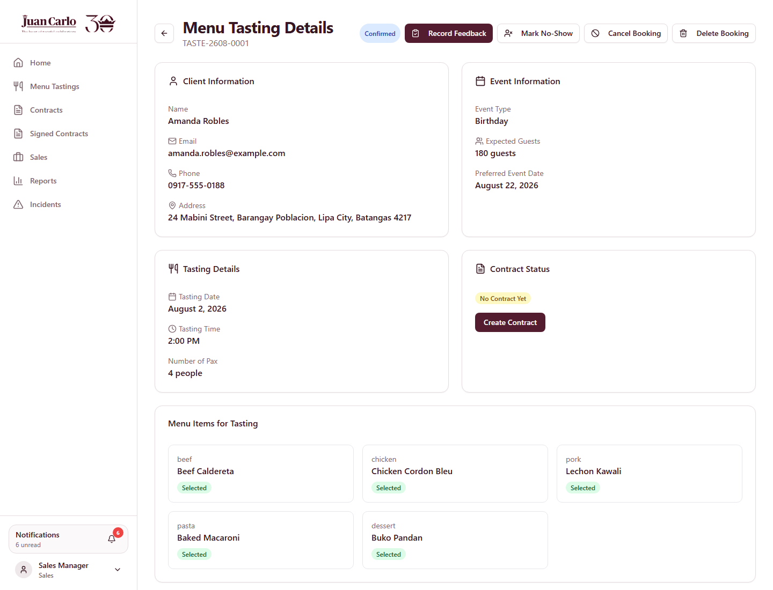
Figure 5.1 Confirmed tasting booking on the tasting day, showing the Record Feedback action

5.2 Recording the Client’s Reaction to Each Dish
Feedback is recorded dish by dish rather than as a single block of text. For every dish served at the tasting, the Account Executive marks whether the client liked it or wants it changed, and may add a short note explaining the client’s comment.
3. The Account Executive clicks Record Feedback. A dialog lists the five dishes that were selected when the booking was made.
4. For each dish, the Account Executive marks the client’s verdict and records any comment.
Beef Caldereta — Liked
Chicken Cordon Bleu — Liked
Lechon Kawali — Needs change: "Serve the sauce on the side."
Baked Macaroni — Needs change: "Reduce the cheese; two guests are lactose intolerant."
Buko Pandan — Liked
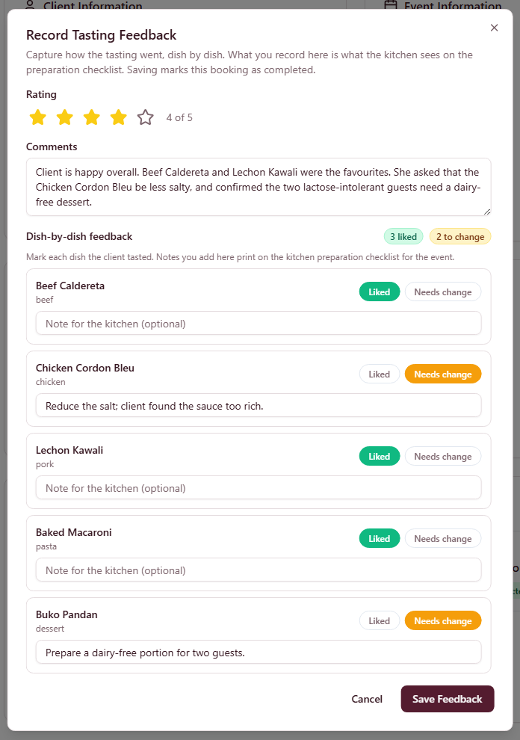
Figure 5.2 Dish-by-dish feedback dialog
5. The Account Executive saves the feedback. The system stores the verdict and note against each dish, and summarises which dishes were liked and which need changes.
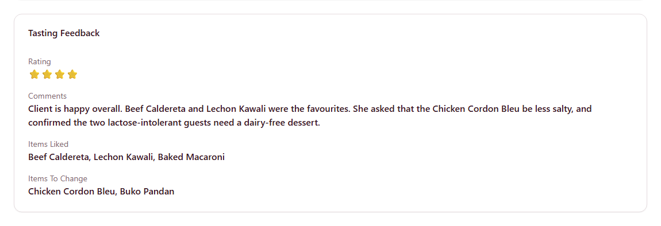
Figure 5.3 Saved tasting feedback summary

5.3 Why the Notes Matter Later
The notes recorded here are not discarded once the tasting is over. When the contract is created in Stage 3, any dish the client selects that was also tasted carries its note forward, and that note is printed on the Kitchen preparation checklist in Stage 7. This is how a preference expressed at the tasting reaches the person actually cooking on the event day.
● Note: Only dishes that appear in the final contract carry their notes forward. A dish that was tasted but not chosen does not appear on the Kitchen checklist.

5.4 What This Hands Over
With the tasting complete and the client’s preferences recorded, the booking is ready to become a contract. The Create Contract action on the booking begins Stage 3.

Chapter 6. Stage 3 – Contract Preparation
Performed by: Sales (Account Executive)
What prompts this stage: The tasting is complete and the client has agreed to proceed. The Create Contract action on the tasting booking carries the client and event details straight into the contract form, so nothing is re-typed.

6.1 Opening the Contract Form
1. On the tasting booking, the Account Executive clicks Create Contract. The contract form opens with the heading Create Contract from Tasting, and the client details are already filled in from the booking.
The form is divided into five sections, shown both as a progress tracker across the top and as tabs beneath it:
Tracker | Tab label | What it covers
1. Client | Client Info | Celebrator, representative and coordinator details
2. Event | Event Details | Event date, venue and guest count
3. Menu | Package & Menu | Package tier and the dishes to be served
4. Inventory | Add-ons | Creative, linen and stockroom requirements
5. Summary | Summary | Pricing, payment terms and final review

The tracker shows how many sections are ready, and a section is only marked ready once its required fields pass validation. This prevents an incomplete draft from being sent onward.
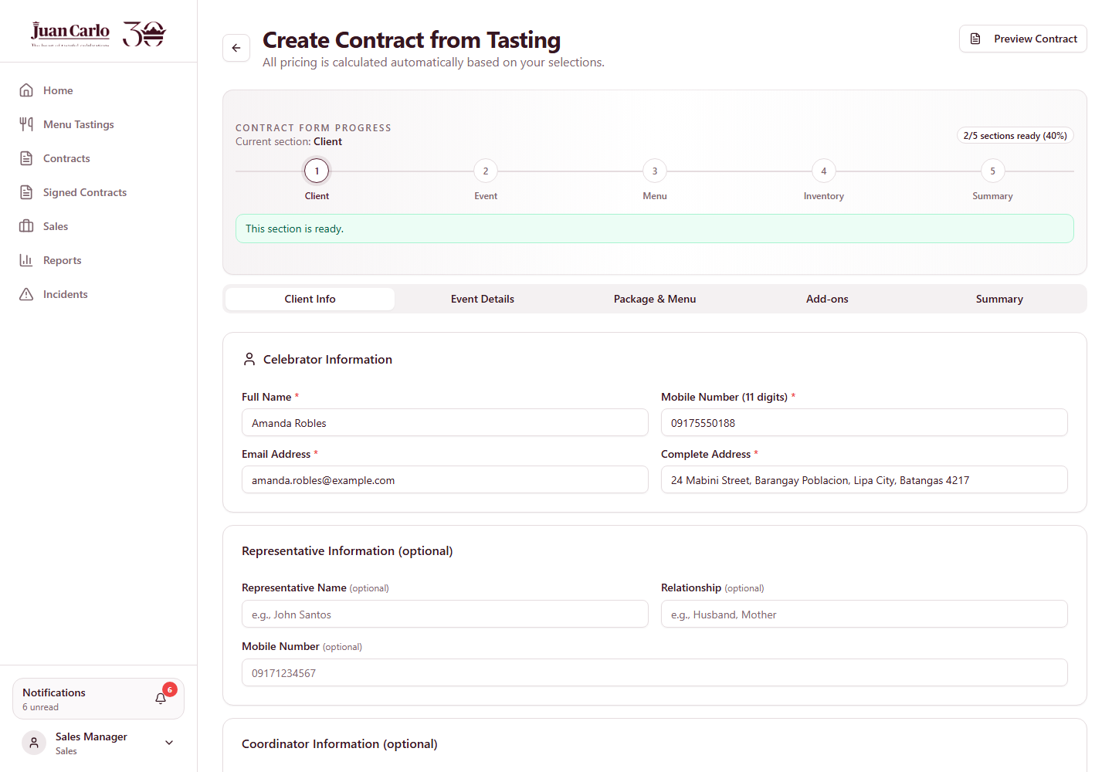
Figure 6.1 Contract form opened from the tasting, with the Client section validated
● Note: The mobile number must be exactly 11 digits with no spaces or hyphens. A number stored on the tasting in another format (for example 0917-555-0188) will be carried across but flagged as Mobile must be 11 digits, and the Client section will not be marked ready until it is corrected.

6.2 Event Details
2. The Account Executive opens the Event Details tab and confirms the event information agreed with the client.
Event date: 22 August 2026
Venue: Lima Park Hotel – Grand Ballroom, Malvar, Batangas
Total packs (guests): 180
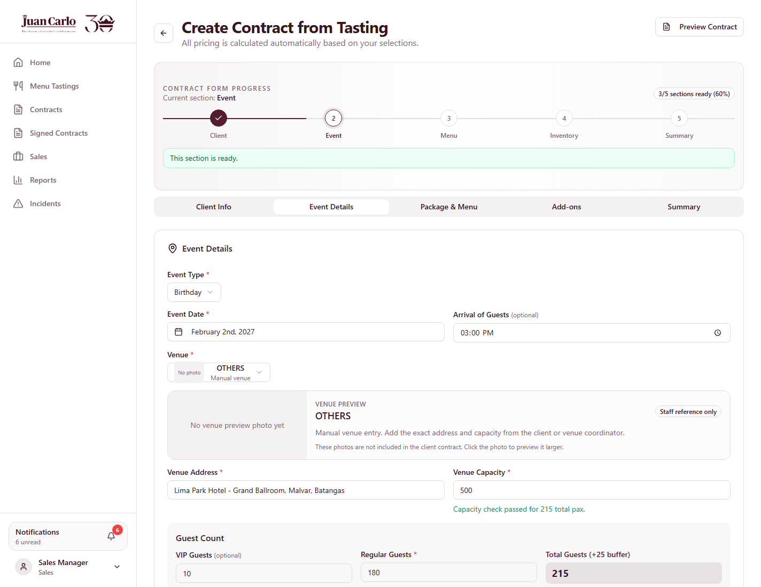
Figure 6.2 Event Details section

6.3 Package and Menu
The package tier fixes how many dishes must be chosen in each course. This is an exact requirement, not an upper limit: a Standard package must carry exactly four main dishes, three sides, two desserts and two drinks. The contract cannot be saved until every course is filled, so the package price and the kitchen’s actual workload can never drift apart.
3. The Account Executive selects the package and the dishes the client confirmed after the tasting.
Package: Standard
Dishes: Beef Caldereta; Chicken Cordon Bleu; Lechon Kawali; Baked Macaroni; Buko Pandan
Business rule applied: Each package tier requires an exact number of dishes per course — Standard: 4 mains, 3 sides, 2 desserts, 2 drinks. Saving is rejected until every course matches, and the message names each shortfall.
● Note: The tasting covered five dishes, but the contract carries eleven. A tasting samples a representative selection; the contract must satisfy the package in full. Only the dishes common to both carry their tasting notes forward.
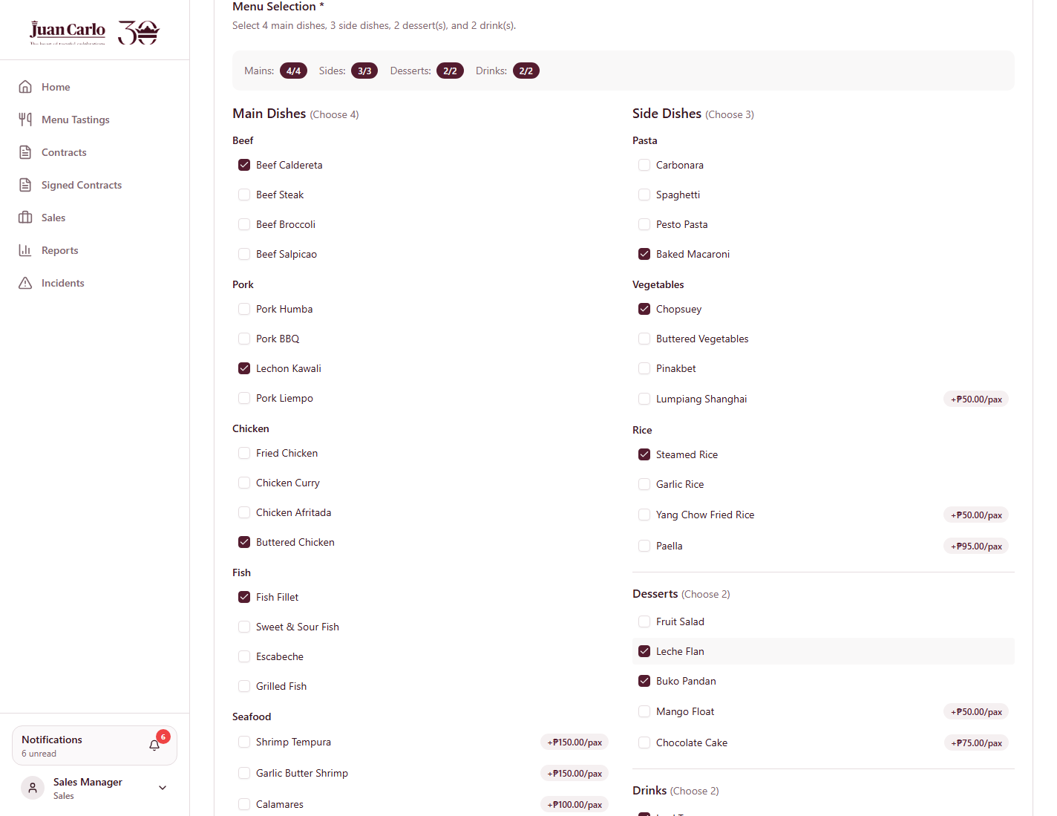
Figure 6.3 Package and menu selection

6.4 Comments on the Chosen Dishes
Beneath the menu selection is a card for recording a short preparation note against each chosen dish. Where a dish was also served at the tasting, the note recorded in Stage 2 is carried across automatically, so the client’s comment survives from the tasting table to the kitchen line.
4. The Account Executive reviews the carried-over notes and adjusts them if the client changed their mind.
Lechon Kawali: "Serve the sauce on the side."
Baked Macaroni: "Reduce the cheese; two guests are lactose intolerant."
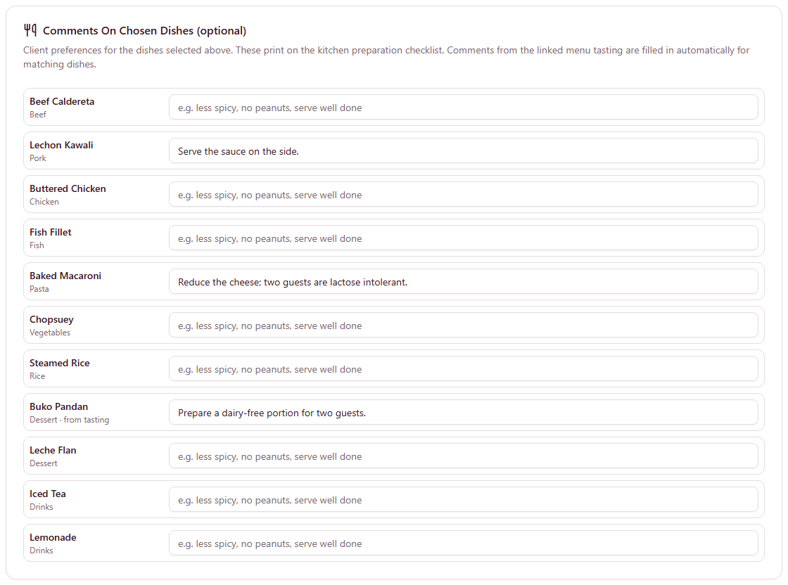
Figure 6.4 Comments on chosen dishes, carried over from the tasting
● Note: These notes are printed on the Kitchen preparation checklist in Stage 7. Only dishes that appear in the contract carry notes forward — a dish tasted but not chosen is not printed.

6.5 Add-Ons and Department Requirements
5. In the Add-ons tab the Account Executive records what the event needs from the inventory departments — decor from Creative, linens from Linen, and equipment from Stockroom. Each line names the item and the quantity required.
● Note: An add-on amount may be cleared while editing, but a zero or negative quantity is rejected when the contract is saved.
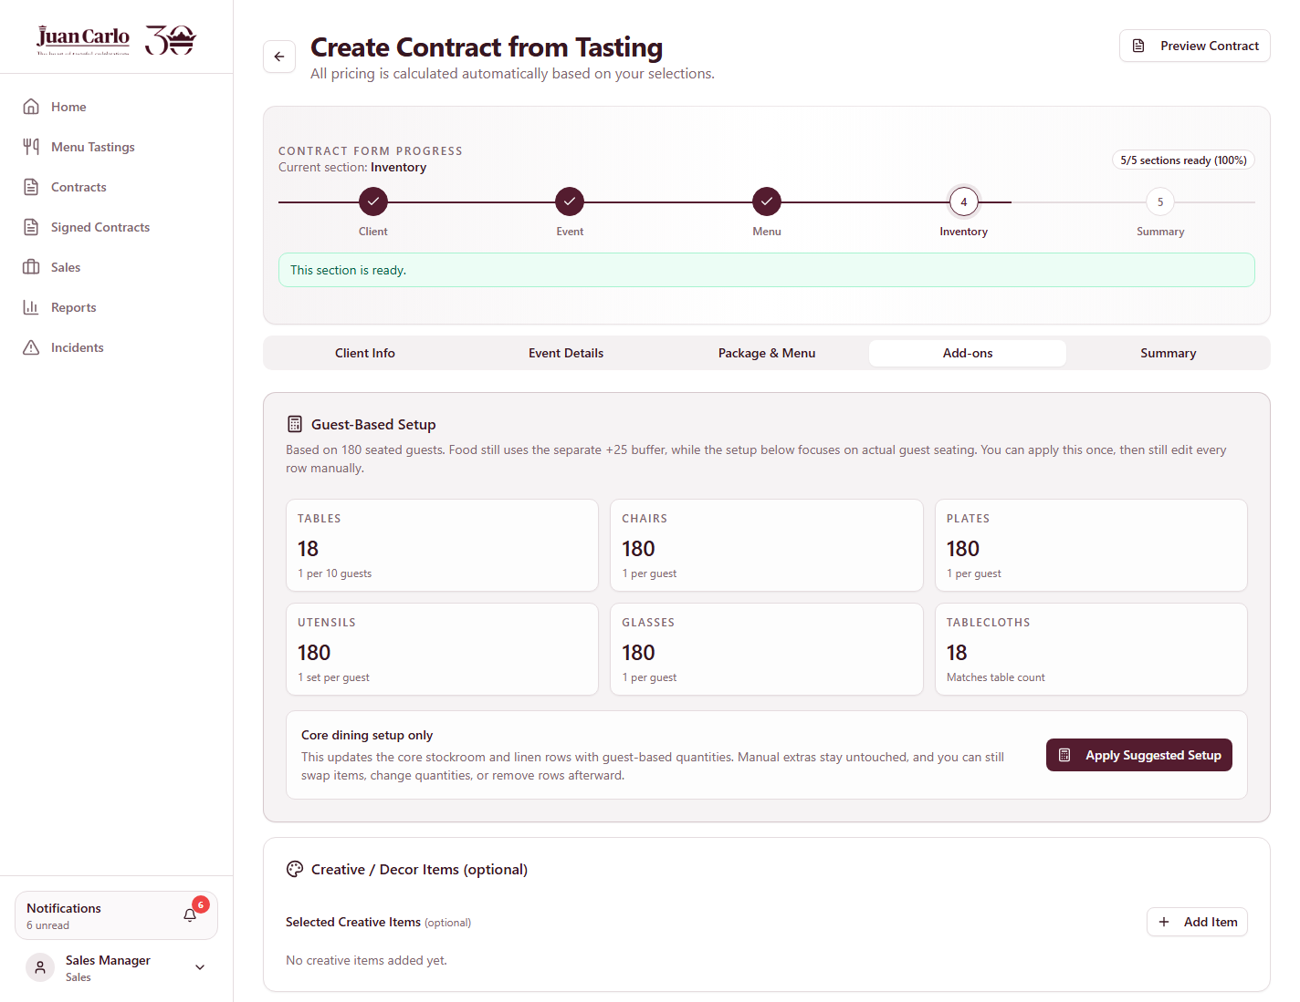
Figure 6.5 Add-ons and department requirements

6.6 Summary and Saving the Draft
6. The Summary tab shows the calculated pricing and the payment arrangement. The Account Executive reviews it and saves the contract.
The system assigns a contract number and saves the contract as a draft. The stage badge reads Awaiting Department Validation, because the inventory departments must confirm their sections before the contract can move forward.
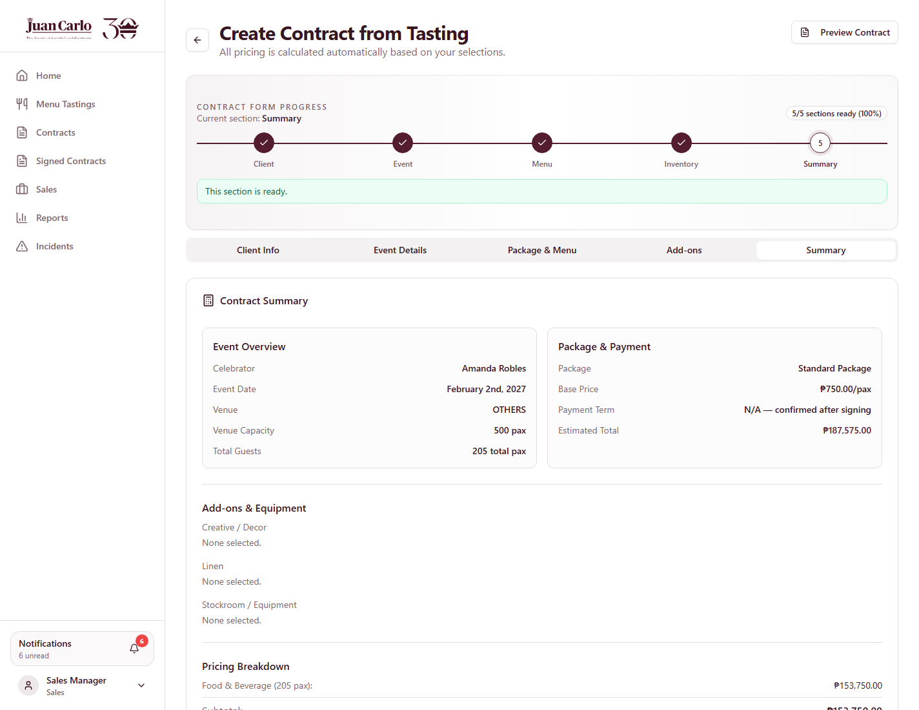
Figure 6.6 Contract summary before saving
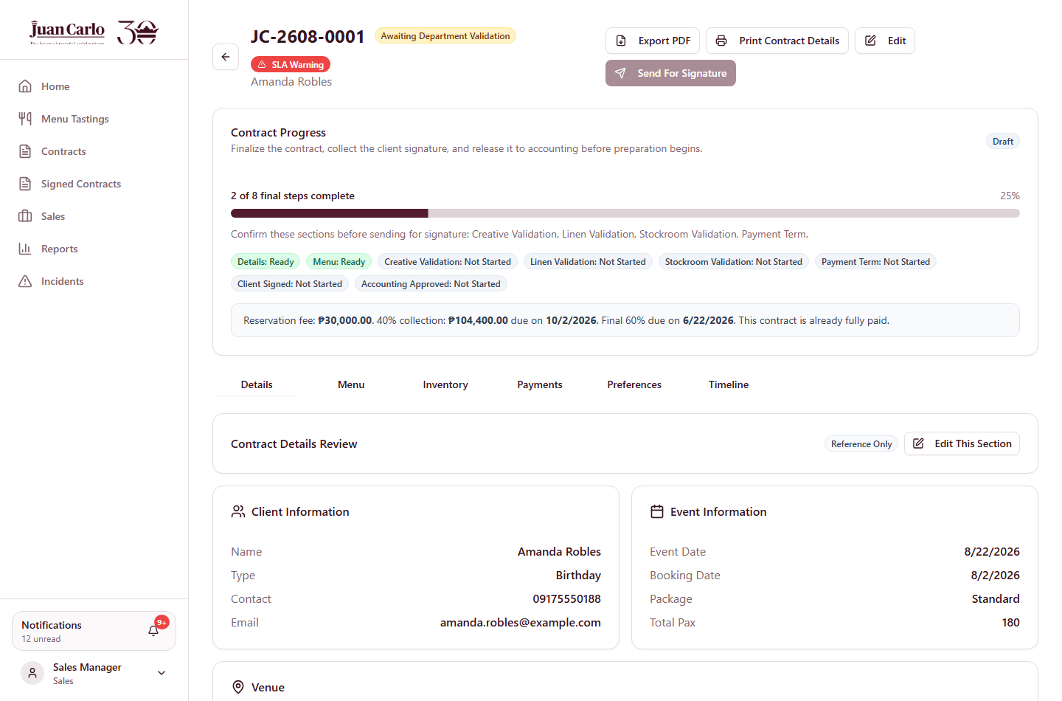
Figure 6.7 Saved draft contract showing the Awaiting Department Validation stage

6.7 What This Hands Over
Saving the draft sends a notification titled Draft inventory validation needed to every inventory department that has items on the contract. Sales cannot proceed to the payment arrangement until those departments confirm their sections, which is Stage 4.

Chapter 7. Stage 4 – Draft Inventory Validation
Performed by: Creative, Linen and Stockroom
What prompts this stage: Saving the draft in Stage 3 sent a notification titled Draft inventory validation needed for JC-2608-0001 to every inventory department that has items on the contract. No department had to look for this work.
Each department checks whether the items assigned to it can actually be supplied on the event date, then either confirms its section or raises a request for the shortfall. Sales cannot finalise the payment arrangement until every section is confirmed.

7.1 Opening the Validation View
1. The Stockroom Manager signs in and opens the notification, which links straight to the contract’s inventory view.
Email address: stockroom@juancarlos.com
The view is deliberately narrow. A banner headed Inventory Review Context states that the department sees only the information needed to validate its own items — the event date, venue, contract stage and guest count — and not the client’s pricing or payment details.
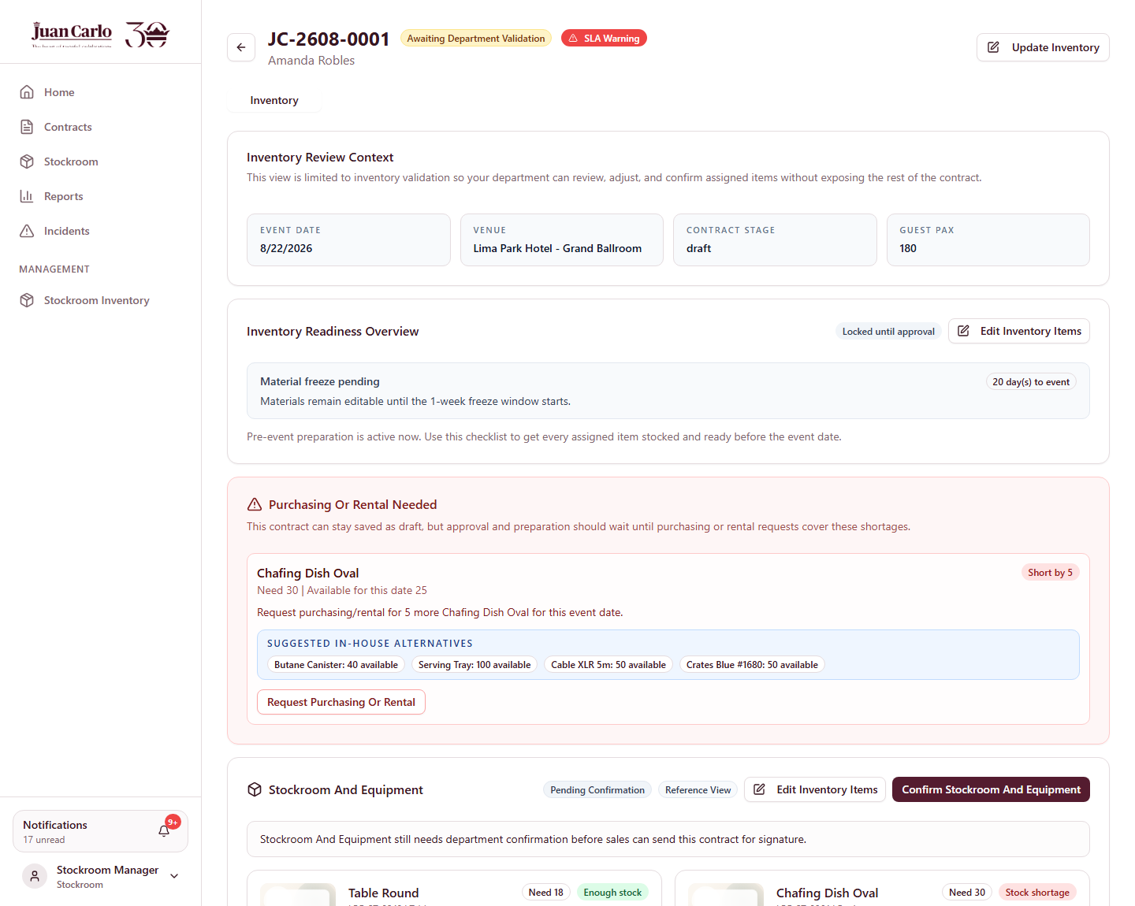
Figure 7.1 Stockroom inventory validation view for JC-2608-0001
● Note: The stage badge reads Awaiting Department Validation. An SLA Warning also appears because the event is less than one month away while the contract is still a draft — the system flags drafts that are running late against the final-details deadline.

7.2 How Availability Is Calculated
Availability is not a simple on-hand count. For every item the system subtracts the quantities already reserved by other active events on the same date, so two events can never be promised the same stock.
In this contract the Stockroom items resolve as follows:
Item | Needed | Free on 22 Aug | Result
Table Round | 18 | 10,010 | Enough stock
Chafing Dish Oval | 30 | 25 | Short by 5

Business rule applied: Stock is reserved per event date. Availability is shown net of other same-day events, and a same-day conflict is named explicitly rather than shown as a bare shortage.

7.3 Handling a Shortage
Where an item is short, a panel headed Purchasing Or Rental Needed appears above the checklist. It states the shortfall in plain terms — *Need 30 | Available for this date 25* — and proposes in-house alternatives already on the shelf, so the department can consider a substitution before committing to a purchase.
2. The Stockroom Manager reviews the shortage on Chafing Dish Oval and the suggested alternatives.
Shortfall: 5 units
Suggested alternatives: Butane Canister (40) · Serving Tray (100) · Cable XLR 5m (50) · Crates Blue #1680 (50)
3. None of the alternatives is a substitute for a chafing dish, so the Manager clicks Request Purchasing Or Rental to raise the shortfall with the Purchasing department.
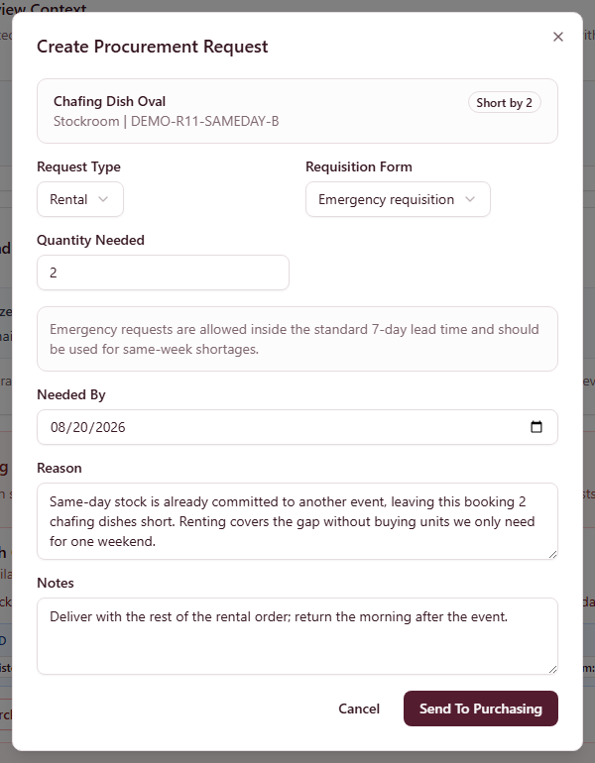
Figure 7.2 Raising a purchasing or rental request for the shortfall, shown on another draft with a live chafing-dish shortage
● Note: The contract can still be saved as a draft while a shortage is outstanding, but approval and preparation should wait until the request is covered. The system states this on the panel rather than silently blocking.

7.4 Confirming a Section
4. Creative and Linen have no shortages, so each opens the same view and clicks the confirmation button for its own section — Confirm Creative Assets and Confirm Linen Requirements respectively.
5. Once a department confirms, its notification re-labels itself with a green Done tag. The tags are independent: confirming Creative does not mark Linen or Stockroom as done.
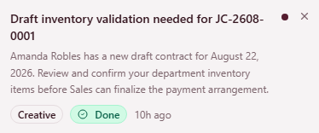
Figure 7.3 Creative notification showing the green Done tag after confirmation
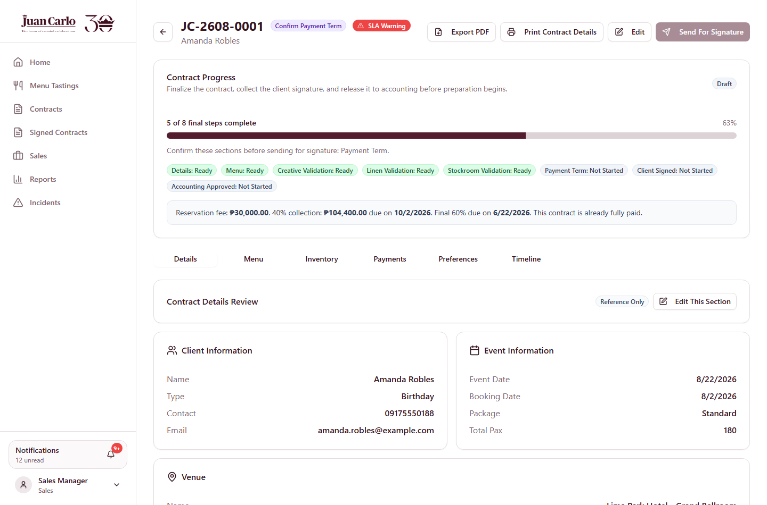
Figure 7.4 Draft contract with all inventory sections confirmed

7.5 What This Hands Over
Two things leave this stage. The shortage becomes a procurement request for Purchasing, which is Stage 5. Once every section is confirmed, Sales receives a notification titled Inventory validation complete, and the contract stage moves to Confirm Payment Term, which is Stage 6.

Chapter 8. Stage 5 – Purchasing and Shortage Handling
Performed by: Purchasing and Accounting
What prompts this stage: The shortage raised in Stage 4 created a notification titled New Stockroom procurement request, addressed to Purchasing. Purchasing never begins this work on its own — a shortage in another department is what starts it.
The request created for this contract is:
Field | Value
Request number | PR-26-0035
Raised by | Stockroom
Item | Chafing Dish Oval (LEG-ST-0864)
Quantity short | 5 units
Type | Rental · Purchase requisition
Needed by | 13 days before the event
Reason | Contract JC-2608-0001 requires 30 chafing dishes; only 25 are free on the event date.
SLA status | On track

Business rule applied: A standard requisition must allow at least 7 days of lead time. This request allows 13 days, so it is accepted as SLA On Track. A request needed sooner than 7 days is rejected and must be filed as an emergency requisition instead, which records the urgency rather than hiding it.

8.1 The Purchasing Queue
1. The Purchasing Manager signs in and opens the notification, which links directly to the request in the purchasing queue.
Email address: purchasing@juancarlos.com
The queue is organised into tabs that follow the life of a request, each showing a live count:
• Needs Budget Request — newly raised, awaiting a supplier and a quote
• Waiting Budget Approval — submitted to Accounting
• Budget Approved — approved, awaiting purchase and proof
• Waiting Expense Confirmation — proof submitted, awaiting Accounting
• Completed — fulfilled
• Supplier Database — the supplier directory
Each request card shows three panels side by side — Request Details, Budget Request and Approval / Proof Status — so the current position of a request is readable without opening it. The queue can also be searched and filtered by department, requisition type and sort order.
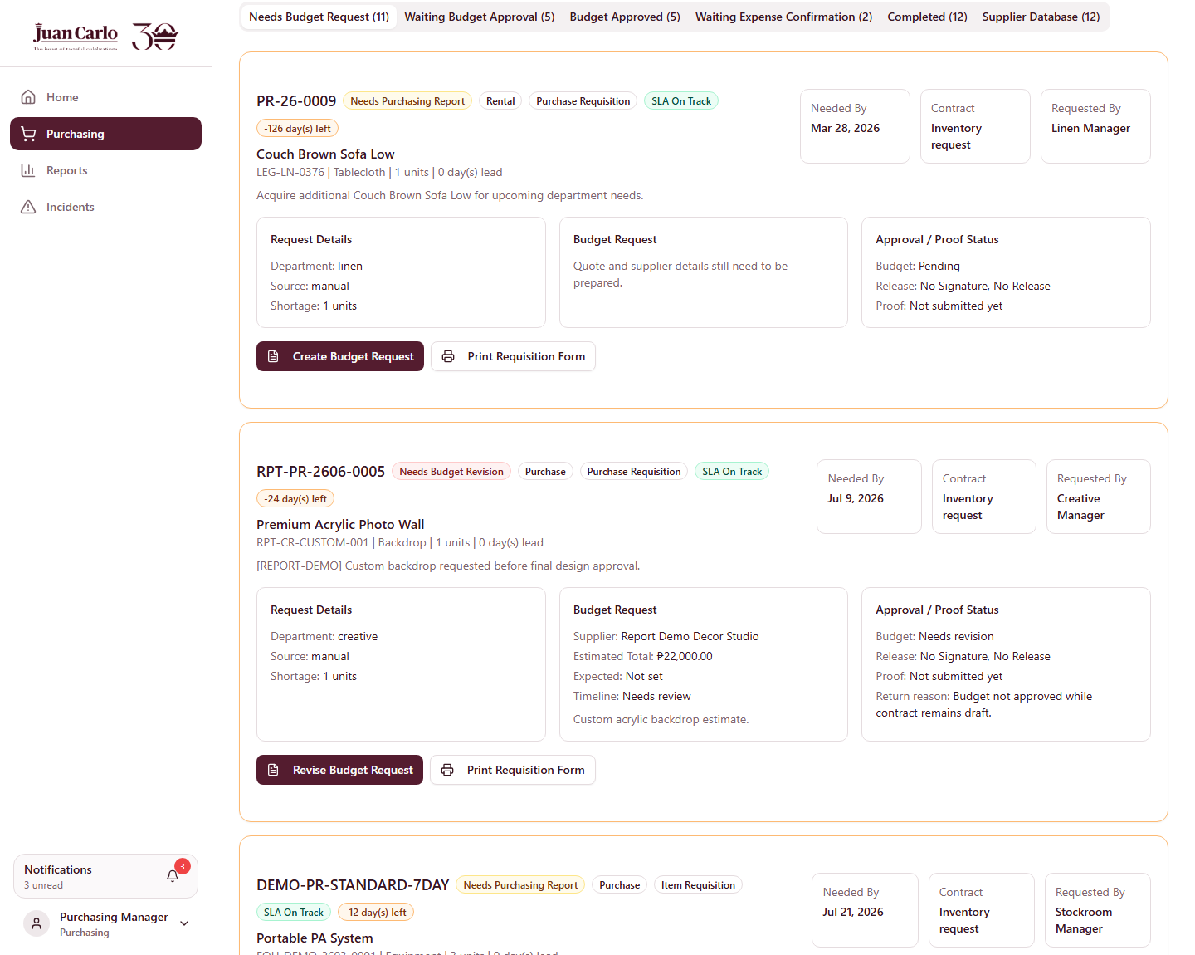
Figure 8.1 Purchasing queue, showing the request lifecycle tabs and card layout
● Note: Opening a notification links to the specific request and highlights it. In this printed walkthrough the queue is shown from the top so the tab structure is visible.

8.2 Sourcing a Supplier and Preparing the Budget Request
2. The Purchasing Manager clicks Create Budget Request on PR-26-0035, selects a supplier from the supplier database, and records the quotation.
Supplier: Batangas Event Rentals Hub
Quantity: 5 units (rental)
Estimated total: as quoted by the supplier
3. Submitting the budget request moves it to Waiting Budget Approval and notifies Accounting with Budget approval needed. The originating department, Stockroom, is separately notified that its request has been submitted, so it is never left guessing.
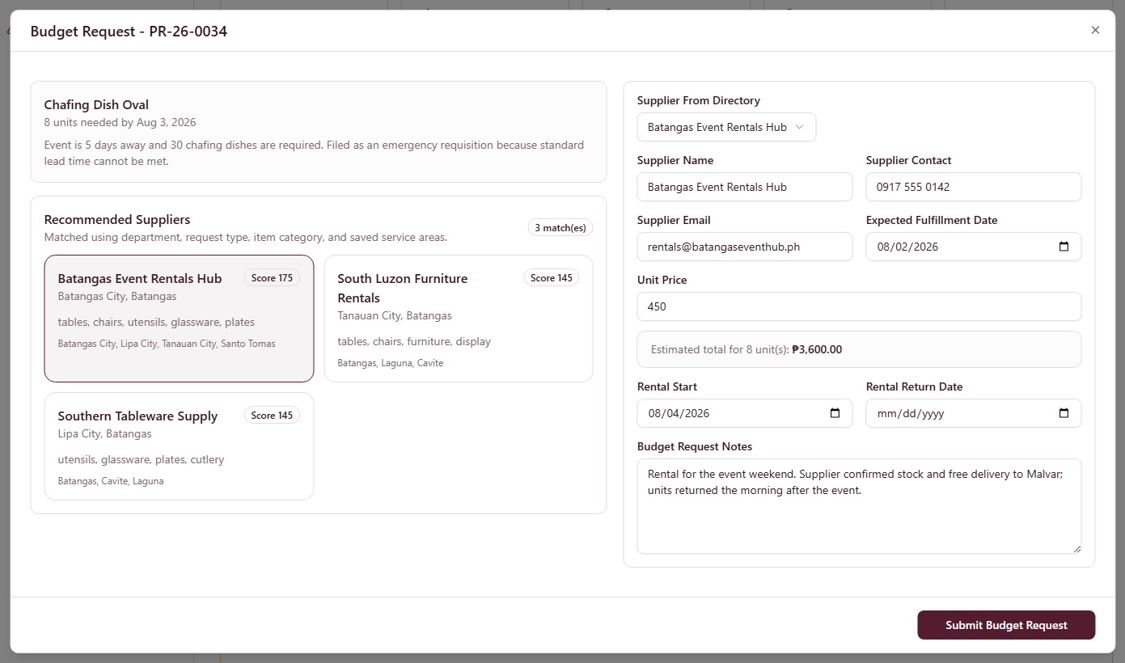
Figure 8.2 Budget request prepared with supplier and quotation, shown on another chafing-dish requisition still awaiting one

8.3 Accounting Approves the Budget
4. The Accounting Manager signs in and opens Procurement Approval, which is split into two queues so the two different decisions are not mixed together.
Email address: accounting@juancarlos.com
• Budget Approval Queue — approve the money before it is spent
• Expense Confirmation Queue — confirm the expense after proof is submitted
Both queues can be sorted by newest, oldest, or event date, so a request for an event happening soon can be brought to the top.
5. Accounting reviews the quotation against the department budget and approves it. Purchasing is notified with Budget request approved; if it were returned instead, the notification would read Budget request needs revision and carry the reason.
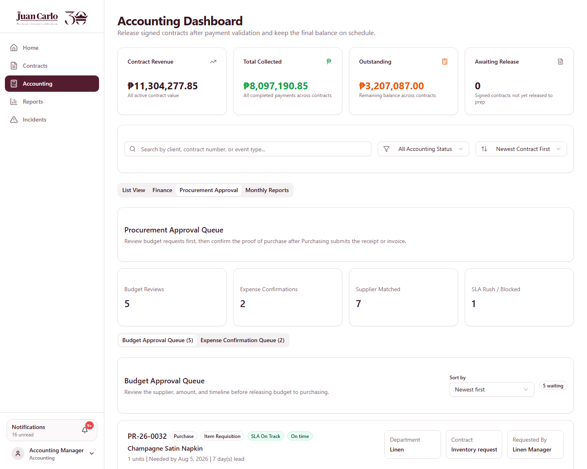
Figure 8.3 Accounting Budget Approval Queue

8.4 Purchase, Proof and Expense Confirmation
6. With the budget approved, Purchasing acquires the items and records the proof of purchase against the request.
7. Submitting the proof moves the request to Waiting Expense Confirmation and notifies Accounting with Expense confirmation needed.
8. Accounting reviews the proof and confirms the expense. The request becomes fulfilled, and the purchased or rented quantity is added to the department’s inventory so the shortage is closed.
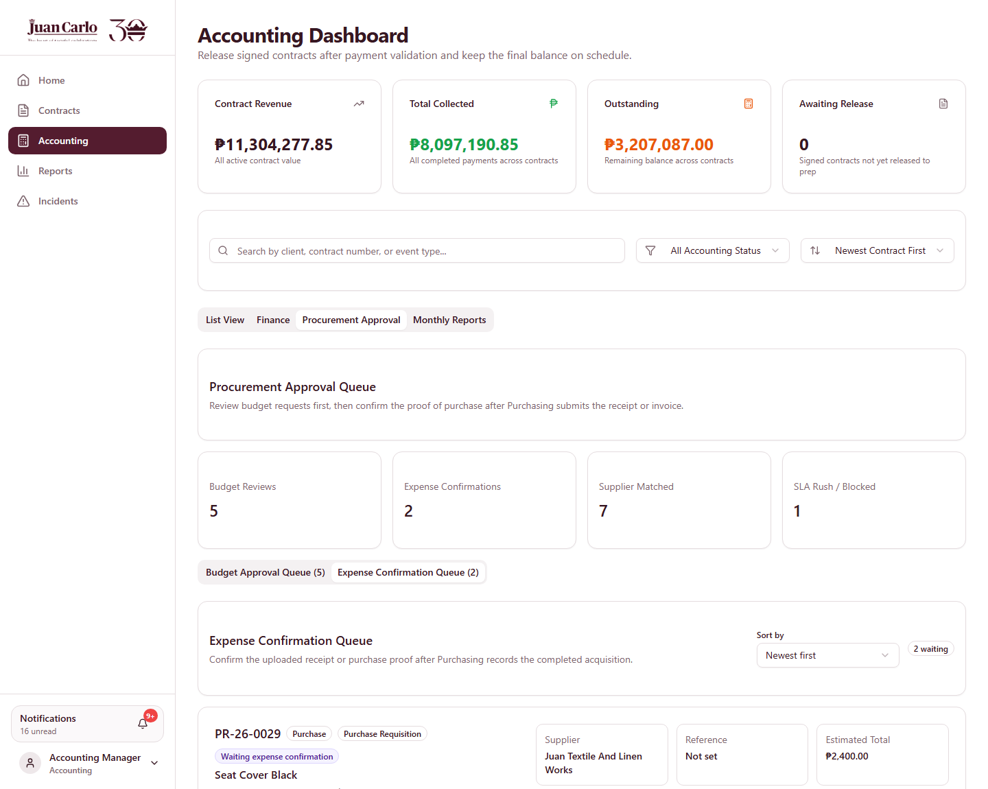
Figure 8.4 Expense Confirmation Queue with the submitted proof
● Note: Because this request is a rental, the added stock is temporary. When the items are returned to the supplier after the event, recording the return removes them again, so rented stock never permanently inflates the on-hand count.

8.5 Done Tags Across the Chain
Every step above notifies both Purchasing and the originating department. As each step completes, the corresponding notification re-labels itself with a green Done tag, resolved against the request’s own status rather than the contract’s. A budget-approval alert is done once Accounting has decided; a purchase-proof alert is done once proof has been submitted.
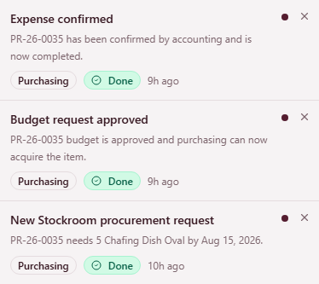
Figure 8.5 Procurement notifications showing Done tags as the chain completes

8.6 What This Hands Over
With the shortfall covered, the Stockroom section of the contract can be confirmed. Once all inventory sections are confirmed, the contract returns to Sales to finalize the payment arrangement, which is Stage 6.

Chapter 9. Stage 6 – Payment and Contract Approval
Performed by: Sales, then Accounting
What prompts this stage: Once every inventory department confirmed its section in Stage 4, Sales received a notification titled Inventory validation complete for JC-2608-0001, and the contract stage moved to Confirm Payment Term. This is the single click that returns the contract to Sales.

9.1 Confirming the Payment Arrangement
1. The Account Executive opens the contract and confirms the payment arrangement. The system will not accept this until every inventory section is confirmed, because inventory changes can still alter the contract total.
The arrangement for this contract is the standard 40/60 collection:
Component | Amount | Due
Total contract value | PHP 261,000.00 | —
Reservation fee (inside the 40%) | PHP 30,000.00 | On booking
40% collection | PHP 104,400.00 | 2 months after booking
Final 60% balance | PHP 156,600.00 | 2 months before the event

Business rule applied: The PHP 30,000 reservation fee validates the booking and is non-refundable. It is not an extra charge — it forms the first part of the 40% collection.

9.2 Signature
2. With the payment term confirmed, the Account Executive sends the contract for client signature. The status becomes Awaiting Client Signature.
3. When the signed copy is returned, the Account Executive records the signature. The status becomes Submitted, the badge Client Signed appears, and Accounting is notified with Signed contract ready for Accounting.
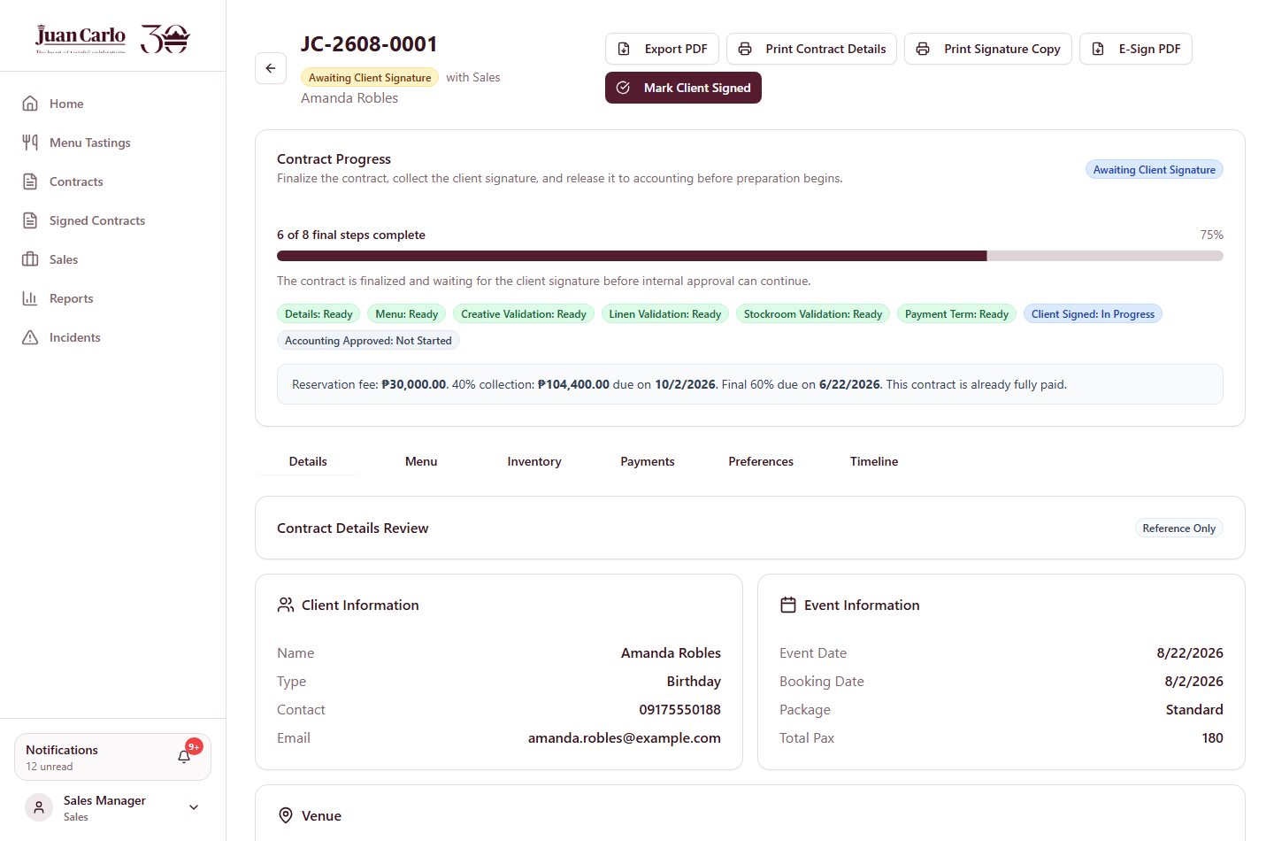
Figure 9.1 Contract awaiting client signature

9.3 Recording Payments
4. The Accounting Manager signs in, opens the Payments tab and clicks Record Payment. Each payment is entered separately so the reservation fee remains identifiable in the history.
Email address: accounting@juancarlos.com
Payment 1 — PHP 30,000.00, Cash, provisional receipt PR-2608-0001, "Non-refundable reservation fee (Appendix H)"
Payment 2 — PHP 74,400.00, Bank Transfer, provisional receipt PR-2608-0002, "Balance of the 40% down payment"
● Note: A provisional receipt number is required on every payment; the system rejects the entry without one. Each recorded payment can then be reprinted from the history using the Provisional Receipt button.
The two payments together satisfy the 40% collection milestone exactly, and the payment status becomes partially paid.

9.4 The Overpayment Guard
The system will not accept a payment larger than what is actually owed. Attempting to pay one centavo over the remaining balance is rejected, and the message states the exact figure to two decimal places.
5. Entering PHP 156,600.01 against a remaining balance of PHP 156,600.00 returns:
"Payment cannot be higher than the remaining contract balance of PHP 156,600.00"
6. Entering the exact remaining balance, PHP 156,600.00, is accepted and closes the balance to zero.
Business rule applied: A payment may never exceed the remaining balance. The comparison tolerates a half-centavo of rounding drift, so an exact final payment is always accepted rather than being rejected as too large.
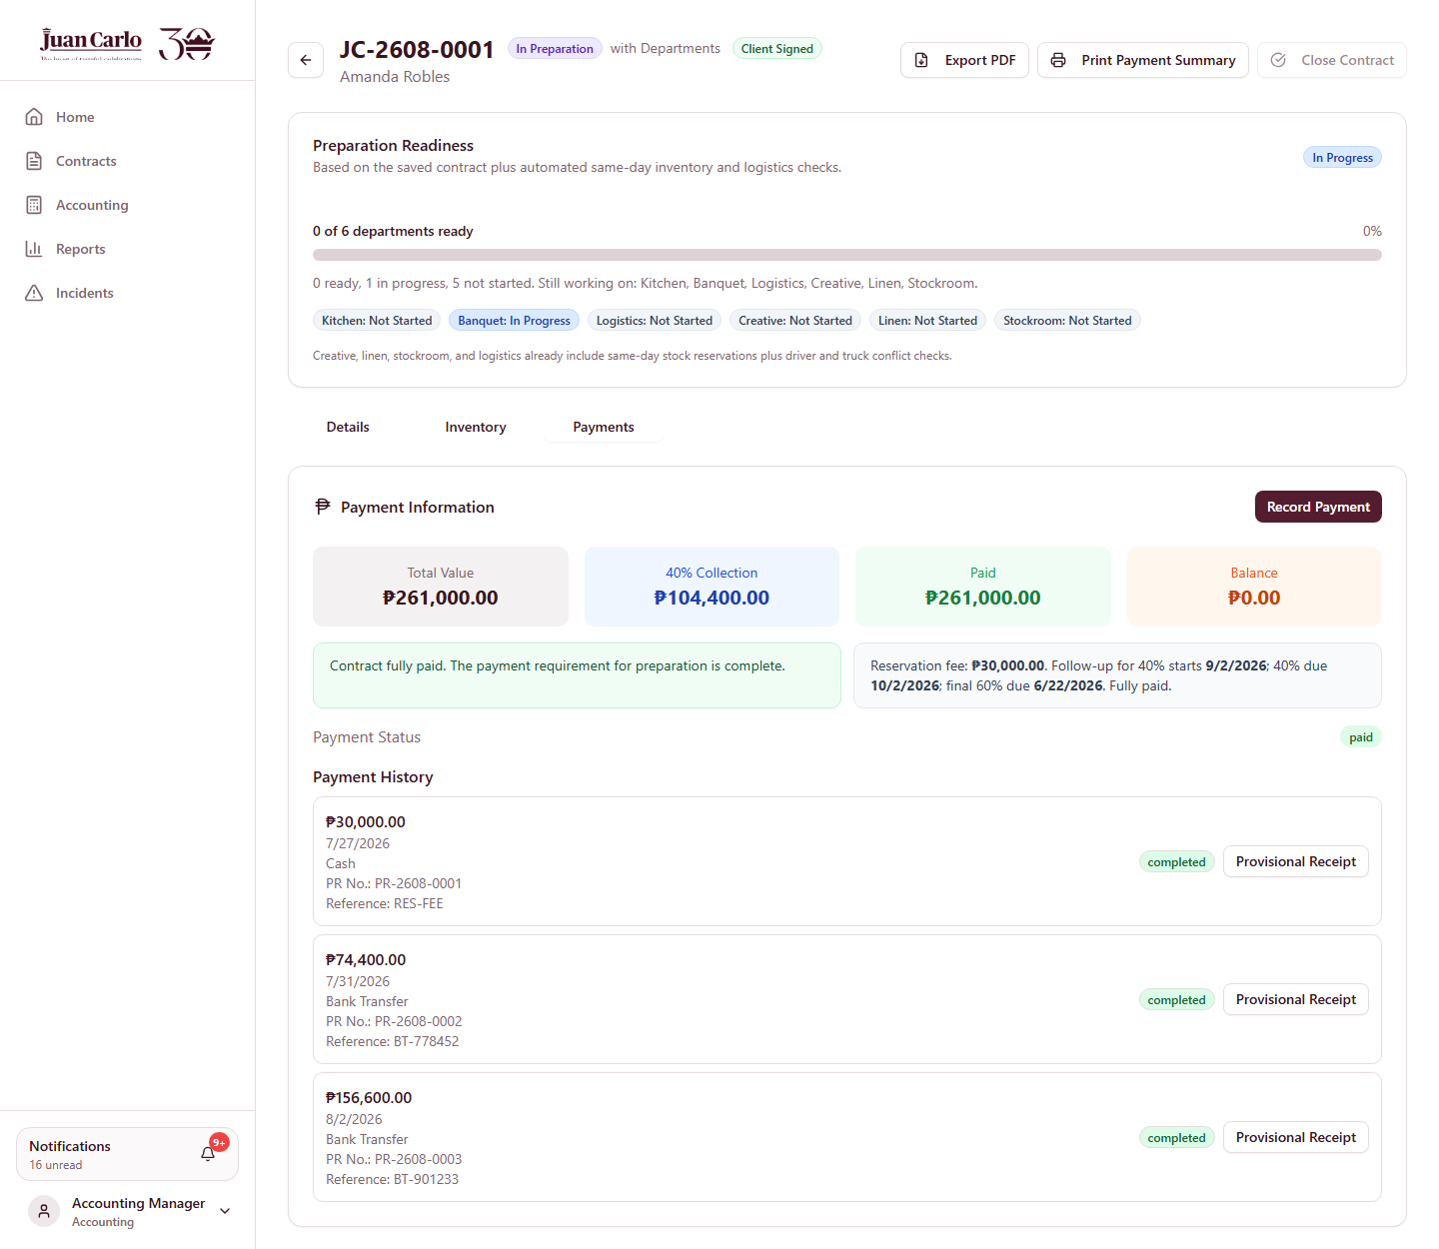
Figure 9.2 Payments tab after the balance is fully settled
● Note: In this walkthrough the event is only twenty days away, so under the collection timeline the final 60% is already due and the client settles the contract in full. On an event booked months ahead, Accounting would approve on the 40% alone and collect the balance later.

9.5 Approving the Contract for Preparation
Approval is the single action that starts operations, so the system checks that nothing is outstanding before allowing it. Two checks apply to this contract:
• The collection requirement. Because the final balance is already past its due date, it must be settled before the event can proceed.
• Outstanding shortages. While Chafing Dish Oval was still short, approval was refused with *"Chafing Dish Oval is still short by 5 for August 22, 2026. Create purchasing or rental request(s) for 5 more items before approving this contract."*
● Note: A shortage must be fulfilled, not merely requested. Raising the procurement request in Stage 4 is not enough — Stage 5 has to complete before the contract can be approved.
7. With the balance settled and the shortage covered, the Accounting Manager clicks Approve For Preparation. The contract status becomes approved and the stage badge reads In Preparation.
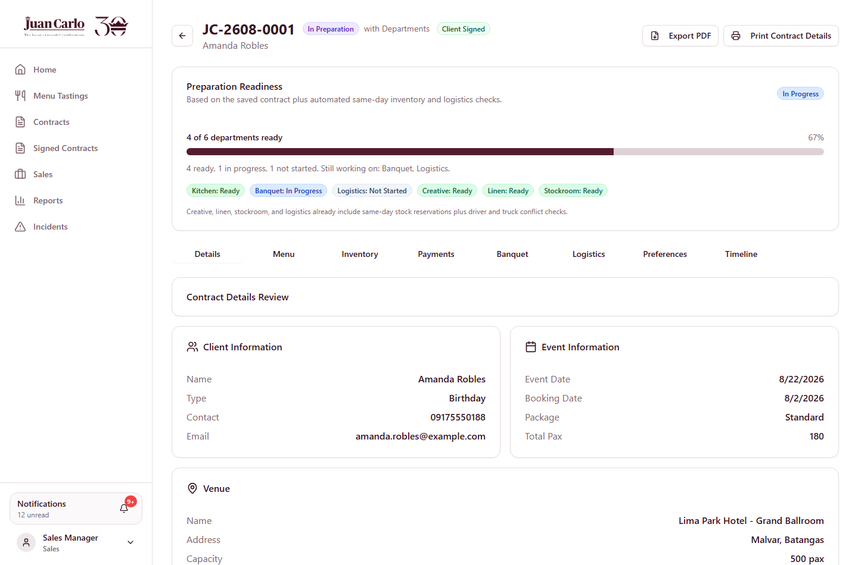
Figure 9.3 Contract approved and moved to In Preparation

9.6 What This Hands Over
Approval is the widest handoff in the whole lifecycle. In a single action the system notifies six departments — Kitchen, Banquet, Logistics, Creative, Linen and Stockroom — that the event is theirs to prepare.
The contract header now shows a Preparation Readiness panel tracking those six departments, beginning at *0 of 6 departments ready*. Each department clears its own part of that panel during Stage 7.
● Note: The Kitchen alert deliberately says *review the menu* rather than *begin cooking*. Kitchen cannot start preparing food until the event is within seven days, and the system sends separate reminders at two weeks and at seven days.

Chapter 10. Stage 7 – Pre-Event Preparation
Performed by: Kitchen, Banquet and Logistics, alongside Creative, Linen and Stockroom
What prompts this stage: The approval in Stage 6 notified all six departments at once. Each received an Approved event ready for … alert naming what it may now begin.
Progress is tracked on the contract header in a Preparation Readiness panel, which begins at *0 of 6 departments ready* and lists each department’s state — Not Started, In Progress or Ready. Sales, Accounting and Admin watch this panel rather than chasing departments individually.
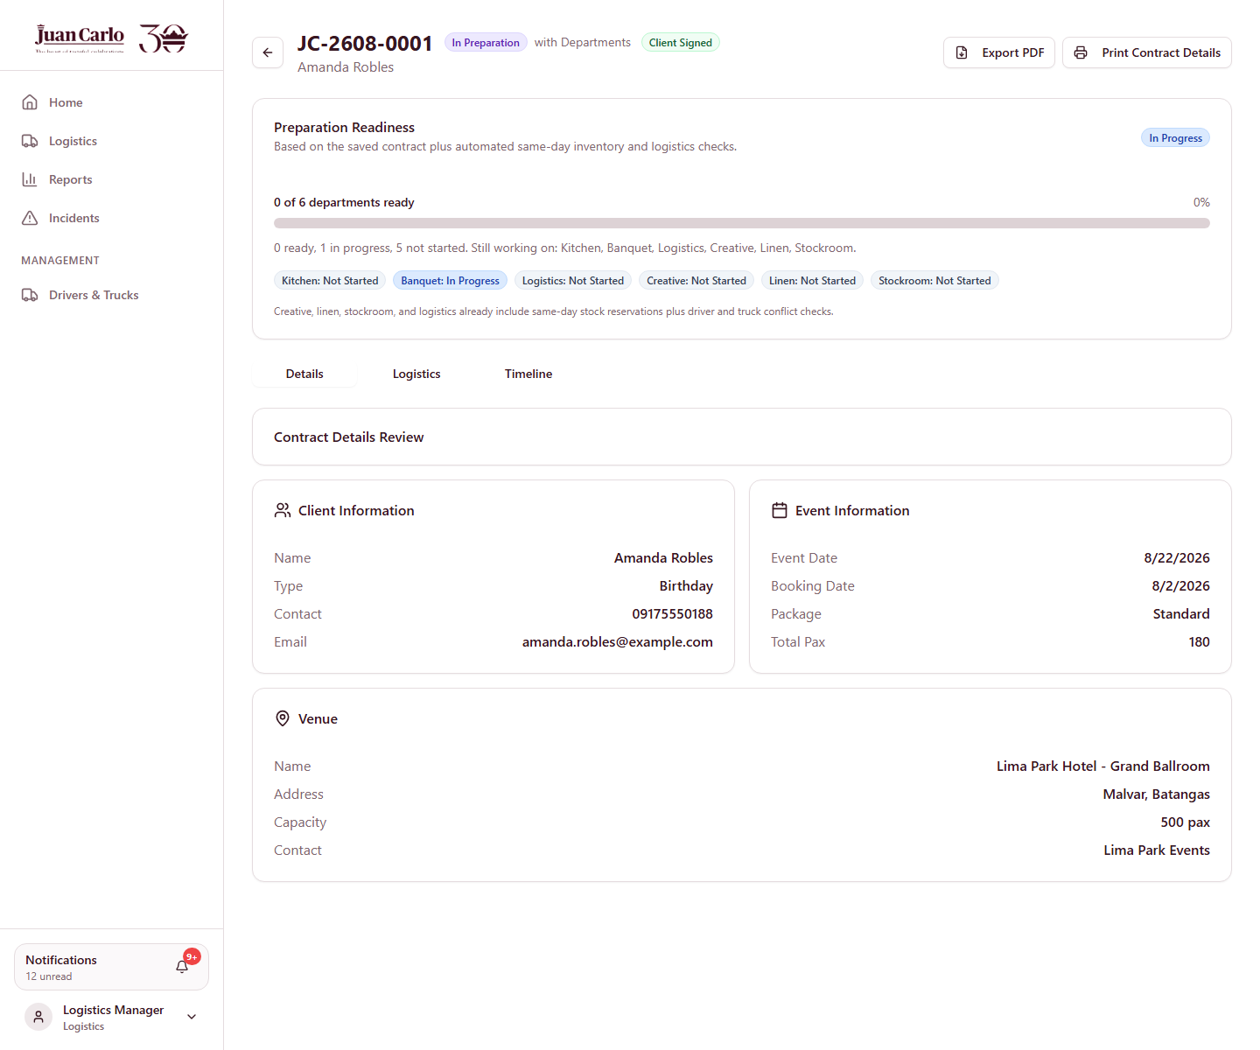
Figure 10.1 Preparation Readiness panel at the start of Stage 7

10.1 Kitchen
Kitchen’s approval alert deliberately asks it to review the menu, not to start cooking. Food preparation is time-gated, and the system sends two further reminders as the event approaches:
When | Reminder
14 days before | Start sourcing ingredients. Cooking opens at 7 days.
7 days before | The preparation window is open — complete the checklist and mark ready.

Business rule applied: Kitchen may only begin preparing food once the event is within 7 days. Both reminders are issued by the kitchen preparation sweep without anyone being logged in.
1. The Kitchen Manager opens the contract’s Menu tab and confirms each dish on the checklist, then sets the ingredient status as sourcing progresses.
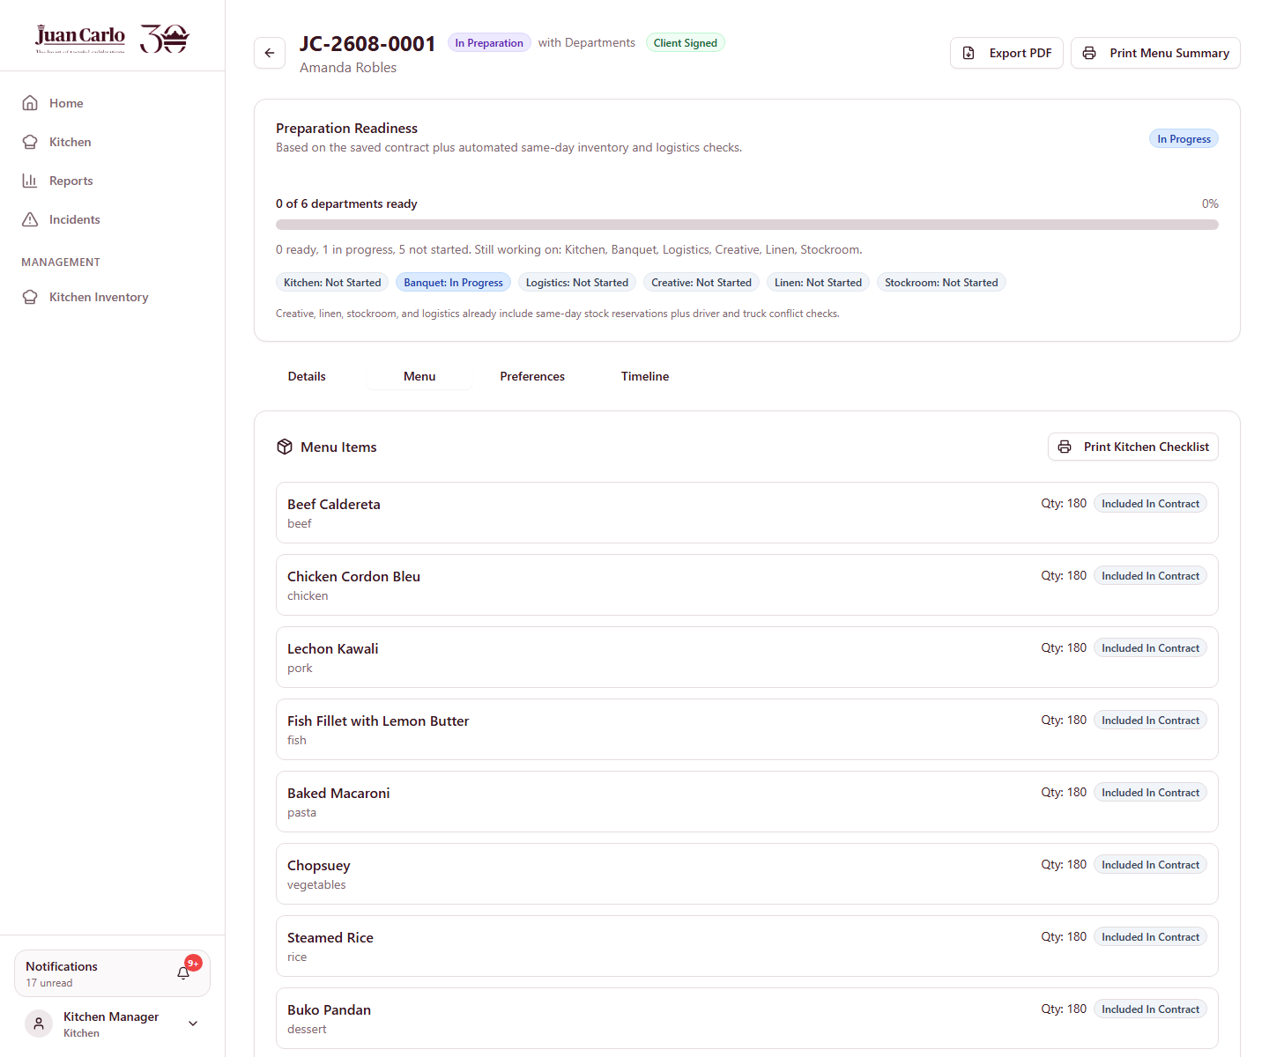
Figure 10.2 Kitchen menu checklist for JC-2608-0001
2. From the Kitchen dashboard’s This Week tab, the Manager prints the preparation checklist. The printout carries the per-dish notes recorded back at the tasting.
Lechon Kawali — "Serve the sauce on the side."
Baked Macaroni — "Reduce the cheese; two guests are lactose intolerant."
● Note: Only dishes that appear in the contract are printed. A dish tasted but not chosen never reaches the kitchen line, so stale preferences cannot leak onto the checklist.
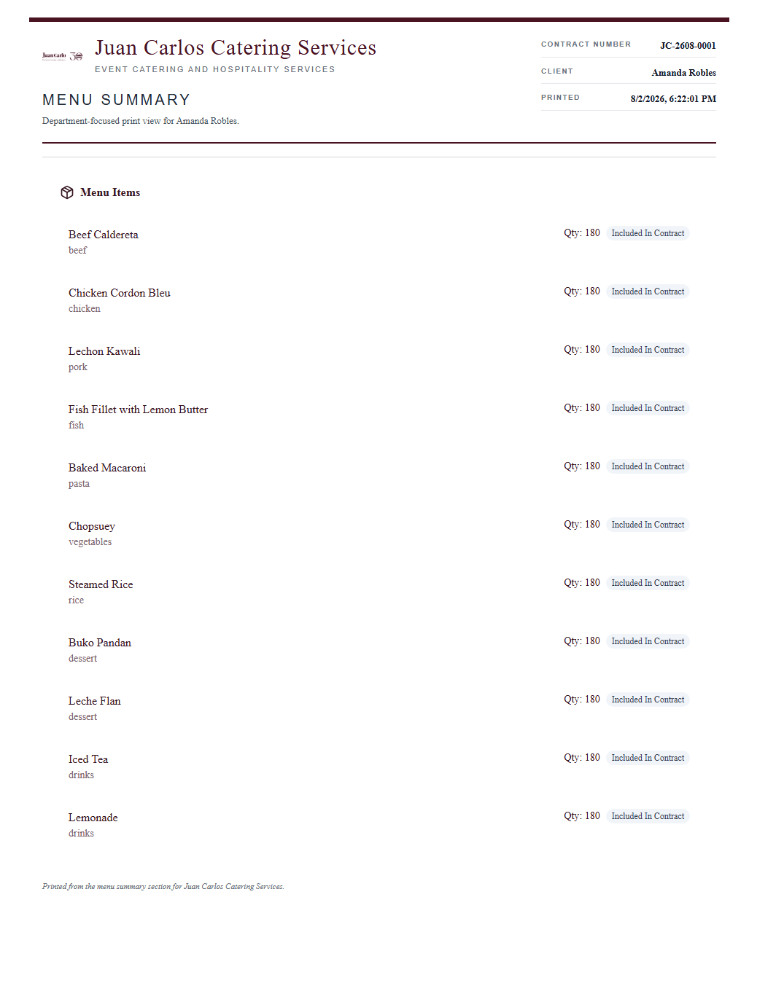
Figure 10.3 Printed menu summary handed to the kitchen, with the contracted quantity per dish

10.2 Banquet
Banquet plans the service team. The required headcount is derived from the guest count rather than left to judgement, so under-staffing is visible as a number.
Business rule applied: One waiter per 25 guests. The system computes the requirement from the seated guest count and shows it against the staff actually assigned.
3. The Banquet Supervisor opens the Banquet tab, reviews the suggested staffing plan, and assigns the team from the available roster.
The roster excludes anyone already assigned to another event on the same date, so a member of staff cannot be double-booked.
4. Once the team is saved, the Supervisor prints the staff attendance sheet for the event day.
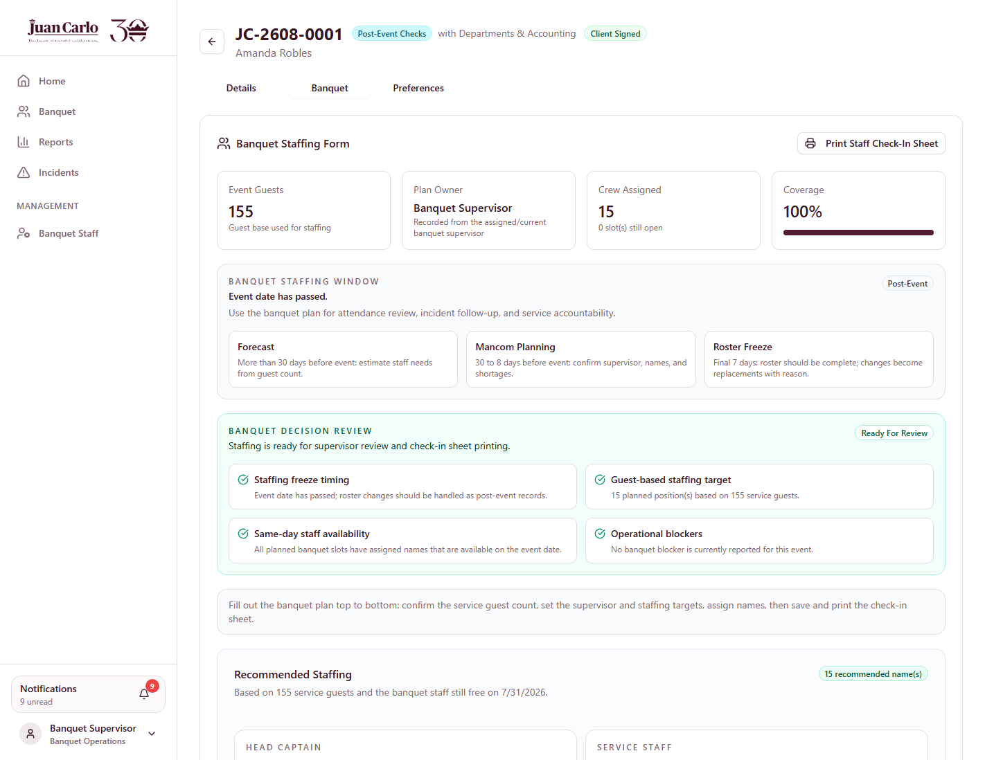
Figure 10.4 Banquet staffing plan showing required against assigned staff
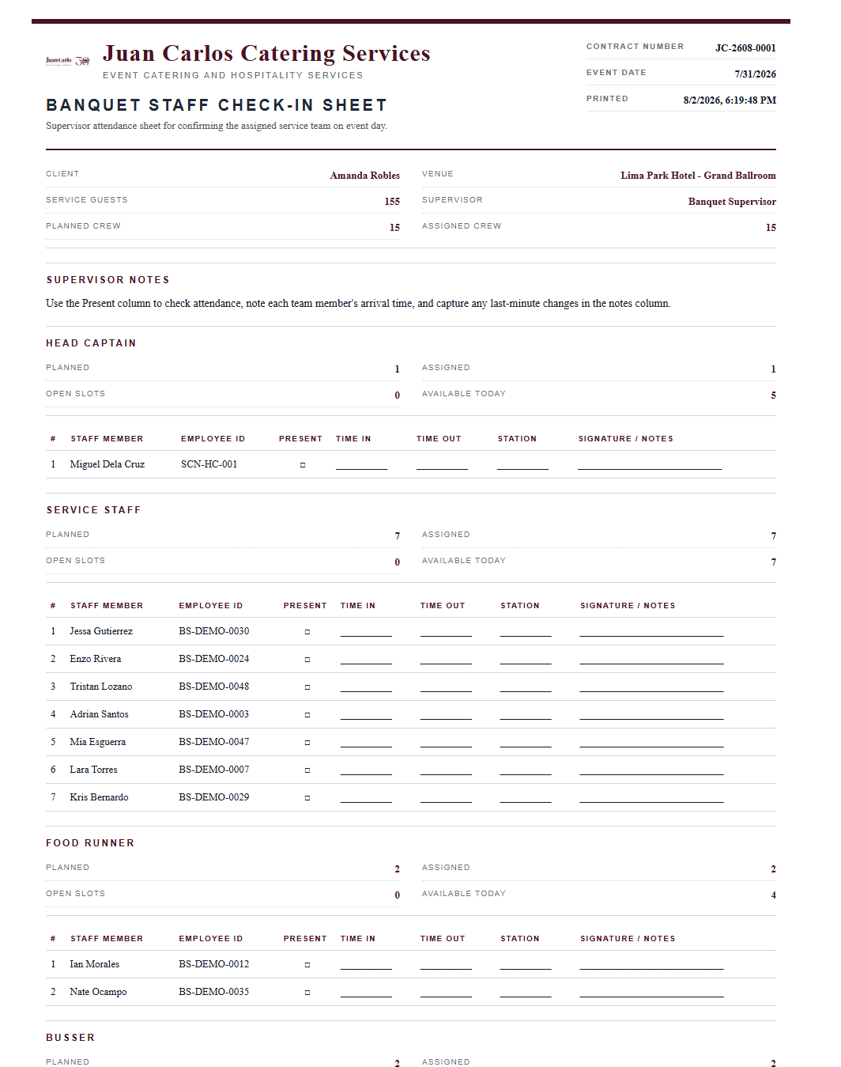
Figure 10.5 Printed banquet staff attendance sheet

10.3 Logistics — Two Separate Bookings
Logistics makes two distinct bookings for every event, shown as numbered steps in the logistics workflow:
Step | Purpose
1. Inventory Transport | A cargo truck and driver to carry the event’s equipment, decor and linen.
2. Staff Transport | Passenger vehicles to carry the assigned event staff.
Load & Dispatch | Informational — confirm readiness, load, dispatch, then close out after the event.

● Note: The two are deliberately separate. Staff are never carried in the back of a cargo truck, and the cargo truck booked for an event cannot also be selected to carry staff.

10.3.1 Inventory Transport
5. The Logistics Manager opens 1. Inventory Transport. The booking form offers only cargo vehicles — passenger vans, coasters, buses and SUVs are excluded, because they carry no load volume.
Alongside the form is the load manifest: every item reserved for this event across Creative, Linen and Stockroom, with quantities and an estimated load volume. This is how Logistics knows what it will be carrying without opening three separate inventories.
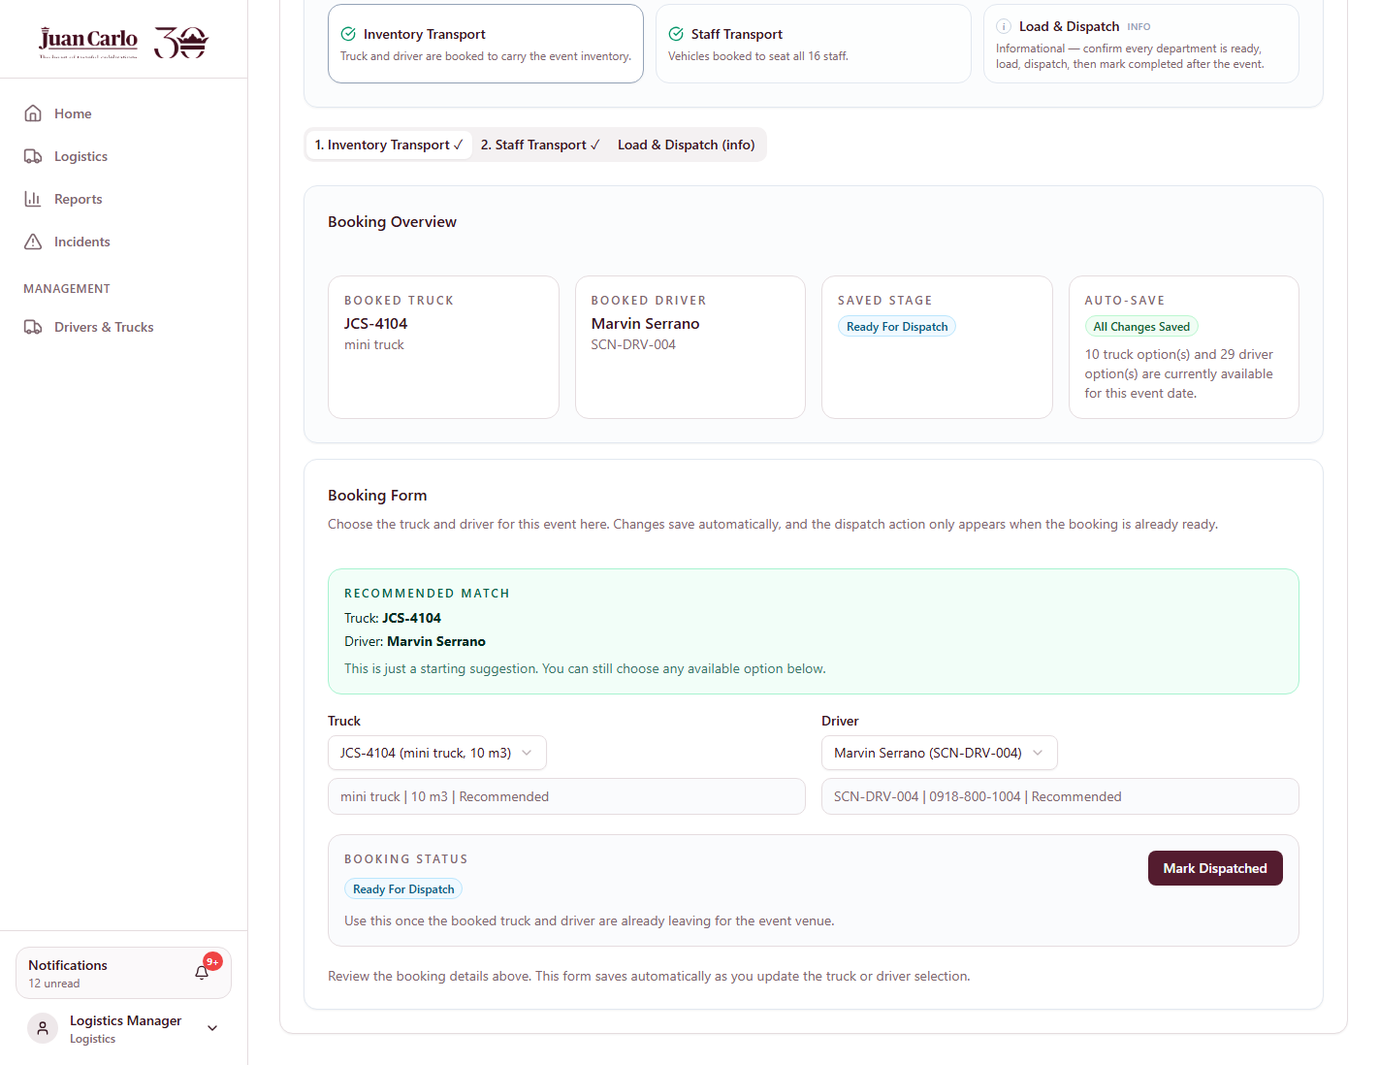
Figure 10.6 Inventory Transport booking with the load manifest

10.3.2 Staff Transport
6. The Manager opens 2. Staff Transport. The vehicle list shows only passenger-tagged vehicles, with their seat capacity checked against the number of staff Banquet assigned.
Business rule applied: Every staff transport vehicle must have a driver. A vehicle selected without one is rejected, and auto-assign only considers vehicles that already have a driver paired to them.
7. Rather than choosing manually, the Manager may click Auto-Assign. The system picks the smallest single vehicle that seats everyone, and only combines vehicles when no single one is large enough.
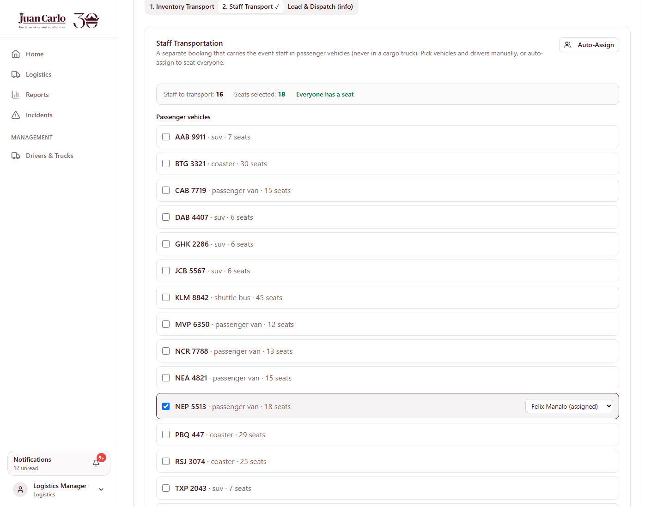
Figure 10.7 Staff Transport with passenger vehicles and seat capacity

10.3.3 Availability and Restrictions
Three rules narrow the vehicle and driver lists before the Manager chooses:
• Same-day bookings are excluded. A vehicle or driver already committed to another event on this date does not appear — whether that other event has it hauling inventory or carrying staff.
• Transport should be arranged at least 3 days before the event. Inside that window the system warns for both bookings, naming Appendix H. It warns rather than blocks, because a genuine last-minute booking must remain possible.
• Metro Manila number coding. When the venue is inside Metro Manila, plates ending in the day’s coded digits cannot be used. Coded vehicles remain listed with a Number-coded tag so the reason is visible, but they cannot be selected.
Event weekday | Plates barred in Metro Manila
Monday | 1 and 2
Tuesday | 3 and 4
Wednesday | 5 and 6
Thursday | 7 and 8
Friday | 9 and 0
Saturday and Sunday | No coding

● Note: This event is at Lima Park Hotel in Malvar, Batangas — outside Metro Manila — so number coding does not restrict it. The rule is shown here because it applies whenever Juan Carlo caters an event at a Metro Manila venue such as the World Trade Center or Blue Leaf Pavilion.
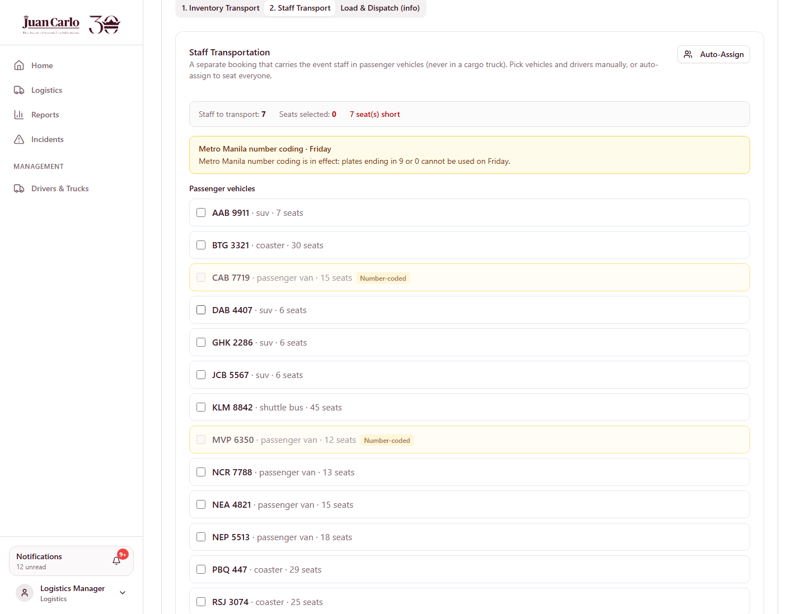
Figure 10.8 Metro Manila number coding: coded plates listed but not selectable

10.4 What This Hands Over
As each department completes its work, the Preparation Readiness panel advances. When the last one finishes, the system sends a single one-shot alert titled All departments ready to Sales, Accounting and Admin — so management is told the event is ready rather than having to keep checking.
The contract then waits for the event week, which is Stage 8.

Chapter 11. Stage 8 – Event Week and the Material Freeze
Applies to: All departments
What prompts this stage: Nothing is clicked. The event crossing into the final seven days is what changes the contract’s behaviour — a rule enforced by the calendar rather than by a person.

11.1 The Contract Changes Stage by Itself
Once the event is within seven days, the contract’s stage badge changes to Event Week – Materials Frozen and a banner appears on every inventory view:
"This event is inside the 1-week material freeze window. Reserved materials are locked to this event: item lists cannot be edited and prepared items cannot be released without a management override."
The panel also counts down — *4 day(s) to event* — so departments can see how much of the window remains.
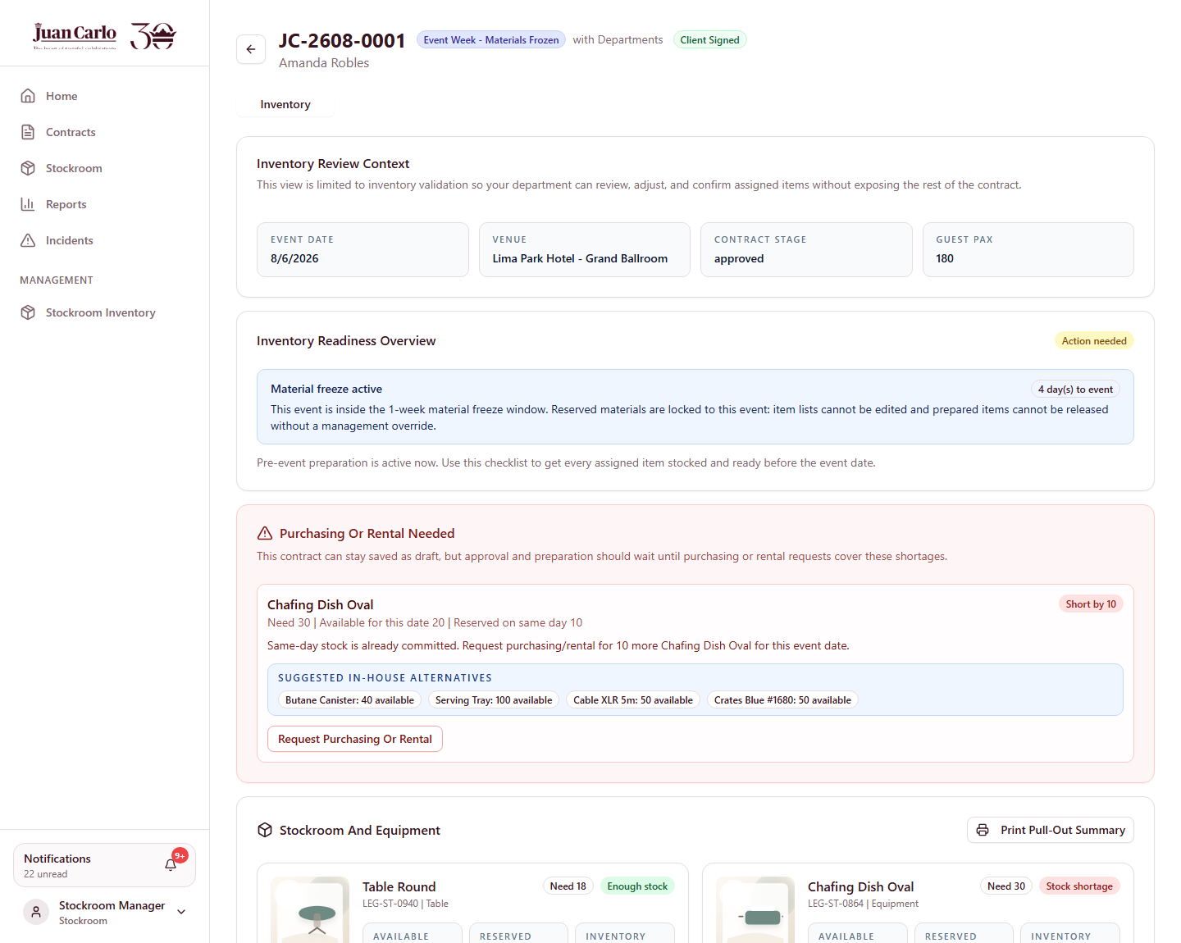
Figure 11.1 Material freeze active during event week
Business rule applied: Within 7 days of the event, reserved materials are locked to that event. Item lists cannot be edited, and an item already marked prepared cannot be released or reassigned. Only an administrator may override, and the override is recorded.

11.2 What the Freeze Prevents
The freeze blocks two specific actions that would otherwise put an event at risk days before it happens:
• Releasing a prepared item. Reverting an item from prepared back to pending is rejected, so stock already set aside cannot quietly be taken for another event.
• Editing the material list. Items cannot be added or removed from the contract, so the load manifest Logistics is working from cannot change underneath them.
1. Attempting either action returns the freeze message rather than failing silently, and names management override as the only route.
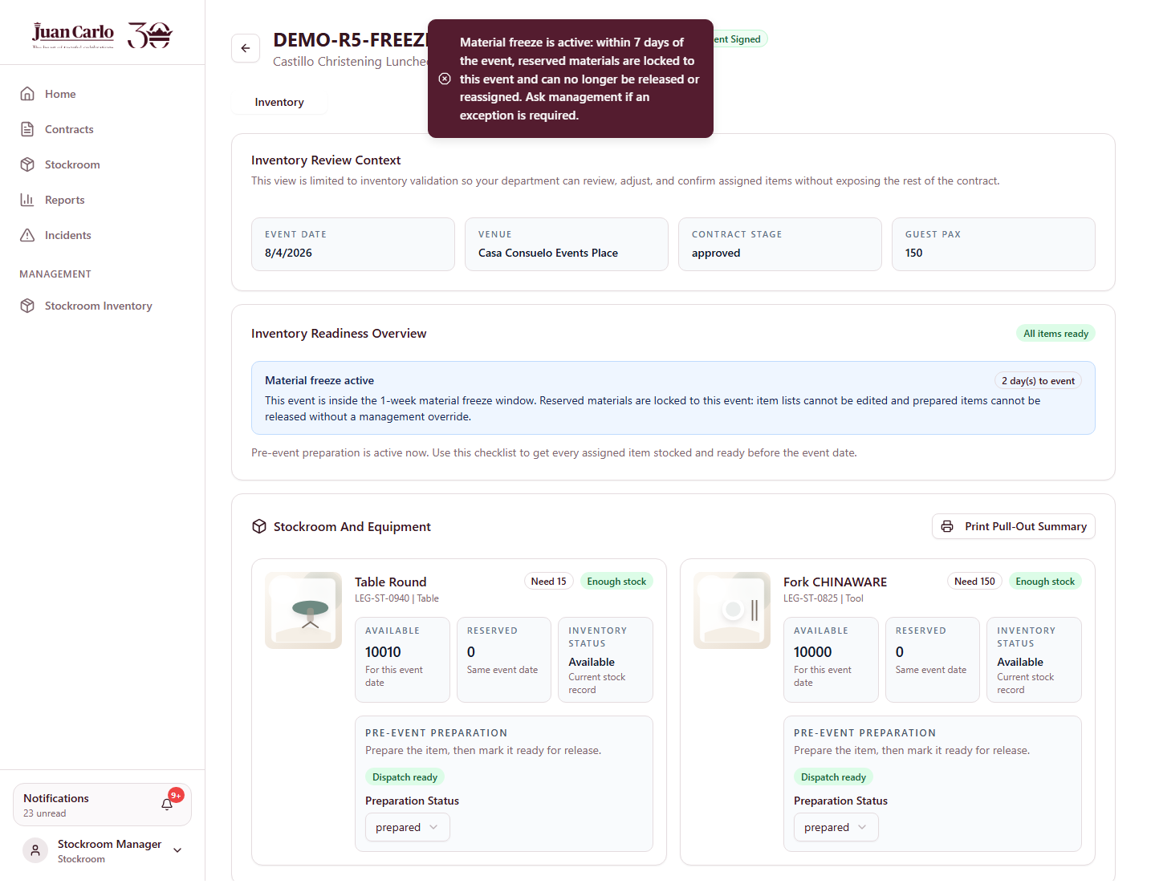
Figure 11.2 Freeze rejection when releasing a prepared item, shown on an event still inside the 7-day window

11.3 What the Kitchen Sees Instead
The freeze governs physical inventory — decor, linen and equipment. It has nothing to do with food, which is prepared fresh. Showing Kitchen a "Materials Frozen" badge would therefore be misleading, so for the Kitchen role the same stage is labelled simply Event Week.
● Note: This is the only place in the system where a stage is deliberately labelled differently for one department, and it is done so the label matches that department’s reality.
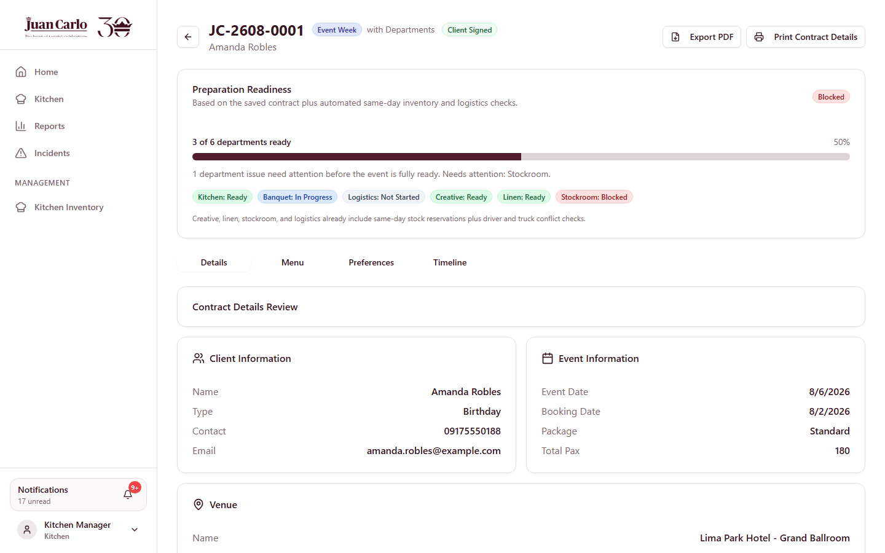
Figure 11.3 The same contract shown to Kitchen as "Event Week"

11.4 Same-Day Stock Is Still Enforced
Availability continues to be calculated against other events on the same date. If another event books the same item for that day, the shortage panel names the cause explicitly — for example *"Need 30 | Available for this date 20 | Reserved on same day 10"* — rather than showing a bare shortfall, so the department can see that the stock exists but is committed elsewhere.

11.5 What This Hands Over
The event takes place. The day after, the system moves the contract into post-event checking, which is Stage 9.

Chapter 12. Stage 9 – Post-Event Checks and Contract Closure
Performed by: Creative, Linen and Stockroom, then Accounting
What prompts this stage: The day after the event, the payment compliance sweep sends Post-event checks ready: JC-2608-0001 to every department that had items on the contract. Nobody has to remember that the event has finished.
● Note: Only departments that actually held items are notified. Accounting is deliberately excluded here — it receives a separate alert once every check is complete.

12.1 Checking the Returned Items
1. Each department opens the notification, which links to its inventory checklist for the contract.
2. For every item, the department records one of two outcomes:
• Checked OK — the item came back complete and undamaged.
• Incident reported — something is missing or damaged; the department records what happened.
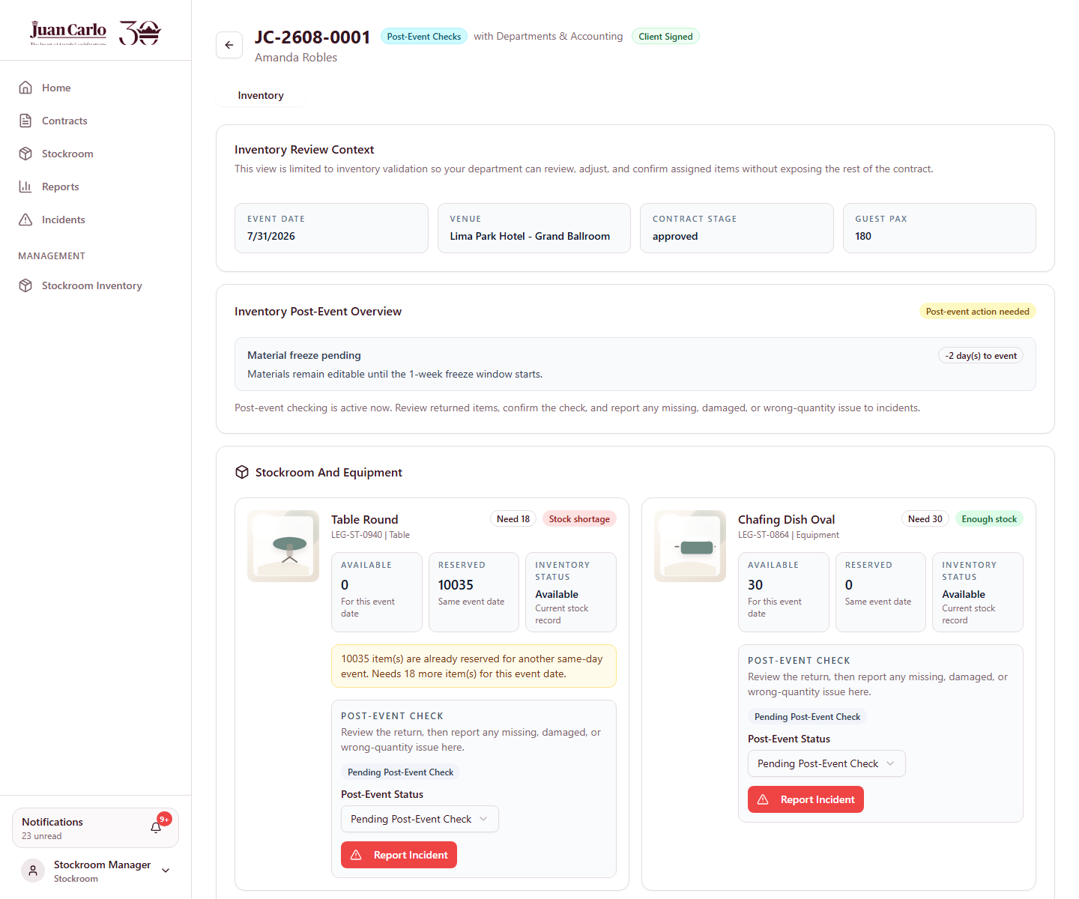
Figure 12.1 Post-event checklist with items marked checked OK
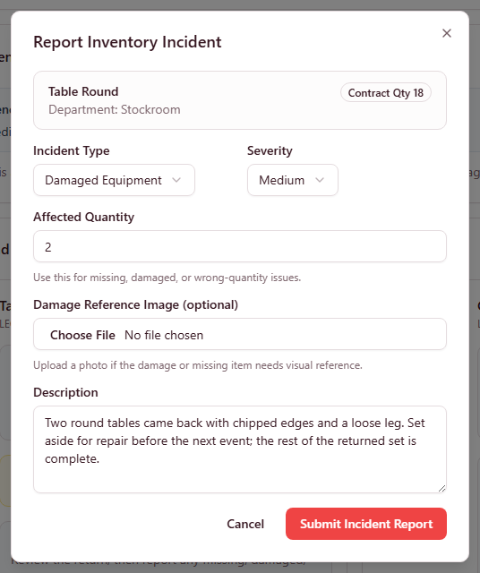
Figure 12.2 Recording an incident against a returned item
● Note: The contract stage reads Post-Event Checks while any item is still outstanding. It only moves on once every department has finished and the logistics booking has been closed out.

12.2 Returning Rented Items
The five chafing dishes obtained in Stage 5 were a rental, so they were added to Stockroom’s inventory only for the duration of this event. When they go back to the supplier, Stockroom records the return and the system removes them again.
Business rule applied: Rented stock is added on fulfilment and removed on return, so it never permanently inflates the on-hand count.

12.3 The Contract Becomes Ready to Close
When the last department finishes its checks and the logistics booking is closed out, the stage changes to Awaiting Contract Close and Accounting receives a one-shot alert titled Ready to close: JC-2608-0001. The message states the outstanding balance, or confirms there is none.
"All post-event checks are complete. This contract is awaiting close. The balance is fully settled, so it can be closed now."
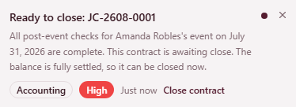
Figure 12.3 Accounting notification that the contract is ready to close

12.4 Closing the Contract
3. The Accounting Manager opens the contract and clicks Close Contract. Any remaining balance must be settled first — for this contract it was already paid in full during Stage 6.
The status becomes completed and the stage badge reads Closed. Notifications belonging to the contract are given a short expiry so they clear from every inbox automatically, because alerts about a closed contract are no longer actionable.
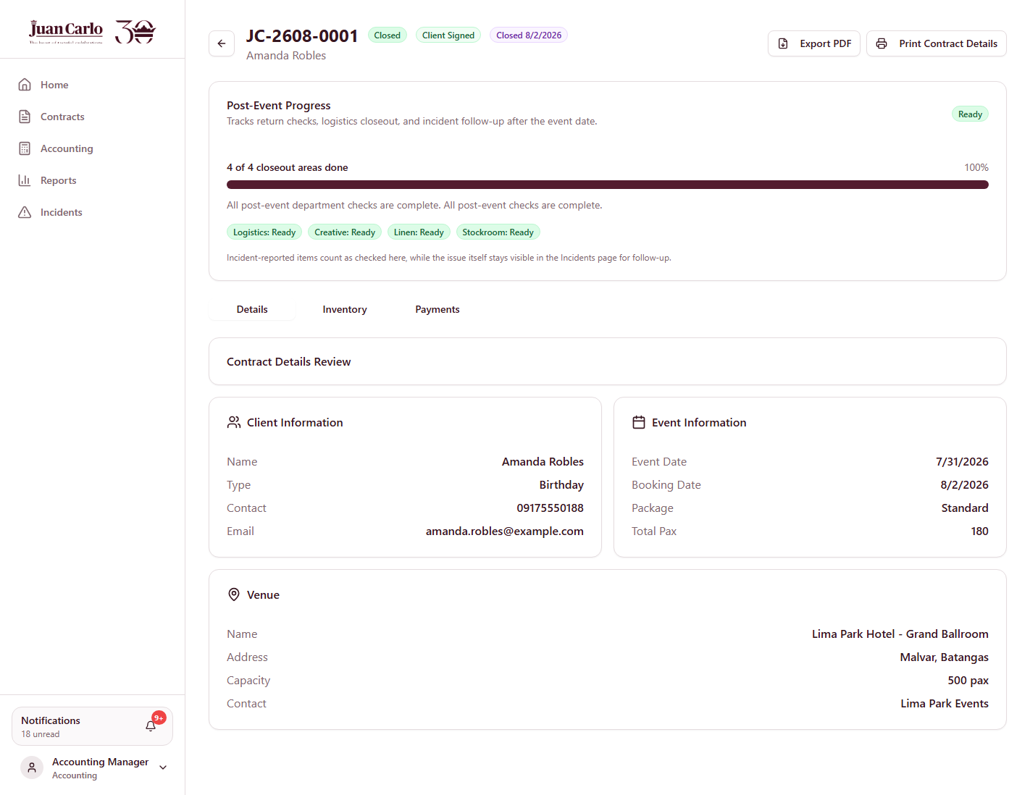
Figure 12.4 Closed contract JC-2608-0001

12.5 The Lifecycle in One View
The contract has now passed through every stage. At no point did a department have to search for its work — each was told, either by a colleague completing the previous step or by the calendar reaching a deadline.
Stage | Who held the contract | What released it to them
1 | Sales | A client enquiry (the only external trigger)
2 | Sales | The tasting date arriving
3 | Sales | The client agreeing to proceed
4 | Creative / Linen / Stockroom | Sales saving the draft
5 | Purchasing → Accounting | A shortage found during validation
6 | Sales → Accounting | All inventory sections confirmed
7 | Six departments at once | Accounting approving the contract
8 | All departments | The event reaching 7 days away
9 | Departments → Accounting | The event day passing

Five of those nine handoffs were triggered by another department finishing its work, three by the calendar, and only the first by anything outside the system.

Appendix A. Business Rules Applied
Every rule below is enforced on the server, not merely displayed, and each was observed while preparing this walkthrough. The Enforcement column distinguishes rules that block an action from those that warn and allow it: the system blocks where a violation would corrupt money or data, and warns where an experienced person may have a legitimate reason.

A.1 Collection and Payment
Rule | Enforcement | Behaviour
PHP 30,000 reservation fee | Stated | Non-refundable, and forms the first part of the 40% collection rather than an additional charge.
40% due 2 months after booking | Reminds | Follow-up alert one month ahead, then a collection task on the due date.
30-day aging window | Reminds | An unpaid 40% past the window marks the account uncollectible.
Final 60% due 2 months before the event | Blocks | Unpaid past that date places the contract on hold automatically; preparation, release and execution stop.
Hold release | Automatic | Settling the balance releases the hold on the next sweep. Management may also release it, with the reason recorded.
Payment cannot exceed the balance | Blocks | Rejected with the exact remaining balance to two decimals. Tolerates half a centavo of rounding drift so an exact final payment always clears.
Provisional receipt number | Blocks | Required on every payment; the entry is rejected without one.

A.2 Contract and Menu
Rule | Enforcement | Behaviour
Package dish counts | Blocks | Each tier requires an EXACT number per course — Standard: 4 mains, 3 sides, 2 desserts, 2 drinks. Saving is rejected until every course matches, and each shortfall is named.
Add-on quantities | Blocks | May be cleared while editing, but zero or negative is rejected on save.
Mobile number | Blocks | Exactly 11 digits, no spaces or hyphens.
Inventory validation before payment term | Blocks | Sales cannot confirm the payment arrangement until every inventory department has confirmed its section.
Approval requires shortages fulfilled | Blocks | A shortage must be procured and fulfilled, not merely requested, before the contract can be approved.

A.3 Inventory and Procurement
Rule | Enforcement | Behaviour
Stock reserved per event date | Blocks | Availability is net of other same-day events. A same-day conflict is named explicitly, with in-house alternatives suggested.
7-day material freeze | Blocks | Within 7 days of the event, item lists cannot be edited and prepared items cannot be released. Admin override only, and it is recorded.
7-day requisition lead time | Blocks | A standard requisition needed sooner is rejected and must be filed as an emergency requisition, which records the urgency.
Active monthly budget | Blocks | Accounting cannot approve a budget request unless an active finance budget exists for that month AND the requesting department has an allocation in it.
Accounting review checklist | Blocks | All four items must be confirmed — inventory need validated, supplier verified, pricing reviewed, timeline confirmed.
Rental returns | Automatic | Rented stock is added on fulfilment and removed on return, so it never permanently inflates the on-hand count.

A.4 Staffing and Transport
Rule | Enforcement | Behaviour
1 waiter per 25 guests | Computes | Required service staff derived from the seated guest count and shown against those actually assigned.
Transport 3 days before the event | Warns | Inside the window the system warns for BOTH the inventory truck and staff transport, naming Appendix H. Advisory, so a genuine last-minute booking remains possible.
Driver required per staff vehicle | Blocks | A staff transport vehicle without a driver is rejected. Auto-assign only considers driver-paired vehicles.
Passenger vehicles carry staff only | Blocks | Cargo trucks cannot be booked to carry staff, and passenger vehicles cannot be booked to carry inventory.
Same-day exclusion | Blocks | A vehicle or driver committed to another event on the same date is excluded from both booking pools and rejected server-side.
One driver, one vehicle | Blocks | A driver cannot be assigned to two vehicles for the same event, nor drive both the cargo truck and a staff vehicle.
Metro Manila number coding | Blocks | When the venue is inside Metro Manila, plates ending in the day’s coded digits cannot be selected. Coded vehicles stay listed with the reason shown. Admin may override for an exempt vehicle.

Metro Manila number coding by weekday:
Event weekday | Plates barred
Monday | 1 and 2
Tuesday | 3 and 4
Wednesday | 5 and 6
Thursday | 7 and 8
Friday | 9 and 0
Saturday and Sunday | No coding

● Note: Coding applies only when the venue is inside Metro Manila. A venue named after Manila but located in a province is correctly treated as outside the zone.

Appendix B. Notification Reference
Every department receives its work through the notification area. This appendix lists what the system sends, what causes it, and what makes it resolve.

B.1 How Notifications Behave
• Routed by department. A department name maps to the roles that should receive the alert, then fans out to every active user in those roles.
• Carry a destination. Each notification stores a direct link to the record needing attention, with an action label such as *Validate inventory* or *Book transport*.
• Sent once. Before writing, the system checks whether that exact contract, type and title already exists. A sweep running four times a day never repeats a reminder.
• Resolve themselves. On every fetch the server re-checks the alert against live state and returns whether it is done, so a completed task shows a green Done tag instead of a red priority.
• Can be dismissed. The × control removes only that recipient’s copy.
• Expire when closed. Notifications for a closed contract are given a short expiry and clear from inboxes automatically.

B.2 Triggered by Another Department
Notification | Sent to | Resolved when
Draft inventory validation needed | Creative, Linen, Stockroom | That department confirms its section
Inventory validation complete | Sales | Payment term confirmed
Waiting for client signature | Sales | Signature recorded
Signed contract ready for Accounting | Accounting | Contract approved
Approved event ready for <department> | Six departments | That department completes its preparation
New <department> procurement request | Purchasing, Admin | A quote is submitted
Budget approval needed | Accounting, Admin | Accounting decides
Budget request approved / needs revision | Purchasing, originating dept | Proof submitted or request revised
Expense confirmation needed | Accounting, Admin | Proof reviewed
All departments ready | Sales, Accounting, Admin | Contract closed
Payment posted / collection milestone met | Accounting, Sales | Contract approved

B.3 Triggered by the Calendar
These require nobody to be logged in. Three sweeps run at server start and every six hours thereafter.
Notification | When | Sent to
Start collection follow-up | Booking + 1 month | Accounting
Collection task due | Booking + 2 months | Accounting
Account uncollectible | +30 days unpaid | Accounting
Final balance due | Event − 3 months | Accounting
Final balance overdue — contract on hold | Event − 2 months, unpaid | Accounting, Sales, Admin
Kitchen: start sourcing ingredients | Event − 14 days | Kitchen, Admin
Kitchen: begin preparations | Event − 7 days | Kitchen, Admin
Transport not booked yet | Event − 3 days, unbooked | Logistics, Admin
Post-event checks ready | Day after the event | Departments holding items
Ready to close | All checks complete | Accounting, Admin

● Note: Because the sweeps run on a six-hour cycle, a reminder may appear up to six hours after the moment it becomes due. No business rule depends on minute-level precision.

B.4 Known Limitations
Stated plainly rather than omitted:
• Notifications are in-app only. A user who never opens the system is not reached by email or SMS.
• The draft stage has no deadline sweep. A draft awaiting department validation can sit indefinitely without anyone being reminded; the groundwork exists but is not yet wired to a notification.
• Refund handling for cancellations is outside the system by design — Appendix H places it with a formal cancellation letter and Execom review.

