JUAN CARLO
The Heart of Tasteful Celebrations
EVENT MANAGEMENT AND OPERATIONS MONITORING SYSTEM
USER MANUAL
A guide to using the system from login to the completion of each department process, covering the full contract and event workflow.
Prepared for Juan Carlo Catering Services
Document Version 2.0
TABLE OF CONTENTS

Chapter 1. Introduction

1.1 Purpose of the User Manual
This user manual serves as a guide for using the Event Management and Operations Monitoring System of Juan Carlo Catering Services. It provides users with the basic procedures for accessing the system, performing their assigned tasks, and following the overall operational flow from booking, contract processing, and department validation to pre-event preparation, post-event checking, and inventory-related activities. The manual is intended to help users understand how to use the system correctly and consistently according to their department responsibilities.

1.2 Overview of the System
The system is designed to support the major operational processes involved in event management. It allows users to manage menu tasting bookings, create and process contracts, coordinate department preparations, monitor inventory requirements based on the event date, handle purchasing-related requests, record and monitor client payments, and conduct post-event checking. It also helps departments work in a more organized manner by providing a shared platform where records, updates, and status changes can be viewed and managed according to authorized access.

1.3 Scope and Coverage
This manual covers the general use of the system for authorized users from different departments. It includes the system flow starting from user login, booking and contract processing, draft validation, contract approval, preparation activities before the event, purchasing and shortage handling, post-event checking, inventory management, and incident handling. The manual focuses on the main business processes supported by the system and does not cover technical system development, source code structure, or administrative configuration beyond normal user access.

1.4 Users and Departments
The system is used by different departments involved in the event management process. These include Sales, Accounting, Creative, Linen, Stockroom, Kitchen, Banquet, Logistics, Purchasing, and Admin. Each department has a specific role in the workflow, and the system provides access only to the functions that are relevant to the user’s assigned responsibility. This role-based structure helps ensure that users can perform their tasks efficiently while maintaining proper control over records and transactions.

1.5 General Process Flow of the System
The general process of the system begins when an authorized user logs in using a valid account. The Sales department, represented by the Account Executive (AE), records the menu tasting booking and prepares the contract based on the client’s finalized details. The concerned inventory departments then validate their assigned items, and the Sales department confirms the payment term before the contract is signed. Once signed, the contract is forwarded to Accounting for payment recording and approval. After approval, the concerned departments carry out their preparation tasks before the event. The system also enforces the payment collection timeline, places contracts on hold when the final balance is overdue, and supports post-event checking, incident reporting, and record completion. Through this flow, the system connects the work of multiple departments into one organized process.

Chapter 2. Accessing the System

2.1 Logging In
To access the system, the user must open the login page and enter a valid email address and password assigned to their department account. After submitting the login credentials, the system verifies the information. If the credentials are correct, the user is granted access and is redirected to the dashboard for their role. If the login credentials are incorrect, the system displays an error message and prompts the user to try again. Only authorized users are allowed to access the system.
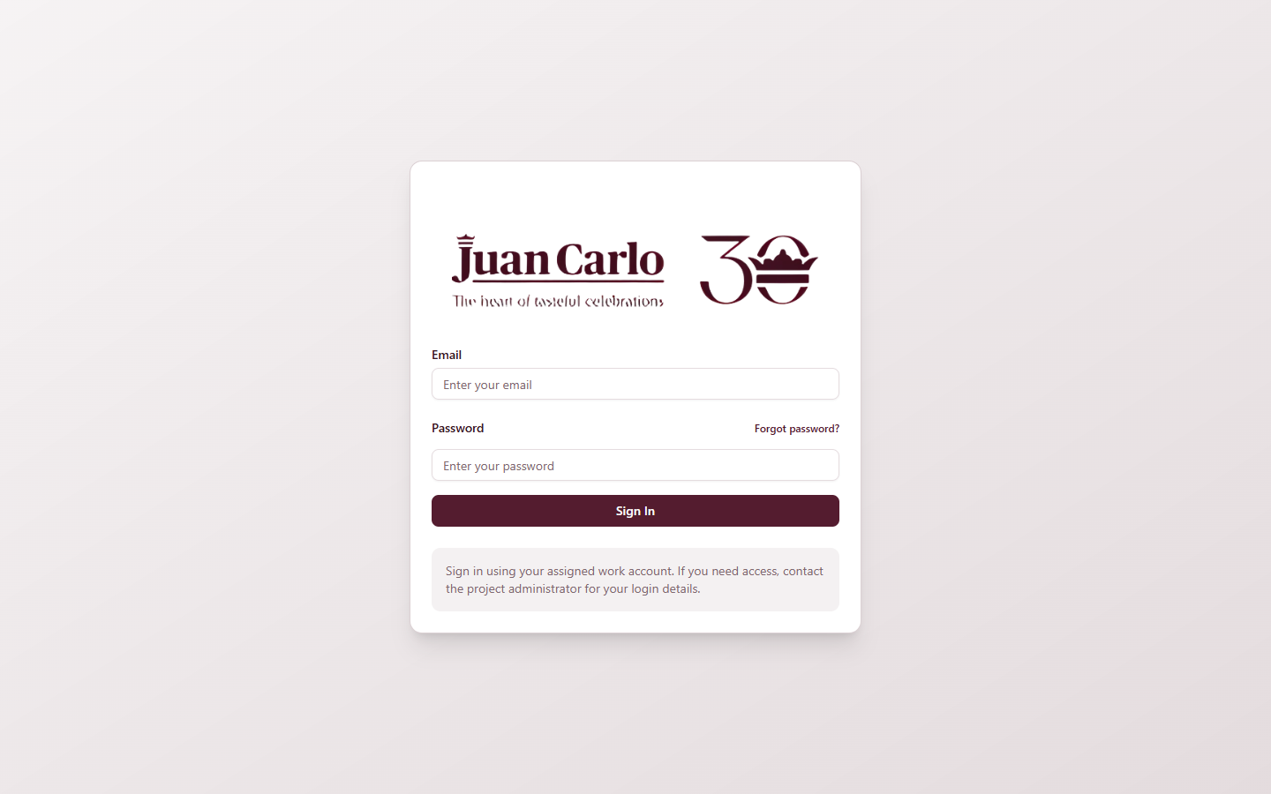
Figure 2.1.1 Login Page

2.2 User Roles and Access
The system follows role-based access control, which means that each user is given access only to the features and processes related to their assigned department. This setup helps ensure that the system remains organized and that users only perform actions within their assigned responsibilities. Table 2.1 summarizes the user roles, their departments, and their main access.
Table 2.1 User Roles, Departments, and System Access
User Role | Main Access | Limitations / Notes
Admin | Full access to all modules, records, and management functions | Highest level of access
Sales (Account Executive) | Menu tasting booking, contract creation, draft review, payment term confirmation, contract signing, booking and calendar views | Handles the main client transaction flow
Accounting | Payment recording, procurement approval, contract approval, financial review, contract closure, payment-hold release review | Focused on approval and financial processing
Creative | Creative inventory, draft contract inventory validation, pre-event preparation, post-event checking, incident reporting | Access limited to the inventory-related part of contracts
Linen | Linen inventory, draft contract inventory validation, pre-event preparation, post-event checking, incident reporting | Access limited to linen-related inventory
Stockroom | Stockroom inventory, equipment validation, pre-event preparation, post-event checking, incident reporting | Limited to stockroom and equipment inventory
Kitchen | Kitchen dashboard, menu checklist, ingredient preparation, kitchen inventory | Focused on menu and kitchen preparation
Banquet | Banquet dashboard, event and preference views, banquet staffing form, staff planning and printout | Views only banquet-related contract information
Logistics | Logistics dashboard, truck and driver assignment, dispatch and trip-ticket preparation | Focused on transport and delivery coordination
Purchasing | Purchasing dashboard, procurement requests, requisition forms, supplier database, request fulfillment | No direct access to general inventory pages

2.3 Navigating the Dashboard
After a successful login, the user is directed to the dashboard associated with their role. The dashboard serves as the main working area of the system and provides access to the modules, records, and processes needed by the user. The navigation menu on the left remains fixed on the screen, and the Notifications panel and the account menu stay visible at the lower-left corner at all times. The displayed options vary depending on the user’s role.

2.3.1 Admin Dashboard
The Admin Dashboard provides an overview of the system and access to all modules, records, and administrative functions. It shows the total number of contracts, events for the week, and approval status counts, and lists the most recent contracts with their current stage.
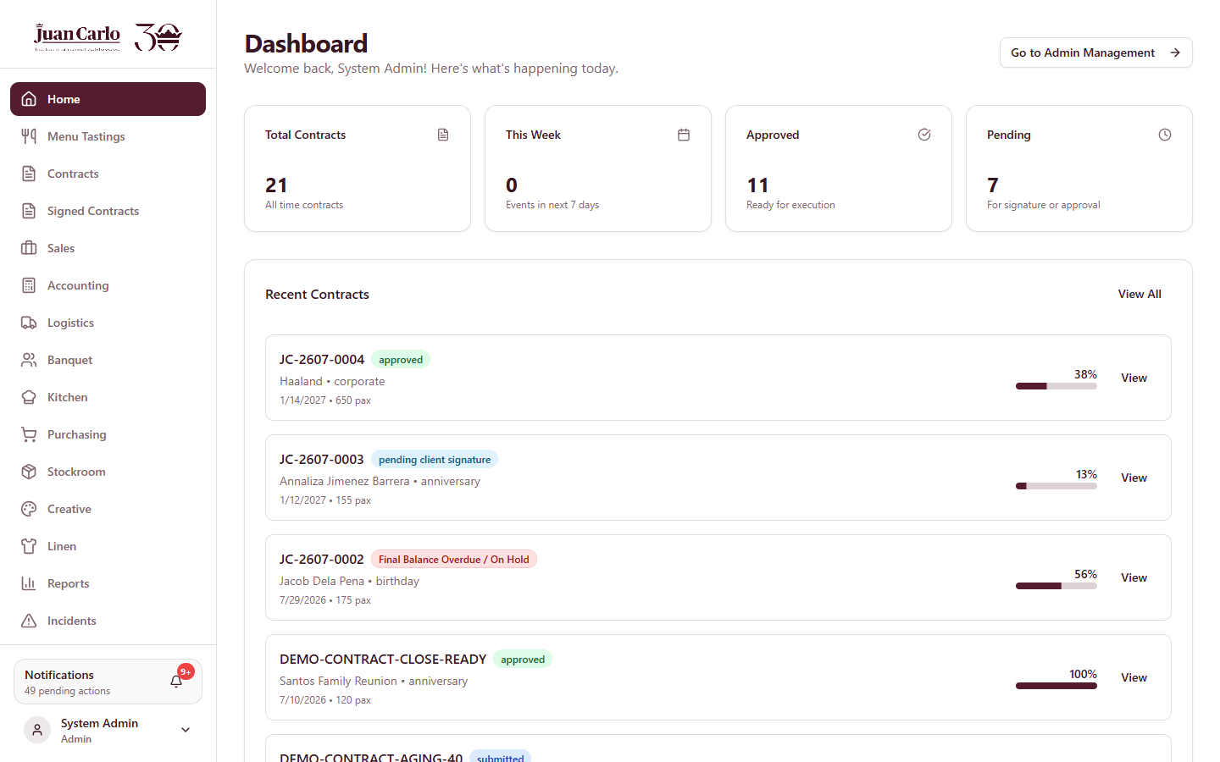
Figure 2.3.1 Admin Dashboard
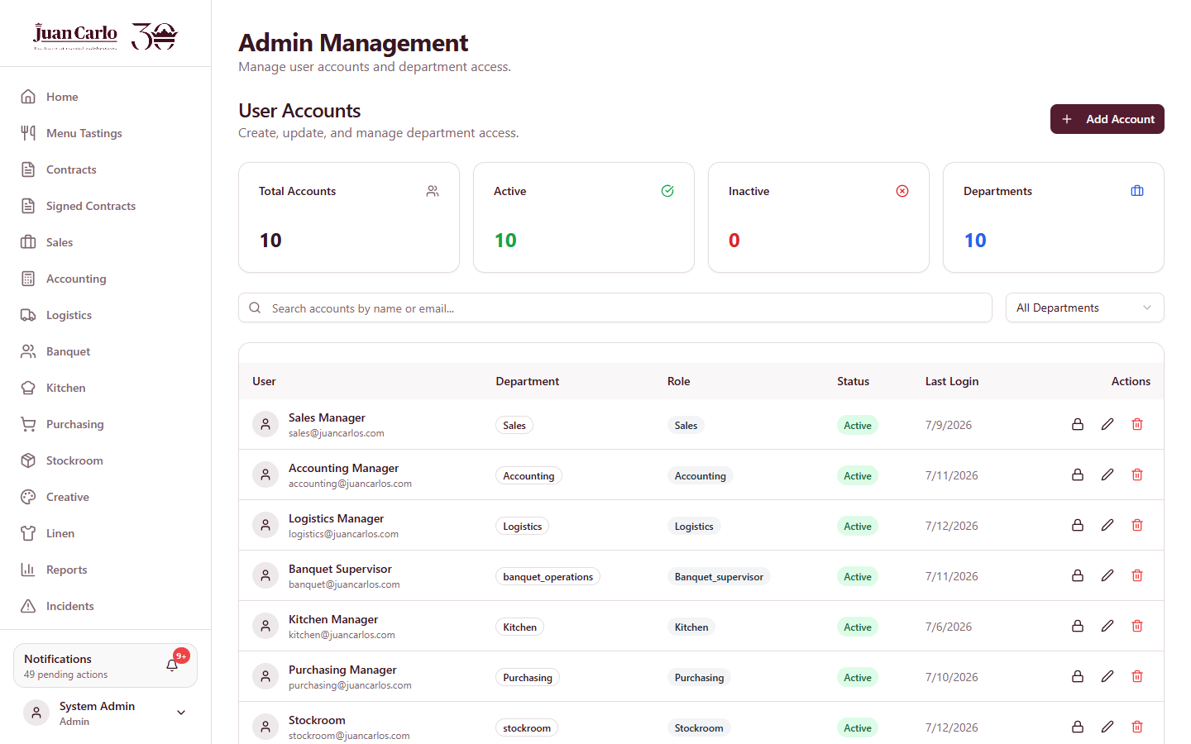
Figure 2.3.2 Admin Management (account creation and role assignment)

2.3.2 Sales Dashboard
The Sales Dashboard is used for handling client transactions such as menu tasting bookings, contract preparation, and contract monitoring. It serves as the main workspace for the early stages of the event process.
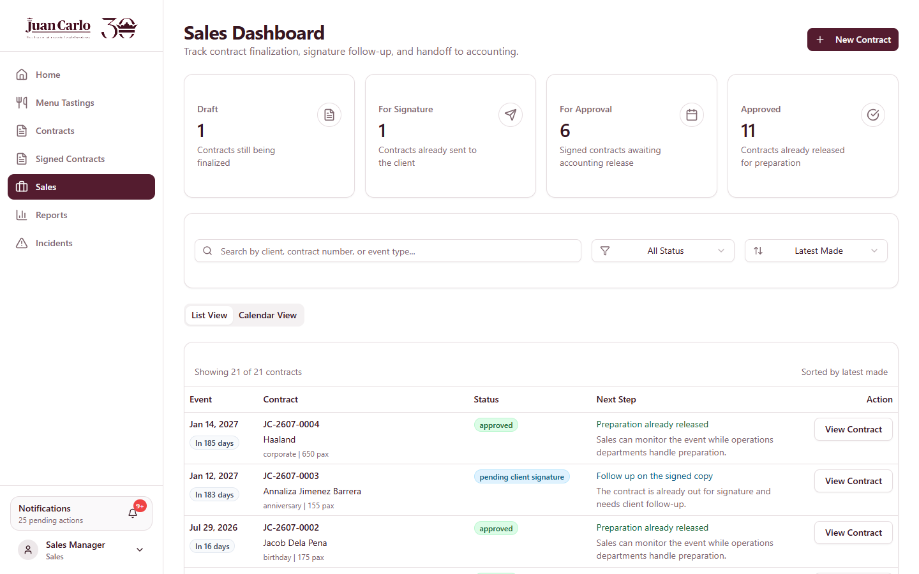
Figure 2.3.3 Sales Dashboard

2.3.3 Accounting Dashboard
The Accounting Dashboard is used for reviewing financial transactions, recording payments, and handling contract or purchasing approvals. It helps monitor transactions that require financial verification and approval.
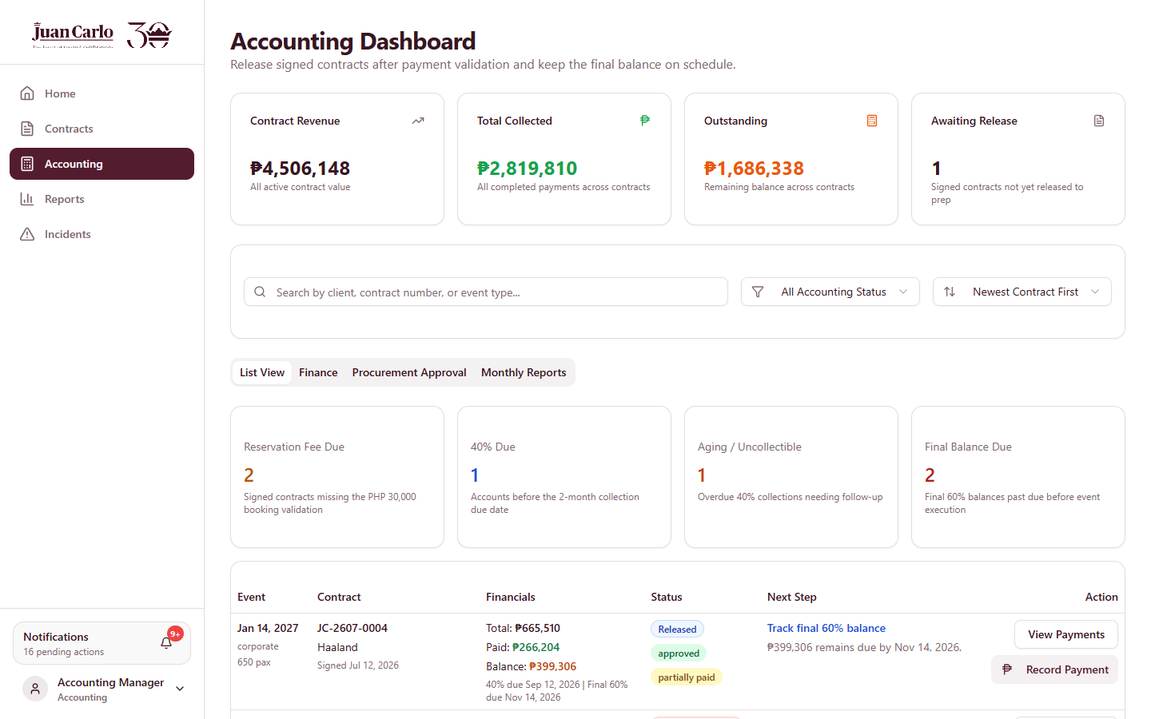
Figure 2.3.4 Accounting Dashboard

2.3.4 Creative Dashboard
The Creative Dashboard is used for validating assigned creative items in draft contracts and for tracking preparation before and after events.
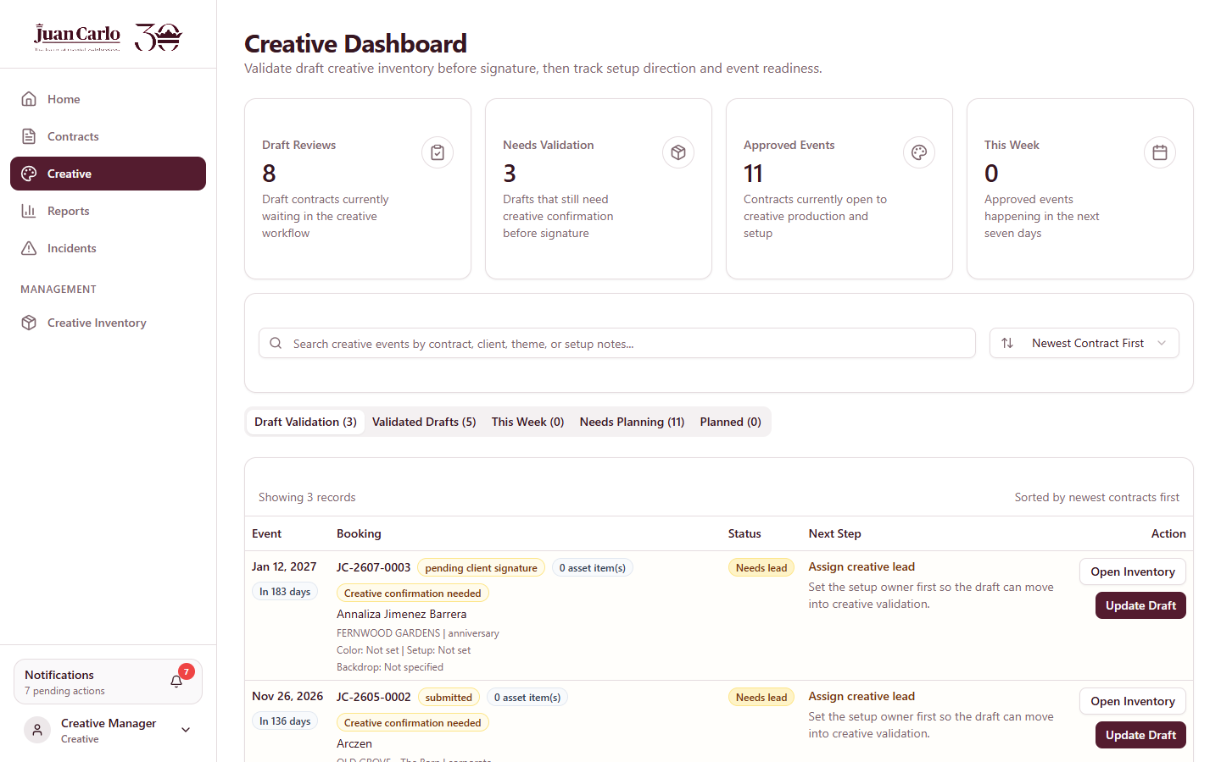
Figure 2.3.5 Creative Dashboard

2.3.5 Linen Dashboard
The Linen Dashboard is used for reviewing and managing linen-related requirements for events and for monitoring assigned items and preparation tasks.
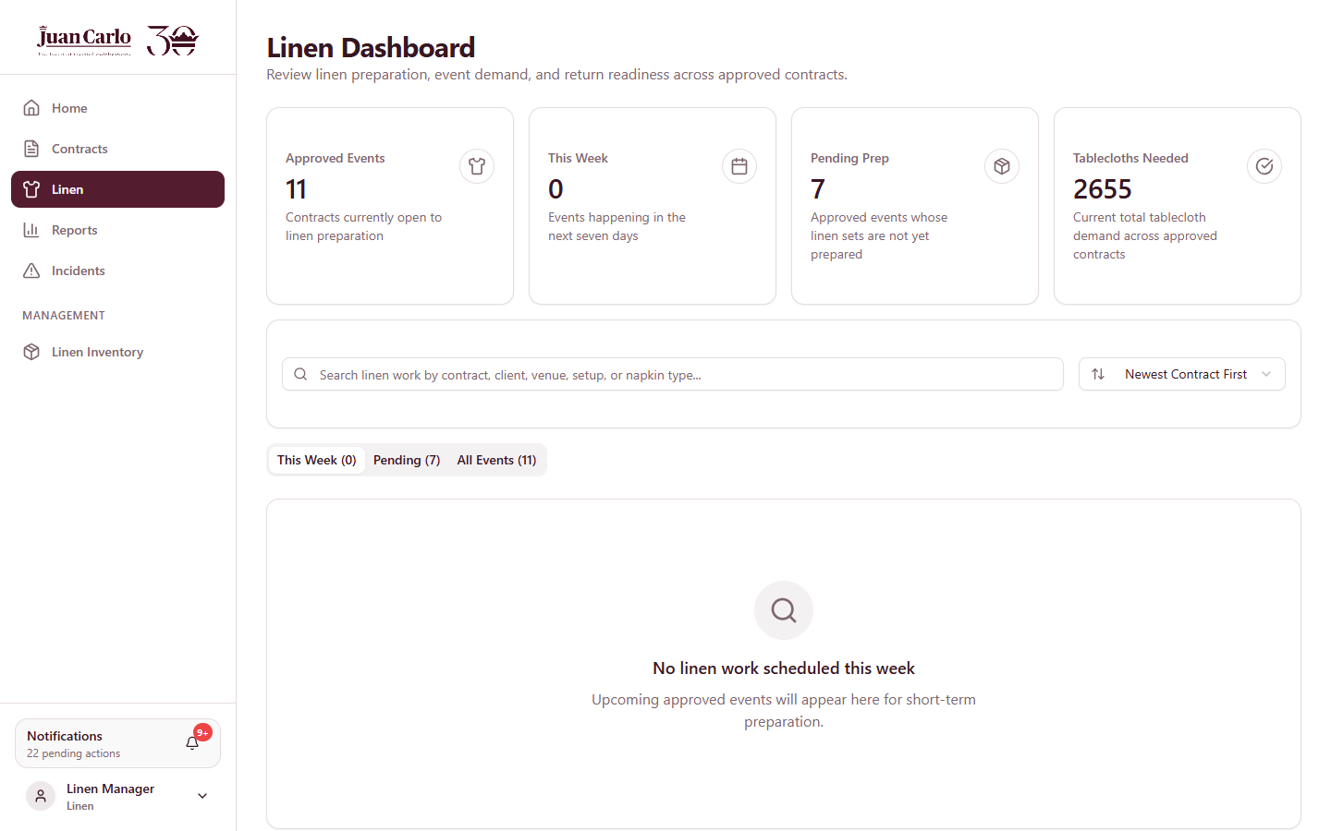
Figure 2.3.6 Linen Dashboard

2.3.6 Stockroom Dashboard
The Stockroom Dashboard is used for managing equipment and stockroom-related inventory needed for events, and for monitoring, checking, and preparing stockroom items used in contracts.
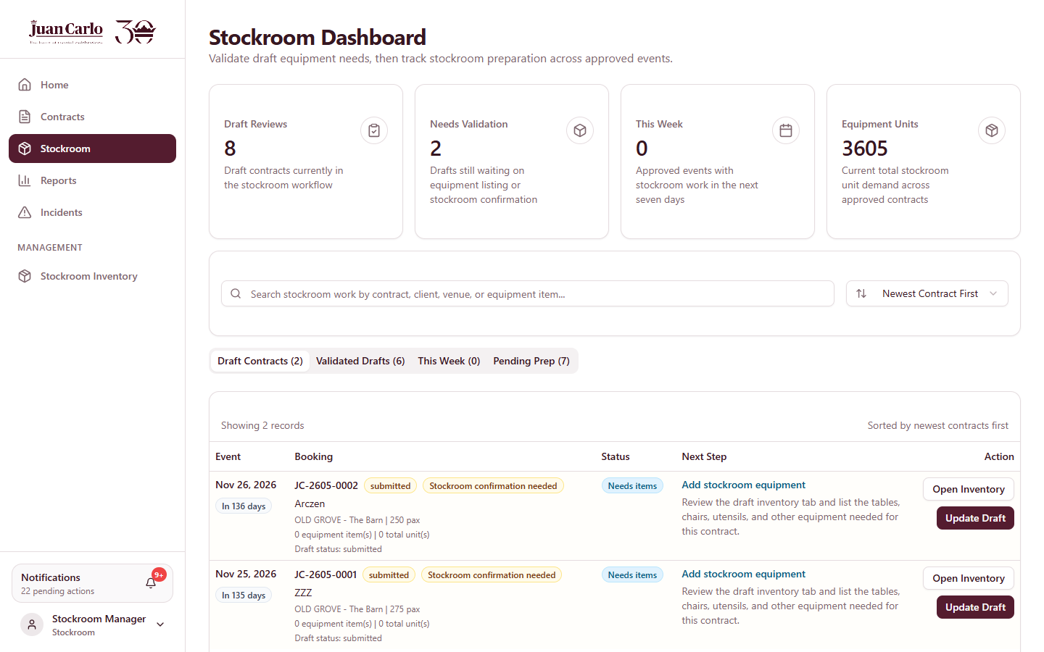
Figure 2.3.7 Stockroom Dashboard

2.3.7 Banquet Dashboard
The Banquet Dashboard is used for viewing event details and preparing banquet staffing requirements. It helps the department monitor assigned events and organize staff planning activities.
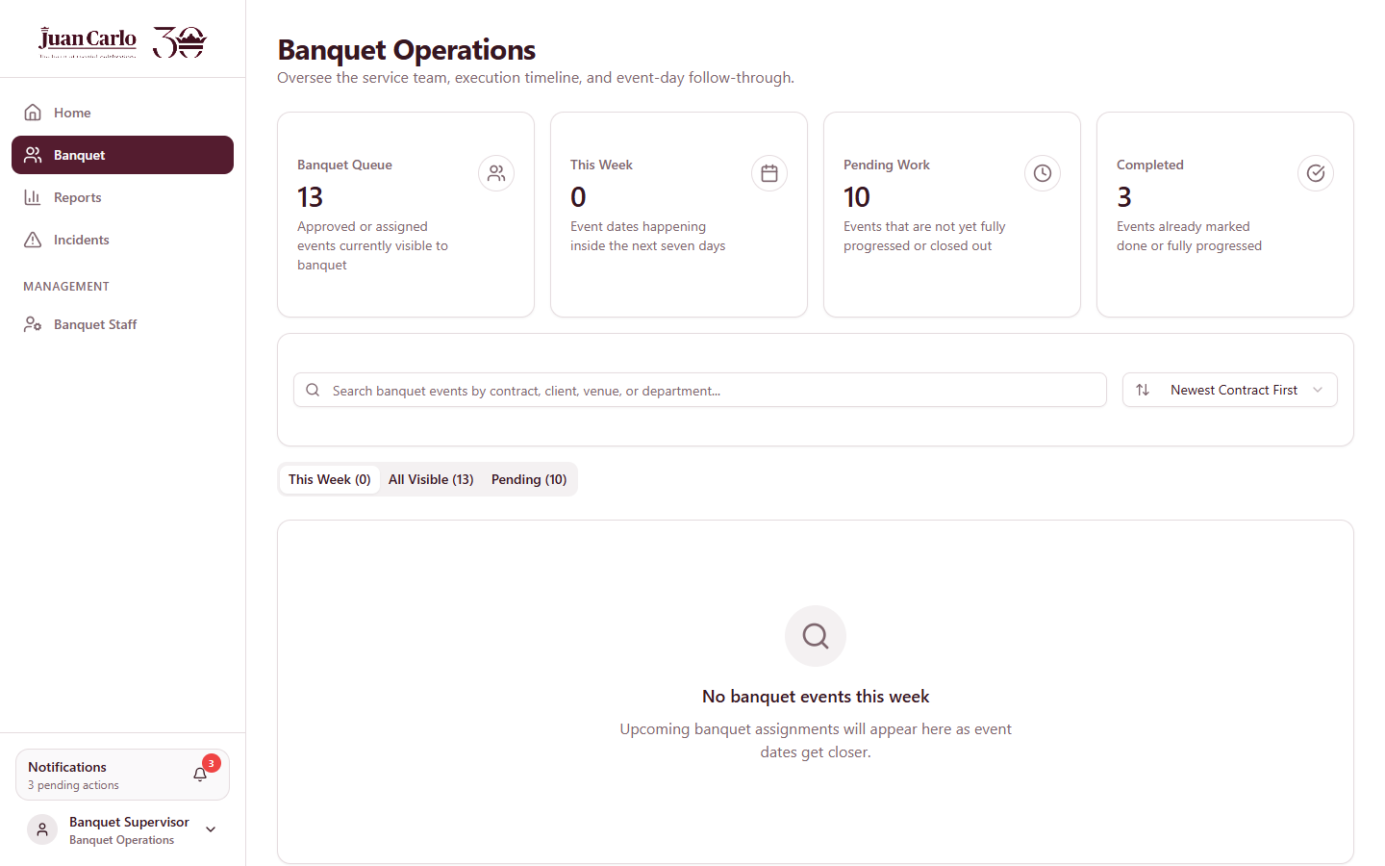
Figure 2.3.8 Banquet Dashboard

2.3.8 Kitchen Dashboard
The Kitchen Dashboard is used for monitoring menu preparation and kitchen-related tasks. It helps the department track preparation work before the event.
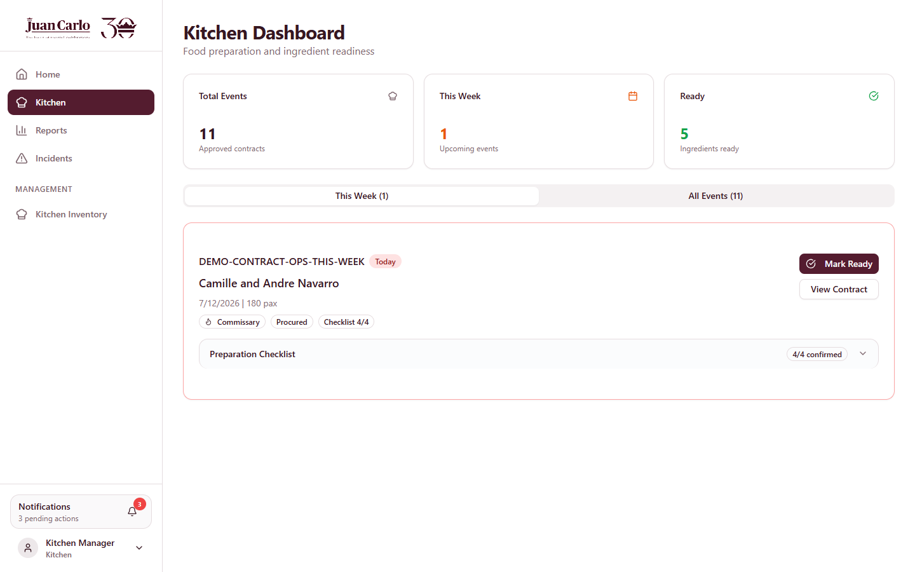
Figure 2.3.9 Kitchen Dashboard

2.3.9 Logistics Dashboard
The Logistics Dashboard is used for coordinating transportation requirements such as truck and driver assignment, and for monitoring logistics preparation and event scheduling.
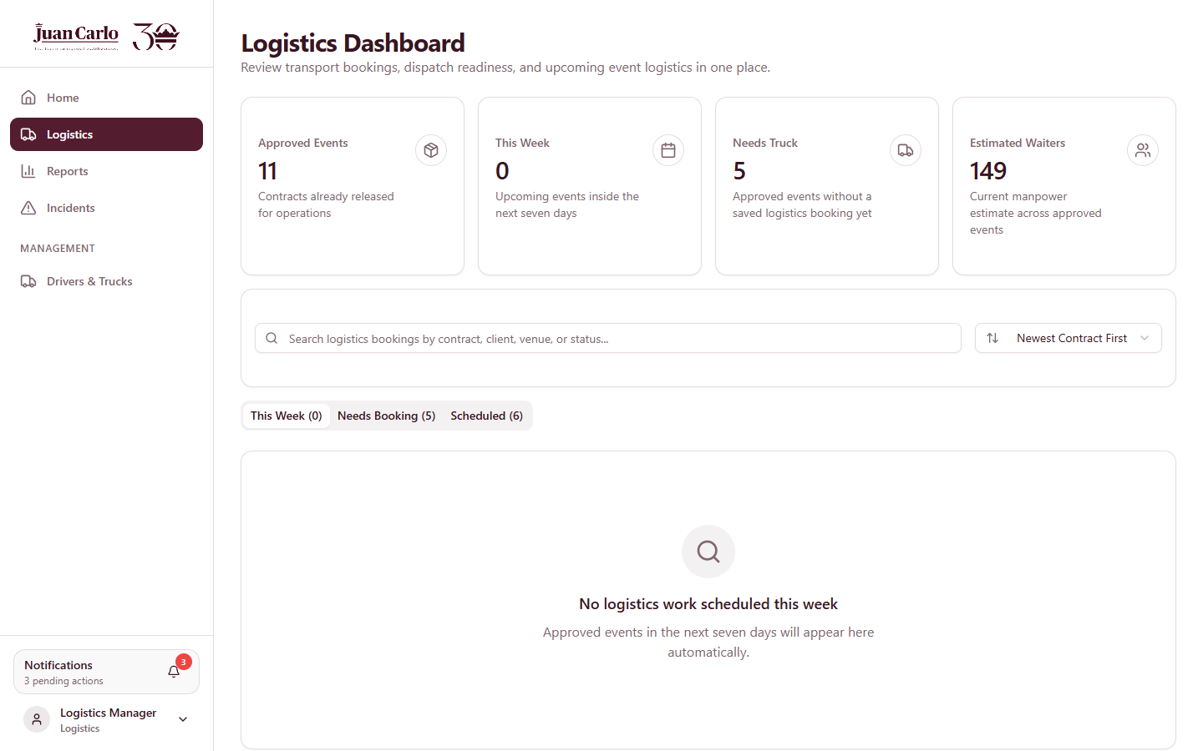
Figure 2.3.10 Logistics Dashboard

2.3.10 Purchasing Dashboard
The Purchasing Dashboard is used for managing procurement requests, supplier records, and request fulfillment. It organizes requests into process stages and supports the printing of requisition forms.
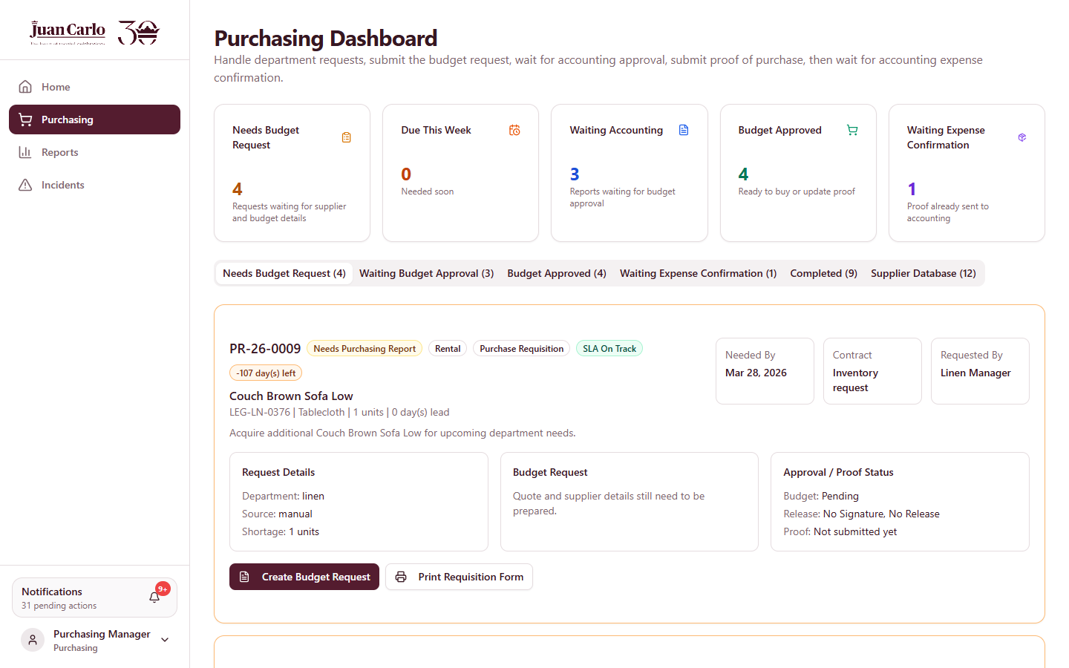
Figure 2.3.11 Purchasing Dashboard

2.4 Notifications
The system provides a Notifications panel that can be opened from the Notifications box at the lower-left corner of the navigation menu, shown in the previous dashboard figures. The box displays the number of pending actions, and opening it lists the contract actions that require attention, such as a contract ready for a department, a payment follow-up, a final-balance reminder, or a contract placed on hold. Each notification links directly to the related contract.

2.5 Logging Out
When the user has finished using the system, they may log out through the account menu located at the lower-left corner. Logging out ends the current session and returns the user to the login page. Users are encouraged to log out properly after every session, especially when using shared computers.

Chapter 3. Booking and Initial Transaction Process

3.1 Menu Tasting Booking
The Menu Tasting Booking process allows the Sales department to schedule a tasting session for the client before contract preparation. This process records the client’s initial transaction details and organizes bookings for future reference.

3.1.1 Navigate and Click Book Tasting
The staff begins by opening the Menu Tastings module from the navigation menu. From this page, the staff clicks the Book Tasting button to open the booking form.
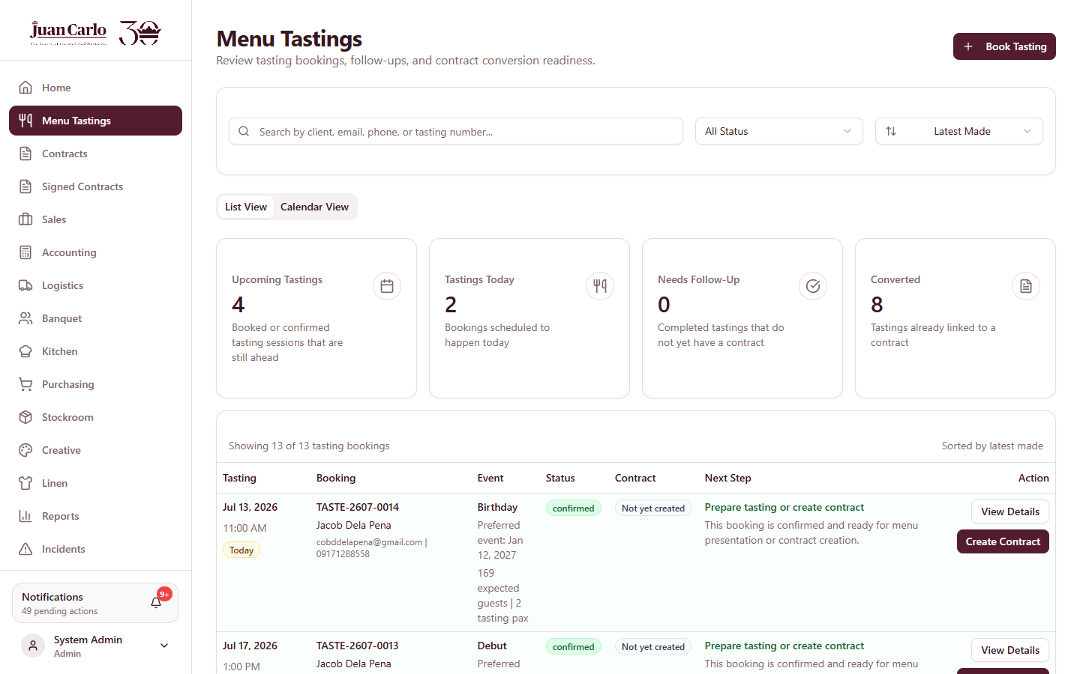
Figure 3.1.1 Menu Tastings List with the Book Tasting button

3.1.2 Fill Up the Necessary Details
After opening the booking form, the user enters the required information such as the client details, event information, expected number of guests, tasting date, tasting time, and number of tasting pax. The tasting time slots run hourly from 10:00 AM to 5:00 PM, and only one booking is allowed per slot per day. The completeness and accuracy of the entered details are important to ensure proper record creation.
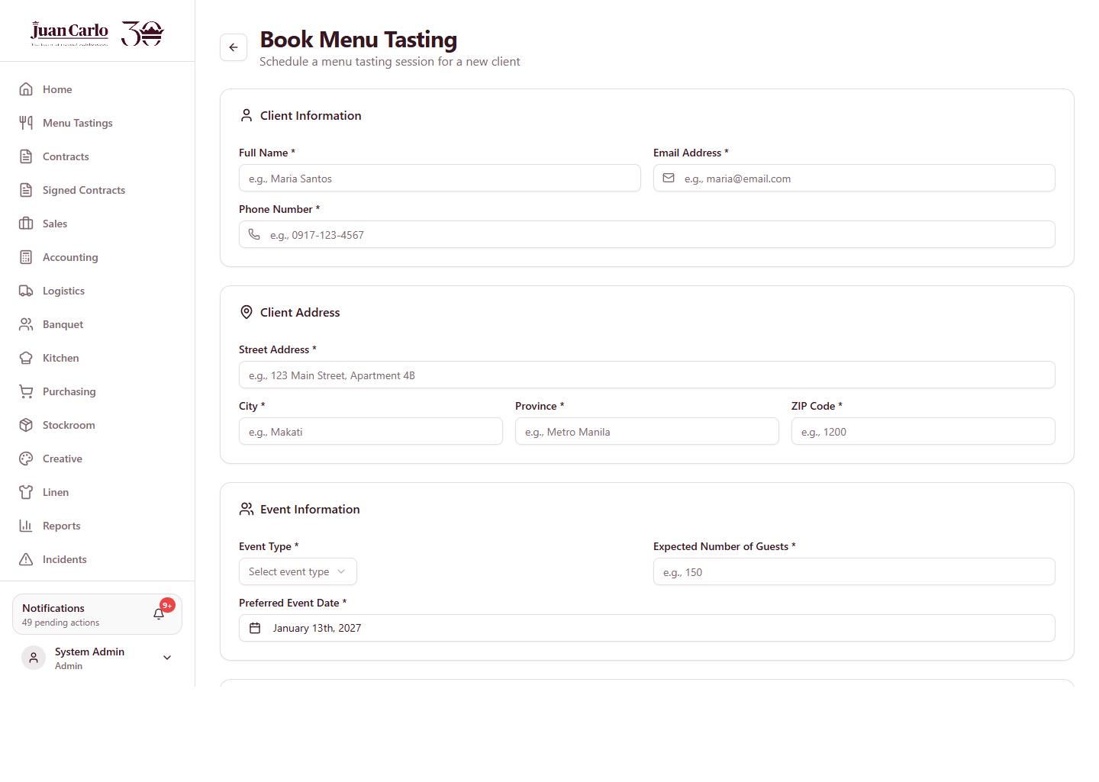
Figure 3.1.2 Book Menu Tasting Form

3.1.3 Click Book Tasting
Once all necessary details have been entered, the user clicks the Book Tasting button to save the record. The system stores the booking and adds it to the list of scheduled menu tastings with the status Booked.

3.2 Viewing and Managing Bookings
After a menu tasting booking has been created, the user may review and manage the saved booking records through the available booking views.

3.2.1 List View
The List View displays the recorded menu tasting bookings in an organized list. This view allows the user to browse booking records, review important details such as the schedule and next step, and identify scheduled transactions. From this view, the user may also click Confirm Booking to mark a booking as confirmed.

3.2.2 Calendar View
The Calendar View displays menu tasting bookings according to their scheduled dates. This view helps the user monitor bookings based on timing and manage daily or weekly booking activities.
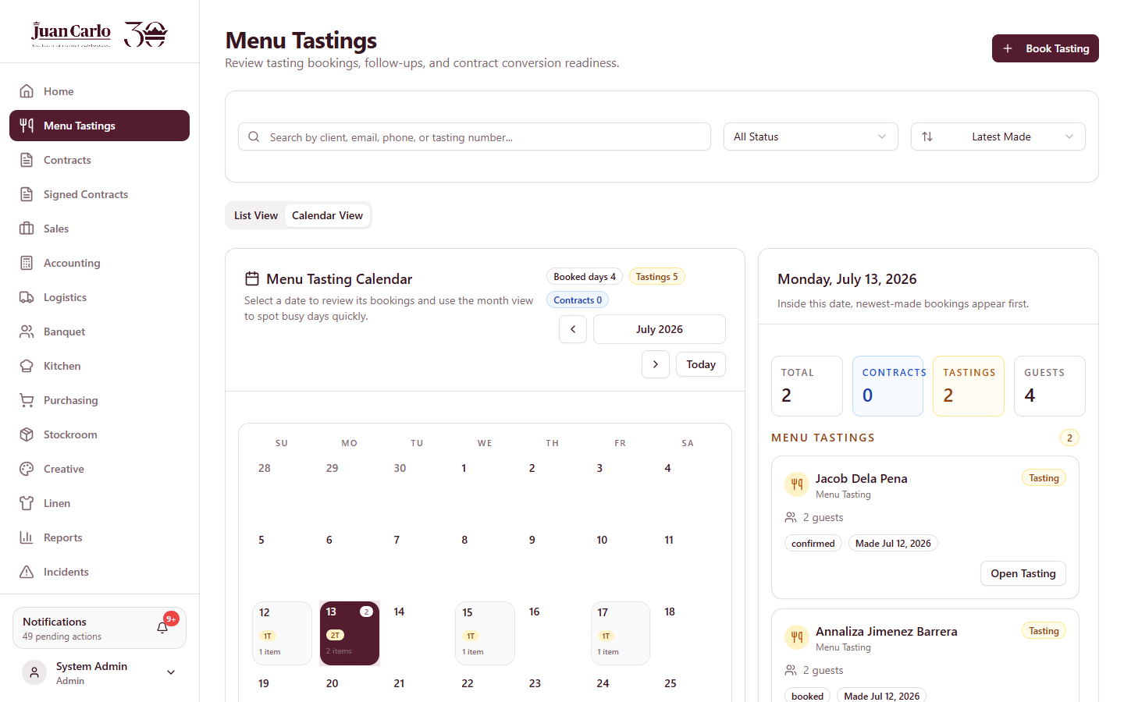
Figure 3.2.1 Menu Tastings Calendar View

3.3 Managing a Booking and Proceeding to Contract
Once the menu tasting booking has been completed and the client is ready to proceed, the booking record may be used as the basis for contract preparation.

3.3.1 View Details of Booking
Before creating a contract, the user opens the selected booking record by clicking View Details and reviews the saved information. On the booking detail page, the Sales department may also Confirm Booking, Record Feedback (which marks the tasting as Completed), Mark No-Show, or Cancel Booking, depending on the current status and the tasting date.
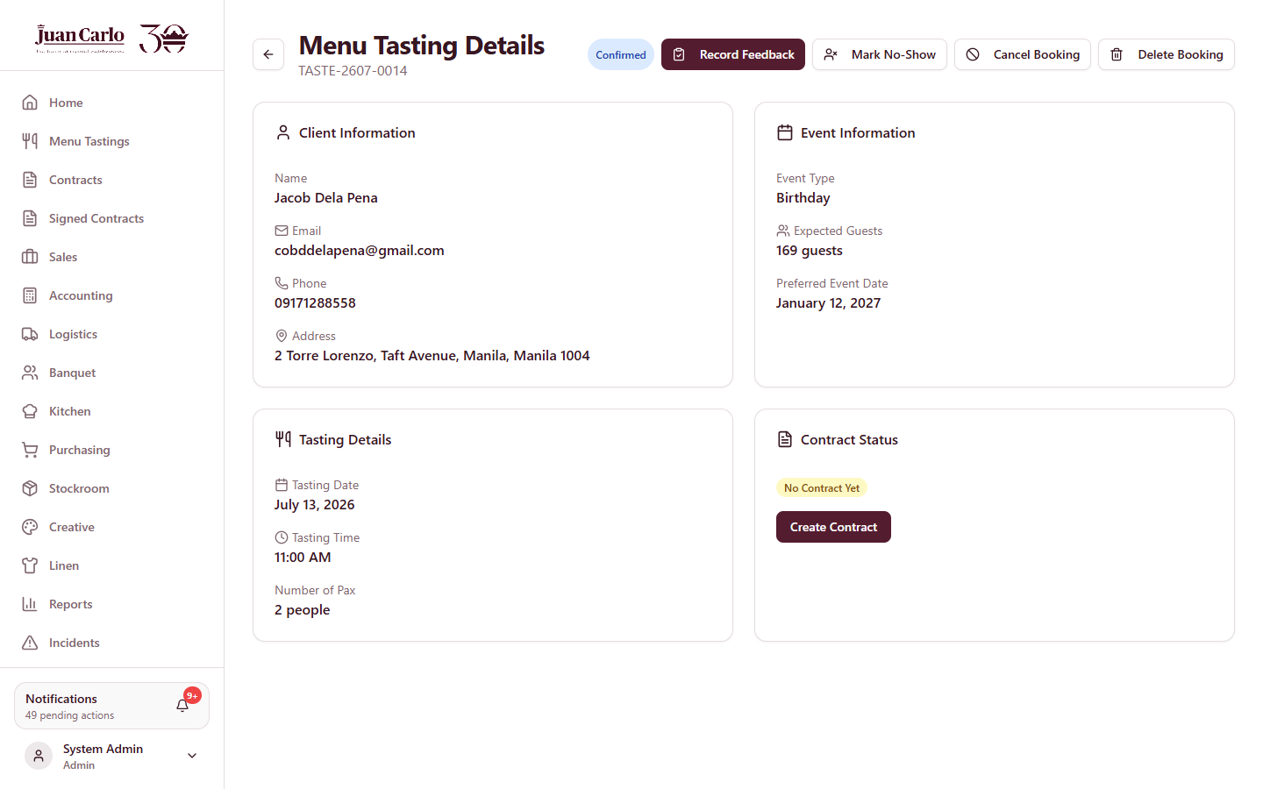
Figure 3.3.1 Menu Tasting Details with lifecycle actions

3.3.2 Click Create Contract
After reviewing the booking details, the user clicks Create Contract from the booking record. The system opens the contract preparation form, pre-filled with the saved booking information.

Chapter 4. Contract Preparation Process
The contract preparation form is organized into tabs. The user completes each tab in order and reviews the entries in the Summary tab before saving the contract as a draft.

4.1 Client Info
This tab contains the client’s basic information needed for the contract record, including the client name, contact number, email address, and complete address. The purpose of this step is to identify the client and establish the essential details required for the transaction.
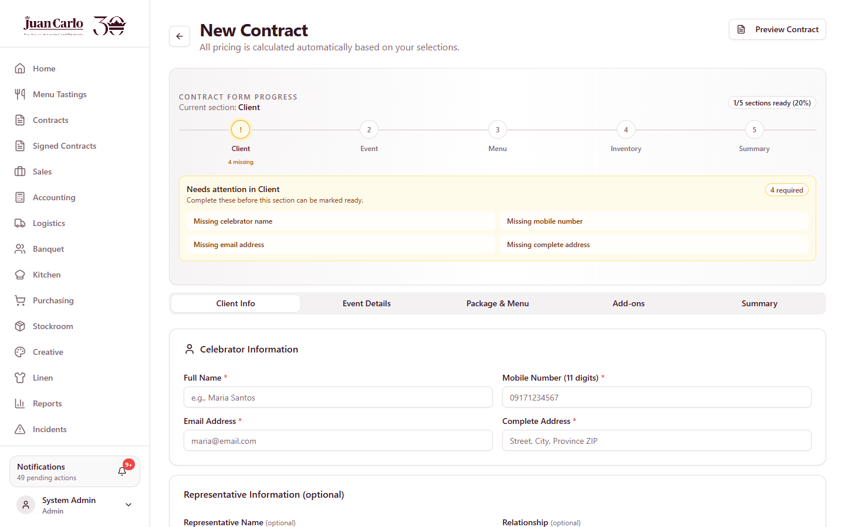
Figure 4.1.1 Contract – Client Info tab

4.2 Event Details
This tab contains the information related to the event itself, such as the event type, event date, and venue details. These details serve as the foundation for planning and coordination in the succeeding stages.
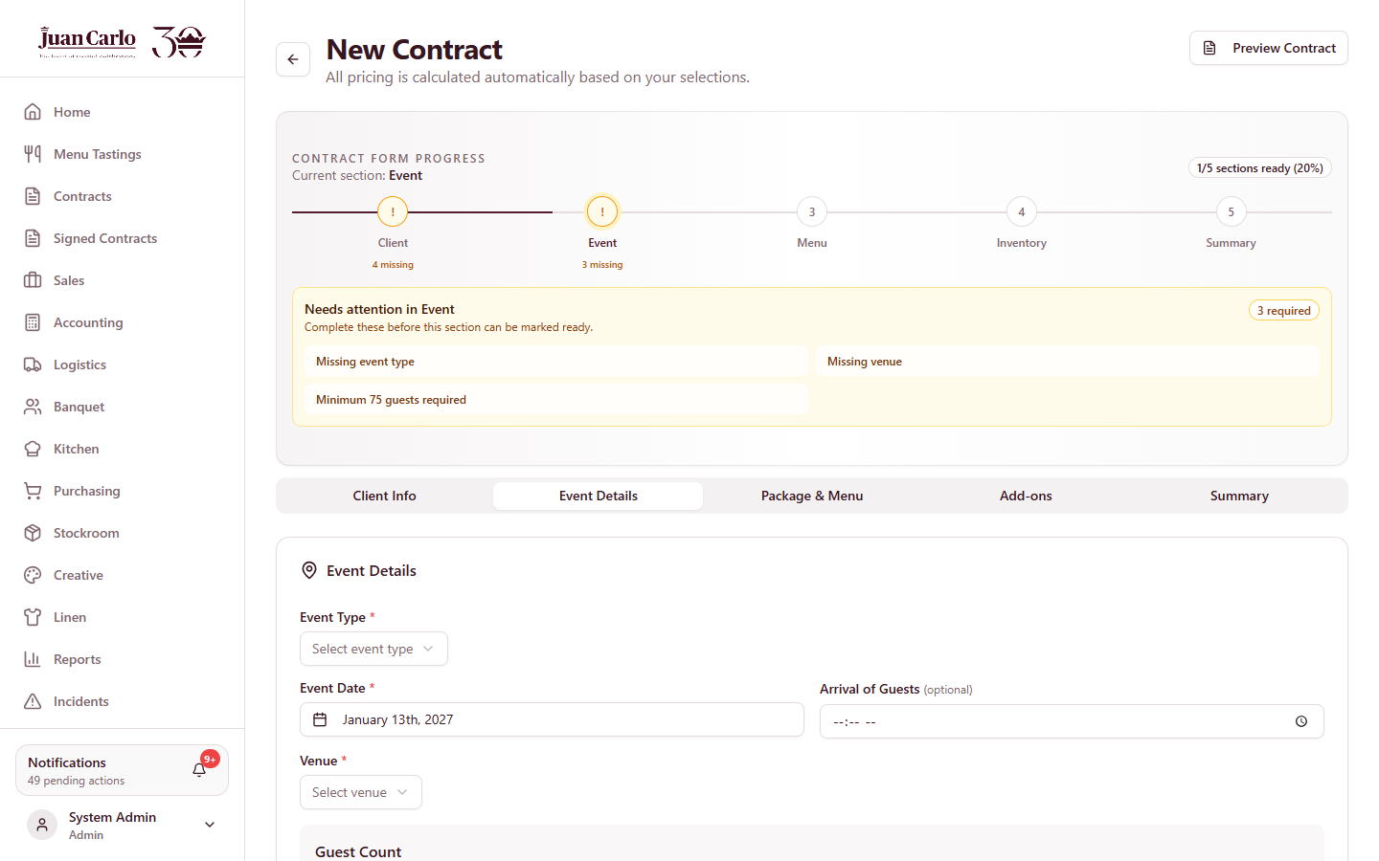
Figure 4.2.1 Contract – Event Details tab

4.3 Package and Menu
This tab allows the user to select the appropriate package and menu for the event. The number of dishes that may be selected is limited by the chosen package (for example, the Basic package allows three main dishes, two side dishes, one dessert, and one drink). This defines the service coverage of the contract and organizes the food-related requirements.
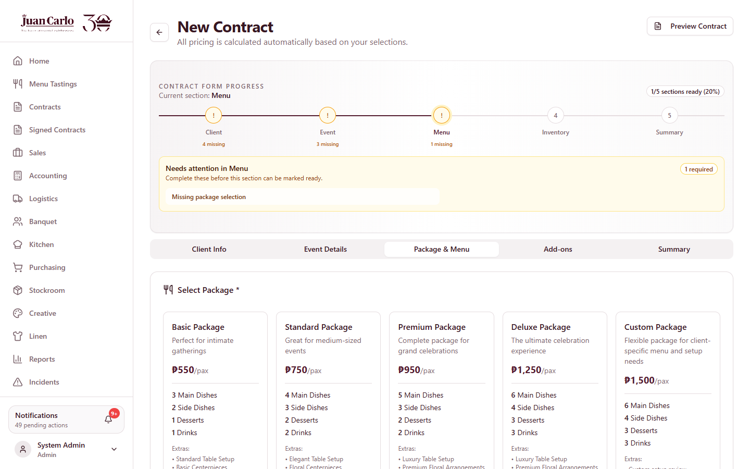
Figure 4.3.1 Contract – Package and Menu tab

4.4 Add-Ons
This tab is used to include the creative, linen, and stockroom items needed for the event. The available items are drawn from the live inventory and are checked against the event date, so quantities already reserved by another same-day event are shown as unavailable. When an item is short, the system suggests alternative items that are available on the same date.
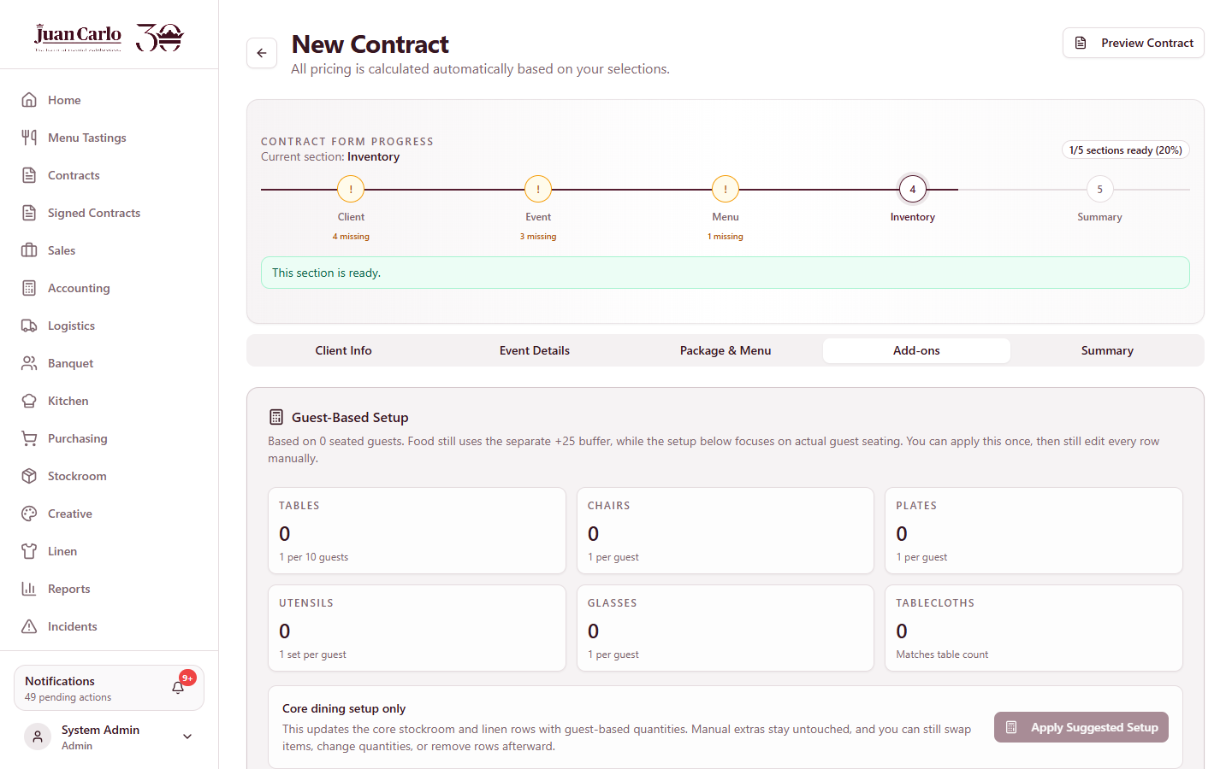
Figure 4.4.1 Contract – Add-Ons tab

4.4.1 Guest-Based Setup
The setup requirements are prepared based on the expected number of guest pax. This helps the user identify the necessary quantity of setup-related items and include them in the contract as part of the preparation process.

4.5 Summary
The Summary tab provides an overview of the details entered in the contract. It allows the user to review the client information, event details, selected package, menu, add-ons, and the financial arrangement before saving the contract as a draft and proceeding to the next stage. A PHP 30,000 reservation fee validates the booking and is counted as part of the 40% down payment.
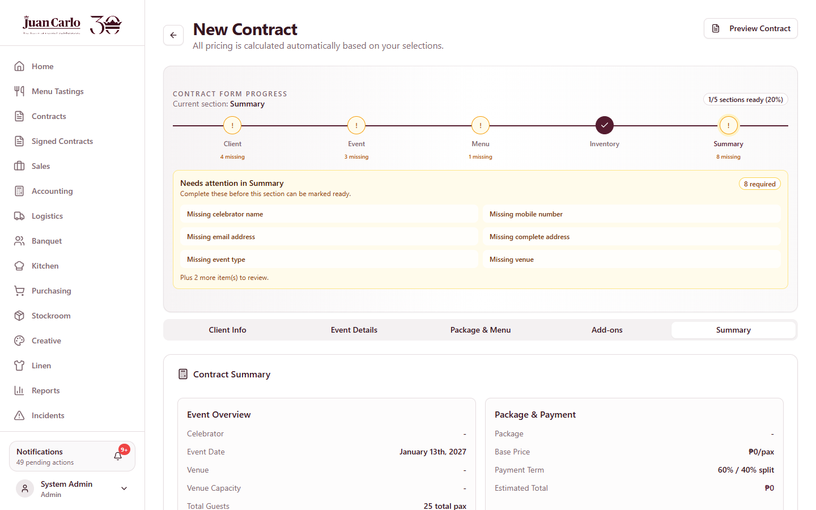
Figure 4.5.1 Contract – Summary tab

Chapter 5. Draft Review and Validation Process

5.1 Reviewing the Draft Contract
After the contract has been saved as a draft, it is reviewed to ensure that the entered information is complete and correct. This includes checking the client information, event details, package and menu selections, add-ons, and other contract details. While the contract is a draft, the status shown to each department reflects the current stage: Awaiting Department Validation, Confirm Payment Term, or Ready For Signature.
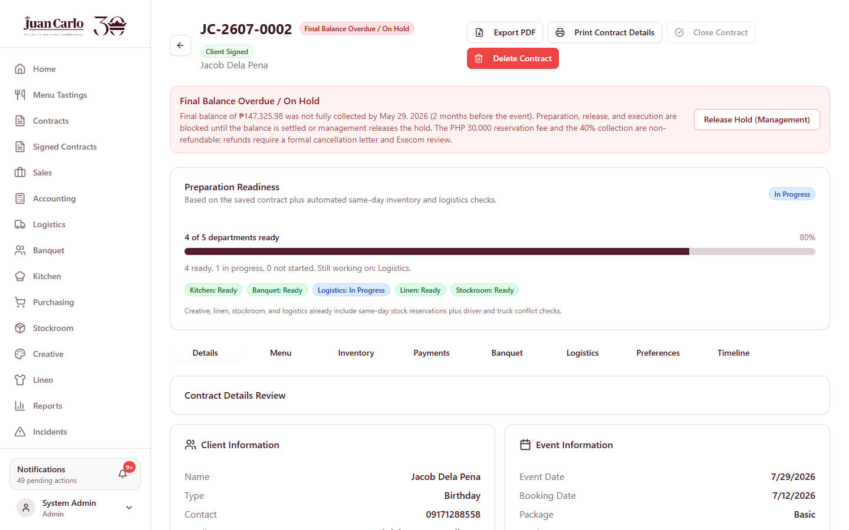
Figure 5.1.1 Contract details page

5.2 Inventory Validation by Concerned Departments
Once the draft contract is ready for review, the concerned inventory departments (Creative, Linen, and Stockroom) validate the listed items required for the event. Each department opens the Inventory tab of the contract, reviews whether the assigned items are complete and appropriate, and confirms its own section. When a department has confirmed its section, the status shown to that department changes to Validated, while the other departments still see Awaiting Department Validation. This step is important because inventory validation may affect the contract total and the readiness for final review.
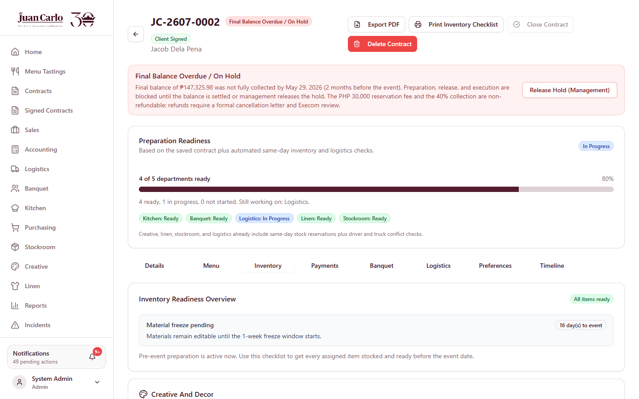
Figure 5.2.1 Contract Inventory tab used for validation and preparation

5.3 Confirm Payment Term
After the required inventory validations have been completed, the Sales department reviews the updated contract total and confirms the agreed payment term on the Payments tab. The system does not allow the payment term to be confirmed until the inventory sections have been validated, ensuring that the financial arrangement reflects the validated requirements.

5.4 Contract Signature
Once the contract details and payment term have been finalized, the Sales department clicks Send For Signature. The contract may then be signed through a printed copy or through the electronic signature option, after which the staff records that the client has signed. This forwards the contract to the Accounting department.

5.5 Print Signed Contract
After the contract has been signed, a printed copy of the signed contract may be generated for documentation and record-keeping. This provides an official reference for the completed agreement.

Chapter 6. Contract Approval

6.1 Accounting Approval
After the contract has been signed, the Accounting department reviews it for approval. This review ensures that the contract is financially and procedurally ready to proceed to the operational stage. The review is performed from the Accounting Dashboard or from the Payments tab of the contract.

6.2 Record Payment
During the approval process, the Accounting department records the client’s payment details on the Payments tab. Payments may only be recorded after the client has signed, and a payment cannot exceed the remaining balance. Each payment is recorded with the amount, method, and provisional receipt number. The first major collection is 40% of the contract value, which becomes due two months after the booking date; the remaining 60% balance must be fully collected two months before the event date. Clients are also allowed to pay the full amount early.
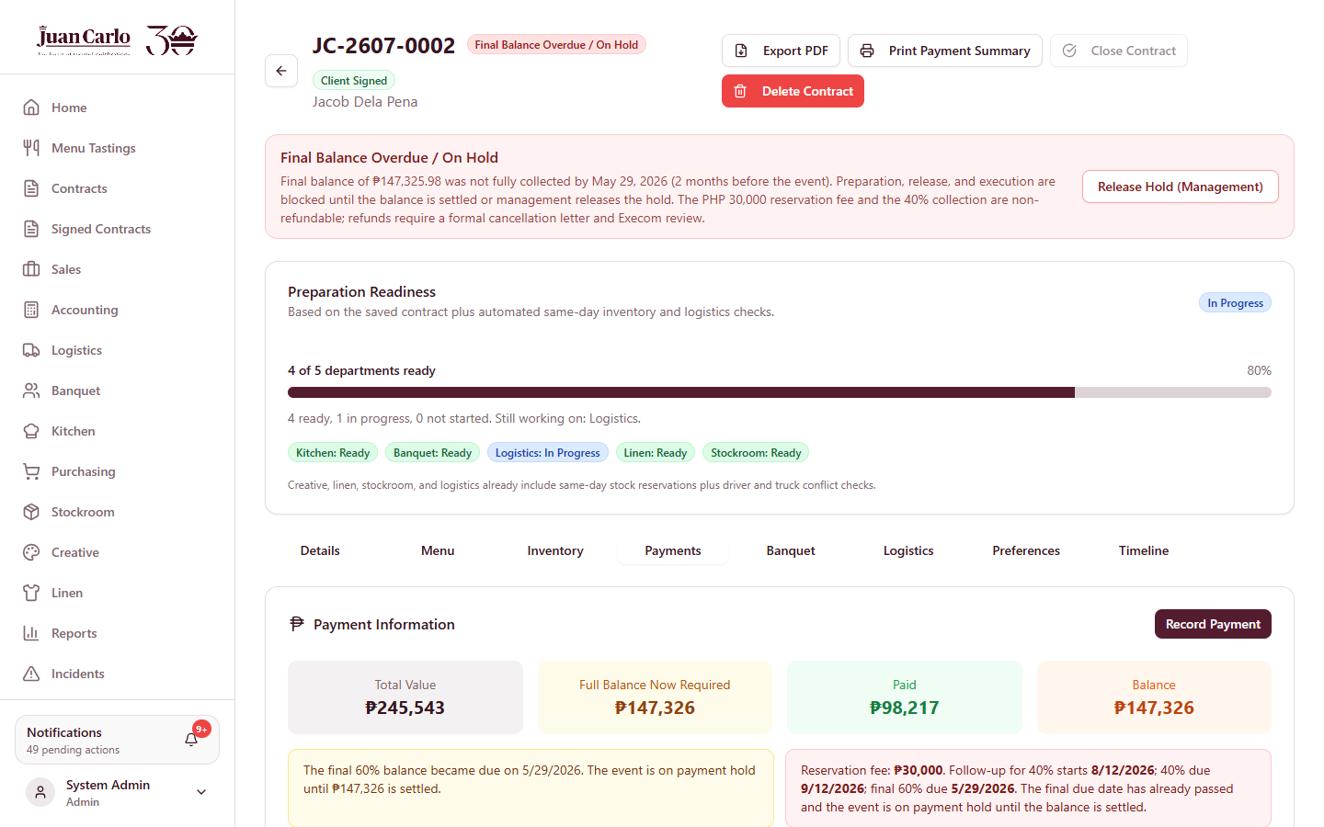
Figure 6.2.1 Contract Payments tab

6.3 Approve for Preparation
Once the contract has been reviewed and the required 40% payment has been recorded, the Accounting department clicks Approve For Preparation. Approval requires the client signature, the 40% collection, full payment if the final due date has already passed, and no uncovered inventory shortages. Approval allows the concerned departments to begin their pre-event preparation tasks.

6.4 Final Balance Overdue and Payment Hold
If the remaining 60% balance is not fully collected by its due date (two months before the event), the system automatically places the contract on hold and marks it as Final Balance Overdue / On Hold. While a contract is on hold, preparation, release, and execution actions are blocked until the balance is settled or management releases the hold. The failure to pay the final balance does not automatically refund the 40% down payment; the PHP 30,000 reservation fee remains non-refundable, and any refund is subject to a formal cancellation letter and executive review. When the balance is fully paid, the hold is lifted automatically.

Figure 6.4.1 Contract placed on Final Balance Overdue / On Hold

Chapter 7. Pre-Event Preparation Process

7.1 Reviewing Approved Contracts
Once the contract has been approved by Accounting, it is routed to the concerned departments and becomes visible on their respective dashboards for preparation tasks. The Kitchen, Banquet, Stockroom, Logistics, Creative, and Linen departments each see the approved event and may begin their assigned tasks. A week before the event, the contract also appears in the This Week tab of the relevant dashboards.

7.2 Department Preparation Activities

7.2.1 Kitchen Department
On the Kitchen Dashboard, the user expands the preparation checklist of the event and marks each dish that has been prepared by clicking the checkbox before the item. Once all items have been prepared, the user clicks Mark Ready to indicate that the kitchen tasks for the event have been completed.
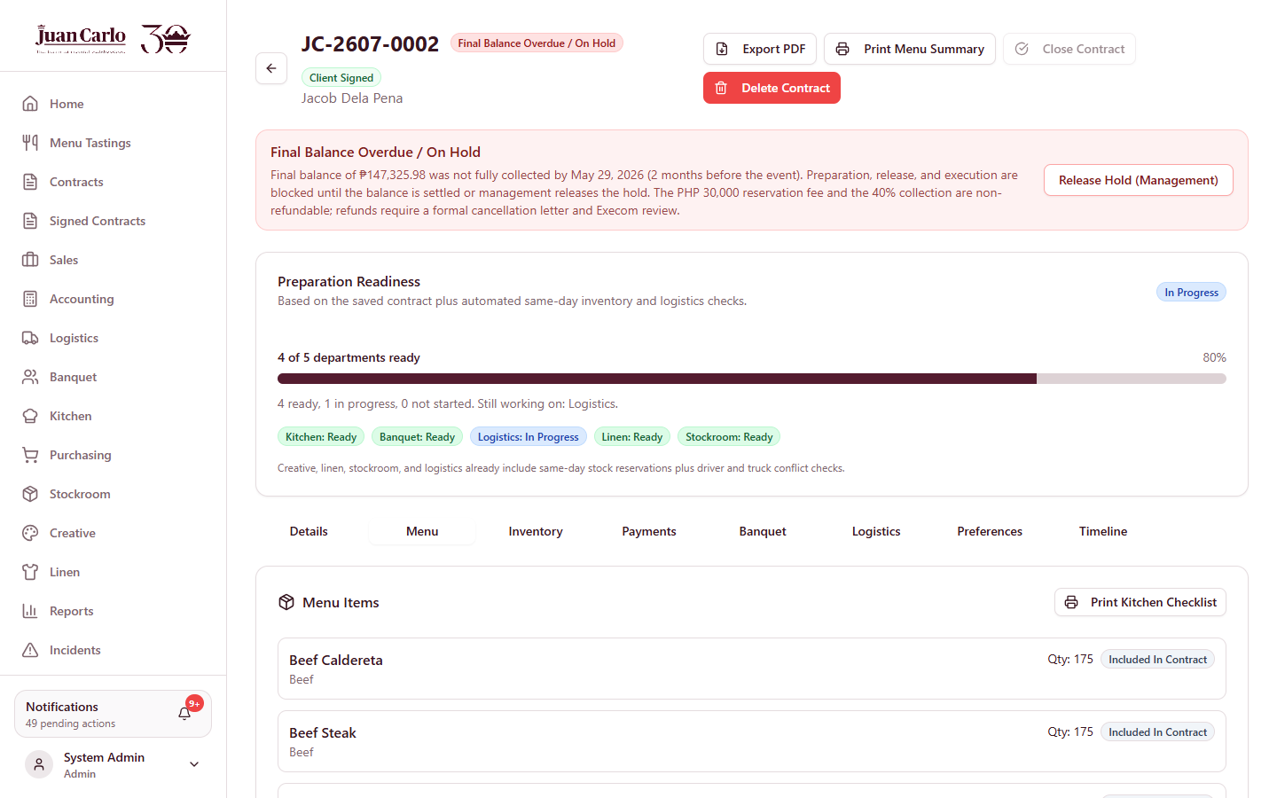
Figure 7.2.1 Contract Menu tab used for kitchen preparation

7.2.1.1 Printing the Kitchen Checklist
The user may print the kitchen checklist to keep a physical copy of the dishes to be prepared. On the contract, the user opens the Menu tab and clicks Print Kitchen Checklist. This exports the basic contract details and the menu checklist.
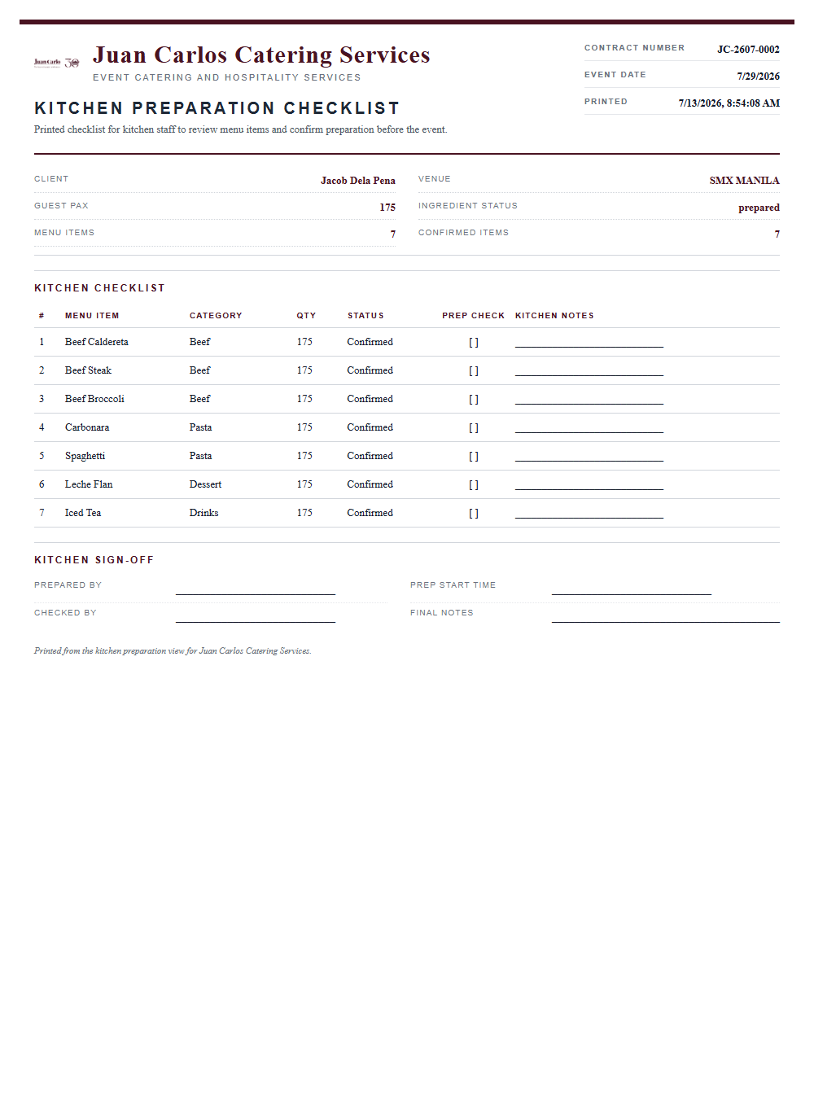
Figure 7.2.2 Printed Kitchen Checklist

7.2.2 Banquet Department
To view the banquet tasks, the user opens the contract and selects the Banquet tab. On this page, the banquet staffing form displays the event details and allows staffing for the event. The user may click Load Recommended Plan to let the system automatically assign staff who are available on the event day, or choose staff manually from the dropdown and click Add Staff. Once staffing is finalized, the user clicks Save Banquet Form.
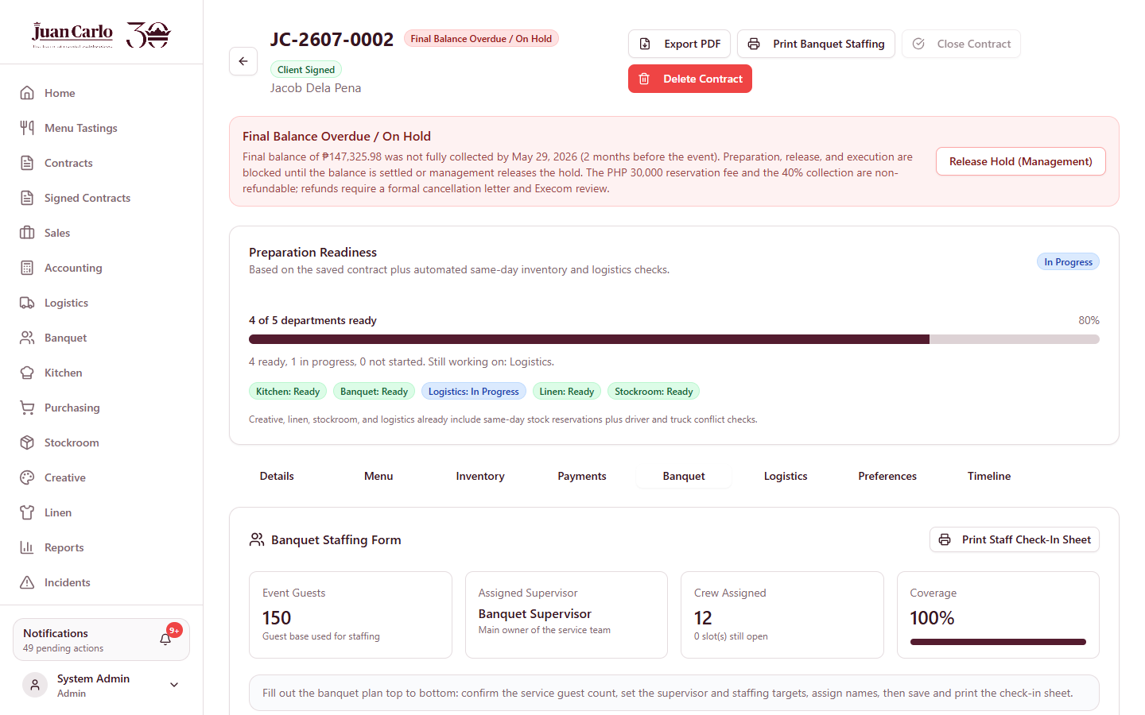
Figure 7.2.3 Contract Banquet tab (staffing form)

7.2.2.1 Printing the Banquet Staff Check-In Sheet
The user may print the staff assignment for the event. On the Banquet tab, the user clicks Print Staff Check-In Sheet. The printed sheet contains the contract details and a per-role crew table with columns for Present, Time In, Time Out, Station, and Signature, along with sign-off blocks for the BISOL (on-site supervisor) and the Account Executive.
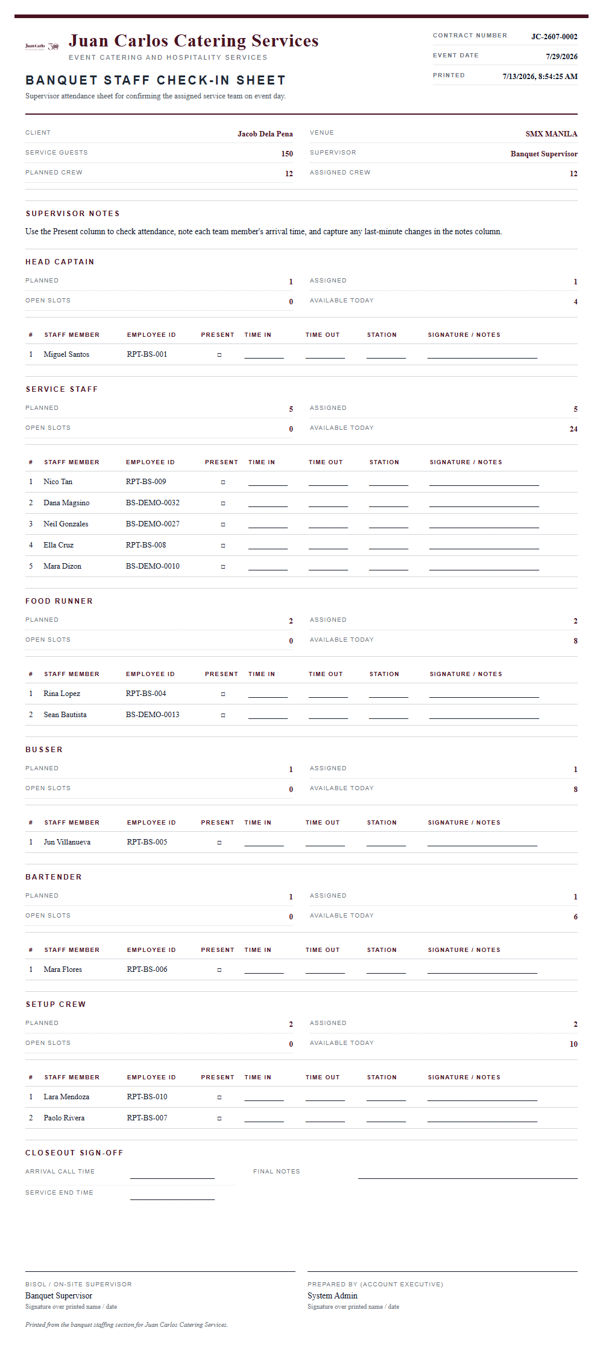
Figure 7.2.4 Printed Banquet Staff Check-In Sheet

7.2.3 Stockroom Department
To view the stockroom tasks, the user clicks View Details on the event and opens the Inventory tab. On this page, the user marks items that are confirmed to be prepared by selecting Prepared from the dropdown for each item. All items must be marked prepared for the tasks to be completed.

7.2.3.1 Printing the Pull-Out Summary
The user may print a pull-out summary of the items to be prepared by the stockroom. On the Inventory tab, the user clicks Print Pull-Out Summary, which exports the contract details and the items that need to be prepared by the department.
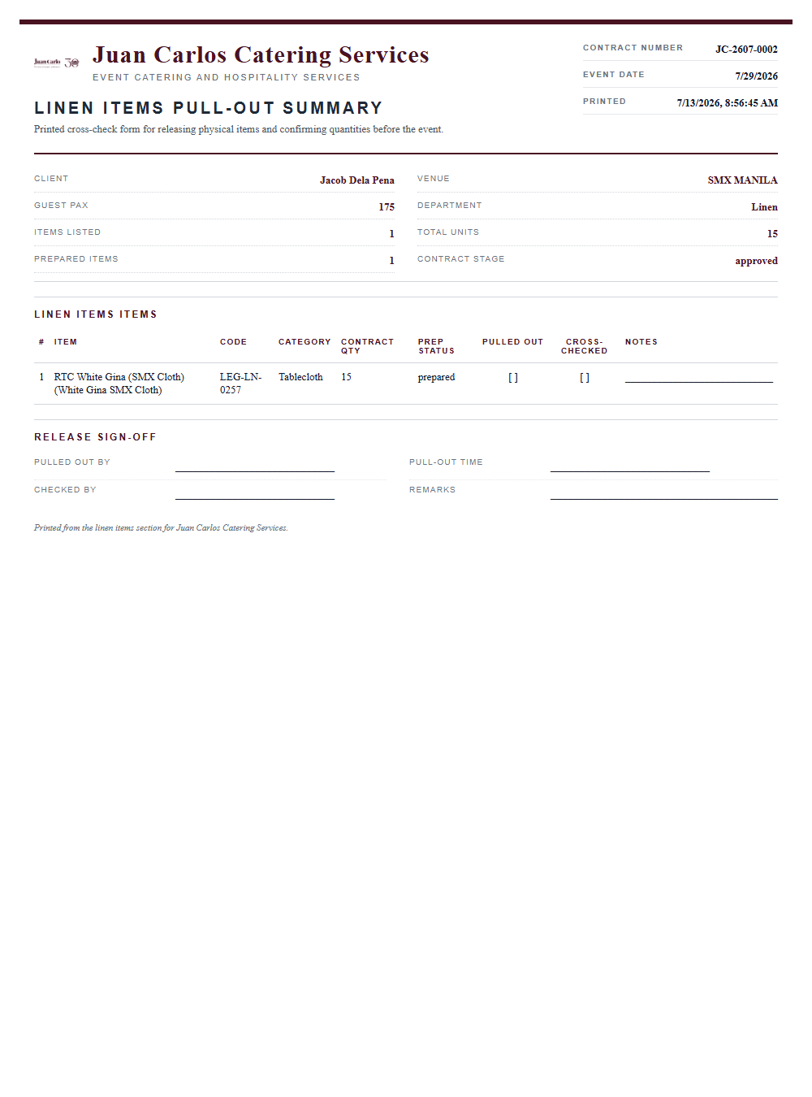
Figure 7.2.5 Printed Pull-Out Summary

7.2.4 Logistics Department
To view the logistics tasks, the user opens the contract and selects the Logistics tab, which shows the Logistics Booking Form. In this form, the user views the event date, venue, and estimated load, and assigns a truck and a driver; the driver details are taken automatically from the database. When the booking is ready, the user may advance the booking status through to dispatched.
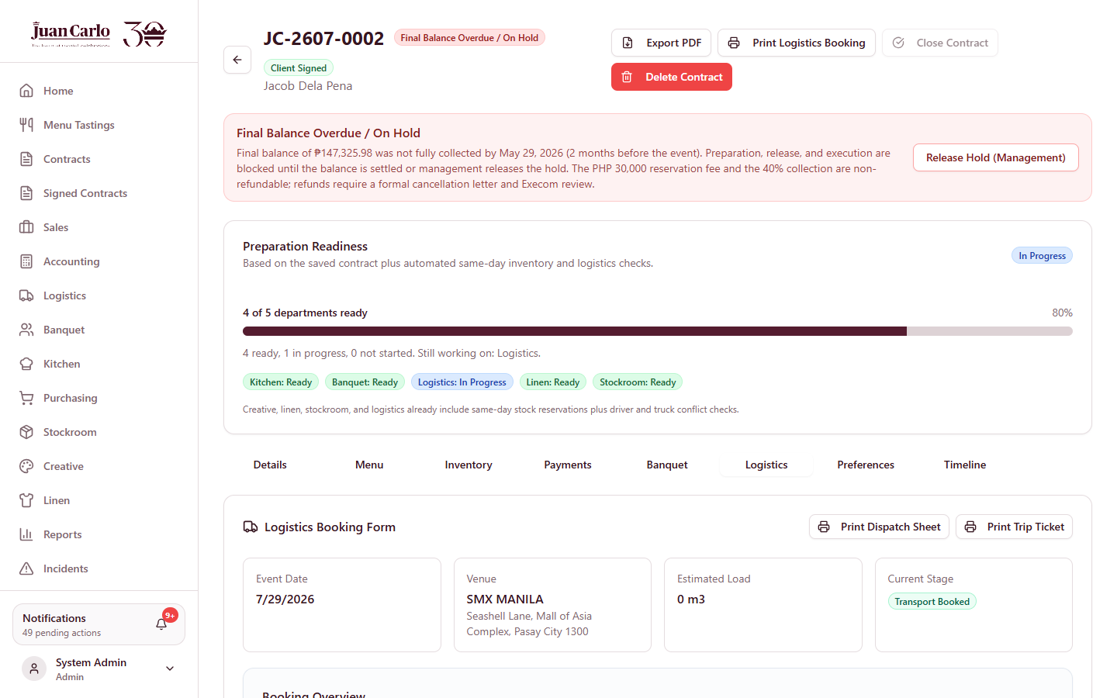
Figure 7.2.6 Contract Logistics tab (booking form)

7.2.4.1 Printing the Trip Ticket and Dispatch Sheet
The Logistics tab provides two printed forms. Print Dispatch Sheet produces a transport and dispatch checklist. Print Trip Ticket produces a complete loading and post-event count sheet that includes the fleet and crew assignment, the standard fleet guideline, the loading date (the day before the event), a full equipment manifest with columns for Loaded, Returned (BISOL count), Warehouse Second Count, and Variance, a missing-and-damaged summary, and sign-off blocks for the driver, BISOL, warehouse checker, and logistics officer.
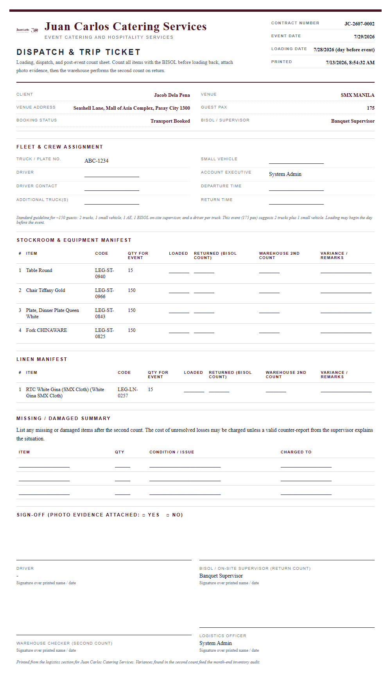
Figure 7.2.7 Printed Dispatch and Trip Ticket

7.2.5 Creative Department
To view the creative tasks, the user clicks Open Inventory on the event, which opens the preparation form. In this page, the user marks items that are confirmed to be prepared by selecting Prepared from the dropdown for each item. All items must be marked prepared for the tasks to be completed. The user may also print a pull-out summary of the items to be prepared by the creative department.

7.2.6 Linen Department
To view the linen tasks, the user clicks Open Inventory on the event, which opens the preparation form. On this page, the user marks items that are confirmed to be prepared by selecting Prepared from the dropdown for each item. The user may also print a pull-out summary of the items to be prepared by the linen department.

7.3 Monitoring Overall Progress Before the Event
To view the preparation readiness for an event, the user clicks View Details on the contract. The Preparation Readiness section displays the percentage of completion of the pre-event tasks and shows which departments have completed their tasks and which have not, allowing the user to easily identify which areas need attention.

Chapter 8. Purchasing and Shortage Handling Process

8.1 Identifying Item Shortages
Item shortages are identified on the Inventory pages, which categorize items by their current status such as Available, In Laundry, or Low Stock. The Low Stock indicator highlights items that need to be replenished. In addition, a shortage alert appears on a contract when multiple contracts require the same item on the same date, consuming most or all of the available stock, which necessitates a purchase or rental.

8.2 Requesting Purchase or Rental
When an item on a contract is short, the concerned department (Creative, Linen, or Stockroom) opens the Inventory tab of the contract and clicks Request Purchasing Or Rental on the item. A pop-up window appears where the user enters the required details, including the request type, quantity needed, date needed, reason, and any additional notes. Once the form is complete, the user clicks Send To Purchasing, which submits the request to the Purchasing department for processing.

8.3 Preparing Purchasing Reports
To process a request, the user opens the Purchasing Dashboard. This dashboard organizes requests into process stages: Needs Budget Request, Waiting Budget Approval, Budget Approved, Waiting Expense Confirmation, and Completed. Under the Needs Budget Request tab, the user reviews the request and completes the budget request by selecting a supplier, setting an expected fulfillment date, and entering the unit price and any notes. The user then submits the budget request to Accounting for approval.

Figure 8.3.1 Purchasing Dashboard queues and request card

8.3.1 Printing the Requisition Form
Each request card provides a Print Requisition Form button. Depending on the request, this produces the Item Requisition Form (for stockable items, requiring the seven-day lead time), the Purchase Requisition Form (for items bought or rented from suppliers, also requiring the seven-day lead time), or the Emergency Requisition Form (used only when the standard lead time has already lapsed, requiring approval from the Material Control Manager). The printed form contains the requested item, supplier quotation and budget, the lead-time note, the cash-versus-purchase-order option, and the full approval-signature chain, following the rule of “no signature, no request, no release.”

8.4 Approval and Fulfillment of Requests
The approval process begins in the Accounting Dashboard, where the user opens the Procurement Approval section to review budget requests for purchases or rentals. After checking the details, the user may approve the request or return it to Purchasing; a checklist guides the review. Once the budget is approved, the Purchasing department acquires the requested items and then opens the Budget Approved tab and clicks Submit Proof Of Purchase. The user enters the invoice, official receipt, or rental reference number, attaches an image of the receipt, and submits the proof to Accounting for a final review before the request is marked as completed.

Figure 8.4.1 Accounting review of procurement requests

8.5 Updating Inventory After Fulfillment
After the Purchasing department has acquired the items and the proof of purchase has been confirmed by Accounting, the inventory records are updated based on the number of items acquired.

Chapter 9. Post-Event Process

9.1 Conducting Post-Event Checking
After the event date has passed, the concerned departments review the items used during the event. On the Inventory tab of the contract, each item is initially labeled with a Pending Post-Event Check status, indicating that verification is still required. This allows the departments to see which items still need to be checked.

9.2 Verifying Returned or Used Items
The user checks whether all items have been returned. If the items are complete, the user selects Checked and Returned from the dropdown. If items are missing or damaged, the user clicks Report Incident and proceeds to incident reporting to document what happened before completing the event process.

9.3 Updating Post-Event Status
On the Logistics tab of the contract, the user clicks Mark Completed to confirm that all items, materials, and trucks have been returned. This confirms that everything has been accounted for before the contract is closed.

9.4 Closing Event-Related Tasks
When everything is complete, the Accounting department clicks Close Contract to finalize the transaction. Closing is allowed only when the event date has passed, the balance is fully paid, the logistics booking is marked completed, and no post-event checks remain pending. Once closed, the contract is recorded as completed.

Chapter 10. Inventory Management Process
The Creative, Linen, and Stockroom departments maintain their own inventory records. The following procedures apply to each department through its respective inventory page.

10.1 Viewing Inventory Records
- To view the inventory records, click the inventory button for the department (Creative Inventory, Linen Inventory, or Stockroom Inventory) in the navigation menu.
- After clicking the button, the page displays the inventory records for that department, including the stock quantity and status of each item.
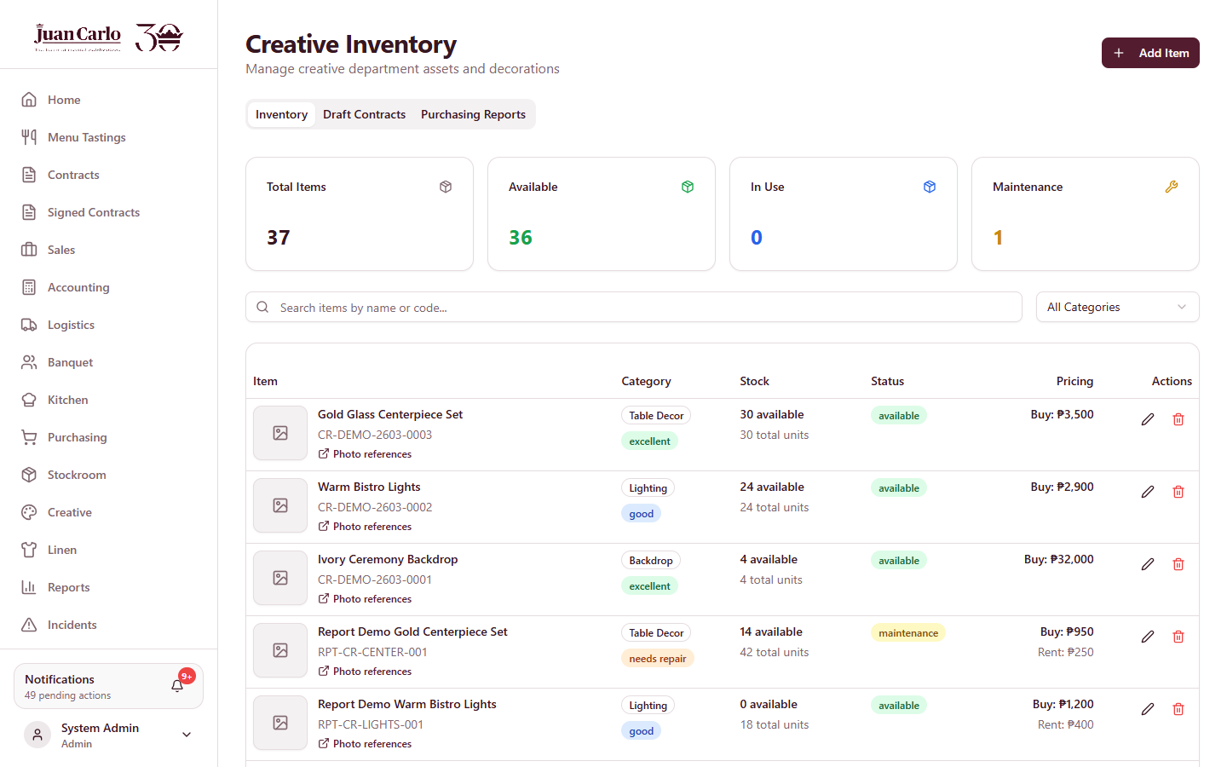
Figure 10.1.1 Creative Inventory page
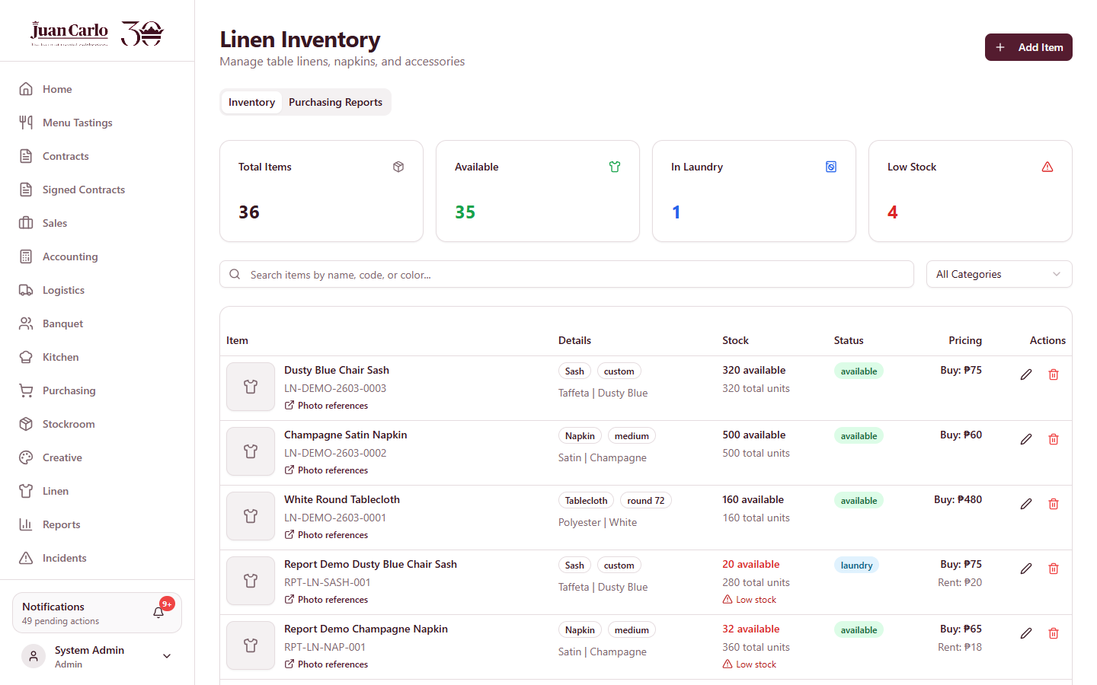
Figure 10.1.2 Linen Inventory page
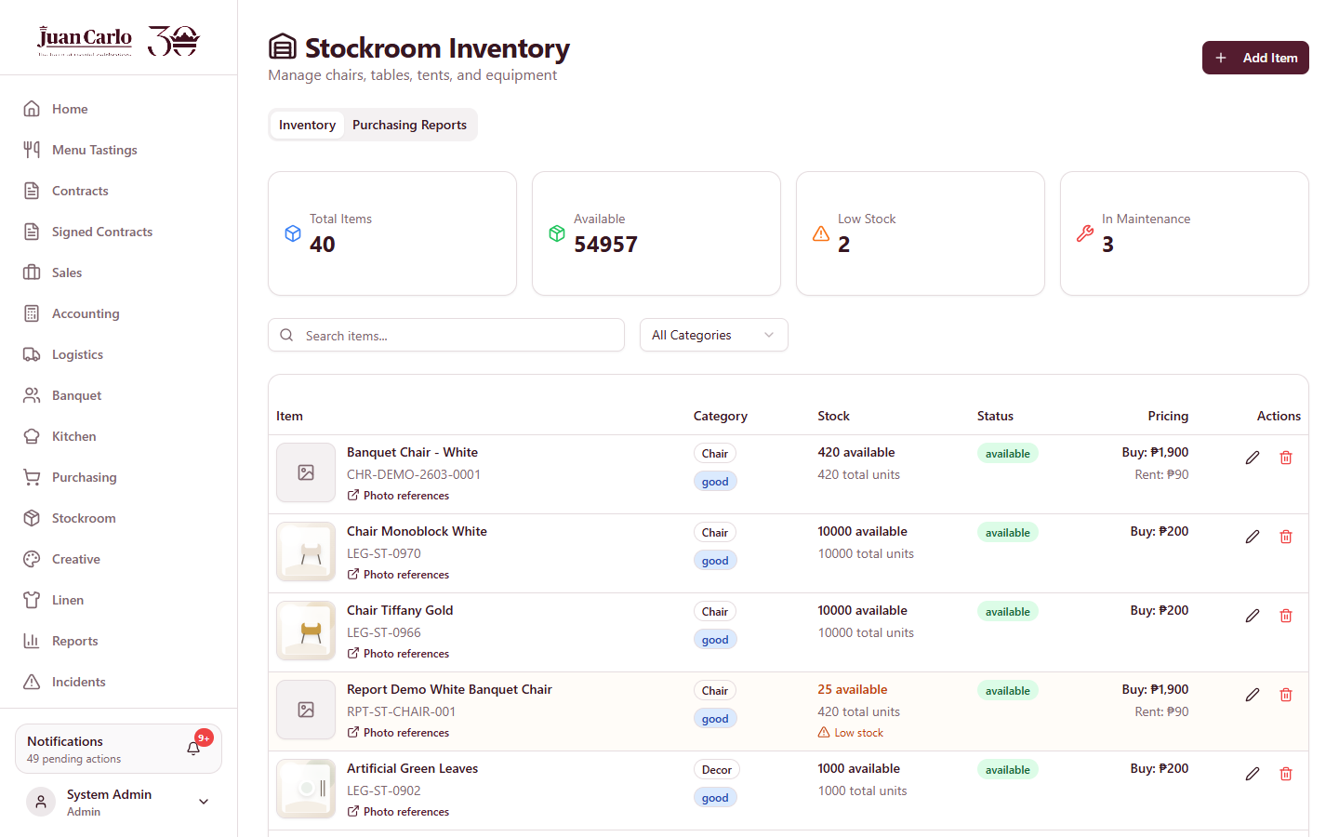
Figure 10.1.3 Stockroom Inventory page
The Kitchen department maintains a separate kitchen inventory for ingredients and supplies.
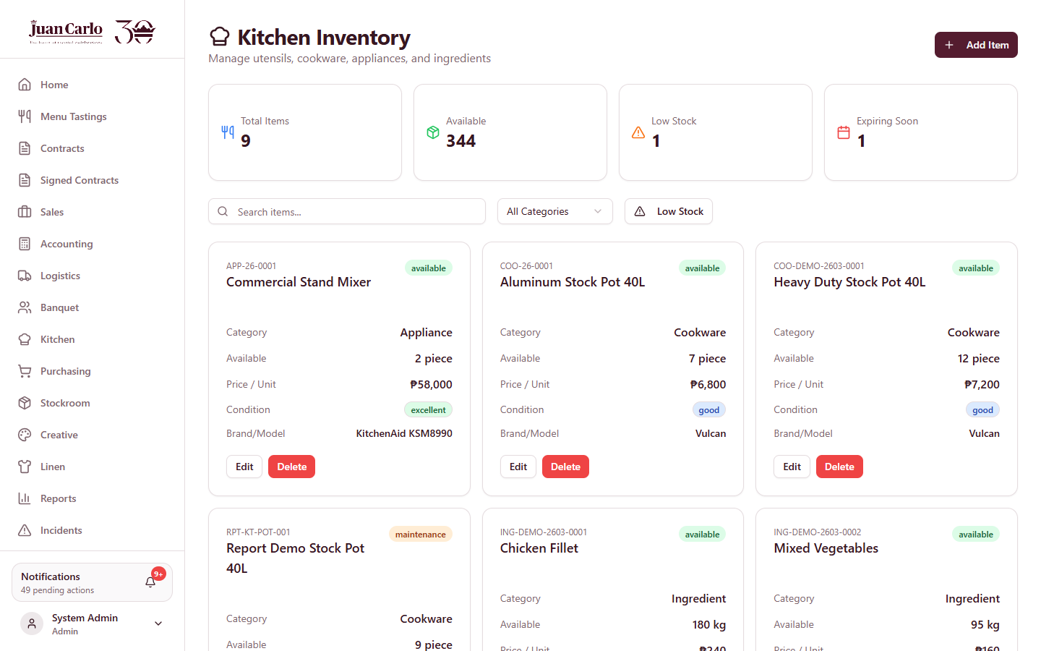
Figure 10.1.4 Kitchen Inventory page

10.2 Adding Inventory Items
- To add an item, click the Add Item button located at the upper-right part of the inventory page.
- A pop-up window appears in which the user fills up the item details.
- Fill up the item information such as the item name, category, quantity, minimum stock, price, condition or status, and image, depending on the department.
- After filling up the form, click Add Item (or Create Item) to add the item to the inventory list.
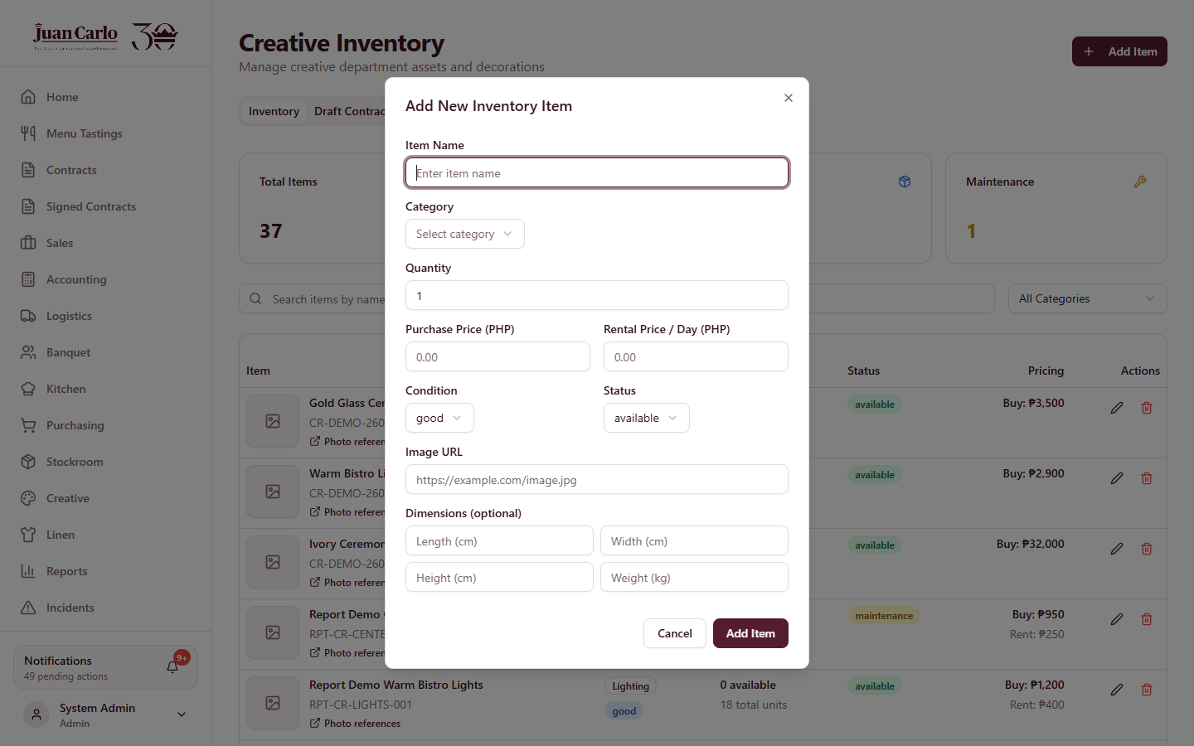
Figure 10.2.1 Add Item dialog

10.3 Editing Inventory Information
- In the inventory list, click the edit (pencil) icon in the Action column of the item to be edited.
- A pop-up window appears where the user can edit the item details.
- After editing the details, click Save Changes to save the updated information.

10.4 Deleting Inventory Items
- In the inventory list, click the trash icon in the Action column of the item to be deleted.
- A confirmation alert appears asking the user to confirm the deletion.
- Once confirmed, the item is removed from the inventory list.

10.5 Monitoring Quantity and Availability
- The quantity and availability of items can be monitored through the Stock column and the Status column of the inventory page.
- The status indicates whether items are available, in use, in laundry, reserved, or in maintenance, depending on the department.
- The search bar and the category dropdown may be used to locate particular items instead of browsing the entire list.

Chapter 11. Incident and Issue Handling Process

11.1 Identifying Problems After the Event
If any incidents occurred during the event, the user opens the Incidents page. This page allows the user to review existing incidents or report new ones before completing the post-event process.
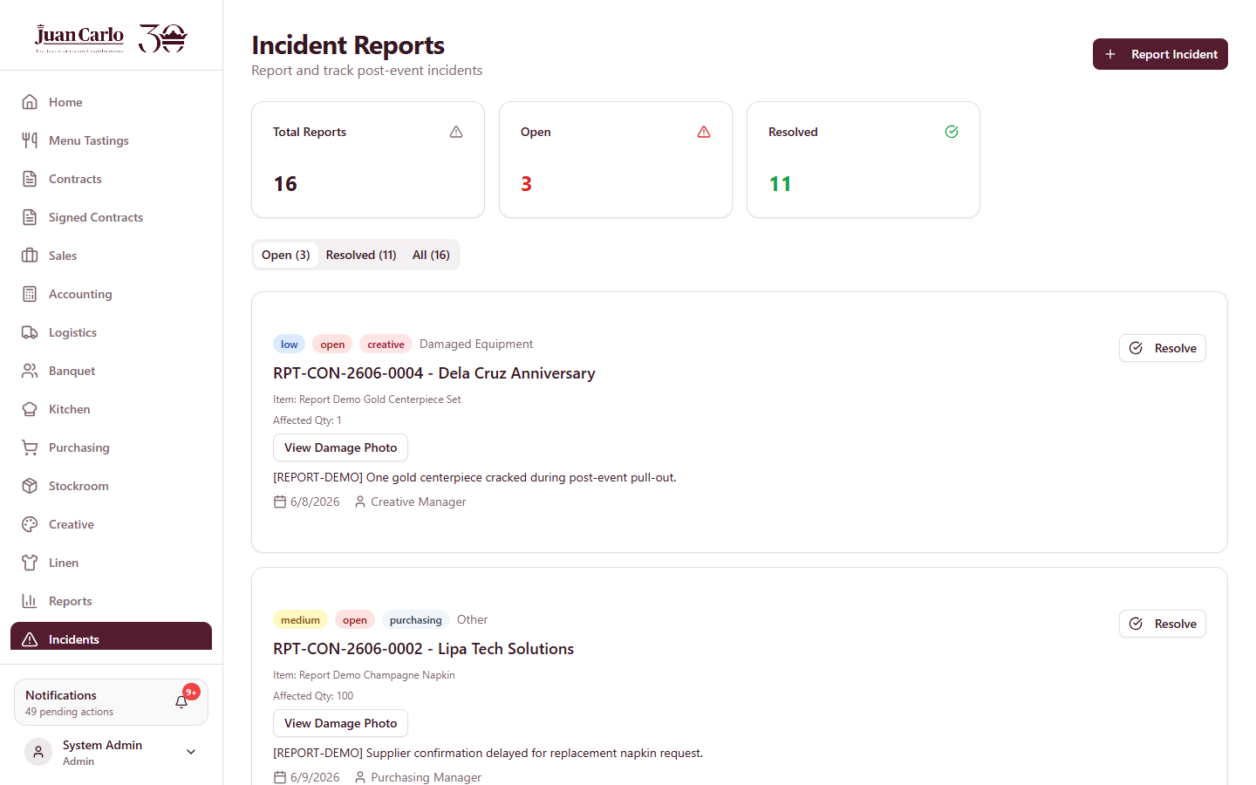
Figure 11.1.1 Incidents page

11.2 Creating an Incident Report
To create a new report, the user clicks the Report Incident button at the upper-right of the page. This opens a form for documenting the issue that occurred.

11.3 Attaching Supporting Details
In the incident form, the user selects the contract and incident type from their dropdown menus, then enters the incident date, chooses the severity, and provides a description. The affected quantity and a damage reference image are optional. An incident may also be reported directly from an item during post-event checking, in which case the contract and item are filled in automatically.
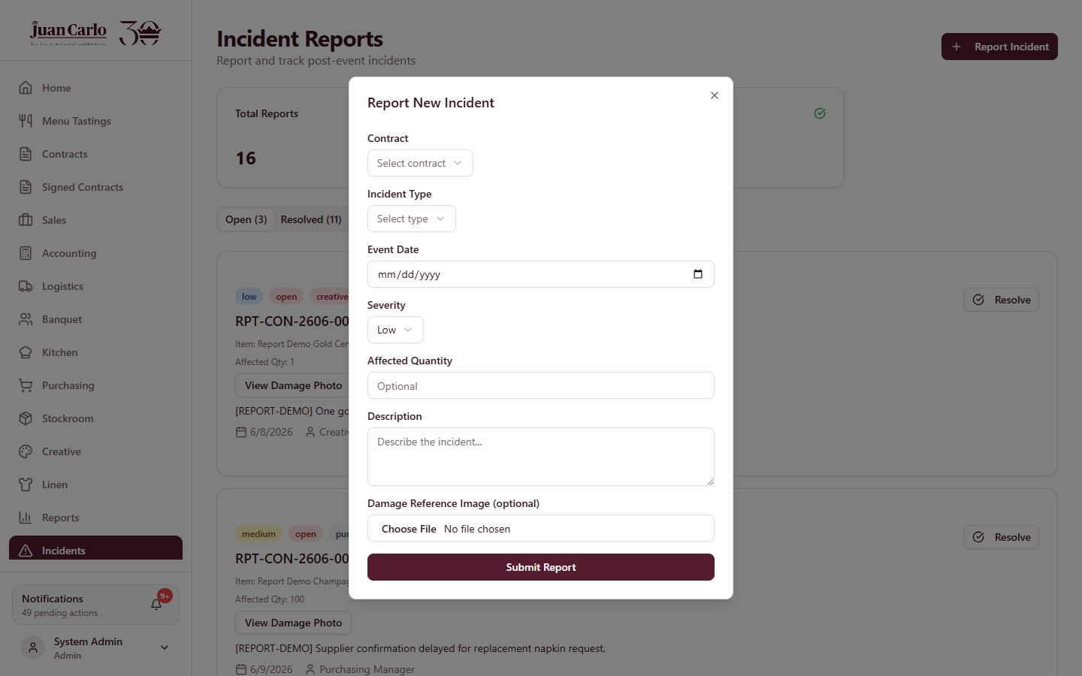
Figure 11.3.1 Report Incident form

11.4 Forwarding Issues to the Proper Department
After filling up the details, the user clicks Submit Report at the bottom of the form to save and finalize the incident report. The incident is linked to the related contract and, where applicable, the specific item.

11.5 Resolving the Incident
The reported incident appears in the Incidents page. When the incident has been resolved, the user clicks Resolve on the incident to mark it as closed.

Appendix A. Reports and Signed Contracts

A.1 Reports
The Reports page provides management with summaries of contracts, payments, and operational activity. It is used to review historical and financial data across the system.
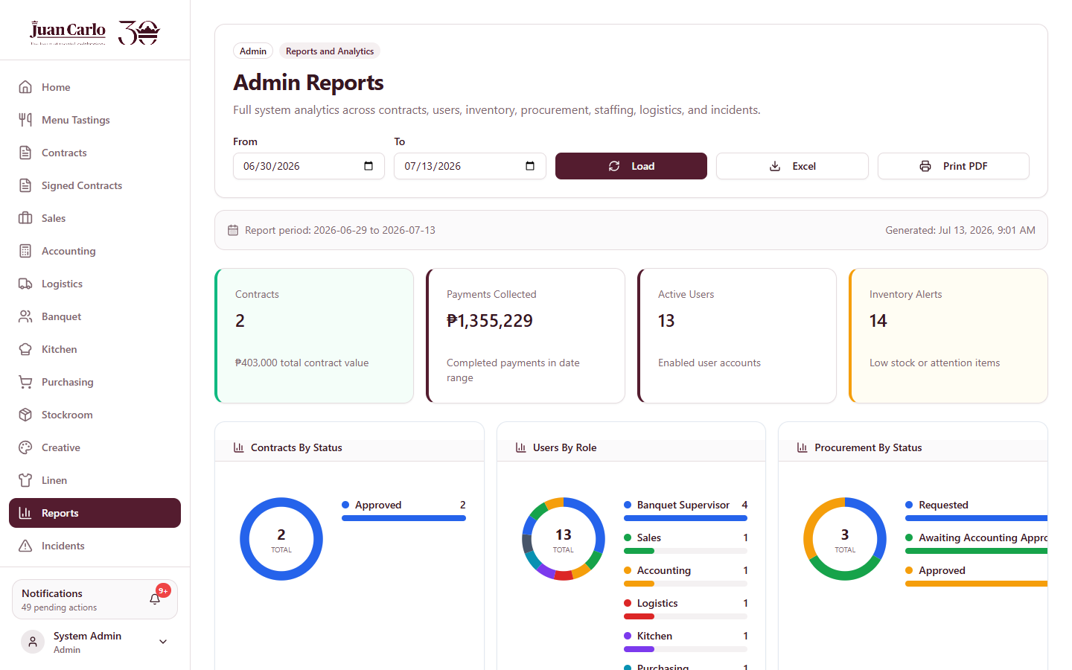
Figure A.1.1 Reports page

A.2 Signed Contracts
The Signed Contracts page lists the contracts that have been signed by the client, allowing the Sales department to monitor and reference completed agreements.
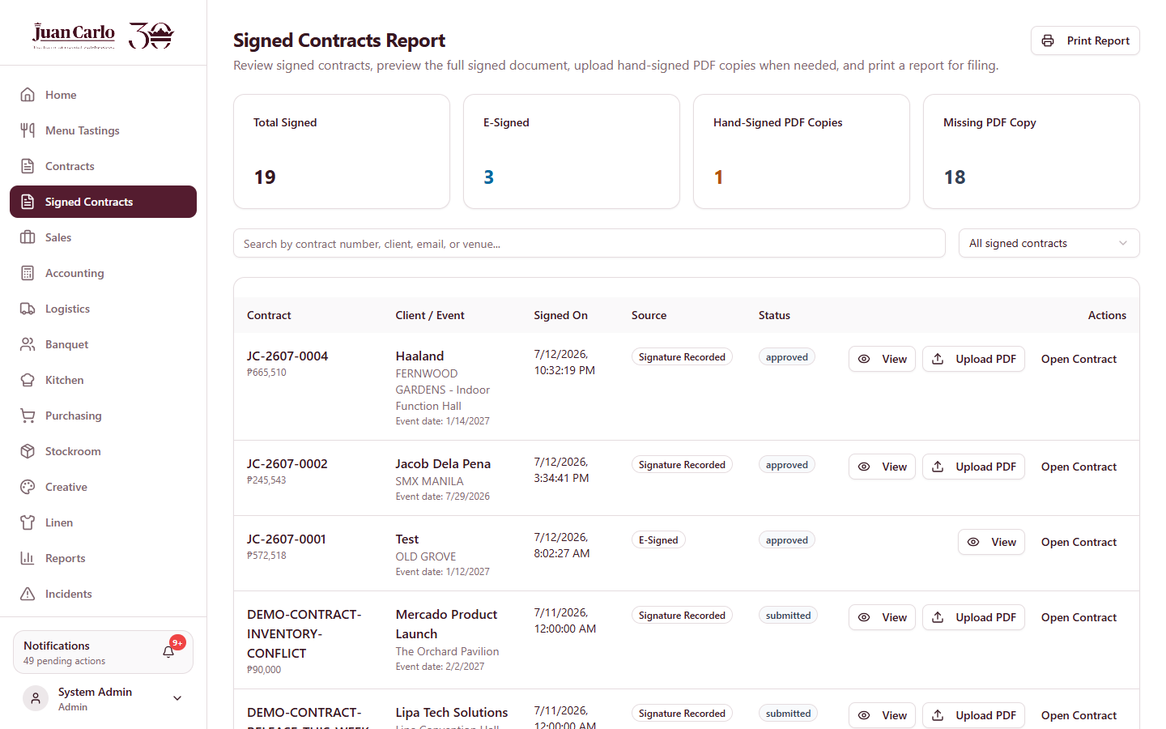
Figure A.2.1 Signed Contracts page

A.3 Collection and Preparation Timeline
The following table summarizes the timing rules enforced by the system. The booking date and the event date operate on separate timelines.
Table A.1 Collection and Preparation Timeline
Rule | Timing | Based On
Reservation fee (PHP 30,000) | Upon booking; counted as part of the 40% | Booking
40% payment follow-up alert | One month before the due date | Booking date
40% payment due | Two months after booking | Booking date
30-day aging to uncollectible | Thirty days after the 40% due date | Booking date
Final 60% balance due | Two months before the event | Event date
Final details deadline (SLA) | One month before the event | Event date
Material freeze | Seven days before the event | Event date
Requisition lead time | Seven days before the date needed | Date needed
Contract closing | After the event date has passed | Event date

