**CME3201 Database Management Systems**

**Project Report**

**a. Detail Problem Description**

This project is about a football team's website. User will login to the website at first and

then he/she will act like the manager for the chosen team. User will be able to manage

functions for the team(Selling, buying, checking fixtures, etc). Also site will

contain some informations about 5 leagues, 40 teams and 400 footballers.

**b. Business Rules**

1- Each user will have a unique user id.User has to register to the site with his/her username, password, birth date,e-mail and team that he/she will manage. User will choose a team and manage its transfer functions and balance it's monthly expenses. Username must be longer than 3 and password must be longer than 5. User must choose a team from a list which includes not chosen teams while registering. Also user' s age must be bigger than 18.

2- There will be 5 leagues that has a unique league id,name, sponsor, foundation year, president, country. Each league will contain 8 teams.

3- Teams are going to have a unique team id, name, foundation year, president, first color, secondary color, championship number, transfer budget, monthly expense, stadium(foreing key from stadium table), country, city and 10 footballers. Teams will be able to sell and buy players. For buying a player team' s transfer budget' s current value must be bigger than player' s testimonial.

4-Footballers are going to have a unique footballer id, name, surname, age, salary, country, birthdate, position, dominant foot, goal number, testimonial and transferlist(Declares if a footballer is transferlisted or not).

5-Each stadium will have a unique stadium id, name, capacity, city, district.

6- Each team will a match fixtures. Matches will have a unique match id, date, referee, stadium, home team(foreign key from teams table) and a away team(foreign key from teams table) .

7-Refrees will have refree id, name, surname, age, salary.

**c. ER diagram**

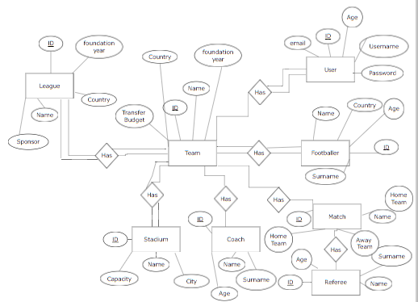

**d. Database Schema**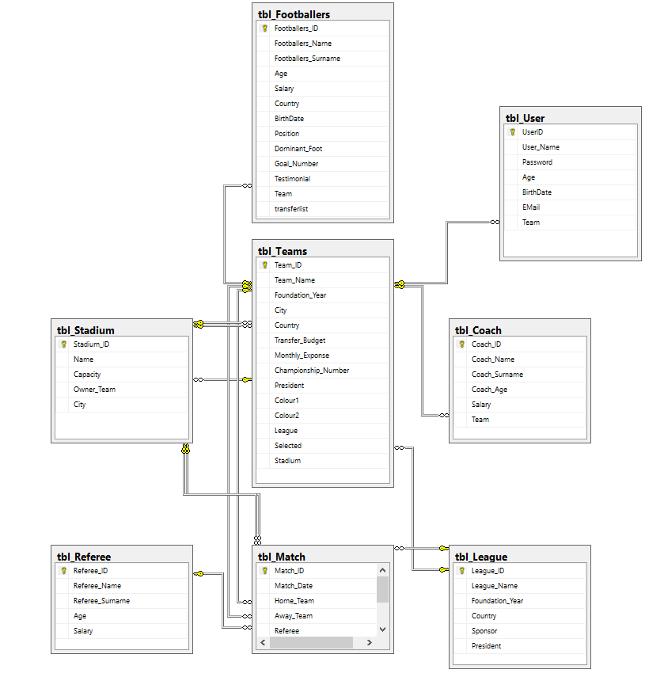

**e. Al SQL Statements**

Document of the sql statements is in the folder of project.(.sql)

**f. Screenshots Of Interfaces SQL Statements**

**f.1) Main Page**

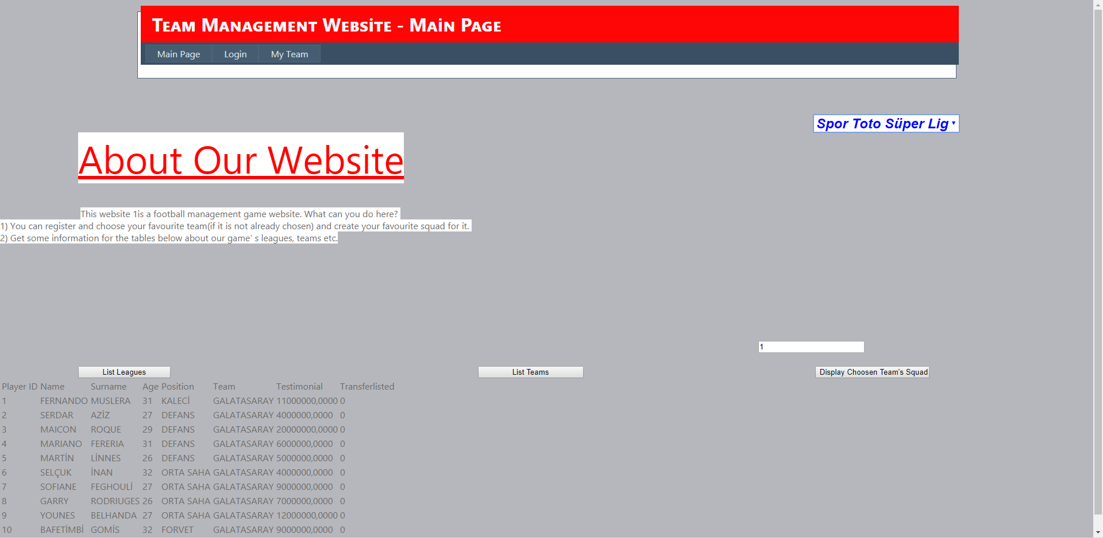

In our main page of the website there is a declaration of our website. At right top corner there is a dropdownlist which lists our leagues that are in the database. You can choose a league and list that league's fixtures at the bottom of the site.

Also bottom there are 3 buttons at bottom. First button(to the far left), on clicked, displays the leagues in a table with their important values. Seccond button(middle one ), on clicked, displays teams with their values as a table. Button to the far right gets the team id from the textbox above it and displays choosen team' s footballers with their values as a table.

// alttaki butonlardan birine basınca oluşan ekran (aynı zamanda sağ üstteki listeye de

// bas bu screenshotu alırken

**f.2) Login**

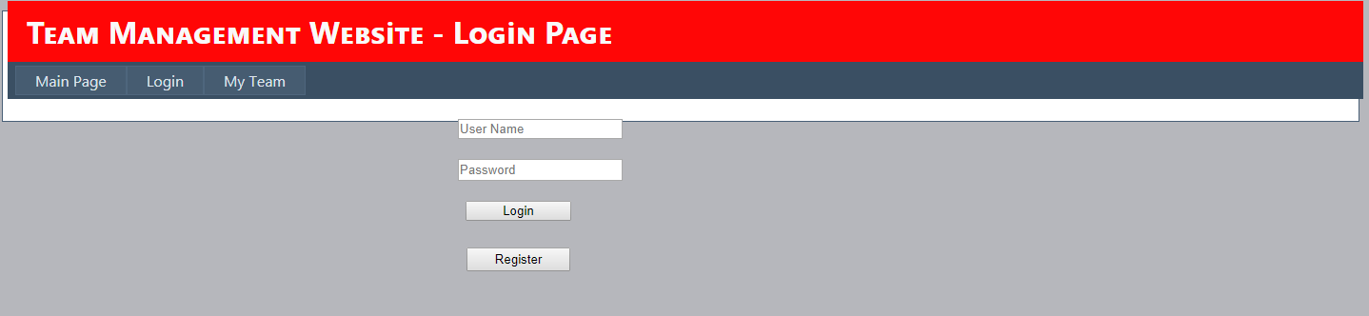

At login page there are 2 buttons and 2 textboxes at first scene. Textboxes get inputs as username(upper textbox) and passsword(lower textbox). Button with "Login" text logins the user to the website if inputs are matching with database values. Button with "Register" text opens a new scene and displays register page with 6 textboxes and a button.

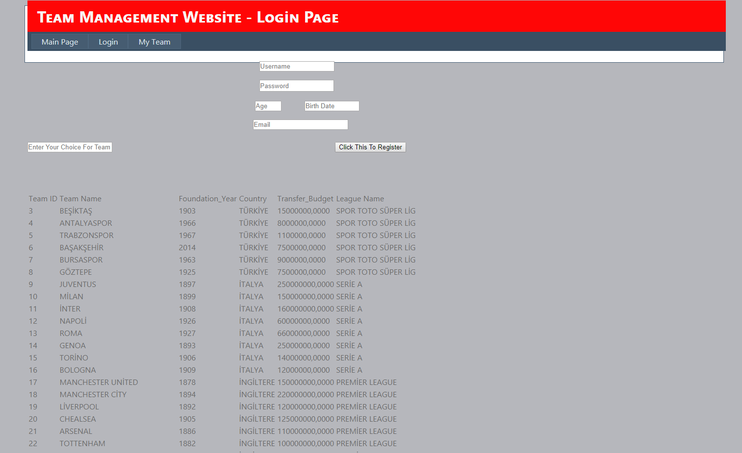

In our second login scene there are textboxes that get inputs from the user for registering to the website. Button at the bottom registers the user to the site if inputs are viable for circumstances.

**f.3) My Team**

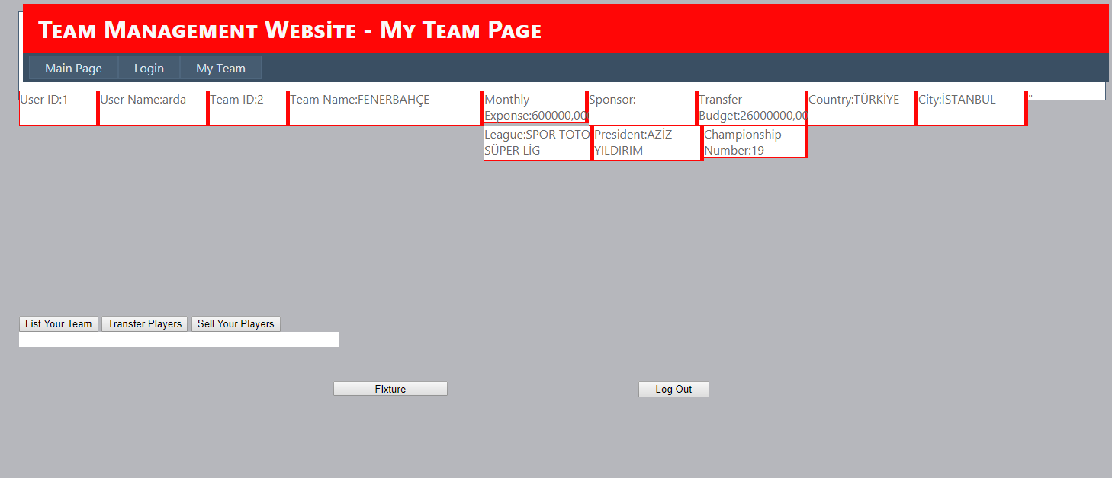

At our my team page there are a lot information boxes at top that gives information about user and user' s team. There is a log out button at far right which logs user out from the page and redirects the user to the main page. Other than that there are 3 buttons side by side. At far left there is a button with "Fixture" text.

Far left button lists user' s current team at the bottom of that button.

Middle button opens search player screen and also lists the transferlisted players at the bottom. Middle textbox gets a footballer id and bottom below that buys the footballer that is choosen.

Far right button lists user' s current team and in this screen there is a textbox and a button. Textbox gets a player id from the user' s team and button below that puts the player on the transferlist.

**f. Additional Properties of Our Project**

Our WebSite is not a simple website. It is a Football Management Game played in a website with other users. Our site has more than 400 footballers in it' s database with 5 leagues, 40 teams. User can choose his/her favourite team and create a new squad for that team using the team' s transfer budget.

**f. Challenges**

In tables with multi foreign keys (ex:matches table ) there must be a view only for left joining tables. We were not able to create that much views so some tables with foreing keys are left without joins.

2015510050 ARDA ONAT

2014510018 BEKİR DEDE