

**LAB-05**

**Cinema Management System**

**01-10-2025**

**Arda Amir Rashid**

**SP25-BCS-013**

**Section-A**

**M. Shahid Bhatti**

**Computer Science**

**COMSATS University**

**Java Class Listings:**

* Seat.java
* Screen.java
* Cinema.java
* CityCinema.java
* SeatDemo.java
* ScreenDemo.java
* CinemaDemo.java
* CityCinemaDemo.java

OUTPUTS:

**Seat Class:**

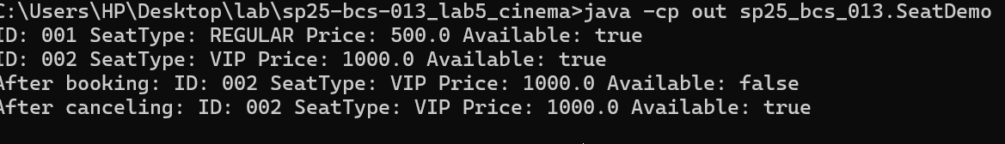

**Screen class:**

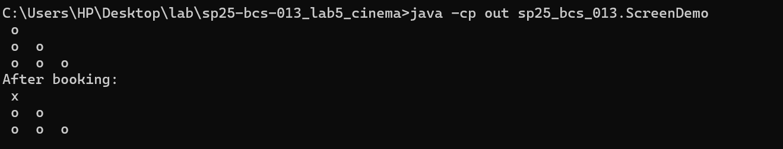

**Cinema class:**

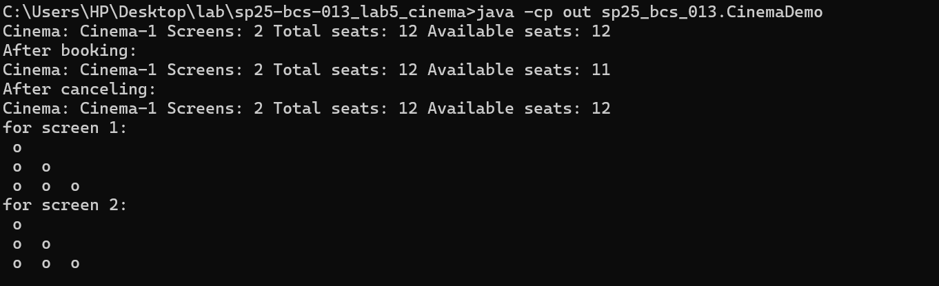

**CityCinema class:**

