ASSIGNMENT #3 – Knapsack Problem

C Code of Knapsack

#include<stdlib.h>  
#include<stdio.h>  
#define MAX 100  
int max(int a, int b) {  
if(a < b)  
return b;  
else  
return a;  
}  
int knapsit(int capacity, int n, int list[], int kg[])  
{  
int K[n+1][capacity+1];  
  
for (int i=0; i<=n; i++) {  
for (int j=0; j<=capacity; j++) {  
if (i == 0 || j == 0) {  
K[i][j] = 0;  
} else if (kg[i-1] > j) {  
K[i][j] = K[i-1][j];  
} else {  
K[i][j] = max(list[i-1] + K[i-1][j - kg[i-1]], K[i-1][j]);  
}  
}  
}  
printf("########################## KNAPSACK TABLE: ########################## \n\n");  
printf("i \t CAPACITY1\t CAPACITY2\t CAPACITY3\t CAPACITY4\n");  
printf("_ \t _________\t _________\t _________\t _________\n\n");  
for (int i = 0; i <= n; ++i)  
{  
for (int j = 0; j <= capacity; ++j)  
{  
// display of the elements of the generated matrix  
printf("%d\t\t", K[i][j]);  
}  
printf("\n");  
}  
// table which allows to have the elements taken  
int x[n];  
int c = n, w = capacity;  
while(c>0 && w>0)  
{  
if (K[c][w]== K[c-1][w]){  
// same weight so element not taken  
x[c-1]= 0;  
}else{  
// weight has changed so element taken  
x[c-1] = 1;  
w = w - kg[c-1];  
}  
c--;  
}  
printf("\n======================================================================== \n");  
for(int j=0;j<n;j++)  
{  
if(x[j]==1)  
{  
// if the value in the table of elements == 1 then the element is taken  
printf("item %d is selected with value %d: weigth :%d \n",j+1, kg[j], list[j]);  
}  
}  
return K[n][capacity];  
}  
int main()  
{  
//values  
int list[MAX] = {6, 9, 18};  
//weight  
int kg[MAX] = {1, 2, 3};  
// maximum capacity  
int capacity = 4;  
// number of elements in the array  
int n=3;  
// call of the knapsack function  
printf("Max value : %d\n", knapsit(capacity, n, list, kg));  
return 0;  
}

Output of Program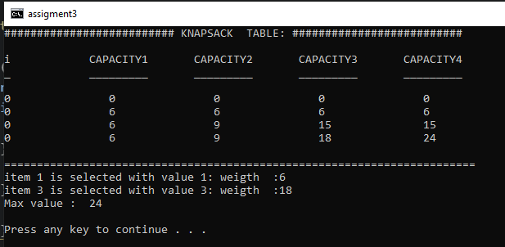

[**Download the C Code File**](https://fromsmash.com/ANALYSIS-OF-ALGORITHMS-Knapsack-Ccode-172701) **(until 11 December.)**