Arda Güney

28997

**CS-405 Project 3 Report**

I will explain what I did in this project task by task.

**Task-1**

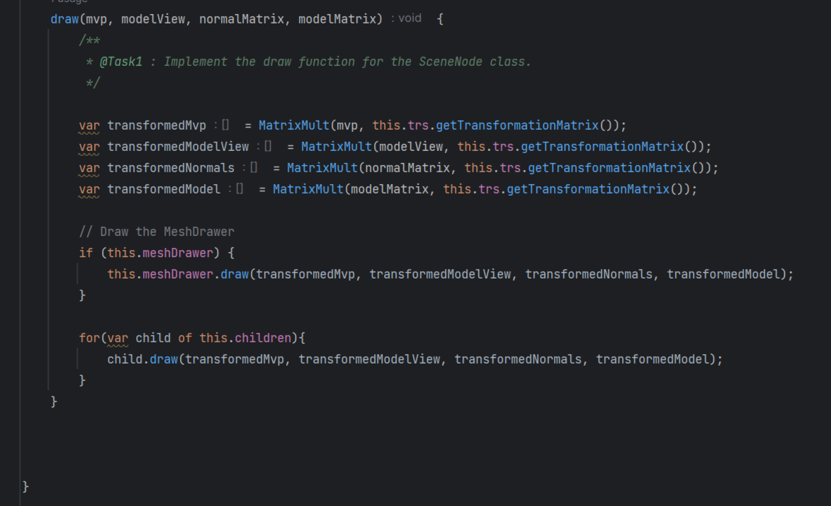

* For accomplishing task one firstly I made the transformaitons to mvp, modelView, normalMatrix and modelMatrix by multiplying them with the transformation matrix got by this.trs.getTransformationMatrix().
* After getting the needed transformed matrices I created a for loop to make the same transitions to the children of current scene node. This loop applies all transformation by draw function to each element in children list attribute in send node.

**Task-2**

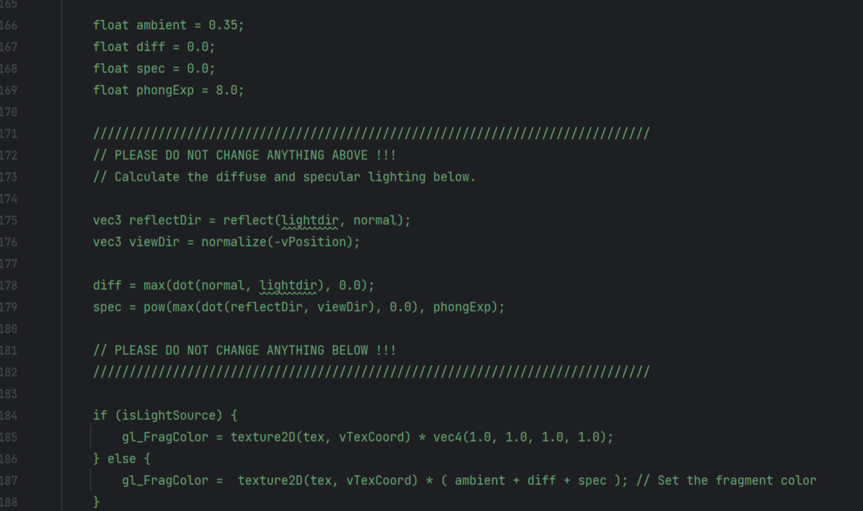

* For accomplishing task two I changed values of the variables diff and spec to their needed value.
* For finding needed diff value which is the diffuse light value I got the dot product of surface normal vector and lightdir which is light direction bu dot function. After that my max function I am being sure that the value is not less than zero.
* For finding needed spec value which is the specular light value I got the dot product of reflectDir (which is the reflection vector found the reflection function that gives the reflection direction of light vector based on surface normal) and viewDir (which is the normalization of a vector opposite of vPoisition) to ensures reflections are in view direction. After than taking the max of this value and 0.0 to ensure that this value stays above zero. Finally I got the power of this value by PhongExp to control shininess.

**Task-3**

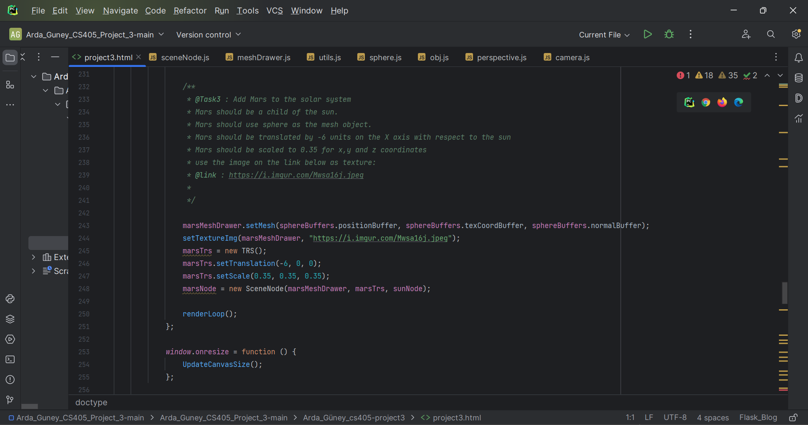

* For task 3 I created another planet visualization around the sun. Because earth is an object that in the same level with expected mars object. Which is a children element in the sun SceneNode, I duplicated all of the earths codes and changed the variable names to mars. By this I created another children element for Sun like given Earth. After that I changed all of the values (scale, translation and image used for texture mapping, all given in project description.) of Earth to Mars values which are given in the project description.

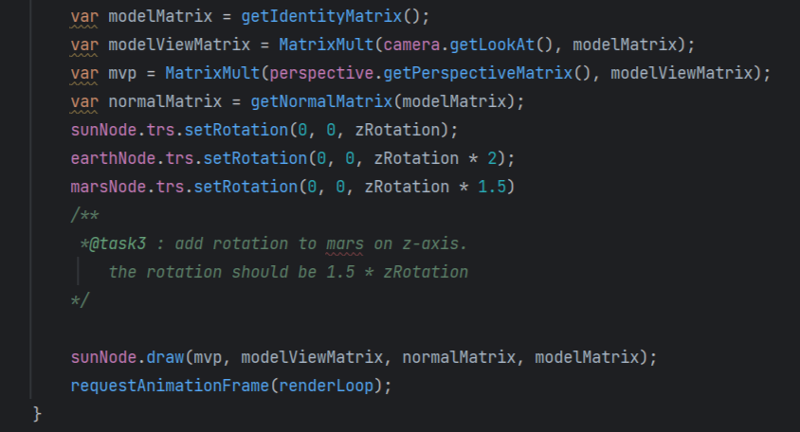

* Finally for also adding Mars object rotation I set marsNode I created above rotation by setRotation function. Again specified value given in projects description.