Arda Güney

28997

**CS 405 Project-1**

I will explain my work bu explaining each task consequently trough the report. Firstly for the task 1 I copied and pasted the given description to Chat GPT. At the beginning Chat GPT didn’t given an outcome as a single matrix but after I demanded a single matrix it gave me the desired outcome. Below the link for my chat with Chat GPT and the visualization of the matrix given by it can be found.

Link for the chat with Chat GPT:

<https://chat.openai.com/share/686726b4-7589-4ddc-8e2b-6ee9292fc7aa>

Screen shot of the visualization of the matrix given by Chat GPT.

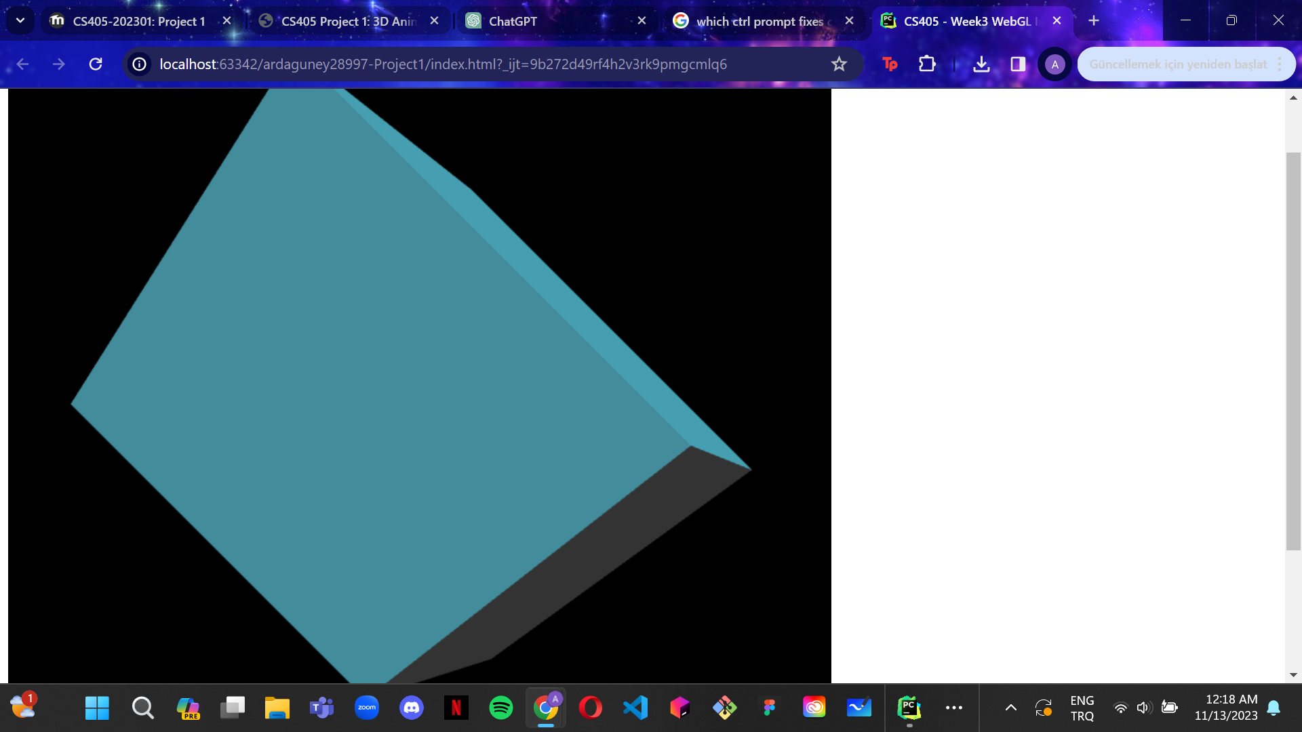

Secondly for task_2, I used the translation, scaling, x, y and z rotation and matrix multiplication functions provided by the “*utlis.js*” file. I created matrices which will be the necessary outputs of translation, scaling, x rotation, y rotation and z rotation functions by the given values at “*transformation-promt.txt”.* After that bu using matrix multiplication function I multiplied the matrices I found by the order of (translation * scaling * rotation *). For rotation matrix I multiplied the x, y and z matrices in the order of (z rotation * y rotation * x rotation). At the end of these processes I found the necessary transformation matrix.

When I compared the matrix of Chat GPT and the matrix I found I realized that they are different than each other. The reason is that the order of multiplication is different than the necessary order. The order of Chat GPT is (rotation * translation * scaling). Which is different than the necessary order mentioned at the previous paragraph.

Lastly for the task_3 again I asked Chat GPT for me to give a code that would provide the animation of transformation between the matrix [(1,0,0,0), (0,1,0,0), (0,0,1,0), (0,0,0,1)]. I created that initial matrix the the create matrix function given in the “*utlis.js”* function. Chat GPT wrote a function that keeps the time of a 10 second period. The function checks if the time is in 0 - 5 or 5 - 10 interval. If the time is in the first interval function animates the initial to final transformation by applying interpolation. Otherwise it animates the the reverse of the first animation. The time checking is also done by the if statements using interpolation and the interpolation is applied by a variable named “*normalizedProgress*” that made out of the modulus od the current time found by “*DateTime*” function divided by half the period.

Link to the chat with Chat Gpt for the “*getPeriodicMovement*” function:

<https://chat.openai.com/share/ecf370b1-f6c3-42e9-bc1d-bc3e4b57ce94>