
VISITOR ACCESS
Guest Wi-Fi
SCAN WITH YOUR PHONE CAMERA
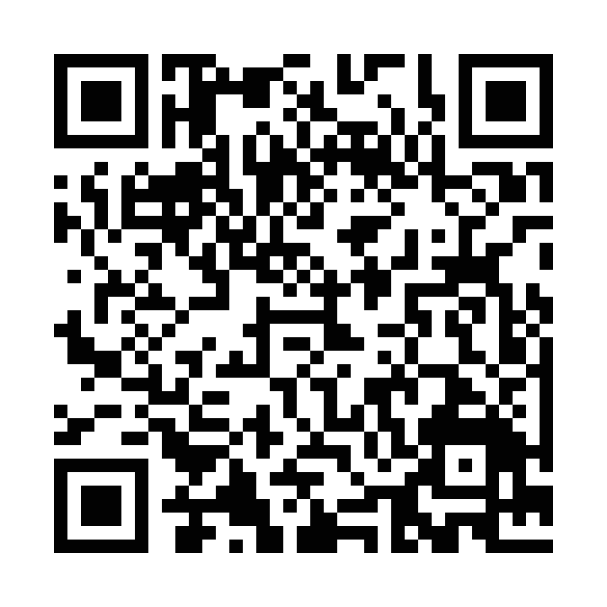
Tap the Wi-Fi prompt to join
NETWORK NAME  WFW-Guest | PASSWORD  05789123

How to connect
- Open your camera
Use the camera app on your phone or tablet.
- Scan the QR code
Hold the camera over the code, then tap the Wi-Fi banner.
- Join WFW-Guest
Confirm the network when prompted.
No camera prompt? Open Wi-Fi settings and enter the details above manually.

