

CS-319

Requirement Analysis Report

**Team**

CrackWare

**Members**

Eren Duran

Mustafa Cem Gülümser

Aslı Karaman

Arda Yıldız

Elifsena Öz

Date: 11/03/2022

**Contents**

1. **Introduction**

a. Current System

b. Proposed System

2. **Overview**

a. Functional Requirements

i. Admin

ii. Student

iii. Coordinator

iv. Faculty Administration Board Members

v. International Student Office

b. Non-Functional Requirements

i. Usability

ii. Maintainability

iii. Reducing Paper Usage

iv. Reliability

v. Performance

3. **System Models**

4. **GUI Descriptions**

5. **References**

# **Introduction**

## Current System

The current online Erasmus application system has various limitations.

* First, the current system cannot establish proper communication between the students and coordinators. Students cannot receive status updates about their application based on the approval/rejection of coordinators or faculty administration board.
* Second, the current system is highly dependent on the usage of paper documents. Students need to sign and upload scanned documents to the system. Similarly, coordinators are required to physically engage with documents and send them to the faculty administration board.
* Third, the workload of coordinators is not smartly managed and is not conspicuously reflected to them. Student placements according to their GPAs can be easily established with the usage of an algorithm, and tasks can be divided between the coordinators based on universities. The current system is incapable of such functionalities.
* Finally, the current system does not offer a proper transfer and upload of all required files in the application. Some files are transferred via emails and some files are submitted by hand.

## Proposed System

Erasmus+ is a web application that facilitates the management of Erasmus applications for students, instructors and faculty coordinators. The main purpose of this application is to combine all Erasmus application procedures in a single application, and to have a smoother, simpler application process. To achieve this, Erasmus+ offers separate user interfaces and functionalities to all stakeholders where they can follow their tasks in a schedule-based interface.

Based on the login credentials of the user, the application displays a separate interface with different functionalities. The main stakeholder in Erasmus+ application are the students. Students can create, manage, view and submit Erasmus applications by providing the necessary information and documents. They can follow the status of these applications and see their resulting placements. Course selection and instructor approval can also be done through Erasmus+. Depending on their choice, students can withdraw or modify their applications before the pre-approval begins. After the pre-approval, students can submit their learning agreement and finish their application process.

Erasmus coordinators can use this application for many purposes. Erasmus+ saves coordinators from making each and every placement manually and automates this process. Coordinators can view the placement results and finalize them with or without making any changes. Placement results are automatically sent to the students. Cancel or dislike requests of students are also automatically sent to the coordinators and the waiting bin is set accordingly. Finally, coordinators can approve or reject learning agreements and submit final course transfer forms to the system for the faculty administration board to evaluate.

For instructors, Erasmus+ offers a much easier way to respond to each course selection. Students send instructors their course wish along with the course syllabus, and instructors can approve or reject courses from the application.

Finally, the faculty administration board can approve or reject pre-approval forms and course transfer lists. Using the Erasmus+ application, approval or rejection of documents can be done online with the addition of e-signatures.

Ultimately, Erasmus+ aims to be a unified platform for all actors of the Erasmus programme. By doing so, Erasmus+ hopes to facilitate communication between stakeholders and eliminate confusion due to cross-platform interaction.

# Overview

# Functional Requirements

There are five main users of the Erasmus+ application: Admins, students, coordinators, faculty administration board members and international student office members. Each user has different privileges, abilities, tasks and user interfaces.

### Admin

Admin users have access to all resources and have the maximum privileges in the application. Such users are very small in number and are the developers of the application. Admin privileges are only used to test and debug the application. Admins can create/delete users, create/delete/manage Erasmus applications, change placements and alter documents.

### Student

Students are the primary users of the application. Student user credentials are appointed by the admins and cannot be changed. They have the ability to create Erasmus applications with information they provide and track the status of their application through its lifecycle. They are allowed to upload documents where necessary and receive the processed document by the relevant stakeholders. Students can also make a course wishlist and have their wishlist approved by instructors.

### Coordinator

Coordinators can view applications of each student and see the placement list. Further, they can manage the placement list and make necessary changes before its finalization. They can create and manage the waiting bin and nominate students to their final universities. Finally, coordinators can view learning agreement forms sent by students and decide to approve/reject them. Coordinators are constantly in communication with students and can send them personal messages.

### Faculty Administration Board Members

Faculty Administration Board Members can view applications and placements at any stage. They have access to each student, coordinator and instructor profile. Their primary task is to approve or reject pre-approval forms and final course transfer lists.

### International Student Office

The only task of International Student Office members is to receive and upload student transcripts from external universities to the applications.

## Non-Functional Requirements

### Usability

Erasmus+ needs to be easy to use and should not require documentation to be read beforehand. The Erasmus+ software solution has different UI views and capabilities for each user. Because the variety of users is considerably large, it will be used by admins, students, coordinators, faculty administration board members, and international student office members. Every user will have different capabilities and jobs. To make this software easy to use with little to no pre-work, the UI should be clear of ambiguity and easy to follow. While designing this software, we tried to go hand in hand with these guidelines.

### Maintainability

Erasmus+ should be maintainable for generations because the Erasmus program frequently changes with new schools or countries, and Bilkent University can add new departments or change the curriculum of some departments. Erasmus+ needs to adapt to these changes and overcome them to be successful. This requires a maintainable system. Also, with every new user comes the risk of software bugs and exploits. Erasmus+ needs to implement fixes with great speed and precision. Speed and precision are guaranteed by following the principles of OOP in our code.

### Reducing Paper Usage

One of the main goals of Erasmus+ is to reduce paper usage for the whole Erasmus program. The previous form of manual procedure requires a document to be printed and signed over and over by different faculty members. By digitalizing this system and adding a signature feature, we reduce paper usage by nearly 100%. This means that every file will be transformed in our system, and there will be no more countless and unorganized e-mails that need printing. Last but not least, reducing paper usage contributes to the efforts of saving the planet and less demand for cutting trees, which is an eco-friendly solution.

### Reliability

Reliability needs to be ensured with Erasmus+. The software will be responsible for all Erasmus placements, and a mistake will cause significant problems. File transfer is one of the most critical parts of this criterion. It should be as reliable as e-mail, and it should not fail without exception. Also, file transfer needs to inform the parties involved about either successful or unsuccessful transfers to ensure reliability. The other most crucial aspect of reliability is the multi-user system that we put in place, ensuring the user and capability with what they can do and don't is important

### Performance

Our Erasmus solution, Erasmus+ needs to handle a maximum of 13.000 users + staff personnel. Change done by some users should be processed fast because many students or other types of users can be waiting for that change. We need to store and access these records with outstanding performance. Also, for the whole waiting list or student applications, the school list is bound to change with application withdrawals, and changes in the order of the schools preferred. These types of events need to take place extremely fast in order to avoid chaos.

# System Models

a) Use Case Diagram:

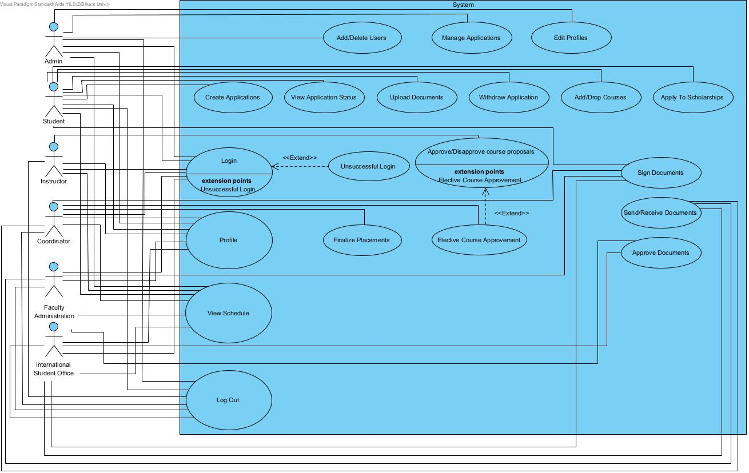

b) Use Case Diagram Descriptions:

**Use Case: Login**

1. Name: Login

2. Participating Actor: Admin, Student, Instructor, Coordinator, Faculty Administration, International Student Office

3. Entry Condition: Actor is not logged in and already signed up by Bilkent University

4. Exit Condition: Actor enters correct id and password provided by Bilkent University

5. Flow Of Events:

i. Actor clicks on username field

ii. Actor enters his/her id by typing it to the username field

iii. Actor clicks on password field

iv. Actor enters his/her password by typing it to the password field

v. Actor clicks on the Login button

6. Special/Quality Requirements: The actor must maintain a stable internet connection during the login process

**Use Case: Unsuccessful Login**

1. Name: Unsuccessful Login

2. Participating Actor: Admin, Student, Instructor, Coordinator, Faculty Administration, International Student Office

3. Entry Condition: Actor is not logged in and is entering invalid username or password

4. Exit Condition: Actor enters correct id and password provided by Bilkent University

5. Flow Of Events:

i. Actor clicks on username field

ii. Actor enters his/her username by typing it to the username field

iii. Actor clicks on password field

iv. Actor enters his/her password by typing it to the password field

v. Actor clicks on the Login button

6. Special/Quality Requirements: The actor must maintain a stable internet connection during the login process

**Use Case: Profile**

1. Name: Profile

2. Participating Actor: Admin, Student, Instructor, Coordinator, Faculty Administration, International Student Office

3. Entry Condition: Actor is logged in

4. Exit Condition: Actor leaves the Profile interface by opening another interface

5. Flow Of Events:

i. The actor displays the Profile interface

ii. The actor exits the Profile interface by opening another interface

6. Special/Quality Requirements: None

**Use Case: View Schedule**

1. Name: View Schedule

2. Participating Actor: Admin, Student, Instructor, Coordinator, Faculty Administration, International Student Office

3. Entry Condition: Actor is logged in and opened the View Schedule interface

4. Exit Condition: Actor leaves the View Schedule interface by opening another interface

5. Flow Of Events:

i. The actor displays the View Schedule interface

ii. The actor exits the View Schedule interface by opening another interface

6. Special/Quality Requirements: None

**Use Case: Add/Delete Users**

1. Name: Add/Delete Users

2. Participating Actor: Admin

3. Entry Condition: The actor must choose Add/Delete Users option. The target user which is to be added must not have an account and the target user which is to be deleted must have an account.

4. Exit Condition: Add/delete option is completed/canceled for the target user

5. Flow Of Events:

i. The actor must choose Add/Delete Users option

ii. The actor adds the user to the system by registering user information or deletes the user from the system by delete option.

iii. The actor completes the selected option or cancels it.

6. Special/Quality Requirements: Permission from the Faculty Administration is required to perform either add or delete user options.

**Use Case: Manage Applications**

1. Name: Manage Applications

2. Participating Actor: Admin

3. Entry Condition: The actor chooses to handle a certain operation(s) in the system

4. Exit Condition: The actor completes the operation or cancels it

5. Flow Of Events:

i. The actor chooses to handle a certain operation(s) in the system

ii. The actor completes the operation or cancels it

6. Special/Quality Requirements: None

**Use Case: Edit Profiles**

1. Name: Edit Profiles

2. Participating Actor: Admin

3. Entry Condition: The actor must choose an existing user account to edit

4. Exit Condition: The edit option is completed or canceled

5. Flow Of Events:

i. The actor must choose Edit Profiles option

ii. The actor chooses an existing user account from the system

iii. The actor completes the edit option or cancels it

6. Special/Quality Requirements: Permission from the Faculty Administration is required to perform edit options.

**Use Case: Create Application**

1. Name: Create Application

2. Participating Actor: Student

3. Entry Condition: The actor must be logged in.

4. Exit Condition: The actor submits the created application or cancels it

5. Flow Of Events:

i. The actor must choose Create Application option

ii. The actor completes the application creation or cancels it

iii. The actor submits the created application or cancels it

6. Special/Quality Requirements: The actor must have a minimum of 2.5 CGPA. Moreover, the actor must be in his/her minimum 3rd, maximum 5th semester to create an application.

**Use Case: View Application Status**

1. Name: View Application Status

2. Participating Actor: Student

3. Entry Condition: The actor must have ongoing application

4. Exit Condition: Opening another interface

5. Flow Of Events:

i. The actor must choose View Application Status option

6. Special/Quality Requirements: None

**Use Case: Sign Documents**

1. Name: Sign Documents

2. Participating Actor: Student, Coordinator, Faculty Administration, International Student Office

3. Entry Condition: The actor chooses Sign Documents option

4. Exit Condition: Document is signed, or option is canceled

5. Flow Of Events:

i. The actor chooses Sign Documents option

ii. The actor signs the target document

6. Special/Quality Requirements: The actor must have a document to sign to complete the Sign Documents option

**Use Case: Upload Documents**

1. Name: Upload Documents

2. Participating Actor: Student

3. Entry Condition: The actor chooses Upload Documents option

4. Exit Condition: Document is uploaded, or option is canceled

5. Flow Of Events:

i. The actor chooses Upload Documents option

ii. The actor uploads the target document

6. Special/Quality Requirements: The actor must have a document to upload to complete the Upload Documents option

**Use Case: Withdraw Application**

1. Name: Withdraw Application

2. Participating Actor: Student

3. Entry Condition: The actor chooses Withdraw Application option

4. Exit Condition: Withdraw Application process is completed or, option is canceled

5. Flow Of Events:

i. The actor chooses Withdraw Application option

ii. The actor withdraws from an ongoing application

6. Special/Quality Requirements: The actor must have an ongoing application to complete the Withdraw Application option

**Use Case: Add/Drop Courses**

1. Name: Add/Drop Courses

2. Participating Actor: Student

3. Entry Condition: The actor chooses Add/Drop Courses option

4. Exit Condition: Target course load quota is reached to complete the adding of courses or option is canceled

5. Flow Of Events:

i. The actor chooses Add/Drop Courses option

ii. Target course load quota is reached to complete the adding of courses

6. Special/Quality Requirements: The actor must have an ongoing application to add or drop courses

**Use Case: Apply To Scholarships**

1. Name: Apply To Scholarships

2. Participating Actor: Student

3. Entry Condition: The actor chooses Apply To Scholarships option

4. Exit Condition: Application process is completed, or option is canceled

5. Flow Of Events:

i. The actor chooses Apply To Scholarships option

ii. Application process is completed, or option is canceled

6. Special/Quality Requirements: None

**Use Case: Approve/Disapprove Course Proposals**

1. Name: Approve/Disapprove Course Proposals

2. Participating Actor: Instructor

3. Entry Condition: The actor chooses Approve or Disapprove Course Proposals option

4. Exit Condition: Approval/disapproval process is completed, or option is canceled

5. Flow Of Events:

i. The actor chooses either Approve or Disapprove Course Proposals option

ii. Approval/disapproval process is completed, or option is canceled

6. Special/Quality Requirements: None

**Use Case: Finalize Placements**

1. Name: Finalize Placements

2. Participating Actor: Coordinator

3. Entry Condition: Having at least one application to place

4. Exit Condition: Sorting all the applications from the highest to the lowest grade

5. Flow Of Events:

i. Erasmus grades are computed for each application

ii. All applications are sorted with respect to computed Erasmus grades

iii. All applications are finalized from top to bottom from the highest grade to the lowest grade

6. Special/Quality Requirements:

**Use Case: Elective Course Approvement**

1. Name: Elective Course Approvement

2. Participating Actor: Coordinator

3. Entry Condition: The actor chooses Approve or Disapprove Elective Course Proposals option

4. Exit Condition: Approval/disapproval process is completed, or option is canceled

5. Flow Of Events:

i. The actor chooses either Approve or Disapprove Elective Course Proposals option

ii. Approval/disapproval process is completed, or option is canceled

6. Special/Quality Requirements: None

**Use Case: Send/Receive Documents**

1. Name: Send/Receive Documents

2. Participating Actor: Coordinator, Faculty Administration, International Student Office

3. Entry Condition: The actor chooses Send Documents option. No entry condition is required except being logged in to Receive Documents

4. Exit Condition: Send Documents process is completed, or option is canceled. No exit condition is required for Receive Documents

5. Flow Of Events:

i. The actor chooses either Send Documents option

ii. The actor chooses the document(s) to be sent

iii. The actor sends the documents

Note: Since no action is required for Receive Documents, there is no flow of events for it.

6. Special/Quality Requirements: At least one document must be selected for Send Documents option.

**Use Case: Approve Documents**

1. Name: Approve Documents

2. Participating Actor: Faculty Administration, International Student Office

3. Entry Condition: The actor chooses Approve Documents option.

4. Exit Condition: The actor approves the documents or cancels it.

5. Flow Of Events:

i. The actor chooses Approve Documents option

ii. The actor chooses the document(s) to be approved, or cancels it

6. Special/Quality Requirements: At least one document must be selected for Approve Documents option.

C) Class Diagram:

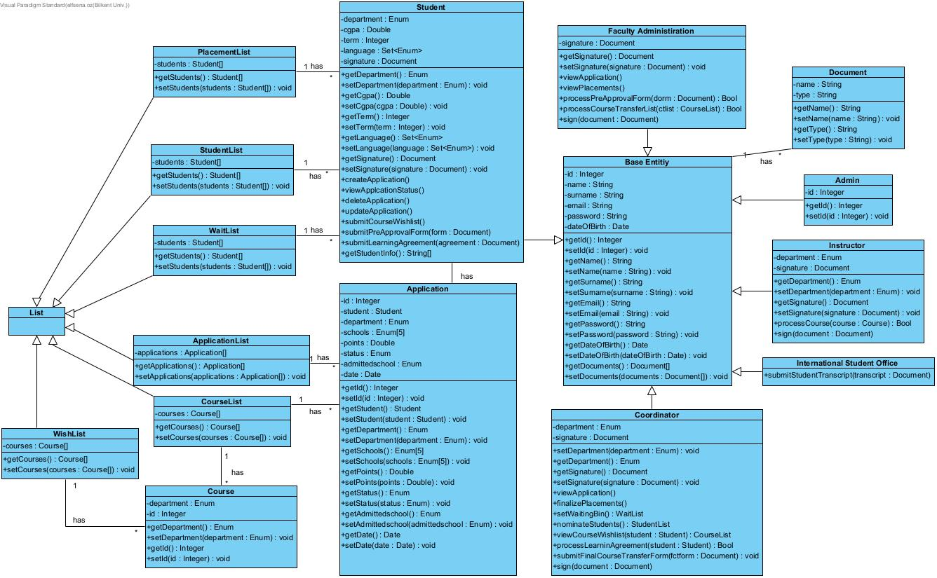

D) State Diagram:

**a. Application State Diagram:**

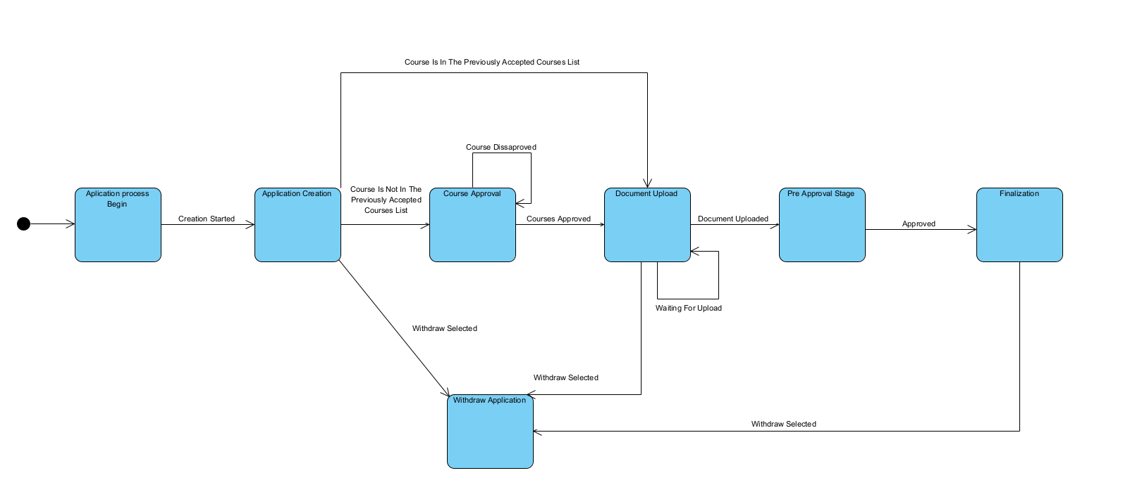

**b. Document State Diagram:**

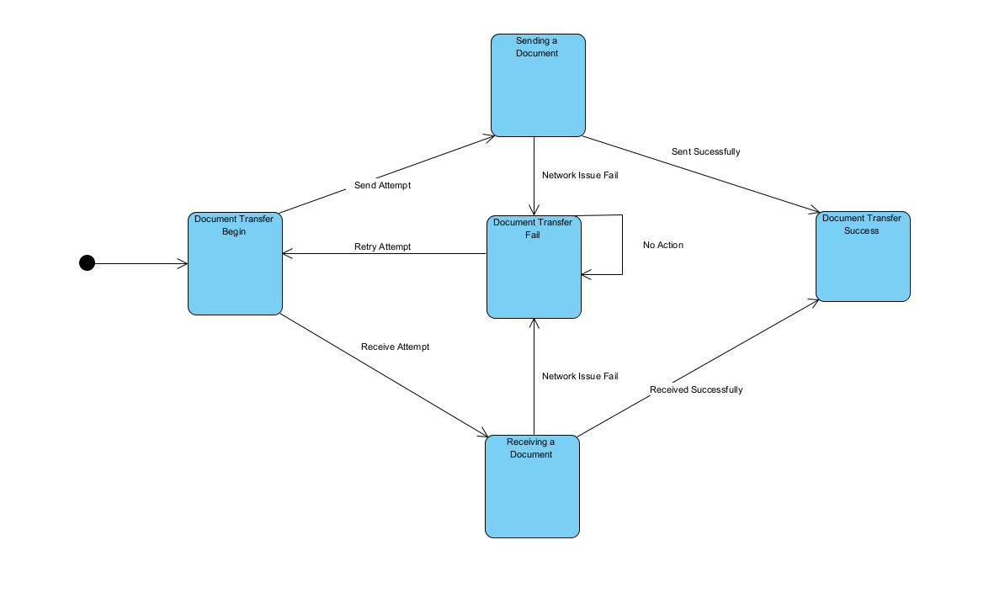

**c. Scholarship State Diagram:**

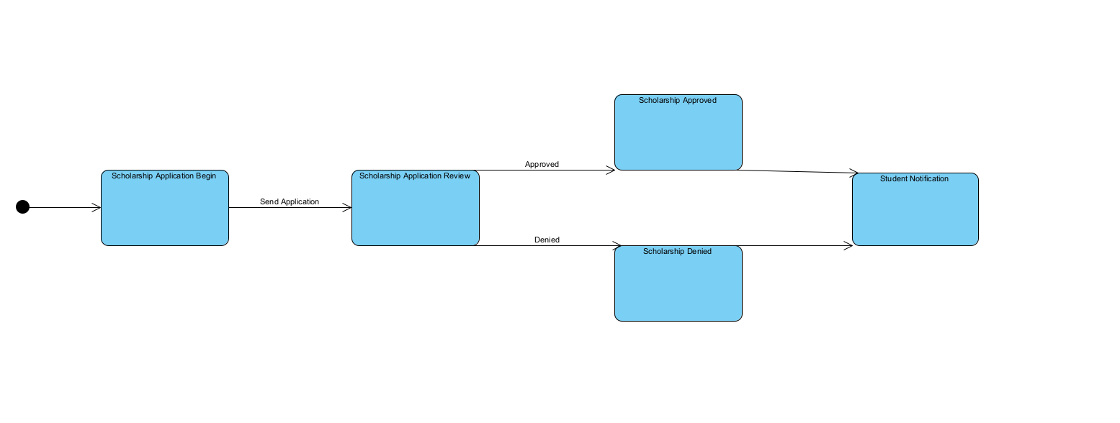

**d. Login State Diagram:**

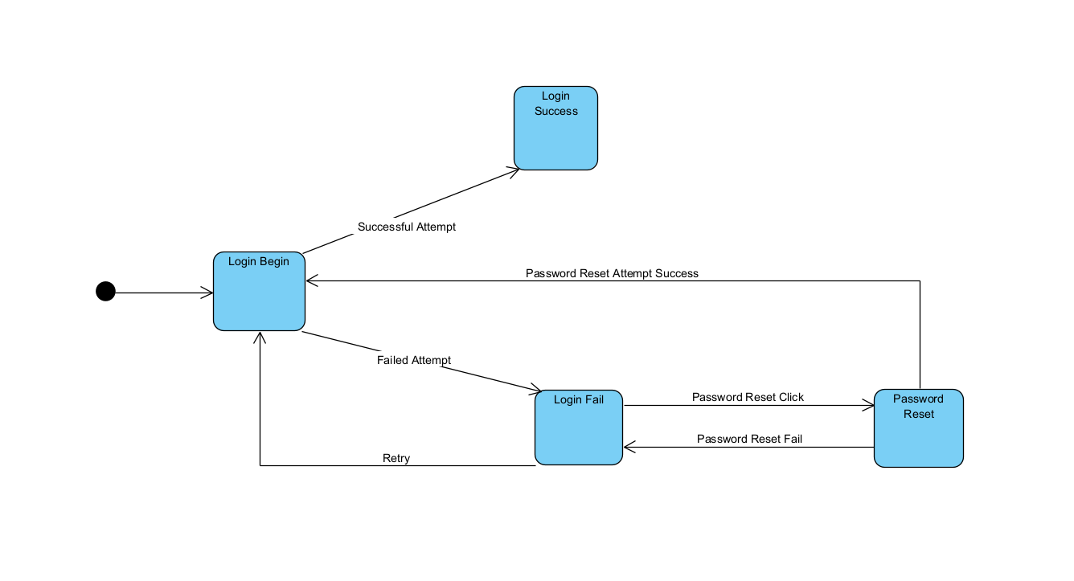

E) Activity Diagram:

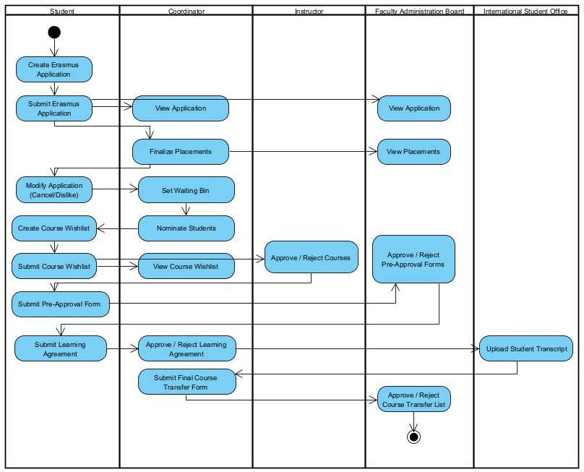

**Scenario**:

In the ideal scenario, application activity starts with the student creating an application and ends with the faculty administration board approving or rejecting the course transfer list. At any point in the application, faculty board members and coordinators can view student applications and make the necessary changes. However, view activities are not mandatory and are not included in the overall flow of the application process.

E) Sequence Diagram:

**i. Student–Application Creation Interaction:**

Student creates an application by using the application button on the student account page. In order to create an application, there are necessary documents to be uploaded to the system by the student. Also, some of these documents must be signed. The creation is done by getting the student information from the student account. After the application creation is done, the application is added to the application list.

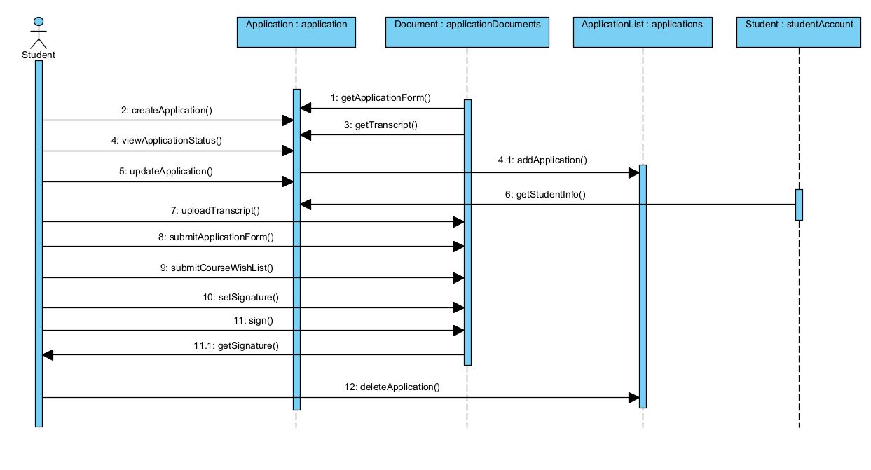

**ii. Student–Coordinator Interaction:**

Student submits necessary documents to the system for the application and offers the elective courses he/she wants to get in the Erasmus. The coordinator views, checks, and confirms the documents for the application. Also, approvement of the offered elective courses is done by the coordinator. Both the student and coordinator sign some of the required documents before the submission.

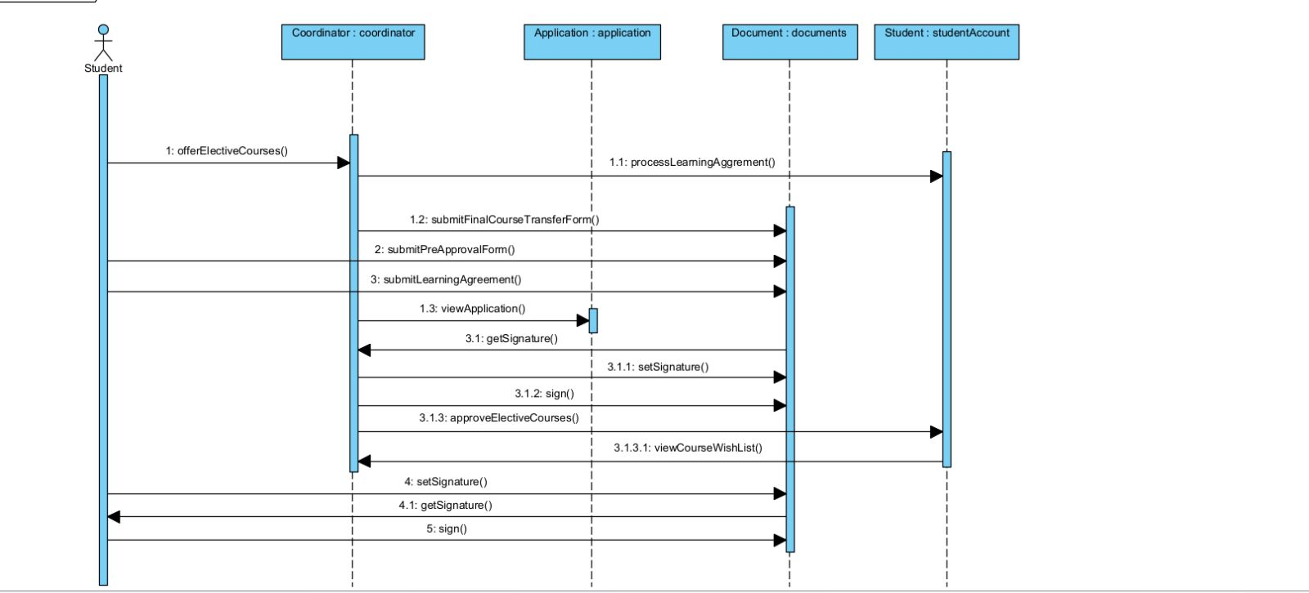

## GUI Descriptions

**Faculty Administration Page:**

The Faculty Administration page will display personal information on the left hand side; with the order from top to bottom starting from the profile photo, name, surname, and department of the faculty administration user. Following the personal information column; Applications, Placements, Approve/Reject Pre-Approvals, and Approve/Reject Course Transfer List tabs appear, from top to bottom fashion again. Applications tab direct the user to the current applications for Erasmus program waiting to be approved and viewed. Placements tab shows the user the finalized placements of the Erasmus applicants. Approve/Reject Pre-Approvals tab allows the user to approve or reject pre-approvals for Erasmus applications. Approve/Reject Course Transfer List tab allows the user to approve or reject courses to be transferred for Erasmus applications. Spanning from middle to the right hand side of the page, To Do List and Schedule appear from top to bottom. To Do List showcases personal notes for remembering tasks and Schedule displays the Date and Event columns for specific events on certain dates to notify the user.

**Login Page:**

The Login page displays two fields for entering ID and Password to login to the account. There is a “Forgot your password ?” clickable option under Password field in case a user forgets his/her login credentials. When clicked, user is directed to another page to follow steps in order to recover/reset login credentials. Under the clickable, LOGIN button appears which allows the user to login to his/her homepage when clicked, if login credentials are correct.

**Coordinator Page:**

The Coordinator page will display personal information on the left hand side; with the order from top to bottom starting from the profile photo, name, surname, ID, and department of the coordinator user. Following the personal information column; Applications List, Waiting Bin, Course Wishlist, Pre-Approval Forms, and Submit Final Course Transfer Forms tabs appear from top to bottom pattern again. Applications List tab direct the user to the current applications for Erasmus program waiting to be finalized and sent to a faculty administration user. Waiting Bin tab directs the user to the waiting Erasmus applicants to be placed to a university. Course Wishlist tab allows the user to approve or reject proposed courses of Erasmus applicants. Pre – Approval Forms tab allows the user to display or pre-approvals for Erasmus applications. Submit Final Course Transfer Forms tab submits the finalized course transfer forms to the faculty administration user. Spanning from middle to the right hand side of the page, To Do List and Schedule appear from top to bottom. To Do List showcases personal notes for remembering tasks and Schedule displays the Date and Event columns for specific events on certain dates to notify the user.

**Student Profile Page:**

The Student Profile page will display personal information on the left hand side; with the order from top to bottom starting from the profile photo, name, surname, ID, department, and semester of the student user. On the profile page there are email, name, surname, date of birth, national ID number, mobile phone number, and gender information. User can edit these information and save the changes by Save Changes button. Application tab on the left allows student to check the status of his/her ongoing Erasmus application, upload files, and check placements.

**Coordinator Profile Page:**

The Coordinator Profile page will display personal information on the left hand side; with the order from top to bottom starting from the profile photo, name, surname, ID, and department of the coordinator user. Following the personal information column; Applications List, Waiting Bin, Course Wishlist, Pre-Approval Forms, and Submit Final Course Transfer Forms tabs appear from top to bottom pattern again having the same functions explained in Coordinator Page. In the middle user’s email, name, surname, mobile phone number, and gender information are displayed. User can edit these information and save the changes by Save Changes button.

**Student Application Page:**

Student Application Page includes application information about Erasmus, as well as previously mentioned personal information features. Application interface includes contact information in 3 rows: email, address, and phone number. Under these 3 rows, Erasmus preferences from 1st to 5th preference are ordered from top to bottom. Under the preferences, documents section contain CV browsing and uploading options. Finally, edits can be saved with Save Application button.

**Student Home Page:**

Schedule table displays the dates and events to take place in near time. Student profile page features including personal information and Application button are included in the Student Home Page as well.

**Application List Page:**

Application List page includes name, surname, ID, department, and GPA of applying students in each row. At the right end of each row, VIEW APPLICATION button directs the coordinator to view the details of each applicant. The order of the applicants are determined with respect to calculated Erasmus grades with respect to GPA and English course letter grades.

**International Student Office:**

The International Student Office page will display a to-do list for the users for convenience of the action plan, a schedule for the upcoming document upload or other kinds of deadlines, and the most essential part will be the upload transcript button for the ongoing application. The International Student Office personnel will upload the international student's transcripts via this page to the software.

**Info:**

The info page will display the currently available schools and their details in a list format. This list is bound to change every year. The info page will also show the list of previously accepted courses to make the decision-making process and scheduling the time for the student easier

# 5. References

1. Bilkent, “Uluslararası Değişim programları uygulama esasları,” *TR / Bilkent Universitesi –*. [Online]. Available: https://w3.bilkent.edu.tr/www/uluslararasi-degisim-programlari-uygulama-esaslari/. [Accessed: 03-Nov-2022].
2. “DEPARTMENTAL EXCHANGE COORDINATORS LIST,” *Bilkent University*. [Online]. Available: https://www.bilkent.edu.tr/bilkent/admission/outgoing_exchange/coordinator.html. [Accessed: 03-Nov-2022].
3. “INFORMATION FOR EXCHANGE COORDINATORS,” *Bilkent University*. [Online]. Available: https://www.bilkent.edu.tr/bilkent/admission/info_exchange_coordinator/index.html. [Accessed: 03-Nov-2022].
4. “RECOGNITION OF EARNED CREDITS,” *Bilkent University*. [Online]. Available: https://www.bilkent.edu.tr/bilkent/admission/outgoing_exchange/earn_credits.html. [Accessed: 03-Nov-2022].
5. “Exchange Program at Bilkent Computer Engineering Department,” *Bilkent University*. [Online]. Available: <http://cs.bilkent.edu.tr/~exchange/>
6. “Erasmus & Exchange Programs,” *Bilkent University*. [Online]. Available: https://docs.google.com/presentation/d/1RHt6Y3VNm3ARlgG-W9Pam_kLgIQeMv5uD_sbCGX5_sc/edit#slide=id.p

# 