Lab 1 UML exercise

Orientation/reference

Throughout this quarter, we will be using UML (Unified Modeling Language) to help understand and express software engineering design decisions.

From Wikipedia: “In software engineering, a class diagram in the Unified Modeling Language(UML) is a type of static structure diagram that describes the structure of a system by showing the system's classes, their attributes, operations (or methods), and the relationships among objects.”

We will only use a small subset of UML to start with and slowly add more features as the quarter proceeds. In general, we will be using the following symbols to denote visibility:

+ | public
- | private
# | protected

And we will also eventually use the following symbols to denote relationships (keep this as a reference for later):

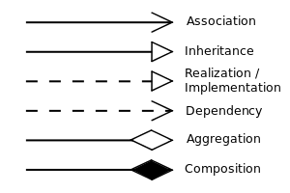

Resources:
This quarter, you are invited to use the freely available Umlet editor (https://www.umlet.com/). A copy is provided with the materials directory.

Task:
Today’s task is intended to start orienting you to the tool and UML. Create a new UML diagram for the code you wrote in part 2 of this lab. Your diagram should show the two important classes in part 2, viz:

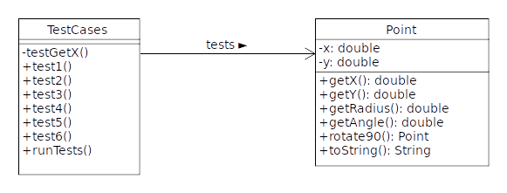

When you use Umlet, you’ll start out with “UML Common Elements” on the right hand side of the screen. When you click on something, you’ll see a description of it. Double-clicking on something creates a copy in your diagram. The program is a little quirky, but generally self-explanatory.

Note that in an association, you can describe how the classes are related. In the example above, it says “tests >”. In Umlet, you can make the four directional arrows on a realation with the characters “<”, “^”, “v” and “>”.

Save your diagram in the file part3/tests.uxf.

