The Question of Interest:
New investors often have difficulty identifying the best stocks to invest in due to the large amount of financial data and market trends available. This can lead to poor decisions because of limited or overwhelming information. So, we are creating a command line application to where user can input the stocks they want to invest in and the investment, and the output will create a portfolio with breakdown of their investment.
The Api’s being implemented for data sources and the members assigned:
- Alpha Vintage API for real time stock price. (Anurag Aggarwal)
- Yahoo Finance API to retrieve historical financial company details. (Alan Sajit)
- News API to retrieve news on the stock. (Liam Mcfadden)
- TextRazor API to retrieve consumer sentiment on the stock (Jaspreet Singh Saini)
- OpenAi API to provide insight and portfolio for the stocks using all the above information (Ahmed Mahmoud)
Structural and behavioural models:
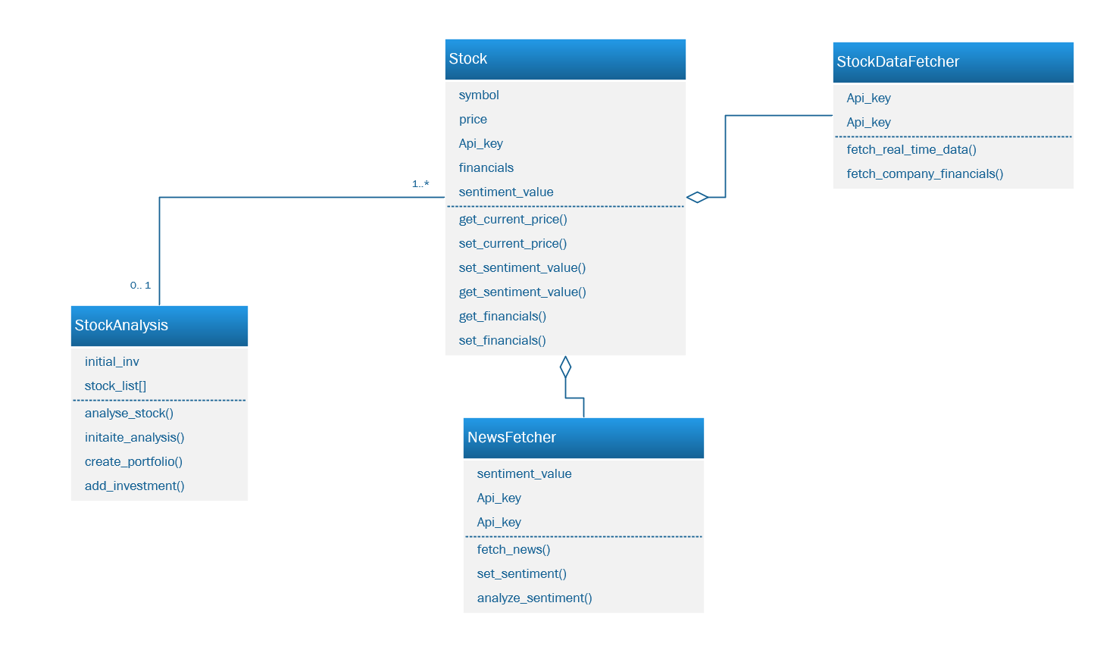
Structural Class Diagram
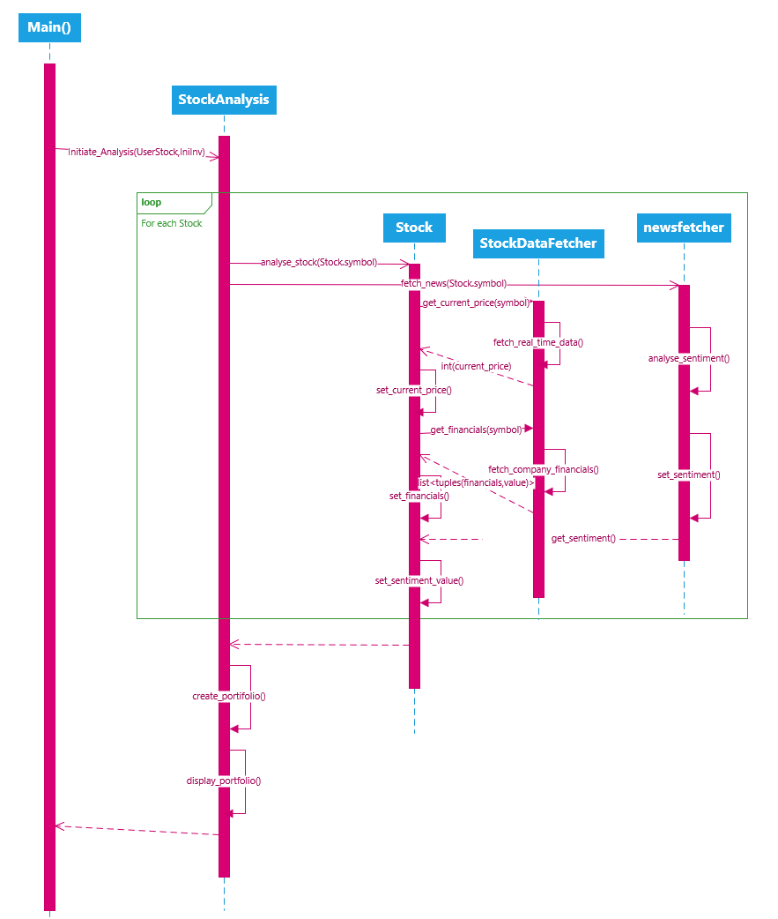
Behavioural Model (Activity Diagram)

